SECTION D
Research Question 3: What Is The Reason For Choice/Particular Pain Assessment Used On Non-Communicative Adult Patients Among Nurses In University Of Nigeria Teaching Hospital Ituku/Ozalla, Enugu?
Table 5: Reason for Choice/Particular Pain Assessment Used On Non-Communicative Adult Patients among Nurses (n = 241)
Reason | Agree | Neutral | Disagree | Mean (X̄)
Easy to remember | 162 (67.2%) | 42 (17.4%) | 37 (15.4%) | 2.52
Fast to complete | 171 (71.0%) | 39 (16.2%) | 31 (12.9%) | 2.58
Trained during orientation | 148 (61.4%) | 53 (22.0%) | 40 (16.6%) | 2.45
Institutional protocol or policy | 155 (64.3%) | 47 (19.5%) | 39 (16.2%) | 2.48
Felt more accurate | 174 (72.2%) | 36 (14.9%) | 31 (12.9%) | 2.59
Recommended by experienced staff | 139 (57.7%) | 60 (24.9%) | 42 (17.4%) | 2.40
Comfortable interpreting behaviours | 166 (68.9%) | 44 (18.3%) | 31 (12.9%) | 2.56
Table 5 shows that most of the respondents (72.2%) agreed that they chose a particular pain assessment scale because it felt more accurate. This was followed by 71.0% who agreed that the tool was fast to complete, and 68.9% who reported being comfortable interpreting behaviours. Other reasons include being easy to remember (67.2%), guided by institutional policy (64.3%), trained during orientation (61.4%), and recommendation from experienced staff (57.7%).

Figure 1: Reason for Choice/Particular Pain Assessment Used On Non-Communicative Adult Patients among Nurses (n = 241)
Reason | Percentage of Agreement (%)
Easy to remember | 67.2
Fast to complete | 71.0
Trained during orientation | 61.4
Institutional protocol or policy | 64.3
Felt more accurate | 72.2
Recommended by experienced staff | 57.7
Comfortable interpreting behaviours | 68.9

Figure 1: Reason for Choice/Particular Pain Assessment Used On Non-Communicative Adult Patients

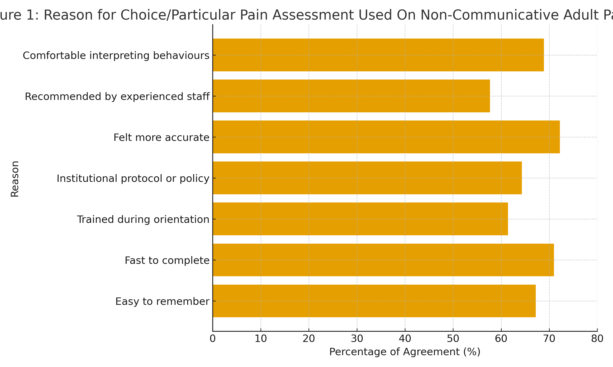
Data in Figure 1 revealed that most (72%) of the respondents agreed that the choice of a particular pain assessment scale was because it was felt to be more accurate. Other reasons include being fast to complete (71%), easy to remember (67%), comfortable interpreting behaviours (69%), institutional protocol or policy (64%), trained during orientation (61%), and recommendation by experienced staff (58%).

Theoretical Framework

Gate Control Theory of Pain (Melzack & Wall, 1965)
The Gate Control Theory (GCT) of pain was proposed by Ronald Melzack and Patrick Wall in 1965 to explain the complex mechanisms involved in the perception of pain. This theory marked a major shift from the traditional view that pain perception was a direct result of tissue damage. Instead, Melzack and Wall proposed that pain is a dynamic process influenced by the interaction between sensory, cognitive, and emotional factors within the nervous system.
The theory suggests that there is a “gate” mechanism located in the dorsal horn of the spinal cord that regulates the transmission of pain signals to the brain. When the gate is open, pain impulses pass freely to the brain and are perceived as pain. Conversely, when the gate is closed, pain signals are inhibited or blocked, reducing pain perception.
According to the theory:
- Small nerve fibers (A-delta and C fibers) carry pain signals to the spinal cord and tend to open the gate.
- Large nerve fibers (A-beta fibers) carry non-painful stimuli (like touch or pressure) and can close the gate.
- Cognitive and emotional factors such as attention, anxiety, stress, and prior experience can also influence whether the gate opens or closes.

Relevance of the Theory to Nursing Practice
The Gate Control Theory emphasizes that pain is not merely a physical sensation, but a subjective experience influenced by biological, psychological, and behavioral factors. This concept is critical in nursing, as it underlines the importance of assessing not only the physiological signs of pain but also behavioral and emotional cues, especially among non-communicative patients who cannot verbally express pain.

Application of the Theory to This Study
This study, “Nurse’s Utilisation of Pain Assessment Scale on Non-Communicative Adult Patients Among Trained Nurses Working in University of Nigeria Teaching Hospital Ituku-Ozalla, Enugu,” is anchored on Melzack’s Gate Control Theory of Pain.
In this context:
- The non-communicative adult patients are unable to verbalize pain; hence, nurses must rely on observable behaviors and physiological indicators to identify pain levels.
- The nurses act as interpreters of pain signals, using standardized pain assessment scales (such as behavioral pain scales, facial expression tools, or physiological markers) to determine whether the “pain gate” is open or closed.
- The theory supports the idea that nurses’ assessment, observation, and interventions can influence the patient’s pain perception by modulating the gate — for instance, through comfort measures, emotional support, and accurate assessment leading to timely pain relief.
- Factors such as training, institutional policy, and clinical experience further enhance the nurse’s ability to interpret pain accurately and apply interventions that help “close the gate,” thus reducing patient suffering.
Hence, Melzack’s Gate Control Theory provides a scientific basis for understanding how pain assessment tools can help nurses interpret and manage pain effectively in non-communicative adult patients. It emphasizes the nurse’s critical role in observing behavioral cues, applying appropriate assessment tools, and initiating interventions that can modulate pain perception and improve patient outcomes.

