ACLCM Web Based Online E-Learning Management System

A Project Study

Presented to the ACLC Colleges of

Mabalacat MacArthur Highway. Dau

Mabalacat, Pampanga

In Partial Fulfilment

Of the Requirements for the Degree

Bachelor of Science in Computer Science

Proponents:

Dominic Calayo

Raffy Bataller

Aaron Paul Angeles

John Michael Datu

Kendrick Rubio

**CHAPTER I: REVIEW OF RELATED LITERATURE AND STUDIES**

1. **INTRODUCTION**

ACLCM Web Based Online E-Learning Management System contains information on courses offered, timetables, exam schedules, and department contact numbers. They may also offer links to useful web resources of ACLC College of Mabalacat. Portals are commonly used in colleges and universities where prompt information and necessary updates must be readily available to direct students to educational resources for learning.

Based on the research and study ACLC College of Mabalacat currently uses Google Classroom and Google meet in Virtual Class. As a result, the institution experiences problem such as slow procedures in distributing the grades of the students and lessons. The researcher's goal is to develop a system that would help to improve the quality of learning and teaching experience.

Student's learning styles or needs should be met. Efficiency and efficacy should improve. To engage learners in the learning process, there should be an increase in user accessibility and time flexibility. This ACLCM Web Based Online E-Learning Management System can be used on various educational technologies like computers, laptops, and smartphones in the comfort of the users’ home, which is a type of distant education. This system is a type of learning that emphasizes the learner's mobility while interacting Online and with regards to adapting to the new normal. This system that can be accessed via the internet where you can log in as a student, teacher, or as an admin.

The current system is a web based online system; they have been using the AMA online E-learning system for many years. The proponents are proposing an ACLCM Web Based Online E-Learning Management System. It is accessible anywhere whether it be at school or at home.

The proponents are providing a system that will be helpful for the admin, instructor, and students because in this system the instructor can encode also their grades online like quizzes, exam, and other activities by using the current standard grading system of the school. The ACLCM Web Based Online E-Learning Management System focuses on the needs of the admin, teachers, and students.

The admin account will provide the teachers and students’ information, post announcements, and as well as monitoring accounts on the system. The teachers will have access to submit, review and edit grades in case of errors or complaints from the students. The teachers’ account can also upload exams, modules, activities, and recorded virtual lessons. While the students’ account can access recorded lessons and answer activities, and exams as well as upload assignments.

1. **STATEMENT OF THE PROBLEM**
2. **General Problem**

Communication between student and instructor is more complicated now with the new normal set-up. There can be miscommunications and misalignment of time availability between students asking things related to their school activities from their instructors. The technology literacy of the users can be a limiting factor. While most students/instructors today have at least some familiarity with technology, some still struggle with more complex systems. Fortunately, many e-learning solutions are adaptable, so it is appropriate to provide a simple interface when the content material itself is simple.

1. **Specific Problem**

* **Online Distance learning.**
* More Challenges encountered by student and teacher.
* **Consume a lot of time with regards the Distribution of lesson.**
* It is time consuming in terms of looking and waiting for the instructor to get their lesson/modules.
* **Lot of paper works in terms of assigning record of students.**
* Manually assigning of names, grades remarks of students in their individual class cards.
* **Lack of Support.**
* Physical absence of the instructor during asynchronous learning. They may not be available to guide or support the student when they need it most.

1. **OBJECTIVES OF THE STUDY**
2. **General Objectives**

The study intends to provide an easier way to release the grades of the student every last term of a semester. To design and develop the ACLCM Web Based Online E-Learning Management System to be accessible anywhere for admins to input information, teachers to input grades, lessons, activities and exam; as well as for students where they could upload their activities and assignments and check their grades.

1. **Specific Objectives**

* Enhance the quality of learning and teaching.
* Easy Monitoring on School.
* Improve user-accessibility and time flexibility.
* To have a web based online E-learning to students.

1. **SCOPE AND LIMITATIONS OF THE STUDY**
2. **Scope of the study**

The study will be focusing on providing the grades, exams, lessons, and activities of the students. The teacher can encode the prelim, midterm and final grades of the students online. The system will have the reports of the population of the school, specifically courses, name of the students and the teachers' load. The filtering of the subjects, it will provide the grades of every current semester. It will provide a unique key for every user.

1. **Limitations of the Study**

* Does not cover Subject Evaluation.
* Does not cover Enrolment Record.
* System is not reliable in the human error.
* Only Registered Students, are qualified to access the system.

1. **SIGNIFICANCE OF THE STUDY**

The importance of this study is to provide an ACLCM Web-Based E-Learning Management System. An ACLCM Web Based Online E-Learning Management System like this can really help the students and Admin staff of ACLC College of Mabalacat.

**School –** The school could also benefit from this system in a way that they can help them in accreditation of the school and for easier monitoring.

**Registrar-** It will lessen their work on the time of releasing the grades, and only small amount of the students will get their grades on the same day, and the admin could easily generate a report.

**Teacher –** They can have access to the system, they can record classes, activities, and grades of the students online.

**Students –** The system can give access to the students anywhere online rather than going to the registrar office in school.

**Researchers –** this Study will serve as training for proponents, to enhance their skills in web development. And this will benefit the researchers, the completion of this project will be for all the requirements needed to pass.

1. **DEFINITION OF TERMS**

* **ACLCM –** AMA Computer Learning Center College of Mabalacat
* **Admin –** people who are employed in an institution to administrate the events.
* **COVID-19 –** a pandemic that struck March 2020.
* **E**-**learning –** a type of learning conducted through electronic media, typically via the internet.
* **Efficiency** –it is often connected to the attainment of a stated education from fewer resources.
* **Efficacy** – refers to the confidence of an instructor’s ability to guide students to success
* **Encode –** to input data online like grades, class codes, student information, etc.
* **New normal –** a way of living that was formed during the surge of the COVID-19 pandemic which basically limits the face-to-face contact of people; also led to work and school to be held remotely in people’s houses.
* **Online –** connecting to another computer and/or to a network
* **Portal –** an online access available anywhere for admins, teachers and students that are registered in an institution.
* **Technology literacy –** is a term used to describe a person's ability to assess, attain and communicate information in a fully digital setting.
* **Upload –** transferring of data from one computer to another for it to be accessible online.

**CHAPTER II: REVIEW OF RELATED LITERATURE AND STUDIES**

This chapter presents the relevant literature and studies that the proponents considered in strengthening the importance of the present study. It also presents the synthesis of the art to fully understand the research for better comprehension of the study.

1. **FOREIGN LITERATURE**

**Online Learning Management in the Era of COVID-19 Pandemic.**

Recently, many publications have extensively investigated online learning during the COVID-19 pandemic from various perspectives. Mishra et al. (2020)[1] have analyzed the various forms of online learning conducted in universities during the COVID-19 pandemic. This work found that the forms Online Learning Management of online learning preferred by lecturers and students were email, WhatsApp, and learning management systems. Alawamleh et al. (2020)[2] have reported the effects of online learning on communication between teachers and students during the COVID-19 pandemic and found the students prefer offline to online learning. This is because online learning has many problems such as lack of students’ motivation, understanding of the topic, and feeling of alienation caused by online classes. Other studies have also explored online learning during the COVID-19 pandemic with specific objectives, such as to analyze students’ adaptation from offline to online learning (Besser et al., 2020).[3]

**Factors Affecting the Quality of E-Learning during the COVID-19 Pandemic from the perspective of Higher Education Students.**

Management of educational institutions should provide a feedback form to the stakeholders with which the teaching quality, administrative support, and resources to support the learning can be analyzed (Raju & Phung, 2018). The rating of the institutes fluctuates between lower and higher based on the increasing number of positive and negative comments (Shah & Cheng, 2019). Focusing on the importance of employees by measuring their knowledge delivery to the students and the value they add to the organization’s growth is an essential process in higher education (Körkkö et al., 2016). The culture of the organization is the combination of structure, ideas, and high quality, which make a pathway for the students to become high-tech employees in the future (Martin & Leurent, 2017).

**Impact of online classes on the satisfaction and performance of students during the pandemic period of COVID 19.**

Many comparative studies have been carried out to prove the point to explore whether face-to-face or traditional teaching methods are more productive or whether online or hybrid learning is better (Lockman & Schirmer, 2020; Pei & Wu, 2019; González-Gómez et al., 2016; González-Gómez et al., 2016). Results of the studies show that the students perform much better in online learning than in traditional learning. Henriksen et al. (2020) highlighted the problems faced by educators while shifting from offline to online mode of teaching. In the past, several research studies had been carried out on online learning to explore student satisfaction, acceptance of e-learning, distance learning success factors, and learning efficiency (Sher, 2009; Lee, 2014; Yen et al., 2018).

**University College Absalon, Denmark**

Online learning is commonly defined in contradistinction to F2F learning (e.g., Ryan et al., 2016). Its most prominent feature is the absence of the physical classroom, which is replaced by the use of web-based technologies offering opportunities for out-of-class learning independent of time, place and pace (Bernard et al., 2014; Chigeza and Halbert, 2014; Northey et al., 2015; Israel, 2015; Potter, 2015). Ryan et al. (2016) point out that “in the context of higher education, the phrase online learning is often interpreted as referencing courses that are offered completely online; Typically, the online learning setting is launched through so-called learning management systems (LMS) or virtual learning environments (VLE) such as Moodle and Blackboard (Pellas and Kazanidis, 2015).

**Cranleigh School.**

Educators have traditionally expressed scepticism about the prospects of reproducing outcomes equivalent to traditional face-to-face instruction by means of online distance learning, according to Paul VanPortfliet and Michael Anderson. In a study comparing outcomes from online and hybrid courses, VanPortfliet and Anderson note that it is believed that academic achievement and retention are worse for students following distance learning programmes than for those being taught in traditional classroom settings. An explanation cited for this relative lack of efficacy traces it back to a lack of contact between students, their teacher and their peers in the online learning environment.

That said, there is also evidence of equivalence across a number of outcome measures. A 2004 meta-analysis by Cathy Cavanaugh et al of 116 effect sizes measured across 14 K-12 web-delivered distance learning programmes between 1999 and 2004 found that there was no significant difference in outcomes between virtual and face-to-face schools.

A 2015 study by Heather Kauffmann explored factors predictive of student success and satisfaction with online learning. Kauffmann notes that several studies have found that online learning programmes lead to outcomes that are comparable to those of face-to-face programmes.

1. **LOCAL LITERATURE**

**Online Distance Learning**

The advent of the Internet and its use for educational purposes is considered as the third phase of distance learning history (Kaplan & Haenlein, 2016). Distance learning, also called distance education, e-learning, and online learning, is a form of education in which the main elements include physical separation of teachers and students during instruction and the use of various technologies to facilitate student-teacher and students communication (Simonson, 2020). In addition, learning becomes more learner centered since it promotes greater participation from them (Markova,et. al., 2017). Research in terms of national and international curricula for early childhood and primary education indicates that ICT competences should already be taught at an early age (Aesaert et al., 2015). The attempt of the Philippines to adapt to online learning was brought about by the pandemic that is affecting the world.

**Online Grading System.** (CLARK COLLEGE OF SCIENCE AND TECHNOLOGY**)**

This study will focus on developing and improving the distribution of class cards of Clark College of Science and Technology. The Online Grading System is specially made for viewing, adding, editing, importing, and calculating student grades. For the admin account the system can add students / student accounts, it can edit student accounts, can view and amend student grades, I can also add subject and section to the teachers. For the teacher accounts the teacher can input and edit student grades. For the student account the system can view through online. The administrator account can restore student account if the student forgot his/her password.

**Online Distance Education**

Further, the study of Qasem and Viswanathappa (2016) entail a positive perception of teachers with the notion of ICT integration using blended learning instruction. With the rapid development of technology-based teaching delivery, it can be argued that the findings of the study showed teachers’ satisfaction in terms of experiencing professional development training through blended learning approach. In the context of virtual classroom, learners have the opportunity to access the learning materials regardless of time and space. Thus, the literature discusses that teachers and students are being mediated with ICT through the notion of blended-based instruction. This implies that teachers and students, in blended learning, are both part of the virtual classroom irrespective of geographical separation (Lalima & Dangwal, 2017) and face-to-face classroom meeting

The study of Qasem and Viswanathappa (2016) entail a positive perception of teachers with the notion of ICT integration using blended learning instruction. With the rapid development of technology-based teaching delivery, it can be argued that the findings of the study showed teachers’ satisfaction in terms of experiencing professional development training through blended learning approach. In the context of virtual classroom, learners have the opportunity to access the learning materials regardless of time and space. Thus, the literature discusses that teachers and students are being mediated with ICT through the notion of blended-based instruction. This implies that teachers and students, in blended learning, are both part of the virtual classroom irrespective of geographical separation (Lalima & Dangwal, 2017) and face-to-face classroom meeting.

**Developing E-learning Services Based on Cache Strategy and Cloud Computing.**

Mohammed Khaleel Hussein (2016) The services of e-learning have developed since the using of computers in teaching role. Yet, there is a desire to change to blended learning services, where computer-based actions are incorporated with classroom-based or practical conditions. We have different E-learning services like training tutors, course contents, lectures, score quizzes and assessment for online exams.

1. 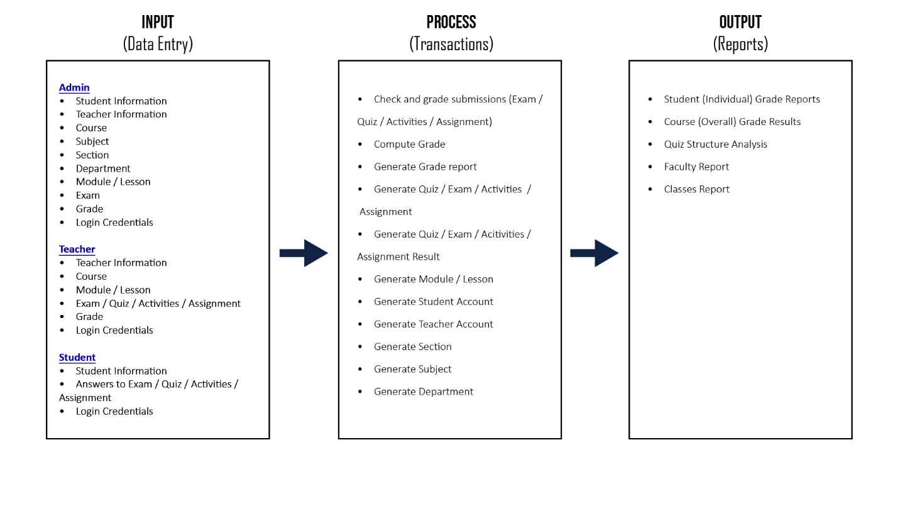**CONCEPTUAL FRAMEWORK**

**Figure 1.** Conceptual Frame Work for ACLCM E-Learning Management System for the ACLC College of Mabalacat.

This Figure shows Input Process and Output of the Users, User Login in ACLCM E-learning Management System; input Student number to Student; Teacher member to their account number and admin can log in. Process is Generate Account generate quizzes, exam compute a grade, and posting school works; remind the student schedule to their class and submission, checking the attendance. Output submit the grade report, classed report and logout the ACLCM E-learning Management System.

**CHAPTER III: CURRENT STATE OF TECHNOLOGY**

**ACLC COLLEGES OF MABALACAT**



**Figure 2.** Current System used by ACLC College of Mabalacat.

This Figure shows the ACLC College of Mabalacat use the traditional way of Virtual education by using the Google Classroom and Google meet for college.

1. **FLOWCHART**

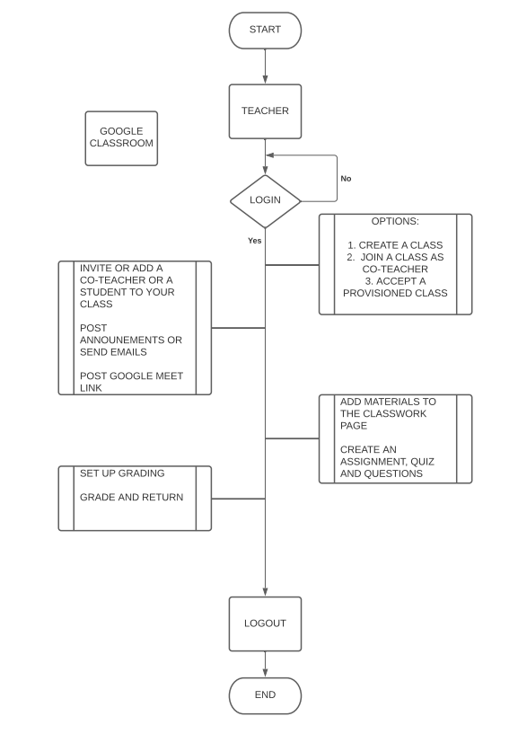

***Figure 3.*** *Teacher**Flowchart for the Current system use of ACLC College of Mabalacat.*

This figure shows the flow of the current system.

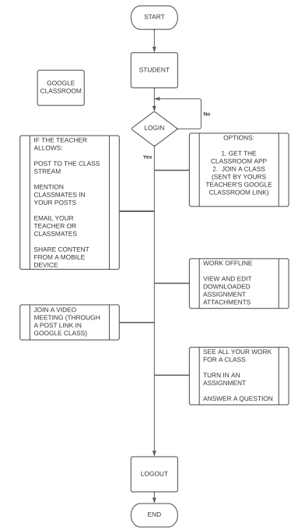

***Figure 4.*** *Student**Flowchart for the Current system use of ACLC College of Mabalacat.*

This figure shows the flow of the current system.

1. **LIST AND SPECIFICATIONS OF CURRENT EQUIPMENT**

|  |  |
| --- | --- |
| 1 | CPU |
| 2 | MONITOR |
| 3 | MOUSE |
| 4 | KEYBOARD |

Table 1: Lists of equipment for current system

1. **LIST OF SOFTWARE CURRENTLY USED**

Table 2: List Software of Current System

|  |  |
| --- | --- |
| 1 | BROWSER |

1. **ESTIMATED COST**

Table 3: Estimated cost when deploying

|  |  |
| --- | --- |
| **EQUIPMENT** | **COST** |
| AWS EKS | Php7,675.00 |
| DOMAIN NAME | Php630.00 |
| DATABASE | Php420.00 |
| **TOTAL** | **Php8,725.00** |

**CHAPTER IV: PROPOSED SYSTEM**

1. **FLOWCHART**

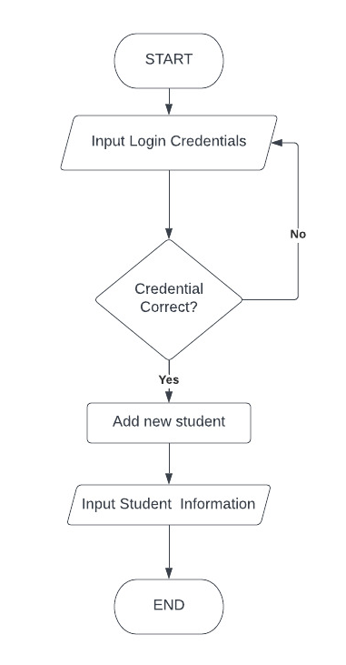

***Figure 5.*** *Admin**Flowchart for creating new student account.*

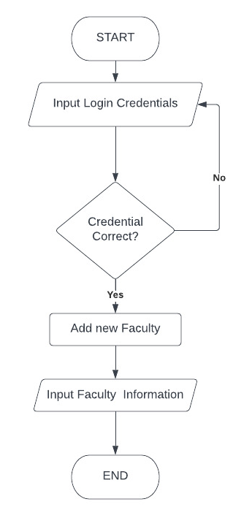

***Figure 6.*** *Admin**Flowchart for creating new faculty account.*

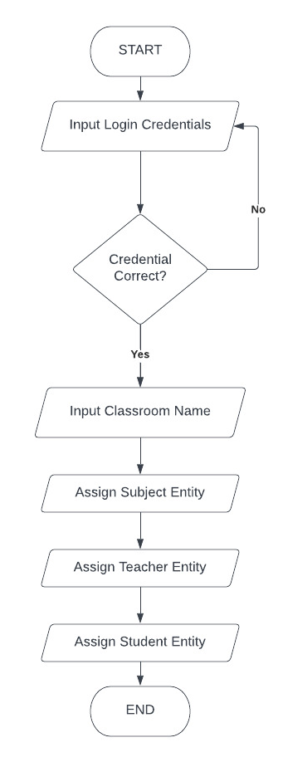

***Figure 7.*** *Admin**Flowchart for creating new classroom account.*

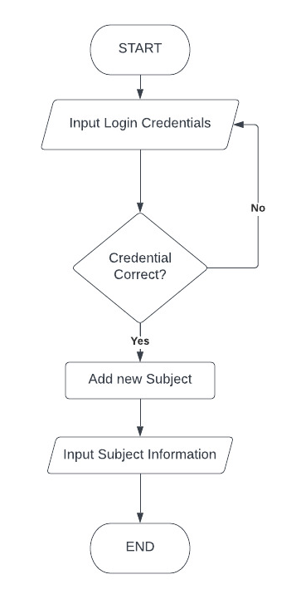

***Figure 8.*** *Admin**Flowchart for creating new subject account.*

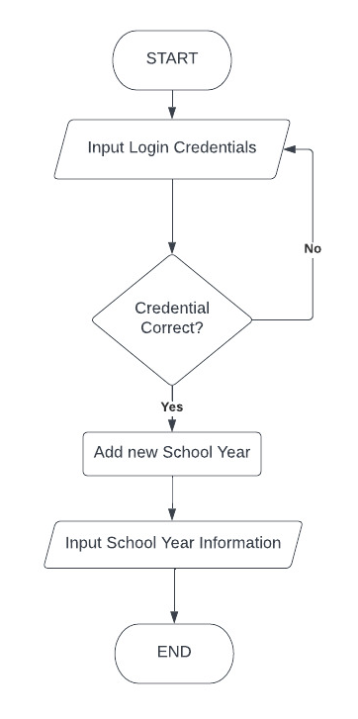

***Figure 9.*** *Admin**Flowchart for creating new school year account.*

1. **DATA FLOW DIAGRAM**
2. 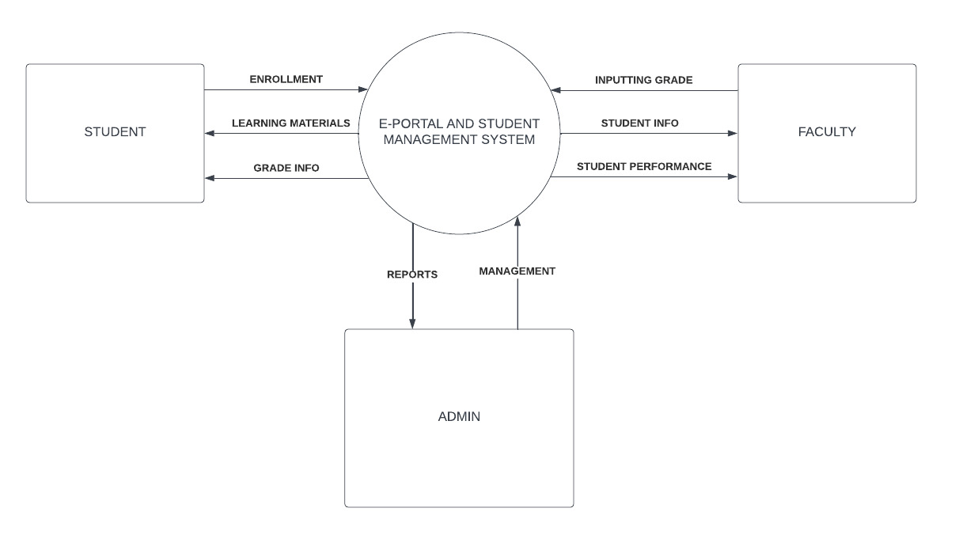**Level 0 Diagram**

***Figure 10.*** *Diagram showing the proposal’s flow.*

1. 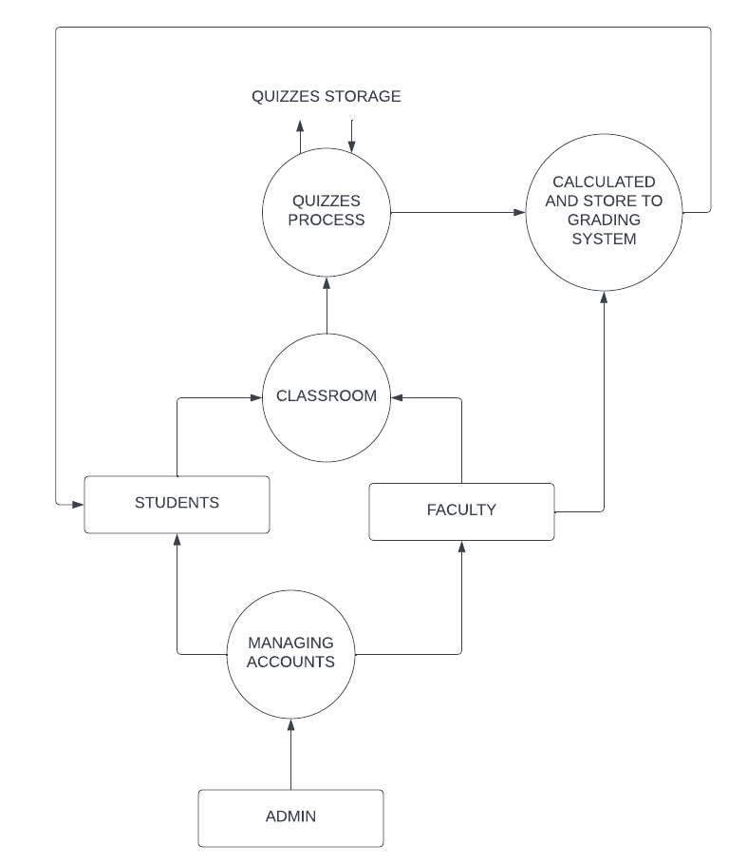**Level 1 Diagram**

***Figure 11.*** *Diagram showing the proposal’s flow.*

1. **ENTITY RELATIONSHIP DIAGRAM**
2. **PRODUCTION COMPARISON**

**CHAPTER V: RESEARCH DESIGN AND METHODOLOGY**

1. **RESEARCH METHOD**

The research method that was used for this study is the Waterfall Methodology. Since this methodology has a project management approach that emphasizes in a linear progression from beginning to end of a project, it was easily applied to how the ACLCM Web Based Online E-Learning Management System is to organize the admin work, teachers lessons and grade encoding; as well as the students’ way of sending their submittals and checking their grades.

1. **RESEARCH INSTRUMENT**

To provide and gather as much informative and relative evaluation descriptive method was used. This method includes the use of questionnaire and interviews. The tools used by the researcher are discussed.

* **Questionnaire**

A questionnaire was used as the main data gathering instrument for this study. There are three sets of questionnaire formed by the researcher, the first 5 business owners and the second for another 5 business owners to compare manual process versus the develop system. In the questionnaire, Likert scale was used to determine if the respondent agreed or disagreed in a statement.

In this survey, five choices are provided for every question or statement. The choices represent the degree of agreement each respondent has on given question.

Table 1. The five-point Likert Scale

| **Scale** | **Weighted Mean** | **Interpretation** |
| --- | --- | --- |
| 5 | 4.20 – 5.00 | Strongly agree |
| 4 | 3.40 – 4.19 | Agree |
| 3 | 2.60 – 3.39 | Neither agree or nor agree |
| 2 | 1 .80 – 2.59 | Disagree |
| 1 | 1.00 – 1.79 | Strongly Disagree |

The questionnaire was prepared by the researcher to determine the acceptance of the respondents. The questionnaire was constructed based on the ISO 1926 an international standard for the evaluation of the software where the non-functional requirements of the system were evaluated. The respondents need to answer the questions based on the five point Likert scale and the following criteria: functionality, reliability, usability, efficiency, portability and maintainability. (See Appendix B)

* **Interview**

As the researcher, I conducted an interview to develop the point of sale/inventory system of sotto mini grocery store. The owners were interviewed on how the sales operation occurred and how they can easily conduct it with my system. The result of the interview supported in the gathered information through the questionnaire. Feedback and recommendation were also acknowledged.

1. **RESEARCH LOCALE**

The study was conducted is at ACLC College of Mabalacat in Pampanga. The proposal is essentially associated with the new normal situation with regards to the education system. It helps either admin, teacher, or students to access the portal remotely is which helps lessen the time to travel to school just to input data.

1. **POPULATION**
2. **DATA GATHERING AND PROCEDURE**
3. **SYSTEM DEVELOPMENT LIFE CYCLE**
4. **TESTING AND OPERATING PROCEDURE**

| **Test Scenario** | **Test Cases** |
| --- | --- |
| **Cashier Activity** | Test the entry of items purchased by a customer is correct |
| Test discounts are applied correctly |
| Check cash management works as expected |
| Check totals and closing match |
| Check for regular sales process |

| **Admin** | Check for correct prices are displayed for merchandise purchased |
| --- | --- |
| Test for billing details or shipping details in payment manager |
| Test for reference transaction |
| Test for print format of the receipt generated |
| Make sure the in-house inventory is well integrated with other outlets or supply chain. |

| **Performance** | Check for speed or time taken to receive a response or send a request |
| --- | --- |
| Check the transaction based rules are applicable (discounts) |
| Check the inventory by entering a code for the item |
| Check how the system response by entering the wrong invoice number |
| Test for a negative transaction |
| Test system for allocating wrong offers or discounts. |

| **Security and Regulatory Compliance** | Test the database for recording customer’s buying history |
| --- | --- |
| Test alert system that notifies security defenders |
| Make sure user can void payment before posting |
| Test user profiles and access levels on the POS software |
| Test database consistency for back up files |
| **Report Testing** | Testing of a trend analysis report |
| Test information related to credit card transaction should be reflected in reports |
| Test for sales report generation |
| Test for purchased order and received items generation |

1. **STATISTICAL TOOLS**

**CHAPTER VI: PRESENTATION, INTERPRETATION AND ANALYSIS**

**CHAPTER VII: SECURITY AND MAINTERNANCE**

**CHAPTER VIII: SUMMARY FINDINGS, CONCLUSIONS AND RECOMMENDATIONS**