ACLCM Web Based Online E-Learning Management System

A Project Study

Presented to the ACLC Colleges of Mabalacat MacArthur Highway. Dau Mabalacat, Pampanga

In Partial Fulfilment

Of the Requirements for the Degree Bachelor of Science in Computer Science

Proponents: Dominic Calayo Raffy Bataller Aaron Paul Angeles John Michael Datu Kendrick Rubio

1. **Introduction**

ACLCM Web Based Online E-Learning Management System contains information on courses offered, timetables, exam schedules, and department contact numbers. They may also offer links to useful web resources of ACLC College of Mabalacat. Portal are commonly used in colleges and universities where prompt information and necessary updates must be readily available to direct students to educational resources for learning.

Based on the research and study ACLC College of Mabalacat currently uses Google Classroom and Google meet in Virtual Class. As a result, the institution experiences problem such as slow procedures in distributing the grades of the students and lessons. The researcher's goal is to develop a system that would help to improve the quality of learning and teaching experience.

Student's learning styles or needs should be met. Efficiencies and efficacy should be improved. To engage learners in the learning process, increase user accessibility and time flexibility. This ACLCM Web Based Online E-Learning Management System uses educational technologies on their mobile devices, computers, laptops, and smartphones at their Comport of their home, which is a type of distant education. This system is a type of learning that emphasizes the learner's mobility while interacting Online and because of the new normal. A system that can be accessed via the internet where you can log in as a student, teacher, or as an admin.

The current system was web based online system, they use the AMA online E-learning system for many years. The proponents propose a ACLCM Web Based Online E-Learning Management System. It is accessible through online and this system will really help them in a way that they don’t need to go on school.

The proponents provide a system that is very helpful for the admin, instructor, and students because in this system the instructor can encode also their grades through online like quizzes, exam, and some other activities by using the current standard grading system of the school. The ACLCM Web Based Online E-Learning Management System focuses on the needs of the admin, teachers, and students.

The admin account will provide the user information and announcement they can also monitor every account on the system. The teacher will have a chance to review the submitted grades in case of errors or complaints from the students. The teacher account can upload Exams, Modules, Activities, and the recorded virtual lesson. While the student account can access the recorded lesson and answer the activities and exam given by their teachers and they can also upload their assignments.

1. **Statement of the Problem.**

Communication between student and instructor is more complicated. Learners can usually still contact a course director for specific answers, but they are less readily available, and time is required for those communications. The technology skills of the learners can be a limiting factor. While most students/instructors today have at least some familiarity with technology, some still struggle with more complex systems. Fortunately, many e-learning solutions are adaptable, so it may be appropriate to provide a simple interface when the content material itself is simple.

**Specific Problem.**

* **Online Distance learning.**
* More Challenges encountered by student and teacher.
* **Consume a lot of time regards the Distribution of lesson.**
* It is time consuming in terms of looking and waiting for the instructor to get their lesson/modules.
* **Lot of paper works in terms of assigning record of students.**
* -Manually assigning of names, grades remarks of students in their individual class cards.
* **Lack of Support.**
* Physical absence of the instructor during asynchronous learning. They may not be available to guide or support the student when they need it most.

1. **Objectives of the Study**

The study intended to provide an easier way to release the grades of the student every last of semester. To design and develop the ACLCM Web Based Online E-Learning Management System that can be able to access the Grade of the students of ACLC College of Mabalacat and also access lesson and activities, the current system will be upgraded into online so that it could access by students anywhere.

* Enhance the quality of learning and teaching.
* Easy Monitoring on School.
* Improve user-accessibility and time flexibility.
* To have a web based online E-learning to students.

1. **Scope and Limitations of the Study.**

**D.1 Scope of the study**

The study will be focusing on providing the grades, exams, lessons, and activities of the students. The teacher can encode the Prelim, midterm and final grades of the students through online. The system will have the reports of the population of the school, specifically courses, name of the students and the Teachers load. The filtering of the subjects, it will provide the grades of every current semester. It will provide its own unique key for user.

**D.2 Limitations of the Study**

* Does not cover Subject Evaluation.
* Does not cover Enrolment Record.
* System is not reliable in the human error.
* Only Registered Students, are qualified to access the system.

1. **Significance of the study**

The importance of this study is to provide a, ACLCM Web-Based E-Learning Management System. A ACLCM Web Based Online E-Learning Management System like this can really help the students and Admin staff of ACLC College of Mabalacat.

**School –** The school could also benefit from this system in a way that they can help them in accreditation of the school. And easy monitoring.

**Registrar-** It will lessen their work on the time of realizing the grades, and only small amount of the students will get their grades on that day, and the admin could generate the report.

**Teacher –** They has an access to the system, they can record Classes, Activity, and grades of the students through online.

**Students –** This system could provide their grades anytime they want it could also help them to save time, they don’t need to go on the registrar office.

**Researchers –** this Study will serve as training for proponents, to enhance their skills in web development. And This will benefit the researchers, the completion of this project the researchers will be able to complete all the requirements they needed to pass.

1. **Definition of Terms.**

**ACLCM –** ACLC College of Mabalacat

1. **REVIEW OF RELATED LITERATURE AND STUDIES**

This chapter presents the relevant literature and studies that the proponents considered in strengthening the importance of the present study. It is also present the synthesis of the art to fully understand the research for better comprehension of the study.

**Foreign Literature**

**ONLINE LEARNING MANAGEMENT IN THE ERA OF COVID-19 PANDEMIC.**

Recently, many publications have extensively investigated online learning during the COVID-19 pandemic from various perspectives. Mishra et al. (2020)[1] have analyzed the various forms of online learning conducted in universities during the COVID-19 pandemic. This work found that the forms Online Learning Management of online learning preferred by lecturers and students were email, WhatsApp, and learning management systems. Alawamleh et al. (2020)[2] have reported the effects of online learning on communication between teachers and students during the COVID-19 pandemic and found the students prefer offline to online learning. This is because online learning has many problems such as lack of students’ motivation, understanding of the topic, and feeling of alienation caused by online classes. Other studies have also explored online learning during the COVID-19 pandemic with specific objectives, such as to analyze students’ adaptation from offline to online learning (Besser et al., 2020).[3]

**FACTORS AFFECTING THE QUALITY OF E-LEARNING DURING THE COVID-19 PANDEMIC FROM THE PERSPECTIVE OF HIGHER EDUCATION STUDENTS.**

Management of educational institutions should provide a feedback form to the stakeholders with which the teaching quality, administrative support, and resources to support the learning can be analyzed (Raju & Phung, 2018). The rating of the institutes fluctuates between lower and higher based on the increasing number of positive and negative comments (Shah & Cheng, 2019). Focusing on the importance of employees by measuring their knowledge delivery to the students and the value they

add to the organization’s growth is an essential process in higher education (Körkkö et al., 2016). The culture of the organization is the combination of structure, ideas, and high quality, which make a pathway for the students to become high-tech employees in the future (Martin & Leurent, 2017).

**Impact of online classes on the satisfaction and performance of students during the pandemic period of COVID 19.**

Many comparative studies have been carried out to prove the point to explore whether face-to-face or traditional teaching methods are more productive or whether online or hybrid learning is better (Lockman & Schirmer, 2020; Pei & Wu, 2019; González-Gómez et al., 2016; González-Gómez et al., 2016). Results of the studies show that the students perform much better in online learning than in traditional learning. Henriksen et al. (2020) highlighted the problems faced by educators while shifting from offline to online mode of teaching. In the past, several research studies had been carried out on online learning to explore student satisfaction, acceptance of e-learning, distance learning success factors, and learning efficiency (Sher, 2009; Lee, 2014; Yen et al., 2018).

**University College Absalon, Denmark**

Online learning is commonly defined in contradistinction to F2F learning (e.g., Ryan et al., 2016). Its most prominent feature is the absence of the physical classroom, which is replaced by the use of web-based technologies offering opportunities for out-of-class learning independent of time, place and pace (Bernard et al., 2014; Chigeza and Halbert, 2014; Northey et al., 2015; Israel, 2015; Potter, 2015). Ryan et al. (2016) point out that “in the context of higher education, the phrase online learning is often interpreted as referencing courses that are offered completely online; Typically, the online learning setting is launched through so-called learning management systems (LMS) or virtual learning environments (VLE) such as Moodle and Blackboard (Pellas and Kazanidis, 2015).

**Cranleigh School.**

Educators have traditionally expressed scepticism about the prospects of reproducing outcomes equivalent to traditional face-to-face instruction by means of online distance learning, according to Paul VanPortfliet and Michael Anderson. In a study comparing outcomes from online and hybrid courses, VanPortfliet and Anderson note that it is believed that academic achievement and retention are worse for students following distance learning programmes than for those being taught in traditional classroom settings. An explanation cited for this relative lack of efficacy traces it back to a lack of contact between students, their teacher and their peers in the online learning environment.

That said, there is also evidence of equivalence across a number of outcome measures. A 2004 meta-analysis by Cathy Cavanaugh et al of 116 effect sizes measured across 14 K-12 web-delivered distance learning programmes between 1999 and 2004 found that there was no significant difference in outcomes between virtual and face-to-face schools.

A 2015 study by Heather Kauffmann explored factors predictive of student success and satisfaction with online learning. Kauffmann notes that several studies have found that online learning programmes lead to outcomes that are comparable to those of face-to-face programmes.

**Local Literature.**

**Online Distance Learning**

The advent of the Internet and its use for educational purposes is considered as the third phase of distance learning history (Kaplan & Haenlein, 2016). Distance learning, also called distance education, e-learning, and online learning, is a form of education in which the main elements include physical separation of teachers and students during instruction and the use of various technologies to facilitate student-teacher and students communication (Simonson, 2020). In addition, learning becomes more learner centered since it promotes greater participation from them (Markova,et. al., 2017). Research in terms of national and international curricula for early childhood and primary education indicates that ICT competences should already be taught at an early age (Aesaert et al., 2015). The attempt of the Philippines to adapt to online learning was brought about by the pandemic that is affecting the world.

**Online Grading System.** (CLARK COLLEGE OF SCIENCE AND TECHNOLOGY**)**

This study will focus on developing and improving the distribution of class cards of Clark College of Science and Technology. The Online Grading System is specially made for viewing, adding, editing, importing, and calculating student grades. For the admin account the system can add students / student accounts, it can edit student accounts, can view and amend student grades, I can also add subject and section to the teachers. For the teacher accounts the teacher can input and edit student grades. For the student account the system can view through online. The administrator account can restore student account if the student forgot his/her password.

**Online Distance Education**

Further, the study of Qasem and Viswanathappa (2016) entail a positive perception of teachers with the

notion of ICT integration using blended learning instruction. With the rapid development of technology-

based teaching delivery, it can be argued that the findings of the study showed teachers’ satisfaction in

terms of experiencing professional development training through blended learning approach. In the

context of virtual classroom, learners have the opportunity to access the learning materials regardless

of time and space. Thus, the literature discusses that teachers and students are being mediated with

ICT through the notion of blended-based instruction. This implies that teachers and students, in blended

learning, are both part of the virtual classroom irrespective of geographical separation (Lalima &

Dangwal, 2017) and face-to-face classroom meeting

The study of Qasem and Viswanathappa (2016) entail a positive perception of teachers with the notion of ICT integration using blended learning instruction. With the rapid development of technology-based teaching delivery, it can be argued that the findings of the study showed teachers’ satisfaction in terms of experiencing professional development training through blended learning approach. In the context of virtual classroom, learners have the opportunity to access the learning materials regardless of time and space. Thus, the literature discusses that teachers and students are being mediated with ICT through the notion of blended-based instruction. This implies that teachers and students, in blended learning, are both part of the virtual classroom irrespective of geographical separation (Lalima & Dangwal, 2017) and face-to-face classroom meeting.

**Developing E-learning Services Based on Cache Strategy and Cloud Computing.**

Mohammed Khaleel Hussein (2016) The services of e-learning have developed since the using of computers in teaching role. Yet, there is a desire to change to blended learning services, where computer-based actions are incorporated with classroom-based or practical conditions. We have different E-learning services like training tutors, course contents, lectures, score quizzes and assessment for online exams.

**Conceptual Frame Work**

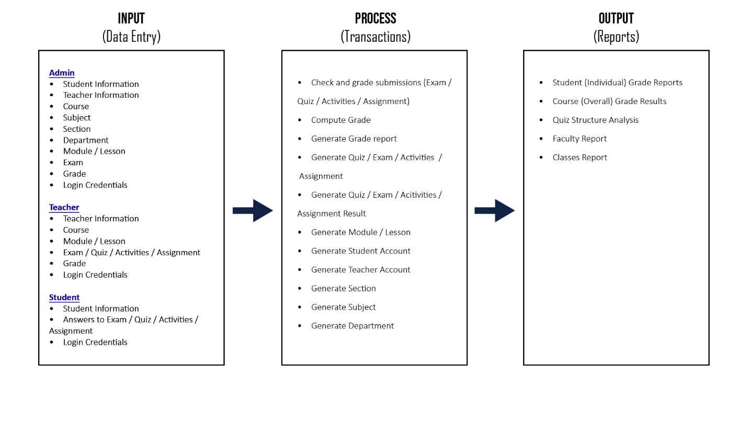

**Figure 1.** Conceptual Frame Work for ACLCM E-Learning Management System for the ACLC College of Mabalacat.

This Figure shows Input Process and Output of the Users, User Login in ACLCM E-learning Management System; input Student number to Student; Teacher member to their account number and admin can log in. Process is Generate Account generate quizzes, exam compute a grade, and posting school works; remind the student schedule to their class and submission, checking the attendance. Output submit the grade report, classed report and logout the ACLCM E-learning Management System.

1. **CURRENT STATE OF TECHNOLOGY**

**ACLC COLLEGES OF MABALACAT**

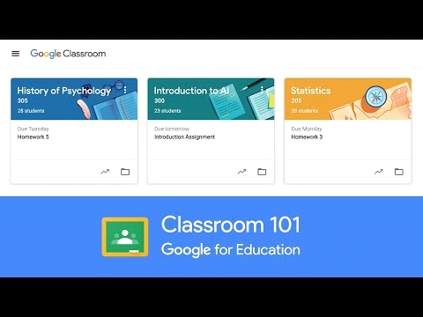

**Figure 2.** Current System use of ACLC College of Mabalacat.

This Figure shows the ACLC College of Mabalacat use the traditional way of Virtual education by using the Google Classroom and Google meet for college.

**Flowchart.**

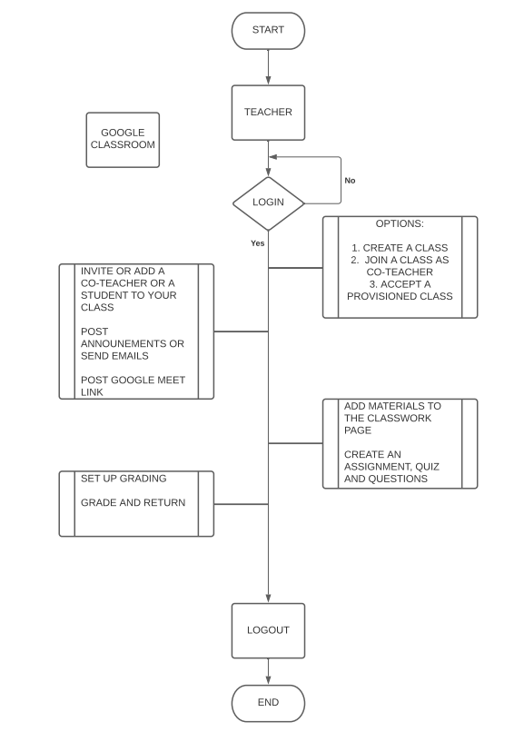

**Figure 3.** TeacherFlowchart for the Current system use of ACLC College of Mabalacat.

This figure show the flow of the current system.

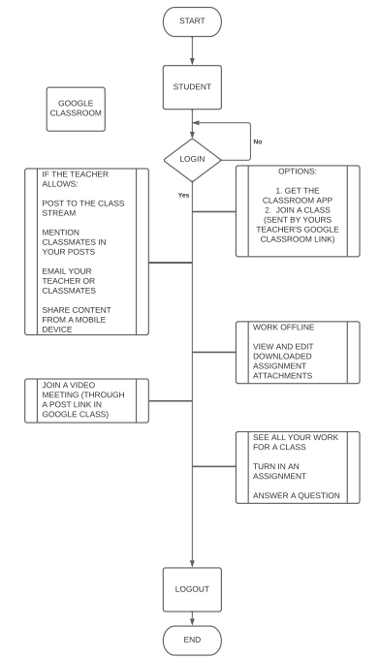

**Figure 4.** StudentFlowchart for the Current system use of ACLC College of Mabalacat.

This figure show the flow of the current system.