Options

Start

Splash Screen

Intro (movie/story/clip/image)

­Main Menu

Quit

Single Player

Profile

Account Info

Tutorial

Dashboard

Join Game

Create Game

Stop

Login

Splash Screen

Splash Screen - Refers to the company name and logo animated before the game starts



sample

Intro

Before the main menu will appear, the game will have its introduction.

A simple short animated effects to introduce the game.

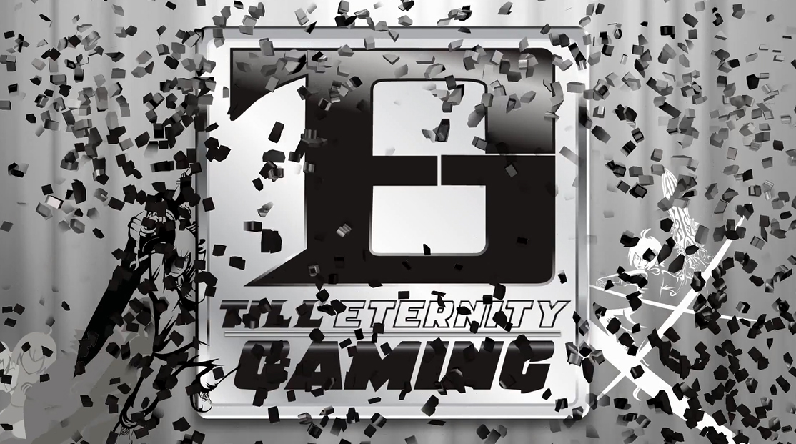

Log In

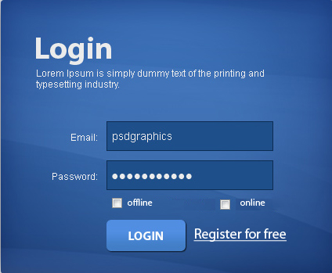

An account and password is necessary that players will be able to store their status points and other stuff for the game.

Online Playing is when a player is connected to the network and can play with other player and upgrade stuff to boost the player status.

Offline Playing is added in case a player is out of network coverage, by this the player can still play the game and gain points but not as much as the online playing game. Maybe the points will be receive is around 50 percent or less.

Main Menu

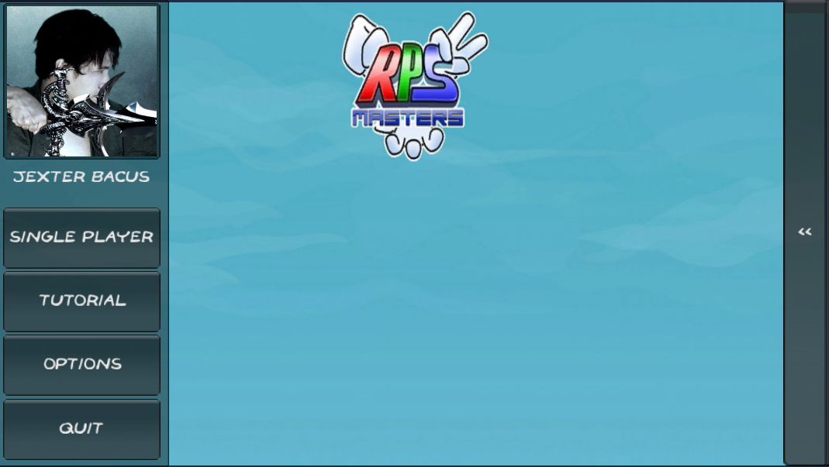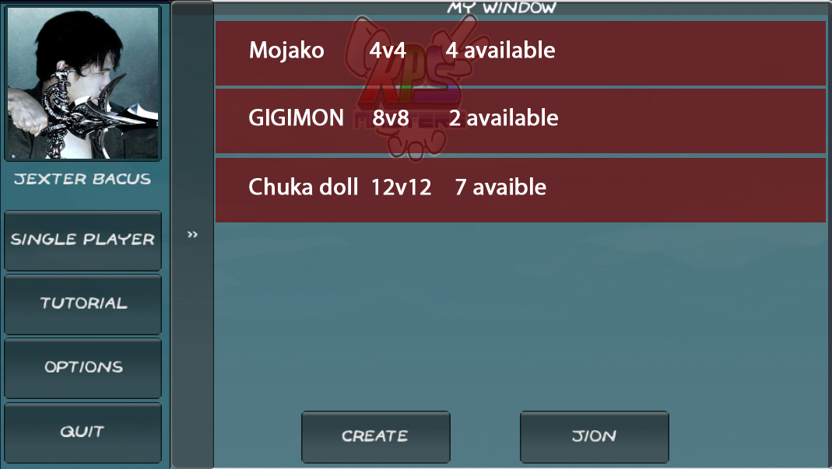



Profile



By clicking the picture you will be directed to the profile menu.

{money} : $30.00 ::



Name: Jexte Bacus

Age: 18

Gender: Male

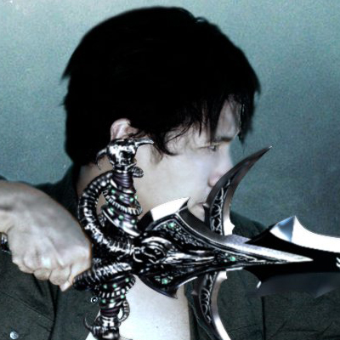

Status

{Trophy} : 20

sasda

{Loss} : 10

{win-stats} : 0.01

Weapons

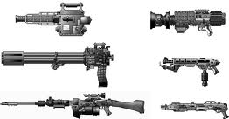

By clicking the weapon you will be able to see its description and upgrade your weapon

By clicking the character you will be able to choose/buy another character

**Single/Multi Player**

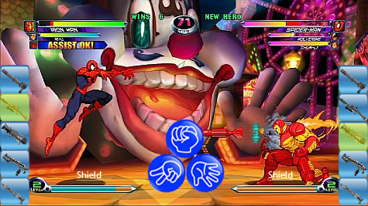

**Power gauge**

**Power gauge**

**40**

**30**

Life – Each player will have 100 points of life this will be deducted base on the weapon they choose. When the life bar is zero the winning part can press the final blow rapidly as fast as the player can to gain more bonus points.

Weapon – Each weapon will give different amount of damage when you win the clash, but if you loose it will also give the same return damage. When weapons are upgrade this will give the same amount of damage but will give less return damage base on how much the weapon is upgraded.

Shield – shield is also very useful in order to give less damage in combat

Time – The players will be given 7 seconds to think what weapon he will try to use and what RPS sign to cast, within this seconds the sign of the hand can be seen by the opponent, but another 3 seconds will be given to choose the final RPS sign this will not be seen already by the opponent until booth cast the sign.

Power gauge – Before the draw is cast, the power gauge will be displayed to tell the opponent how much power a player cast to throw it to the opponent

Start

Select Background

Tournament Type

Start Game

Intro

Game Screen

Winner/Loser

Main Menu

Change Game

Ranking Chart

Menu

Play Again?

Tutorial

For now tutorial will be a document image type, but later on it will be upgraded to an interactive type.

Option

Maybe the only option the game can have for now is sound/volume.

Quit

Game Quit