Options

Start

Splash Screen

Intro (movie/story/clip/image)

­Main Menu

Quit

Single Player

Profile

Account Info

Tutorial

Dashboard

Join Game

Create Game

Stop

Login

Splash Screen

Splash Screen - Refers to the company name and logo animated before the game starts



sample

Intro

Before the main menu will appear, the game will have its introduction.

A simple short animated effects to introduce the game.



Log In

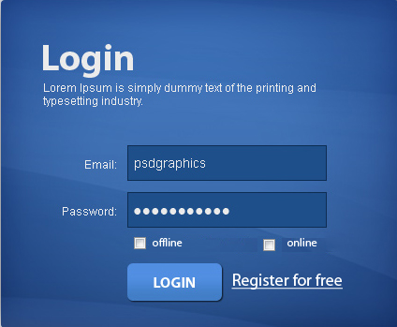

An account and password is necessary that players will be able to store their status points and other stuff for the game.

Online Playing is when a player is connected to the network and can play with other player and upgrade stuff to boost the player status.

Offline Playing is added in case a player is out of network coverage, by this the player can still play the game and gain points but not as much as the online playing game. Maybe the points will be receive is around 50 percent or less.