**TBL_USERS:**

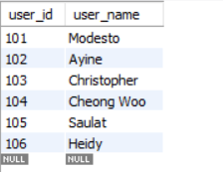

**TBL_GROUPS:**

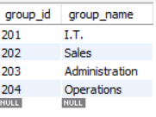

**TBL_ROOMS:**

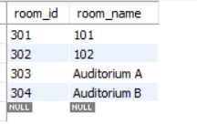

**TBL_USER_GROUPS:**

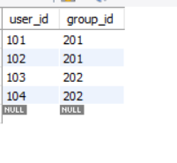

**TBL_GROUP_ROOMS:**

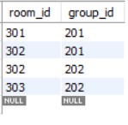

**Question 1:**

select a.*,c.user_name

from tbl_groups a

left join tbl_user_groups b

on a.group_id = b.group_id

left join tbl_users c on b.user_id = c.user_id

;

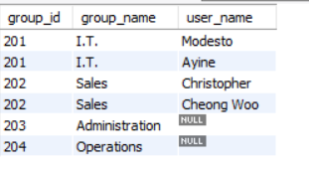

**Question 2:**

select a.*,c.group_name

from tbl_rooms a

left join tbl_group_rooms b

on a.room_id = b.room_id

left join tbl_groups c on b.group_id = c.group_id

;

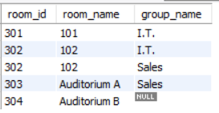

**Question 3:**

select

a.user_name,c.group_name,e.room_name

from

tbl_users a

left join tbl_user_groups b

on

a.user_id = b.user_id

left join tbl_groups c

on

c.group_id = b.group_id

left join tbl_group_rooms d

on

c.group_id = d.group_id

left join tbl_rooms e

on

d.room_id = e.room_id

order by a.user_name,c.group_name,e.room_name asc

