---------------------------------------------------------------------------------------------------------------------------

Changes in the app

1. design in some blue color the graphics for it.

2. in app color, we just use some shade of blue on top and white everywhere else.

3. Lets get rid of Overview (both introduction and Cover letter) . we do not need it. so it starts from resume sections.

4.we need these sections in the same order

Contact Info

Objective

Experience

Education

Achievements

Skills

lets remove other sections. Add items can we change to "Add Sections "

Change "Export PDF" to "Export Resume as PDF"

5. When we create a new section, it goes to bottom of the resume. Is there a simple way to rearrange the sections by the user.

One idea is to be able to move sections up or down. Its like in thunderbird message filters, any rule can be moved up or down. On the right of rules, they show buttons "Move Up" or "Move Down". We select the rule and then make it go up or down.

if we can do, then any section can be moved up or down.

Something that is easier to do.

6. Contact Info

change "Tap here to update image" to "Tap here to update photo"

our UI when entering information can be change to look like this UI

<https://play.google.com/store/apps/details?id=com.careerigniter.app>

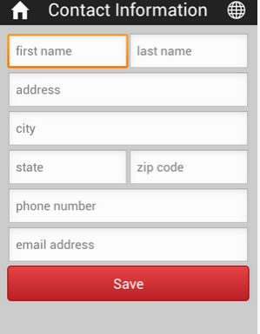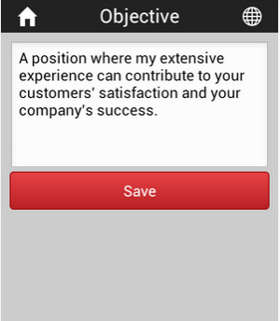

in contact info, all fields are optional. We should not force them to enter any field. Whatever they enter, we show.

when we show contact info in resume, we are not showing the heading "contact info", that is good. This is the way it had to be.

6, Objective:

we should show a box there to enter info. In the box, we say Objective and that is overwritten when user enters anything.

7, Experience

we should same fields and same name as these guys

https://play.google.com/store/apps/details?id=com.careerigniter.app

show under work experience,

fields are

Hire month hire hear

end month end year

Company

Position

Duties

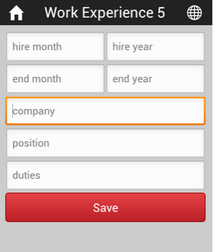

both in experience and education, they may have to enter more experience. What is easier way for it ??

after they save, we can show agan and ask for entering more experience. or any other way

8. Education

again, we copy from same guys as above

we show these fields

Year Completed

School Name

Level (e.g. B.S, M.S., Ph.D., or High school)

Major

none of these fields is mandatory. we only show what they enter.

after they save, same like experience. a way for them to enter more.

Achievements and Skills

its okay we have. we just need to change UI to be like careerigniter.app

https://play.google.com/store/apps/details?id=com.careerigniter.app

Final showing as PDF

Righ now it s hows all fields, even if they are not filled by user. We should only show fields which are filled by the user.

Menu item:

resume (where we show all the subsections like home page now)

PDF (when they click, we show resume as pdf)

Help ( I will write section by section, but it will be combined here)