
Analyzing Indian Agricultural Crop Production: A Comprehensive Study (1997-2021)
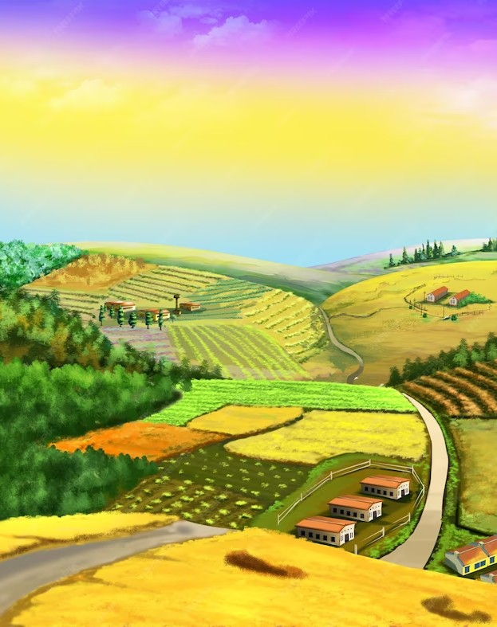

Introduction


Welcome to the presentation on Analyzing Indian Agricultural Crop Production: A Comprehensive Study (1997-2021). This study aims to provide a comprehensive analysis of the crop production trends in India over the past 25 years. We will explore key factors inﬂuencing crop production, examine the impact of climate change, and discuss potential strategies for sustainable agriculture. Let's dive into the fascinating world of Indian agricultural crop production!
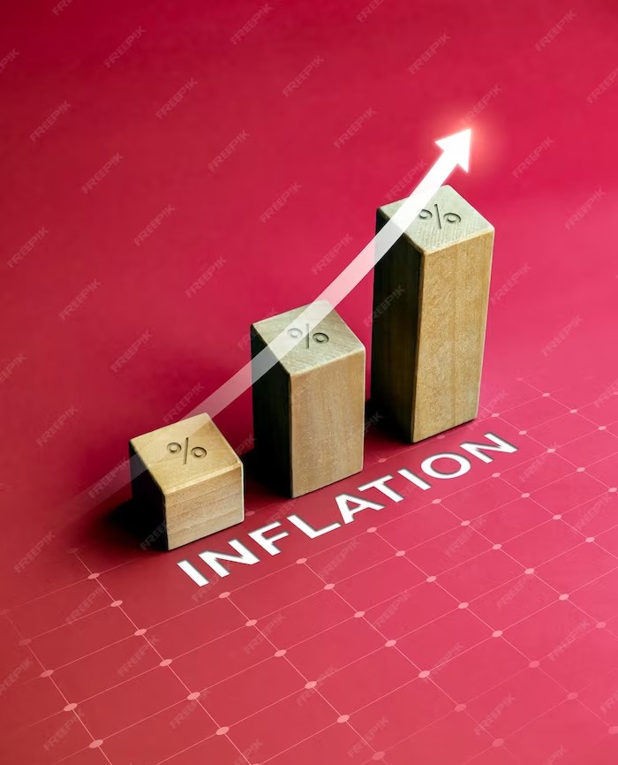

Crop Production Overview





In this section, we will provide an overview of Indian crop production from 1997 to 2021. We will analyze the yield, area cultivated, and production of major crops like rice, wheat, and pulses. By understanding the historical trends and patterns, we can gain insights into the overall performance of the agricultural sector in India.
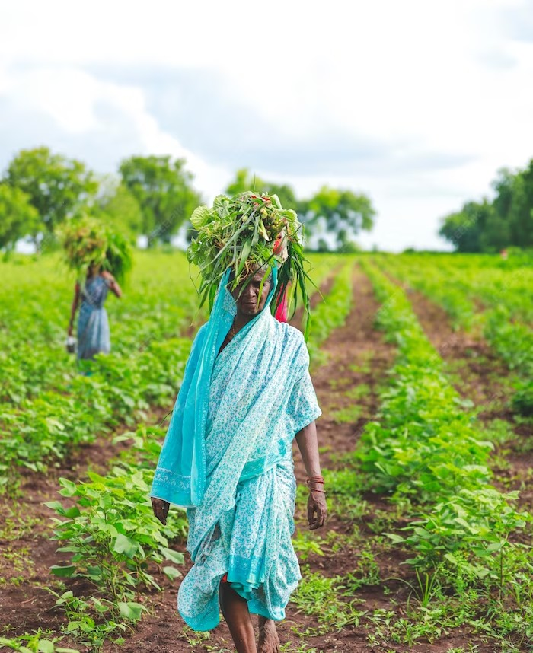

Climate Change and Crop Production


Climate change poses signiﬁcant challenges to Indian crop production. Rising temperatures, changing rainfall patterns, and increased frequency of extreme weather events impact crop yields and overall agricultural productivity. We will examine the effects of climate change on various crops and discuss adaptation strategies to mitigate its adverse impacts.
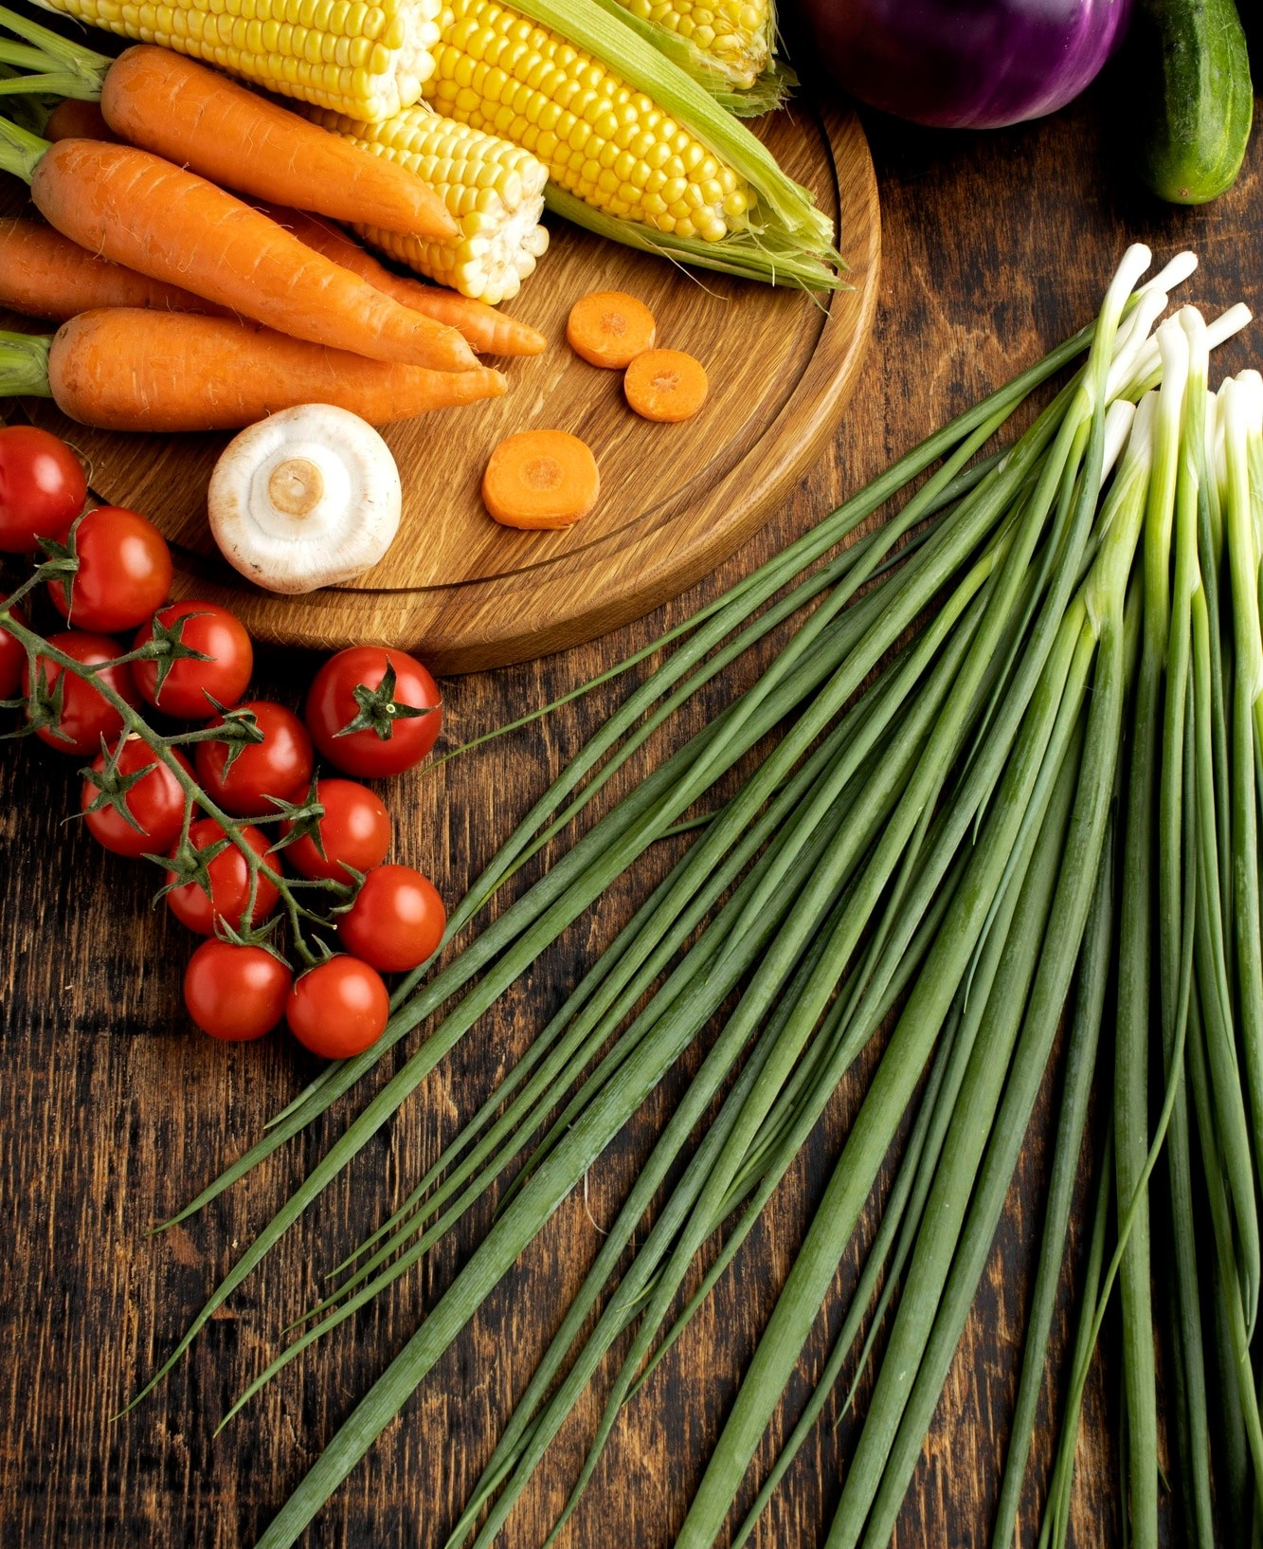

Crop Diversiﬁcation and Sustainable Agriculture

Crop diversiﬁcation is essential for sustainable agriculture in India. By promoting the cultivation of a diverse range of crops, we can reduce the dependence on a few staple crops and enhance food security. This section will explore the beneﬁts of crop diversiﬁcation, challenges faced, and potential solutions to promote sustainable agricultural practices.


Government Initiatives and Policies



The Indian government has implemented various initiatives and policies to support and improve crop production. These include subsidies, crop insurance schemes, research and development programs, and market reforms. We will discuss the impact of these initiatives on the agricultural sector and evaluate their effectiveness in promoting sustainable crop production.
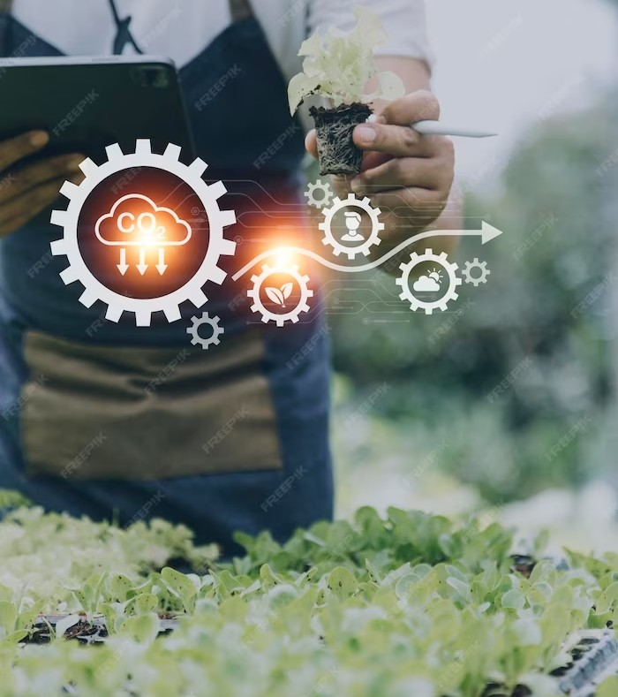

Challenges and Opportunities





Indian agriculture faces several challenges, such as water scarcity, pest and disease management, market volatility, and lack of infrastructure.
However, these challenges also present
opportunities for innovation and growth. This section will highlight the key challenges faced by the agricultural sector and explore potential opportunities for sustainable
crop production.
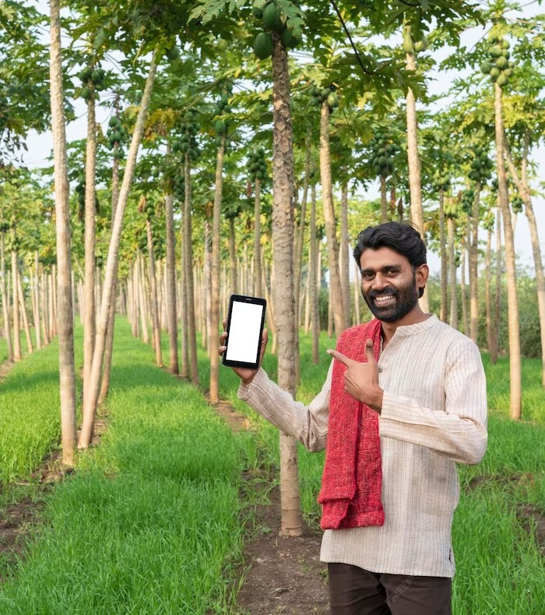

Future Trends and Projections


In this section, we will analyze the future trends and projections for Indian crop production. By considering factors like population growth, changing dietary preferences, technological advancements, and climate scenarios, we can make informed predictions about the future of crop production in
India.
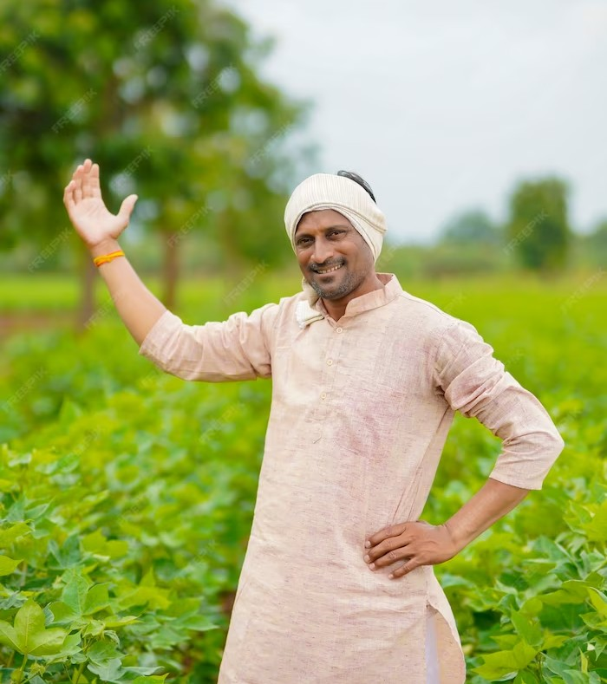

Case Studies: Successful Crop Production Models

This section will showcase case studies of successful crop production models in India. We will explore examples of sustainable farming practices, innovative technologies, and community- driven initiatives that have led to signiﬁcant improvements in crop productivity. These case studies will provide valuable insights and inspire farmers and policymakers to adopt similar models.

Conclusion
In conclusion, the comprehensive study on Indian agricultural crop production from 1997 to 2021 highlights the importance of sustainable practices, adaptation to climate change, and government support. By addressing challenges, leveraging opportunities, and learning from successful models, India can ensure a resilient and productive agricultural sector. Let's work together towards a sustainable future for Indian crop production!

Thank You!

Presented by, S.Nithiya P.Revathi M.Sivaranjani A.Yasmin Jeni

