GARMENT CREDIT MANAGEMENT SYSTEM
23CS54C – MODERN WEB TECHNOLOGIES
Submitted by
JEYA KIRTHIKA V-24104067
In partial fulfillment for the award of the degree
of
BACHELOR OF ENGINEERING/TECHNOLOGY
in
COMPUTER SCIENCE AND ENGINEERING/ INFORMATION
TECHNOLOGY

NATIONAL ENGINEERING COLLEGE
(An Autonomous Institution affiliated to Anna University, Chennai)
K.R.NAGAR, KOVILPATTI - 628503
OCTOBER - 2025

NATIONAL ENGINEERING COLLEGE
(An Autonomous Institution affiliated to Anna University, Chennai)
K.R.NAGAR, KOVILPATTI - 628503
BONAFIDE CERTIFICATE
This is to certify that this project report, “Garment Credit Management System”, is the bonafide work of JEYA KIRTHIKA V (24104067)who carried out the project work under my supervision.
Course Instructor/Guide
Submitted to the 23CS54C – MODERN WEB TECHNOLOGIES Viva-Voce examination held at National Engineering College, K.R.Nagar, Kovilpatti on _____________
Internal Examiner Co Examiner
TABLE OF CONTENTS
CH NO | TITLE | PAGE NO
1 | INTRODUCTION | 3
2 | OBJECTIVES | 4
3 | DESCRIPTION | 5
4 | CLASS DIAGRAM | 6
5 | TABLE STRUCTURES | 7
6 | ER DIAGRAM | 11
7 | TECH STACK | 12
8 | MODULES | 13
9 | CONCLUSION | 42

CHAPTER 1
INTRODUCTION
The Garment Credit Management System (commercially branded as ThreadLine Garment ERP & Khata) is an enterprise-grade full-stack web application architected to digitize, streamline, and govern wholesale apparel distribution, retail counter Point of Sale (POS) invoicing, multi-godown inventory control, and ledger-based trade credit (Khata) recovery. In traditional textile and garment trading clusters, transactions heavily rely on informal credit books, handwritten registers, and fragmented phone communications. These manual mechanisms introduce substantial operational liabilities, including untracked credit balance accumulation, credit limit breaches, stock discrepancies between dispersed storage godowns, missed collection deadlines, and lack of predictive planning for high-volume festive seasons. The system replaces these vulnerable traditional practices with a cohesive, data-driven management platform providing distinct role-based access for Administrators, Wholesale Merchants, Field Collection Agents, and Retail Store Patrons.
The Administrator and Merchant command comprehensive authority across operational domains, with capabilities to manage customer accounts, set tailored credit limits, govern multi-territory route assignments, track multi-godown inventory levels (Godown 1 and Godown 2), issue tax-compliant sales invoices, and monitor business intelligence indices. To address field collection friction, the system incorporates territory area mapping where retail stores are organized into geographical routes with designated recovery days (Monday through Saturday). Field recovery agents execute systematic route visits equipped with live digital checklists, recording on-spot cash or UPI payments and issuing instantaneous digital receipts. Furthermore, the integrated Automated Overdue Reminder engine continuously scans the centralized MySQL ledger to detect aging receivables, dispatching standardized payment notifications through integrated WhatsApp and SMS gateways.
In addition to credit control, the application features an advanced Supplier and Inward Procurement Management module, enabling direct interaction with regional textile mills and weavers across hubs such as Surat, Kanchipuram, Tiruppur, and Ahmedabad. A dedicated Festival Demand Calendar provides specialized planning advisory for major cultural events—including Deepavali, Pongal, and Ramzan—identifying fabric stock deficits, lead times, and seasonal consumer preferences. The Retail Customer Portal empowers retail clients to authenticate securely, inspect their ongoing Khata ledger balances, track available credit lines, explore new garment catalogs, and submit bespoke tailoring requirements. By uniting financial rigor, route logistics, inventory visibility, and automated client engagement, the system delivers an indispensable operational foundation for modern garment enterprises.
CHAPTER 2
OBJECTIVES
• To provide role-based authentication and authorization using JSON Web Tokens (JWT) ensuring secure access segregation between Super Administrators, Wholesale Merchants, and Retail Customers.
• To maintain a centralized, highly reliable MySQL relational database for managing customer accounts, territory areas, garment inventory, sales invoices, supplier purchases, and payment transactions.
• To eliminate manual credit ledger discrepancies by providing automated, real-time Khata balance calculations, debit/credit journal tracking, and instantaneous balance updates upon invoice creation or payment settlement.
• To implement an algorithmic Credit Risk Profiling engine that dynamically computes risk scores (Low, Medium, High Risk) based on balance-to-credit limit utilization ratios and overdue aging duration.
• To structure geographic territory management by organizing customer accounts into assigned route zones with dedicated recovery days (Monday to Saturday) and assigned field agents.
• To establish a streamlined Daily Field Recovery module enabling on-route collection agents to verify store visit statuses, record partial or full settlements, and log on-spot cash/UPI transactions.
• To enforce multi-godown inventory management with item-level tracking across central storage facilities (Godown 1 and Godown 2), automated stock depletion upon billing, and visual low-stock warnings.
• To deliver an agile Point of Sale (POS) counter terminal supporting rapid barcode/SKU lookups, dynamic cart computation, cash versus Khata credit transaction modes, and tax invoice generation.
• To automate overdue credit recovery through a background cron scheduler that evaluates customer payment due dates and facilitates one-click WhatsApp and SMS notification dispatches.
• To build a comprehensive Supplier and Inward Procurement subsystem for tracking textile mill directories, quality ratings, delivery lead times, purchase orders, and vendor payment obligations.
• To introduce a specialized Festival Demand Calendar providing procurement advisories, regional weaver origins, stock deficit alerts, and bilingual guidance (English and Tamil) for peak textile seasons.
• To provide executive Business Intelligence telemetry and visual analytics displaying gross sales revenue, net profit margins, collection recovery velocity, and category turnover trends.
• To empower retail customers with a dedicated Self-Service Portal to review account statements, examine available credit lines, browse new garment designs, and log bespoke tailoring requirements.
• To ensure robust data integrity, input validation, security event audit logging, and automated bidirectional synchronization between runtime memory structures and persistent MySQL storage.

CHAPTER 3
DESCRIPTION
The Garment Credit Management System is engineered as a robust, client-server web application created to address the end-to-end commercial workflows of textile wholesalers, garment manufacturers, and retail merchants. Traditional garment trade networks frequently suffer from unmonitored trade debt, delayed debt recovery, and inventory stock-outs during festival booms. The application resolves these systemic challenges through a decoupled multi-tier architecture comprising a React-driven Single-Page Application (SPA) frontend, an Express.js and Node.js REST API application tier, and a MySQL relational database management system. All critical business entities—including customers, credit limits, products, invoices, areas, suppliers, and collection logs—are modeled with relational rigor to enforce transactional consistency.
System security is anchored upon stateless Bearer JWT authentication, which distinguishes between store administration privileges and retail customer self-service rights. The Administrator interface acts as a central operations command center, furnishing live telemetry on daily sales volume, accumulated market receivables, recovered funds, and critical overdue accounts. Through the Customer Khata module, managers can configure strict credit thresholds, review individual transaction ledgers, and freeze accounts that breach safety margins. The application innovates field debt collection by introducing geographic route optimization: retail stores are allocated to defined territory areas, allowing field agents to execute scheduled route visitations on designated weekdays. Agents record settlements directly through responsive mobile-friendly views, instantly updating the central ledger and triggering WhatsApp payment receipts.
Beyond financial bookkeeping, the system integrates advanced merchandise and supply chain capabilities. Multi-godown inventory tracking provides clear segregation of physical stock between primary showrooms and secondary warehouses, preventing inadvertent overselling. The integrated Point of Sale (POS) system enables counter staff to draft bills with flexible settlement options, accommodating split payments where a portion is settled in cash or UPI while the remaining sum is debited to the buyer's Khata account. Integrated supplier management and festival demand forecasting empower merchants to align seasonal procurement with anticipated surges during Diwali, Pongal, and Wedding seasons. With comprehensive data validation, scheduled cron automation, and high-performance querying, the Garment Credit Management System guarantees exceptional operational efficiency, financial liquidity, and transparency across the enterprise.
CHAPTER 4
CLASS DIAGRAM
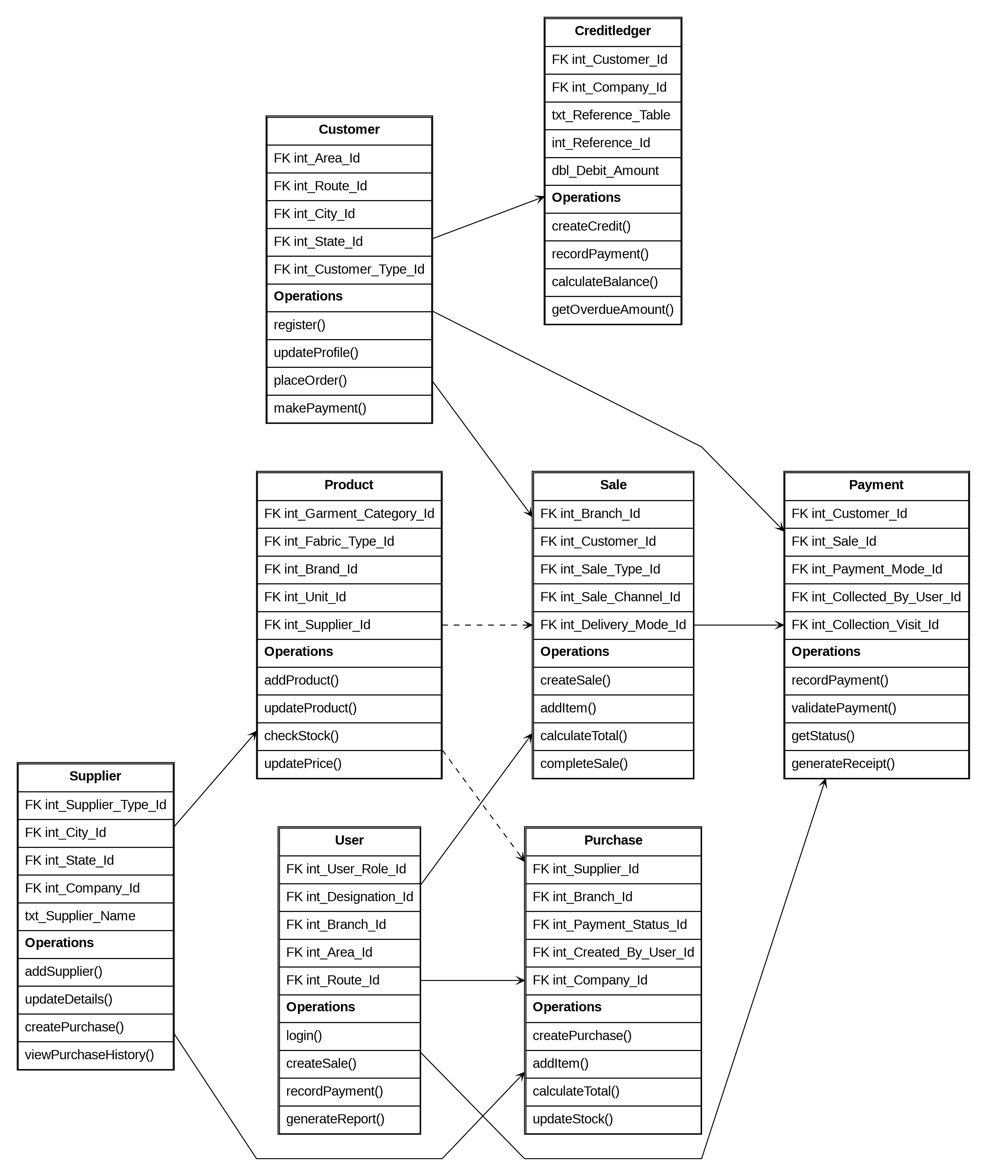

Fig 4.1 – Domain Class Diagram – Object-oriented model depicting system entities, structural attributes, operations, and relational multiplicities.
The Class Diagram illustrates the object-oriented structure of the Garment Credit Management System, representing its main business entities, attributes, methods, and relationships. The primary classes include User, Customer, Supplier, Product, Purchase, Sale, Payment, and CreditLedger.
The User class manages system users and authentication through operations such as login(), createSale(), recordPayment(), and generateReport(). The Customer class maintains customer information, credit details, and account activities using methods such as register(), updateProfile(), placeOrder(), and makePayment().
The Product class manages garment information, pricing, and stock availability through addProduct(), updateProduct(), checkStock(), and updatePrice(). The Sale class handles customer sales transactions using createSale(), addItem(), calculateTotal(), and completeSale(). The Purchase class manages supplier purchases and inventory updates through createPurchase(), addItem(), calculateTotal(), and updateStock().
The Supplier class maintains supplier information and purchase history, while the Payment class records customer payments, validates transactions, and generates receipts. The CreditLedger class manages customer credit transactions, outstanding balances, and overdue amounts using createCredit(), recordPayment(), calculateBalance(), and getOverdueAmount().
Overall, the class relationships support the major operations of the system, including customer management, product and inventory management, purchasing, sales processing, payment tracking, and credit management, providing a structured and maintainable design for the Garment Credit Management System.

CHAPTER 5
TABLE STRUCTURES
The persistent storage layer of the Garment Credit Management System is built on MySQL (database: threadline_db). The schema enforces relational integrity, foreign key constraints, primary keys, and appropriate field data types across all tables. The detailed structural specifications of the database tables are defined below:
1. Customers Table
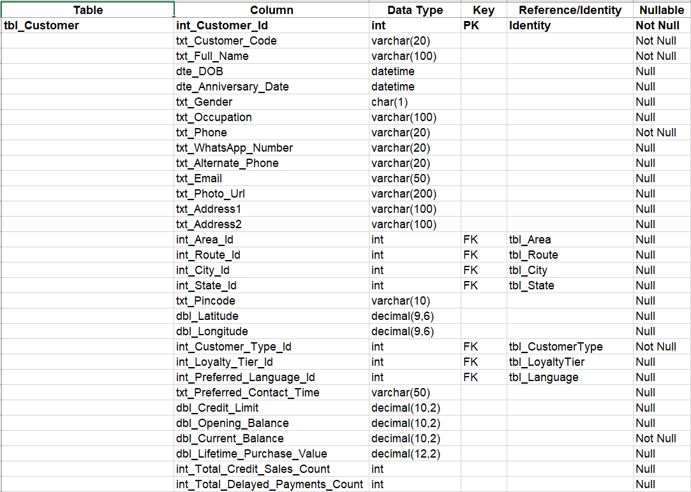
2. Areas Table
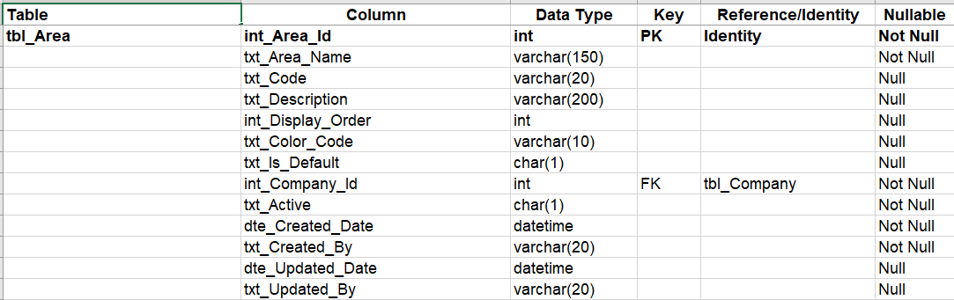
3. Products Table
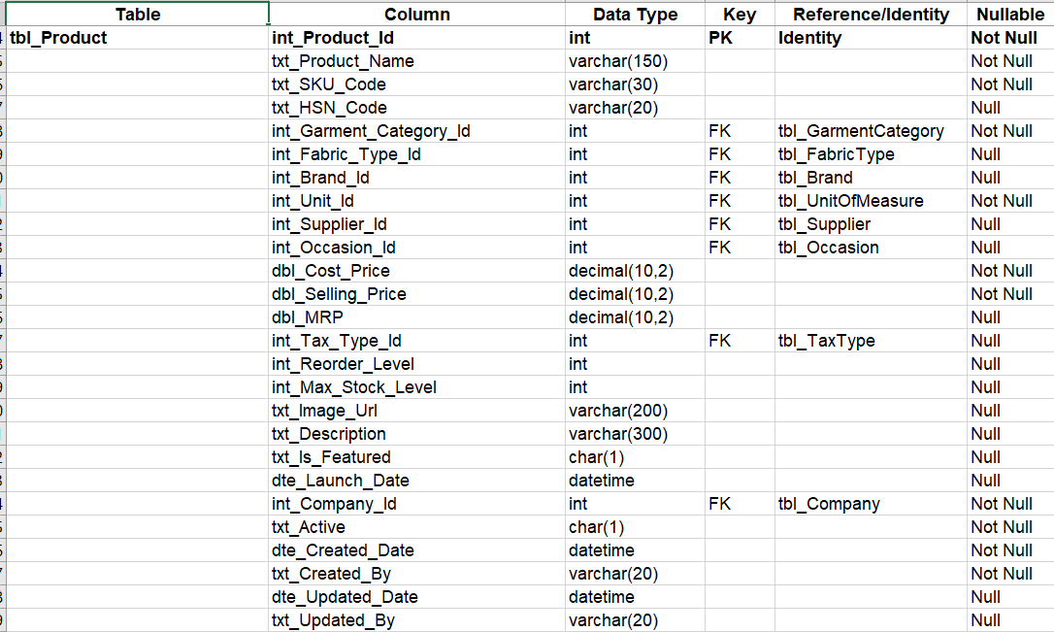
4. Sales Table
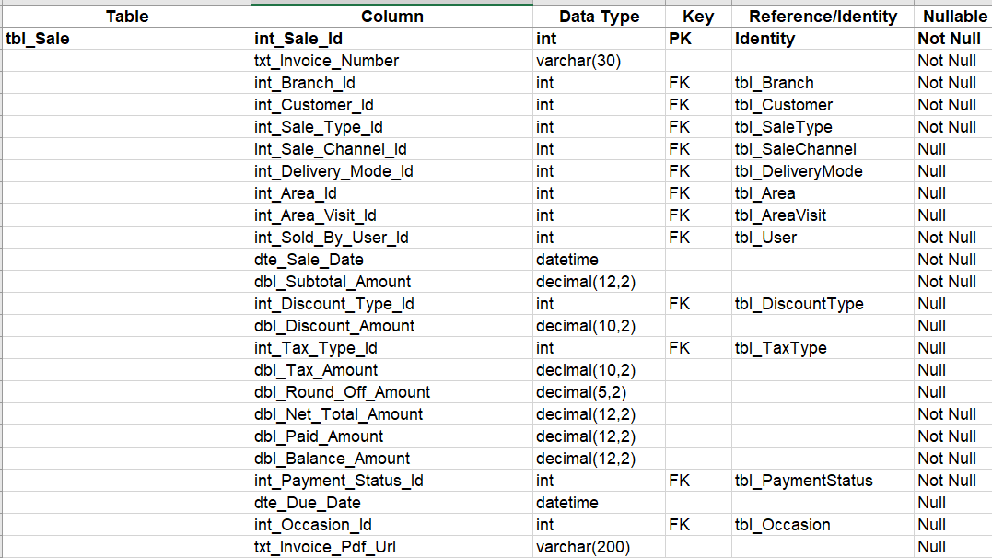

5. Suppliers Table
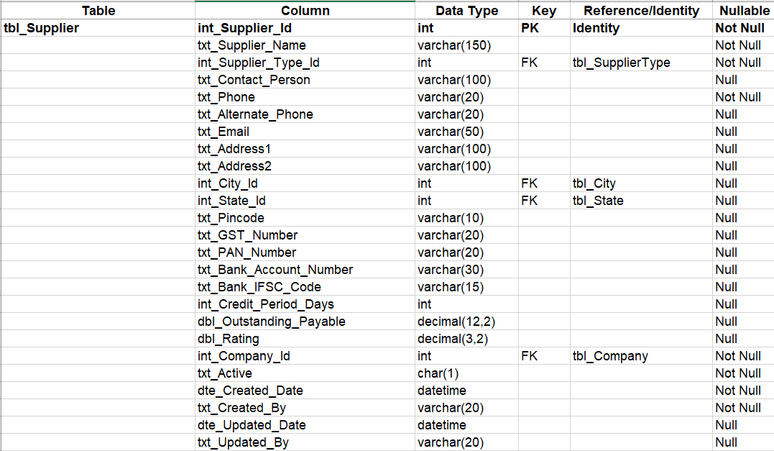
6. Purchases Table
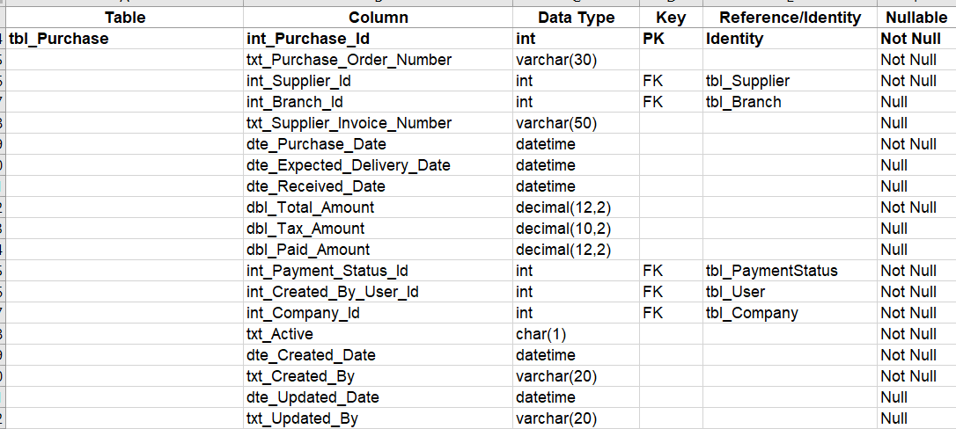

7. Payment Table
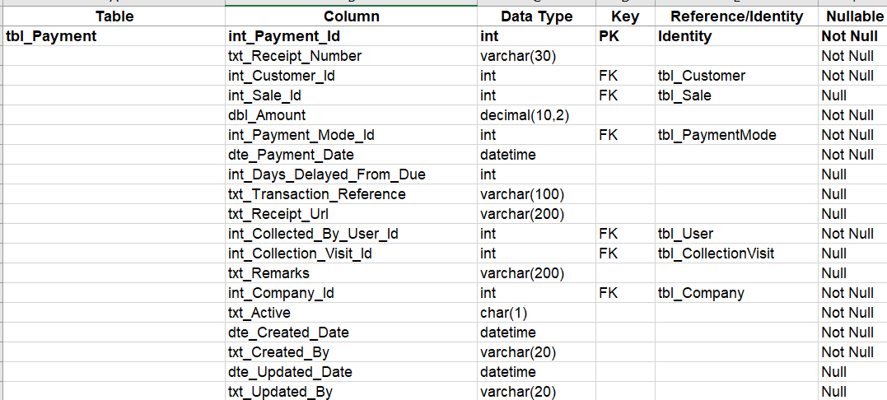
8.WeeklyAreaSchedule Table
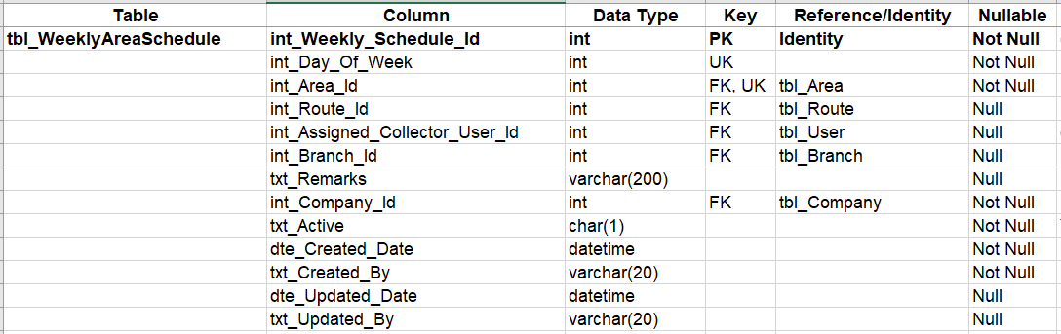
9.AreaVisit Table
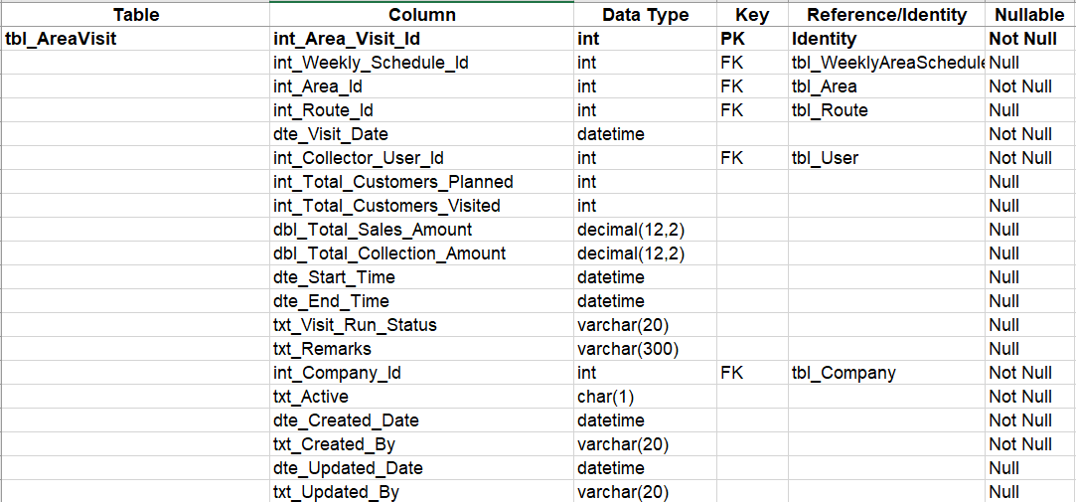
10.PaymentDelayPrediction
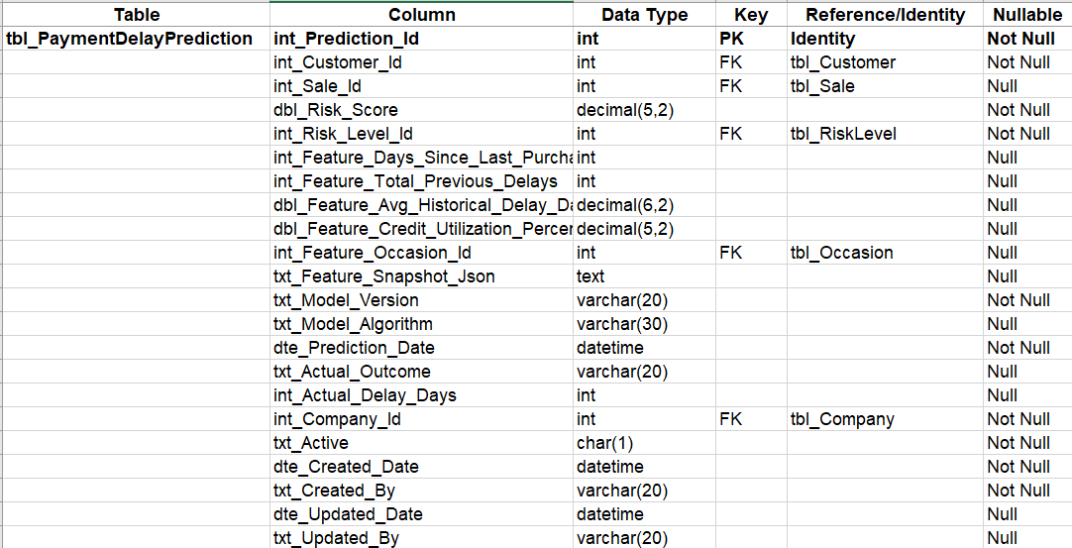
11.Customerfeedback Table
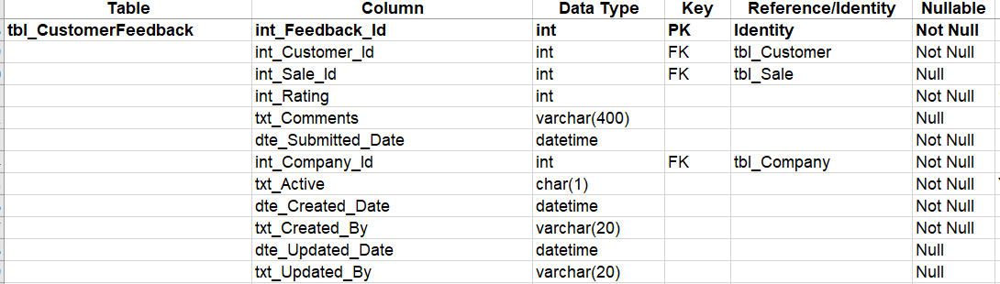
12.Notification Table
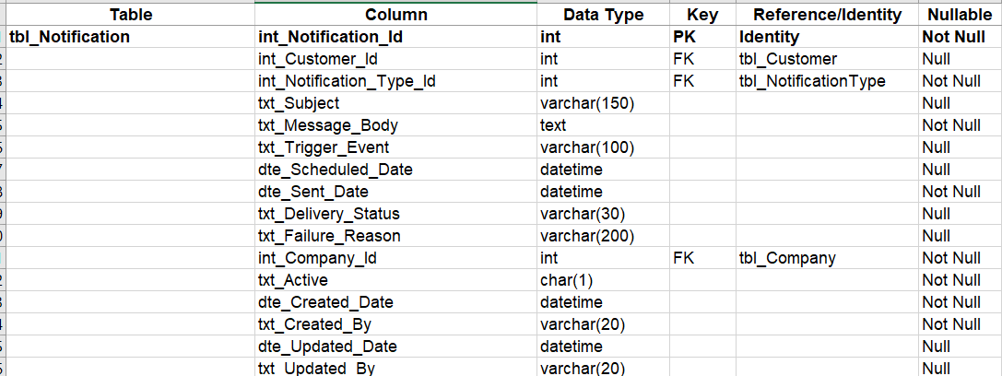
13.CuatomerRequirement Table
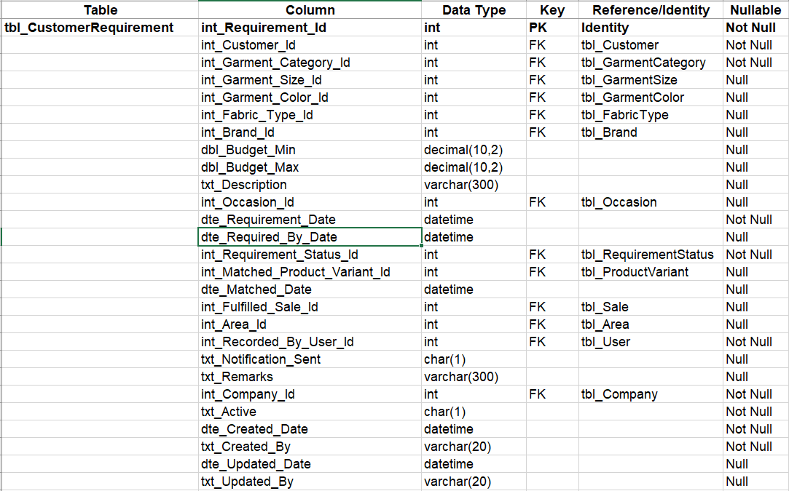
CHAPTER 6
ER DIAGRAM
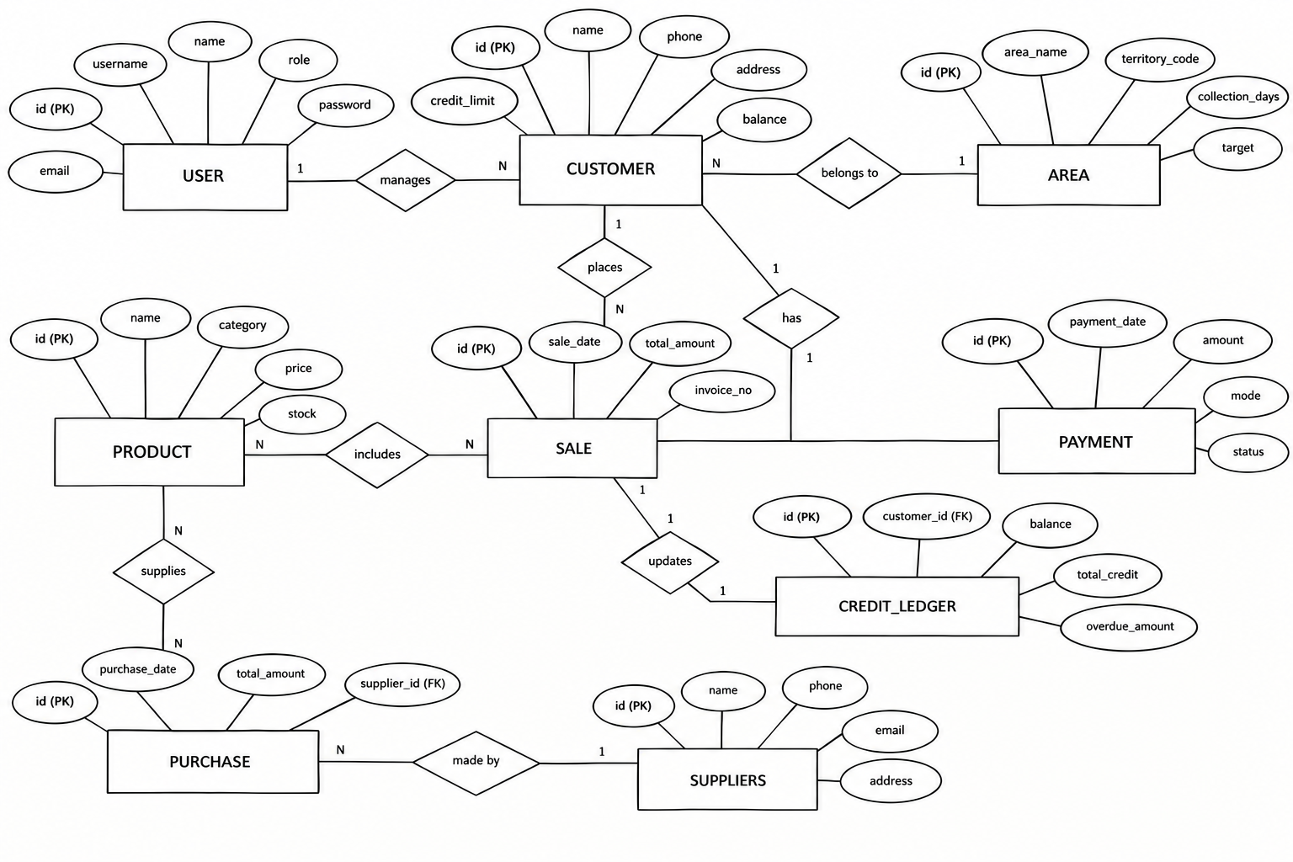

Fig 6.1 – Entity-Relationship (ER) Diagram – Conceptual schema displaying relational entities, attributes, primary/foreign keys, and cardinality constraints.
The ER Diagram represents the database structure of the Garment Credit Management System. It shows the main entities such as User, Customer, Supplier, Product, Purchase, Sale, Payment, and Credit Ledger.
A User manages customers, and a Customer can have multiple sales and payments. Products are included in sales, while Suppliers provide products through purchase transactions. The Credit Ledger stores customer credit and outstanding balance details.
The diagram also shows Primary Keys (PK) and Foreign Keys (FK) to uniquely identify records and connect related entities. Overall, the ER diagram helps to understand how customers, products, sales, purchases, payments, and credit information are connected in the system.

CHAPTER 7
TECH STACK
Frontend Technologies: React.js (v18.3), Vite, Tailwind CSS
Backend Technologies: Node.js (v24.18), Express.js (v4.19)
Middleware: Bearer JWT Authentication Middleware (authenticateJwt, optionalJwt), CORS Middleware, Body Parser (JSON 20MB limit), File Upload & Pinterest Image Proxy Middleware
Database: MySQL
Approach: Hybrid Relational & Centralized Real-time Sync, Async/Await Programming, RESTful API Design, Modular Architecture, Background Cron Schedulers (node-cron), Heuristic Credit Risk Modeling
Architecture: MVC (Model-View-Controller) Architectural Pattern
• Models: MySQL relational schema definitions (schema.sql) and centralized persistent storage layer (db.js) managing database pooling, transaction queries, and entities (Customers, Areas, Products, Sales, Suppliers, Purchases, Reminders).
• Views: Responsive React Single-Page Application (SPA) component hierarchy handling modern UI rendering, interactive dashboards, dynamic data tables, modals, toast feedback, and localized bilingual presentation.
• Controllers: Modular Express route handlers (apiV1.js, auth.js, apiReminders.js, chatbotApi.js, analytics.js) managing incoming HTTP requests, executing credit risk calculations, governing database transactions, and returning structured JSON API payloads.

CHAPTER 8
MODULES
8.0 Design Approach
Each module of the Garment Store Management System is described here the way a system design problem is solved: by walking through the same seven steps in the same order, every time. This keeps the explanation of every module complete and comparable, and shows why each design decision was taken rather than only what the screen looks like.
Step | Question it answers | Presented in each module as
1. Functional requirements | What must the module do? | Section x.1
2. Non-functional requirements | How fast, how big, how available? Where does the CAP trade-off fall? | Section x.2
3. Tech stack | Which tools suit this problem, and why? | Section x.3
4. Back-of-the-envelope | How many users, requests and how much storage? | Section x.4
5. Low-level architecture | Which components exist and who talks to whom? | Section x.5 (diagram + request flow)
6. API design | What is the contract between client and server? | Section x.6
7. DB design | Which tables, keys and indexes store the data? | Section x.7

Shared baseline for all modules
Non-functional baseline. Every request travels through Helmet (HTTP hardening), CORS, a 20MB payload size limit, a rate limiter (rateLimiter.js) and the JWT authentication middleware (authMiddleware.js) before it reaches a controller. All data lives in a single MySQL database (threadline_db) with a resilient local persistence fallback (data/store.json), so the system chooses consistency over availability in CAP terms (CP): a user may briefly be unable to save if the database is unreachable, but two users can never see conflicting versions of a customer credit balance, an invoice, a purchase order, or stock levels across Godown 1 and Godown 2. Money columns use DECIMAL(12,2) or DECIMAL(15,2), never floating point, so totals and khata balances reconcile exactly.
Sizing baseline (assumptions).
Quantity | Estimate | Basis
Named users | ≈ 25 | Store Owner/Super Admin, Inventory Manager, Sales Staff, Mill Suppliers, Field Collection Agents, Retail Buyers (assumption)
Working days / year | 300 | Garment wholesale and retail trading calendar (assumption)
Requests per user per day | ≈ 350 | Counter POS billing, barcode lookups, route visits, stock adjustments, ledger audits, reminder scans (assumption)
Total requests per day | 25 × 350 = 8,750 | Derived
Average load | 8,750 ÷ 36,000 s ≈ 0.24 req/s | Spread over a 10-hour working day
Peak load | ≈ 4–6 req/s | 15× to 25× the average, e.g. morning field collection departures, festival counter rushes
Total tables | 13 | Live schema in threadline_db

A single Node.js process and one MySQL instance handle this load comfortably. The design keeps the application stateless (JWT instead of server sessions), so extra Node.js instances can be added behind a load balancer if usage grows.
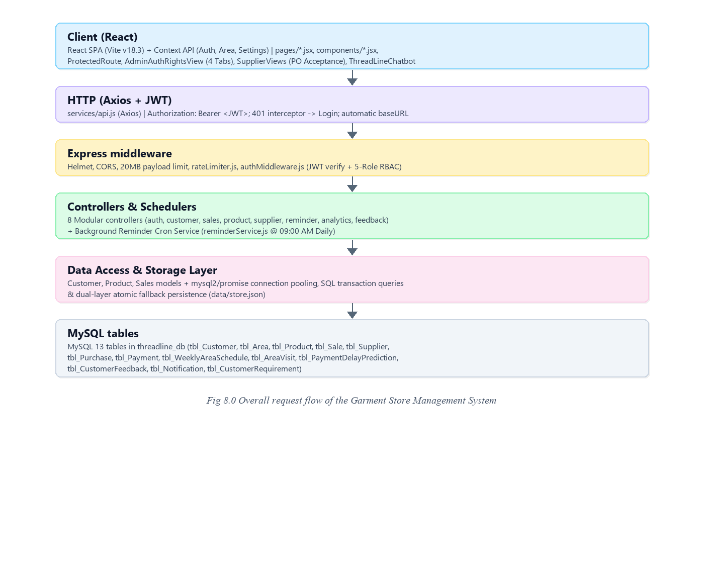
8.1 FOLDER STRUCTURE
8.1.1 BACKEND FOLDER STRUCTURE
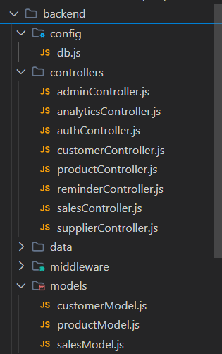

Fig 8.1.1 – Backend Folder Structure – Modular organization of backend source code, database access layer, controllers, and schedulers.
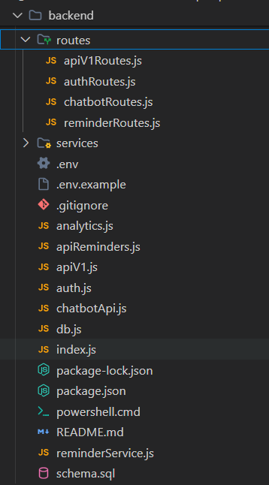
Fig 8.1.2 – Backend Routes – Defined RESTful API routing architecture connecting client endpoints to controller logic.
In a modern Node.js and Express-based application, the routes, services, and controllers together form the backbone of the backend architecture, ensuring modularity, readability, and long-term maintainability. Routes define the various RESTful API endpoints (URLs) through which the React client communicates with the server. Each route maps to a specific HTTP verb—such as GET, POST, PUT, or DELETE—connecting incoming network payloads to the corresponding controller functions.
Controllers serve as the orchestration link between HTTP routes and the underlying business logic. They ingest incoming request parameters, execute rigorous input validation, trigger database operations, enforce credit policy rules, and construct standardized JSON responses. By segregating routing declarations from business operations, controllers maintain clean, lightweight endpoints that simplify debugging and scalability.
The Database Module (db.js and schema.sql) establishes reliable MySQL connection pooling through mysql2/promise, safeguarding against connection timeouts and facilitating high-concurrency read/write transactions. In addition, the Reminder Service (reminderService.js) operates as a continuous background daemon utilizing node-cron. It automatically evaluates customer credit aging every morning at 09:00 AM, identifies accounts exceeding allowable terms, and prepares WhatsApp and SMS payment alerts for dispatch.
8.1.2 FRONTEND FOLDER STRUCTURE
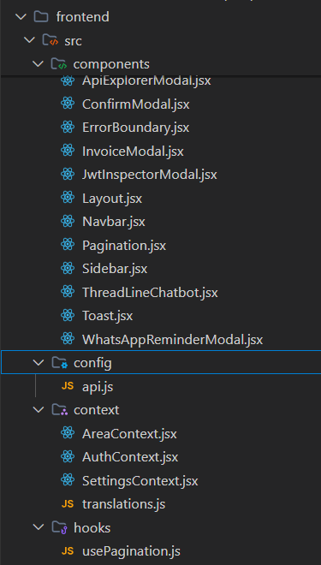
Fig 8.1.3 – Frontend Folder Structure – Layout of React-based frontend directories with context providers, hooks, and views.
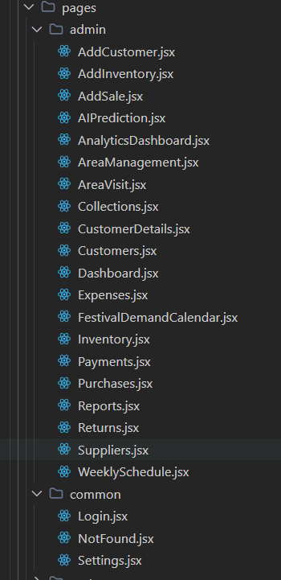
Fig 8.1.4 -Structure of pages
The Garment Store Management System & POS ERP application is built with a clear separation of concerns, featuring a Backend API Server and a Frontend User Interface. This architecture is standard for modern enterprise web applications and promotes modularity, independent development, testability, and scalability.
The frontend, found in the frontend/src/ directory, is a user-facing Single Page Application (SPA) built with React and Vite, responsible for presentation, rich data visualization, and user interaction. Screen views are segregated into dedicated directories: pages/admin/ (management views including Store Dashboard, Customer Khata Management, Stock Inventory, Supplier Hub, Sales Studio, AI Risk Predictions, and Reports), pages/customer/ (patron self-service views including Garment Catalog, My Purchases, Credit Ledger & Invoices, Restock Requirements, Feedback, and Notifications), and pages/common/ (Login, System Settings, and 404 Not Found).
Reusable UI components such as Navbar.jsx, Sidebar.jsx, InvoiceModal.jsx, ConfirmModal.jsx, Toast.jsx, Pagination.jsx, AdminAuthRightsView.jsx, and ThreadLineChatbot.jsx promote visual consistency and high reliability across all user roles.
8.2 USER AUTHENTICATION & ACCESS RIGHTS MANAGEMENT (RBAC & SECURITY GOVERNANCE)
8.2.0 Purpose & Scope
Provides tokenized authentication, secure credential management, password reset capabilities, and granular Role-Based Access Control (RBAC) across five system roles. Enforces session lifecycles, Google OAuth 2.0 Single Sign-On, Two-Factor Authentication policies, and real-time security audit logging.
8.2.1 Functional Requirements
What the module must do:
• Multi-Role Segregation: Supports five distinct roles: Admin (Store Owner / Super Admin), Supplier (Textile Mill Partner), Inventory Manager (Warehouse & Godown Storekeeper), Sales Manager (POS Billing, Credit Khata & Route Recovery), and Retail Customer (Store Buyer).
• Credential & Password Governance: Admin can inspect account login credentials and trigger an interactive Reset Password modal equipped with a Random Strong Password Generator.
• Account Activation & Suspension Controls: Ability for Admin to suspend any non-admin account with immediate login blocking and instant session invalidation.
• Role Permission Matrix: Interactive 26-module capability matrix spanning Inventory, Catalog, Sales, Khata Ledger, Procurement, Routes, Reports, and System Settings with granular grant/revoke checkboxes.
• Security Policies & 2FA: Configurable JWT Session Timeout (15m, 1h, 8h, 24h, 7d, 30d), Google OAuth 2.0 SSO toggle, and Two-Factor Authentication policy enforcement.
• Live Security Audit Log Telemetry: Continuous event tracking logging LOGIN_SUCCESS, LOGIN_FAILED, PASSWORD_RESET, ACCOUNT_STATUS_CHANGE, PERMISSIONS_MODIFIED, and POLICY_UPDATED.
8.2.2 Non-Functional Requirements
How well the module must do it (the system-wide baseline also applies):
• Security: Passwords salted and hashed with bcryptjs. Hashes are never returned by the API.
• Brute-Force Defence: Throttling consecutive failed login attempts with automatic account lockout after 5 failures.
• Session Length: Configurable token expiration (default 7 days) balancing operational convenience with token security.
• Scalability: Stateless JWT tokens enable any backend worker to validate requests without a shared session store.
• Latency Target: Token validation adds < 1 ms overhead per authenticated request.
• CAP Positioning: Consistency-first (CP); suspended accounts are blocked immediately on their next request.
8.2.3 Tech Stack
Concern | Choice | Why it fits this module
Password Hashing | bcryptjs (Salted) | Pure JavaScript implementation eliminating native build dependencies.
Token Protocol | JSON Web Token (HS256) | Stateless authorization payload carrying role, customer ID, and supplier ID.
Rate Limiting | express-rate-limit | Protects authentication routes from brute-force dictionary attacks.
Management UI | AdminAuthRightsView.jsx | Dedicated four-tab administrative dashboard with instant visual feedback.

8.2.4 Back-of-the-Envelope Estimation
Quantity | Estimate | Basis
User Accounts | 5 primary system accounts + retail customer records | ≈ 100 KB total user records
Token Validations | ≈ 8,750 validations / day | ≈ 0.1 ms CPU time each
Audit Stream | ≈ 50 to 200 events / day | ≈ 25 KB / day, auto-pruned at 100 entries

8.2.5 Low-Level Architecture
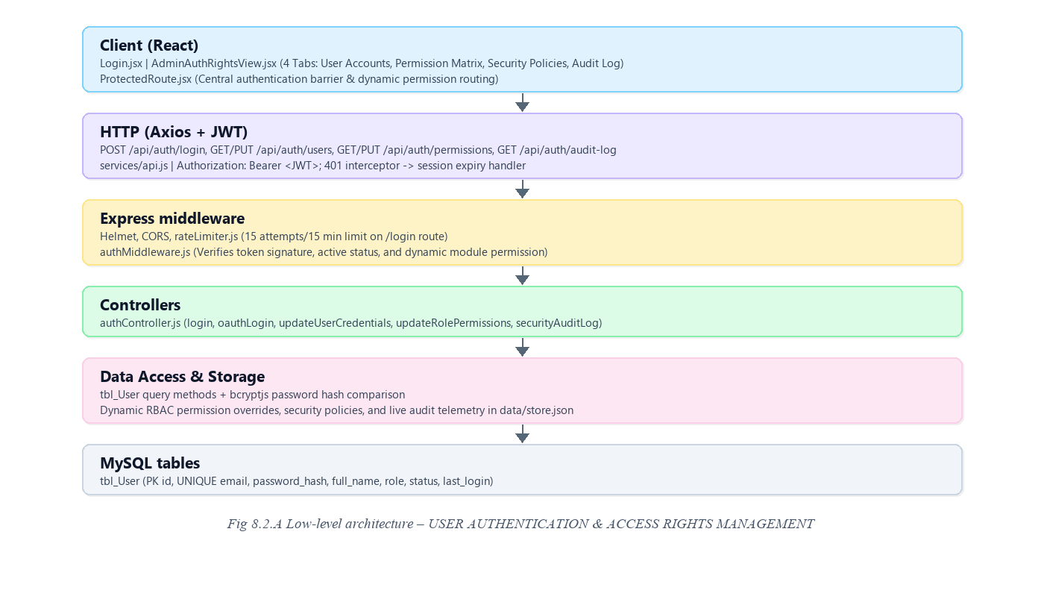
Request flow:
• Login.jsx submits credentials; rateLimiter.js verifies the IP has not exceeded the attempt threshold.
• authController queries tbl_User by email, verifies active status, and performs bcrypt password hash comparison.
• On match, a signed JWT bearer token is generated with user claims and returned alongside user profile metadata.
• The React client stores the token in localStorage and injects it into every Axios request header.
• authMiddleware.js validates the token signature and verifies module permissions before routing to controllers.
8.2.6 API Design
Method | Endpoint | Purpose / contract
POST | /api/auth/login | Authenticates email and password. Returns JWT token and user profile payload.
POST | /api/auth/oauth | Verifies Google OAuth 2.0 credential and issues JWT session.
GET | /api/auth/verify | Validates active Bearer JWT token signature and expiration.
GET | /api/auth/users | Admin-only: Returns directory of all 5 system accounts with passwords and status.
PUT | /api/auth/users/:key | Admin-only: Updates user password, active/suspended status, or display name.
GET | /api/auth/permissions | Fetches active role permission matrix across all capability modules.
PUT | /api/auth/permissions | Admin-only: Saves customized permissions for roles.
GET | /api/auth/security-policies | Fetches global session timeout, 2FA, and password complexity policies.
PUT | /api/auth/security-policies | Admin-only: Updates security policies.
GET | /api/auth/audit-log | Retrieves live security telemetry stream.
POST | /api/auth/audit-log/clear | Clears security audit event history.

8.2.7 DB Design
Table | Keys & indexes | Key columns
tbl_User | PK id (auto increment)  UNIQUE email | email varchar(150), password varchar(255), full_name varchar(150), role enum('admin','supplier','inventory','sales','user'), status enum('Active','Suspended'), last_login datetime

• The unique index on email ensures single-index lookups during authentication and guarantees no duplicate user profiles.
• Dynamic RBAC permission overrides, security policies, and live audit telemetry are persisted in the resilient storage layer.
8.2.8 Screenshots
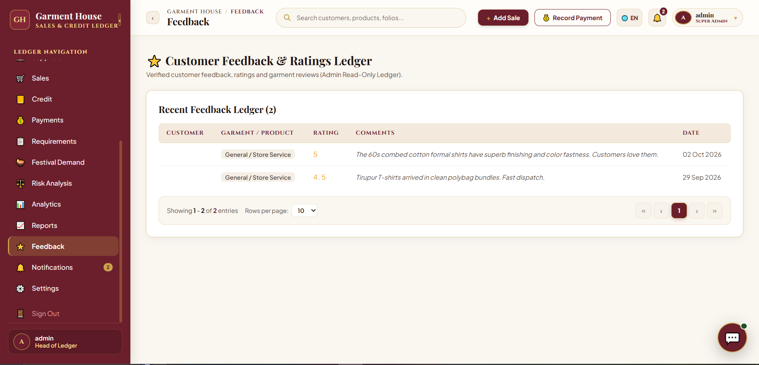
Fig 8.22 – System Settings & Configuration Page – Interface for System Customization, RBAC Governance, and Security Policies
The System Settings & Configuration page provides administrators with centralized control over store preferences, system appearance, regional settings, tax information, payment reminders, invoice configuration, data management, and the Master Authentication & Access Rights hub.
Through the Authentication & Access Rights view (AdminAuthRightsView.jsx), the administrator manages the complete security perimeter of the garment enterprise across four dedicated tabs: User Accounts & Password Reset Generator, 26-Module Role Permission Matrix, Security Policies & 2FA, and Live Security Audit Log.
8.3 MASTER DATA & TERRITORY MANAGEMENT (CUSTOMER DIRECTORY, ROUTE ZONES & PRODUCT CATALOG)
8.3.0 Purpose & Scope
Maintains foundational business records across retail customer profiles, geographic sales territory route mappings, and multi-godown garment apparel inventories.
8.3.1 Functional Requirements
What the module must do:
• Customer Master Registry: Stores client credentials, phone numbers, trade credit ceilings, ongoing balance, and account freeze status.
• Geographic Route Territory Scheduling: Groups retail stores into distinct regional zones (e.g., Tenkasi Main Bazaar, Tirupur Textile Hub, Erode Textile Market, Madurai Wholesale Hub) with assigned weekly collection days (Monday through Saturday) and designated collection agents.
• Garment Master Catalog: Maintains garment names, SKU codes, HSN classifications, fabric compositions, wholesale pricing, suggested MRP, and profit margin percentages.
• Search & Faceted Filtering: Enables multi-criteria search by store name, contact number, territory area, and apparel fabric category.
8.3.2 Non-Functional Requirements
How well the module must do it (the system-wide baseline also applies):
• Read-Heavy Optimization: Master data experiences a ~100:1 read-to-write ratio; optimized indexing ensures queries complete in < 15 ms.
• Data Integrity: Foreign key constraints prevent orphaned records between customers and territorial sales routes.
• Consistency Guarantee: Immediate transactional consistency (CP) guarantees newly updated credit limits or product rates apply across all terminals instantaneously.
8.3.3 Tech Stack
Concern | Choice | Why it fits this module
Territory State | AreaContext.jsx | Context API sharing live route schedules and mapped customer counts across all views.
Data Presentation | Responsive React Table | Interactive data grid with real-time text filtering, status badges, and quick action buttons.
Database Schema | MySQL Relational Tables | Enforces foreign key relationships between customers, areas, and product catalogs.

8.3.4 Back-of-the-Envelope Estimation
Quantity | Estimate | Basis
Customer Accounts | ≈ 150 – 500 accounts | Regional retail garment clients (≈ 1 KB per record)
Territory Areas | 4 – 12 sales routes | Assigned across Tamil Nadu textile hubs
Garment SKUs | 50 – 200 catalog items | Active apparel product lines with margins and pricing
Query Response Time | < 15 ms | Indexed lookups on customer phone, area code, and product SKU

8.3.5 Low-Level Architecture
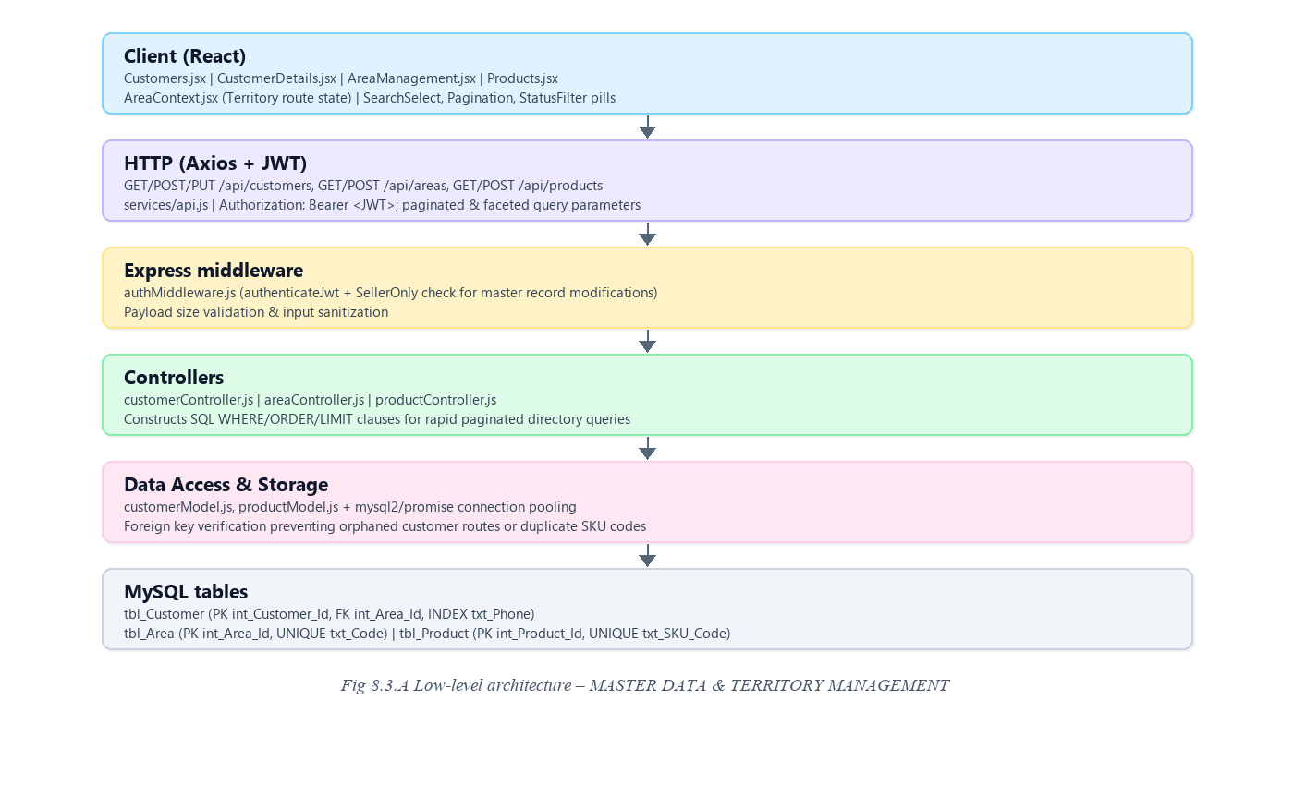
Request flow:
• The Customer Directory view issues an authenticated GET request with search query parameters.
• customerController validates the session role and applies SQL WHERE filters and pagination limits.
• The database returns matching customer records along with computed outstanding credit balances.
• The React client renders individual customer cards with contact details, credit limits, and quick action buttons.
8.3.6 API Design
Method | Endpoint | Purpose / contract
GET | /api/customers | Retrieves paginated list of customers with optional search, area, and status filters.
POST | /api/customers | Creates a new retail customer account with credit limit and territory assignment.
PUT | /api/customers/:id | Updates customer contact details, credit limit, or account freeze status.
GET | /api/areas | Retrieves all sales territory zones with mapped customer counts and targets.
POST | /api/areas | Registers a new territory area code and assigns weekly recovery days.
GET | /api/products | Fetches active garment catalog with wholesale prices, MRP, and store margins.

8.3.7 DB Design
Table | Keys & indexes | Key columns
tbl_Customer | PK int_Customer_Id  FK int_Area_Id  INDEX (txt_Phone) | txt_Customer_Code, txt_Full_Name, txt_Phone, dbl_Credit_Limit, dbl_Current_Balance, int_Area_Id, txt_Active
tbl_Area | PK int_Area_Id  UNIQUE txt_Code | txt_Area_Name, txt_Code, int_Display_Order, txt_Color_Code, txt_Active
tbl_Product | PK int_Product_Id  UNIQUE txt_SKU_Code | txt_Product_Name, txt_SKU_Code, txt_HSN_Code, dbl_Cost_Price, dbl_Selling_Price, dbl_MRP, int_Reorder_Level

• Indexed telephone numbers enable instantaneous customer lookups during point-of-sale billing.
• Credit limit and current balance columns utilize DECIMAL(10,2) to eliminate rounding errors in trade debt calculations.
8.3.8 Screenshots
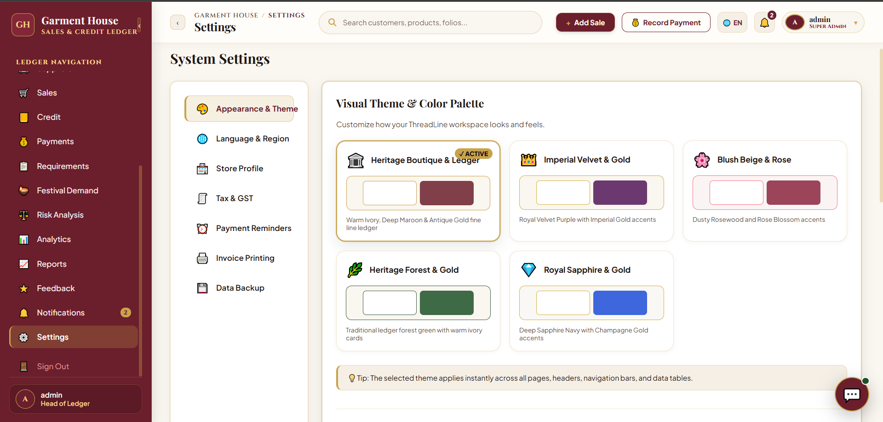
Fig 8.7 – Customer Directory Page – Interface for managing customer records and credit balances.
The Customer Directory page enables store administrators to manage customer profiles, monitor outstanding trade debt, and adjust allowable credit ceilings. The page header features quick action shortcuts including '+ Add Sale' and 'Record Payment'.
Customer profiles are displayed as structured cards detailing store name, proprietor contact, total lifetime purchases, pending balance, and allowable credit limits. An inline edit control allows instant modifications to credit parameters.
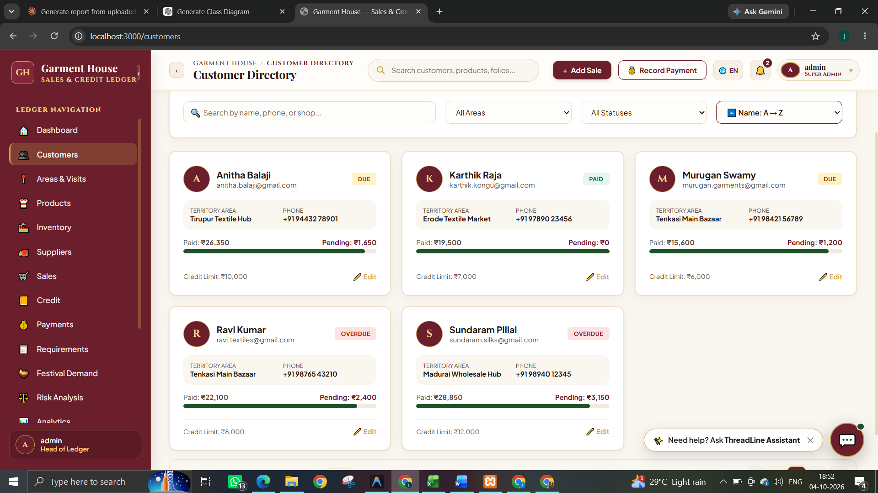
Fig 8.8 – Area & Route Management Page – Interface for Managing Field Sales Territories and Collection Targets
The Area & Route Management page organizes regional debt recovery into systematic territory routes. Summary metric cards display Total Sales Areas, Route Days, Mapped Customers, and Total Area Balance.
The All Field Sales Territories table details area codes, assigned weekdays, mapped customer counts, outstanding balances, daily targets, and visual progress bars tracking collection performance.
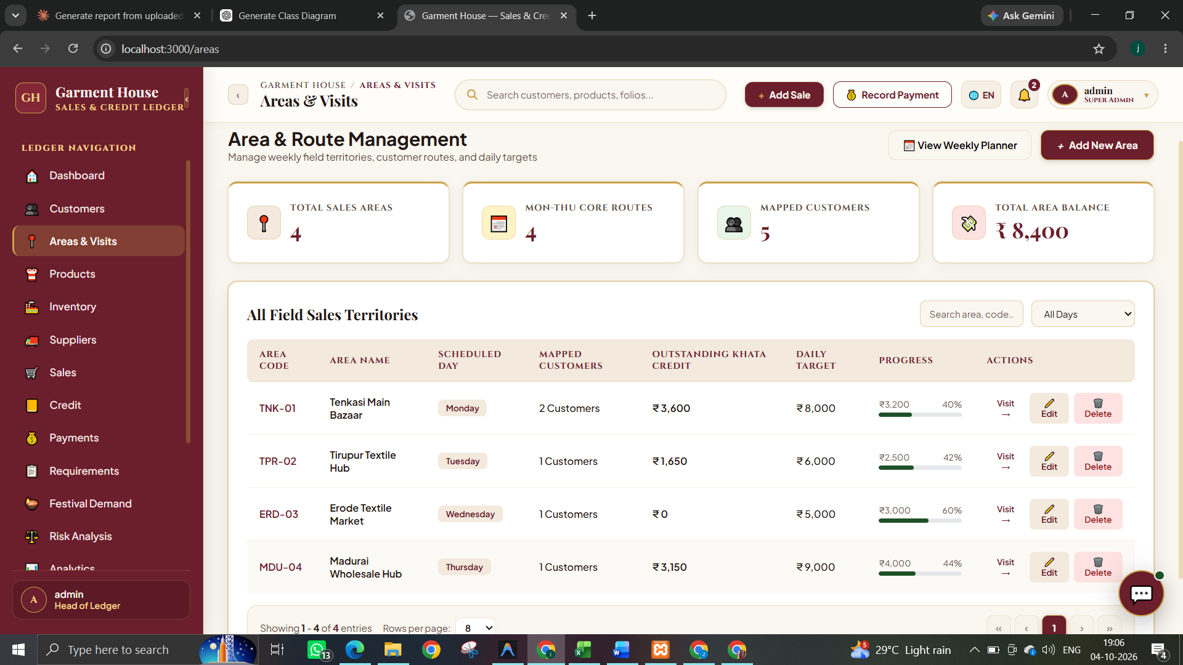
Fig 8.9 – Product Catalog & Inventory Studio Page – Interface for Managing Garment Inventory and Wholesale Products
The Product Catalog & Inventory Studio provides a visual designer lookbook and wholesale catalog. Administrators can toggle between visual Product Cards and tabular Stock Table views.
Each product card highlights wholesale pricing, store profit margins (e.g., 38% for formal shirts, 37% for silk sarees), fabric compositions, and instant 'Order Now' procurement triggers.
8.4 PURCHASE ORDER (PO) MANAGEMENT & TEXTILE MILL PROCUREMENT (WITH SUPPLIER PO ACCEPTANCE FLOW)
8.4.0 Purpose & Scope
Governs the complete inbound procurement lifecycle from textile mills and weavers across regional hubs (Surat, Kanchipuram, Tiruppur, Erode), featuring an official Supplier Purchase Order Acceptance workflow.
8.4.1 Functional Requirements
What the module must do:
• Textile Mill Vendor Directory: Profiles fabric mills, weaving centers, quality ratings (e.g., 4.8 / 5.0), and delivery lead times.
• Purchase Order Creation: Admin generates sequential purchase orders (e.g., PO-772) with line items, quantities, unit prices, GST rates, and delivery due dates.
• Supplier Purchase Order Acceptance Workflow: Initial PO status is raised as 'Pending / Waiting for Supplier Acceptance'. The supplier logs into their dedicated portal, reviews order details, and clicks 'Accept Purchase Order'. The status transitions to 'Accepted by Supplier'.
• Role Boundaries: Mill suppliers CANNOT create purchase orders; PO creation is strictly restricted to Store Administrators.
• PO Status Lifecycle: Draft → Pending / Waiting for Supplier Acceptance → Accepted by Supplier → Inward Stock Received → Completed / Cancelled.
• Controlled Order Cancellation: Purchase orders can only be cancelled prior to physical gate inward, requiring a mandatory documented reason.
8.4.2 Non-Functional Requirements
How well the module must do it (the system-wide baseline also applies):
• Financial Accuracy: Monetary columns use DECIMAL(12,2) with unit costs at DECIMAL(15,6) to prevent calculation drift.
• Transaction Atomicity: Purchase order header and all constituent line items commit or rollback in a single atomic database transaction.
• Auditability: State transitions record timestamps and user IDs to ensure complete procurement traceability.
8.4.3 Tech Stack
Concern | Choice | Why it fits this module
Procurement UI | React Modals & SupplierViews | Clean two-panel order builder for Admin and dedicated review portal for Suppliers.
State Management | Lifecycle State Machine | Enforces strict sequential order transitions from Pending to Accepted to Received.
Data Persistence | MySQL Relational Tables | Links suppliers, purchase orders, and multi-line item details atomically.

8.4.4 Back-of-the-Envelope Estimation
Quantity | Estimate | Basis
Registered Mill Suppliers | 10 – 50 vendors | Active textile mills and weaving centers
Purchase Orders / Month | 15 – 30 orders | Regular inventory replenishment cycles
Order Storage Size | ≈ 3.5 KB / order | PO header plus 3–5 apparel line items
Annual Procurement Volume | ≈ ₹25,00,000 – ₹50,00,000 | Wholesale fabric and garment procurement value

8.4.5 Low-Level Architecture
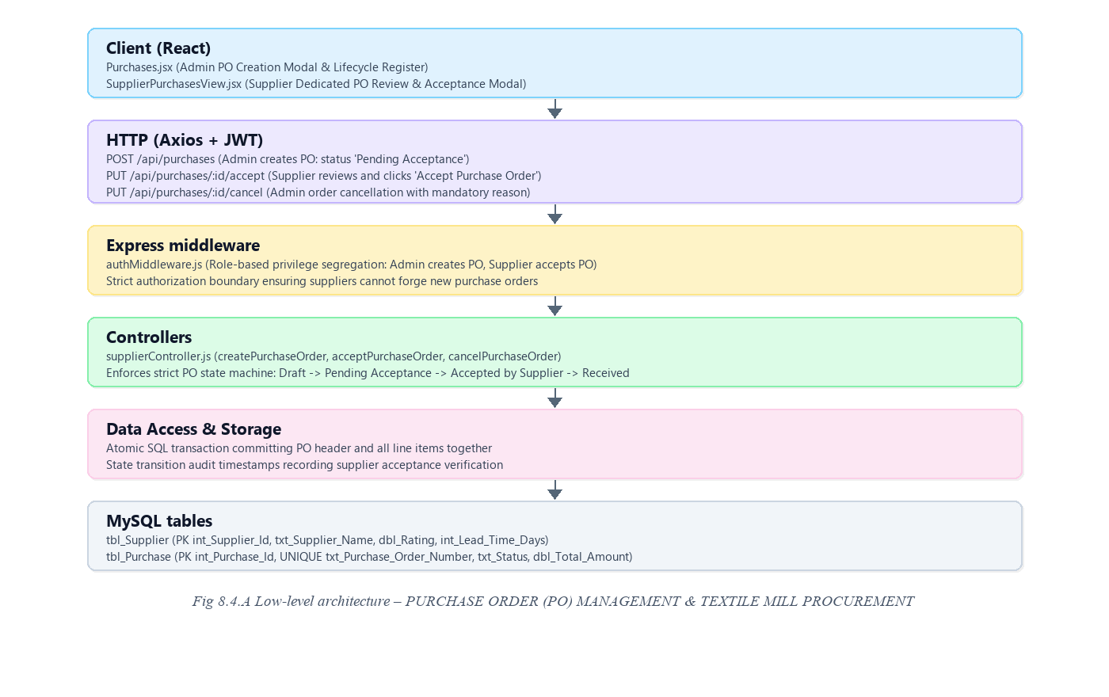
Request flow:
• Admin selects a registered textile mill, adds garment items with unit rates and tax rates, and submits the order.
• The backend generates a sequential order number (e.g., PO-772) with status 'Pending / Waiting for Supplier Acceptance'.
• The mill supplier logs into the Supplier Portal and inspects pending purchase orders in SupplierPurchasesView.jsx.
• The supplier clicks 'Accept Purchase Order', which sends a PUT request updating the order status to 'Accepted by Supplier'.
• The inventory warehouse supervisor can now proceed with physical stock inward once goods arrive.
8.4.6 API Design
Method | Endpoint | Purpose / contract
GET | /api/suppliers | Lists all registered textile mills with ratings, contact info, and lead times.
POST | /api/suppliers | Registers a new textile mill supplier profile.
GET | /api/purchases | Retrieves purchase order register with status filters.
POST | /api/purchases | Admin-only: Creates new purchase order with status 'Pending / Waiting for Supplier Acceptance'.
PUT | /api/purchases/:id/accept | Supplier-only: Formally accepts the purchase order; transitions status to 'Accepted by Supplier'.
PUT | /api/purchases/:id/cancel | Cancels a purchase order with a mandatory documented reason.

8.4.7 DB Design
Table | Keys & indexes | Key columns
tbl_Supplier | PK int_Supplier_Id  INDEX (txt_Supplier_Name) | txt_Supplier_Name, txt_Contact_Person, txt_Phone, txt_GST_Number, dbl_Rating, int_Credit_Period_Days
tbl_Purchase | PK int_Purchase_Id  UNIQUE txt_Purchase_Order_Number  FK int_Supplier_Id | txt_Purchase_Order_Number, int_Supplier_Id, dte_Purchase_Date, dbl_Total_Amount, dbl_Tax_Amount, int_Payment_Status_Id, txt_Status

• Unique constraint on txt_Purchase_Order_Number prevents accidental duplication during concurrent saves.
• Purchase order status enforces a strict state machine preventing stock inward against unaccepted orders.
8.4.8 Screenshots
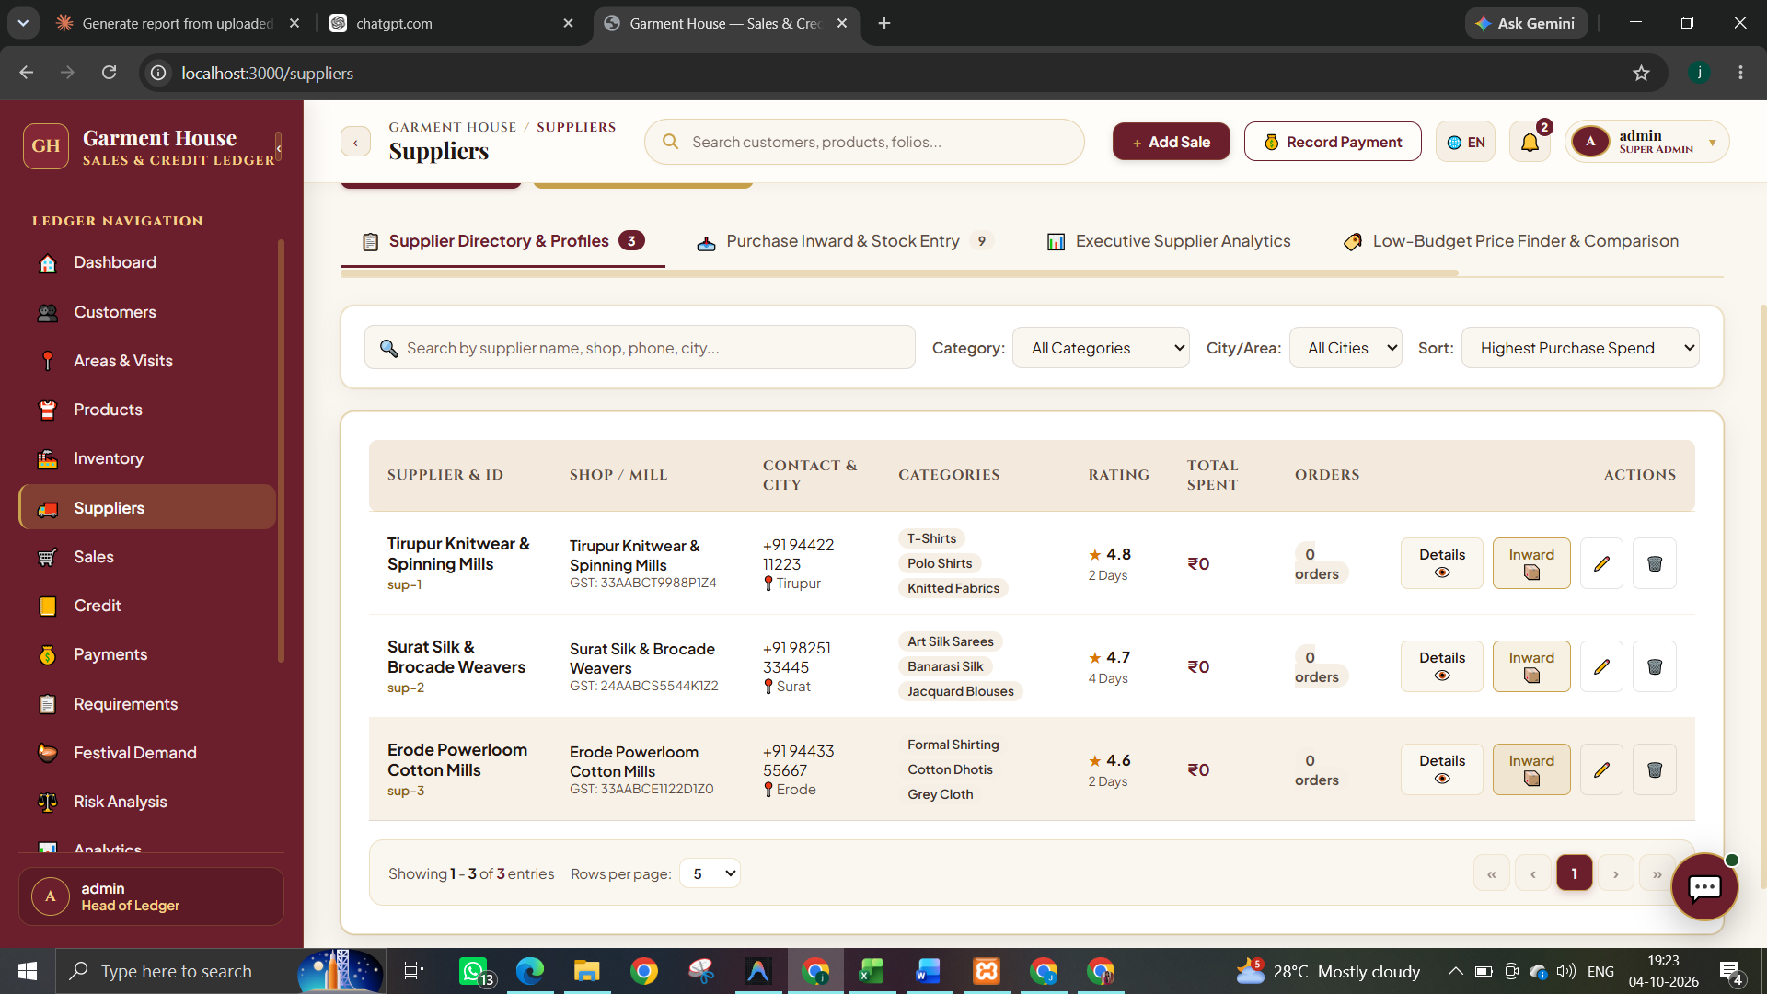
Fig 8.11 – Supplier Directory & Procurement Management Page – Interface for vendor profiling, textile mill directories, and purchase tracking.
The Supplier Directory & Procurement Management page enables store administrators to organize textile mill partnerships, track procurement orders, and monitor vendor performance across four operational tabs.
The mill directory lists verified manufacturers including Tirupur Knitwear & Spinning Mills (4.8 rating, 2-day lead time), Surat Silk & Brocade Weavers (4.7 rating, 4-day lead time), and Erode Powerloom Cotton Mills (4.6 rating, 2-day lead time).
Action buttons provide quick access to supplier details, inward stock entry, and purchase order tracking.
8.5 MULTI-GODOWN INVENTORY & STOCK INWARD / GRN (GODOWN 1 & GODOWN 2 CONTROL)
8.5.0 Purpose & Scope
Manages physical garment stock across multiple storage facilities (Godown 1: Main Showroom and Godown 2: Annex Warehouse), combining inward stock induction with automated inventory depletion and low-stock warnings.
8.5.1 Functional Requirements
What the module must do:
• Multi-Godown Inventory Segregation: Tracks piece-level stock quantities separately across Godown 1 (Main Showroom) and Godown 2 (Annex Storage).
• Goods Receipt Note (GRN) Inward: Inducts physical stock from accepted purchase orders into the designated warehouse location.
• Automated Stock Depletion: Deducts stock in real time upon point-of-sale invoice completion from the chosen godown.
• Low Stock & Reorder Alerts: Flags apparel items whose live quantities fall to or below configured reorder thresholds.
• Stock & Requirement Matcher: Automatically matches available warehouse inventory against pending retail customer restock demands.
8.5.2 Non-Functional Requirements
How well the module must do it (the system-wide baseline also applies):
• Zero Negative Stock Enforcement: Database transaction verifies available stock prior to depletion; overselling is rejected.
• Concurrency Safety: Row-level locking ensures concurrent sales transactions do not read stale stock balances.
• CAP Balance: Prioritizes consistency (CP) to ensure showroom staff and warehouse clerks observe identical stock counts.
8.5.3 Tech Stack
Concern | Choice | Why it fits this module
Multi-Location Tracking | Dual-Godown Schema | Segregates showroom floor inventory from bulk storage.
Stock Verification | Server-Side Locking | Guarantees atomic decrement during invoice generation.
Inventory Analytics | Dynamic Stock Valuation | Computes total capital asset value across all SKUs in real time.

8.5.4 Back-of-the-Envelope Estimation
Quantity | Estimate | Basis
Total Stored Units | ≈ 90 – 1,000 Pcs | Live inventory across active garment styles
Total Stock Valuation | ≈ ₹47,000 – ₹5,00,000 | Cumulative cost value of stored garments
Daily Stock Mutations | 50 – 150 operations | Sales deductions, inward receipts, and godown transfers

8.5.5 Low-Level Architecture
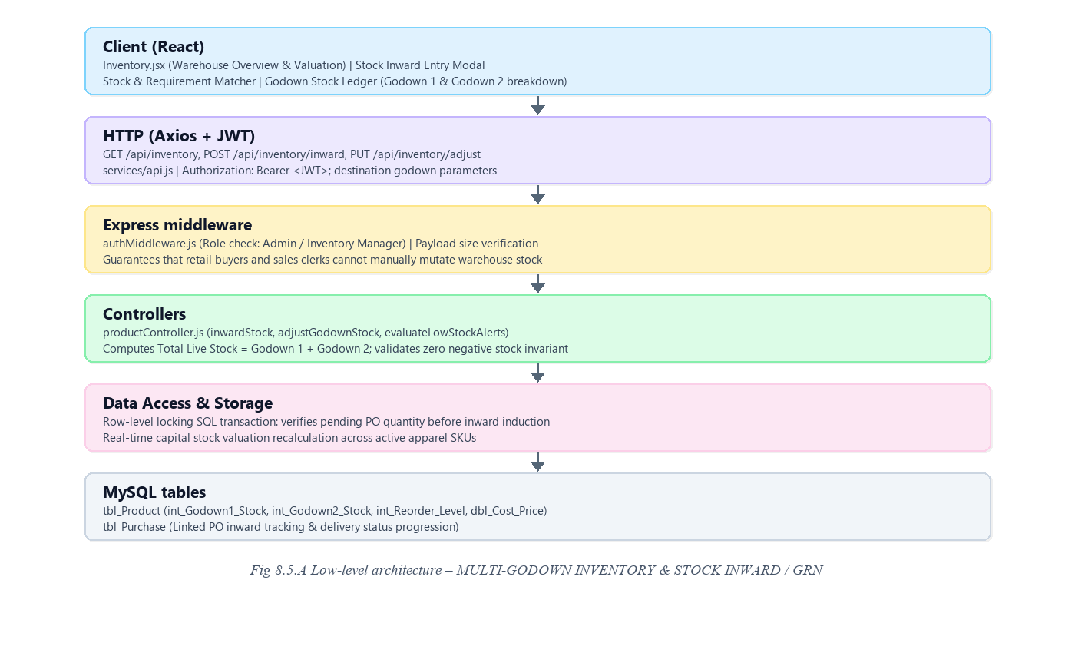
Request flow:
• The store manager opens the Warehouse Inventory Overview page to review stock distribution.
• Upon physical receipt of goods from a supplier, the Inward Stock modal is submitted with quantity and destination godown.
• The server updates tbl_Product adding stock to Godown 1 or Godown 2 inside an atomic SQL transaction.
• When a sale is finalized, stock is automatically depleted and live totals are recalculated.
8.5.6 API Design
Method | Endpoint | Purpose / contract
GET | /api/inventory | Retrieves complete inventory ledger with Godown 1, Godown 2, and total live stock.
POST | /api/inventory/inward | Inducts new garment stock into the warehouse from accepted purchase orders.
PUT | /api/inventory/adjust | Adjusts physical inventory counts for audits or inter-godown transfers.
GET | /api/inventory/low-stock | Returns SKUs approaching or below reorder levels for restocking advisory.

8.5.7 DB Design
Table | Keys & indexes | Key columns
tbl_Product | PK int_Product_Id  INDEX (txt_SKU_Code) | txt_Product_Name, txt_SKU_Code, dbl_Cost_Price, dbl_Selling_Price, int_Godown1_Stock, int_Godown2_Stock, int_Reorder_Level

• Total Live Stock is computed dynamically as int_Godown1_Stock + int_Godown2_Stock to guarantee consistency.
• Stock Valuation is calculated as Total Stock × dbl_Cost_Price across all active SKUs.
8.5.8 Screenshots
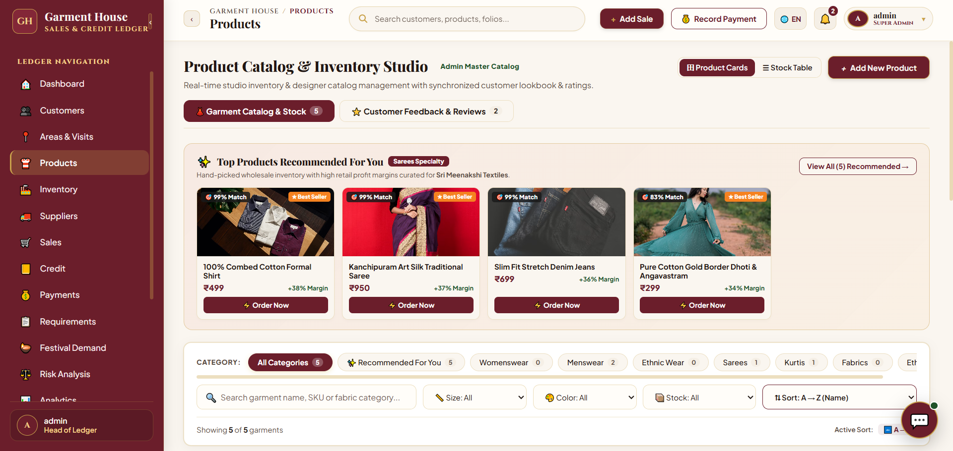
Fig 8.10 – Warehouse Inventory Overview & Stock Control Page – Interface for multi-godown stock management and inventory valuation.
The Warehouse Inventory Overview & Stock Control page provides comprehensive visibility into stored garment quantities and warehouse capital valuation. Four summary cards present Total Stock Valuation (₹47,322), Total Warehoused Pcs (90 Pcs), Garment Master Items (5 SKUs), and Low Stock Alerts (1 Item).
The Godown Stock Ledger displays item-level tracking across Godown 1 (Main Showroom) and Godown 2 (Annex Storage), including Combed Cotton Shirts (16 pcs Godown 1, 8 pcs Godown 2), Silk Sarees (8 pcs Godown 1, 4 pcs Godown 2), and Kurti Sets (12 pcs Godown 1, 6 pcs Godown 2).
8.6 POINT OF SALE (POS) BILLING & CUSTOMER KHATA CREDIT LEDGER
8.6.0 Purpose & Scope
Handles high-velocity retail and wholesale counter billing, customer credit limit verification, split-payment settlement (Cash/UPI plus Khata Credit), automated GST invoice generation, and double-entry trade credit ledger reconciliation.
8.6.1 Functional Requirements
What the module must do:
• Two-Panel Billing Studio: Left panel handles customer and apparel product selection; right panel manages the dynamic shopping cart and payment calculation.
• Credit Limit Governance: Displays customer balance and allowable credit line; automatically flags and blocks credit transactions that exceed the approved threshold.
• Flexible Split Payment Settlement: Accommodates partial immediate cash/UPI payment while debiting the residual balance to the customer's trade credit ledger.
• Automated GST Invoice Generation: Computes item subtotal, applicable GST (5% / 12%), round-off, and grand total; generates sequential invoice numbers (e.g., INV-0074).
• Khata Credit Control & Ledger: Maintains a double-entry debit/credit ledger tracking cumulative credit issued, total recovered funds, and active outstanding dues.
• Digital Receipts & WhatsApp Slips: Produces printable thermal and A4 tax invoices with one-click WhatsApp sharing links for immediate customer dispatch.
8.6.2 Non-Functional Requirements
How well the module must do it (the system-wide baseline also applies):
• Financial Rigor: All monetary values stored as DECIMAL(12,2); client-submitted sums are recomputed and verified server-side.
• Atomic Commit: Invoice header, line items, stock depletion, and customer khata balance update commit together in one transaction.
• Sub-Second Response: Invoice creation, stock reduction, and receipt generation complete in under 500 ms.
8.6.3 Tech Stack
Concern | Choice | Why it fits this module
Billing Interface | React Sales Studio (Sales.jsx) | Rapid keyboard/barcode navigation with instant line and total calculations.
Invoice Engine | Thermal / A4 InvoiceModal | Renders standards-compliant GST tax invoices with print and PDF capabilities.
Ledger Math | SQL Transactional Queries | Enforces strict mathematical balance reconciliation between sales and payments.

8.6.4 Back-of-the-Envelope Estimation
Quantity | Estimate | Basis
Invoices per Day | ≈ 20 – 60 bills | Wholesale counter transactions and field billing
Average Invoice Value | ₹4,500 – ₹25,000 | B2B wholesale apparel bundles
Credit vs Cash Ratio | 70% Credit, 30% Cash | Standard textile trading commercial practice
Storage per Invoice | ≈ 2.5 KB / invoice | Invoice header, line items, and payment split records

8.6.5 Low-Level Architecture
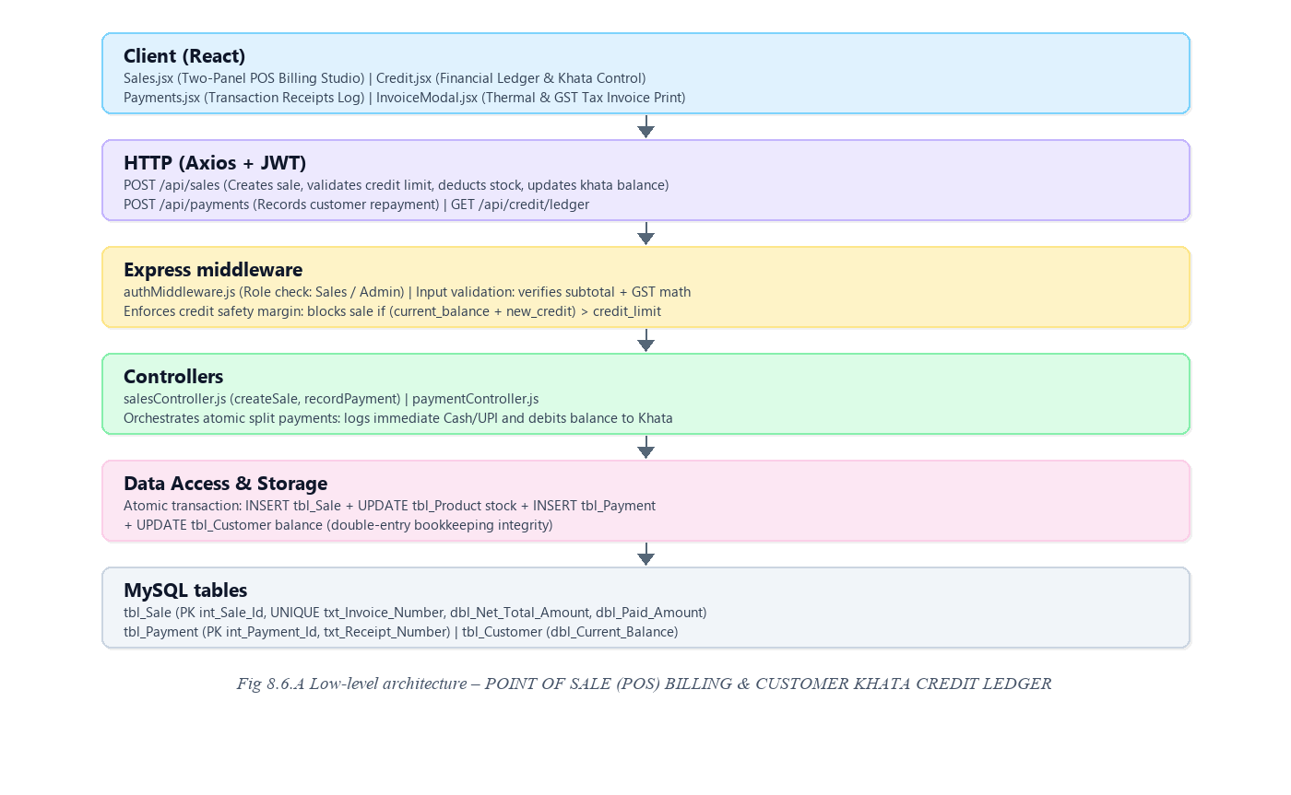
Request flow:
• The billing clerk selects a retail customer; the UI displays current balance, credit limit, and remaining credit margin.
• Garments are added to the cart with live subtotal, GST (5%), and total calculations.
• The clerk enters immediate cash paid; the remainder is assigned to Khata credit.
• The server verifies credit limit compliance, creates the sale record, creates a payment record if cash was paid, updates the customer balance, and reduces stock.
• The client displays InvoiceModal.jsx with instant thermal printing and WhatsApp receipt options.
8.6.6 API Design
Method | Endpoint | Purpose / contract
POST | /api/sales | Creates sales invoice: verifies credit limit, deducts stock, records payment, updates khata balance.
GET | /api/sales | Retrieves paginated sales records with date, customer, and payment mode filters.
GET | /api/sales/:id/invoice | Fetches complete printable GST invoice data including customer and line items.
POST | /api/payments | Records standalone customer payment, updates customer ledger balance, logs receipt.
GET | /api/credit/ledger | Returns executive Khata overview: total credit issued, total collected, and overdue balance.

8.6.7 DB Design
Table | Keys & indexes | Key columns
tbl_Sale | PK int_Sale_Id  UNIQUE txt_Invoice_Number  FK int_Customer_Id | txt_Invoice_Number, int_Customer_Id, dte_Sale_Date, dbl_Subtotal_Amount, dbl_Tax_Amount, dbl_Net_Total_Amount, dbl_Paid_Amount, dbl_Balance_Amount, int_Payment_Status_Id
tbl_Payment | PK int_Payment_Id  UNIQUE txt_Receipt_Number  FK int_Customer_Id | txt_Receipt_Number, int_Customer_Id, int_Sale_Id, dbl_Amount, int_Payment_Mode_Id, dte_Payment_Date, txt_Receipt_Url

• Customer current balance in tbl_Customer is updated inside the same transaction that inserts tbl_Sale and tbl_Payment.
• Invoice numbers follow strict sequential numbering (INV-XXXX) with database-level uniqueness enforcement.
8.6.8 Screenshots
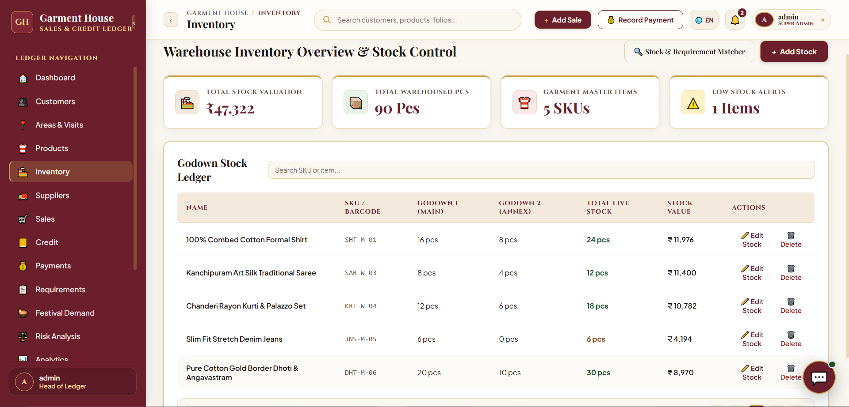
Fig 8.12 – Garment Sales Studio & POS Billing Page – Interface for order creation, customer credit validation, and invoice generation.
The Garment Sales Studio page provides sales operators and billing clerks with a structured two-panel terminal for rapid checkout.
The left section enables customer selection with immediate visibility of current balance (e.g., Ravi Kumar, ₹2,400 balance, ₹8,000 credit limit).
The right section features the live order cart, calculating Subtotal (₹4,497), GST 5% (₹225), and Net Total (₹4,722) with split-payment options.
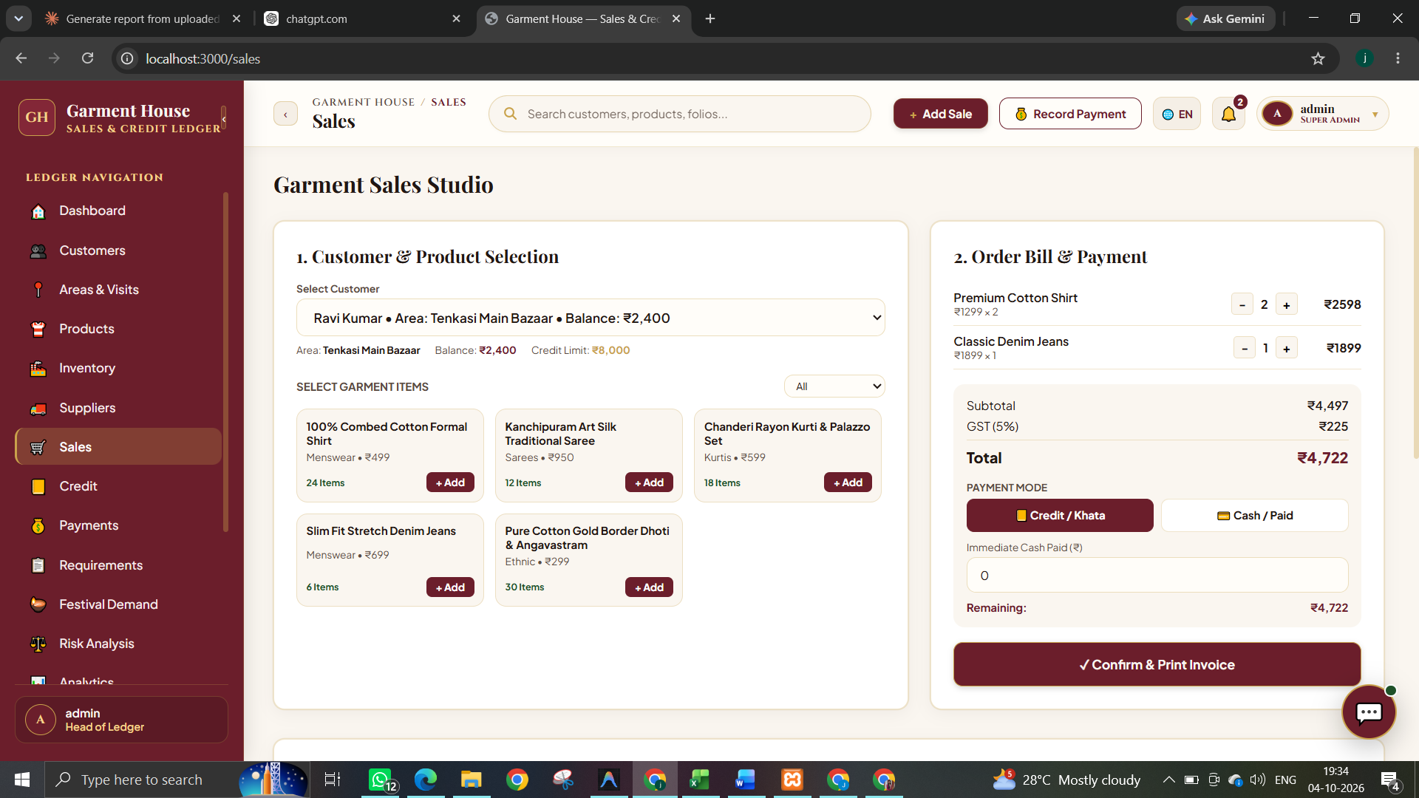
Fig 8.13 – Financial Ledger & Khata Credit Control Page – Interface for Managing Credit Limits, Customer Balances, and Overdue Payments
The Financial Ledger & Khata Credit Control page provides complete transparency into accounts receivable. Four summary cards present Total Credit Issued (₹1,20,800), Total Collections (₹1,12,400 with 93% Recovery Rate), Outstanding Khata Credit (₹8,400), and Overdue Khata (₹5,550).
The Khata ledger table lists customer records with purchase volumes, credit ceilings, outstanding balances, payment progress indicators, and instant 'Collect' and 'Remind' actions.
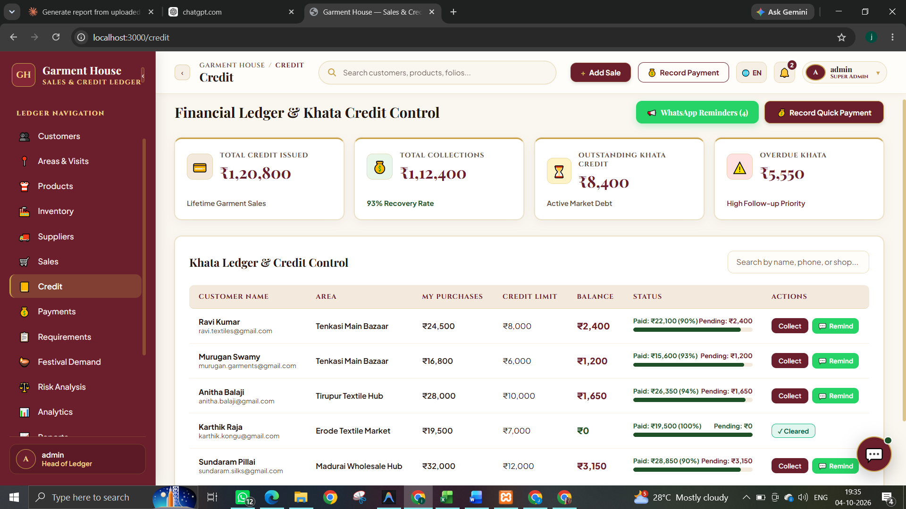
Fig 8.14 – Payment Receipts & Transaction Log Page – Interface for Recording Payments, Verifying Payment Modes, and Sharing Digital Receipts
The Payment Receipts & Log page maintains an immutable audit trail of customer payment receipts. Summary metric cards highlight Total Collections (₹5,896) and Digital Payment Ratio (60%).
The transaction table records receipt numbers (COL-101 to COL-105), customer names, settled amounts, payment modes (UPI, Cash, Bank Transfer, Cheque), and green 'WhatsApp Slip' buttons for sharing payment confirmations.
8.7 DAILY FIELD ROUTE COLLECTION & AUTOMATED REMINDERS
8.7.0 Purpose & Scope
Coordinates field debt recovery across geographic sales routes (Monday to Saturday) and automates daily overdue payment follow-ups using a background cron scheduler and WhatsApp integration.
8.7.1 Functional Requirements
What the module must do:
• Territory Route Planning: Organizes collection routes by day of the week (Monday through Saturday) with assigned collection agents.
• Field Agent On-Route Execution: Enables mobile agents to conduct store visits, verify visit statuses, record partial/full cash or UPI settlements, and log visit notes.
• Automated Overdue Reminder Daemon: A background service (reminderService.js) runs every morning at 09:00 AM using node-cron to scan customer due dates in the database.
• Overdue Detection Algorithm: Flags accounts exceeding permissible credit terms, calculates days overdue, and drafts customized WhatsApp/SMS reminder templates.
• Anti-Spam Business Rules: Automatically skips customers with zero outstanding balance and prevents duplicate reminders from being generated for the same customer on the same day.
• Manual Overdue Scan Trigger: Provides administrators with a 'Run Overdue Check Now' button for on-demand ledger scans.
8.7.2 Non-Functional Requirements
How well the module must do it (the system-wide baseline also applies):
• Scheduler Reliability: Daily cron execution runs as an independent server-side daemon with comprehensive execution logging.
• Mobile Responsiveness: Field route checklists optimized for low-bandwidth mobile devices used by on-road collection agents.
• WhatsApp Delivery Integration: Generates pre-formatted URI-encoded WhatsApp links for instant one-click messaging without third-party API costs.
8.7.3 Tech Stack
Concern | Choice | Why it fits this module
Cron Automation | node-cron | Lightweight in-process cron daemon executing daily 09:00 AM overdue scans.
Messaging Protocol | WhatsApp URL Schemes | Enables direct, zero-cost WhatsApp messaging with personalized text templates.
Territory State | AreaContext.jsx | Maintains active territory routes, scheduled days, and collection targets across the app.

8.7.4 Back-of-the-Envelope Estimation
Quantity | Estimate | Basis
Weekly Routes | 6 scheduled days | Monday through Saturday route distribution
Field Visits per Day | 10 – 25 store visits | Mapped retail customers per territory
Daily Recovery Amount | ₹15,000 – ₹50,000 | Average field collections logged per route
09:00 AM Scan Duration | < 1.5 seconds | Evaluates all customer due dates in threadline_db

8.7.5 Low-Level Architecture
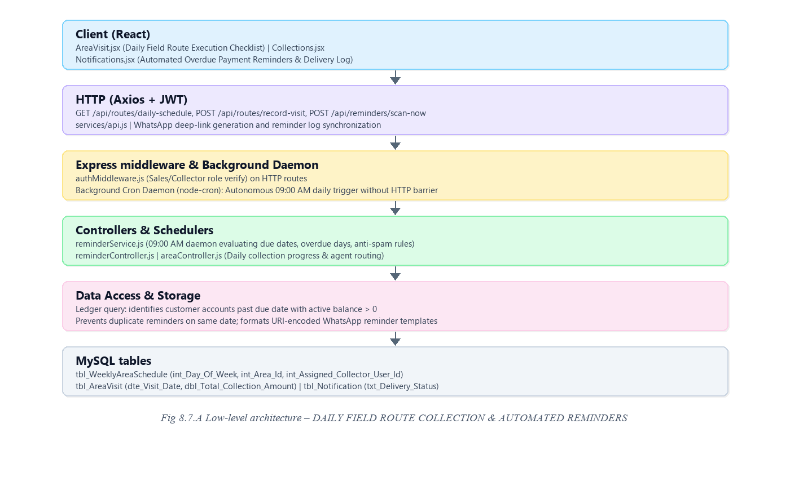
Request flow:
• The automated reminder daemon awakens daily at 09:00 AM and executes an overdue evaluation query.
• Accounts past due date are detected; the system calculates overdue days and interest/balance figures.
• Personalized reminder records are inserted into tbl_Notification with status 'Pending' or 'Sent'.
• Administrators review the delivery log in Notifications.jsx and click 'WhatsApp' to dispatch reminders directly.
• Field agents execute the day's route, recording collected payments which automatically clear overdue flags.
8.7.6 API Design
Method | Endpoint | Purpose / contract
GET | /api/routes/daily-schedule | Returns scheduled territory routes and customer checklists for the active day.
POST | /api/routes/record-visit | Logs field agent visit outcome, notes, and on-spot payment settlement.
POST | /api/reminders/scan-now | Triggers immediate manual overdue check across all customer accounts.
GET | /api/reminders/logs | Retrieves reminder delivery log filtered by status (Sent, Delivered, Pending, Failed).
POST | /api/reminders/send-whatsapp | Dispatches formatted WhatsApp reminder message to customer mobile.

8.7.7 DB Design
Table | Keys & indexes | Key columns
tbl_WeeklyAreaSchedule | PK int_Weekly_Schedule_Id  UK int_Day_Of_Week, int_Area_Id | int_Day_Of_Week, int_Area_Id, int_Assigned_Collector_User_Id, txt_Remarks
tbl_AreaVisit | PK int_Area_Visit_Id  FK int_Weekly_Schedule_Id | dte_Visit_Date, int_Collector_User_Id, dbl_Total_Collection_Amount, txt_Visit_Run_Status
tbl_Notification | PK int_Notification_Id  FK int_Customer_Id | int_Customer_Id, txt_Subject, txt_Message_Body, dte_Scheduled_Date, dte_Sent_Date, txt_Delivery_Status

• Unique key on (int_Day_Of_Week, int_Area_Id) ensures exactly one route schedule per weekday per territory.
• Delivery status values (Pending, Sent, Delivered, Failed) enable complete operational auditing of notification dispatches.
8.7.8 Screenshots
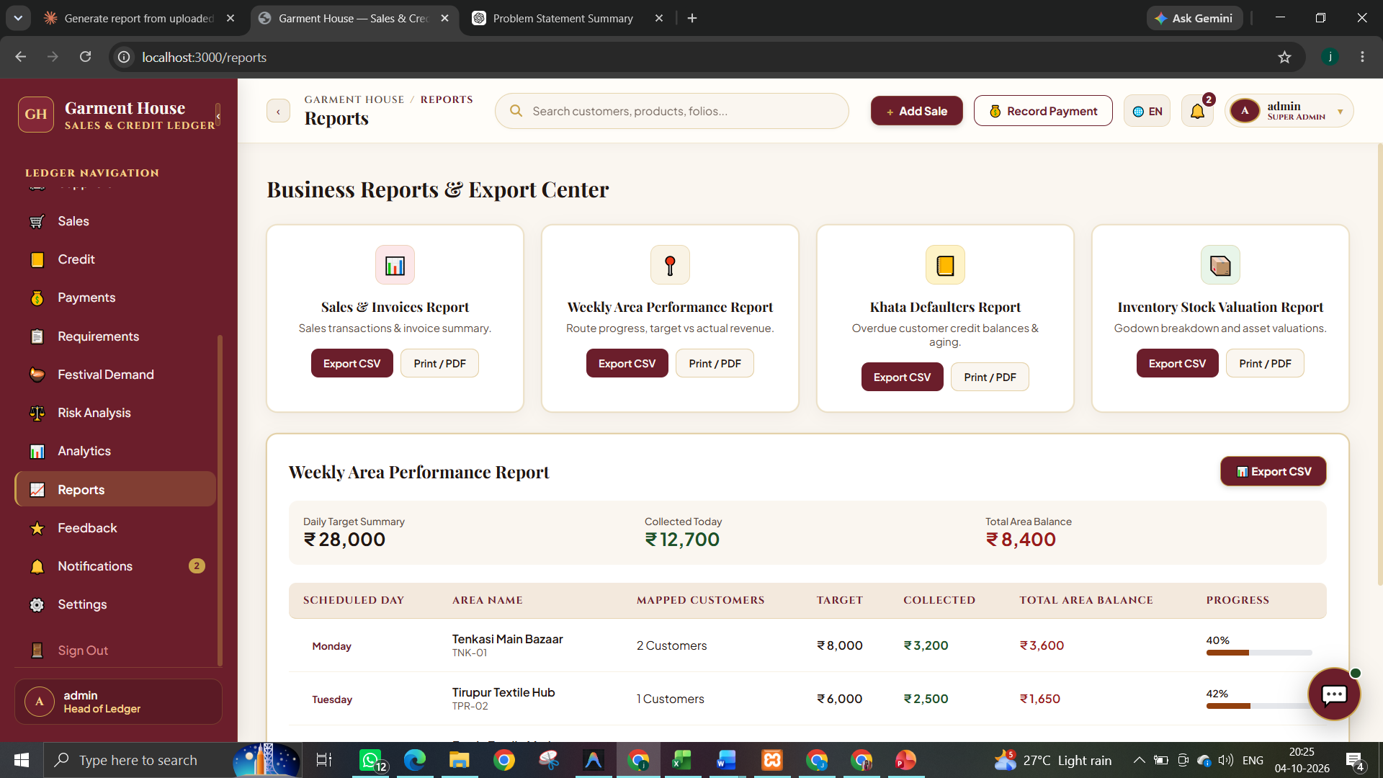
Fig 8.21 – Automated Overdue Payment Reminders & Delivery Log Page – Interface for Automated Payment Follow-Up and Notification Tracking
The Automated Overdue Payment Reminders & Delivery Log page provides store administrators with centralized control over automated payment follow-ups.
Summary cards show Total Reminders Logged (2 Logs), Overdue Amount Covered (₹5,550), Daily Scan Schedule (09:00 Daily), and Scheduler Status (Active with green pulse).
The reminder ledger details Customer Name, Phone Number, Pending Amount, Due Date, Days Overdue, Generated Message, and direct action triggers.
8.8 EXECUTIVE DASHBOARD & BUSINESS ANALYTICS (WITH AI RISK & FESTIVAL CALENDAR)
8.8.0 Purpose & Scope
Furnishes store owners and executive management with operational intelligence, KPI tracking, comparative sales/collection velocity, algorithmic credit risk scoring, and predictive festival demand forecasting.
8.8.1 Functional Requirements
What the module must do:
• Executive KPI Telemetry: Live summary cards tracking Today's Sales, Today's Collection, Total Outstanding Khata Credit, and Active Customer count.
• Comparative Sales vs Collection Analytics: Visual dual-bar chart comparing gross daily sales revenue against recovered credit collections.
• Algorithmic Credit Risk Profiling: Evaluates customer repayment velocity and credit utilization ratios to assign risk probability scores (Low, Medium, High Risk).
• Credit Safety Governance: Recommends policy actions (e.g., 'Cash Only', 'Freeze Credit') for high-risk accounts to prevent bad debt accumulation.
• Festival Demand & Procurement Calendar: Dedicated advisory calendar for major Indian cultural events (Deepavali, Thai Pongal, Ramzan, Wedding season) identifying fabric deficits, lead times, and regional weaver origins (Surat, Kanchipuram, Tiruppur).
• Multi-Format Report Export Center: Generates structured audit reports across Sales & Invoices, Weekly Area Performance, Khata Defaulters, and Inventory Valuation with CSV and PDF downloads.
8.8.2 Non-Functional Requirements
How well the module must do it (the system-wide baseline also applies):
• Read-Only Safety: Analytical queries never mutate transaction tables, eliminating the possibility of data corruption.
• High Performance Aggregation: Dashboard queries complete in < 2 seconds through optimized SQL GROUP BY aggregation.
• Streaming Exports: Large tabular reports stream directly to browser memory without server memory exhaustion.
8.8.3 Tech Stack
Concern | Choice | Why it fits this module
Business Intelligence | SQL Aggregate Queries | Computes multi-dimensional totals, margins, and collection velocities efficiently.
Data Visualization | React Chart Components | Lightweight, responsive visual bar charts and risk distribution graphs.
Document Generation | CSV & PDF Formatters | Enables one-click spreadsheet analysis and printable executive documentation.

8.8.4 Back-of-the-Envelope Estimation
Quantity | Estimate | Basis
Dashboard Queries | 5 – 6 aggregate queries | Executes on load and manual refresh (< 200 ms total)
Executive Users | ≈ 5 concurrent viewers | Owner, accountants, and branch managers
Report Export Size | ≈ 50 KB – 500 KB | Typical monthly and annual audit reports in CSV format

8.8.5 Low-Level Architecture
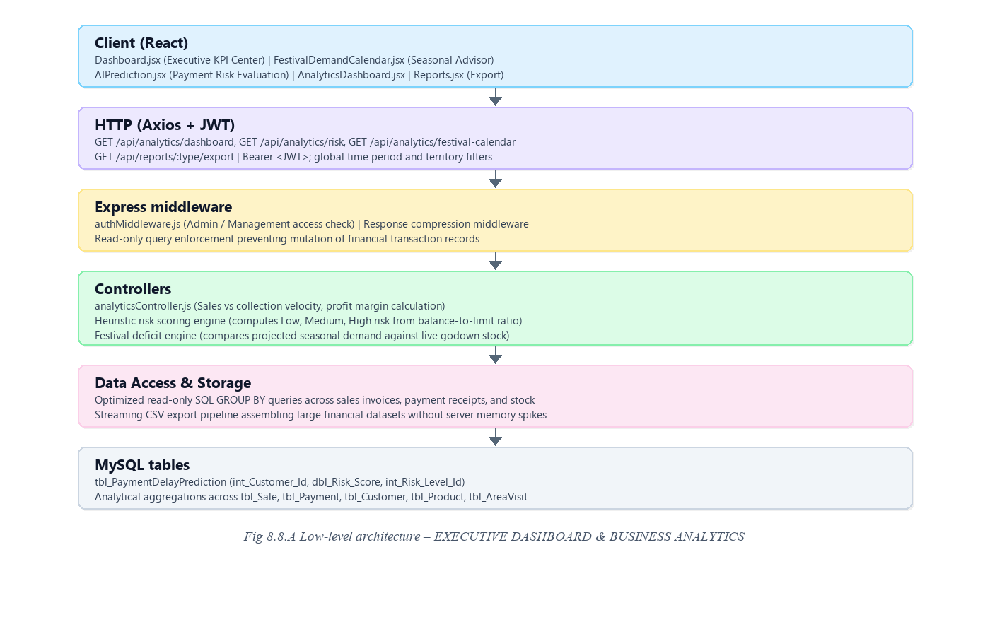
Request flow:
• The dashboard loads and fires aggregate queries retrieving daily revenue, collections, pending debt, and route targets.
• The risk profiling engine evaluates customer transaction histories and assigns risk probability percentages.
• The Festival Demand Calendar compares seasonal demand projections against current godown stock, alerting on deficits.
• The Reports view allows managers to filter by date range and territory, previewing the grid before exporting to CSV or PDF.
8.8.6 API Design
Method | Endpoint | Purpose / contract
GET | /api/analytics/dashboard | Returns executive KPI summary cards, monthly series, and route progress.
GET | /api/analytics/risk-analysis | Retrieves algorithmic credit risk evaluations, risk distribution, and freeze recommendations.
GET | /api/analytics/festival-calendar | Fetches upcoming festival dates, demand projections, fabric stock deficits, and weaver origins.
GET | /api/reports/:type | Returns structured report data for on-screen grid preview.
GET | /api/reports/:type/export | Streams formatted CSV file for spreadsheet-based financial auditing.

8.8.7 DB Design
Table | Keys & indexes | Key columns
tbl_PaymentDelayPrediction | PK int_Prediction_Id  FK int_Customer_Id | int_Customer_Id, dbl_Risk_Score, int_Risk_Level_Id, dbl_Credit_Utilization_Percent, txt_Actual_Outcome
Analytical Aggregations | Read-only queries across tables | Aggregates tbl_Sale, tbl_Payment, tbl_Customer, tbl_Product, tbl_AreaVisit

• Analytical indexes on dte_Sale_Date, dte_Payment_Date, and int_Area_Id accelerate date-range report generation.
• Risk scores are dynamically computed from balance-to-limit ratio and overdue duration.
8.8.8 Screenshots
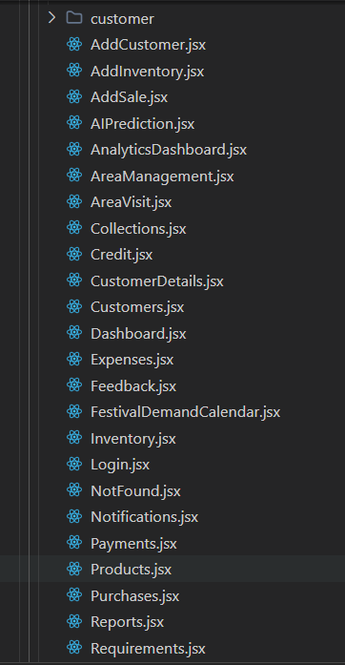
Fig 8.6 – Admin Dashboard – Displaying All – Dashboard summarizing Sales, Collections, Credit Balances, and Customers.
The Admin Dashboard serves as the central operations command center for the garment business, providing real-time visibility across all operational domains.
Summary metric cards highlight Today's Sales (₹28,450), Today's Collection (₹45,320), Outstanding Khata Credit (₹1,28,750), and Active Customers (12 across 4 territories).
The central panel displays the Sales & Collection Overview chart, Today's Route progress, and quick action shortcuts.
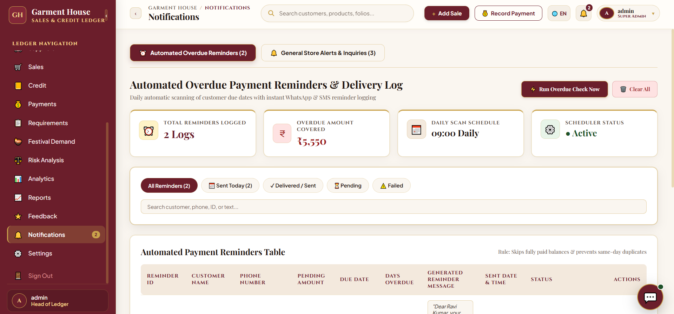
Fig 8.16 – Festival Demand Calendar & Predictive Procurement Page – Interface for Seasonal Demand Forecasting, Festival Planning, and Procurement Analysis
The Festival Demand Calendar helps store managers forecast seasonal requirements and avoid inventory stock-outs during major cultural celebrations.
Interactive tabs support Deepavali, Thai Pongal, Ramzan, Wedding season, and Navratri. The Deepavali advisory highlights an Estimated Demand of 440 pcs against 60 pcs in stock, signaling a Procurement Deficit of +380 pcs.
Advisories recommend sourcing Silk Sarees and Designer Kurtis from Surat and Kanchipuram weavers with a live countdown of 15 Days, 9 Hours.
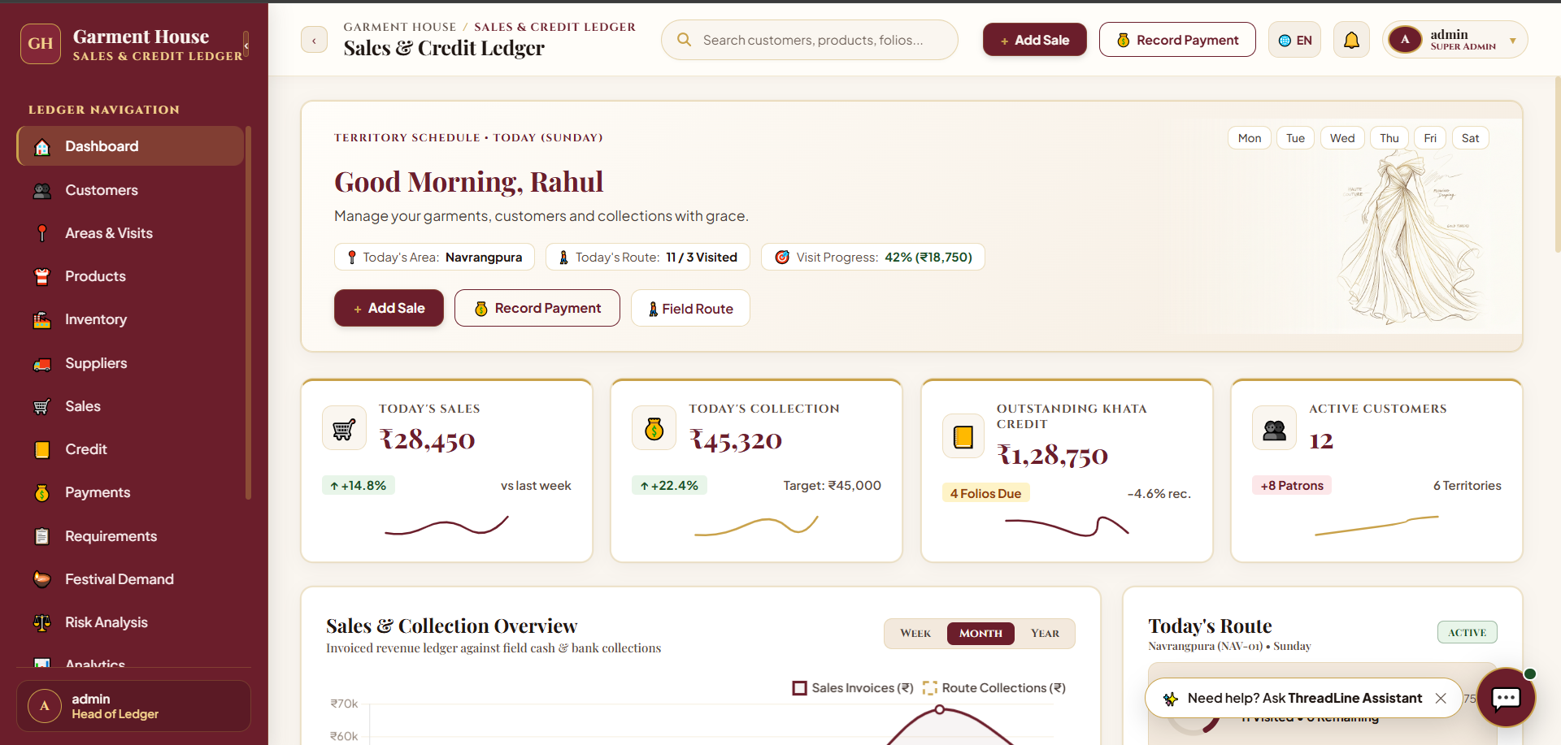
Fig 8.17 – Payment Risk Analysis Page – Interface for Automated Default Prediction and Credit Risk Evaluation
The Payment Risk Analysis page provides automated default risk evaluation using credit utilization ratios and payment delays.
Summary cards display Predicted High Risk Customers (2 Customers), At-Risk Exposure (₹5,550), and Low Risk Customers (3 Customers).
The Customer Risk Evaluation table details risk probabilities (e.g., Ravi Kumar, 85% High Risk) with immediate 'Freeze Credit' and 'Notice' actions.
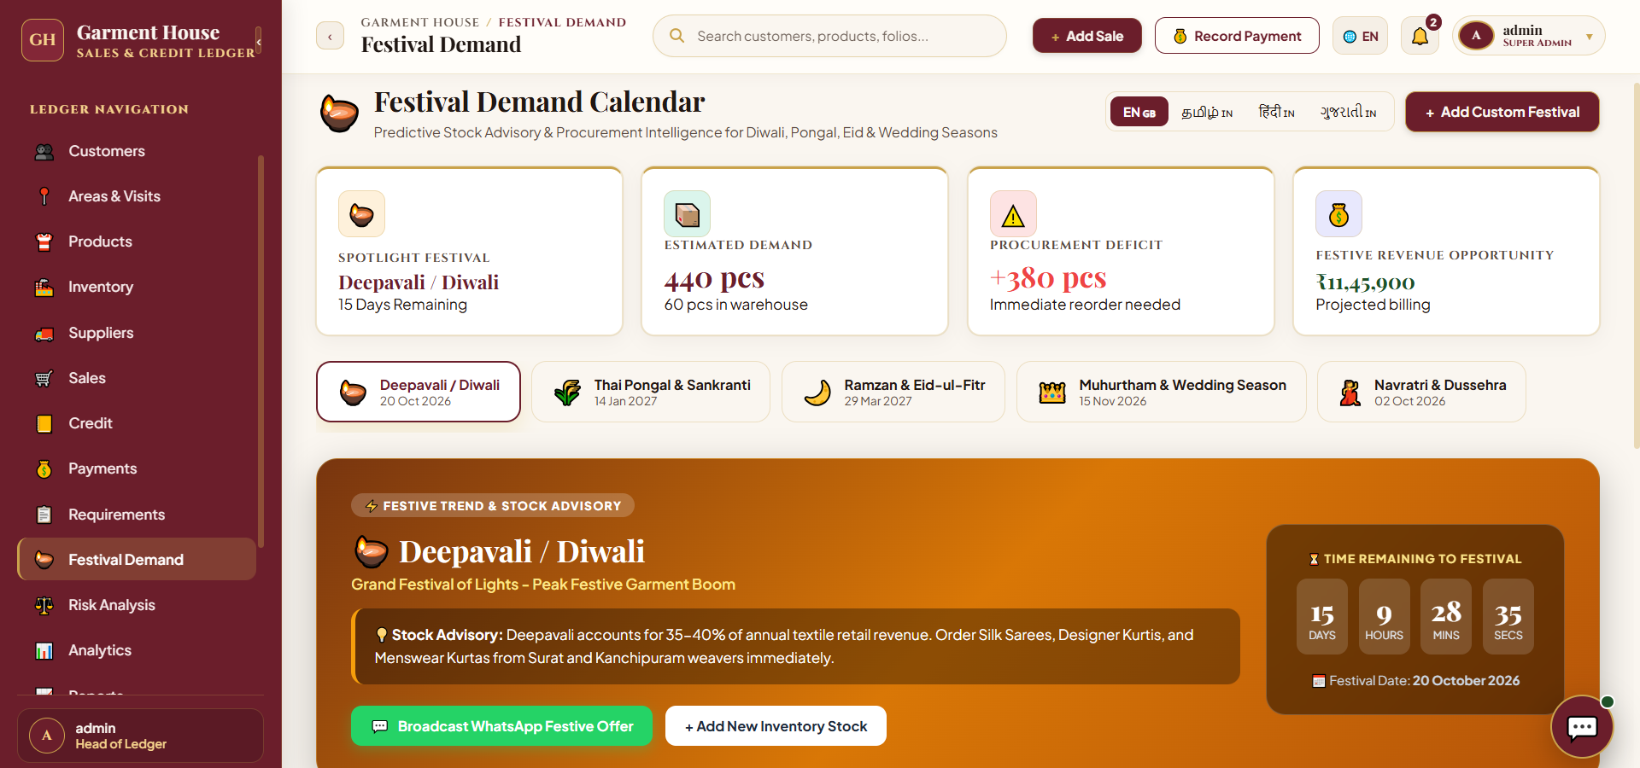
Fig 8.18 – Garment Analytics & Business Intelligence Page – Executive Dashboard for Business Performance, Profitability, and Financial Analysis
The Garment Analytics & Business Intelligence page provides in-depth executive telemetry with global filters for Time Period, Territory Area, and Garment Category.
Metric cards display Total Sales Revenue (₹11,987), Total Purchases (₹2,06,650), Total Collected (₹8,440), Gross Profit Margin (₹4,067 / 33.9%), and Supplier Payables (₹16,200).
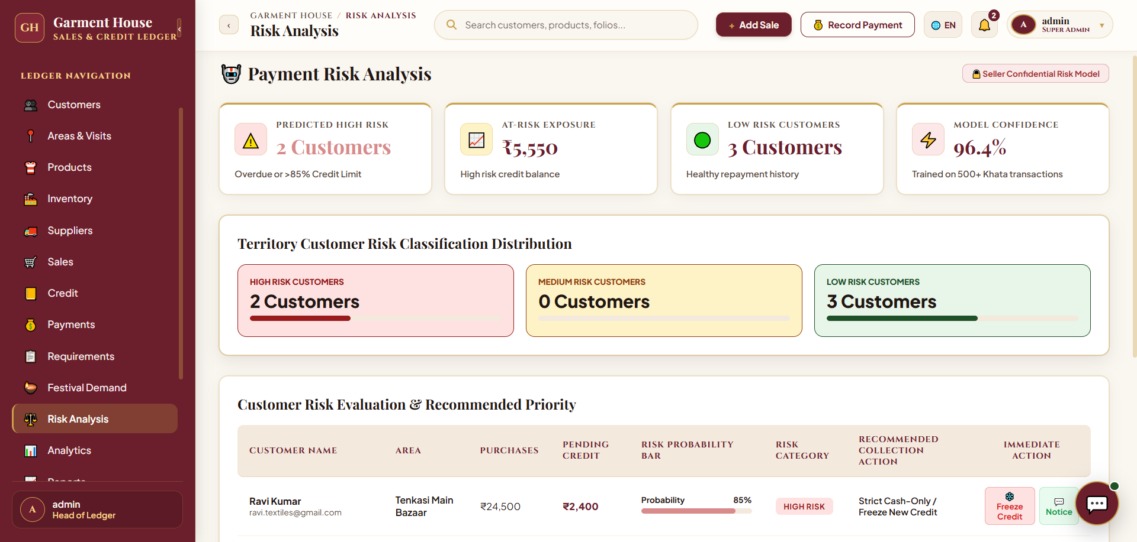
Fig 8.19 – Business Reports & Export Center Page – Interface for Generating Business Reports, Auditing Records, and Exporting Data
The Business Reports & Export Center provides four standardized report modules: Sales & Invoices Report, Weekly Area Performance Report, Khata Defaulters Report, and Inventory Stock Valuation Report.
The Weekly Area Performance Report displays Daily Target Summary (₹28,000), Collected Today (₹12,700), and Total Area Balance (₹8,400) with CSV and PDF export options.
8.9 RETAIL CUSTOMER SELF-SERVICE PORTAL & CONVERSATIONAL ASSISTANT
8.9.0 Purpose & Scope
Empowers retail garment buyers with a personalized digital portal to monitor their trade credit khata, inspect invoices, browse wholesale couture lookbooks, log custom restock requirements, submit fabric feedback, and interact with the 24/7 ThreadLine AI Assistant.
8.9.1 Functional Requirements
What the module must do:
• Customer Account Dashboard: Displays personalized welcome banner, credit ceiling, settled ledger ratio, and active custom garment demands.
• Haute Couture Lookbook & Digital Catalog: Enables buyers to browse wholesale collections by category, view store profit margins, and place restocking orders.
• My Purchases & Invoice Archive: Provides complete transparency over past transactions with full GST tax invoice downloads.
• Customer Credit Khata Ledger: Displays individual credit balance, repayment history, and credit health status.
• Custom Restock Requirements System: Allows retail buyers to submit bespoke apparel requirements with automated matching against warehouse inventory.
• Fabric Quality & Store Service Reviews: Structured feedback portal for rating garment fabric quality, stitching, and packaging.
• Client Portal Theme Customizer: Five luxury themes (Heritage Boutique, Imperial Velvet, Blush Beige, Forest Green, Royal Sapphire) selectable via CSS variables.
• ThreadLine Conversational AI Assistant: Accessible 24/7 chatbot resolving stock availability queries, khata balance lookups, and order placements.
8.9.2 Non-Functional Requirements
How well the module must do it (the system-wide baseline also applies):
• Strict Tenant Isolation: Customers can only access their own invoices, transactions, and restock requests.
• High UI Polish: Luxury boutique aesthetic with responsive desktop and mobile layouts.
• Real-Time Chatbot Response: Conversational assistant delivers contextual answers in < 1 second.
8.9.3 Tech Stack
Concern | Choice | Why it fits this module
Client Portal UI | React Customer Views (pages/customer/) | Dedicated self-service interface segregated from administrative controls.
Conversational Bot | ThreadLineChatbot.jsx | Contextual assistant modal with quick-action prompt chips and voice input support.
Dynamic Theming | CSS Custom Properties | Client-side instant visual theme switching without requiring server round-trips.

8.9.4 Back-of-the-Envelope Estimation
Quantity | Estimate | Basis
Retail Client Accounts | 100 – 300 buyers | Registered retail stores in the wholesale trading network
Daily Portal Visits | ≈ 50 – 120 sessions | Buyers checking balance, new arrivals, and order statuses
AI Chatbot Inquiries | ≈ 80 – 150 queries / day | Stock availability checks and restock requirement submissions

8.9.5 Low-Level Architecture
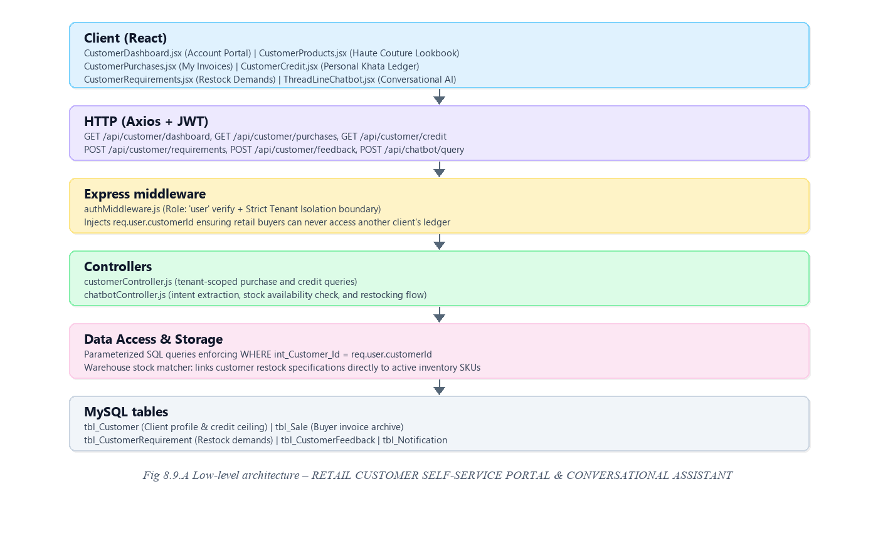
Request flow:
• The retail customer signs in and is directed to their personalized Customer Account Dashboard.
• The dashboard retrieves the customer's personal credit balance, settled ratio, and recommended apparel lines.
• When browsing the Couture Lookbook, the customer can click 'Order Now' or launch ThreadLine Assistant for stock checks.
• The customer can submit special tailoring requirements, which are automatically checked against warehouse stock.
8.9.6 API Design
Method | Endpoint | Purpose / contract
GET | /api/customer/dashboard | Returns customer profile, credit ceiling, balance, and recommended products.
GET | /api/customer/purchases | Retrieves customer's personal sales invoices with download links.
GET | /api/customer/credit | Fetches individual Khata ledger debit/credit transaction history.
POST | /api/customer/requirements | Submits bespoke garment restock requirement with target budget.
POST | /api/customer/feedback | Submits customer review, star rating, and quality comments.
POST | /api/chatbot/query | Processes conversational AI query for stock, balance, or product lookups.

8.9.7 DB Design
Table | Keys & indexes | Key columns
tbl_CustomerRequirement | PK int_Requirement_Id  FK int_Customer_Id | int_Customer_Id, int_Garment_Category_Id, dbl_Budget_Max, int_Requirement_Status_Id, int_Matched_Product_Variant_Id
tbl_CustomerFeedback | PK int_Feedback_Id  FK int_Customer_Id | int_Customer_Id, int_Rating, txt_Comments, dte_Submitted_Date

• Customer queries strictly enforce WHERE int_Customer_Id = req.user.customerId to prevent horizontal privilege escalation.
• Matched product variant ID links customer demands directly to inventory SKUs.
8.9.8 Screenshots
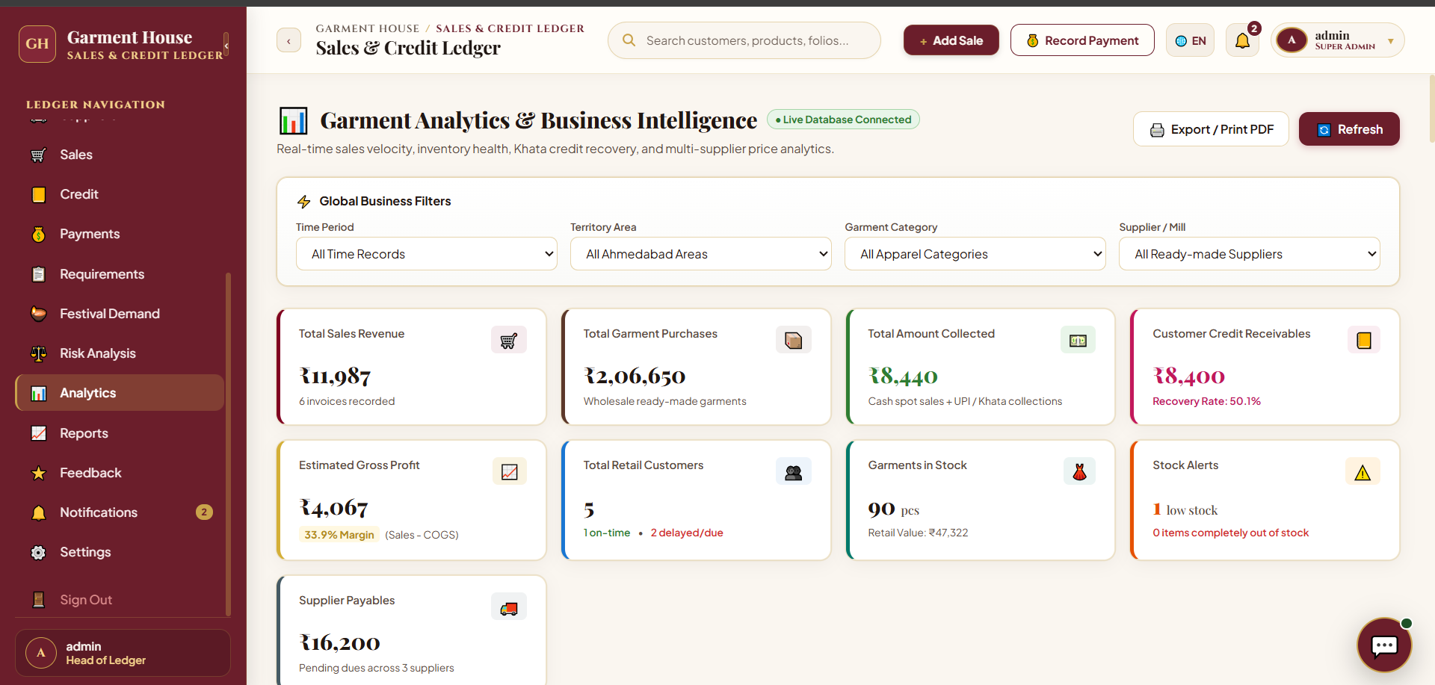
Fig 8.20 – Customer Feedback & Ratings Ledger Page – Interface for Monitoring Customer Reviews, Product Quality, and Satisfaction
The Customer Feedback & Ratings Ledger displays verified customer reviews regarding fabric quality, stitching, and store services.
Entries record customer ratings including a 5.0/5 star rating for combed cotton formal shirts and a 4.5/5 rating for Tirupur T-shirts packaging.
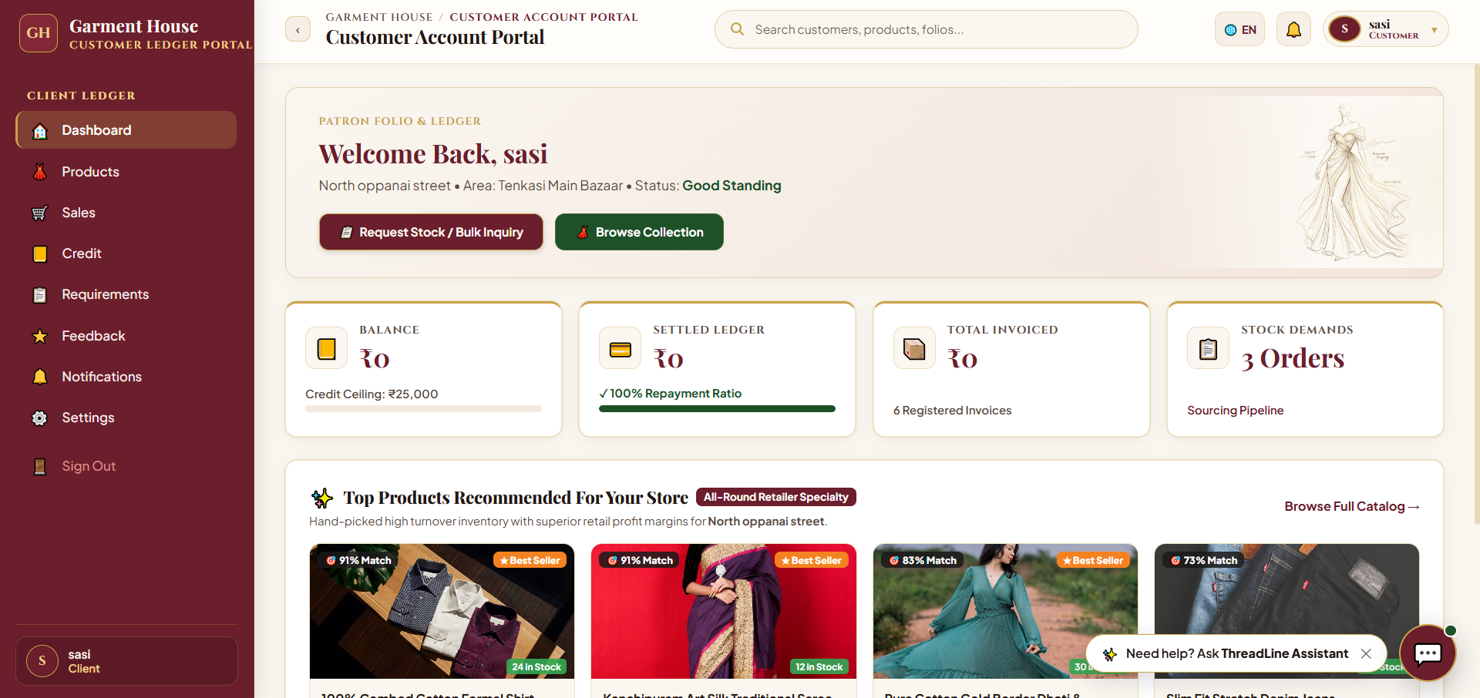
Fig 8.23 – Customer Account Portal Dashboard – Self-Service Interface for Retail Buyers
The Customer Account Portal Dashboard provides retail buyers with an intuitive self-service portal.
Summary cards show Balance (₹0 pending of ₹25,000 credit limit), Settled Ledger (₹0 / 100% repayment ratio), Total Invoiced (₹0 across 4 invoices), and Stock Demands (3 Orders in pipeline).
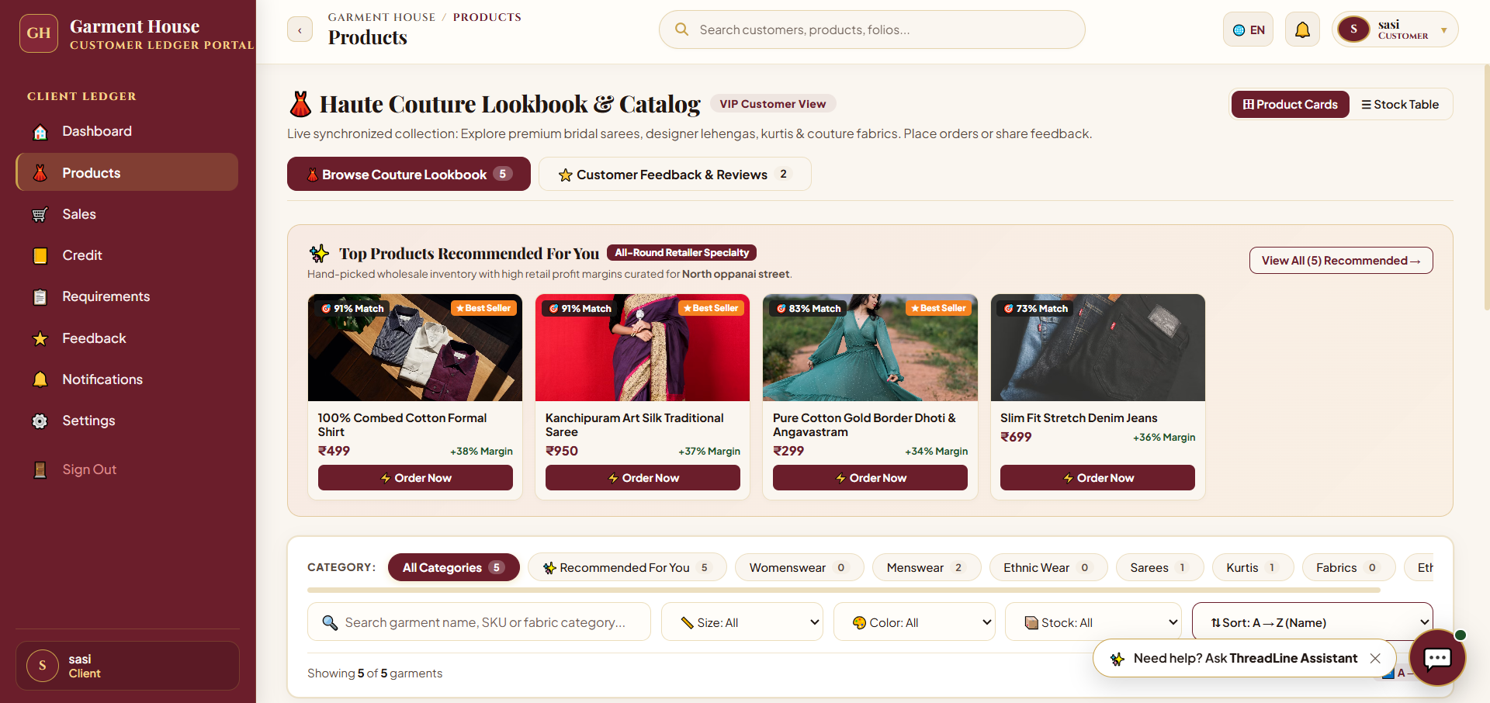
Fig 8.24 – Customer Haute Couture Lookbook & Catalog Page – Buyer Interface for Browsing Wholesale Collections and Placing Restock Orders
The Haute Couture Lookbook provides retail buyers with an interactive digital catalog to explore collections, compare wholesale prices, and place restock orders.
Product cards highlight wholesale pricing, estimated store margins, and recommendation match scores with quick 'Order Now' triggers.
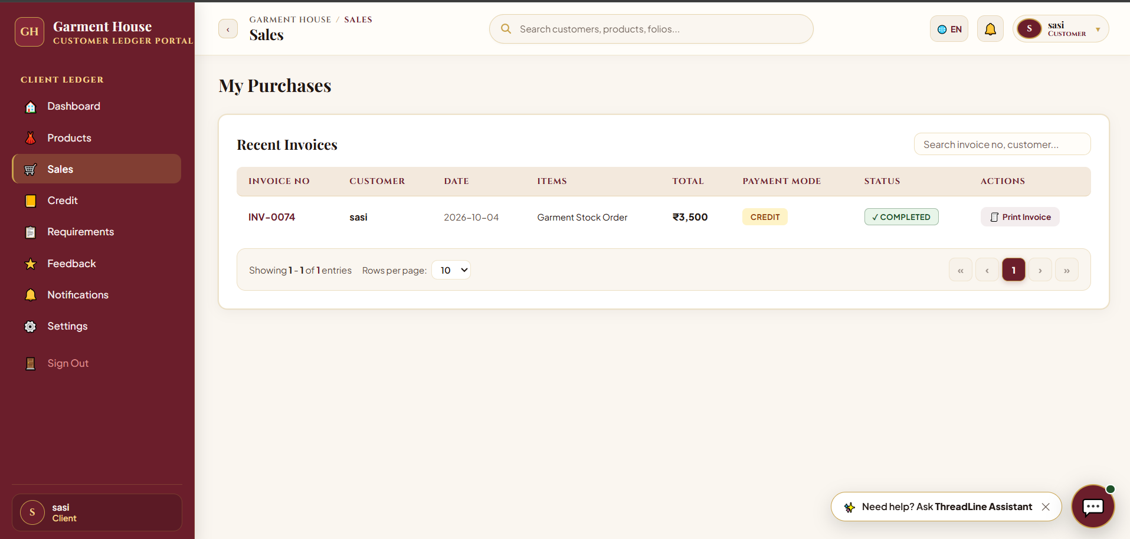
Fig 8.25 – Customer Purchases & Invoices Page – Retail buyer interface for tracking order history, credit purchases, and downloading tax invoices.
The Customer Purchases page gives retail buyers direct access to their order history and official GST tax invoices.
The invoice table displays invoice numbers (e.g., INV-0074), dates, billed amounts, payment modes (Credit / Cash), and 'Print Invoice' buttons.
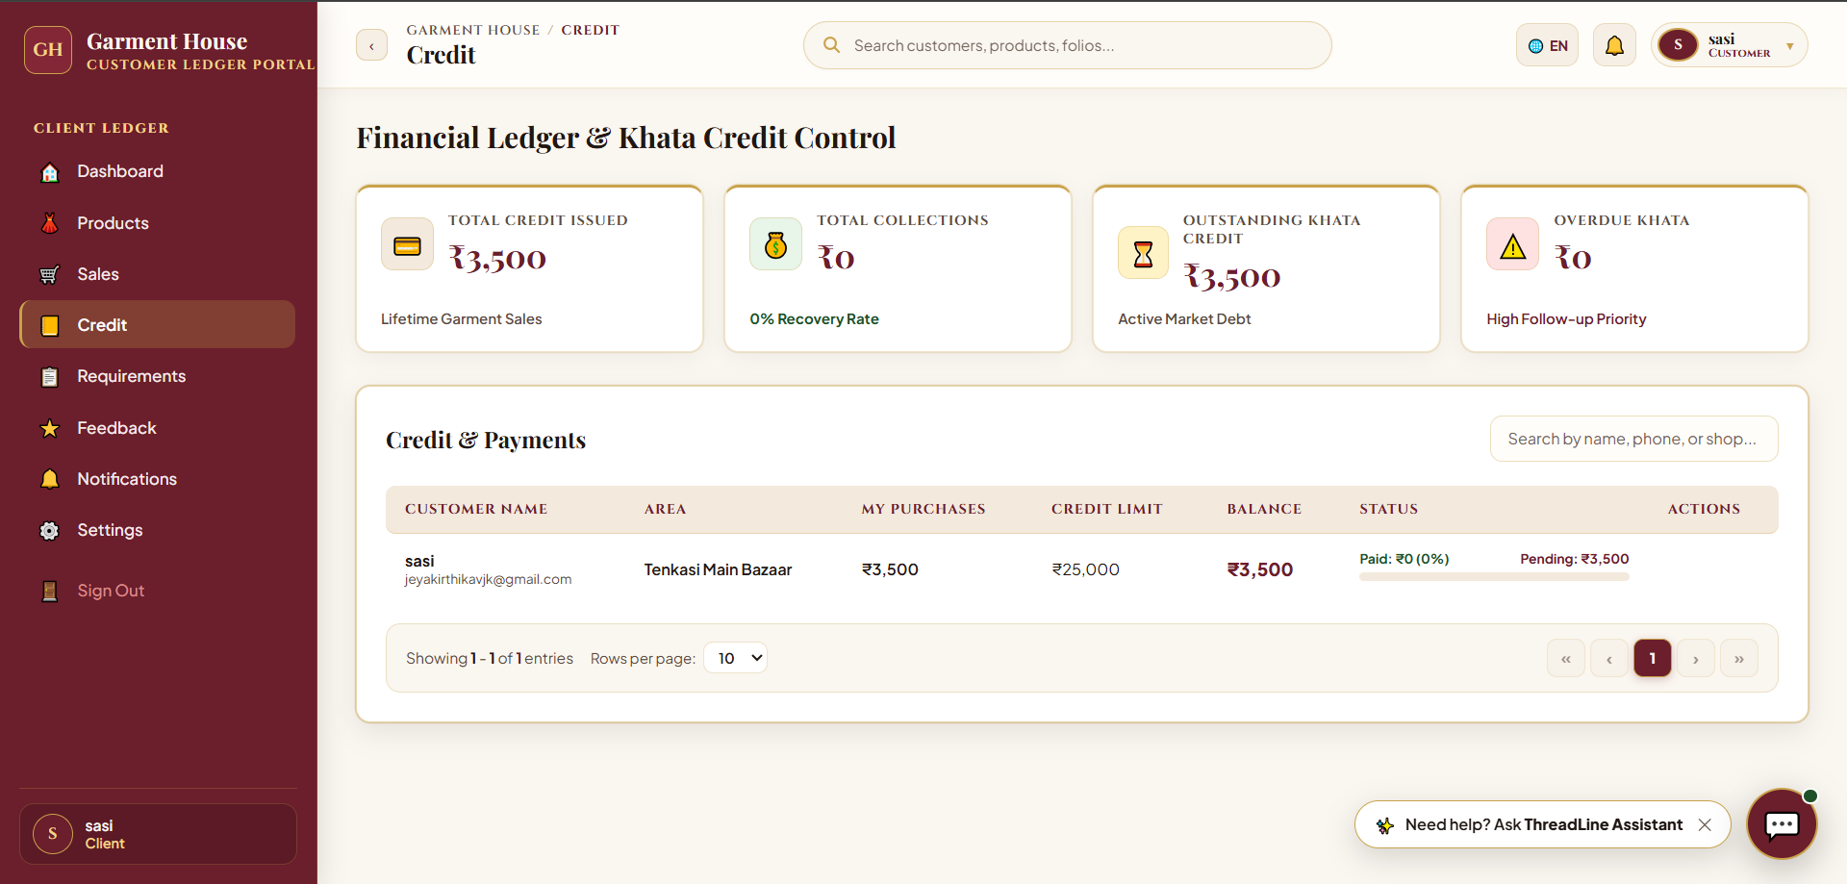
Fig 8.26 – Customer Khata Credit Ledger & Balance Page – Self-service view for retail buyers to track outstanding balances and credit limits.
The Customer Credit Ledger page provides retail store owners with an individual, transparent view of their credit khata.
Summary metric cards confirm Total Credit Issued (₹3,500), Total Collections (₹0), Outstanding Khata Credit (₹3,500), and Overdue Khata (₹0).
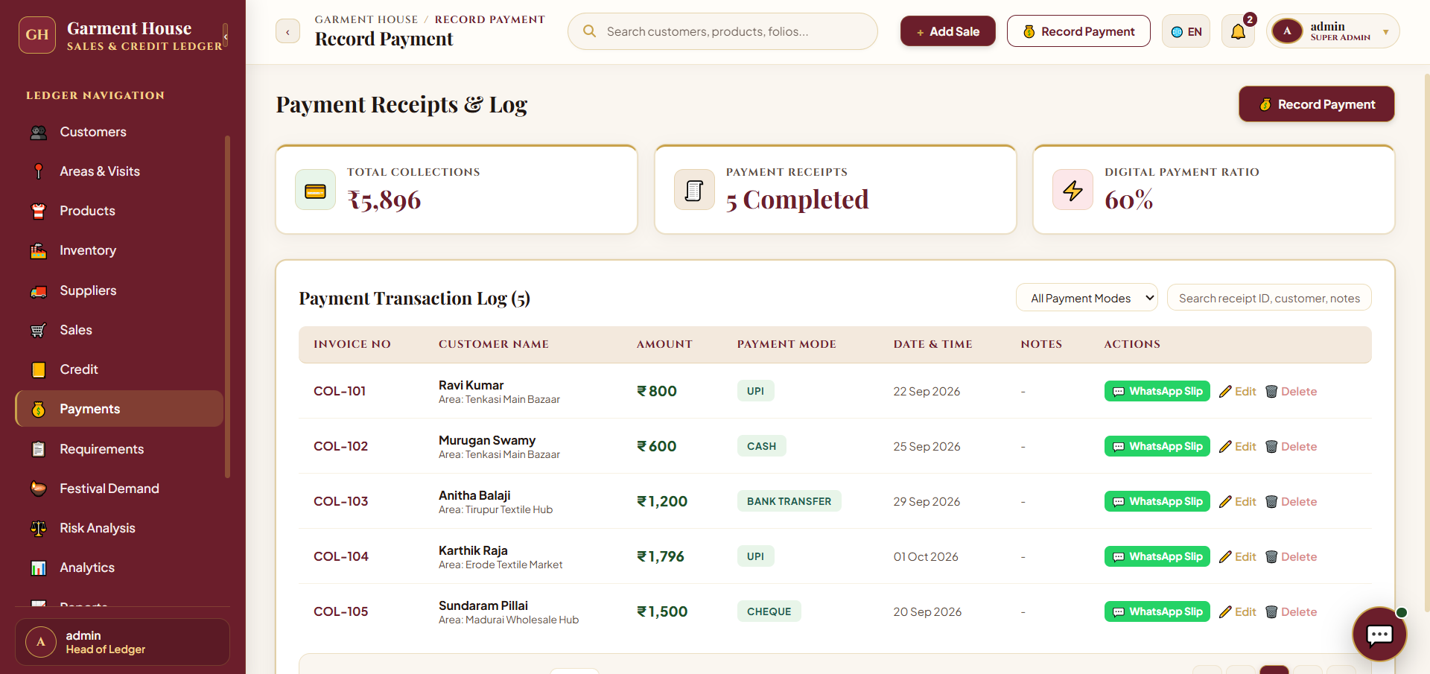
Fig 8.15 – Customer Requirement System & Restock Center Page – Interface for Logging Customer Demands and Managing Stock Procurement
The Customer Requirement System page is designed to help store managers and retailers record customer garment requirements, track restock requests, and manage the procurement process. A '+ Log Customer Requirement' button allows users to quickly record new garment requirements from retail customers.
The page connects retail customer demands directly with warehouse availability and textile mill procurement pipelines, reducing the risk of unmet customer restock requests.
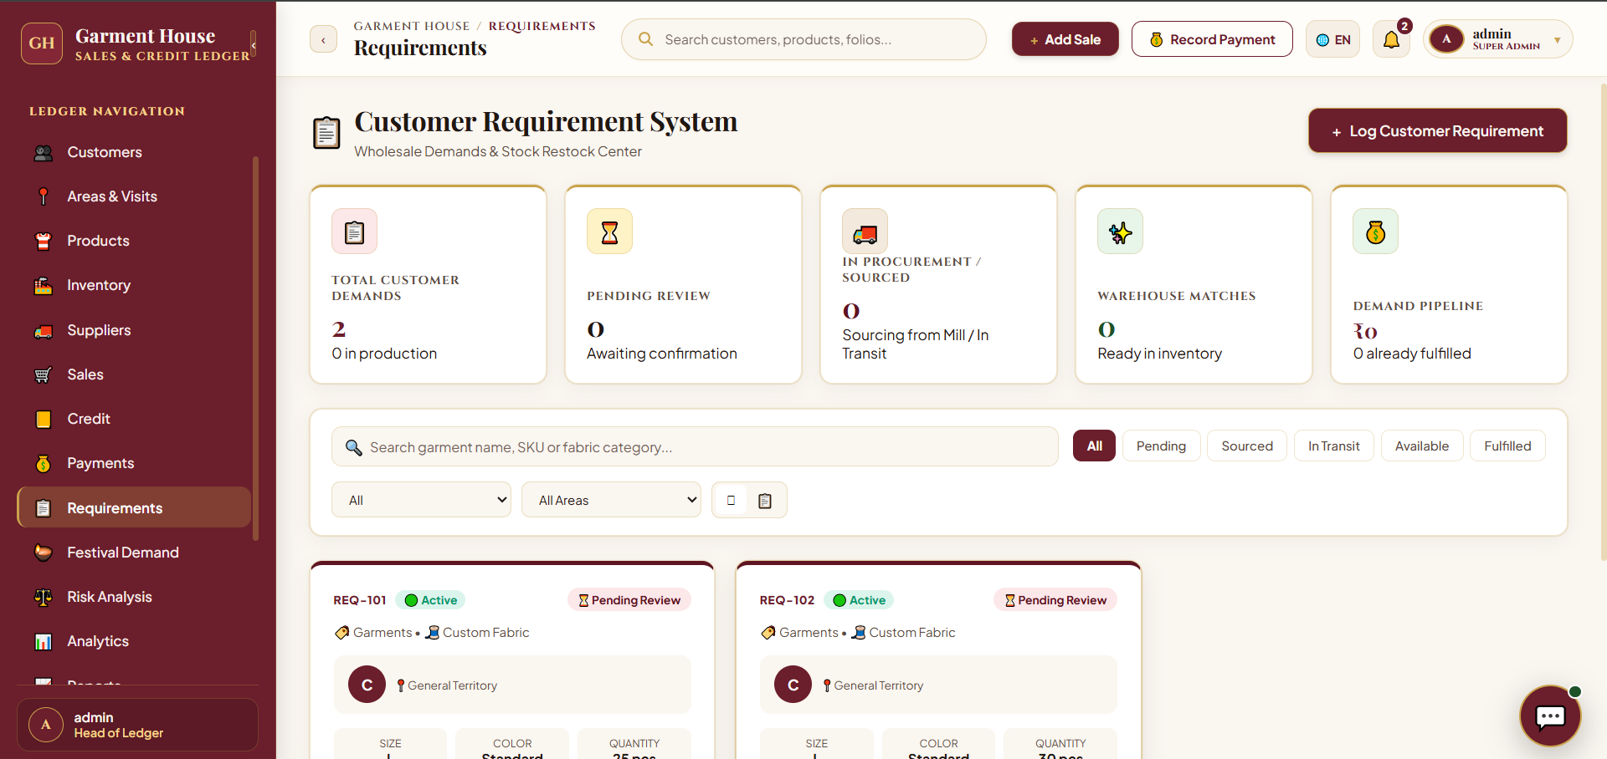
Fig 8.27 – Customer Restock Requirements & Demand Tracker Page – Self-service interface for retail buyers to track custom requests and warehouse stock matches.
The Customer Requirements page allows retail clients to log custom garment demands and track procurement.
Requirement cards feature active match alerts (e.g., 'Studio: Matched in stock product: Kanchipuram Art Silk Traditional Saree') for immediate dispatch.
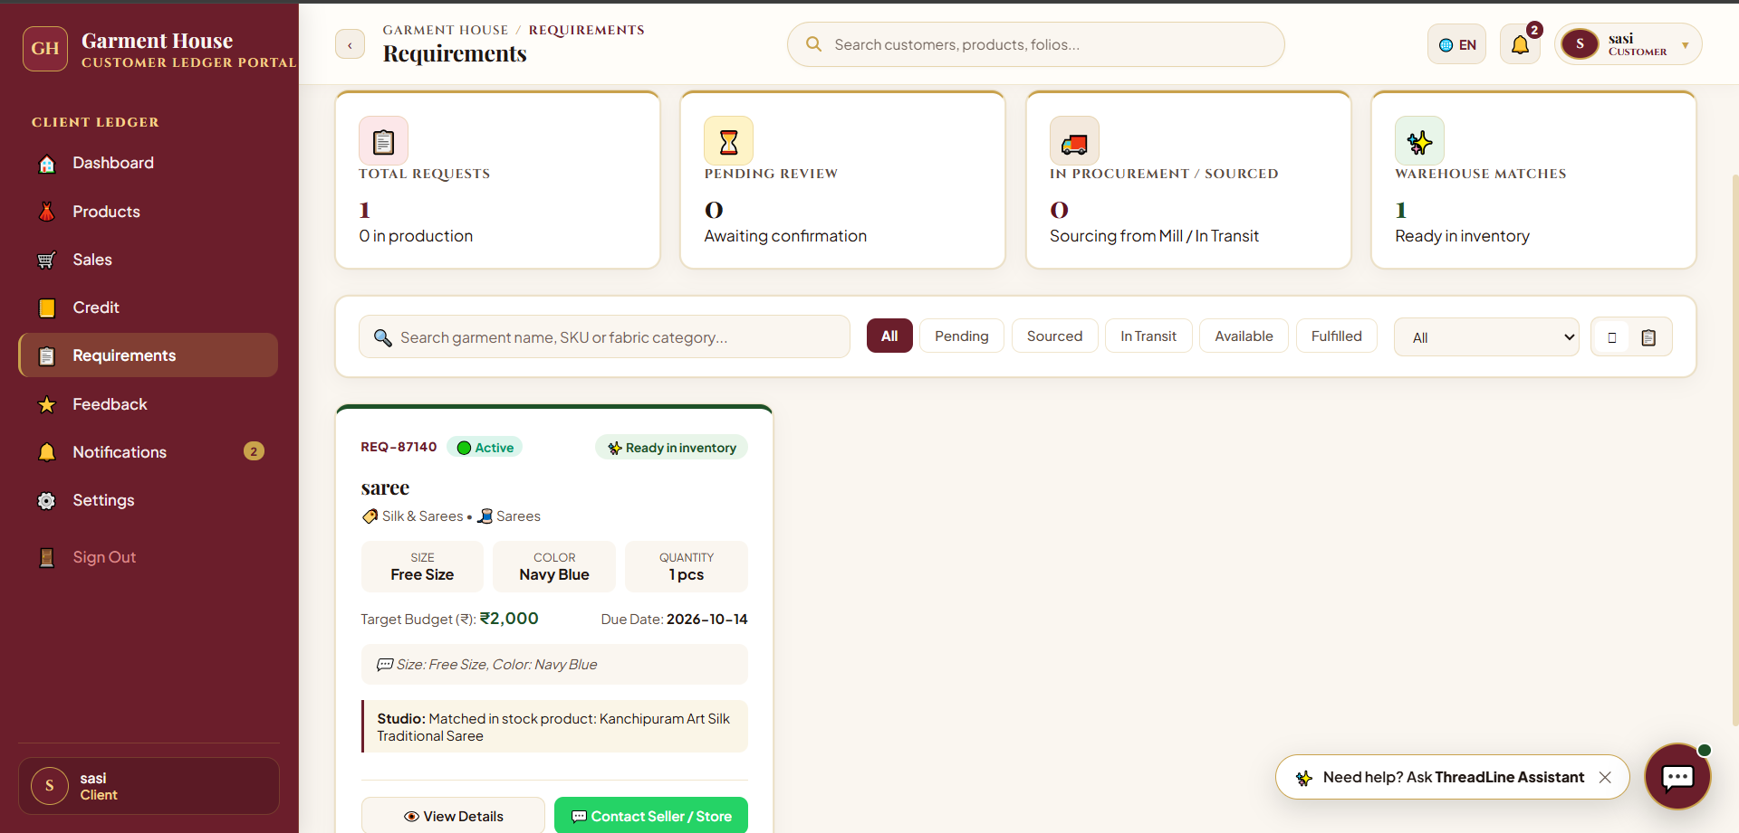
Fig 8.28 – Customer Feedback & Reviews Page – Client feedback submission and review history ledger.
The Customer Feedback page enables clients to submit reviews regarding fabric quality, fit, and fulfillment speed.
The recent reviews table allows clients to inspect past submitted feedback and ratings.
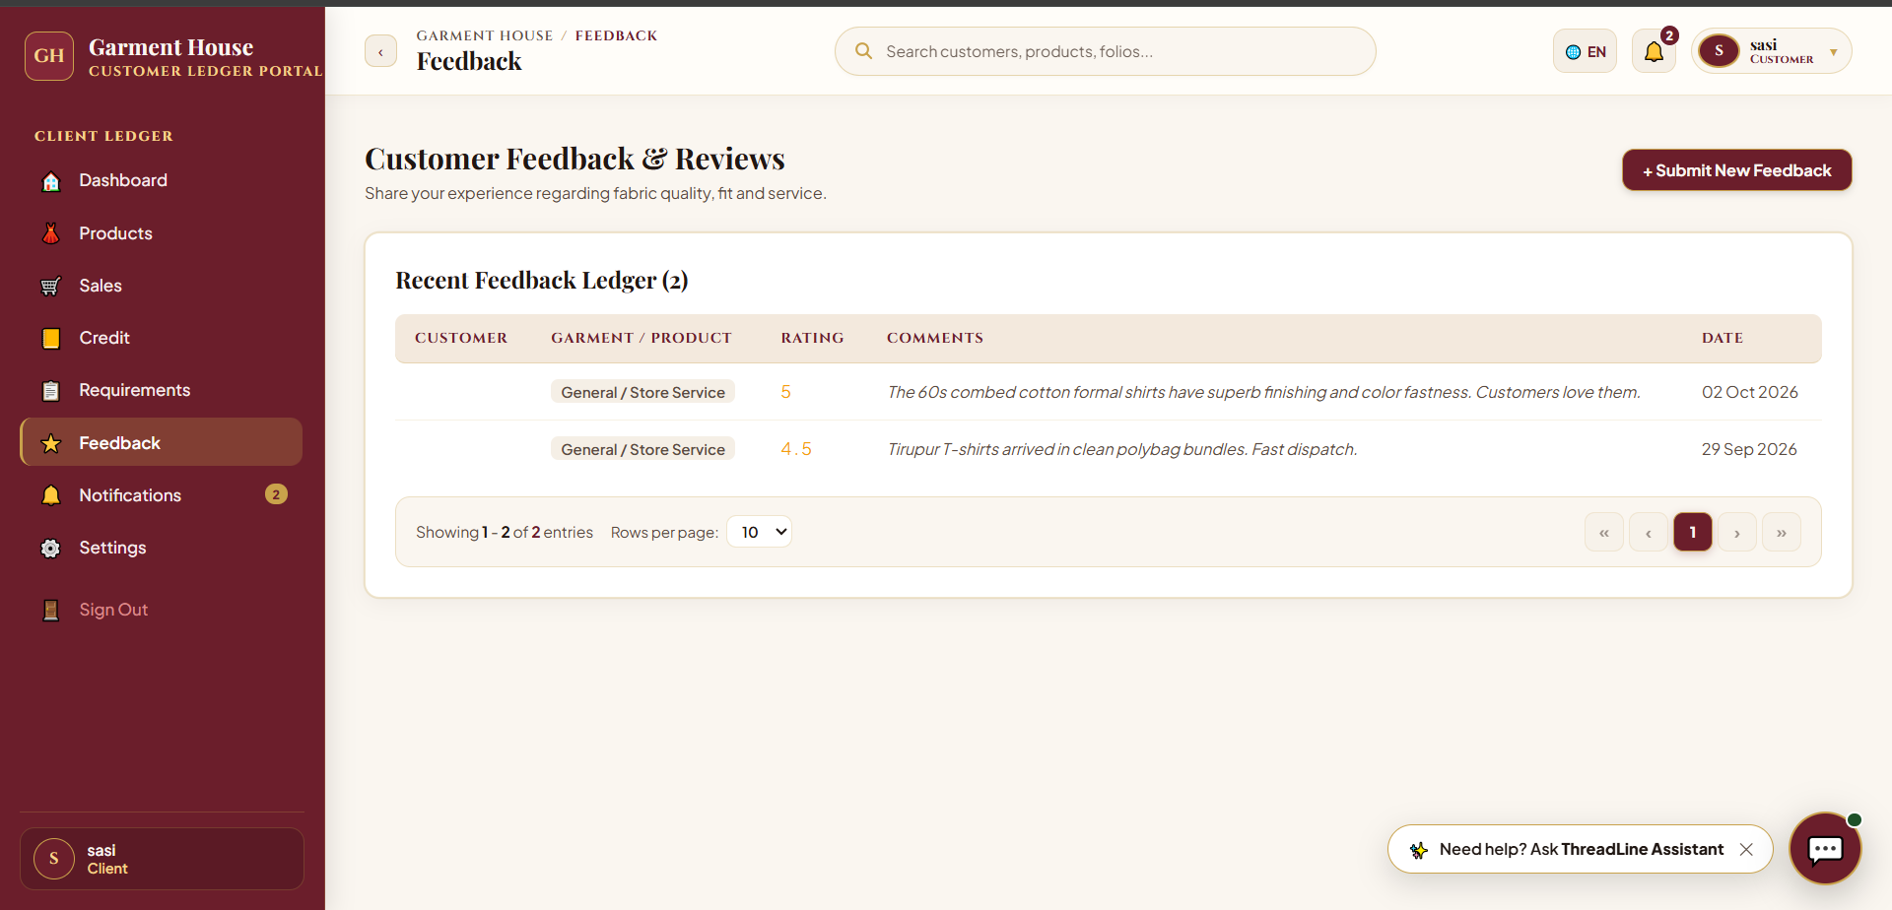
Fig 8.29 – Customer Overdue Reminders & Notifications Page – Client payment reminder log and scheduler status interface.
The Notifications page provides clients with full transparency into automated payment due-date alerts and reminders.
Summary cards show Total Reminders Logged (0 Logs), Overdue Amount Covered (₹0), Daily Scan Schedule (09:00 Daily), and Scheduler Status (Active).
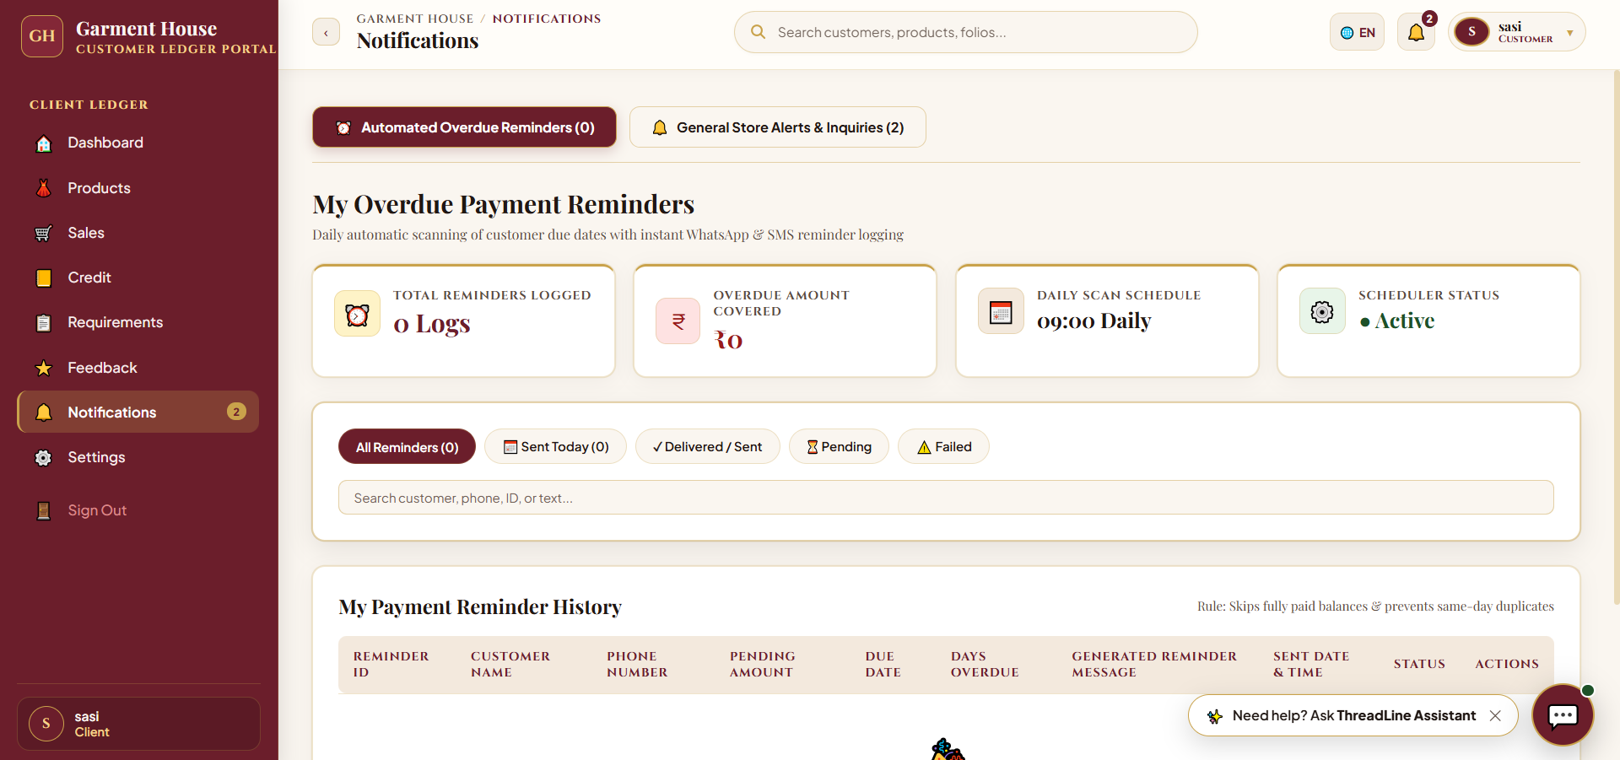
Fig 8.30 – Client Portal Settings & Theme Customization Page – Personalization and theme configuration interface.
The Settings page within the Customer Portal enables clients to personalize their workspace with luxury color palettes.
Selectable themes include Heritage Boutique & Ledger, Imperial Velvet & Gold, Blush Beige & Rose, Heritage Forest & Gold, and Royal Sapphire & Gold.
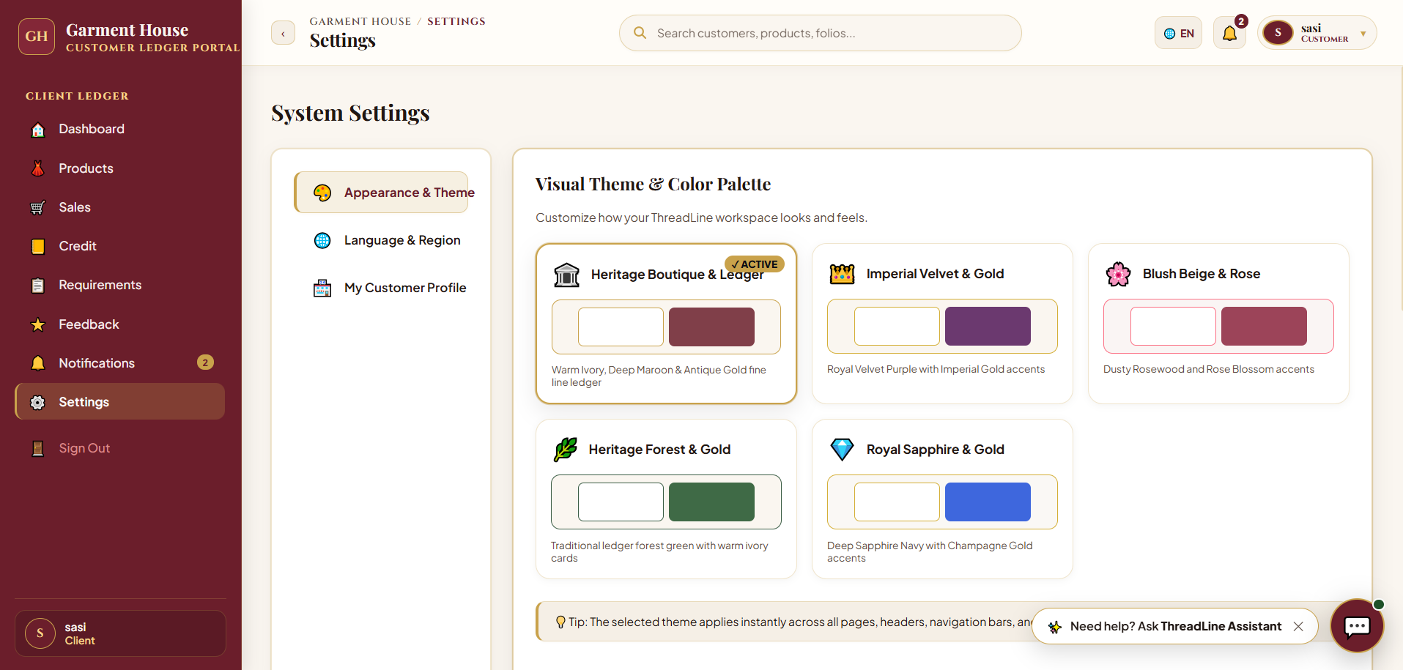
Fig 8.31 – ThreadLine Conversational AI Assistant – Interactive customer bot for real-time stock inquiries and restock requests.
The ThreadLine Assistant provides 24/7 conversational AI support to retail buyers.
Clicking 'Browse In-Stock Garments' embeds live product cards directly in the chat with thumbnail images, stock counts, and inline 'Request' buttons.
CHAPTER 9
CONCLUSION
In conclusion, the Garment Credit Management System provides an advanced, highly reliable, and comprehensive software solution engineered specifically to address the complex operational and financial challenges of the wholesale textile and garment distribution industry. By successfully eliminating antiquated manual paper ledgers, fragmented phone communications, and unmonitored trade debt, the application establishes a modern digital foundation that empowers wholesale merchants to scale their businesses with confidence, financial liquidity, and uncompromised ledger accuracy.
The system achieves complete end-to-end integration across all critical functional domains of garment enterprise operations. The implementation of role-based JWT authentication guarantees secure, segregated workflows for Super Administrators, Wholesale Managers, and Retail Customers. The Customer Khata module enforces strict credit limit governance and mathematical risk profiling, while the innovative Territory Management and Daily Area Visit features transform debt collection into a disciplined, route-based operation supported by on-spot electronic receipts and automated WhatsApp reminders. Simultaneous multi-godown inventory tracking ensures that physical stock counts remain synchronized across showroom and warehouse facilities, preventing stock-outs and overselling.
Furthermore, the strategic inclusion of a specialized Festival Demand Calendar, bilingual procurement advisories, and direct supplier mill relationship tracking aligns distributor operations with the unique rhythmic demands of Indian cultural celebrations like Deepavali, Pongal, and Eid. Built on a scalable, modular architecture uniting React, Vite, Node.js, Express, and MySQL, the application demonstrates exceptional computational performance, relational integrity, and UI responsiveness. The system serves as an exemplary academic and industry-grade modern web solution, setting a new benchmark for software-driven management in the textile economy.

