**Githhub**

Git is a distributed revision control and source code management system with an emphasis on speed. Git was initially designed and developed by Linus Torvalds for Linux kernel development. Git is a free software distributed under the terms of the GNU General Public License version 2.

**Download Github 32 bit based on your version**

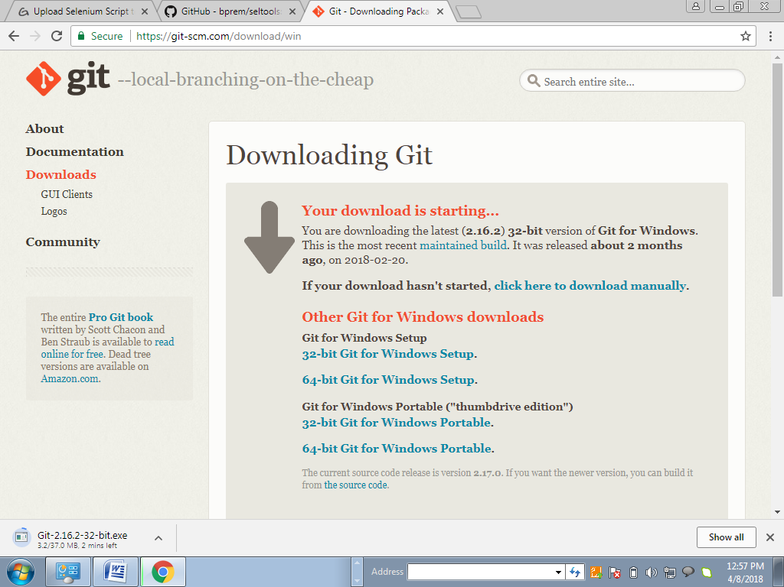

Go to Github and Signup and create a New account

[Jeyalakshmipaul1@gmail.com](mailto:Jeyalakshmipaul1@gmail.com)

Indian123

Start a New Project and create a new Repository

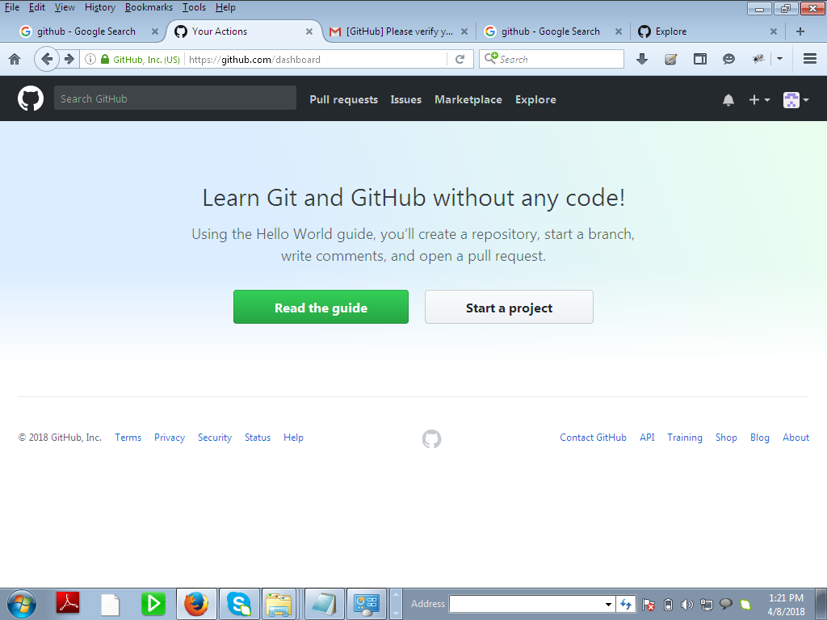

Create a new Repository and select read only

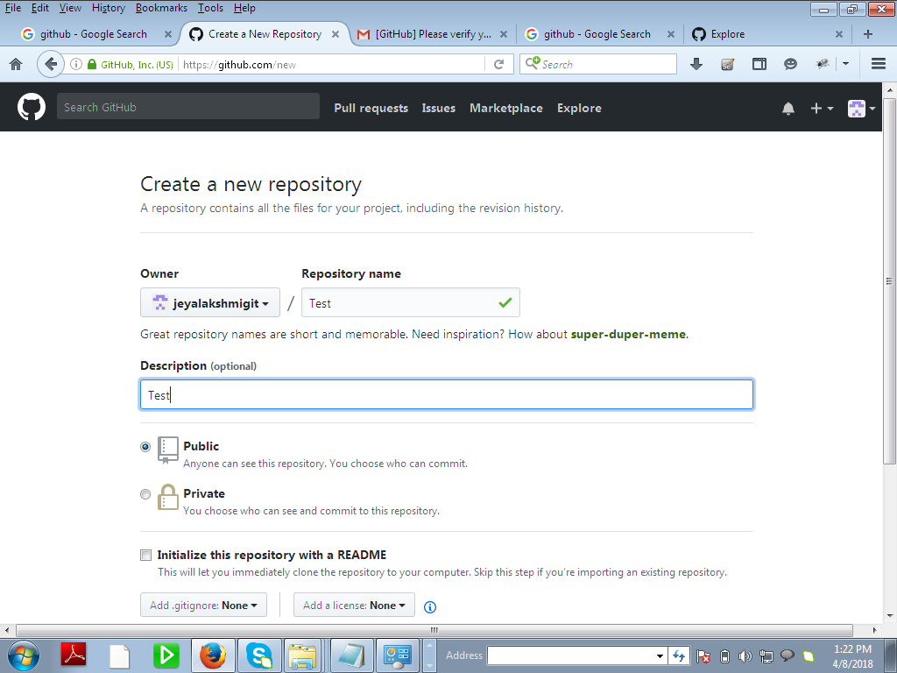

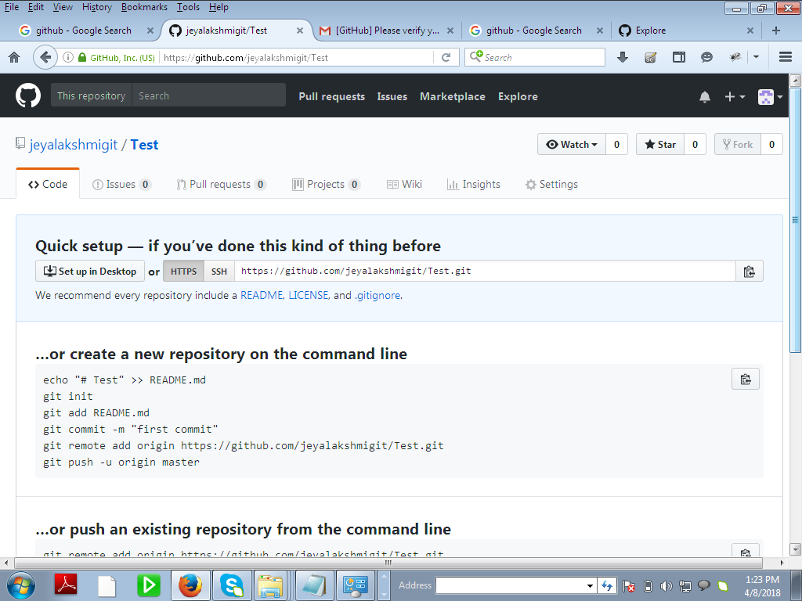

Select Create Repository a Repository will be created

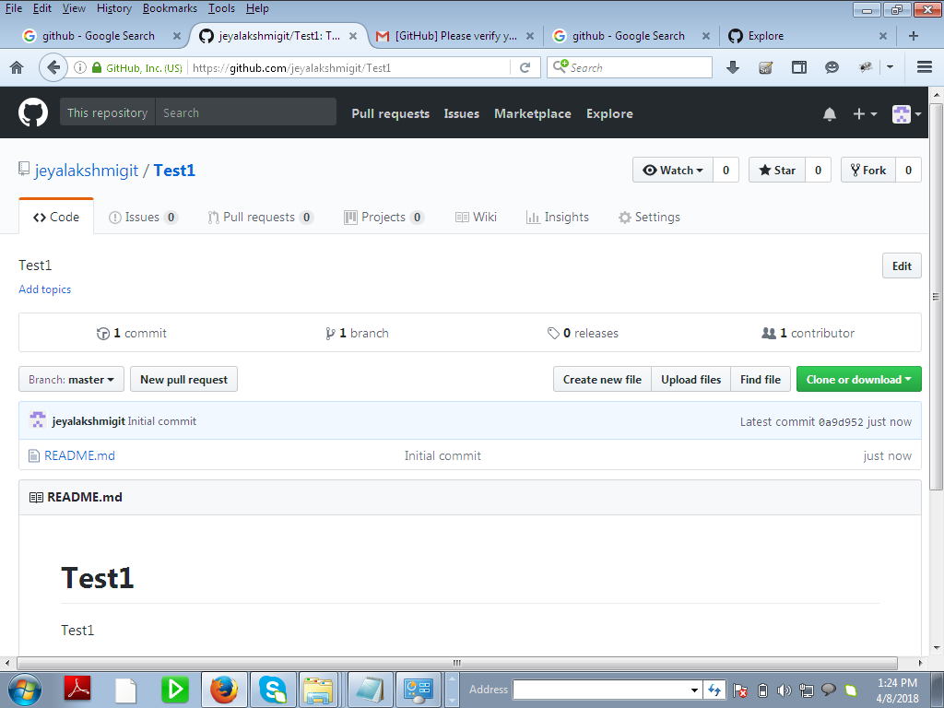

Readme.md will be created. Select it and if needed edit it

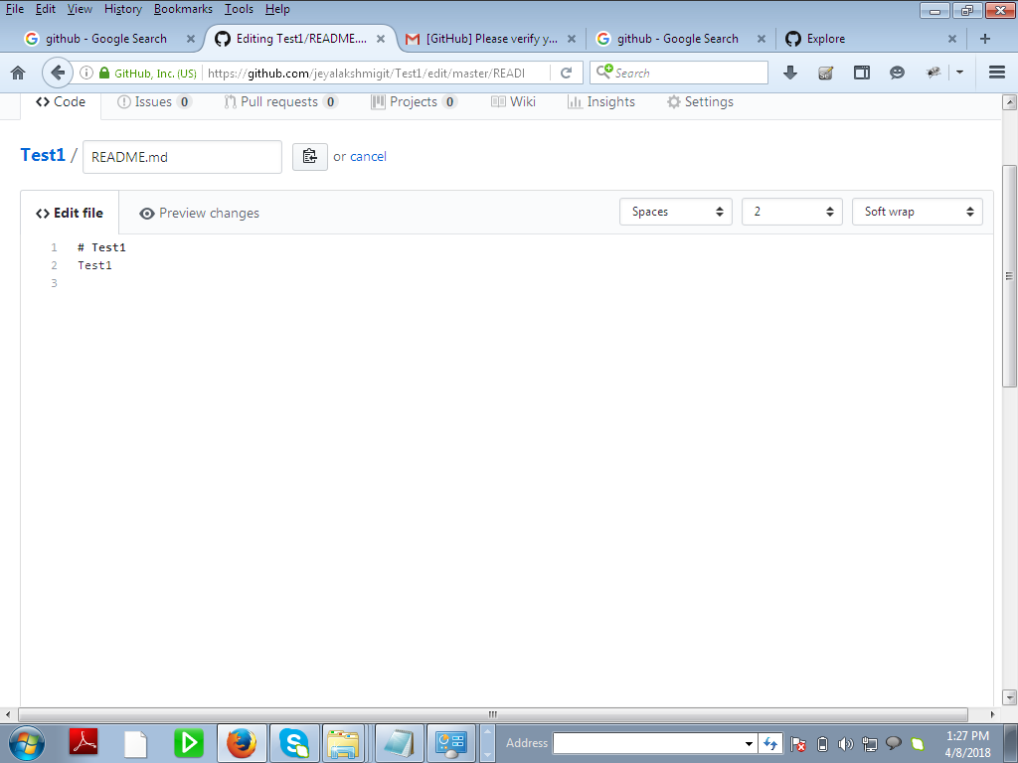

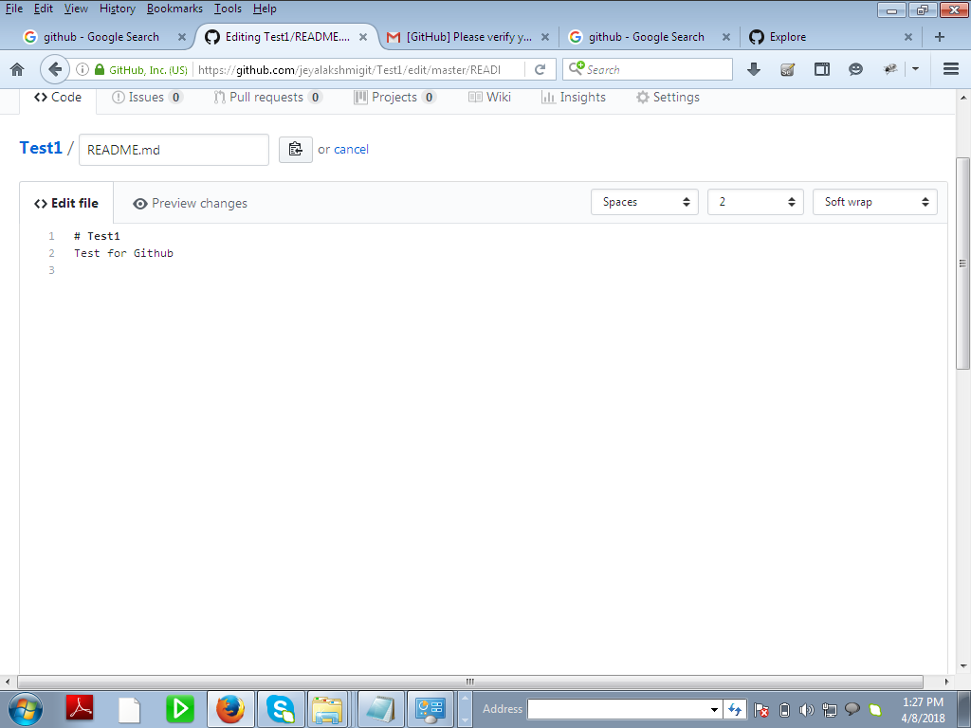

Click on Commit

W 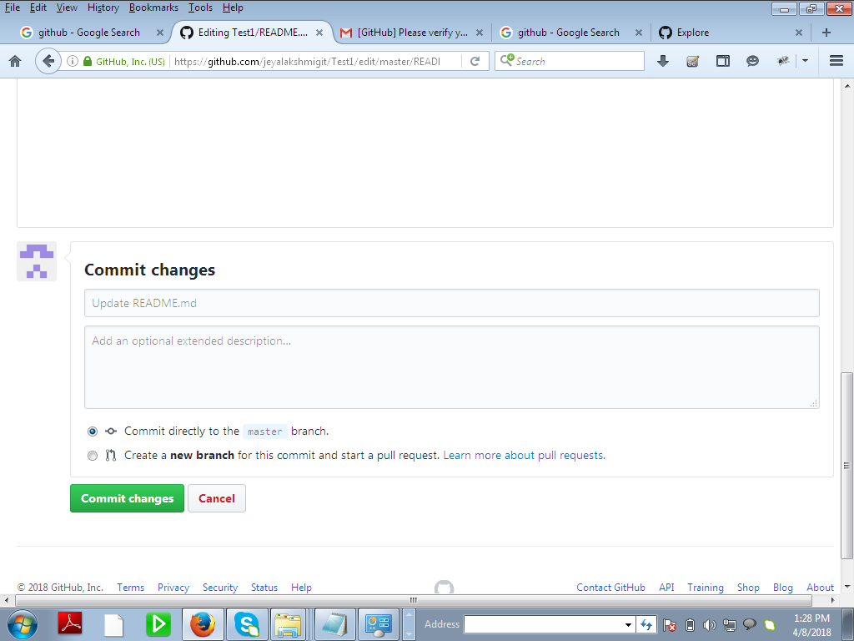

Create new folder🡪 click New file and then add the folder name and press/

Folder and click / 🡪 New folder will be created