**Prerequisite**

1. VS code extension - SQL Server (mssql) v1.20.1 or above

**List of Features**

1. Capability to access design engineering entities of the platform including hierarchical data structures like customer, project, process, component, documents, service, process sections, and methods for viewing.
2. Clicking on any method will display the corresponding stored procedure from the configured application database in read-only mode.
3. To edit stored procedures, users can click on the toggle icon next to the method name.

**Steps for Installation**

1. Launch Visual Studio Code
2. Click Extension (Ctrl + Shift + X) in Activity Bar
3. Enter **Ramco Model Explorer** in the Search Bar
4. The search results will display the **Ramco Model Explorer v1.1.17** extension in the list of results.
5. Proceed with the **Install** option.

**Steps for Configuration**

1. Once the installation is complete, click on the **Manage** button, and then choose the **Extension Settings** option.

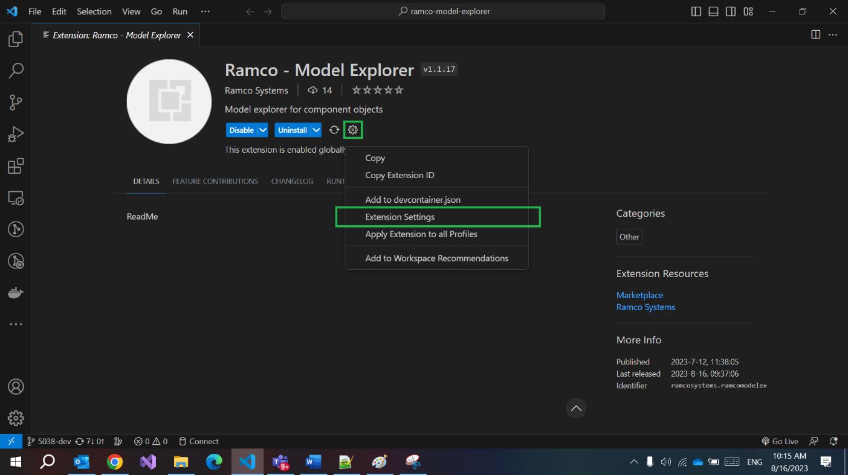

1. Creating a New Environment – Provide a descriptive name for a platform model.

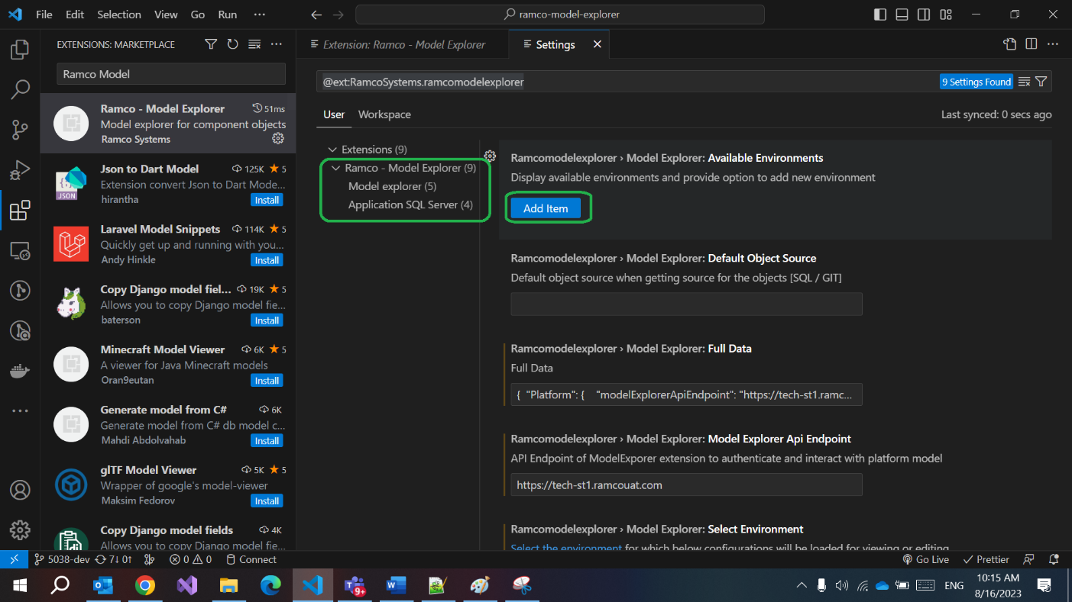

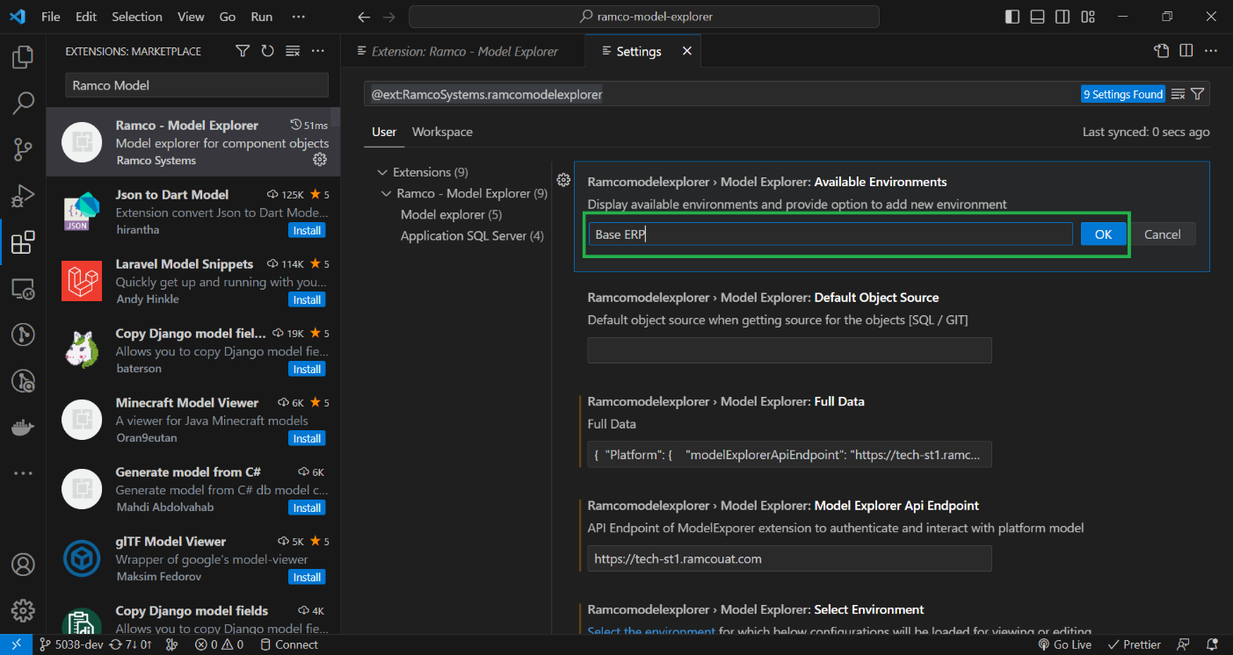

1. Select newly created environment and set up the following properties:
2. Default object source when getting source for the objects [SQL / GIT]

**SQL**

(You need to update this according to your base platform URL and application database connection)

1. Platform Model URL

[**https://tech-st1.ramcouat.com**](https://tech-st1.ramcouat.com)

1. Sql Server Name

**TECHWARCNV57.RAMCO,49821**

1. Sql Server DB Name

**SCMDB**

1. Sql Server Username

**sa**

1. Sql Server Password

**\*\*\*\*\*\*\*\*\*\***

