Test Case 1: Register
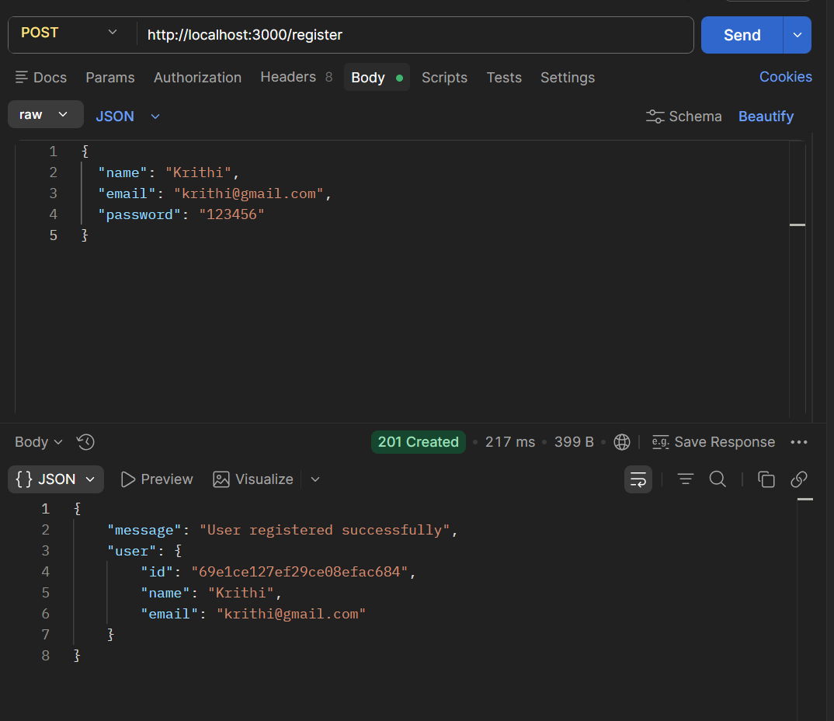
Test Case 2: Login
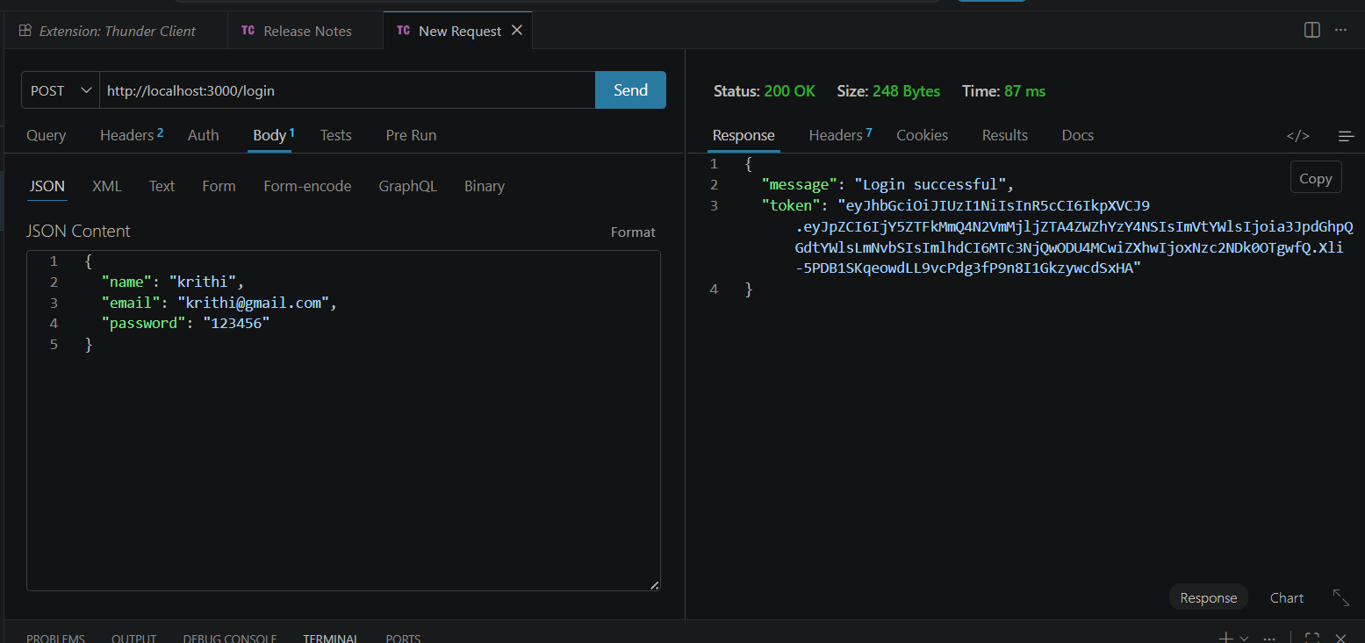
Test Case 3: Get all products
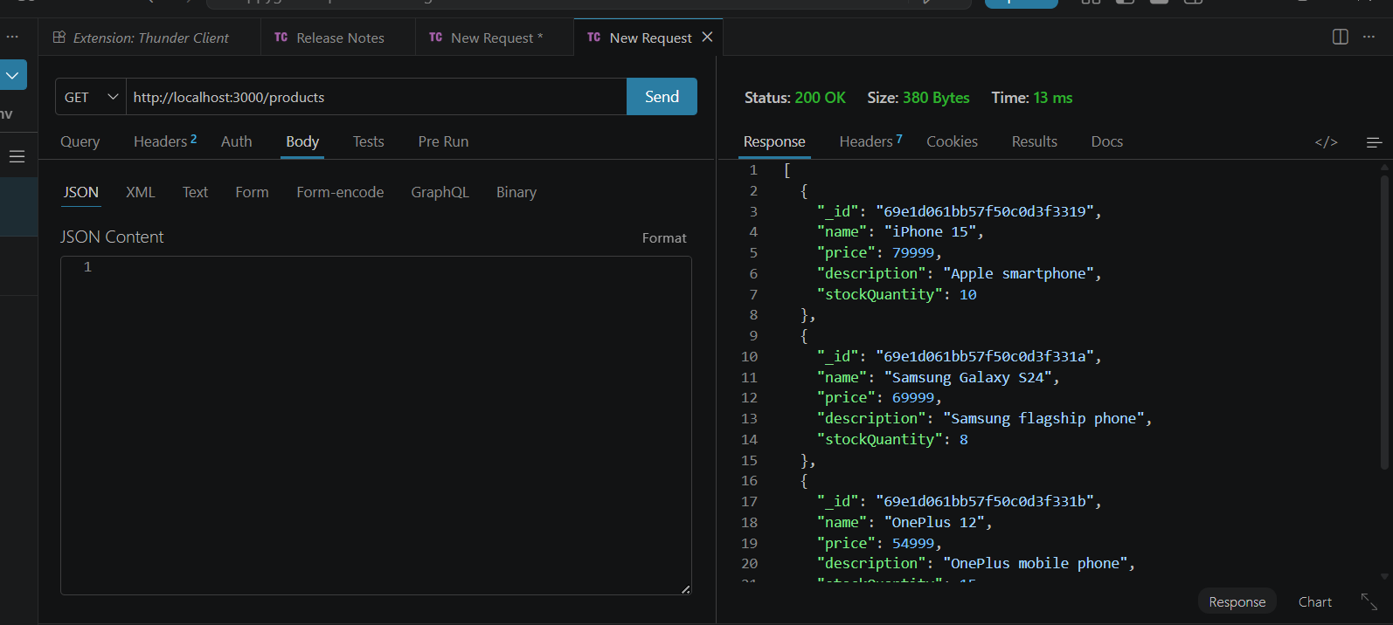

Test Case 4: Get single product

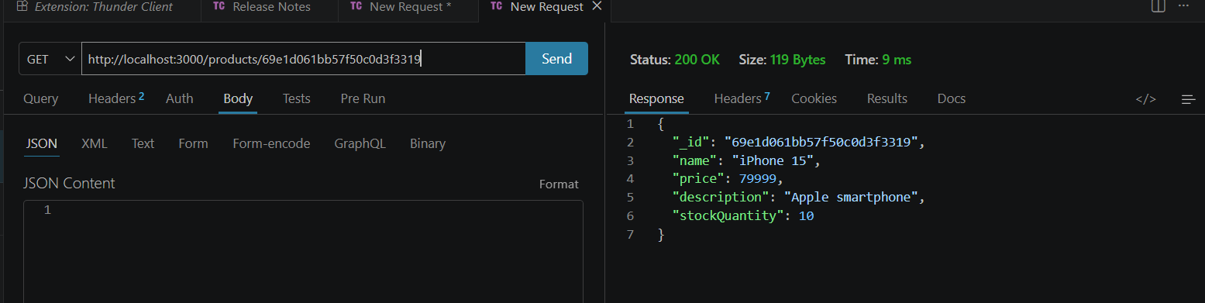

Test Case 5: Add to cart
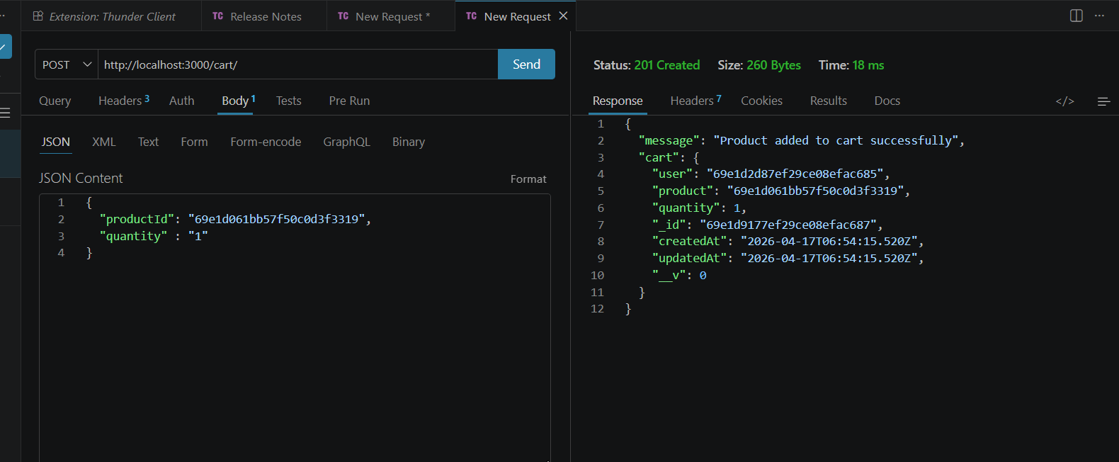
Test Case 6: Update cart
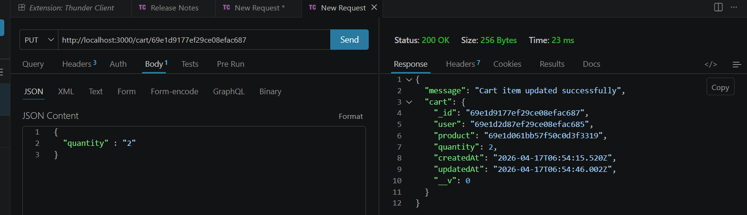
Test Case 7: Delete cart item
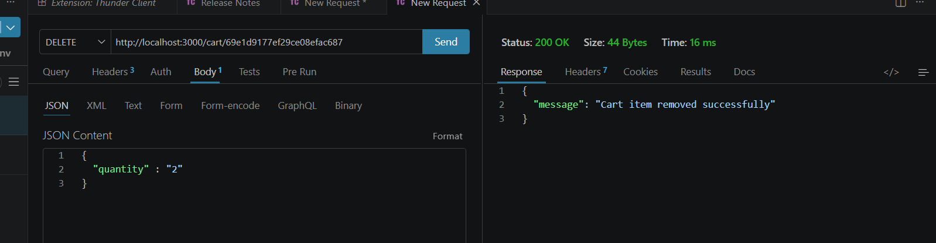
Test Case 8: Register with missing fields
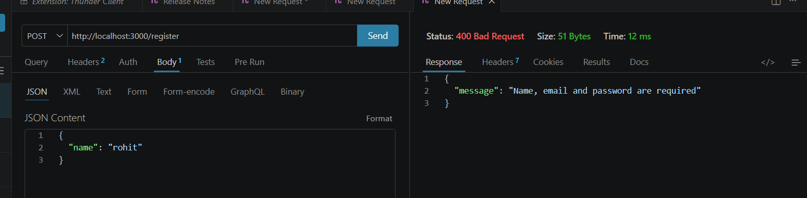
Test Case 9: Login with wrong password
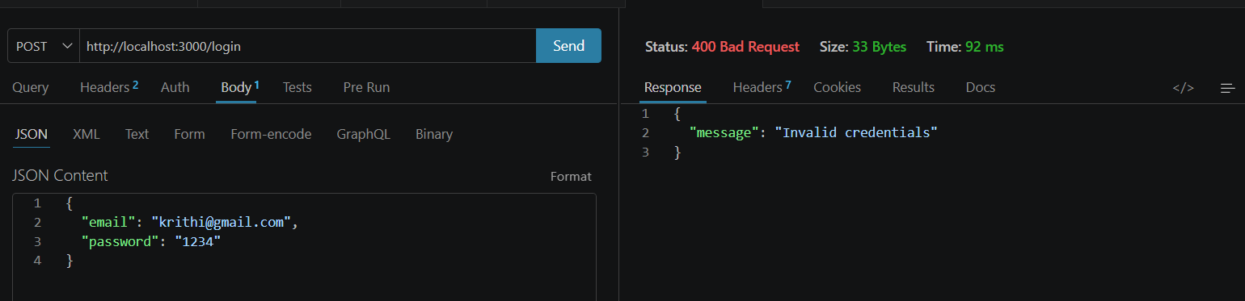
Test Case 10: Product not found
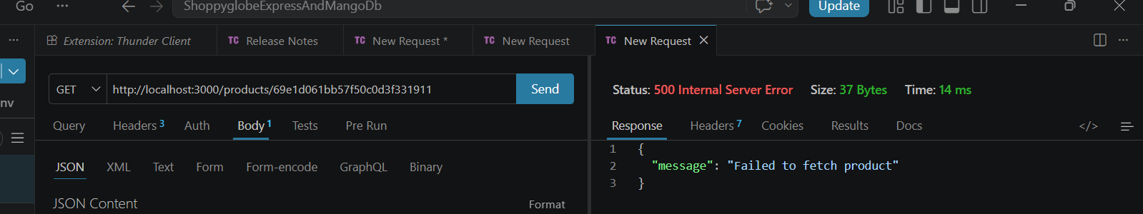

Test Case 11: Add to cart without token
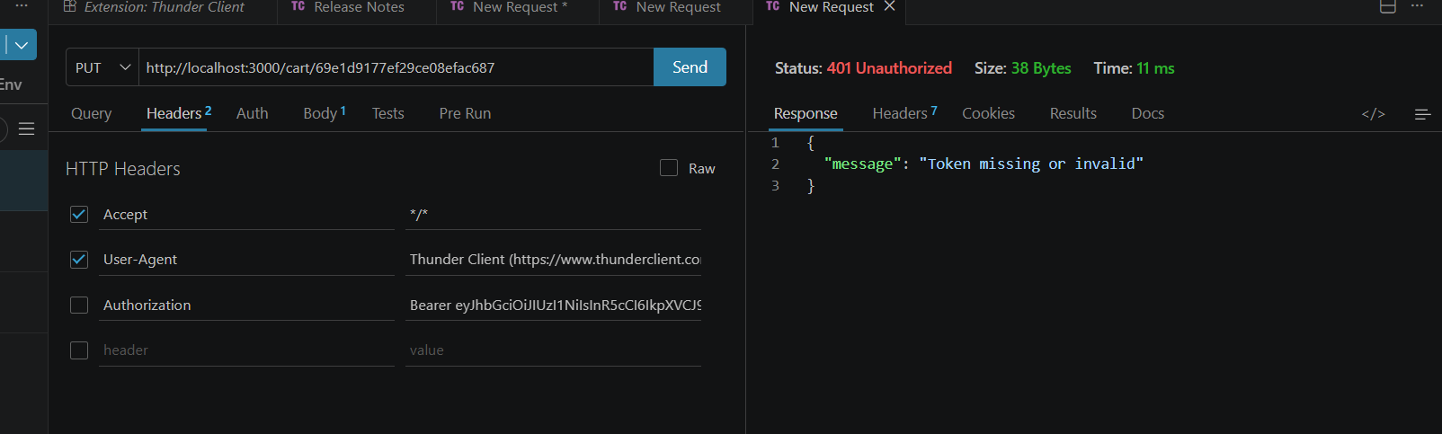
Test Case 12: Update cart with invalid quantity
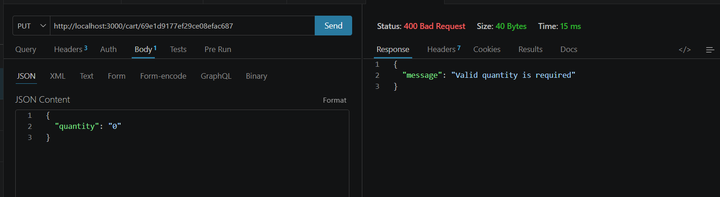

Test Case 13: Delete invalid cart ID
