**Public Transport Opitimization**

**Introduction :**

Efficient public transportation systems play a pivotal role in the growth and sustainability of urban areas. They offer numerous benefits, including reduced traffic congestion, lower carbon emissions, improved accessibility, and increased mobility for the community. However, many public transportation systems face challenges such as inefficient routes, overcrowding, and outdated technology, leading to a decline in overall service quality. To address these issues, we are embarking on a comprehensive Public Transportation Optimization Project.

**Circuit Stimulation Diagram :**

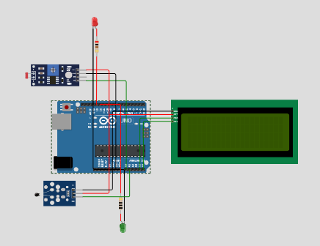

**Platform Developed :**

We have developed the stimulation in the **wokwi** platform.The code is development in the stimulation platform.

<https://wokwi.com/projects/378291601637348353>

**Code :**

#include <Wire.h>

#include <LiquidCrystal_I2C.h>

const int ldrPin = A0;

const float BETA = 3950;       // LDR input pin

const int ledPin1 = 13;

int ledpin2=12;         // LED for night/day indication

const int tempSensorPin = A1;   // Temperature sensor input pin

const int i2cAddress = 0x27;    // I2C address of your LCD display

LiquidCrystal_I2C lcd(i2cAddress, 20, 4); // Initialize the LCD library with the I2C address and size

int ldrThreshold = 500;          // Adjust this value based on your LDR sensitivity

int temperatureThreshold = 25;   // Adjust this value based on your desired low temperature

void setup() {

pinMode(ledPin1, OUTPUT);

pinMode(ledpin2, OUTPUT);

lcd.init();                      // Initialize the LCD

lcd.backlight();                 // Turn on the backlight

**Serial**.begin(9600);

}

void loop() {

int ldrValue = analogRead(ldrPin);

int tempValue = analogRead(tempSensorPin);

float voltage = (tempValue / 1024.0) * 5.0; // Convert analog reading to voltage

float celsius = 1 / (log(1 / (1023. / tempValue - 1)) / BETA + 1.0 / 298.15) - 273.15; // Convert voltage to temperature in Celsius

**Serial**.print("LDR Value: ");

**Serial**.println(ldrValue);

**Serial**.print("Temperature: ");

**Serial**.println(celsius);

if (ldrValue < ldrThreshold) {

// It's dark, turn on the LED for night indication

digitalWrite(ledPin1, HIGH);

} else {

// It's light, turn off the LED for day indication

digitalWrite(ledPin1, LOW);

}

lcd.clear();

lcd.setCursor(0, 0);

if (digitalRead(ledPin1) == HIGH) {

lcd.print("Night Time");

} else {

lcd.print("Day Time");

}

lcd.setCursor(0, 1);

lcd.print("Temperature: ");

lcd.print(celsius);

lcd.print("C");

if (celsius < temperatureThreshold) {

// Temperature is low, make the LED glow lightly

digitalWrite(ledpin2, 1); // Adjust the value as needed for desired brightness

} else {

// Temperature is not low, turn off the LED

digitalWrite(ledpin2, 0);

}

delay(1000); // Delay for 1 second before taking readings again

}

**Conclusion :**

This project seeks to transform public transportation into a more efficient, accessible, and sustainable mode of travel. By optimizing routes, schedules, and technology, we aim to enhance the overall transportation experience for the community while addressing congestion and environmental concerns. The success of this project will result in a more vibrant, sustainable, and accessible urban environment for all residents.