**Autoimmune disorder Prediction App**

- **Machine Learning**

**Jeyaselvalakshmi**

**Date: 1 April 2024**

**1.Abstract**:

Machine learning is a part of artificial intelligence (AI) focused on creating algorithms and models that help computers perform tasks without being directly told what to do. Instead, they learn from patterns and data. The main idea is for computers to get better at tasks over time without needing specific instructions for each one. Autoimmune diseases happen when the body's immune system mistakenly attacks its own tissues, thinking they are invaders. Conditions like rheumatoid arthritis, lupus, multiple sclerosis, and Type 1 diabetes are examples. These diseases vary in severity and symptoms but involve the immune system malfunctioning and attacking healthy tissues. Treatment usually involves managing symptoms and reducing the immune response to limit damage.

**2.Problem Statement**:

Diagnosing and treating autoimmune diseases accurately remains difficult due to their complexity and the limitations of current methods. These diseases often go undetected or misdiagnosed, leading to delays in treatment and poor outcomes. Machine learning shows promise in helping with this challenge by using computer algorithms to analyse large amounts of medical data. However, making machine learning work effectively for autoimmune diseases requires overcoming obstacles like the need for better data and ensuring that the models are reliable and can be used in real medical settings. The problem is to develop reliable machine learning tools that can help diagnose autoimmune diseases early and tailor treatments to individual patients, ultimately improving patient outcomes.

**3.Market/customer/Business Assessment:**

Machine learning can aid in autoimmune disorder prediction by leveraging algorithms to analyse diverse datasets containing patient information, laboratory results, imaging studies, and genetic data.

1. ***Pattern Recognition*:** Machine learning algorithms can identify complex patterns and associations in large datasets that may not be apparent to human observers. By analysing diverse patient data, including demographic information, medical history, symptoms, and laboratory results, machine learning models can uncover subtle correlations indicative of autoimmune disorders.
2. ***Early Detection:*** Machine learning algorithms can assist in the early detection of autoimmune disorders by identifying predictive biomarkers or risk factors associated with disease onset. By analysing longitudinal patient data over time, machine learning models can detect subtle changes or deviations from normal physiological parameters, enabling early intervention and treatment.
3. ***Personalized Risk Assessment***: Machine learning algorithms can provide personalized risk assessments for autoimmune disorders based on individual patient characteristics, genetic predisposition, and environmental factors. By integrating multiple data sources, machine learning models can estimate an individual's likelihood of developing an autoimmune disorder, enabling targeted preventive measures or interventions.
4. ***Differential Diagnosis:*** Machine learning algorithms can aid in the differential diagnosis of autoimmune disorders by distinguishing between different disease subtypes or conditions with similar clinical presentations. By analysing comprehensive patient data and comparing it to established disease patterns, machine learning models can help healthcare providers make more accurate and timely diagnostic decisions.
5. ***Treatment Response Prediction:*** Machine learning algorithms can predict individual patient responses to specific treatments or medications for autoimmune disorders. By analysing patient data, including treatment history, genetic factors, and disease progression, machine learning models can identify predictive biomarkers or treatment signatures associated with therapeutic efficacy, enabling personalized treatment strategies.
6. ***Clinical Decision Support:*** Machine learning algorithms can serve as decision support tools for healthcare providers by synthesizing vast amounts of patient data and providing actionable insights for diagnosis, treatment planning, and disease management. By integrating machine learning models into clinical workflows, healthcare providers can make more informed decisions and optimize patient care.

Overall, machine learning holds great promise in improving autoimmune disorder prediction by leveraging advanced data analytics and predictive modelling techniques to identify high-risk individuals, enable early detection, and personalize treatment approaches. By harnessing the power of machine learning, healthcare providers can enhance patient outcomes and improve the overall management of autoimmune disorders.

**4.Target Specifications and Characterization**:

* ***Accuracy:*** The model should be really good at predicting if someone has an autoimmune disorder.
* ***Sensitivity*** and Specificity: It should be good at catching the disease when it's there and ruling it out when it's not.
* ***Feature Importance***: It should figure out which factors are most important in predicting the disease.
* ***Generalizability:*** It should work well for different types of people and diseases.
* ***Interpretability:*** Doctors should be able to understand why the model made a prediction.
* ***Timeliness:*** It should make predictions quickly so that patients can get help sooner.
* ***Ethical Considerations***: It should respect patient privacy and follow the rules for using medical data safely.

**5. External Searches (Information searches):**

***1.Objectives***:

* To develop a machine learning model for accurately predicting autoimmune disorders based on patient data.
* To identify key biomarkers and risk factors associated with autoimmune disorders using advanced data analytics.
* To assess the performance and generalizability of the predictive model across diverse patient populations and autoimmune disease types.
* To evaluate the clinical utility and impact of the predictive model on patient outcomes and healthcare delivery

***2. Methodology:***

* . Literature Review: Conduct a comprehensive review of existing research literature on autoimmune disorders, machine learning, and predictive modeling approaches.
* Data Collection: Gather patient data from electronic health records, biomedical databases, and clinical repositories. Data will include demographic information, medical history, symptoms, laboratory results, imaging studies, and treatment outcomes.
* Feature Selection: Identify relevant features and biomarkers associated with autoimmune disorders through statistical analysis and domain expertise
* Model Development: Develop machine learning algorithms, such as logistic regression, decision trees, random forests, or neural networks, to build predictive models for autoimmune disorder detection.
* Model Evaluation: Assess the performance of the predictive model using metrics such as accuracy, sensitivity, specificity, precision, recall, and area under the receiver operating characteristic curve (ROC-AUC).
* Cross-Validation: Validate the predictive model using cross-validation techniques to ensure robustness and generalizability across different datasets and patient populations
* Ethical Considerations: Obtain approval from the Institutional Review Board (IRB) to ensure compliance with ethical guidelines and data protection regulations. Protect patient privacy and confidentiality throughout the research process

***3. Data Collection Methods:***

* Patient Data Sources: Electronic health records (EHRs), clinical databases, research repositories, and public health datasets.
* Data Acquisition: Collaborate with healthcare institutions, academic medical centres, and research organizations to access patient data with appropriate permissions and approvals.
* Data Preprocessing: Clean, preprocess, and anonymize patient data to remove noise, handle missing values, and ensure data quality and integrity

***4. Analysis Plan:***

* Descriptive Analysis: Analyse descriptive statistics and distributions of patient data to understand the characteristics of the study population.
* Feature Engineering: Extract and engineer features from patient data to capture relevant information for autoimmune disorder prediction.
* Model Training: Train machine learning models using labelled patient data, optimizing model parameters and hyperparameters for optimal performance.
* Model Evaluation: Evaluate the performance of the predictive model using appropriate evaluation metrics and validation techniques.
* Interpretation: Interpret the model predictions and identify key features contributing to autoimmune disorder prediction.

***5. Study Population:***

* The study population will include patients with diagnosed autoimmune disorders as well as control groups without autoimmune disorders.
* Patients will be recruited from healthcare institutions, clinics, and research registries, representing diverse demographics, disease types, and geographic regions.

***6. Study Duration:***

* The study duration is estimated to be [insert duration], including data collection, model development, evaluation, and dissemination phases.
* Timelines for each phase of the study will be outlined in the research plan, with milestones and checkpoints for monitoring progress.

***7.Ethical Considerations:***

* Protect patient privacy and confidentiality by anonymizing and securely storing patient data.
* Obtain informed consent from patients participating in the study, ensuring transparency about the research objectives and potential risks and benefits.
* Adhere to ethical guidelines and regulations governing human subjects research, including obtaining approval from the Institutional Review Board (IRB)

By following this research study proposal, we aim to advance knowledge in autoimmune disorder prediction using machine learning and contribute to the development of clinically useful tools for improving patient care and outcomes.

**6. Benchmarking alternate products**:

For autoimmune disorder diagnosis, several factors come into play to assess their efficacy and suitability. Existing alternatives, such as conventional diagnostic tests and imaging techniques, serve as benchmarks for comparison. These traditional methods, although widely used, may lack the sensitivity and specificity required for accurate autoimmune disorder detection

In contrast, emerging technologies, such as advanced biomarker assays, genetic testing, and molecular imaging modalities, offer promising alternatives. These innovative approaches aim to improve diagnostic accuracy, sensitivity, and specificity, potentially outperforming conventional methods. Additionally, alternative diagnostic tools may prioritize ease of use, rapid turnaround times, and cost-effectiveness, addressing limitations associated with traditional approaches. By benchmarking against these alternatives, stakeholders can evaluate the relative strengths and weaknesses of different diagnostic strategies, informing decision-making and guiding the adoption of optimal approaches for autoimmune disorder diagnosis.

**7.Applicable Regulations (Government/Environmental Regulations imposed by countries):**

* Data Protection: Laws that ensure patient data is kept private and secure, like GDPR or HIPAA.
* Medical Device Rules: Some countries may classify the app as a medical device, needing approval from regulatory bodies like the FDA.
* Telemedicine Guidelines: If the app offers remote consultations, it must follow rules for telehealth services.
* Accessibility Standards: The app should be usable by everyone, following accessibility guidelines.
* Marketing Regulations: Advertising the app must be honest and comply with healthcare advertising rules.
* Ethical Considerations: Developers must also consider ethical guidelines, like obtaining informed consent from users.

**8.Applicable Constraints (needs for space/budgets/expertise):**

* Space: The app's storage capacity may be limited, so efficient data management is crucial.
* Budget: Costs for development, software, and maintenance must be considered to stay within budget.
* Expertise: Skilled developers with knowledge of healthcare and regulations.
* Regulatory Compliance: Adhering to healthcare laws requires careful planning and resources.
* Time: Developing a quality app takes time, so prioritize tasks to meet deadlines.
* User Needs: Consider user feedback to ensure the app meets the needs of patients and healthcare providers.

**9.Business Model:**

The business opportunity for a machine learning app focused on predicting autoimmune disorders:

**Growing Need for Personalized Healthcare**: Many people want personalized health advice, especially for conditions like autoimmune disorders.

**New Technology Makes Predictions Possible**: Advances in technology, like machine learning, let us analyse health data to predict who might develop autoimmune disorders.

**People Want to Stay Healthy**: People are becoming more interested in preventing health issues before they happen, rather than waiting until they're sick.

**Apps Can Help, Especially Now**: With COVID-19, more people are using apps and telemedicine for healthcare. An app for predicting autoimmune disorders can be part of this trend.

**Working with Healthcare Providers and Insurers**: We can partner with doctors and insurance companies to use the app to help patients and identify people at risk.

**Research and Collaboration**: By working with researchers and other experts, we can improve the app and make it more accurate.

**Global Opportunity**: The app can be used by people all over the world, making it a big opportunity for growth.

There's a big opportunity to use technology to help people stay healthy by predicting autoimmune disorders before they happen. We can work with healthcare providers, insurers, and researchers to make the app even better and reach people everywhere.

**10.Concept Generation:**

Autoimmune disorders happen when the body's defence system mistakenly attacks its own healthy cells. This leads to various health issues like arthritis or diabetes. It's like the body's defences getting confused and attacking its own team instead of the opponent. Understanding this concept helps us find better ways to treat and manage these conditions, improving the lives of those affected by them.

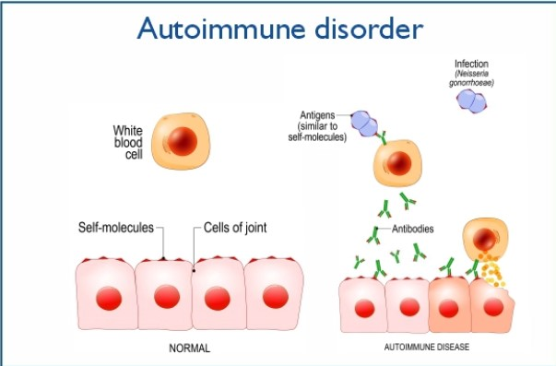

Using machine learning for autoimmune disorders app means using smart computer programs to understand and improve how we deal with these conditions. These programs can analyse lots of information from patients, like their symptoms and test results, to help doctors diagnose diseases more accurately and quickly. They can also predict how a patient might respond to different treatments, making it easier to find the best option for each person. Additionally, machine learning autoimmune disorders app can help monitor patients over time, spotting any changes in their condition and adjusting treatment plans accordingly. By using these smart tools, we can better understand autoimmune disorders, find better treatments, and improve the lives of people affected by them. The autoimmune disorders dataset is prepared by following information

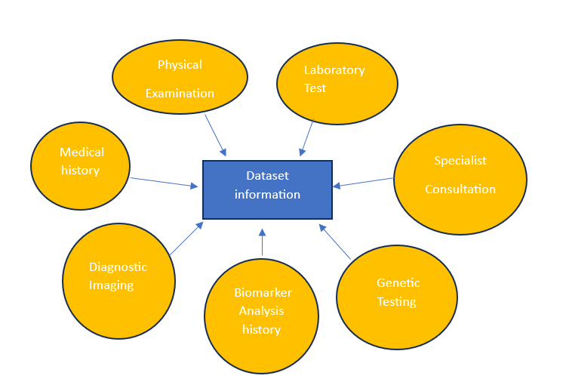

|  |  |
| --- | --- |
|  |  |
|  |  |
| We start with a dataset about autoimmune disorders. First, we convert this dataset into a CSV format and then bring it into a Jupyter Notebook. In the notebook, you'll be using Python with libraries like pandas, scikit-learn, and Seaborn. These libraries are great for training machine learning models.  People can undergo tests and provide samples either at a clinic or at home. After gathering this data, you input it into an application (App). In just a few minutes, the app gives you a prediction result. This prediction is made using a deployment software, and it comes with a detailed report. The report accurately predicts the development of your autoimmune disorder. |  |
|  |  |
|  |  |
|  |  |
| If the prediction is positive, we can also assist by recommending specialist consultation tailored to their individual requirements. |  |

**11.Final Product Prototype:**

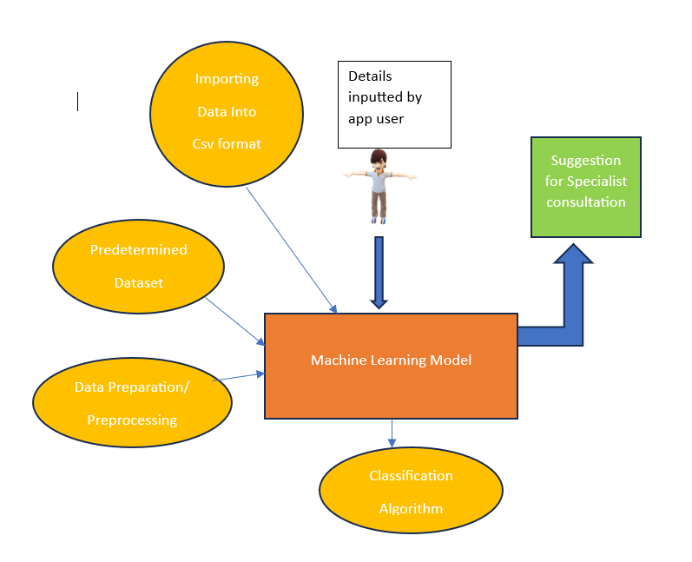

**12.Product Details:**

Our app is designed to help people understand and manage autoimmune disorders. Users can create a profile and input their health data, like symptoms and test results. Using advanced technology, the app analyses this data to predict the likelihood of developing autoimmune disorders. Based on these predictions, personalized recommendations are provided to help users make lifestyle changes and seek appropriate medical care. The app also offers educational resources, health tracking tools, and a supportive community for users to connect with others facing similar challenges. We prioritize user privacy and security, and regularly update the app based on feedback and advancements in healthcare. With our app, we aim to empower individuals to take control of their health and live their best lives.

**13.Conclutions:**

The autoimmune disorder app represents a groundbreaking advancement in healthcare technology, offering both positive and negative implications. On the positive side, the integration of machine learning algorithms like logistic regression enables early detection and personalized management of autoimmune diseases. By analysing vast datasets and identifying intricate patterns, the app empowers healthcare providers to make informed decisions and improve patient outcomes

Furthermore, the app facilitates seamless communication between patients and healthcare professionals, fostering a collaborative approach to treatment and empowering individuals to take an active role in managing their health. Through personalized recommendations and predictive insights, it has the potential to revolutionize the healthcare landscape, offering hope for better diagnosis, treatment, and ultimately, improved quality of life for patients with autoimmune disorders.

However, it's important to acknowledge the potential limitations and challenges associated with the autoimmune disorder app. While machine learning algorithms can enhance diagnostic accuracy, they may also introduce biases or errors if not properly calibrated or validated. Additionally, concerns related to data privacy, security, and the ethical use of patient information must be carefully addressed to ensure trust and compliance with regulatory standards.

In summary, while the autoimmune disorder app holds immense promise in advancing healthcare innovation and improving patient care, it's essential to approach its development and implementation with careful consideration of both the positive impacts and potential challenges it may entail. Through continued research, collaboration, and adherence to ethical principles, we can harness the full potential of technology to address the complexities of autoimmune diseases and enhance the well-being of individuals worldwide.

**14.Reference:**

* <https://www.healthline.com/health/autoimmune-disorders#symptoms>
* <https://www.ncbi.nlm.nih.gov/pmc/articles/PMC9147288/>
* <https://regeneratehealthmc.com/blog/5-lifestyle-changes-to-help-reverse-your-autoimmune-disease/>
* <https://drhyman.com/blog/2015/07/24/10-strategies-to-reverse-autoimmune-disease/>