**UI/UX Testing Report**

|  |
| --- |
| Design |
|  |
| Actual |

**Report:**

1.Logo is missing

2.” Leapyfy Talk” is not mentioned in design

3.There is not enough space between Logo and Home menu

4.Get started button is highlighted in different colour

5.Full Home Menu is in different colour (it should not be in blue colour)

6.Menu text should be in white colour.

7.Only “Home” should be highlighted

8.There should be enough space between “sign in” and Get Started” Menu button

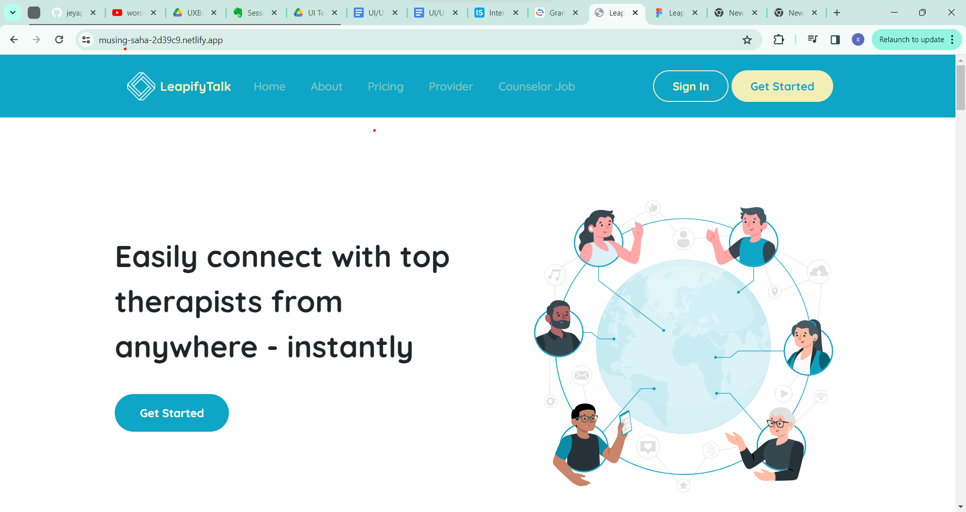

**1**.Easily connect with top - is not aligned properly  
therapists from  
anywhere – instantly

2.” Get Started” button is not in specified colour.

Page 2:

Design

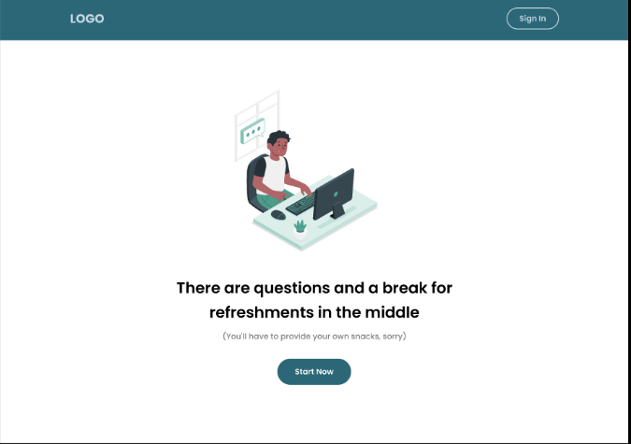

Actual: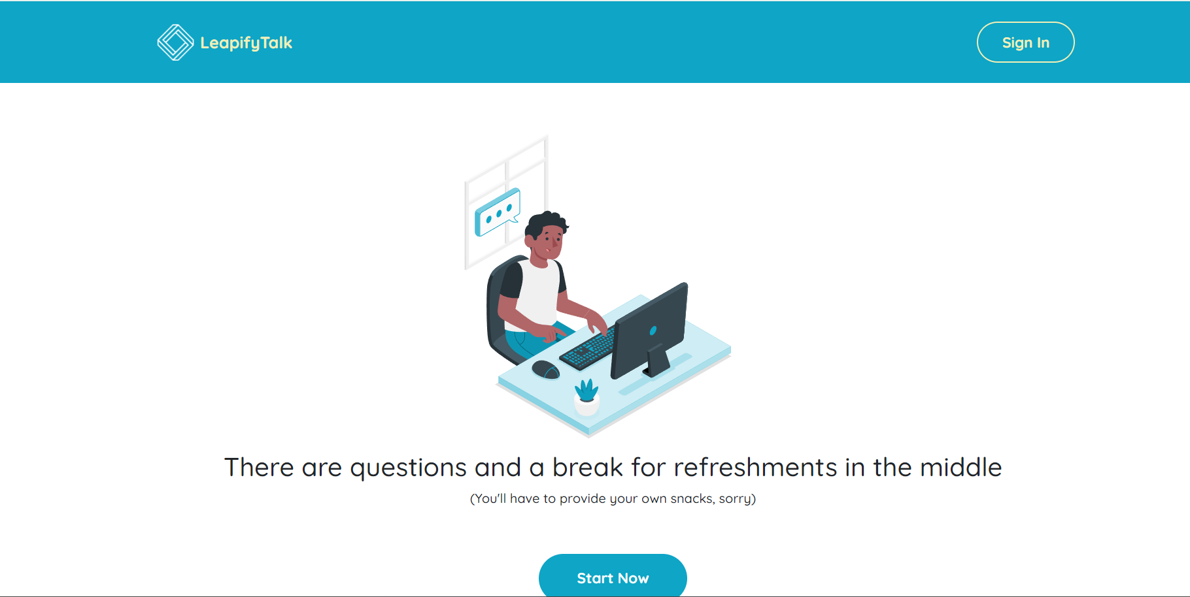

1.Menu Bar is in different colour

2.Logo is missing

3.Text alignment is different. (it is in 2 line)

4.” Start Now” button highlighted in different colour.

5.All green colour are in blue colour including pictures

**Page 3:**

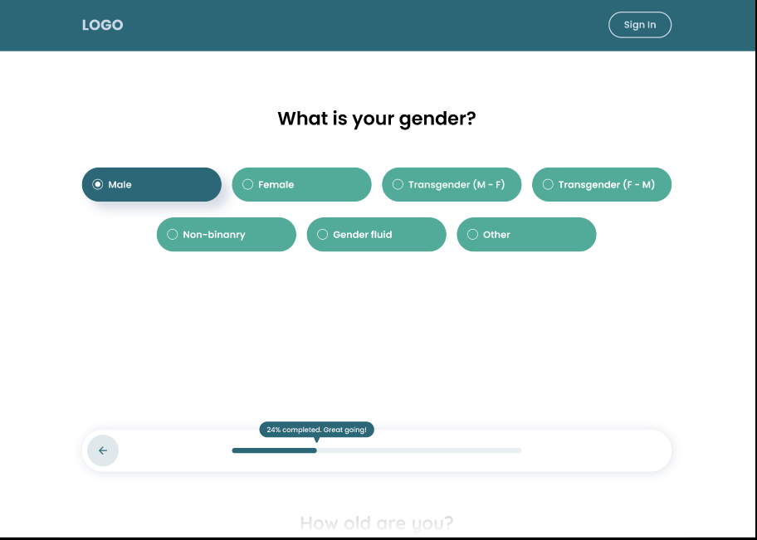

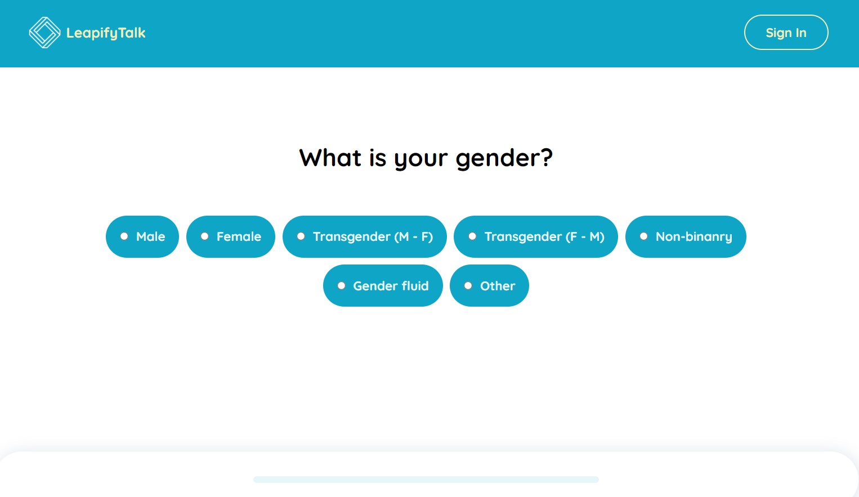

1.All blue colour are in green colour

2.font is different

3.Radio button circle is bigger than as mentioned

4.Allignment of button is also different (first four button, then three button)

5.All text box should be in same size

6.Logo Text is replaced with some logo and LeapifyTalk

Design

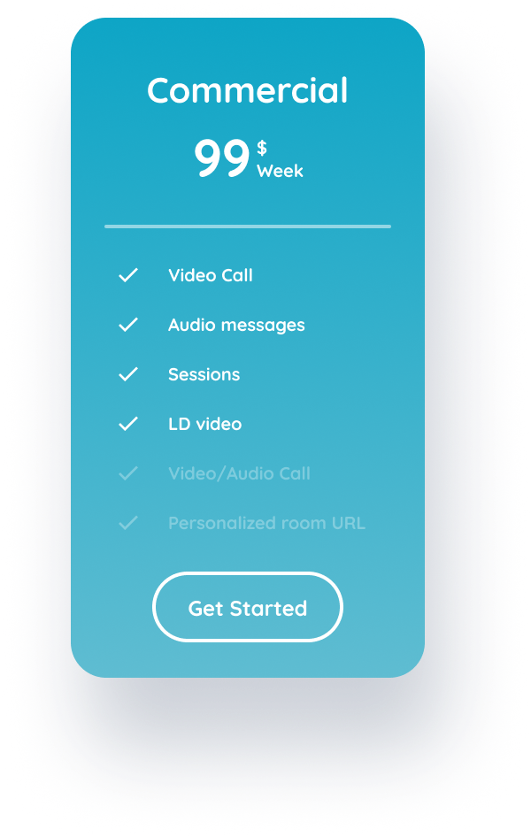

Actual

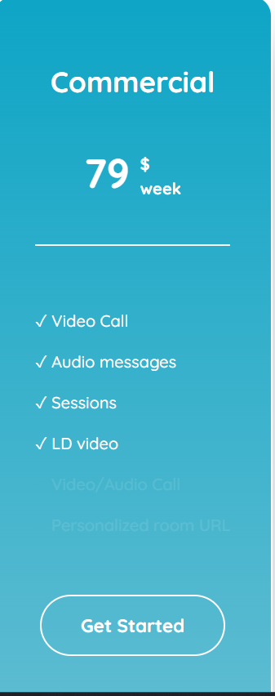

Report:

1.No Navigation arrow

2.99 $ is texted as 79$

3.disabled text is not clearly visible

