Drug Tracebility

**TIP**

Participants can use their cursors to point at where sticky notes should go on the grid. The facilitator can confirm the spot by using the laser pointer holding the **H key** on the keyboard.

# Before you collaborate

#### A little bit of preparation goes a long way with this session. Here’s what you need to do to get going.

##### 10 minutes

**1**

# Define your problem statement

**TIP**

Add customizable tags to sticky notes to make it easier to find, browse, organize, and categorize important ideas as themes within your mural.

**2**

# Brainstorm

#### Write down any ideas that come to mind that address your problem statement.

##### 10 minutes

**3**

# Group ideas

**TIP**

You can select a sticky note and hit the pencil [switch to sketch] icon to start drawing!

##### 20 minutes

**4**

# Prioritize

#### Your team should all be on the same page about what's important moving forward. Place your ideas on this grid to determine which ideas are important and which are feasible.

**20 minutes**

# After you collaborate

You can export the mural as an image or pdf to share with members of your company who might find it helpful.

**Quick add-ons**

Use this template in your own brainstorming sessions so your team can unleash their imagination and start shaping concepts even if you're

**A** Mahindra jeyaram .T (Team leader)

R.A Aravind G.Jeno joselin K.Vishwag

organizational and geographical boundaries, providing critical backbone to services vital for everyday life.

Maintaining patient safety is an increasingly complex task, as it involves potential risk

A medical supply chain intends to keep a log of medicine at each stage of its journey.

**PROBLEM**

**How might we [your problem statement]?** Healthcare supply chains are complex structures spanning across multiple

|  |  |  |
| --- | --- | --- |
| The concern of | The public healthcare system is a source of social and economic wealth that creates jobs and plays an important role | Patient safety ] is one factor that indicates the quality status of health services and is considered a priority in healthcare |
| medical |
| professionals |
| regarding patient |
| safety in the |
| assistance process |
| is nothing new |

**Person 1**

Traceability of patients and medications may be even more important for those drugs that are considered high risk

**Person 2**

A

It is important to note that all the medication that is to be included in this work has special characteristics

dditionally, for ach medication repared, the lot

and expiry date of ach of the omponents, roduction date,

e p

e c p

and expiry of the final product are registered.

**Person 3**

**Person 4**

n addition to the perfect dosage, it greatly facilitates the sustainability of the public health system.

Currently, a

significant portion of the drugs that are administered to patients in the Day Hospital are prepared and dosed by the Pharmacy Service

**+**

Medication is received at the Day Hospital but the patient is no longer in

Existing traditionally

supply chain barcodes and

**A Share the mural**

**Share a view link** to the mural with stakeholders to keep them in the loop about the outcomes of the session.

**B Export the mural**

Export a copy of the mural as a PNG or PDF to attach to emails, include in slides, or save in your drive.

## not sitting in the same room.

solutions within

management

have

used

RFID tags as

identification

### Keep moving forward

through different stages

and share product information to facilitate tracking of goods

data, and Electronic Product Code (EPC) to identify, capture,

techniques, Wireless Sensor Networks (WSN) to capture

**Person 5**

**Person 6**

**Person 7**

**Person 8**

**Strategy blueprint**

Define the components of a new idea or strategy.

[**Open the template**](https://app.mural.co/template/e95f612a-f72a-4772-bc48-545aaa04e0c9/984865a6-0a96-4472-a48d-47639307b3ca)

### Importance

If each of these tasks could get done without any difficulty or cost, which would have the most positive impact?

**Customer experience journey map**

Understand customer needs, motivations, and obstacles for an experience.

[**Open the template**](https://app.mural.co/template/b7114010-3a67-4d63-a51d-6f2cedc9633f/c1b465ab-57af-4624-8faf-ebb312edc0eb)

**Strengths, weaknesses, opportunities & threats**

Identify strengths, weaknesses, opportunities, and threats (SWOT) to develop a plan.

[**Open the template**](https://app.mural.co/template/6a062671-89ee-4b76-9409-2603d8b098be/ca270343-1d54-4952-9d8c-fbc303ffd0f2)

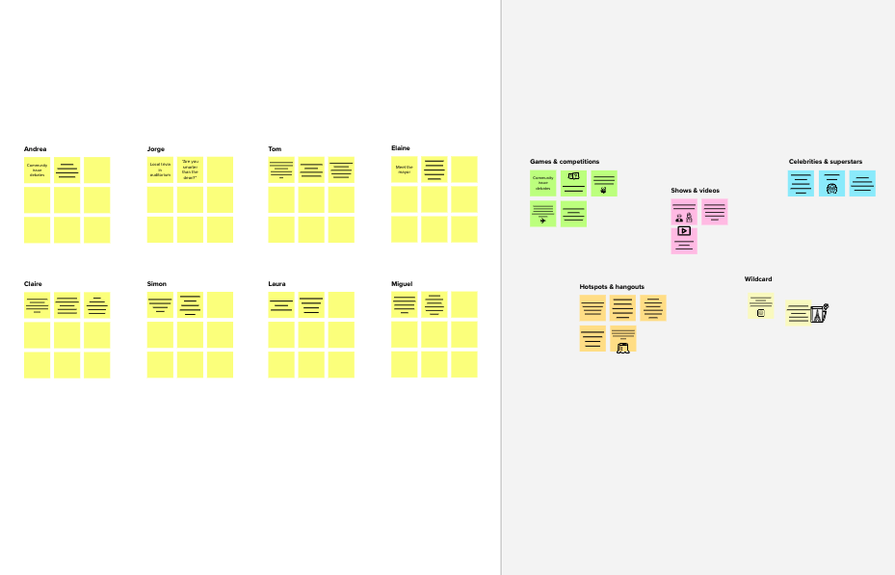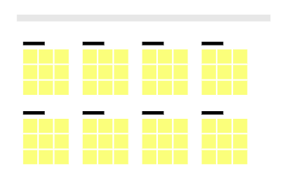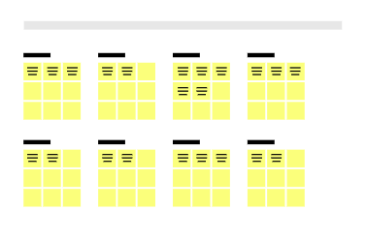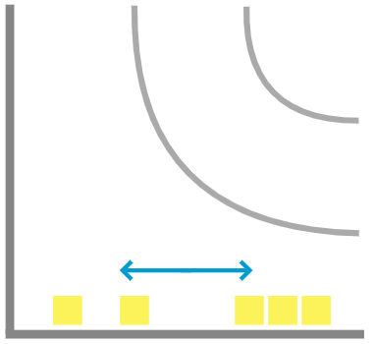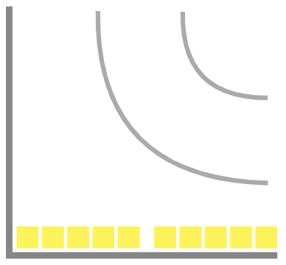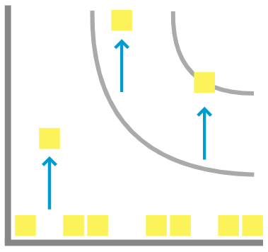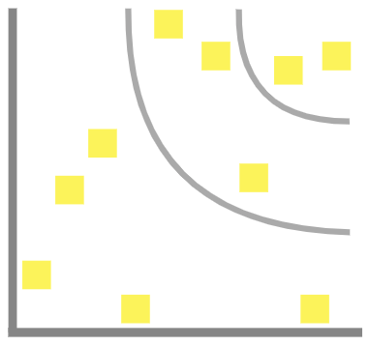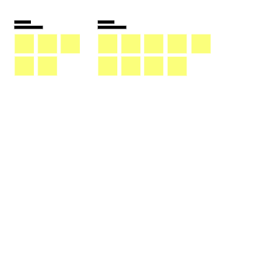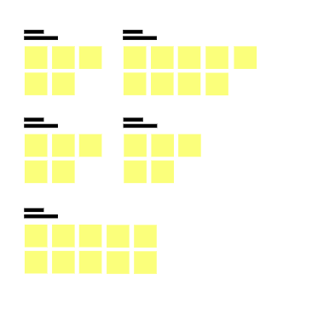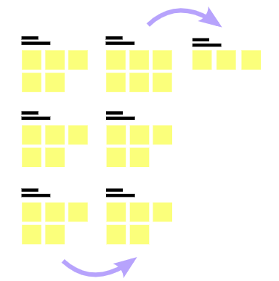

**Template**

[**Share template feedback**](https://muralco.typeform.com/to/CiqaHVat?typeform-source=app.mural.co)

**-**

### - Feasibility +

Regardless of their importance, which tasks are more

feasible than others? (Cost, time, effort, complexity, etc.)

**Need some inspiration?**

See a finished version of this template to kickstart your work.

###### [Open example](https://app.mural.co/template/e5a93b7b-49f2-48c9-afd7-a635d860eba6/93f1b98d-b2d2-4695-8e85-7e9c0d2fd9b9)