**CHAPTER 1 INTRODUCTION**

## 1.1 ABOUT THE PROJECT

Intruder detection and security monitoring using IOT is an advanced system that uses various sensors and IOT devices to monitor and detect unauthorized access or intrusion into a particular area. The system is designed to provide real-time security monitoring and alert notifications in case of any suspicious activity. Intruder detection and security monitoring using IOT has become increasingly popular in recent years due to its cost-effectiveness and efficiency compared to traditional security systems. With the increasing availability of low- cost sensors and IOT devices, it has become easier for anyone to set up a security system that can monitor and detect unauthorized access or intrusion. In summary, intruder detection and security monitoring using IOT is an innovative and advanced system that offers an effective solution to security-related problems.

It provides real-time monitoring and alert notifications, making it an essential tool for ensuring the safety and security of homes, offices, and other sensitive areas. Security is a paramount concern in various settings, including homes, offices, and public spaces. Traditional intruder detection systems often rely on motion sensors, which may lack precision in determining the location and identity of potential intruders. In this project, we propose an advanced intruder detection system that combines multiple technologies to enhance security measures.The system utilizes an ESP32 camera module for real-time surveillance, allowing for high-resolution image capture.

Additionally, IR sensors are strategically positioned to detect movement and ascertain the direction of the intruder's approach. A servo motor is integrated to adjust the camera's orientation based on the detected direction, ensuring optimal coverage of the intruder's movement.To facilitate efficient alerting, an Arduino microcontroller serves as the central processing unit, receiving data from the intruder detection system and initiating notification actions. These actions may include sending SMS messages or making phone calls to pre- registered mobile numbers, enabling swift response to security threats.

# CHAPTER 2 SYSTEM ANALYSIS

## EXISTING SYSTEM

There are several existing systems for intruder detection and security monitoring using IOT. Some of the commonly used systems include:

**Smart Home Security Systems:** These systems use IOT devices such as sensors and detect suspicious activity in homes. They are designed to send alerts to homeowners in case of any unauthorized access or intrusion.

**Industrial IoT Security Systems:** These systems are used in industrial settings to monitor and detect unauthorized access or intrusion into sensitive areas such as manufacturing facilities, power plants, and refineries.

* + - The security system will monitor and detects if an intruder enters.
    - The system will automatically make alert to the surroundings by ringing alarm
    - The security system will record the CCTV footages and give the feedbacks

## DISADVANTAGES

* + - * One potential disadvantage of using IoT for intruder detection and security monitoring is the risk of cybersecurity threats.
      * As IoT devices are connected to the internet, they are vulnerable to hacking and other security breaches, which can compromise the entire system and put the security of the premises at risk.
      * Another disadvantage is the cost of implementing such a system, which may be prohibitive for some individuals or organizations.
      * Additionally, the system may require regular maintenance and updates to ensure that it is functioning properly, which can add to the overall cost and complexity of the system.

## PROPOSED SYSTEM

**Sensors:** The system uses various types of sensors such as IR sensors to detect any unusual activity in the building. These sensors are connected to the IoT devices and can detect any movement or changes in the environment. Cameras: The system uses cameras to provide visual monitoring of the building. The cameras can be placed in strategic locations to capture any suspicious activity and can be accessed remotely through the IoT devices. Alert Notifications: The system is designed to send alert notifications to homeowners or security personnel in case of any unauthorized access or intrusion. These notifications can be sent via SMS, email, or push notifications to a mobile device.

Our proposed intruder detection system integrates IR sensors, a servo motor, facial recognition technology, and an Arduino microcontroller for enhanced functionality. IR sensors detect intruder movement and guide the servo motor to adjust the camera's orientation, ensuring accurate monitoring. Facial recognition technology distinguishes between authorized individuals and potential intruders, reducing false alarms. The Arduino microcontroller enables remote alerting via SMS or phone calls to registered mobile numbers. Automatic camera adjustment eliminates the need for manual intervention, ensuring continuous surveillance.

## 2.2.1 ADVANTAGES OF PROPOSED SYSTEM

There are several advantages of using IOT for intruder detection and security monitoring:

**Real-time monitoring:** IOT devices can monitor premises in real-time, providing instant alerts and notifications in case of any security breaches.

**Enhanced security:** IOT devices can be equipped with sensors, cameras devices to provide enhanced security, making it difficult for intruders to enter the premises undetected.

**Remote access:** With IOT, security personnel can remotely access and monitor thesecurity system, providing increased flexibility and convenience.

# CHAPATER 3 SYSTEM SPECIFICATION

## HARDWARE REQUIREMENTS

* + - NODEMCU 8266
    - ESP32 CAM
    - GSM
    - BUZZER
    - IR SENSOR
    - SERVO
    - PERSONAL COMPUTER
    - LCD DISPLAY
    - PROCESSOR : Intel(R) Core(TM) i5
    - RAM : 8 GB
    - HARD DISK : 160 GB
    - OPERATING SYSTEM : Windows 10

## SOFTWARE REQUIREMENTS

* + - SOFTWARE : ARDUINO IDE
    - LANGUAGE : PYTHON & EMBEDDED C

# CHAPTER 4 SOFTWARE DESCRIPTION

## ARDUINO IDE



### Figure 4.1 Arduino Icon

The Integrated Development Environment (IDE)is a combination of editor, linker and a compiler which helps the developer to make their Firmware for their Innovative Projects. Arduino IDE play a major role in open source platform for fast prototyping and easy to access of library. It is user friendly tool for beginners and it supports programming language like embedded C, Luna etc. Over the years Arduino has been the brain of thousands of projects, from everyday objects to complex scientific instruments. It supportsall the variant of Arduino boards like Arduino Uno, Nano and Mega etc. As soon as it reaches a wider community, the Arduino board started changing to adapt to new needs and challenges, differentiating its offer from simple 8-bit boards to products for IOT applications, wearable, 3D printing, and embedded environments.

**Code Editor:** The IDE provides a text editor that supports syntax highlighting, code completion, and error checking to help programmers write and debug code.

**Library Manager:** The IDE comes with a built-in library manager that provides access to a large collection of pre-written code libraries that can be used to simplify coding and speed up development.

**Serial Monitor:** The IDE has a serial monitor that allows programmers to view and send data to the microcontroller, making it easier to debug and test code.

**Board Manager:** The IDE includes a board manager that allows programmers to select the specific Arduino board they are using, set the processor frequency,and configure other board- specific settings.

**Sketches:** The IDE uses a concept called "sketches," which are code files that contain the Arduino code. Sketches can be easily saved, edited, and uploaded to the microcontroller using the IDE.

Overall, the Arduino IDE is a powerful tool for developing and testing code for Arduino microcontrollers. Its user-friendly interface and wide range of features make it a popular choice among hobbyists and professional developers alike.

## PYTHON IDLE

Python IDLE (Integrated Development and Learning Environment) is a graphical user interface (GUI) that provides a simple and convenient way to write, run, and debug Python programs. It comes pre-installed with most Python distributions and is available onWindows, macOS, and Linux operating systems.

Python IDLE includes several key features that make it a popular choice for developers:

**Code editing:** Python IDLE includes a text editor that allows you to write, edit, and save Python code. It supports syntax highlighting, code folding, and auto-indentation, which can help improve code readability and reduce errors.

**Code execution**: Python IDLE provides a built-in Python interpreter that allows you to execute Python code directly from the editor. This makes it easy to test code and experiment with different programming concepts.

**Debugging:** Python IDLE includes a debugger that allows you to step through code, set breakpoints, and inspect variables. This can be helpful when trying to locate and fix errors in your code.

**Python shell:** In addition to the editor and debugger, Python IDLE also includes a Python shell that provides an interactive command-line interface for testing and experimenting with Python code.

**Autocomplete:** Python IDLE includes a powerful autocomplete feature that can help you write code more quickly and accurately. When you start typing a Python command or function, IDLE will suggest possible completions based on the context and available libraries.

**Integration with Python libraries:** Python IDLE integrates with many popular Python libraries, such as NumPy, SciPy, and Matplotlib, making it a powerful tool for scientific and data analysis tasks.

**Customizable settings:** Python IDLE allows you to customize many of its settings to fit your coding preferences. You can configure settings for the editor, shell, debugger, and more, including font size, color scheme, and tab spacing.

**Integration with version control:** Python IDLE supports integration with popular version control systems, such as Git and Subversion. This allows you to manage your code changes and collaborate with other developers more effectively.

**Support for multiple platforms:** Python IDLE is a cross-platform tool that is available on Windows, macOS, and Linux operating systems. This makes it a popular choice for developers working on different platforms.Overall, Python IDLE is a powerful and flexible development environment for Python programming that includes many useful features for coding, testing, and debugging. Its user-friendly interface and integration with popular libraries and tools makeit an excellent choice for both beginners and experienced developers alike.

## EMBEDDED C LANGUAGE

**Memory management:** Embedded C requires a programmer to have a thorough understanding of memory management. In embedded systems, memory is typically limited, and optimizing the use of memory is critical to ensure that the system functions correctly. Embedded C provides low-level memory access through pointers and arrays, allowing developers to fine-tune memory usage and performance.

**Access to hardware resources:** One of the significant advantages of Embedded C is that it allows direct access to hardware resources, such as input/output (I/O) ports and timers. This low-level access is essential in embedded systems, where devices must interact with the physical world and often require real-time responses.

**Real-time performance:** Embedded C is designed to provide real-time performance, which is essential in many embedded systems. In real-time systems, tasks must be completed within strict time constraints.

**Small footprint:** Embedded systems often have limited processing power and memory, so Embedded C is designed to have a small memory footprint. The language is optimized for code size, allowing programs to be compact and efficient.

**Interrupt handling:** In embedded systems, interrupts are often used to signal events that require immediate attention. Embedded C provides built-in support for interrupt handling, allowing developers to respond to interrupts quickly and efficiently.

**Debugging:** Embedded C supports various debugging tools, such as in-circuit emulators and hardware debuggers, which can help developers diagnose and fix issues in their programs.

## HARDWARE DESCRIPTION

* NODEMCU 8266
* ESP32 CAM
* GSM
* BUZZER
* IR SENSOR
* SERVO MOTO

## NODEMCU 8266

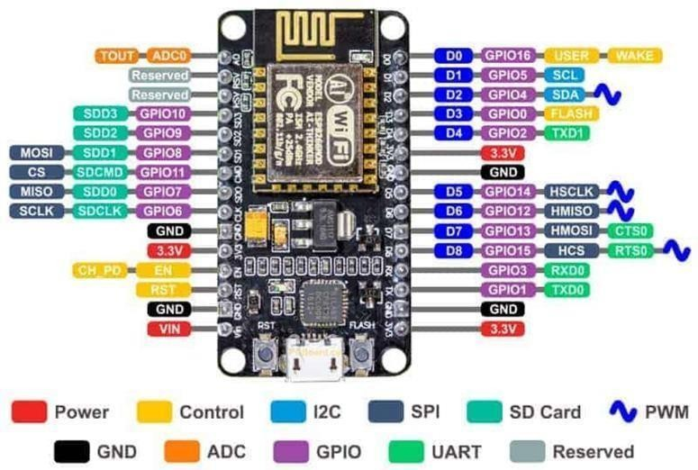

**Figure 4.2 NodeMCU 8266**

NodeMCU is an open-source development board based on the ESP8266 system-on- chip (SoC) from Espressif Systems. The ESP8266 is a highly integrated Wi-Fi chip that can be programmed to connect to wireless networks and communicate with other devices over the Internet. NodeMCU makes it easy to get started with ESP8266 development by providing a simple and convenient platform for programming and interfacing with the chip. NodeMCU is designed to be easy to use and highly customizable. It features an integrated USB-to-serial converter, which allows it to be programmed directly from a computer using the Arduino Integrated Development Environment (IDE). NodeMCU can also be programmed using Lua, a lightweight scripting language that is well-suited for IoT applications.

NodeMCU includes a number of features that make it ideal for IoT development. These include support for Wi-Fi connectivity, as well as a variety of digital and analog input/output pins that can be used to interface with sensors, actuators, and other devices. NodeMCU also includes a built-in power regulator, which allows it to be powered from a wide range of input voltages. Overall, NodeMCU is a versatile and powerful development board that is well- suited for a wide range of IOT applications. Its ease of use, support for Wi-Fi connectivity, and powerful features make it an excellent choice for both hobbyists and professional developers alike.

## ADVANTAGES OF NODEMCU

NodeMCU is a popular open-source firmware and development kit based on the ESP8266 Wi-Fi module. Here are some advantages of using NodeMCU:

**Low cost:** NodeMCU is an inexpensive option for IoT projects, making it accessible to hobbyists and small-scale developers.

**Easy to use:** The NodeMCU firmware provides a simple interface for programming and controlling the ESP8266 module, making it easy for developers to get started with building their IOT applications.

**Built-in Wi-Fi:** The ESP8266 module used by NodeMCU has built-in Wi-Fi, which means that devices built using NodeMCU can connect to Wi-Fi networks and communicate with other devices over the internet.

**Small size:** The NodeMCU development board is small in size, making it ideal for applications where space is limited.

**Support for multiple programming languages:** NodeMCU supports several programming languages, including Lua, JavaScript, and Python, giving developers the flexibility to choose the language they are most comfortable with.

**Large community and ecosystem:** NodeMCU has a large community of developers and enthusiasts, with a vast collection of resources and tutorials available online. This makes it easy for developers to get help and find solutions to problems they encounter while building their IOT projects.

Overall, NodeMCU is a powerful and versatile tool for building IOT applications, with a wide range of features and a large community of developers supporting it.

## DISADVANTAGES OF NODEMCU

While NodeMCU offers several advantages for IoT projects, there are also some potential disadvantages that developers should be aware of:

**Limited processing power:** While the ESP8266 module used by NodeMCU is capable of running at high speeds, it has limited processing power compared to more powerful microcontrollers.

**Limited storage space:** The ESP8266 module used by NodeMCU has limited flash memory, which can be a constraint when developing applications that require storing large amounts of data or complex program logic.

**Security vulnerabilities:** Like any IOT device, NodeMCU devices can be vulnerable to security threats, such as hacking, data breaches, or other attacks. Developers need to take appropriate measures to secure their applications, such as implementing encryption, authentication, and access control mechanisms.

**Dependency on Wi-Fi networks:** Since NodeMCU devices rely on Wi-Fi networks to connect to the internet, they may be subject to network disruptions or interference.

**Limited hardware support:** While NodeMCU supports a wide range of sensors and peripherals, it may not be compatible with all types of hardware. Developers may need to carefully select the hardware components they use to ensure compatibility with NodeMCU.

**Power consumption:** The ESP8266 module used by NodeMCU can consume a significant amount of power, which can be a concern for battery-powered devices or applications that require low power consumption.

## ESP32-CAM

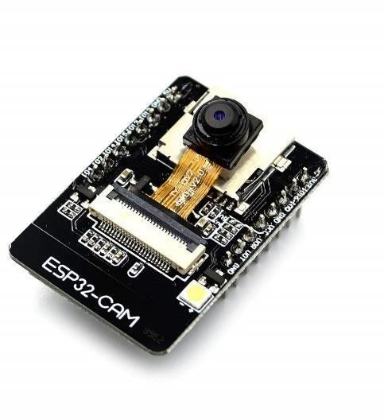

**Figure 4.3 ESP32-CAM**

ESP32-CAM is a low-cost ESP32-based development board with onboard camera, small in size. It is an ideal solution for IOT application, prototypes constructions and DIY projects. The board integrates Wi-Fi, traditional Bluetooth and low power BLE , with 2 high performance 32-bit LX6 CPUs. It adopts 7-stage pipeline architecture, on-chipsensor, Hall sensor, temperature sensor and so on, and its main frequency adjustment ranges from 80MHz to 240MHz.

Fully compliant with Wi-Fi 802.11b/g/n/e/i and Bluetooth 4.2 standards, it can be used as a master mode to build an independent network controller, or as a slave to other host MCUs to add networking capabilities to existing devices ESP32-CAM can be widely used in various IoT applications. It is suitable for home smart devices, industrial wireless control, wireless monitoring, QR wireless identification, wireless positioning system signals and other IoT applications.

It is an ideal solution for IoT applications. ESP32-CAM is a low-cost, small-sized camera module that integrates an ESP32-S chip and a OV2640 camera. It provides onboard Wi-Fi and Bluetooth connectivity, making it an ideal solution for IoT applications that require video streaming, such as surveillance cameras, doorbells, and robots.

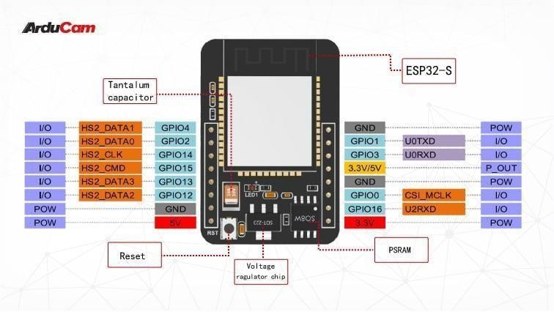

**Figure 4.4 ESP32-CAM Circuit Diagram**

* + - * Please be sure that the power supply for the module should be at least 5V 2A, otherwise maybe there would be water ripple appearing on the image.
      * ESP32 GPIO32 pin is used to control the power of the camera, so when the camera is in working, pull GPIO32 pin low.
      * Since IO pin is connected to camera XCLK, it should be left floating in using, and do not connect it to high/low level.
      * The product has been equipped with default firmware before leaving the factory, and we do not provide additional ones for you to download. So, please be cautious when you choose to burn other firmwares.

## ADVANTAGES OF ESP32 CAM

The ESP32-CAM is a versatile and low-cost development board based on the ESP32 microcontroller and designed specifically for camera applications. Here are someadvantages of using the ESP32-CAM:

**Low cost:** The ESP32-CAM is an inexpensive development board that provides a cost-effective way to add camera functionality to your projects.

**Integrated camera module:** The ESP32-CAM has an integrated camera module, which reduces the complexity of the hardware and allows for faster and easier development.

**Wi-Fi and Bluetooth connectivity:** The ESP32-CAM has built-in Wi-Fi and Bluetooth connectivity, making it easy to connect to the internet and other devices.

**Small size:** The ESP32-CAM is a small development board, making it ideal for projects where space is limited.

**Easy to program:** The ESP32-CAM can be programmed using the Arduino IDE, whichis a popular and easy-to-use programming environment for beginners and experienced developers alike.

**Open-source software:** The ESP32-CAM is supported by an active and growing community of developers, and the software is open source, meaning that it can be customized and modified to suit your specific needs.

**Multiple interfaces:** The ESP32-CAM has multiple interfaces, including SPI, I2C, UART, and GPIO, allowing it to be easily integrated with other devices and sensors.

**Camera control:** The ESP32-CAM provides advanced camera control features, such asframe rate control, exposure control, and image size control, making it a powerful tool for image and video processing applications.

In summary, the ESP32-CAM is a low-cost and powerful development board that provides a range of advanced camera and connectivity features. Its small size, easy programming, and open-source software make it an attractive option for developers working on camera and IOT projects.

## DISADVANTAGES OF ESP32 CAM

**Limited memory:** The ESP32-CAM has limited memory, with only 4MB of flash memory and 520KB of SRAM. This can be a limitation when working with large or complex programs.

**Limited camera resolution:** The integrated camera module on the ESP32-CAM has a maximum resolution of 2 megapixels, which may not be sufficient for some applications that require higher resolution images.

**No onboard USB port:** Unlike other development boards, the ESP32-CAM does not have an onboard USB port for programming and power. Instead, an external USB-to- serial converter is required.

.

**Compatibility issues:** The ESP32-CAM may have compatibility issues with some third-party libraries and hardware components. It is important to thoroughly test and verify compatibility before using the board in a larger project.

**Limited support for audio:** While the ESP32-CAM has built-in support for video streaming, it has limited support for audio streaming, which may be a limitation for some projects.

**Single camera support:** The ESP32-CAM only supports a single camera module, which may be a limitation for applications that require multiple cameras.In summary, the ESP32-CAM has some limitations, including limited memory, camera resolution, and compatibility issues. However, its low cost and built-in camera module make it an attractive option for developers looking to add camera functionality to their projects, especially those with limited space and budget.

## SPECIFICATIONS

* + - * Microcontroller: ESP32-S chip
      * Wi-Fi: 802.11 b/g/n
      * Bluetooth: BLE 4.2
      * Camera: OV2640 2MP camera
      * Image sensor: 1/4 inch
      * Output format: YUV(422/420)/YCbCr422 RGB565/555 JPEG
      * Maximum resolution: 1600 x 1200
      * Lens: F2.8 aperture, 60-degree viewing angle
      * Flash memory: 4 MB
      * RAM: 520 KB SRAM
      * GPIO: 9
      * Voltage range: 5V DC
      * Operating temperature: -20°C to 85°C
      * Dimensions: 27mm x 40.5mm
      * Weight:10grams

## GSM

**Figure 4.5 GSM**

A GSM (Global System for Mobile Communications) module is a device that allows mobile communication using the GSM network. It consists of a GSM modem that communicates with the network and a supporting circuitry that allows for easy integration with other devices. The module typically requires a SIM (Subscriber Identity Module) card that identifies the subscriber's account and enables authentication on the network. GSM modules can be used for a variety of applications, including voice and data communication, SMS messaging, and mobile internet access. One of the key advantages of GSM modules is their ability to provide reliable and secure mobile communication, with support for encryption and authentication mechanisms. They are also widely available and compatible with most GSM networks around the world, making them a popular choice for international communication.

## ADVANTAGES OF GSM

GSM (Global System for Mobile Communications) is a digital cellular network technology used for mobile communication. Here are some of the advantages of GSM:

**Compatibility:** GSM is compatible with a wide range of devices, including mobilephones, laptops, tablets, and other data devices.

**Improved voice quality:** Compared to analog networks, GSM provides better voice quality due to the use of digital modulation techniques.

**Security:** GSM uses strong encryption techniques to ensure secure communication between devices, which makes it more secure than older analog technologies.

**Enhanced features:** GSM offers enhanced features such as SMS messaging, caller ID, call forwarding, and more.

**Roaming:** GSM allows users to roam seamlessly between different countries and networks, making it a convenient option for international travelers.

Overall, GSM has played a significant role in the development of mobile communication technology, and its advantages have made it a popular choice for mobile network providers around the world.

### DISADVANTAGES OF GSM

GSM (Global System for Mobile Communications) is a widely used mobile communication standard that has revolutionized the way we communicate and stay connected. However, like any other technology, it has its fair share of disadvantages, including:

**Limited Coverage:** While GSM has a broad global coverage, it is still not available insome remote areas.

**Security Issues:** GSM has been known to be vulnerable to eavesdropping and other forms of security attacks. This is because it uses a weaker encryption algorithm that can be easily hacked by cybercriminals.

**Limited Data Transfer:** The original GSM standard was primarily designed for voicecommunications, and as a result, it has limited data transfer capabilities. This makes it unsuitable for data-intensive applications such as video streaming and large file transfers.

**Limited Capacity:** GSM has a limited capacity to handle the growing demand for mobile communication services. This can result in congestion and dropped calls, especially during peak hours.

## IR SENSOR

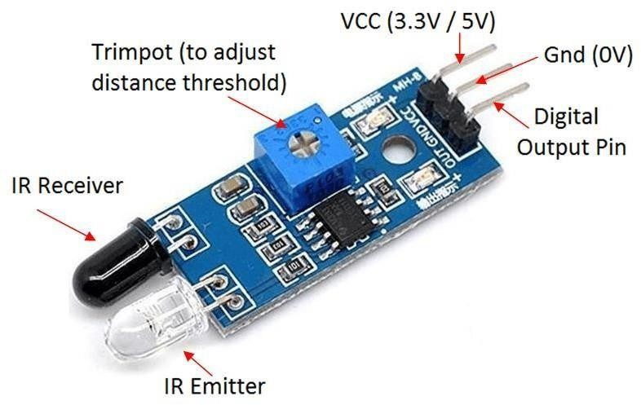

**Figure 4.6 IR Sensor**

An IR (infrared) sensor is a device that can detect the presence of an object or an obstacle in its surrounding by emitting and receiving infrared radiation. It works on the principle that all objects with a temperature greater than absolute zero emit heat in the form of infrared radiation. The IR sensor has two main components: the IR transmitter andthe IR receiver. The transmitter emits an infrared light beam, which is reflected by any object in its path. The receiver detects the reflected light and converts it into an electrical signal that can be processed and analyzed by a microcontroller or a computer. IR sensors are widely used in different applications such as motion detection, object detection, proximity sensing, and temperature measurement. They are commonly found in home security systems, automatic doors, automatic faucets, and other automation systems.

### ADVANTAGES OF IR SENSOR

Infrared (IR) motion sensors are electronic devices that detect motion in a given area by sensing changes in the infrared radiation levels. They are commonly used in security systems, automatic lighting systems, and home automation systems, among others. Some advantages of using IR motion sensors include:

**Energy Efficiency:** IR motion sensors can help conserve energy by turning lights on only when motion is detected in a room or area. This is useful in spaces where lighting is needed only temporarily, such as bathrooms, hallways, and storage rooms.

**Cost-effective:** IR motion sensors are relatively inexpensive and require little maintenance. They are also easy to install, making them a cost-effective option for homeowners and businesses.

**Accurate Detection:** IR motion sensors can detect even small movements with a high degree of accuracy. They can sense movement in any direction, making them useful in detecting intruders in a security system.

**Versatility:** IR motion sensors can be used in a variety of applications, such as automatic doors, temperature sensing, and ventilation systems, making them versatile and useful in different settings.

**Increased Safety:** IR motion sensors can enhance safety by detecting motion in dark areas or blind spots, preventing accidents and injuries.

**Security:** IR motion sensors are commonly used in security systems to detect intrudersand trigger alarms, making them a valuable tool in protecting homes and businesses.

### DISADVANTAGES OF IR SENSOR

While infrared (IR) motion sensors have many advantages, they also have some disadvantages, including:

**Limited Detection Range:** IR motion sensors have a limited detection range, which can make them less effective in large areas. Depending on the sensitivity of the sensor, the detection range may be limited to a few meters.

**Line of Sight:** IR motion sensors require a clear line of sight between the sensor and the object being detected. This means that they may not detect motion behind objects or obstacles, which can result in false alarms or missed detections.

**Sensitivity to Temperature Changes:** IR motion sensors can be sensitive to temperature changes, which can affect their accuracy and reliability.

**Power Dependency:** IR motion sensors require a power source, which can be a disadvantage in areas where power is not readily available. Battery-powered sensors may require frequent battery replacements, which can be costly and inconvenient.

**Limited Functionality:** IR motion sensors are primarily designed to detect motion, and as such, they may not be suitable for applications that require more complex sensing capabilities, such as detecting different types of motion or sensing changes in environmental conditions.

**Privacy Concerns:** IR motion sensors can be used to monitor people's movements, which can raise privacy concerns in certain settings. This can make some people feel uncomfortable or even violated.

## BUZZER

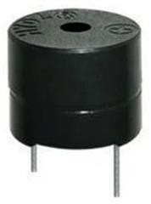

**Figure 4.7 Buzzer**

Buzzer is an electronic component that produces an audible sound when an electrical signal is applied to it. It consists of a piezoelectric or electromagnetic element that vibrates rapidly when a voltage is applied to it, producing a tone or sound. Buzzer modules are commonly used in various applications such as alarms, timers, doorbells, and other warning or signaling devices. They are also used in electronic games, toys, and musical instruments. The tone or sound produced by the buzzer module depends on the frequency of the electrical signal applied to it.

They can be powered by a range of voltage levels and are typically connected to a microcontroller or other electronic circuit using simple wiring connections. One of the key advantages of buzzer modules is their simplicity and ease of use. They are inexpensive and widely available, making them a popular choice for a wide range of applications that require audible signaling or alerting. They can also be used in combination with other electronic components to create more complex signaling systems.

## ADVANTAGES OF BUZZER

Buzzer is an electronic device that generates a continuous or intermittent sound signal:

**Audible Warning:** Buzzer provides an audible warning signal, making it an effective way to alert users to specific events or conditions, such as low battery or an alarm.

**Easy to Use:** Buzzer is easy to use and requires minimal setup or configuration. It can be easily installed in a variety of devices and can be controlled with simple input signals.

**Low Power Consumption:** Buzzer typically has a low power consumption, making it ideal for battery-powered devices, such as portable alarms or electronic toys.

**Compact Size:** Buzzer is typically compact and lightweight, making it easy to integrateinto small devices or circuit boards.

**Cost-effective:** Buzzer is relatively inexpensive and can be purchased in bulk at a low cost. This makes it a cost-effective option for manufacturers and hobbyists.

**Reliable:** Buzzer is a reliable electronic device that can operate for long periods of time without malfunctioning. It is also resistant to shock and vibration, making it suitable for use in harsh environments.

Overall, buzzer is a simple, low-cost, and reliable electronic device that provides an audible warning signal. Its versatility, compact size, and low power consumption makeit an ideal choice for a wide range of applications.

### DISADVANTAGES OF BUZZER

While buzzers have several advantages, there are also some disadvantages that should be considered, including:

**Limited Sound Options:** Buzzer typically produces a single, monotone sound, whichcan be limiting in certain applications that require a range of sounds or tones.

**Sound Volume:** Buzzer can produce a loud and sometimes annoying sound, which canbe a disadvantage in certain settings, such as quiet environments or residential areas.

**Limited Functionality:** Buzzer is designed to produce a single sound, and as such, it may not be suitable for applications that require more complex or customizable sounds.

**Power Dependency:** Buzzer requires a power source to operate, which can be a disadvantage in applications where power is limited or not readily available.

**Durability:** Some buzzers may be prone to wear and tear over time, which can affecttheir reliability and lifespan.

**Lack of Visual Feedback:** Buzzer provides only audible feedback, which can be a disadvantage in situations where visual feedback is also needed.

**Design Constraints:** Buzzers are typically limited in size and shape, which can make it difficult to integrate them into certain designs or products.

Overall, while buzzer is a simple and reliable electronic device, its limited sound options, sound volume, and lack of functionality may make it unsuitable for certain applications. Its power dependency and design constraints should also be considered before selecting it for a particular use case.

## SERVO MOTOR

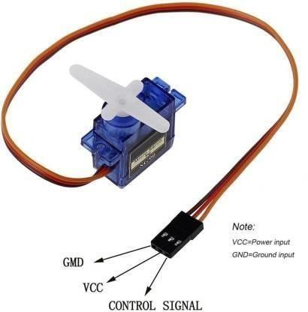

**Figure 4.8 Servo Motor**

A servo motor is a type of motor that is commonly used in robotics and other applications where precise control of movement is required. It consists of a small DC motor that is connected to a gearbox, which in turn is connected to a control circuit that regulates the position of the motor. The control circuit consists of a potentiometer, which is used to set the desired position of the motor.

One of the key advantages of servo motors is their ability to maintain a precise position even under heavy loads. They are also known for their high torque-to-weight ratio, which makes them ideal for applications where space and weight are limited. Additionally, servo motors are easy to control and canbe interfaced with a wide range of microcontrollers and other control systems.

## ADVANTAGES OF SERVO MOTOR

Servo motors are a type of electric motor that uses feedback control to precisely control the movement of a mechanical component. They have several advantages, including:

**High Precision:** Servo motors provide high precision movement control, making them ideal for use in applications that require accurate positioning, such as robotics and automation.

**High Torque:** Servo motors can generate high torque, even at low speeds, which makes them suitable for applications that require high torque and low speed, such as industrial machinery and heavy-duty equipment.

**Speed Control:** Servo motors provide precise speed control, which allows for smooth and gradual changes in speed and acceleration. This makes them suitable for applications that require smooth and precise movement control, such as CNC machines and 3D printers.

**Feedback Control:** Servo motors use feedback control to maintain accurate position and speed control. This allows for greater control and accuracy, and also helps to prevent damage to the motor or the system.

**Low Vibration and Noise:** Servo motors typically operate with low vibration and noise, making them suitable for use in environments where noise and vibration are a concern, such as in laboratory equipment or medical devices.

**Compact Size:** Servo motors are often compact and lightweight, making them suitable for use in small devices and equipment.

Overall, servo motors provide high precision, torque, and speed control, making them suitable for a wide range of applications. Their feedback control, low vibration and noise, compact size, and energy efficiency make them an attractive option for many industries.

## DISADVANTAGES OF SERVO MOTOR

While servo motors have many advantages, there are also some disadvantages that should be considered, including:

**Cost:** Servo motors can be more expensive than other types of motors, which may be a disadvantage for some applications with budget constraints.

**Complexity:** Servo motors are more complex than other types of motors and may require more expertise and knowledge to set up and operate properly.

**Maintenance:** Servo motors may require more maintenance than other types of motors, as they have more moving parts and may require regular calibration and adjustments.

**Power Consumption:** Servo motors require a constant source of power to maintain their position and speed, which can lead to higher power consumption and energy costs.

**Control Circuitry:** Servo motors require a dedicated control circuitry, which adds complexity and cost to the system.

**Limited Range:** Servo motors are generally designed for specific ranges of motion and may not be suitable for applications that require a wide range of motion.

Overall, while servo motors provide precise control and high torque, their complexity, cost, and maintenance requirements may make them less suitable for some applications. Their power consumption and limited range of motion should also be considered, as well as the potential for interference from electrical noises.

## POWER SUPPLY

Power supply is a reference to a source of [electrical power](http://en.wikipedia.org/wiki/Electrical_power). A device or system that supplies [electrical](http://en.wikipedia.org/wiki/Electrical) or other types of [energy](http://en.wikipedia.org/wiki/Energy) to an output [load](http://en.wikipedia.org/wiki/External_electric_load) or group of loads is called a power supply unit or PSU. The term is most commonly applied to electrical energy supplies, less often to mechanical ones, and rarely to others. Power supplies for electronic devices can be broadly divided into linear and switching power supplies.

The linear supply is a relatively simple design that becomes increasingly bulky and heavy for high current devices; voltage regulation in a linear supply can result in low efficiency. A switched-mode supply of the same rating as a linear supply will be smaller, is usually more efficient, but will be more complex.

### Linear Power supply:

An [AC](http://en.wikipedia.org/wiki/Alternating_current) powered linear power supply usually uses a [transformer](http://en.wikipedia.org/wiki/Transformer) to convert the voltage from the wall outlet (mains) to a different, usually a lower voltage. If it is used to produce [DC](http://en.wikipedia.org/wiki/Direct_current), a [rectifier](http://en.wikipedia.org/wiki/Rectifier) is used. A [capacitor](http://en.wikipedia.org/wiki/Capacitor) is used to smooth the pulsating current from the rectifier. Some small periodic deviations from smooth direct current will remain, which is known as [ripple](http://en.wikipedia.org/wiki/Ripple_(electrical)). These pulsations occur at a frequency related to the AC [power frequency](http://en.wikipedia.org/wiki/Utility_frequency) (for example, a multiple of 50 or 60 Hz).

The voltage produced by an unregulated power supply will vary depending on the load and on variations in the AC supply voltage. For critical electronics applications a [linear](http://en.wikipedia.org/wiki/Linear_regulator) [regulator](http://en.wikipedia.org/wiki/Linear_regulator) will be used to stabilize and adjust the voltage. Adjustable linear power supplies are common laboratory and service shop test equipment, allowing the output voltage to be set over a wide range. For example, a bench power supply used by circuit designers may be adjustable up to 30 volts and up to 5 amperes output. Some can be driven by an external signal, for example, for applications requiring a pulsed output.

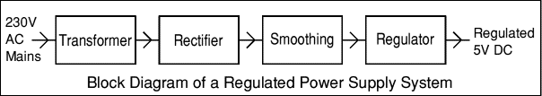

### Transformer:

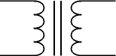

Transformers convert AC electricity from one voltage to another with little loss of power. Transformers work only with AC and this is one of the reasons why mains electricity is AC.

Step-up transformers increase voltage, step-down transformers reduce voltage. Most power supplies use a step-down transformer to reduce the dangerously high mains voltage (230V in UK) to a safer low voltage.

The input coil is called the primary and the output coil is called the secondary. There is no electrical connection between the two coils; instead they are linked by an alternating magnetic field created in the soft-iron core of the transformer. The two lines in the middle of the circuit symbol represent the core.

The ratio of the number of turns on each coil, called the turn’s ratio, determines the ratio of the voltages. A step-down transformer has a large number of turns on its primary (input) coil which is connected to the high voltage mains supply, and a small number of turns on its secondary (output) coil to give a low output voltage.

Turns ratio=Vp/Vs=Nn/Ns and Power out=Power in Vs*Is=Vp * Ip

|  |  |
| --- | --- |
| Vp = primary (input) voltage Np = number of turns on primary coil  Ip = primary (input) current | Vs = secondary (output) voltage Ns = number of turns on secondary coil  Is = secondary (output) current |

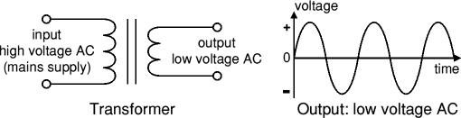

The low voltage AC output is suitable for lamps, heaters and special AC motors. It is not suitable for electronic circuits unless they include a rectifier and a smoothing capacitor.

### Rectifier:

There are several ways of connecting diodes to make a rectifier to convert AC to DC. The [bridge rectifier](http://www.kpsec.freeuk.com/powersup.htm#bridgerectifier) is the most important and it produces full-wave varying DC. A full- wave rectifier can also be made from just two diodes if a center-tap transformer is used, but this method is rarely used now that diodes are cheaper. A [single diode](http://www.kpsec.freeuk.com/powersup.htm#singlediode) can be used as a rectifier but it only uses the positive (+) parts of the AC wave to produce half-wave varying.

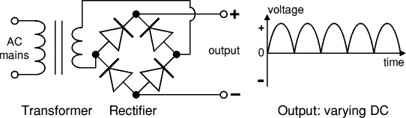

The varying DC output is suitable for lamps, heaters and standard motors. It is not suitable for electronic circuits unless they include a smoothing capacitor.

## ARDUINO UNO

Arduino/Genuino Uno is a microcontroller board based on the ATmega328P ([datasheet](http://www.atmel.com/Images/doc8161.pdf)). It has 14 digital input/output pins (of which 6 can be used as PWM outputs), 6 analog inputs, a 16 MHz quartz crystal, a USB connection, a power jack, an ICSP header and a reset button. It contains everything needed to support the microcontroller; simply connect it to a computer with a USB cable or power it with a AC-to-DC adapter or battery to get started, worst case scenario you can replace the chip for a few dollars and start over again.

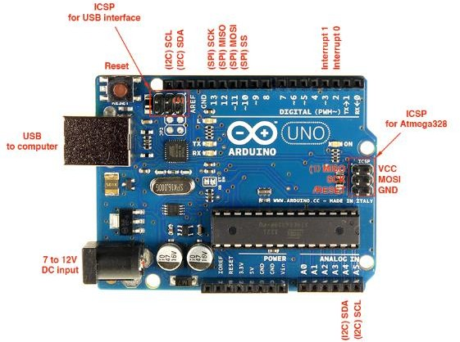"Uno" means one in Italian and was chosen to mark the release of Arduino Software (IDE) 1.0. The Uno board and version 1.0 of Arduino Software (IDE) were the reference versions of Arduino, now evolved to newer releases.

### Figure 4.9 Arduino UNO

**Arduino** is an open source, computer hardware and software company, project, and user community that designs and manufactures [microcontroller](https://en.wikipedia.org/wiki/Microcontroller) kits for building digital devices and interactive objects that can sense and control objects in the physical world. The project's products are distributed as [open-source hardware](https://en.wikipedia.org/wiki/Open-source_hardware) and [software](https://en.wikipedia.org/wiki/Open-source_software), which are licensed under the [GNU Lesser General Public License](https://en.wikipedia.org/wiki/GNU_Lesser_General_Public_License) (LGPL) or the [GNU General Public](https://en.wikipedia.org/wiki/GNU_General_Public_License) [License](https://en.wikipedia.org/wiki/GNU_General_Public_License) (GPL),[[1]](https://en.wikipedia.org/wiki/Arduino#cite_note-1) permitting the manufacture of Arduino boards and software distribution by anyone. Arduino boards are available commercially in preassembled form, or as [do-it-](https://en.wikipedia.org/wiki/Do-it-yourself) [yourself](https://en.wikipedia.org/wiki/Do-it-yourself) kits.

The Arduino Uno is a microcontroller board based on the ATmega328 (datasheet). It has 14 digital input/output pins (of which 6 can be used as PWM outputs), 6 analog inputs, a 16 MHz ceramic resonator, a USB connection, a power jack, an ICSP header, and a reset button. It contains everything needed to support the microcontroller; simply connect it to a computer with a USB cable or power it with a AC-to-DC adapter or battery to get started. The Uno differs from all preceding boards in that it does not use the FTDI USB-to-serial driver chip. Instead, it features the Atmega16U2 (Atmega8U2 up to version R2) programmed as a USB-to-serial converter. Revision 2 of the Uno board has a resistor pulling the 8U2 HWB line to ground, making it easier to put into DFU mode Revision 3 of the board has the following new features: 1.0 pinout: added SDA and SCL pins that are near to the AREF pin and two other new pins placed near to the RESET pin, the IOREF that allow the shields to adapt to the voltage provided from the board. In future, shields will be compatible with both the board that uses the AVR, which operates with 5V and with the Arduino Due that operates with 3.3V.

Arduino board designs use a variety of microprocessors and controllers. The boards are equipped with sets of digital and analog [input/output](https://en.wikipedia.org/wiki/Input/output) (I/O) pins that may be interfaced to various expansion boards (shields) and other circuits. The boards feature serial communications interfaces, including [Universal Serial Bus](https://en.wikipedia.org/wiki/Universal_Serial_Bus) (USB) on some models, which are also used for loading programs from personal computers.

The Arduino project started in 2003 as a program for students at the [Interaction](https://en.wikipedia.org/wiki/Interaction_Design_Institute_Ivrea) [Design Institute Ivrea](https://en.wikipedia.org/wiki/Interaction_Design_Institute_Ivrea) in [Ivrea,](https://en.wikipedia.org/wiki/Ivrea) Italy, aiming to provide a low-cost and easy way for novices and professionals to create devices that interact with their environment

using [sensors](https://en.wikipedia.org/wiki/Sensor) and [actuators.](https://en.wikipedia.org/wiki/Actuator) Common examples of such devices intended for beginner hobbyists include simple [robots](https://en.wikipedia.org/wiki/Robot), [thermostats,](https://en.wikipedia.org/wiki/Thermostat) and [motion detectors.](https://en.wikipedia.org/wiki/Motion_detector)

## LCD DISPLAY

Liquid crystal cell displays (LCDs) are used in similar applications where LEDs are used. These applications are display of display of numeric and alphanumeric characters in dot matrix and segmental displays.

### LCDs are of two types:

1. Dynamic scattering type
2. Field effect type

### The construction of a dynamic scattering liquid crystal cell:

The liquid crystal material may be one of the several components, which exhibit optical properties of a crystal though they remain in liquid form. Liquid crystal is layered between glass sheets with transparent electrodes deposited on the inside faces.

When a potential is applied across the cell, charge carriers flowing through the liquid disrupt the molecular alignment and produce turbulence. When the liquid is not activated, it is transparent.

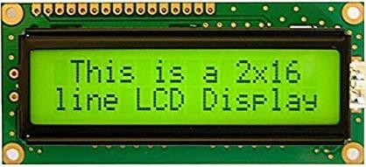

**Figure 4.10 LCD Display**

The construction of a field effect liquid crystal display is similar to that of the dynamic scattering type, with the exception that two thin polarizing optical filters are placed at the inside of each glass sheet. The liquid crystal material in the field effect cell is also of different type from employed in the dynamic scattering cell.

The material used is twisted numeric type and actually twists the light passing through the cell when the latter is not energised.A liquid crystal display (LCD) is an electronically-modulated optical device shaped into a thin, flat panel made up of any number of color or monochrome pixels filled with liquid crystals and arrayed in front of a light source (backlight) or reflector. It is often utilized in battery-powered electronic devices because it uses very small amounts of electric power. LCD has material, which continues the properties of both liquids and crystals. Rather than having a melting point, they have a temperature range within which the molecules are almost as mobile as they would be in a liquid, but are grouped together in an ordered from similar to a crystal. The inner surface of the glass plates is coated with transparent electrodes which define in between the electrodes and the crystal, which makes the liquid crystal molecules to maintain a defined orientation angle.

### Working:

When sufficient voltage is applied to the electrodes the liquid crystal molecules would be aligned in a specific direction. The light rays passing through the LCD would be rotated by the polarizer, which would result in activating/highlighting the desired characters. The power supply should be of +5v, with maximum allowable transients of 10mv. To achieve a better/suitable contrast for the display the voltage (VL) at pin 3 should be adjusted properly. A module should not be removed from a live circuit.

# CHAPTER 5 PROJECT DESCRIPTION

## MODULES

* + - Intruder identification
    - Intruder movement detection
    - Alert notification
    - Alarming the environment

## INTRUDER IDENTIFICATION

Intruder identification using Python can be accomplished using computer vision techniques and machine learning algorithms. Here is a general overview of the steps involved:

**Collect training data:** To train a machine learning model to recognize intruders, you will need to collect a large set of images or videos of both intruders and non-intruders. This will serve as the training data for the machine learning algorithm.

**Preprocess the data:** The training data will need to be preprocessed to prepare it for use in the machine learning algorithm. This may include resizing, cropping, and normalizing the images or videos.

**Train the machine learning model:** The next step is to train the machine learning model using the preprocessed training data. This can be done using a variety of machine learning algorithms, such as convolutional neural networks (CNNs), support vector machines (SVMs), or decision trees.

**Test the model:** Once the machine learning model has been trained, it will need to be tested to evaluate its performance. This can be done using a separate set of test data that was not used in the training process.

**Deploy the model:** Once the machine learning model has been trained and tested, it can be deployed to identify intruders in real-time. This can be done by capturing live videofeed from a security camera and processing the images using the trained machine learning model.

In summary, intruder identification using Python can be accomplished using computer vision techniques and machine learning algorithms. The process involves collecting and preprocessing training data, training and testing a machine learning model, and deploying the model to identify intruders in real-time.

## INTRUDER MOVEMENT DETECTION

Intruder movement detection using an IR sensor, servo motor, and ESP32 CAM can be achieved through the following steps:

**Connect the IR sensor:** Connect the IR sensor to the ESP32 board, ensuring that the power, ground, and signal pins are connected correctly.

**Connect the servo motor:** Connect the servo motor to the ESP32 board, ensuring that the power, ground, and signal pins are connected correctly.

**Set up the ESP32 CAM:** Set up the ESP32 CAM to capture live video feed from thesecurity camera and send it to the ESP32 board.

**Write the code:** Write a code in Arduino IDE or Micro Python that will read the output of the IR sensor and use it to control the servo motor. When an intruder is detected, the servo motor should rotate to face the intruder, and the ESP32 CAM should capture images or videos of the intruder.

**Send alert:** Once the intruder is detected, an alert can be sent to the security personnel using various methods such as email, SMS, or push notification.

## ALERT NOTIFICATION

Set up a GSM module: First, you will need to set up a GSM module with your ESP32 board. This will enable your device to send SMS messages to your phone when an intruderis detected.

**Detect an intruder:** To detect an intruder, you can use an IR sensor, motion sensor, or any other sensor that is capable of detecting movement. When an intruder is detected, your device should trigger an event.

**Send an SMS message:** Once an intruder is detected, your device should send an SMS message to your phone using the GSM module.

**Sound an alarm:** In addition to sending an SMS message, your device should also sound an alarm to alert anyone in the vicinity of the intrusion. This could be a loud noiseor flashing lights.

## ALARMING THE ENVIRONMENT

If you want to activate the buzzer only when an authorized person replies to the alert message from the GSM module, you can modify the code as follows Store the phone numbers of authorized persons in an array or list.When an intruder is detected, send an SMS message to the phone numbers in the array using the GSM module. When an authorized person replies to the alert message, the message will be received by the GSM module and can be processed in the code.

If the message received matches any of the authorized phone numbers, the buzzer will be activated. When an intruder is detected, the code sends an SMS message to each authorized number. If an authorized person replies to the message, the GSM module will receive the message and check if it matches any of the phone numbers given. If a match is found, the buzzer will be activated.

## BLOCK DIAGRAM

The objective of intruder detection and security monitoring using IOT is to develop a system that can detect intruders in a given area and alert the concerned authorities. This system uses various sensors such as IR motion sensors to detect any intrusion. The sensors are connected to a microcontroller, such as Arduino, which processes the signals from the sensors and triggers an alarm or sends a notification to the authorized personnel. The system can also be connected to a mobile application, which allows the user to monitor the security of their premises in real-time. The main objective of this system is to provide a cost-effective and efficient solution for intruder detection and security monitoring, which can be easily installed and used by anyone. The system can be used in various applications, such as home security, office security, and industrial security.

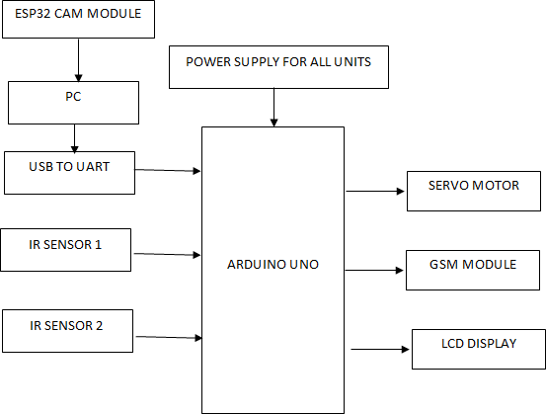

**Figure 5.1 Block Diagram**

## 

## BLOCK DIAGRAM EXPLANATION

Here the NODEMCU 8266 microcontroller acts as brain of the project, it can process the data’s which was gather from the sensor which was connected with node. We have used the IR sensor in the project, the IR sensor will detected if there is any object is available or not available and it is acting as input device. GSM is used to send the message to the particular number. If there is any intruder is detected by the IR sensor, then the GSM module will send the message to the particular. ESP32 CAM also connected with the NODEMCU 8266, the major work of ESP32 CAM is it will show live video of the particular place and using this we can able to monitor the current situation.

# CHAPTER 6

* 1. **TEST STRATEGIES**

# SYSTEM TESTING

The purpose of testing is to discover errors. Testing is the process of trying to discover every conceivable fault or weakness in a work product. It provides a way to check the functionality of components, subassemblies, assemblies and/ora finished product It is the process of exercising software with the intent of ensuring that the Software system meets its requirements and user expectations and does not fail in an unacceptable manner. There are various types of test. Each test type addresses a specific testing requirement.

## UNIT TESTING

Unit testing involves the design of test cases that validate that the internal program logic is functioning properly, and that program inputs produce valid outputs. All decision branches and internal code flow should be validated. It is the testing of individual softwareunits of the application.it is done after the completion of an individual unit before integration. This is a structural testing, that relies on knowledge of its construction and is invasive. Unit tests perform basic tests at component level and test a specific business process, application, and/or system configuration.

Unit testing is usually conducted as part of a combined code and unit test phase of the software lifecycle, although it is not uncommon for coding and unit testing to be conductedas two distinct phases. Test strategy and approach Field testing will be performed manually and functional tests will be written in detail.

### Test objectives

* All field entries must work properly.
* Pages must be activated from the identified link.
* The entry screen, messages and responses must not be delayed.

### Features to be tested

* Verify that the entries are of the correct format
* No duplicate entries should be allowed
* All links should take the user to the correct page.

## INTEGRATION TESTING

Integration tests are designed to test integrated software components to determine if they actually run as one program. Testing is event driven and is more concerned with the basic outcome of screens or fields. Integration tests demonstrate that although the components were individually satisfaction, as shown by successfully unit testing, the combination of components is correct and consistent. Integration testing is specifically aimed at exposing the problems that arise from the combination of components.

Software integration testing is the incremental integration testing of two or more integrated software components on a single platform to produce failures caused by interface defects. The task of the integration test is to check that components or software applications.

## SYSTEM TESTING

System testing ensures that the entire integrated software system meets requirements. It tests a configuration to ensure known and predictable results. An example of system testing is the configuration oriented system integration test. System testing is based on process descriptions and flows, emphasizing pre-driven process links and integration points.

## WHITE BOX TESTING

White Box Testing is a testing in which in which the software tester has knowledge of the inner workings, structure and language of the software, or at least its purpose. It is purpose. It is used to test areas that cannot be reached from a black box level.

## BLACK BOX TESTING

Black Box Testing is testing the software without any knowledge of the inner workings, structure or language of the module being tested. Black box tests, as most other kinds of tests, must be written from a definitive source document, such as specification or requirements document, suchas specification or requirements document. It is a testing in which the software under test is treated, as a black box .you cannot “see” into it. The test provides inputs and responds to outputs without considering how the software works.

# CHAPTER 7

**SYSTEM IMPLEMENTATION**

System implementation is the important stage of project when the theoretical design is tunes into practical system. The main stages in the implementation are as follows:

* + - * Planning
      * Training
      * System testing
      * Changeover planning

Implementation is the process of bringing a developed system into operational use and turning it over to the user. Implementation activities extend from planning through conversion from the old system to the new.

## SYSTEM MAINTENANCE

Security and authentication is maintained in both user level as well as the management level. The data stored is highly reliable and simpler to use, the user level security is managed with the help of password options and sessions, whichfinally ensures that all the transactions are made securely. The application’s validations are made, taken into account of the entry levels available in various modules. Possible restrictions like number formatting, date formatting and confirmations for both save and update options ensures the correct data to be fed into the database. Thus all the aspects are charted out and the complete project study is practically implemented successfully for the end user.

## SYSTEM IMPLEMENTATION

Implementation is the stage of the project where the theoretical design is turned into a working system. At this stage the main work load, the greatest upheaval and the major impact on the existing system shifts to the user department. If the implementation is not carefully planned a controlled it can cause confusion.

Implementation includes all those activities that take place to convert fromthe old system to the new one. The new system may be totally new, replacing an existing manual or automated system or it may be a major modification to an existing system. Proper implementation is essential to provide a reliable system to meet the organization requirements.

.

The system can be implemented only after thorough testing is done and if it is found to be working according to the specifications. The system personnel check the feasibility of the system. The most crucial stage is achieving a new successful system and giving confidence on the new system for the user that it will work efficiently and effectively. It involves careful planning, investigation of the current system and its constraints on implementation, design of methods to achieve the changeover.The more complex the system being implemented, the more involvement in system analysis and the design effort required just for implementation. The system implementation has three main aspects. They are education and training, system testing and changeover.

* + - Careful planning.
    - Investigation of system and constraints.
    - Design of methods to achieve the changeover.
    - Training of the staff in the changeover phase.
    - Evaluation of the changeover method.

## IMPLEMENTATION PROCEDURES

Implementation of software refers to the final installation of the package in its real environment, to the satisfaction of the intended users and the operation of the system. In many organizations someone who will not be operating it, will commission the software development project. The people are not sure that the software is meant to make their job easier.

* + - In the initial stage, they doubt about the software but we have to ensure that the resistance does not build up, as one has to make sure that.
    - The active user must be aware of the benefits of using the system
    - Proper guidance is imparted to the user so that he is comfortable in using the application.
    - Before going ahead and viewing the system, the user must know that for viewingthe result, the server program should be running in the server. If the server objectis not up running on the server, the actual processes will not take place.

# CHAPTER 8

**CONCLUSION & FUTURE ENHANCEMENTS**

## CONCLUSION

Intruder detection and security monitoring using IoT is an effective way to enhance the security of homes, offices, and other premises. By combining hardware components such as IR sensors, servo motors, and GSM modules with cloud-based services, it is possible to create a system that can detect intruders and alert authorized individuals through SMS or email notifications. Additionally, the integration of a servo motor and a buzzer allows authorized individuals to control the system and turn off the alarm if necessary.

The system implementation requires expertise in hardware and software development, as well as an understanding of networking and cloud computing concepts. It is important to follow best practices for IoT security and data privacy to ensure that the system is secure and reliable. Regular maintenance and monitoring are also required to ensure that the system is functioning properly and to prevent any potential security threats.

Overall, intruder detection and security monitoring using IoT provides an innovative solution for enhancing security, which can be customized and expanded to meet the needs of different environments.

## FUTURE ENHANCEMENTS

### Facial recognition:

Implementing facial recognition technology could enhance the accuracy of intruder detection, and allow authorized individuals to be identified quickly.

### Machine learning:

By integrating machine learning algorithms, the system could learn and adapt to different environments, and improve its accuracy over time.

### Real-time video streaming:

Adding real-time video streaming to the system would enable authorized individuals to monitor the premises in real-time, and identify any suspicious activities.

### Multi-factor authentication:

Using multi-factor authentication such as biometrics or smart cards could further enhance the security of the system, and prevent unauthorized access.

### Integration with other IOT devices:

Integrating with other IOT devices such as smart locks or security cameras could provide a comprehensive security solution, and allow authorized individuals to monitor and control the system from a single interface.

### Voice recognition:

Adding voice recognition technology to the system couldenable authorized individuals to control the system using voice commands, and eliminate the need for physical inputs.

### Environmental monitoring:

By adding sensors for monitoring temperature, humidity, and other environmental factors, the system could detect and alert authorized individuals to any abnormalities, such as a fire or gas leak.

Overall, intruder identification and security monitoring using IOT provides a scalable and customizable solution that can be enhanced with new technologies to meet the evolving security needs of different environments. The security system will be modified with the help of web applications, In future the option will be done in both android application and IOS application. In future the system will catch the intruder by itself by spraying gases. In future the security system will be updated by installing many features.

# CHAPTER 9 APPENDIX

## SOURCE CODE Python code

import face_recognition import cv2

import numpy as np import os

import six.moves.urllib as urllib import datetime

import pandas as pd import serial

ser = serial.Serial('COM3',baudrate=9600,timeout=0.3) cam='[http://192.168.124.200/cam-hi.jpg'](http://192.168.124.200/cam-hi.jpg%27)

print("Data Train_1")

kishore_image = face_recognition.load_image_file("kishore.jpeg") kishore_face_encoding = face_recognition.face_encodings(kishore_image)[0] print("Data Train_2")

mahadeven_image = face_recognition.load_image_file("mahadeven.jpeg") mahadeven_face_encoding = face_recognition.face_encodings(mahadeven_image)[0] print("Data Train Completed")

# Create arrays of known face encodings and their names known_face_encodings = [

kishore_face_encoding, mahadeven_face_encoding

]

known_face_names = [ "kishore", "mahadeven",

]

# Initialize some variables face_locations = [] face_encodings = []

face_names = [] process_this_frame = True while True:

## serial_func()

## ret, frame = cam.read()

img_resp = urllib.request.urlopen(cam)

img_arr = np.array(bytearray(img_resp.read()), dtype=np.uint8)

# Grab a single frame of video frame = cv2.imdecode(img_arr, -1)

# Resize frame of video to 1/4 size for faster face recognition processing small_frame = cv2.resize(frame, (0, 0), fx=0.25, fy=0.25)

# Convert the image from BGR color (which OpenCV uses) to RGB color (which face_recognition uses)

rgb_small_frame = small_frame[:, :, ::-1]

# Only process every other frame of video to save time if process_this_frame:

# Find all the faces and face encodings in the current frame of video face_locations = face_recognition.face_locations(rgb_small_frame)

face_encodings = face_recognition.face_encodings(rgb_small_frame, face_locations) face_names = []

for face_encoding in face_encodings:

# See if the face is a match for the known face(s)

matches = face_recognition.compare_faces(known_face_encodings, face_encoding) name = "Unknown"

# Or instead, use the known face with the smallest distance to the new face

face_distances = face_recognition.face_distance(known_face_encodings, face_encoding)

best_match_index = np.argmin(face_distances) if matches[best_match_index]:

name = known_face_names[best_match_index] face_names.append(name)

process_this_frame = not process_this_frame

# Display the results

for (top, right, bottom, left), name in zip(face_locations, face_names):

# Scale back up face locations since the frame we detected in was scaled to 1/4 size

top *= 4

right *= 4

bottom *= 4

left *= 4

# Draw a box around the face

cv2.rectangle(frame, (left, top), (right, bottom), (0, 0, 255), 2)

# Draw a label with a name below the face

cv2.rectangle(frame, (left, bottom - 35), (right, bottom), (0, 0, 255), cv2.FILLED) font = cv2.FONT_HERSHEY_DUPLEX

cv2.putText(frame, name, (left + 6, bottom - 6), font, 1.0, (255, 255, 255), 1)

## cv2.imwrite("capture.jpg",frame) if(name=="Unknown"):

ser.write('1'.encode()) print("unknown")

if(name=="kishore"): print("kishore")

if(name=="mahadeven"): print("mahadeven")

##

cv2.imshow('frame',cv2.resize(frame,(800,600))) # Hit 'q' on the keyboard to quit!

if cv2.waitKey(1) & 0xFF == ord('q'): break

# Release handle to the webcam video_capture.release() cv2.destroyAllWindows()

## Embedded C

// include the library code: #include <LiquidCrystal.h> #include <SoftwareSerial.h>

SoftwareSerial mySerial(6, 7); // RX, TX

const int rs = 8, en = 9, d4 = 10, d5 = 11, d6 = 12, d7 = 13; LiquidCrystal lcd(rs, en, d4, d5, d6, d7);

#include <Servo.h>

Servo myservo; // create servo object to control a servo

// twelve servo objects can be created on most boards

int pos = 0; // variable to store the servo position void gsm_send();

void gsm_send1(); void make_call();

const String PHONE = "+919787857769"; //use your number with country code

void setup() { myservo.attach(3);

Serial.begin(9600); mySerial.begin(9600); pinMode(4,INPUT); pinMode(6,OUTPUT); pinMode(5,INPUT);

lcd.begin(16, 2);

// Print a message to the LCD. lcd.print(" WELCOME "); digitalWrite(6,LOW);

}

void loop()

{

int a=digitalRead(4); int b=digitalRead(5); if(a==0)

{

myservo.write(180); lcd.setCursor(0,0);

lcd.print("left IR detected");

}

if(b==0)

{

myservo.write(0);

lcd.setCursor(0,0); lcd.print("Right IR Detected");

}

if (Serial.available() > 0) { int c = Serial.read(); if(c=='1')

{

digitalWrite(6,HIGH); make_call();

delay(2000);delay(2000);

gsm_send(); delay(2000); digitalWrite(6,LOW);

gsm_send1(); delay(2000);

}

}

}

void gsm_send()

{

lcd.clear(); lcd.setCursor(0,0);

lcd.print("sending sms1. ");

delay(500);

Serial.print("AT"); // SIM CARD READY CHECK delay(100); delay(100);

Serial.write(13); // ENTER delay(1000);

Serial.write(10); // NEW LINE delay(1000);

Serial.print("AT+CMGF=1"); // SIM CARD READY CHECK

delay(100); delay(100); Serial.write(13); // ENTER

delay(1000);

Serial.write(10); // NEW LINE delay(1000);

Serial.print("AT+CNMI=2,2,2,0"); // SIM CARD READY CHECK

delay(100); delay(100); Serial.write(13); // ENTER delay(1000);

Serial.write(10); // NEW LINE delay(1000);

Serial.print("AT+CMGS="); // SMS SEND FUNCTION

delay(100); delay(100); Serial.print('"'); delay(100); delay(100);

Serial.print("9787857769"); delay(100); delay(100); Serial.print('"');

delay(100); delay(100); Serial.write(13); delay(1000); Serial.print("Intruder alert "); delay(100); delay(100);

Serial.write(13); // ENTER delay(1000);

Serial.write(10); // NEW LINE delay(1000);

Serial.write(26); // CTRL+Z delay(100); delay(100); lcd.setCursor(0,0);

delay(600);

lcd.print(" COMPLETED ");

}

void gsm_send1()

{

lcd.clear(); lcd.setCursor(0,0);

lcd.print("sending sms1. ");

delay(500);

Serial.print("AT"); // SIM CARD READY CHECK

delay(100); delay(100); Serial.write(13); // ENTER delay(1000);

Serial.write(10); // NEW LINE delay(1000);

Serial.print("AT+CMGF=1"); // SIM CARD READY CHECK

delay(100); delay(100); Serial.write(13); // ENTER delay(1000);

Serial.write(10); // NEW LINE delay(1000);

Serial.print("AT+CNMI=2,2,2,0"); // SIM CARD READY CHECK

delay(100); delay(100); Serial.write(13); // ENTER delay(1000);

Serial.write(10); // NEW LINE delay(1000);

Serial.print("AT+CMGS="); // SMS SEND FUNCTION

delay(100); delay(100); Serial.print('"'); delay(100); delay(100);

Serial.print("8072592779"); delay(100); delay(100); Serial.print('"');

delay(100); delay(100); Serial.write(13); delay(1000); Serial.print("Intruder alert "); delay(100); delay(100);

Serial.write(13); // ENTER delay(1000);

Serial.write(10); // NEW LINE delay(1000);

Serial.write(26); // CTRL+Z delay(100); delay(100); lcd.setCursor(0,0);

delay(600);

lcd.print(" COMPLETED ");

}

//*****************************************************

// call_funtion

//***************************************************** void make_call()

{

lcd.clear(); lcd.setCursor(0,0); lcd.print("calling ");

Serial.println("calling ");

Serial.println("ATD9787857769;"); delay(20000); //20 sec delay Serial.println("ATH");

delay(1000); //1 sec delay

}

## SCREENSHORTS:

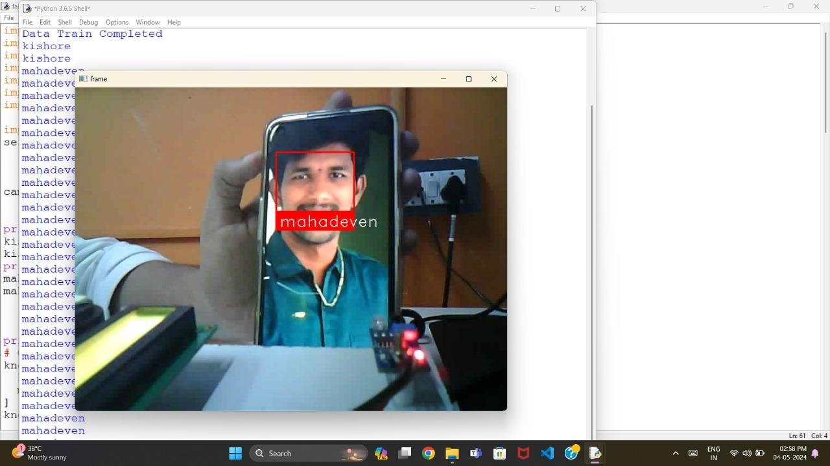

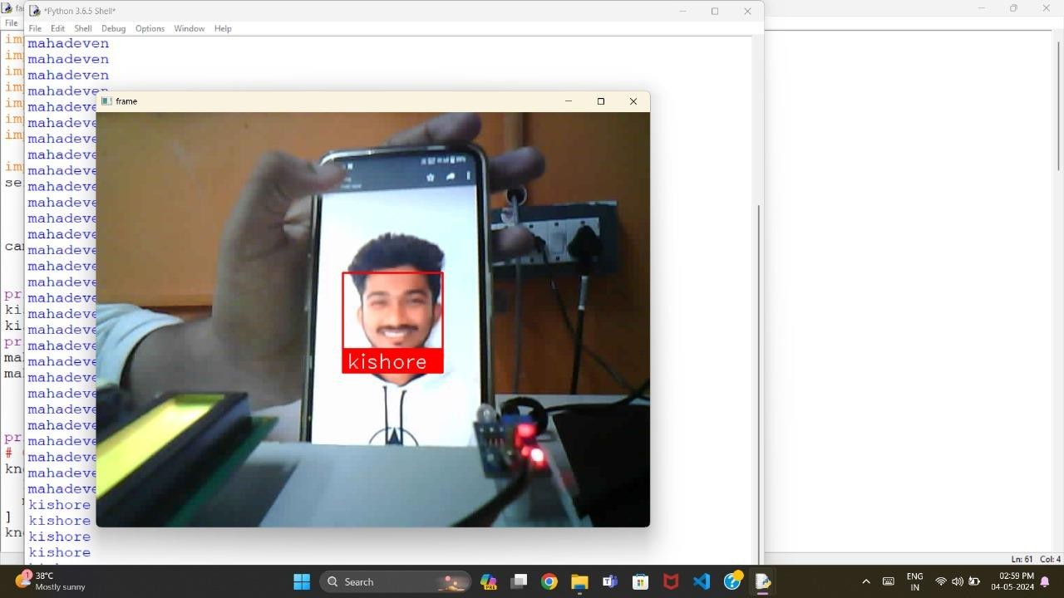

**Figure 9.1 Authorization Person Face Detection**



## Figure 9.2 Training The Data To The System

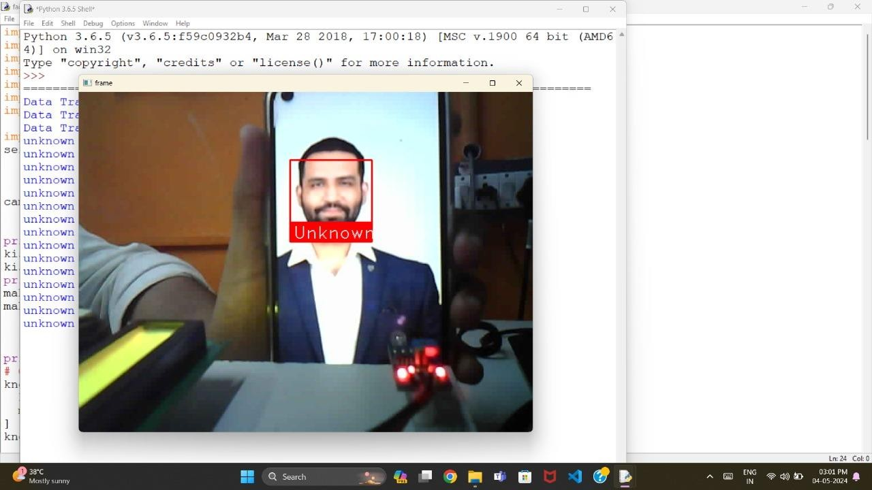

**Figure 9.3 Unknown Person Face Detection**

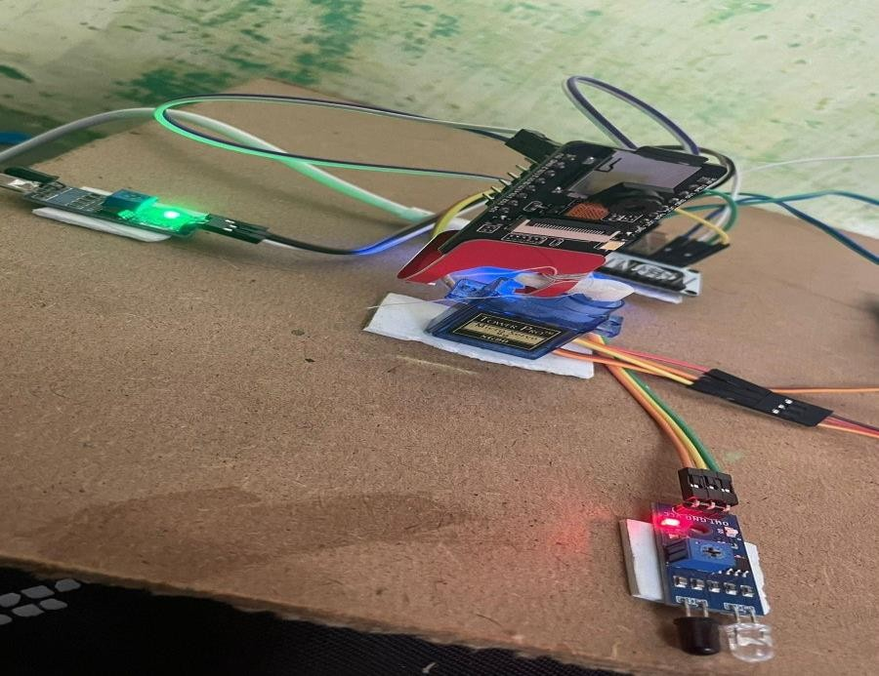

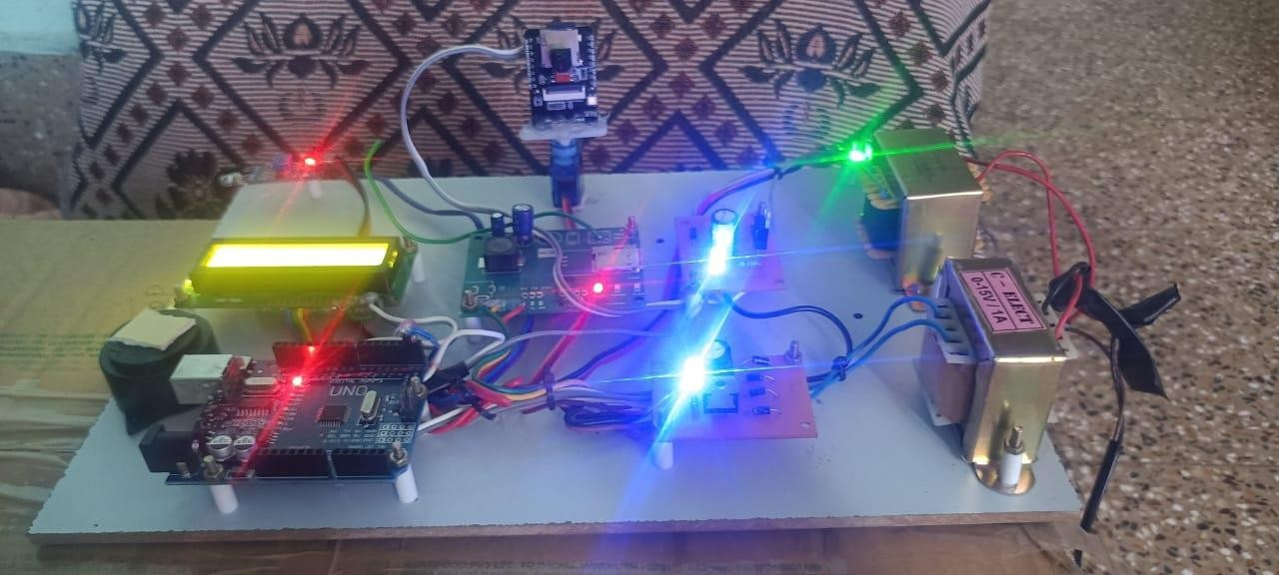

## Figure 9.4 For Intruder Movement Detection

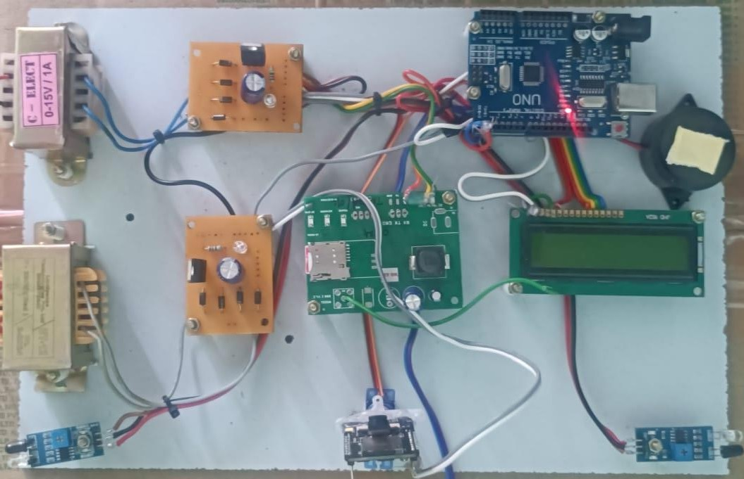

**Figure 9.5 Hardware Connection**

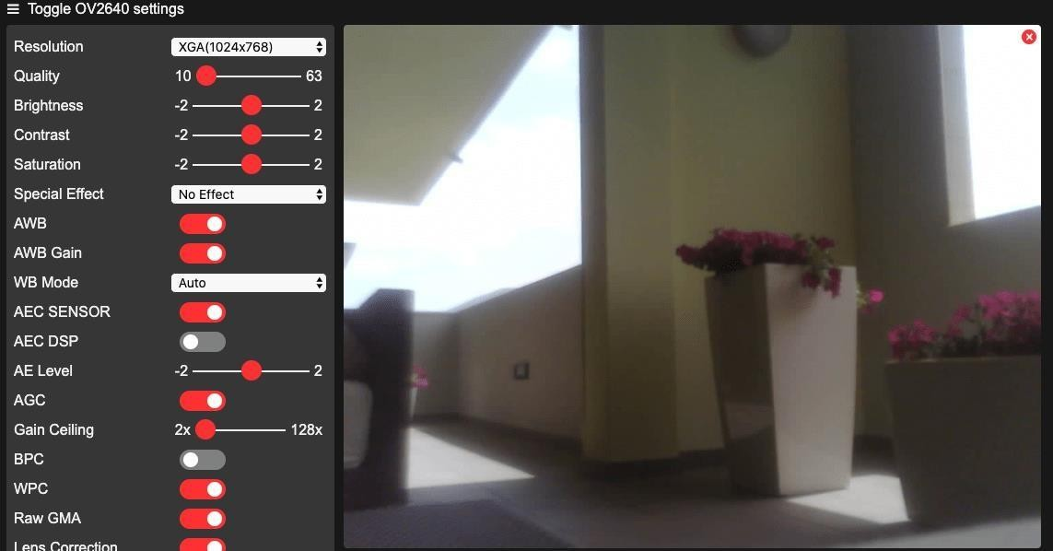

## Figure 9.6 Live Streaming

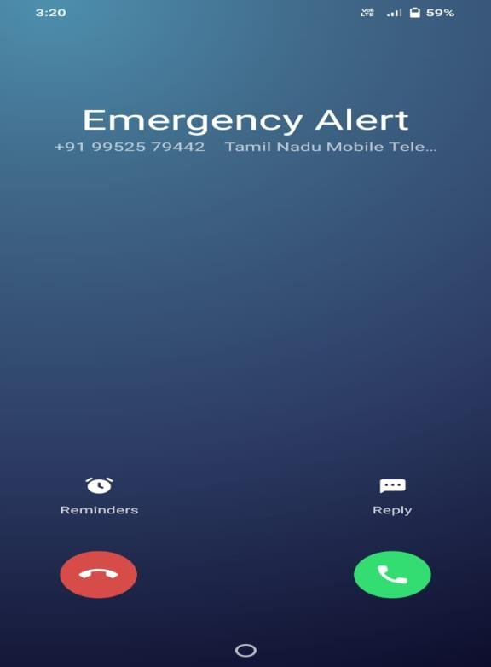

**Figure 9.7 Emergency Phone Call**

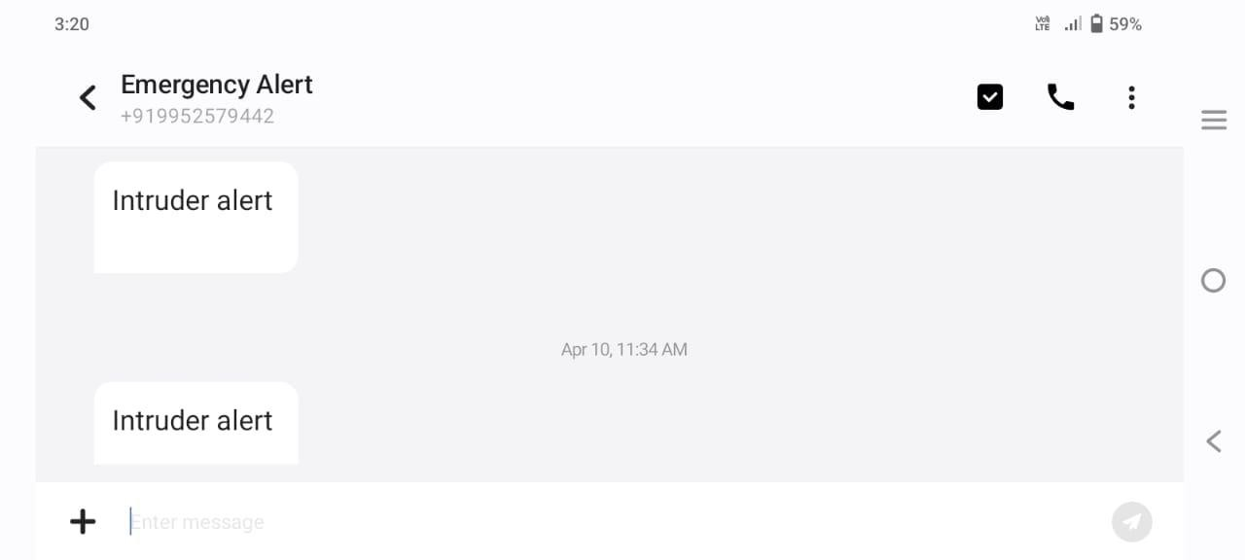

**Figure 9.8 Message Notification**

# CHAPTER 10 REFERENCES

## BOOK REFERENCES

* + 1. M. Pirbazari, M. Farmanbar, A. Chakravorty, and C. Rong, ‘‘Shortterm load forecasting using smart meter data: A generalization analysis,’’ Processes, vol. 8, no. 4, p. 484, Apr. 2020.
    2. Ranking Security of IoT-Based Smart Home Consumer Devices, NABA M. ALLIFAH AND IMRAN A. ZUALKERNAN, 2022.
    3. A Smart Home Energy Management System Utilizing Neuro computing-Based Time- Series Load Modeling and Forecasting Facilitated by Energy Decomposition for Smart Home Automation, YU-HSIU LIN , HUEI-SHENG TANG , TING-YU SHEN , AND CHIH-HSIEN HSIA,2022.
    4. S. Y. Chen and Z. L. Hu, ‘‘A smart grid-based home energy aware system,’’ Sens. Mater., vol. 29, pp. 1513–1522, 2017.
    5. T. L. Chen, T. C. Kang, C. Y. Chang, T. C. Hsiao, and C. C. Chen, ‘‘Smart home power management based on Internet of Things and smart sensor networks,’’ Sens. Mater., vol. 33, pp. 1687–1702, 2021.
    6. M. Jin, S. Liu, S. Schiavon, and C. Spanos, ‘‘Automated mobile sensing: Towards high- granularity agile indoor environmental quality monitoring,’’ Building Environ., vol. 127, pp. 268–276, Jan. 2018.
    7. W. L. Hsu, W. T. Chen, H. H. Kuo, Y. C. Shiau, T. Y. Chern, S. C. Lai, and W. H. Fan, ‘‘Establishment of smart living environ.
    8. M. Inoue, K. Uemura, Y. Minagawa, M. Esaki, and Y. Honda, ‘‘A home automation system,’’ IEEE Trans. Consum. Electron., vol. CE-31, no. 3, pp. 516–527, Aug. 1985, doi: 10.1109/TCE.1985.289966.

## WEB REFERENCES

* + 1. https://[www.javatpoint.com/iot-internet-of-things](http://www.javatpoint.com/iot-internet-of-things)
    2. https://[www.educba.com/data-science/data-science-tutorials/iot-tutorial/](http://www.educba.com/data-science/data-science-tutorials/iot-tutorial/)
    3. https://developer.ibm.com/technologies/iot/tutorials/
    4. https://[www.javatpoint.com/embedded-system-c-programming](http://www.javatpoint.com/embedded-system-c-programming)
    5. https://[www.iotforall.com/embedded-programming-iot](http://www.iotforall.com/embedded-programming-iot)