SWOT RISK
Enterprise Edition
GRC Platform Walkthrough
Risk Management & SOC 2 Alignment
Prepared: February 2026 | Classification: Confidential

1. Introduction

Purpose of the Application
The SWOT Risk Management platform is a comprehensive Governance, Risk, and Compliance (GRC) solution designed to centralize and automate the lifecycle of risk management. It provides a single source of truth for identifying, assessing, mitigating, and monitoring organizational risks while ensuring transparency and accountability.

Target Users
- Security & Compliance Teams: To manage SOC 2 controls, evidence, and risk registers.
- Risk Managers: To oversee the risk landscape and coordinate mitigation efforts.
- IT & Operations: To implement technical controls and respond to incidents.
- Management & Executive Board: To gain high-level visibility for strategic decision-making.

GRC Pillars Supported
- Risk Governance: Standardized methodologies for risk identification and scoring.
- Control Oversight: Systematic tracking of Control Library effectiveness.
- Continuous Monitoring: Real-time dashboards and AI-powered drift detection.
- Audit Readiness: Detailed audit trail of all risk treatments for SOC 2 Type I/II.

2. SOC 2 Context Overview
The platform is engineered to align with the AICPA Trust Services Criteria (TSC), specifically supporting the following SOC 2 principles:
SOC 2 Principle | Platform Support
Security | Centralized risk identification and incident tracking to protect against unauthorized access.
Availability | Monitoring of operational risks (e.g., system downtime) and remediation planning.
Confidentiality | Role-Based Access Control (RBAC) ensuring sensitive data is visible only to authorized personnel.
Processing Integrity | Standardized scoring models and AI-assisted analysis for consistency and accuracy in risk reporting.

3. User Access & Authentication
Effective logical access control is a cornerstone of SOC 2 (CC6.1). The platform implements strict Role-Based Access Control (RBAC) to ensure that users only access functionality necessary for their roles.

Role-Based Visibility
- Admin: Full governance control, user management, and system configuration.
- Risk Manager: Oversight of all risks and controls; ability to assign tasks.
- Auditor: Specialized Read-Only access to all registers and evidence.
- Standard User: Focused view of assigned risks and remediation actions.
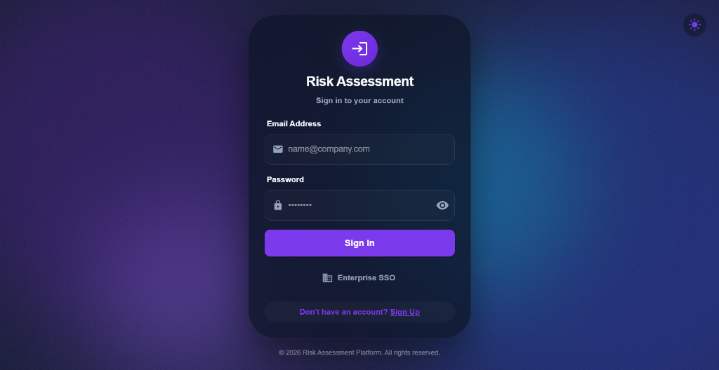
Figure 1: Secure Login portal with Role-Based Access Control and Enterprise SSO integration.

4. Dashboard — Risk Visibility
The Dashboard provides the Continuous Monitoring required for SOC 2 (CC4.1). It offers real-time visualization of the risk landscape, allowing leadership to perform rapid oversight.

Key Metrics
- Analytics Overview: Real-time tracking of Total Risks, Critical items, Mitigated, and Closed risks.
- Risk Distribution Matrix (Heatmap): Visualizes risk density across Likelihood and Impact axes.
- Portfolio Health: Immediate visibility into critical exposures requiring urgent attention.
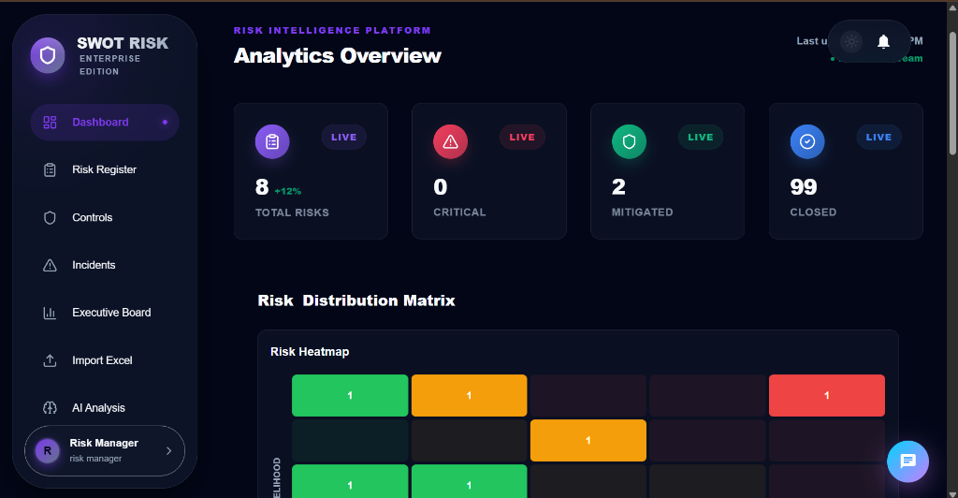
Figure 2: Analytics Overview illustrating live risk distribution and portfolio monitoring.

5. Risk Identification
A structured risk identification process (SOC 2 CC3.2) is critical for comprehensive coverage. The Risk Register allows systematic capture of potential threats across all departments.

Risk Attributes
- Unique Identifiers: Automated ID generation (e.g., RISK-2026-157) for precise audit traceability.
- Severity Categorization: Visual indicators for severity (Critical, High, Medium, Low).
- Departmental Context: Mapping risks to IT, Marketing, Operations, Finance, and HR.
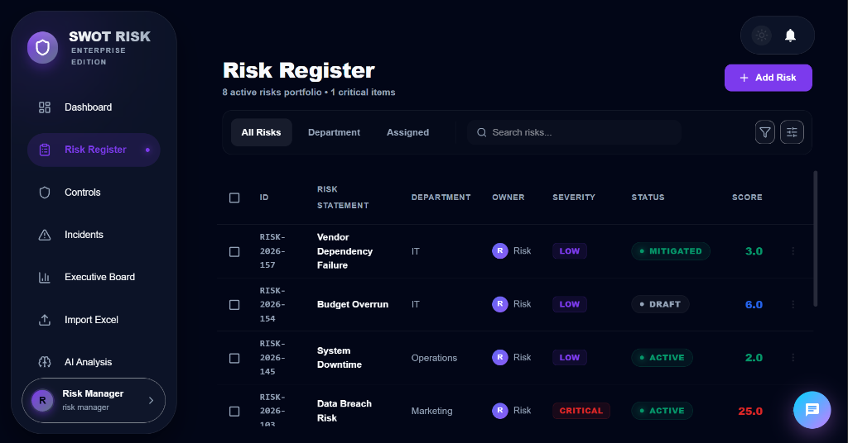
Figure 3: Centralized Risk Register displaying categorized threats and current status tracking.

6. Risk Assessment & Scoring
The platform utilizes a standardized scoring methodology to ensure objective risk prioritization. Risks are assessed based on Impact and Likelihood, resulting in an objective risk score.

AI-Powered Methodology
- AI Strategic Insights: Deep-learning analysis provides context-aware assessments and mitigation suggestions.
- AI Scoring Assistant: Recommends objective scores based on risk statements and descriptions.
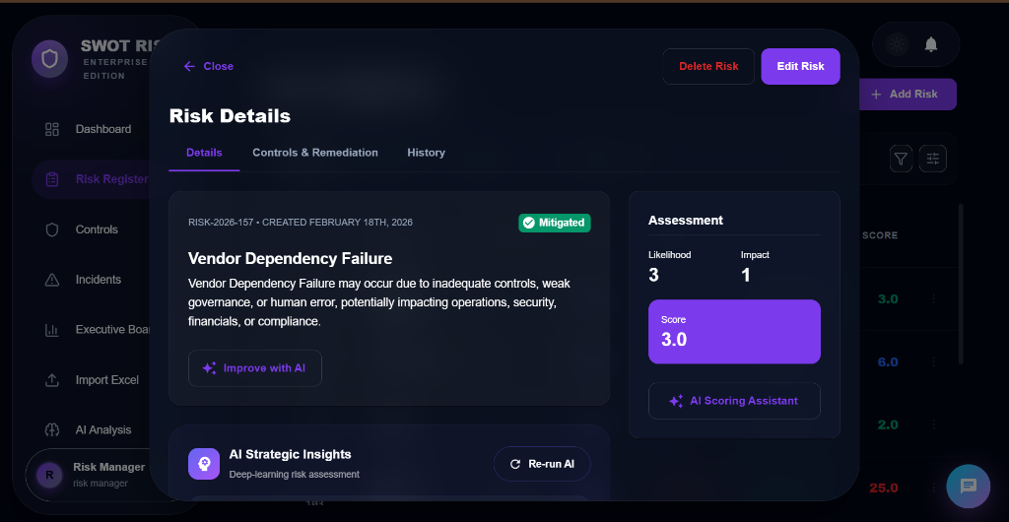
Figure 4: Detailed Risk Assessment view with AI-powered scoring assistance and strategic insights.

7. Risk Treatment & Mitigation
Once assessed, risks must be treated (SOC 2 CC3.3). The platform supports primary treatment strategies: Reduction, Acceptance, Transfer, and Avoidance.

Remediation Tracking
Remediation plans are linked to controls and tracked through lifecycle statuses (Identified → In Progress → Mitigated → Closed). The My Risks view provides individual owners with a tailored checklist of their responsibilities.
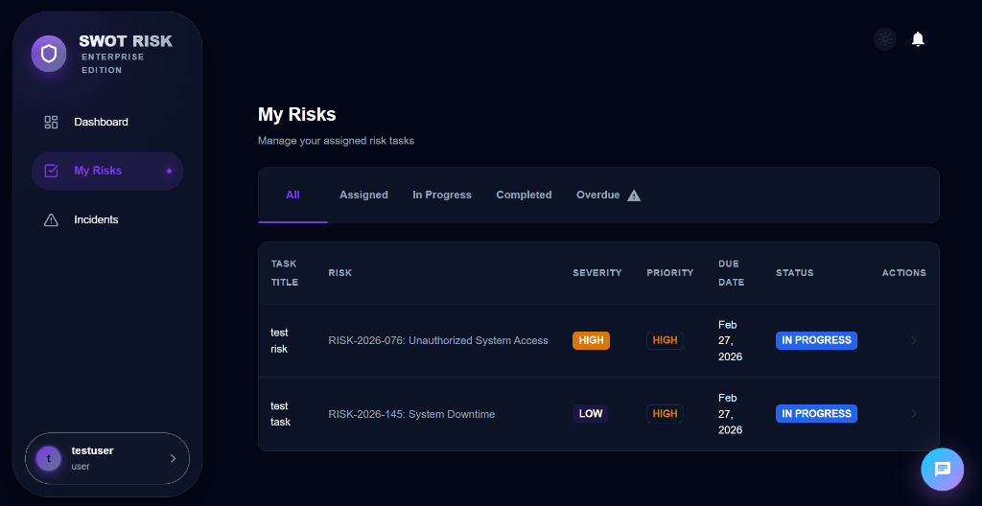
Figure 5: Personal Risk Dashboard (My Risks) ensuring accountability for remediation tasks.

8. Control Mapping & Evidence (SOC 2 Critical)
Traceability is the 'Golden Thread' of an audit. The Control Library links specific security controls directly to identified risks and operational tasks.

Control Attributes
- Classification: Preventive, Detective, or Corrective controls.
- Implementation Tracking: Real-time status updates (Designed, Implemented, Optimized).
- Effectiveness Scoring: Standardized assessments to provide assurance to auditors.
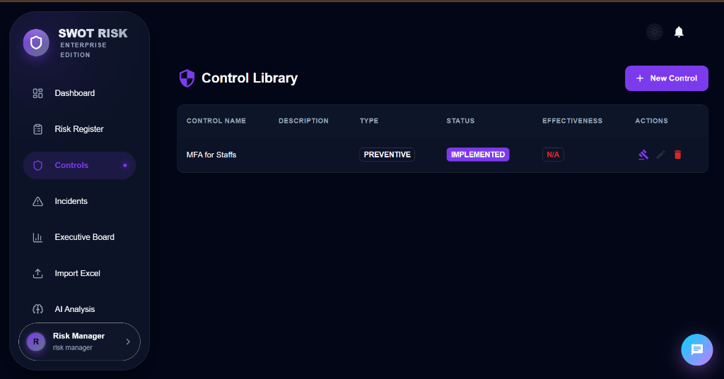
Figure 6: Control Library managing enterprise security controls and implementation status.

9. AI Risk Assistant
The platform features a built-in AI Risk Assistant (Chat Bot) that provides conversational access to the entire risk landscape. Available on every page, it enables instant querying without navigating menus.

Capabilities
- Natural Language Querying: Ask questions like "What are my most critical IT risks?" or "Show overdue tasks."
- Contextual Intelligence: Provides immediate insights based on the current view (Compliance, Risks, or Controls).
- Audit Support: Quickly retrieves evidence or control status during auditor walkthroughs.
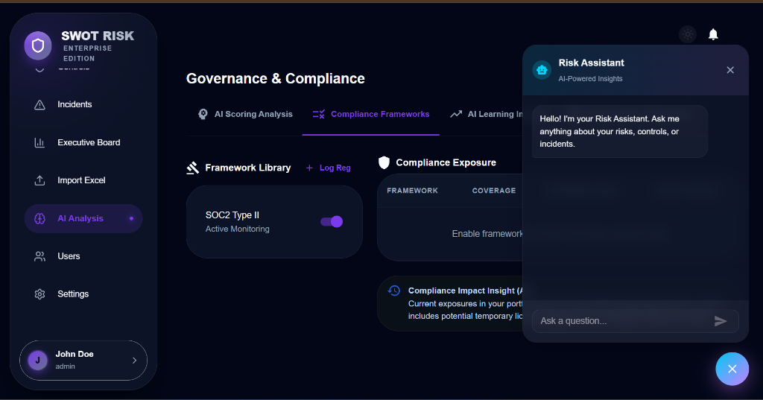
Figure 7: AI Risk Assistant providing real-time, conversational insights into the GRC environment.

10. Monitoring & Incident Management
SOC 2 requires the logging and resolution of security events (CC7.2). The Incidents page centralizes the monitoring of threats and their full lifecycle management.

Features
- Event Logging: Capture security events with severity levels (Critical, High, Medium, Low).
- AI Root Cause Analysis: AI-assisted deep-dive investigation into systemic failures.
- Resolution Tracking: Every incident has a documented resolution, vital for audit evidence.
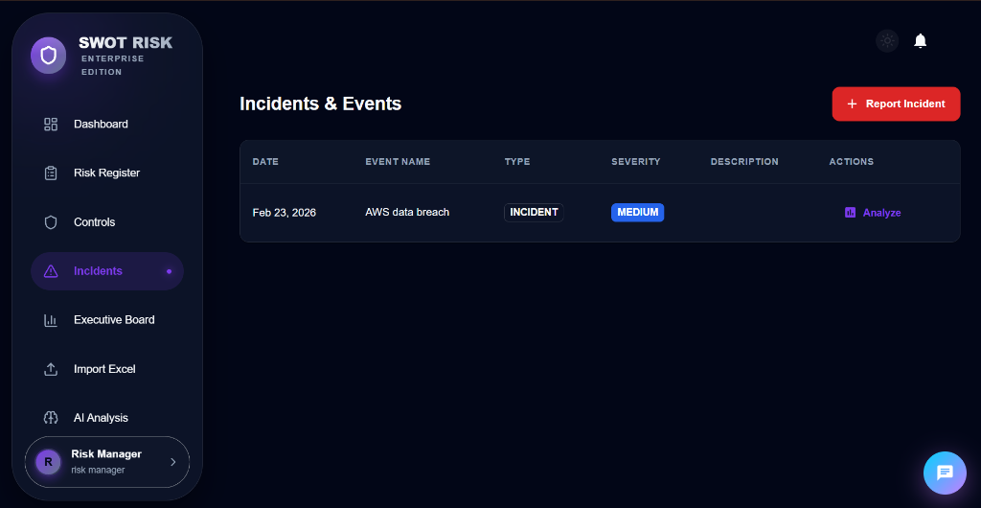
Figure 8: Centralized Incident & Event monitoring for SOC 2 security compliance.

11. Reporting & Executive Governance
The Executive Board Deck provides automated, AI-generated summaries tailored for stakeholders, the Board, and external auditors.

Deliverables
- AI Executive Summary: Narrative summaries of current risk posture and compliance status.
- Stakeholder Briefs: Tailored report generation for CRO, Auditor, and Board of Directors.
- Exportable Artifacts: PDF export for Board meetings and SOC 2 audit submissions.
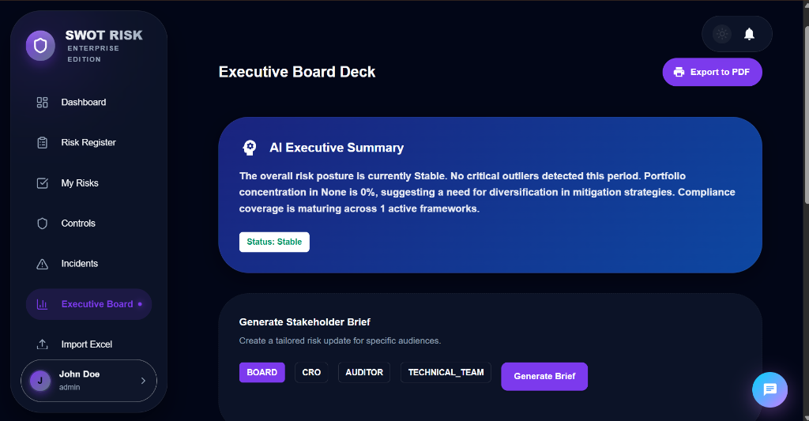
Figure 9: Executive Board Deck featuring AI-generated stakeholder summaries.

12. Governance & Compliance Frameworks
The AI Analysis module provides dedicated governance tooling, including compliance framework monitoring. The platform actively monitors SOC 2 Type II as its primary framework.

Framework Monitoring
- Compliance Exposure: Real-time visibility into framework coverage and control gaps.
- Compliance Impact Insight (AI): AI-driven alerts on potential regulatory scrutiny based on current exposures.
- Framework Library: Centralized management of SOC 2, ISO 27001, and other industry standards.
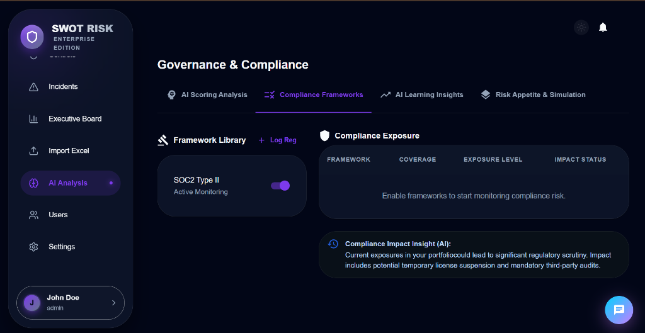
Figure 10: Governance & Compliance module monitoring SOC 2 framework alignment and exposure.

13. Administration & Configuration
Admin Settings allow governance teams to configure the platform to specific risk appetite, scoring models, and AI capabilities.

Configuration Areas
- AI Controls: Granular toggles for AI Risk Scoring, Outlier Detection, and Excel Import mapping.
- User Management: Centralized control over roles, departments, and user status (Active/Inactive).
- Audit History: Comprehensive logs of all administrative and governance changes.
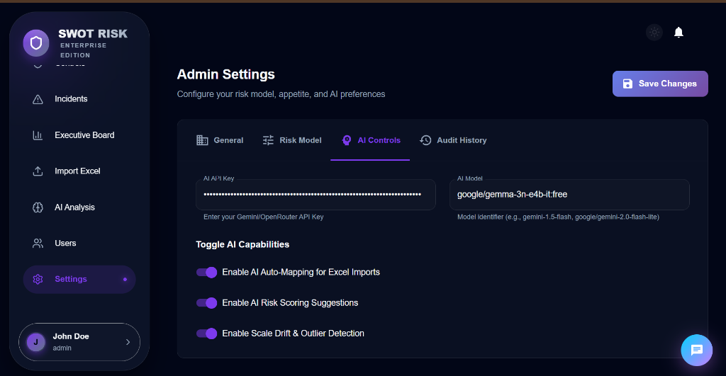
Figure 11: Administrative settings for configuring AI parameters and organizational governance.

14. Summary
The SWOT RISK platform provides a comprehensive, audit-ready GRC solution. By combining structured risk identification, AI-powered scoring, automated reporting, and a conversational AI assistant, the platform dramatically reduces the compliance burden while improving organizational risk posture.

© 2026 SWOT Risk Platform | All Rights Reserved | Confidential

