SOFTWARE REQUIREMENTS
SPECIFICATION
SmartLog
Web-Based Real-Time Scholar Attendance
and Center Monitoring System
For Passerelles Numériques Philippines (PNPh)

Document Information | Value
Document Type | Software Requirements Specification (SRS)
Version | 1.0
Project Type | Client-based / Capstone Project
Client | Passerelles Numériques Philippines (PNPh)
System | SmartLog
Prepared By | Project Development Team
Status | Baseline for client review and approval
Date | 07 October 2026

Prepared as a formal requirements baseline for design, development, testing, and client validation.

Document Control

Revision History
Version | Date | Description | Prepared / Reviewed By
0.1 | Initial draft | Initial requirements draft for SmartLog. | Project Team
1.0 | 07 Oct 2026 | Professionalized SRS incorporating the supplied project notes, workflow, architecture, database reference, and UI mockup. | Project Development Team

Approval / Acceptance
Role | Name | Signature | Date
Client Representative – PNPh
Project Adviser / Instructor
Project Team Representative

Document Status
This document is the requirements baseline for the SmartLog project. Any requirement that changes after client review should be recorded as a controlled revision so that design, implementation, testing, and acceptance remain aligned.

Table of Contents
1. Introduction
2. Project Overview
3. Stakeholders and User Roles
4. Scope and Boundaries
5. Product Perspective and System Architecture
6. Functional Requirements
7. Business Rules and Data Policies
8. User Interface and Dashboard Requirements
9. Data and Database Requirements
10. Non-Functional Requirements
11. Security, Privacy, and Audit Requirements
12. System Workflows
13. Reporting Requirements
14. Acceptance Criteria and Traceability
15. Assumptions, Constraints, and Dependencies
16. Future Enhancements
Appendix A. Requirement Summary
Appendix B. Reference Design Artifacts

1. Introduction

1.1 Purpose
This Software Requirements Specification (SRS) defines the functional, non-functional, data, security, interface, and operational requirements for SmartLog, a web-based attendance and center-monitoring system proposed for Passerelles Numériques Philippines (PNPh). The system replaces the traditional paper-based logbook with a centralized digital process for recording scholar Time In and Time Out, monitoring current attendance status, maintaining historical records, and producing reports.

1.2 Project Background
PNPh monitors scholars entering and leaving the center to support accountability, safety, and efficient student management. The current paper-based process can lead to incomplete records, handwriting errors, delayed monitoring, difficult report preparation, and time-consuming retrieval. SmartLog is intended to provide a secure and organized digital alternative with controlled access for scholars, social workers, and administrators.

1.3 Objectives
- Replace the traditional paper-based logbook with a digital attendance record.
- Monitor scholar entry and exit activities in near real time.
- Organize scholars by batch year and block section for easier monitoring.
- Generate and manage unique PN IDs automatically.
- Provide controlled academic-information updates during administrator-approved periods.
- Provide centralized attendance history and reporting for authorized staff.
- Allow scholars to view their own attendance records through mobile read-only access.
- Reduce manual record-keeping and improve the accuracy and traceability of attendance data.

1.4 Intended Audience
This SRS is intended for PNPh client representatives, administrators and social workers, the project development team, database and application developers, UI/UX designers, testers, project advisers, and other stakeholders involved in review, implementation, and acceptance.

1.5 Source Basis
The requirements in this version consolidate the existing SRS draft with the supplied project notes, registration and PN ID rules, dashboard layout, system architecture diagram, database/ERD reference, and interface mockups. Items that remain dependent on client policy are explicitly marked for validation rather than being treated as confirmed policy.

2. Project Overview

2.1 Product Description
SmartLog is a responsive web application with three primary access contexts: a designated logbook station for attendance encoding, an administrator/social-worker interface for monitoring and reports, and a scholar mobile interface for read-only attendance viewing.

2.2 Core Capabilities
Capability | Description
Authentication & access control | Verifies authorized users and limits features according to role.
Scholar registration | Registers scholars using an official organizational email and required academic information.
PN ID management | Automatically generates a unique PN ID using the defined batch-year and alphabetical-order rule.
E-Logbook | Records Time In and Time Out with system-generated date and time.
Live monitoring | Shows current scholar status and recent attendance activity on authorized dashboards.
Academic information management | Allows approved academic fields to be updated during an administrator-controlled update period.
History & search | Retrieves daily, weekly, monthly, and filtered attendance records.
Reports | Generates daily, late, absent, and monthly attendance reports and supports PDF/Excel export.
Mobile read-only view | Lets scholars view their own attendance information without editing or encoding records.

2.3 Expected Benefits
Stakeholder | Expected Benefit
Scholars | Faster logging and transparent access to personal attendance history.
Social Workers | Real-time monitoring, searchable records, and faster reporting.
PNPh Management | Centralized records, reduced paperwork, improved accountability, and better access to attendance summaries.

3. Stakeholders and User Roles

3.1 Stakeholders
Stakeholder | Primary Interest
PNPh Management | Reliable monitoring, accountability, reporting, and controlled student information.
Administrators | System configuration, user management, scholar records, monitoring, and reports.
Social Workers | Daily monitoring, attendance tracking, record search, and reporting.
Scholars | Accurate attendance recording and access to their own attendance history.
Project Development Team | Requirements implementation, testing, deployment, and maintenance.

3.2 Role Permissions
Function | Scholar | Social Worker | Administrator
Register / access own account | Yes | N/A | Manage accounts
View own attendance | Yes | Yes | Yes
Encode Time In / Time Out | At logbook station | Authorized | Authorized
View other scholars | No | Yes | Yes
Manage scholar records | No | Limited / monitoring | Yes
Manage attendance records | No | Monitor | Yes
Generate reports | No | Yes | Yes
Export reports | No | As authorized | Yes
Configure academic setup | No | No | Yes
Control academic update period | No | No | Yes
Review update history | No | Yes / as authorized | Yes

Access levels should be enforced by role-based authorization rather than by interface visibility alone.

4. Scope and Boundaries

4.1 In Scope
- Scholar account registration and organizational-email verification.
- PN ID generation and scholar identity management.
- Academic setup: school year, semester, batch year, and block section.
- Administrator-controlled academic information update periods.
- Time In and Time Out recording at the designated logbook station.
- Real-time or near-real-time attendance monitoring for authorized staff.
- Scholar attendance history and filtered search.
- Daily, late, absent, and monthly attendance reports.
- PDF and Excel report export.
- Responsive scholar read-only access on mobile devices.
- Audit history for controlled updates and important system actions.

4.2 Out of Scope for Version 1.0
- QR-code, RFID, and biometric attendance capture.
- Native Android/iOS application.
- SMS and email alert automation beyond account verification requirements.
- Predictive attendance analytics.
- Integration with external school information systems unless separately approved.

4.3 System Boundary
SmartLog covers the digital recording, storage, monitoring, retrieval, and reporting of PNPh scholar attendance and related account/academic information. Physical security procedures, hardware procurement, and PNPh policies outside the application are external to the software boundary.

5. Product Perspective and System Architecture

5.1 Technology Baseline
Layer | Technology / Component | Purpose
Presentation | HTML, CSS, JavaScript, Bootstrap | Responsive web interfaces.
Application | PHP / Laravel | Business logic, authentication, access control, attendance processing, reporting.
Data | MySQL | Centralized storage for scholar, attendance, account, academic, and system data.
Client Devices | Desktop / Laptop / Mobile browser | Logbook station, staff monitoring, and scholar read-only access.

5.2 Logical Architecture and Interface Reference
The reference architecture separates user access, application services, and persistent data. The main application services are Authentication, E-Logbook, Student/Scholar Attendance View, Monitoring, and Reporting. Authorized requests are processed by the Laravel/PHP application layer and stored or retrieved from the MySQL database.

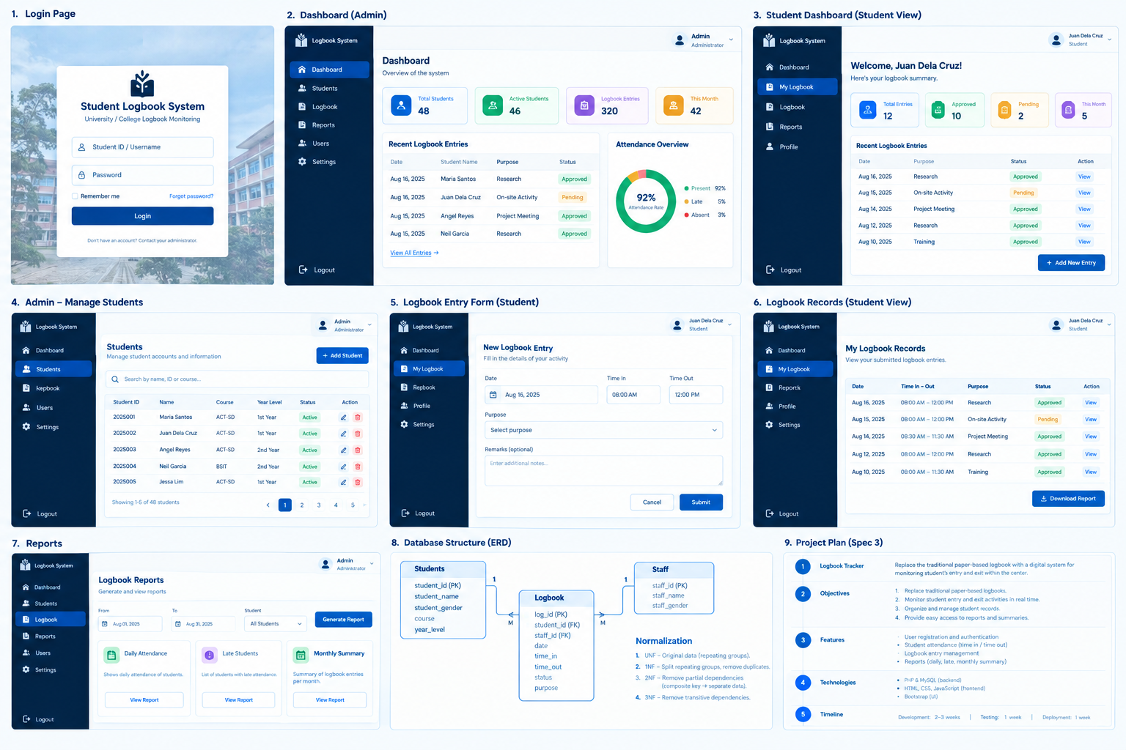
Figure 1. Supplied SmartLog interface mockup used as a visual reference for the required screen hierarchy and role-based navigation.

5.3 Access Contexts
- Designated Logbook Station — write access for attendance transactions after identity verification.
- Administrator / Social Worker Device — authorized access to dashboards, monitoring, scholar records, and reports.
- Scholar Mobile Device — read-only access to the authenticated scholar's own attendance information.

6. Functional Requirements
Each requirement below is stated using the testable form “The system shall…”. Priority values indicate the baseline importance for Version 1.0: Must = required for acceptance; Should = important but may be scheduled after core functions.
ID | Requirement | Priority | Description | Input / Condition | Expected Result
FR-01 | Scholar Registration | Must | The system shall allow a scholar to register using an official PNPh organizational email and required registration information. | Full name, organizational email, password, school year, semester, batch year, block section. | Validated account created; unique PN ID generated.
FR-02 | Login Authentication | Must | The system shall authenticate authorized users before granting access to protected functions. | PN ID / approved credentials and password. | Successful login or clear authentication failure.
FR-03 | Automatic PN ID Generation | Must | The system shall generate a unique six-digit PN ID using the defined batch-year and alphabetical-order rule. | Approved scholar profile and batch year. | Unique PN ID assigned and stored.
FR-04 | Academic Setup | Must | The system shall allow administrators to configure school year, semester, batch year, and block section. | Academic setup values. | Active academic configuration available to the system.
FR-05 | Time In Recording | Must | The system shall record a scholar's entry using a verified identity and a system-generated date/time. | PN ID and authentication. | Attendance transaction stored with IN status.
FR-06 | Time Out Recording | Must | The system shall record a scholar's exit and update the corresponding attendance transaction using a system-generated date/time. | PN ID and authentication. | Attendance transaction updated with OUT/time-out data.
FR-07 | Real-Time Dashboard Monitoring | Must | The system shall display current attendance information to authorized staff and update the monitoring view when new transactions are recorded. | Attendance data. | Current status, scholar identity, batch/block, and time information displayed.
FR-08 | Search Scholar Records | Must | The system shall allow authorized staff to search and filter scholar attendance information. | PN ID, name, batch, block section, date. | Matching records displayed.
FR-09 | Attendance History | Must | The system shall retain attendance history and allow authorized users to view daily, weekly, and monthly records. | Date range / scholar filters. | Historical attendance displayed without altering original records.
FR-10 | Mobile Read-Only Access | Must | The system shall allow authenticated scholars to view their own attendance history on mobile devices. | Scholar credentials. | Personal attendance records displayed; edit/delete/encode actions unavailable.
FR-11 | Report Generation | Must | The system shall generate daily attendance, late attendance, absent scholar, and monthly attendance reports. | Report type and date/filter parameters. | Report preview or generated report.
FR-12 | Report Export | Must | The system shall export authorized reports in PDF and Excel (.xlsx) formats. | Generated report. | Downloadable report file.
FR-13 | Academic Information Update | Must | The system shall allow scholars to update approved academic information only when the administrator has opened an update period. | School year, semester, and block section; subject to configured policy. | Submitted changes recorded and reflected after the defined approval/update process.
FR-14 | Academic Update Administration | Must | The administrator shall be able to open/close the academic update period, set a deadline, monitor submissions, and review update history. | Update-period settings and submitted changes. | Controlled update window and history available.
FR-15 | Audit Logging | Must | The system shall record important controlled changes with date/time and the responsible account. | Update or administrative action. | Audit entry stored for traceability.
FR-16 | Access Restriction | Must | The system shall prevent scholars from editing/deleting attendance records or viewing other scholars' records. | Authenticated role. | Unauthorized action denied.

6. Functional Requirement Details

6.1 Registration and PN ID Rules
- The scholar provides full name, official organizational email, password, school year, semester, batch year, and block section.
- The system validates required fields and verifies the organizational email.
- After successful registration, the system generates a unique PN ID.
- The PN ID uses the format BBBBOO, where BBBB represents the batch year and OO represents the student's alphabetical order within the batch.
- Alphabetical ordering is based on surname, then first name, then middle name.
- Example: 202601, 202602, 202603, 202604 for the first four scholars in the ordered batch list.
- The PN ID is treated as permanent and must not be editable by the scholar.

6.2 Controlled Academic Updates
Based on the supplied project notes, academic information is editable only during an administrator-controlled update period. The administrator may open or close the update period, set a deadline, monitor submitted changes, and review update history. The student may update approved academic fields such as school year, semester, and block section only while the feature is active.

6.3 Permanent Information
- Full name — not editable by the scholar.
- PN ID — not editable by the scholar.
- Batch year — not editable by the scholar.
Any correction to permanent information should be handled through an administrator-controlled process and recorded in the system history.

6.4 Dashboard Organization
The main monitoring dashboard shall group scholars according to batch year and block section. Within each block section, scholars shall be displayed in alphabetical order to support quick searching and monitoring.

6.5 Attendance Status
Status | Meaning
Logged | The scholar has completed a valid logbook transaction according to the configured attendance process.
Not Returned | The scholar has logged out/left but has not yet recorded a subsequent return/entry, where the monitoring workflow expects a return.
Current / Inside | The latest valid attendance state indicates that the scholar is currently inside the center.
Outside | The latest valid attendance state indicates that the scholar is currently outside the center.

The final status vocabulary and exact transition rules should be confirmed by PNPh before production deployment because the supplied materials use both transaction status and current-location concepts.

7. Business Rules and Data Policies
Rule | Area | Business Rule
BR-01 | Identity | Every scholar must have a unique PN ID generated by the system.
BR-02 | PN ID format | PN ID follows BBBBOO: four digits for batch year plus two digits for alphabetical order.
BR-03 | Ordering | Alphabetical ordering uses surname, first name, then middle name.
BR-04 | Immutability | Scholar cannot modify full name, PN ID, or batch year through the academic update feature.
BR-05 | Controlled updates | School year, semester, and block section may be updated only while an administrator-approved update period is open.
BR-06 | Auditability | Controlled changes must record the responsible account and date/time.
BR-07 | Attendance integrity | The system must prevent duplicate or logically invalid attendance transactions.
BR-08 | Authorization | A scholar can view only their own attendance records; staff access depends on assigned role.
BR-09 | System timestamps | Attendance date and time are generated by the system rather than manually entered by the scholar.
BR-10 | Historical integrity | Historical attendance records must remain retrievable and should not be silently overwritten.
BR-11 | Reporting | Reports must be generated from stored attendance records and reflect the selected date/filter criteria.
BR-12 | Academic setup | School year, semester, batch, and block section are controlled academic classifications used to organize scholar records.

8. User Interface and Dashboard Requirements

8.1 Design Principles
- Professional, clean, and consistent visual hierarchy.
- Responsive layouts for desktop, laptop, and mobile screens.
- Clear role-based navigation so users see only relevant functions.
- Readable status indicators and tables for rapid monitoring.
- Consistent primary actions, validation messages, and confirmation feedback.
- Accessible forms with clear labels, required-field indicators, and error messages.

8.2 Required Screens
Screen | Requirement
Login Page | PN ID/username, password, remember-me option, password recovery, and organizational context.
Administrator Dashboard | Overview cards, recent logbook entries, attendance overview, and navigation to students, logbook, reports, users, and settings.
Scholar Dashboard | Personal welcome area, attendance summary, recent entries, and read-only access to personal logbook records.
Manage Students | Search, student list, student details, academic classification, and administrator-controlled actions.
New Logbook Entry | Date/time context, Time In/Time Out action, required activity information if retained in the approved design, remarks if approved by client.
My Logbook Records | Historical records with date, time in/out, status, and view action; no edit/delete for scholars.
Reports | Date filters, scholar filters, report type, report preview, and PDF/Excel export.
Academic Update | Only available to scholars while the administrator-approved update period is open; shows editable academic fields and submission state.

8.3 Interface Reference
The supplied mockup shows a navy/white professional dashboard style with a left navigation panel, top user profile area, summary cards, tabular recent entries, and role-specific actions. The final implementation should preserve the information hierarchy while avoiding visual overlap and unnecessary decorative elements.

9. Data and Database Requirements

9.1 Logical Data Entities
Entity | Key Data | Purpose
Students / Scholars | student_id / PN ID, name, email, batch, block, academic fields | Stores scholar identity and academic classification.
Logbook / Attendance | log_id, student_id/PN ID, date, time_in, time_out, status | Stores attendance transactions.
Staff / Users | staff/user ID, name, gender or profile fields, credentials, role | Stores authorized staff accounts and access roles.
Academic Setup | academic year, semester, batch, block section | Controls and classifies the active academic structure.
Audit History | actor, action, target, timestamp, before/after or change details | Provides traceability for controlled changes.

9.2 Database Integrity
- Primary keys shall uniquely identify records.
- Foreign keys shall enforce valid relationships between attendance records and their associated scholar/staff records where applicable.
- Required fields shall not accept null values when the business rule requires a value.
- Passwords shall never be stored as plain text.
- Indexes should be applied to frequently searched fields such as PN ID, scholar name, batch, block section, and attendance date as appropriate.
- Database transactions should preserve attendance consistency when Time In/Time Out records are created or updated.

9.3 Reference ERD

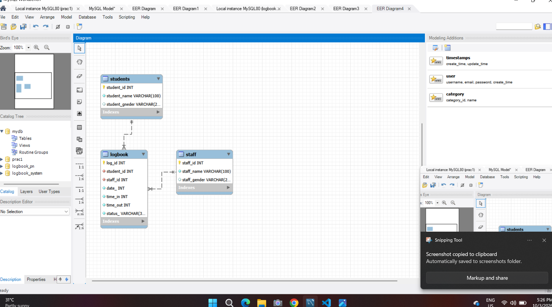
Figure 2. Supplied MySQL/ERD reference. The implementation should retain clear PK/FK relationships and align names with the final approved schema.

9.4 Schema Alignment Note
The supplied ERD reference contains Students, Logbook, and Staff entities. The final schema should use consistent naming (for example, Staff rather than the earlier draft spelling “Stuff”) and appropriate data types such as VARCHAR for names and status values and DATE/TIME or DATETIME for attendance timestamps. Exact column names and constraints should be finalized before database implementation.

10. Non-Functional Requirements
ID | Quality Attribute | Requirement
NFR-01 | Security | Passwords shall be securely hashed; role-based access control shall be enforced; unauthorized access shall be denied; attendance modification shall be restricted; important system actions shall be logged.
NFR-02 | Performance | Login requests should complete within 3 seconds under normal operating conditions; attendance transactions should be recorded within 2 seconds under normal conditions.
NFR-03 | Reliability | The system shall maintain accurate attendance records, automatically save transactions, and prevent duplicate attendance entries.
NFR-04 | Availability | The system should be available during PNPh operating hours, subject to hosting, network, and maintenance conditions.
NFR-05 | Usability | The system shall be responsive on desktop and mobile devices, provide clear navigation, and require minimal training for routine use.
NFR-06 | Maintainability | The system architecture and codebase should support future enhancements such as QR, RFID, mobile application, and notifications.
NFR-07 | Data Integrity | Stored records shall preserve required relationships and validation rules and shall not be silently corrupted by invalid inputs.
NFR-08 | Auditability | Administrative and controlled academic changes shall be traceable to a user account and timestamp.
NFR-09 | Compatibility | The web application should support modern browsers commonly available on PNPh desktop, laptop, and mobile devices.

10.1 Performance Measurement Conditions
Performance targets are intended for normal operating conditions and should be validated during system testing using representative PNPh data volumes and the actual deployment environment. Network latency and server availability should be recorded when evaluating results.

11. Security, Privacy, and Audit Requirements

11.1 Authentication
- Protected pages shall require an authenticated session.
- Organizational-email registration shall be validated before account activation, according to PNPh's approved process.
- Passwords shall be securely hashed and shall not be exposed in logs or reports.
- Sessions should expire or be invalidated according to the security policy.

11.2 Authorization
- Role-based access control shall separate Scholar, Social Worker, and Administrator permissions.
- Scholar accounts shall not be able to view or alter another scholar's records.
- Only authorized staff may access monitoring dashboards and reports.
- Administrative controls for academic update periods shall not be available to scholars.

11.3 Academic Update Controls
- Administrator can open or close the update period.
- Administrator can set an update deadline.
- System should show whether the update window is open or closed.
- Submitted changes shall be traceable through update history.
- Full name, PN ID, and batch year shall not be directly editable by scholars.

11.4 Audit Trail
At minimum, the audit trail should capture who performed the action, what action was performed, which record was affected, and the date/time. For academic updates, storing the previous and new values is recommended where technically and operationally appropriate.

11.5 Privacy
Because SmartLog stores scholar identity and attendance information, access should be limited to legitimate PNPh purposes. Reports and exported files should be accessible only to authorized users and handled according to PNPh's applicable privacy and records-management policies.

12. System Workflows

12.1 Scholar Registration
- Scholar opens the registration page.
- Scholar enters official organizational email and required personal/academic information.
- System validates the input and verifies the organizational email.
- System creates the account.
- System generates a unique PN ID according to the batch-year/alphabetical-order rule.
- Scholar can log in after successful registration/verification.

12.2 Attendance / Logbook
- Scholar goes to the designated logbook station.
- Scholar provides PN ID/credentials.
- System authenticates the scholar.
- Scholar selects or performs the appropriate Time In or Time Out action.
- System generates the date/time automatically.
- System validates the transaction and stores it in MySQL.
- Dashboard monitoring data is updated.
- Authorized staff can view the resulting status.

12.3 Academic Update
- Administrator opens the academic update period and sets the deadline.
- Scholar signs in through the approved interface.
- Scholar accesses the academic information page.
- Scholar updates permitted fields such as school year, semester, and block section.
- System validates the submission and records the change.
- System records the update in the history/audit trail.
- After the deadline or closure, the update feature becomes unavailable to scholars.

12.4 Monitoring and Reporting
- Authorized staff signs in.
- System loads the monitoring dashboard.
- Staff views scholars grouped by batch and block section and their current attendance status.
- Staff searches or filters records when needed.
- Staff selects a report type and date/filter criteria.
- System generates the report.
- Authorized staff exports the report as PDF or Excel when required.

13. Reporting Requirements
Report | Purpose | Minimum Content
Daily Attendance Report | Review attendance for a selected day. | Date, PN ID, scholar name, batch/block, Time In, Time Out, status.
Late Attendance Report | Identify scholars who entered beyond the allowed schedule. | Date, PN ID, scholar name, recorded Time In, late status/indicator.
Absent Scholar Report | Identify scholars with no attendance record for a selected day or period. | Date/period, PN ID, scholar name, batch/block, absence indicator.
Monthly Attendance Report | Summarize attendance over a month. | Scholar, dates/attendance counts, relevant status summary.
Monitoring View | Support live operational monitoring. | Scholar, batch/block, latest Time In/Out, current status.

13.1 Report Filters
- Date or date range.
- Scholar / PN ID.
- Batch year.
- Block section.
- Report type.
- Other filters approved by PNPh.

13.2 Export
Generated reports shall support PDF and Excel (.xlsx) export for authorized users. Exported reports should contain the selected filters and a clear report title/date so that the file remains understandable outside the application.

14. Acceptance Criteria and Traceability

14.1 High-Level Acceptance Criteria
- An authorized scholar can register and obtain a unique PN ID.
- An authorized user can log in and is restricted to the correct role permissions.
- A valid Time In transaction is stored with a system-generated date/time.
- A valid Time Out transaction updates the appropriate attendance record.
- Duplicate or invalid attendance transactions are rejected or handled according to the defined rules.
- Authorized staff can monitor current attendance and search historical records.
- Scholars can view their own attendance on mobile without edit/delete/encoding capability.
- Administrators can configure academic setup and control the academic update window.
- Academic changes made during an approved period are recorded in the audit history.
- Daily, late, absent, and monthly reports can be generated and exported to PDF/Excel.
- Core operations meet the defined performance targets under normal test conditions.

14.2 Requirements Traceability Matrix
Objective | Goal | Mapped Requirements | Acceptance Evidence
OBJ-01 | Replace paper logbook | FR-05, FR-06, FR-07 | Attendance transactions are recorded digitally and visible to authorized monitors.
OBJ-02 | Real-time monitoring | FR-07, FR-08 | Authorized staff can see and search current attendance.
OBJ-03 | Organize scholars | FR-03, FR-04, FR-08 | PN ID, batch, block, and search support organized monitoring.
OBJ-04 | Secure records | FR-02, FR-10, FR-16, NFR-01 | Role restrictions protect records.
OBJ-05 | Easy access to records | FR-09, FR-10, FR-11 | History and reports are available.
OBJ-06 | Controlled academic updates | FR-13, FR-14, FR-15 | Updates are allowed only during controlled periods and are auditable.

15. Assumptions, Constraints, and Dependencies

15.1 Assumptions
- PNPh will provide the approved organizational email/account validation process.
- PNPh will define the official attendance schedule used to identify late attendance.
- PNPh will identify authorized administrator and social-worker accounts.
- PNPh will confirm the final status vocabulary and attendance transition rules.
- Users have access to a supported browser and network connection.
- System date/time is correctly configured on the application/server environment.

15.2 Constraints
- Version 1.0 is a web application and depends on browser/network availability.
- Future QR, RFID, biometric, mobile-app, SMS, and analytics features are not core Version 1.0 requirements.
- Final database column names and constraints must be aligned with the approved ERD and implementation.
- Attendance policy rules such as allowable duplicate prevention, overnight records, and late thresholds require client confirmation.

15.3 Dependencies
- PHP/Laravel runtime.
- MySQL database service.
- Web server and network access.
- PNPh organizational email or identity verification process.
- Authorized user accounts and role assignments.

16. Future Enhancements
- QR Code Time In / Time Out.
- RFID card integration.
- Biometric authentication.
- SMS notifications.
- Email alerts.
- Native mobile application.
- Advanced analytics dashboard.
- Attendance trend analysis and prediction.
These items are retained from the existing project requirements as future enhancements and are not acceptance requirements for Version 1.0 unless the client approves a scope change.

Appendix A. Requirement Summary
Area | Version 1.0 Requirement Baseline
Core identity | Registration, organizational email verification, PN ID generation, authentication
Academic management | School year, semester, batch year, block section, controlled update period
Attendance | Time In, Time Out, automatic timestamps, duplicate/invalid transaction prevention
Monitoring | Batch/block grouping, alphabetical student arrangement, current status, search
Scholar access | Mobile read-only personal attendance history
Staff access | Monitoring, scholar search, attendance history, reports
Administration | User management, academic configuration, attendance management, export
Reporting | Daily, late, absent, monthly; PDF and Excel
Security | Role-based access, protected records, audit history
Technology | HTML/CSS/JavaScript/Bootstrap, PHP/Laravel, MySQL

Appendix B. Reference Design Artifacts
The following supplied artifacts were used as design references for this SRS:
- Login, administrator dashboard, scholar dashboard, student management, logbook entry, logbook records, reports, ERD, and project-plan mockups.
- Handwritten PN ID, registration, academic update, security, dashboard grouping, student arrangement, and status-indicator requirements.
- Logical system architecture showing user access, Laravel/PHP application services, and MySQL data storage.
- MySQL Workbench ERD reference containing Students, Logbook, and Staff relationships.
Reference artifacts are design inputs; the final implemented screens, database schema, and business rules should be reviewed and approved by PNPh before deployment.

Appendix B.1 System Architecture Reference
The supplied architecture diagram shows Student, designated logbook station, administrator/social-worker device, and student mobile access connecting through the Laravel/PHP application server to the MySQL database.
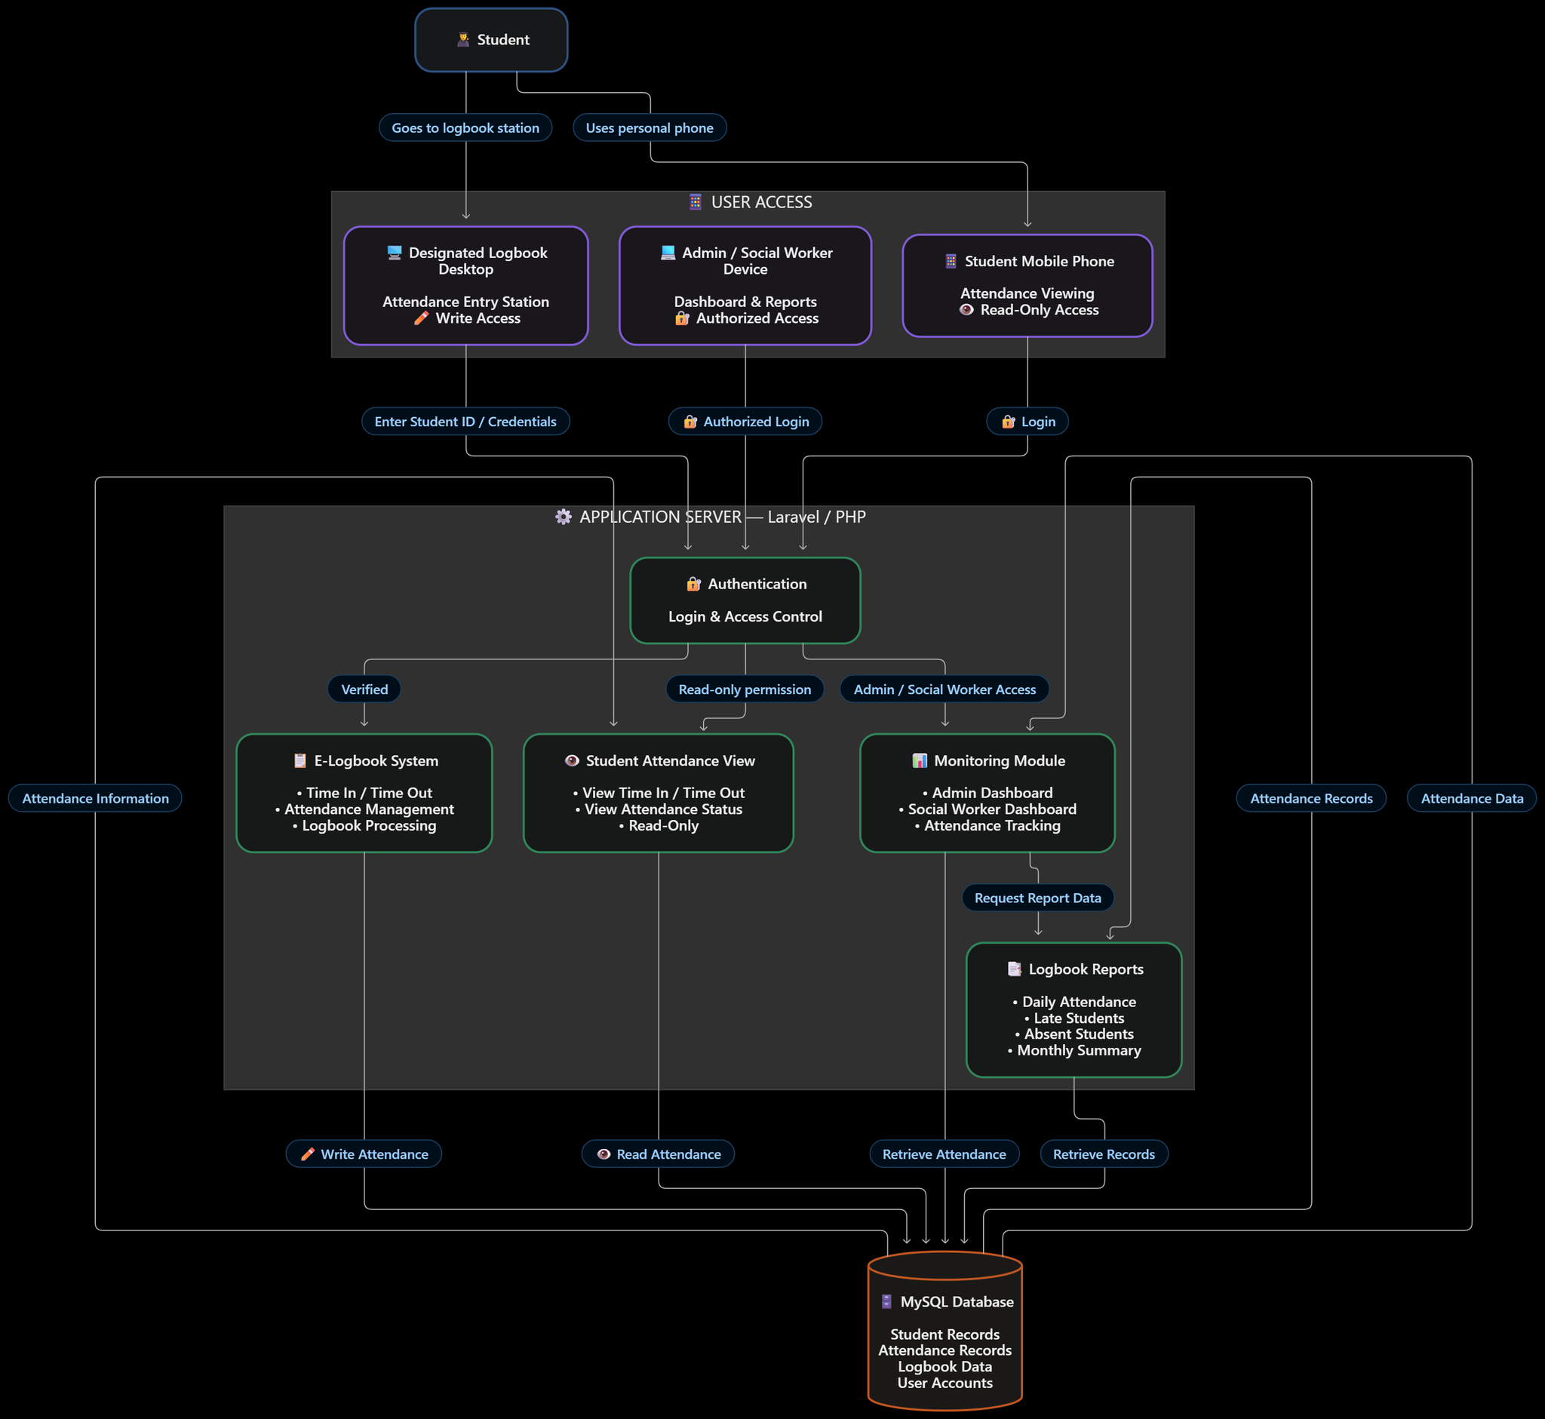
Figure 3. Supplied logical system architecture reference.

Client Review and Sign-Off
Approval of this document indicates that the client and project team agree that the requirements described herein are sufficiently defined to proceed to detailed design and implementation, subject to the change-control process.
Approval Role | Name | Signature | Date
PNPh Client Representative
PNPh Authorized Administrator
Project Adviser / Instructor
Project Team Lead

END OF SOFTWARE REQUIREMENTS SPECIFICATION

