Performance Assessment: Task 2

Justin Hughes-Coleman

Western Governors University

D793: Formal Languages Overview

Dr. Kristin Thielfoldt

November 5, 2025
Gitlab URL: https://gitlab.com/wgu-gitlab-environment/student-repos/jhughe13/d793-formal-languages-overview
Commit URL: https://gitlab.com/wgu-gitlab-environment/student-repos/jhughe13/d793-formal-languages-overview/-/commits/main?ref_type=HEADS
Commit Screenshot: (Additional screenshot will be provided that shows this file being pushed and committed)
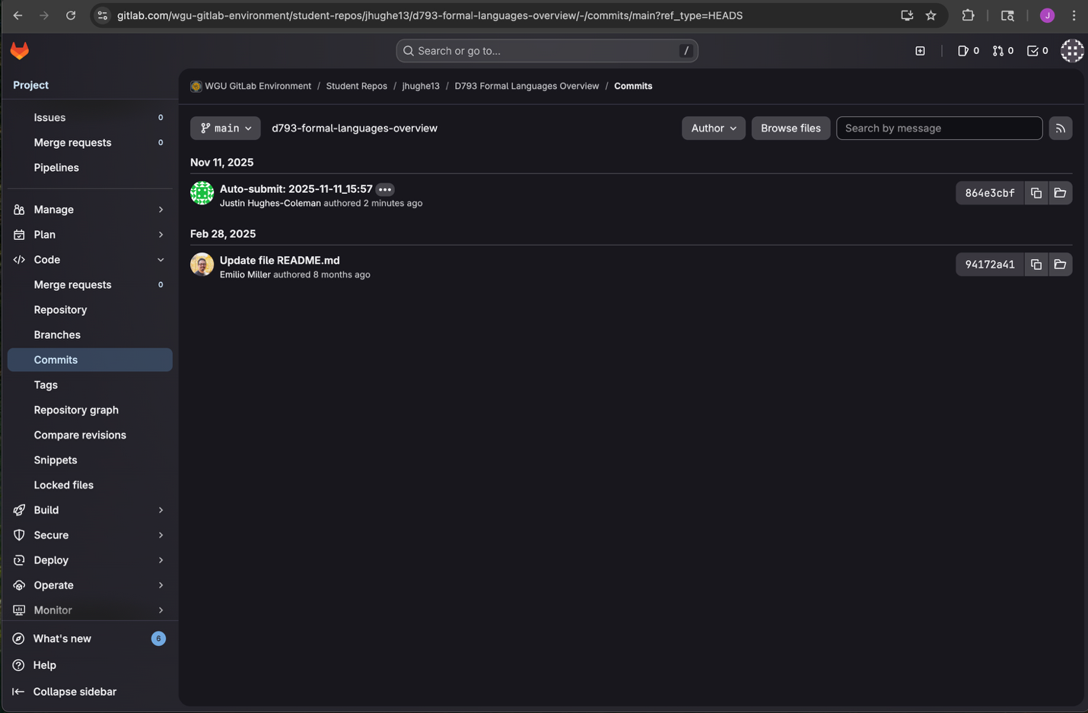

Language selection
For this assignment, I chose three object-oriented programming (OOP) languages: Python, Java, and C++. Each of these languages has all the properties that make up OOP languages and is very popular across industries. Personally, I chose Python because of its multiple advantages over other options. Firstly, I have the most experience with Python, whether through my professional use or from learning how to code initially. I have minimal knowledge of both Java and C++. Since I do not have any experience with Fortran, I did not want my limited understanding of the other languages to hinder my ability to translate and test the weather program properly. I also prefer the readability and maintainability of Python. Although Java and C++ have a broad community support, they also have a higher skill ceiling, meaning it would be harder to debug and solve problems unless I were already an expert. The downside of using Python over Java and C++ is that they are generally faster at processing data. However, since this is a small project and not an enterprise-level software offering, the trade-off is worth it for the other advantages.

Translation method
For the translation from Fortran to Python, I first attempted to translate as much as I could on my own. I believe I got pretty; I was able to build the class from the constructor in Fortran, and I understood how the state changed based on the functions. The issue I ran into was how to call weather.f90 from main.f90. I then pivoted and utilized an LLM, Anthropic's Claude.ai (Claude AI (Anthropic, 2024)), to assist with the initial translation of Fortran code to Python. With Claude, I simply put in both f90 files and allowed it to do the translation. I provided an open-ended prompt to match the expected output and to translate the files into separate Python files. Next, since I am accustomed to Python modules, I wanted to know how to call the F90 files with a single command. I input this question into the chat for Claude, and it presents the Makefile solution. With this, I can do what Python does with __main__, which is to call all the functions referenced in that file. With this method, just as I can issue the command' python3 main.py' in the terminal, I can run the command 'make clean && make run' in the terminal to compile both the F90 files and delete their executables. I hope to integrate this further into my ongoing software development journey.

Test plan
I wanted to utilize Python's unit test library for all my tests since this program is straightforward. The expected values do not necessarily change, and I understand how the functions work, so I did not want to perform any black-box testing. I wanted to ensure the function calculations are correct, so I created a couple of tests that would display the expected output for the average temperature. I also wanted to include an edge case, something along the lines of a negative Fahrenheit temperature, to ensure it worked correctly. Below is a selection of the test results. The whole test script is with the program files—the results of my test. I developed the tests, but I utilized Claude.ai to make the outputs more verbose and easier to read. (Claude AI (Anthropic, 2024). In the future, I plan to use the continuous integration pipeline in GitLab to automate this testing process.
Since the program only has a few functions, I expected all the tests to pass. Indeed, none of the tests failed, and all the actual outputs matched the expected outputs.
Test Case ID | Input(s) | Expected Output | Actual Output | Pass/Fail
TC1 – Avg Temps | Input Data - Highs: [90, 85, 88, 92, 87, 89, 91]  Input Data - Lows: [65, 60, 63, 68, 62, 64, 66] | Expected Average High: 88.86°F  Expected Average Low: 64.00°F | Actual Average High: 88.86°F  Actual Average Low: 64.00°F | PASS
TC2 – Extreme Cold Test | Extreme Cold Lows: [-10, -15, -8, -5, -12, -9, -11] | Expected Minimum Low: -15°F | Actual Minimum Low: -15°F | PASS
TC3 – Extreme Hot Test | Extreme Heat Highs: [120, 115, 118, 122, 119, 121, 117] | Expected Maximum High: 122°F | Actual Maximum High: 122°F | PASS

Testing method

I only did unit tests because I wanted to use this opportunity to explore Python's unit test library. I believe these tests were the best use for a program of this size because the functions and overall structure are very modular. I employed a hybrid approach combining automatic and manual testing. Since I can execute the weather_app_test.py file, I can ensure that I cover all the tests in that module. However, I have yet to integrate this into the .gitlab-ci.yml file, so it is not truly automatic. When I pull these files into the student repository for assessment, the testing suite will not execute automatically. As mentioned above, my goal is to implement this in future projects to foster my software development learning. For all work done, I used VS Code and tried to utilize the command line interface or terminal for all commands. This runs on Python 3.12, so when executing the files, I needed to use python3.
References

Anthropic. (2024). Claude (Version 3.5) [Large language model]. https://claude.ai

