NATIONAL UNIVERSITY
College of Computing and Information Technologies
FINAL PROJECT DOCUMENT
FinTrack Stark
Personal Finance, Bill Reminder, and Payment Tracking Integration System
Approved Project Theme No. 8 — Mobile and Web Application Track
Course Code: [ILAGAY DITO]
Course Name: Systems Integration and Architecture
Section: [ILAGAY DITO] Group No.: [ILAGAY DITO]
Group Name: Project Stark
Members
Cain, Akhemee Yujinn
Dabasol, Arvy Karlson
Dela Cruz, John Paul
Heray, Neezar Ivan
Libaton, Jerico
Instructor: [ILAGAY DITO]
Date of Submission: [ILAGAY DITO]

Table of Contents
1. Introduction 1
1.1 Background of the Project 1
1.2 Problem Statement 2
1.3 Project Objectives 2
1.4 Scope and Limitations 3
1.5 Target Users 4
2. Current-State Analysis 5
2.1 Current-State Process 5
2.2 Current-State Problems 5
2.3 Stakeholder Analysis 6
3. Requirements Analysis 7
3.1 Functional Requirements 7
3.2 Nonfunctional Requirements 7
3.3 Interface and Data Exchange Requirements 8
3.4 Integration Requirements Traceability Matrix 9
4. Enterprise Architecture 10
4.1 Business Architecture 10
4.2 Data Architecture 10
4.3 Application Architecture 11
4.4 Technology Architecture 11
5. Target-State Architecture 13
5.1 Target-State Process 13
5.2 Target-State Architecture Diagram 14
5.3 Architecture Style Selection 15
5.4 Integration Pattern Selection 15
5.5 Architecture Decision Record 16
6. System Design 17
6.1 Use-Case Diagram 17
6.2 Context Diagram 18
6.3 Data-Flow Diagram 19
6.4 Sequence Diagram 19
6.5 Database Design 21
6.6 User Interface Design 24
7. Integration Design and Implementation 33
7.1 Integration Scenario 33
7.2 API / Workflow / Webhook / Messaging Components 33
7.3 Data Mapping Table 36
7.4 Sample Payload or Data Format 38
7.5 Validation and Error Handling 41
7.6 Integration Logs 42
8. Security, Governance, and Risk Management 44
8.1 Role-Based Access Control Matrix 44
8.2 Least Privilege and Separation of Duties 44
8.3 Data Privacy and Protection 45
8.4 Audit Trail 45
8.5 Integration Ownership and Governance 46
8.6 Risk Register 47
9. Testing and Evaluation 48
9.1 Test Plan 48
9.2 Functional Test Cases 48
9.3 Integration Test Cases 49
9.4 Error-Handling Test Cases 49
9.5 End-to-End Test Scenario 50
9.6 Test Results Summary 50
10. Deployment, Backup, and Recovery 52
10.1 Deployment Environment 52
10.2 Deployment Evidence 52
10.3 Backup Plan 53
10.4 Recovery Plan 54
11. System Demonstration Guide 55
11.1 Demo Script 55
11.2 Demo Accounts 55
11.3 Sample Data 56
12. Limitations and Future Enhancements 57
12.1 System Limitations 57
12.2 Recommended Enhancements 57
13. Individual Contribution 58
14. References 59
15. Appendices 60
Appendix A — Complete API Endpoint List 60
Appendix B — Additional Screenshots 61
Appendix C — Complete Test Results 66
Appendix D — Source Code Excerpts 68
Appendix E — Project Folder Structure 69

1. Introduction

1.1 Background of the Project
Filipino households manage a steady stream of recurring obligations: electricity (Meralco), water (Maynilad, Manila Water), internet and mobile plans, rent, credit cards, and a growing number of subscriptions. These are paid through many different channels — payment centres, bank apps, and e-wallets such as GCash and Maya — and each channel keeps its own record, if it keeps one at all. Income arrives just as irregularly: salary, freelance work, allowances.
In practice the information that a person needs to stay on top of their money is scattered: due dates sit in SMS messages and paper bills, payments sit in separate apps, receipts sit in a drawer or a phone's photo gallery, and totals sit in a notebook or a spreadsheet that is updated by hand when there is time. Nothing connects these pieces, so a missed due date, a typing mistake, or a budget that has already run out is usually discovered too late.
FinTrack Stark is an integrated web and mobile (installable Progressive Web App) system that brings these pieces together. It connects the user's wallet records, bill reminders, payment status, budget tracking, a receipt review workflow, a notification system and a financial dashboard — the integration focus named for Approved Project Theme No. 8. The project's emphasis, as the specification requires, is on how these modules, users and services are connected: a payment automatically becomes an expense entry, a notification and an audit record; a separate reminder service raises alerts on its own schedule through a shared database; a submitted receipt automatically enters a review queue and every decision is pushed to the people concerned as it happens.

How the specification's terms map to this project
The project specification is written for a creative-production pipeline (projects, assets, artists, renders). Because the approved theme is a personal-finance system, each generic component is implemented with its finance equivalent. Table 1 is used throughout this document.
Table 1. Mapping of the specification's generic components to FinTrack Stark
Specification term | FinTrack Stark equivalent | Where in the system
Project / Production Module | Bill categories (Utilities, Housing, Internet, Credit, Subscription, Other) and the bills inside each | Bill Categories, Category Detail, Bill Reminders
Project List / Project Details | List of bill categories with totals / one category with its bills and statuses | /categories, /categories/:name
Asset / File Submission | A receipt or proof of payment (photo, PDF, or Google Drive / OneDrive / Dropbox link) attached to an income or expense entry | Log Income/Expense, My Entries
Task status | Bill status (Upcoming, Due Today, Overdue, Paid) and receipt status (For Review, Verified, Needs Revision, Rejected) | Bills, My Entries, Receipt Review
Version Tracking (v1, v2, revised, approved, rejected, final) | Entry versions (v1 → v2, Earlier version, Deleted) and receipt versions (v1 Needs Revision → v2 Verified) | Revision History, Receipt dialog
Review and Approval Workflow | A Reviewer verifies, rejects or requests a revision of each submitted receipt | Receipt Review
Comment / Feedback Module | Personal notes and notes on entries, including the Reviewer's decision notes | Notes / Feedback
Reviewer / Director | Reviewer role | Review Desk
Artist, Animator, Client | User (member) — records their own money and submits receipts | Home dashboard
Admin / Project Manager | Admin role — accounts, roles, password resets, audit log | Admin Console

1.2 Problem Statement
Individuals and households who pay several recurring bills through different channels have no single, reliable record of what is due, what has been paid, what each peso was spent on, and whether the records are backed by proof. The current, manual way of working causes:
- Missed and late payments — due dates are remembered, or not; there is no reminder that arrives before the due date, so penalties and disconnections happen.
- Double work and transcription errors — every payment is made in one place and then copied by hand into a notebook or spreadsheet, where amounts are mistyped and corrections overwrite the original with no history.
- Scattered, unverifiable proof — receipts and payment screenshots are kept in drawers and galleries; nobody checks that a recorded figure matches its receipt.
- No early warning on spending — budgets, if any, are checked at the end of the month, after they have already been exceeded.
- No accountability trail — there is no record of who recorded, changed, or deleted what and when.

The project addresses the question: how can bill reminders, payment records, income and expense entries, receipts, budgets and notifications be integrated into one system so that payments are recorded once, reminders and warnings arrive on time, every figure can be traced and verified, and every action is accounted for?

1.3 Project Objectives

General objective
To design, develop, integrate, deploy and defend a web and mobile (PWA) personal-finance system that connects bill reminders, payment tracking, income and expense records, receipt submission and review, budgets, notifications and a financial dashboard, using appropriate architecture, integration patterns, security controls, logging, testing and documentation.

Specific objectives
- Identify the problems of the current manual bill-and-receipt process and analyse its current and target states (Sections 2 and 5).
- Identify the stakeholders, systems, interfaces and data exchanged between them (Sections 2.3 and 3.3).
- Design the business, data, application and technology architecture (Section 4).
- Select and justify an architecture style (layered, with event-driven elements) and integration patterns (point-to-point REST, shared database, event-driven messaging) (Section 5).
- Develop a working, deployed prototype with role-based dashboards for User, Reviewer and Admin (Sections 6 and 10).
- Implement integration components: the bill-payment workflow cascade, the receipt review workflow, live event messaging, the scheduled reminder service and external-storage links (Section 7).
- Apply validation, error handling, role-based access control, least privilege and separation of duties (Sections 7.5 and 8).
- Produce audit and integration logs that record successful and failed actions with a reference to the record involved (Sections 7.6 and 8.4).
- Perform functional, integration, error-handling, security and end-to-end testing with automated, repeatable tests (Section 9).
- Prepare backup, recovery and deployment evidence (Section 10).

1.4 Scope and Limitations

In scope
- Account registration, sign-in and three roles (User, Reviewer, Admin) with role-specific dashboards.
- Bills organised by category, with due dates, monthly repetition, payment recording and payment history.
- Automated bill reminders (three days before, on the due date, and when overdue) from a scheduled reminder service.
- Income and expense entries that count immediately, with edit-as-new-version and soft delete (Revision History).
- Receipt / proof-of-payment submission (upload up to 2 MB or cloud link), versioning, and review by a Reviewer.
- Monthly budgets per category with warnings at 80% and 100%.
- Notes and feedback, an in-app notification log, live updates without refreshing, and reports.
- Audit and integration log with Success/Failed status; user, role and password administration.
- Responsive web interface installable on phones as a Progressive Web App; cloud deployment; backup and restore.

Out of scope / limitations
- No real payment processing: the system records payments made elsewhere and never connects to banks or e-wallets (specification §21.7).
- No e-mail or SMS delivery: notifications are in-app and live; password recovery is done by an Admin-issued temporary password.
- No native Android/iOS application: the mobile experience is an installable PWA (the specification allows "mobile and/or web").
- No automatic reading (OCR) of receipt contents: a Reviewer compares the receipt with the entry.
- Single currency (Philippine peso) and single time zone (Asia/Manila).
- Sample data only; no real personal or financial data is used (specification §21.8).

1.5 Target Users
Table 2. Target users and roles
Role | Who they are | What they do in the system
User | Any individual or household member managing their own bills and money (students, young professionals, families). | Records bills, payments, income and expenses; attaches receipts; sets budgets; writes notes; reads their dashboard, reports and notifications.
Reviewer | A trusted checker — for example a household head, a treasurer of a shared fund, or a finance officer. | Checks submitted receipts against the entries they prove; verifies, rejects or requests a revision. Also has their own wallet.
Admin | The person responsible for operating the system. | Manages accounts and roles, resets passwords, monitors the Admin Console and the audit log. Also has their own wallet; cannot see other people's money or receipts.
Reminder Service (system actor) | An automated background process. | Checks unpaid bills every day and raises reminders and overdue alerts.

2. Current-State Analysis

2.1 Current-State Process
Before integration, the process for a typical bill is entirely manual and spread across disconnected tools (Figure 1): a bill arrives on paper, by SMS or by e-mail; the person writes the due date down somewhere; whether it is paid on time depends on memory; payment is made at a payment centre, a bank app or an e-wallet; the receipt or screenshot is kept wherever it lands; the amount is copied by hand into a notebook or spreadsheet; and at the end of the month, if at all, spending is added up by hand. Income is recorded the same way. No one checks the copied figures against the receipts.
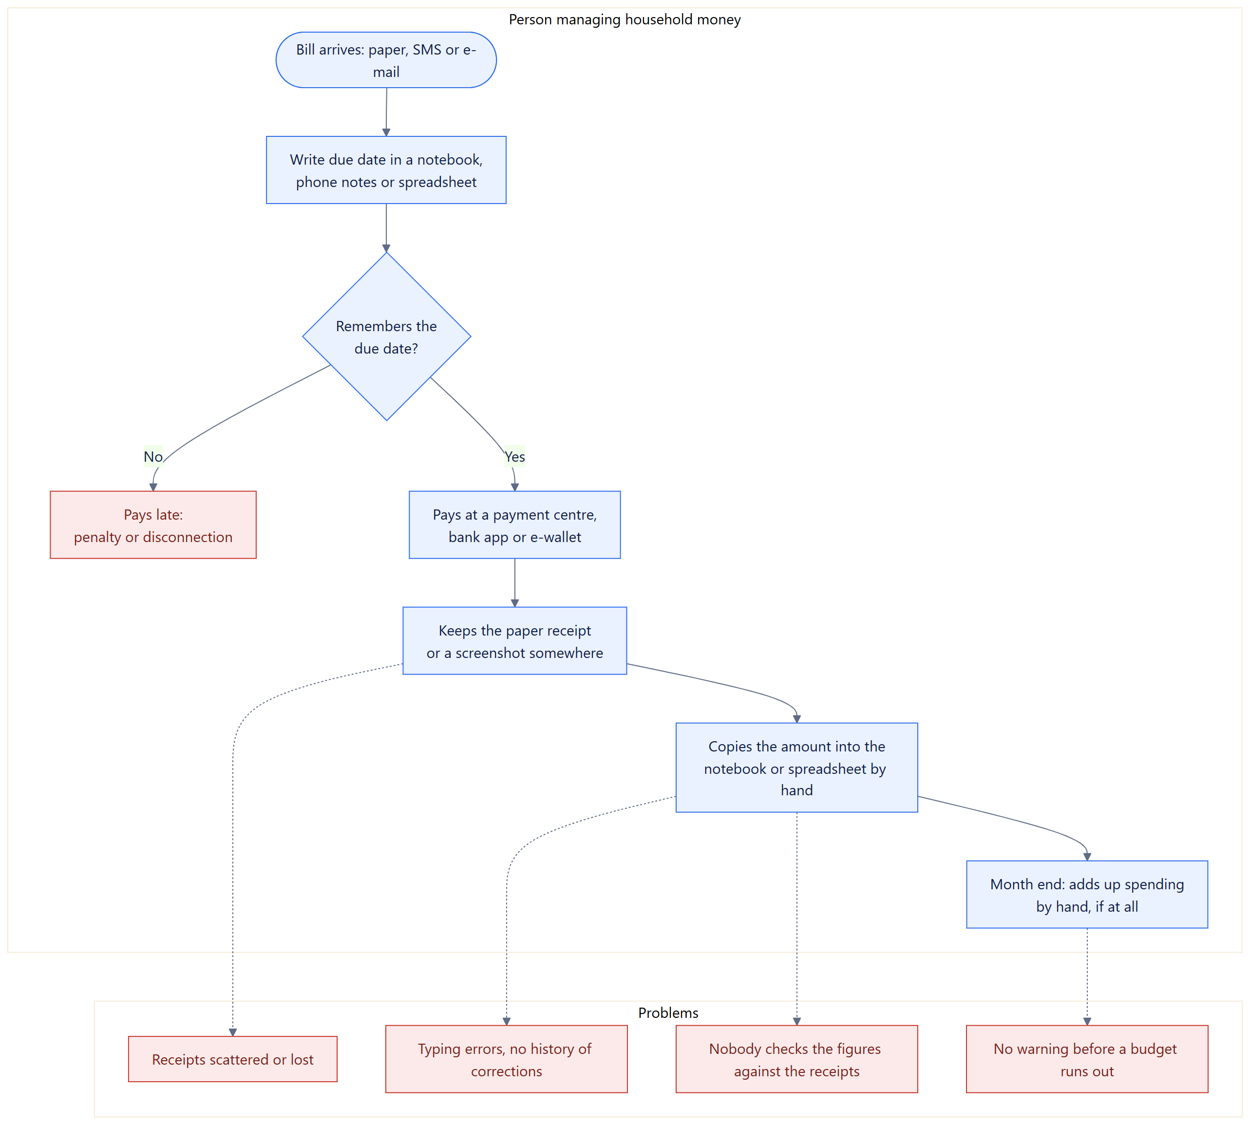
Figure 1. Current-State Process Flow (before integration)

2.2 Current-State Problems
Table 3. Current-state problems and how the target system addresses them
Problem | Effect | Addressed in FinTrack Stark by
Manual tracking of due dates | Late payments, penalties, disconnections | Reminder service: alerts 3 days before, on the day, and when overdue (FR-011)
Payments recorded twice (pay, then copy) | Double work; forgotten or mistyped entries | Mark Paid creates the expense entry automatically (workflow automation, FR-007)
Scattered receipts | Lost proof; disputes cannot be settled | Receipts attached to the entry they prove, as an upload or a cloud link (FR-003)
No checking of figures against receipts | Errors and false entries go unnoticed | Receipt Review: a Reviewer verifies, rejects or requests a revision (FR-005)
Corrections overwrite the original | No history; changes cannot be explained | Editing creates v2 and keeps v1; deleting is a soft delete (FR-004, FR-015)
Budgets checked after the month ends | Overspending discovered too late | Budget alerts at 80% and 100% as each expense is recorded (FR-012)
Duplicated and inconsistent versions | Two different totals for the same month | One shared database; one current version per entry; atomic updates prevent duplicates (NFR-010)
Unclear responsibility | Nobody knows who changed what | Audit log of every action with user, time, status and record reference (FR-010)

2.3 Stakeholder Analysis
Table 4. Stakeholders
Stakeholder | Interest / need | Involvement in the system | Influence
Users (members) | Never miss a due date; know where money goes; keep proof of payments | Primary users of every finance screen | High
Reviewers | A clear queue of receipts and the entry each one must prove | Receipt Review, Review Desk | Medium
Administrator | Accounts that work, correct roles, visibility of what happens | Admin Console, User & Role Management, Audit Log | High
Project team (developers) | A maintainable, testable, defensible system | Builds, tests, deploys and documents the system | High
Instructor / technical panel | Evidence that integration, security and testing requirements are met | Evaluates the prototype, document and defense | High
Billers, banks and e-wallets | Paid on time (indirect) | External: payments happen there and are recorded here | Low
Cloud providers (Render, MongoDB Atlas) | Service terms, resource limits | Host the application and the database | Medium
Cloud storage (Google Drive, OneDrive, Dropbox) | — | Hold receipt files that are attached by link | Low

3. Requirements Analysis

3.1 Functional Requirements
Table 5. Functional requirements (15)
ID | Requirement | Actor | Priority
FR-001 | The system must allow people to register and authorized users to log in, and must give each role its own dashboard. | All | Must
FR-002 | The system must allow users to create, edit and delete bills, organised by category (the "project" records). | User | Must
FR-003 | The system must allow users to record income and expense entries and to submit a receipt for an entry as an uploaded file (JPG, PNG, WEBP, PDF) or a cloud file link. | User | Must
FR-004 | The system must track versions of entries (v1, v2 …) and of receipts, keeping earlier versions. | System | Must
FR-005 | The system must allow Reviewers to verify, reject, or request a revision of a submitted receipt. | Reviewer | Must
FR-006 | The system must store notes and feedback, per entry and personal, including the Reviewer's decision notes. | User, Reviewer | Must
FR-007 | The system must automatically update statuses after submission, payment or review (receipt → For Review; bill → Paid with an expense entry; next monthly bill scheduled). | System | Must
FR-008 | The system must record notification logs for important workflow events and deliver them to the addressed user without a page refresh. | System | Must
FR-009 | The system must display dashboard summaries (balance, spending by category, bills, budgets; review queue; system activity). | All | Must
FR-010 | The system must record audit logs for important user actions, including failed and refused actions. | System | Must
FR-011 | The system must remind users of unpaid bills before the due date, on the due date and when overdue, without duplicate alerts. | Reminder Service | Must
FR-012 | The system must let users set monthly budgets per expense category and warn at 80% and 100% use. | User | Should
FR-013 | The system must allow the Admin to manage user roles, delete accounts and issue temporary passwords. | Admin | Must
FR-014 | The system must provide reports of spending by category, budgets and bill payments. | User | Should
FR-015 | The system must allow users to correct and delete their own entries without losing the history. | User | Must

3.2 Nonfunctional Requirements
Table 6. Nonfunctional requirements (11)
ID | Category | Requirement | How it is met / measured
NFR-001 | Security | Only authenticated users can access records. | Every /api route except login, register and health requires a valid session token (ST-01).
NFR-002 | Authorization / Privacy | Users can only access their own records; receipts are visible only to their owner and Reviewers. | Owner checks in every controller; Admin cannot read others' entries or receipt files (ST-02, ST-04, RT-31).
NFR-003 | Auditability | All approval, rejection, revision, payment, edit and deletion actions — and failures — must be recorded in audit logs. | Audit log with status and record reference (FT-08, ET-07, IT-07).
NFR-004 | Reliability | The system must validate required fields and data types before saving or sending data. | Server-side validation on every write; schema limits (ET-01, ET-02, RT-04, RT-30).
NFR-005 | Usability | Dashboards must be understandable; screens must work on phones from 320 px wide. | Role dashboards; bottom tab bar on phones; no sideways scrolling (RT-13, RT-14, RT-33).
NFR-006 | Error handling | The system must give clear error messages for failed submissions and keep what was typed. | Plain-language 4xx messages; forms kept on failure (ET-01–ET-07, RT-11).
NFR-007 | Availability / Recoverability | Data and receipt files must be backed up and restorable. | npm run backup / restore including receipt files (RT-34; Section 10).
NFR-008 | Maintainability | Code and documentation must be clear enough for technical review. | Layered folders (routes, middleware, controllers, services, models); this document; README.
NFR-009 | Performance | A screen must refresh with one request; a change must reach open screens within about a second. | GET /api/sync; Server-Sent Events (RT-20, IT-02); typical API calls 20–40 ms locally (Section 7.4).
NFR-010 | Integrity / Concurrency | Simultaneous actions must not create duplicates (double payment, double decision, two v2s). | Atomic conditional updates; tested with 10 simultaneous requests (ET-05, RT-02, ET-07).
NFR-011 | Session security | Passwords and session tokens must never be stored in readable form; sessions must expire. | scrypt password hashes; SHA-256 token hashes; 8-hour expiry; rate-limited login (RT-06).

3.3 Interface and Data Exchange Requirements
Table 7. Interfaces and data exchanged between modules and systems
From → To | Data | Format / channel | Trigger
Web client → API | Credentials; bills; entries; receipts (base64 file or URL); budgets; notes; review decisions | HTTPS, REST, JSON; Bearer token | User action
API → Web client | All of the signed-in person's data in one response | GET /api/sync, JSON | Page load, live event, reconnect
API → Web client (live) | "Something changed" events with a topic (no data) | Server-Sent Events, GET /api/events | Any write that concerns the user or their role
Bill payment workflow → Transactions | Expense entry built from the bill (category, amount, date, note) | Internal service call, MongoDB write | POST /api/bills/:id/pay
Receipt workflow → Notifications / Comments / Audit | Decision, note, version, entry summary | Internal, MongoDB writes | Receipt submitted or decided
Reminder Service ↔ Database | Reads unpaid bills due within 3 days; writes notifications, lastRemindedOn, audit entry | Shared MongoDB database | Daily schedule (08:00) and API start-up
Web client → Cloud storage | Receipt file link (Google Drive, OneDrive, Dropbox) | https URL stored as text | User attaches a link
API ↔ MongoDB Atlas | All persistent data | MongoDB wire protocol over TLS | Every request
Operator → Backup file | Every collection including receipt files | JSON file (base64 for files) | npm run backup / restore

3.4 Integration Requirements Traceability Matrix
Each requirement is traced to the stakeholder who needs it, the module or system that implements it, the diagram that shows it, and the automated test cases that verify it (Section 9).
Table 8. Requirements traceability matrix
Req. | Stakeholder | Module / system | Diagram | Test cases
FR-001 | All users | Auth API, sessions, role dashboards | Use-Case, Context | FT-01, RT-08, RT-13
FR-002 | User | Bills API, Bill Categories | Use-Case, DFD 2.0 | FT-02, FT-09
FR-003 | User | Transactions API, Receipts API | DFD 3.0/4.0, Sequence | FT-03, FT-11, ET-06
FR-004 | User, Reviewer | Transaction & Receipt versioning | ERD, Receipt states | FT-04, IT-07, RT-19
FR-005 | Reviewer | Receipt Review workflow | Sequence, Target-State | FT-12, IT-07, E2E-02
FR-006 | User, Reviewer | Comments API, Notes screen | DFD D7 | FT-06, RT-27, RT-28
FR-007 | User | Payment cascade, receipt automation | Payment cascade, Target-State | IT-01, IT-07, RT-17
FR-008 | User, Reviewer | Notifications, event bus (SSE) | Application, Sequence | IT-02, IT-03, RT-29
FR-009 | All | Dashboards (Home, Review Desk, Admin Console) | Application | FT-07, RT-13
FR-010 | Admin, panel | Audit service, failure log | DFD 6.0 | FT-08, ET-07
FR-011 | User | Reminder worker + in-API sweep | Deployment, DFD 5.0 | IT-06, RT-23
FR-012 | User | Budgets, budget alerts | DFD 3.0 | IT-05, RT-18
FR-013 | Admin | Users API | Use-Case | ST-03, RT-06
FR-014 | User | Reports screen | Application | E2E-01, IT-05
FR-015 | User | Transactions API (versions, soft delete) | ERD | FT-05, RT-01
NFR-001/002 | All users | requireAuth, owner checks, RBAC | Context | ST-01, ST-02, ST-04, RT-31
NFR-003 | Admin, panel | Audit log | DFD 6.0 | FT-08, ET-07, IT-07
NFR-004/006 | All users | Controllers, schemas, central error handler | Payment cascade | ET-01–ET-07, RT-30
NFR-007 | Admin | backup.js, restore.js | Deployment | RT-34
NFR-010 | All users | Atomic claims | Sequence, Payment cascade | ET-05, RT-02, ET-07

4. Enterprise Architecture

4.1 Business Architecture
The system supports eight business processes. Each has a single owning module, a trigger and a defined output, which is what makes them integrable: the output of one process is the trigger of another (for example, a payment produces the expense entry that the budget process then checks).
Table 9. Major business processes
Process | Actor | Trigger | Output
BP1 Account and access management | User, Admin | Registration, sign-in, role change, password reset | Account, session token, role-specific dashboard, audit entry
BP2 Bill lifecycle | User, Reminder Service | Bill added; daily schedule; Mark Paid | Reminders, Paid bill, expense entry, next monthly bill
BP3 Income and expense recording | User | Entry saved, edited or deleted | Counted entry, new version, soft-deleted entry
BP4 Receipt submission and review | User, Reviewer | Receipt attached; Reviewer decision | Receipt version with status, decision note, notifications
BP5 Budget monitoring | System | Expense recorded or paid | 80% / 100% budget alert
BP6 Notification | System | Any workflow event | Notification log entry; live update to open screens
BP7 Oversight and audit | Admin | Any action, success or failure | Audit/integration log; Admin Console activity
BP8 Backup and recovery | Operator (Admin) | Before a deployment, weekly, or after a failure | JSON backup; restored database

4.2 Data Architecture
All persistent data lives in one MongoDB database (nine collections). For each entity there is exactly one source of truth — the module allowed to create and change it — which is the rule that keeps the shared-database integration safe (Section 5.4).
Table 10. Data entities and their source of truth
Entity (collection) | Holds | Source of truth (writer) | Key rules
User (users) | Name, email, password hash, role | Auth API (self), Users API (Admin) | Email unique; role ∈ Admin, Reviewer, User
Session (sessions) | SHA-256 hash of the token, role copy, expiry | Auth API | Expires after 8 hours (TTL index)
Bill (bills) | Name, category, amount, due date, paid state, repetition | Bills API; Reminder Service owns only lastRemindedOn | Paid bills cannot be edited or deleted
Transaction (transactions) | Income/expense entries and their versions | Transactions API; payment workflow | One current version per chain; never hard-deleted
Receipt (receipts) | Uploaded file or link, version, review status | Receipts API (owner submits, Reviewer decides) | ≤ 2 MB; type checked; one decision per version
Budget (budgets) | Monthly limit per category | Budgets API | Unique per user and category
Comment (comments) | Notes and decision notes | Comments API; receipt review | Editable only by its author
Notification (notifications) | Message addressed to one user | Notification service; Reminder Service | Readable only by the addressee
AuditLog (auditlogs) | Who, what, when, status, detail, record reference | Audit service, failure-log middleware, Reminder Service | Append-only through the application

4.3 Application Architecture
FinTrack Stark is made of three applications that interact: the web client (a React single-page application that installs as a PWA), the API server (Node.js and Express, organised in layers), and the reminder service (a separate Node.js process with its own schedule). The database is shared. The table below lists the modules; the architecture diagram in Section 5.2 shows how they interact.
Table 11. Application modules
Module | Responsibility | Main interactions
Authentication & sessions | Register, log in, log out, profile, password change, 8-hour sessions | Every other module (requireAuth)
Bills & payments | Bills by category, Mark Paid cascade, monthly repetition | Transactions, Notifications, Audit, Budgets
Entries (transactions) | Income and expenses, versions, soft delete | Budgets, Receipts, Comments
Receipts & review | File/link submission, versions, Reviewer decisions | Transactions, Comments, Notifications, Audit, events
Budgets & alerts | Monthly limits, 80% / 100% warnings | Notifications
Notes / feedback | Personal notes and notes on entries | Transactions, Receipts
Notifications & live events | Notification log; Server-Sent Events to open screens | All writing modules
Audit & integration log | Success and failure records with reference ids | All modules; Admin Console
Administration | Roles, account deletion, temporary passwords | Sessions, Audit, Notifications
Reminder service | Daily sweep of unpaid bills | Bills, Notifications, Audit (via shared database)
Sync | One response with everything a screen shows | All read models

4.4 Technology Architecture
Table 12. Technology components
Component | Technology (version) | Purpose / reason
Frontend | React 18.3, React Router 7.18, Vite 5.4 | Single-page app; every screen has its own address; fast production build
Mobile | Progressive Web App (Web App Manifest + service worker) | Installs on Android and iPhone home screens; opens offline; no app store needed
Backend / API | Node.js 24, Express 4.22 | REST JSON API, static file serving, Server-Sent Events
Data access | Mongoose 8.24 (MongoDB driver 6.20) | Schemas, validation, atomic conditional updates
Database | MongoDB Atlas M0 (AWS Hong Kong), replica set of 3 nodes | Managed cloud database; TLS; least-privilege database user
File storage | Receipt files in MongoDB (≤ 2 MB); links to Google Drive / OneDrive / Dropbox | No separate storage service needed; external storage simulated by links
Scheduler / worker | node-cron 4.6 (separate process); in-API daily sweep | Bill reminders on a schedule
Notification service | In-process event bus + Server-Sent Events; notification collection | Live, in-app notifications without polling
Security | Node crypto (scrypt, SHA-256, randomBytes), hand-written rate limiter and security headers | Password hashing, session tokens, brute-force protection, CSP/HSTS
Hosting | Render Web Service (Singapore), HTTPS via Render's edge | Runs API and built frontend as one service; builds from GitHub
Testing | Playwright 1.63 with Chrome | 68 automated tests against an isolated test database
Source control | Git, GitHub (jeypydc02-ui/SIA-Final-Project) | Version history, deployment source, code backup
Dashboard | Role dashboards built into the client (Home, Review Desk, Admin Console) | Summaries, activity, review queue

5. Target-State Architecture

5.1 Target-State Process
The figure below shows the improved, integrated workflow. A bill is entered once; the reminder service warns the user before it is due; marking it paid triggers a cascade (expense entry, notification, audit record, next monthly bill and a budget check) with no retyping. Any income or expense can carry a receipt; attaching one automatically puts it in the review queue and notifies the Reviewers, whose decision is returned to the owner as a notification and a note. Each step is written to the audit log with its status, and every open screen updates by itself.
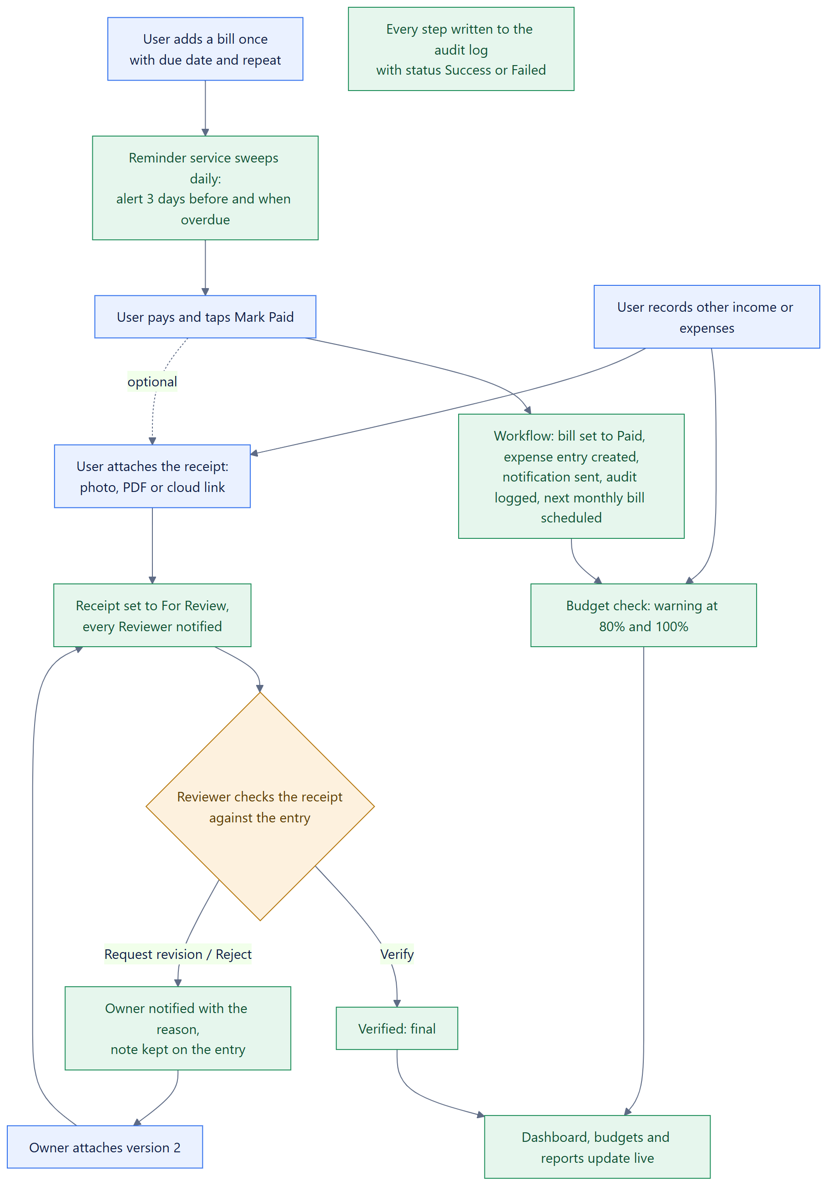
Figure 2. Target-State Process Flow (after integration)

5.2 Target-State Architecture Diagram
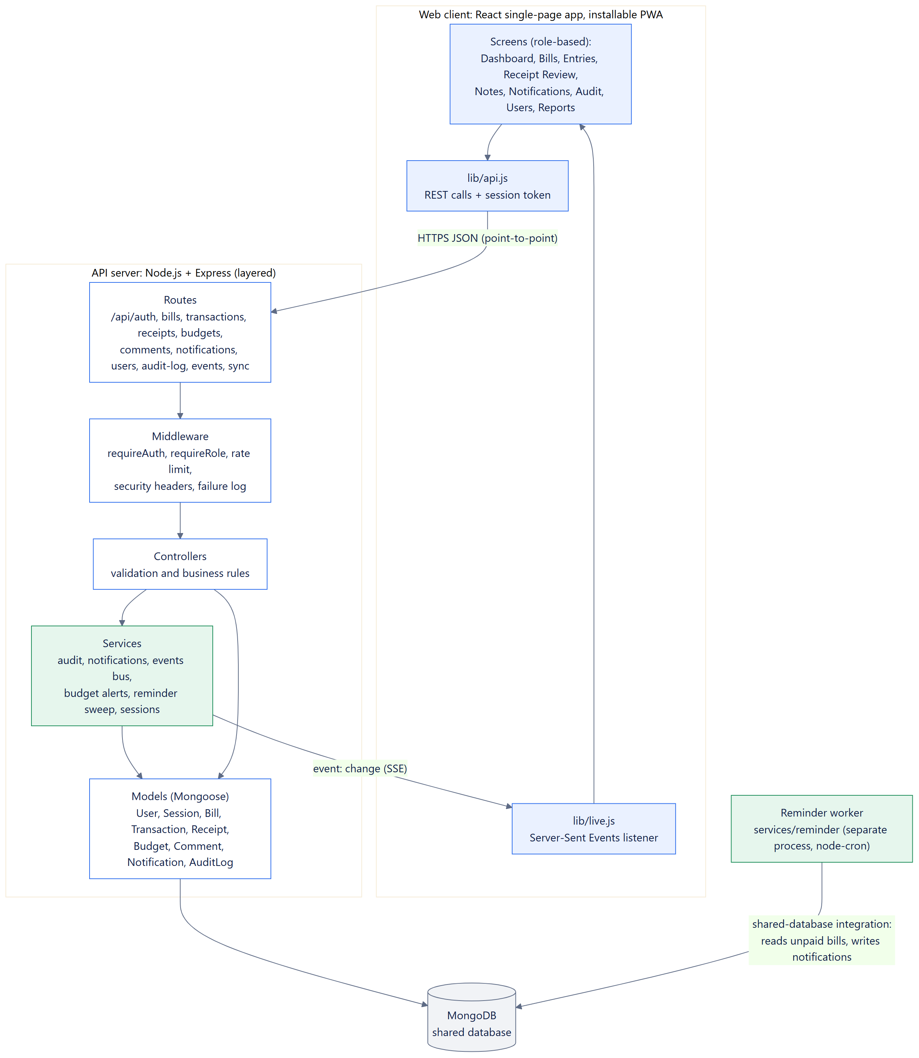
Figure 3. Target-state / application architecture: modules and how they are connected
The client talks to the API point-to-point over HTTPS (REST/JSON). Inside the API, a request passes through routes, middleware (authentication, role checks, failure logging), controllers (validation and business rules), services (audit, notifications, events, budget alerts) and models. The services publish change events on an in-process bus, which the events route streams to open browsers. The reminder worker is a separate process that integrates through the shared database.

5.3 Architecture Style Selection
Table 13. Comparison of architecture styles
Style | Strengths for this project | Weaknesses for this project | Decision
Layered | Clear separation of UI, business logic and data access; easy to explain, test and maintain for a five-person team; one deployable unit fits free hosting | Layers can become tightly coupled if rules leak into routes | Selected (primary)
Service-Oriented (SOA) | Reusable services (notification, audit, reporting) | Needs a service contract/registry and network calls between services; heavy for one database and one team | Partly adopted: services are internal modules (audit, notifications, events)
Microservices | Independent deployment and scaling per service | Several deployables, network failures between them, distributed data; free hosting allows one web service; not justified by the load | Not selected
Event-Driven | Upload, review, payment and reminder are naturally events that trigger responses; enables live updates | Harder to trace if used for everything; needs a broker for multiple processes | Selected (secondary): in-process event bus + SSE for notifications and live updates

Justification. A layered architecture keeps each concern in one place — routes only map URLs, middleware enforces access, controllers hold the rules, services perform cross-cutting work, and models own the data — which made it possible to add the receipt review module and the integration log without touching unrelated code. Event-driven elements are used exactly where the domain is event-shaped: a payment, a submitted receipt, a decision or a reminder happens, and other parts react (notification, live refresh of open screens, audit). Microservices were rejected because the system's scale does not need independent scaling, and the free hosting tier supports a single web service.

5.4 Integration Pattern Selection
Table 14. Comparison of integration patterns
Pattern | Where it would fit | Risk / cost | Decision
Point-to-Point | Web client ↔ API: one consumer, one provider, a clear REST contract | Becomes hard to maintain with many systems — not the case here (two) | Used for client ↔ API
Hub-and-Spoke | A central broker routing data among many systems | Extra infrastructure with only one API and one worker | Not used (no hub needed)
Shared Database | API and reminder service both work on bills and notifications | Risky if data ownership is unclear | Used for API ↔ reminder service, with explicit field ownership and atomic claims
Event-Driven | Workflow events (payment, receipt submitted/decided, reminder) trigger notifications and live updates | Events must not carry private data; ordering | Used inside the API and to clients (SSE); events carry only a topic

Justification. The combination keeps each connection as simple as it can be. The client–API link is point-to-point because there is one client application and one API. The reminder service uses the shared database because it must work while no one is using the app and even if the API is asleep; its risk is controlled by ownership: the reminder service may only set lastRemindedOn on a bill and insert notifications and its own audit entry, and it claims each bill with a conditional update (lastRemindedOn ≠ today) so two sweeps on the same day can never send the same alert twice (verified in IT-06 and RT-23). Event-driven messaging delivers workflow results to people as they happen; events contain only a topic such as receipts, and the browser then reloads its own data through the authorised API, so no private data travels in an event.

5.5 Architecture Decision Record
Table 15. Architecture decision records
ADR | Decision | Context and rationale | Consequences
ADR-001 | Layered modular monolith: Express API + React client, deployed as one service | Five-person team, one database, free single-service hosting; clarity for the defense matters more than independent scaling | + simple deployment and testing; + one URL. − whole app redeploys for any change; scaling is vertical only
ADR-002 | Reminder service integrates through the shared database (not through the API) | Reminders must run on a schedule independent of user activity; the API may be asleep on free hosting | + works with no user online; + the worker never needs credentials to the API. − field ownership must be respected (documented in 8.5); the API also runs the sweep daily so reminders still happen where no worker is hosted
ADR-003 | Live updates with Server-Sent Events, not polling or WebSockets | Updates flow one way (server → browser); SSE works over plain HTTPS through proxies; polling would multiply requests on slow mobile data | + notifications appear without refresh; + events carry no data. − one open connection per tab (capped at 10 per account); an in-process bus means one API instance
ADR-004 | Review the receipt, not the entry | An earlier version required approval before an entry counted; users found the delay confusing. The specification still requires Asset Submission and Review/Approval | + entries count immediately; + review checks real evidence. − an unverified entry still counts in the balance (shown by its receipt status)
ADR-005 | Server-side sessions with hashed tokens instead of stateless JWT | Logout, password change and role change must take effect at once on every device | + immediate revocation; + a leaked database does not leak working tokens. − one database lookup per request
ADR-006 | Store receipt files (≤ 2 MB) in MongoDB, or store a link | No paid object storage; most receipts are photos that compress well | + backups include the files; + no extra service. − size limit; large files must be attached as a cloud link

6. System Design

6.1 Use-Case Diagram
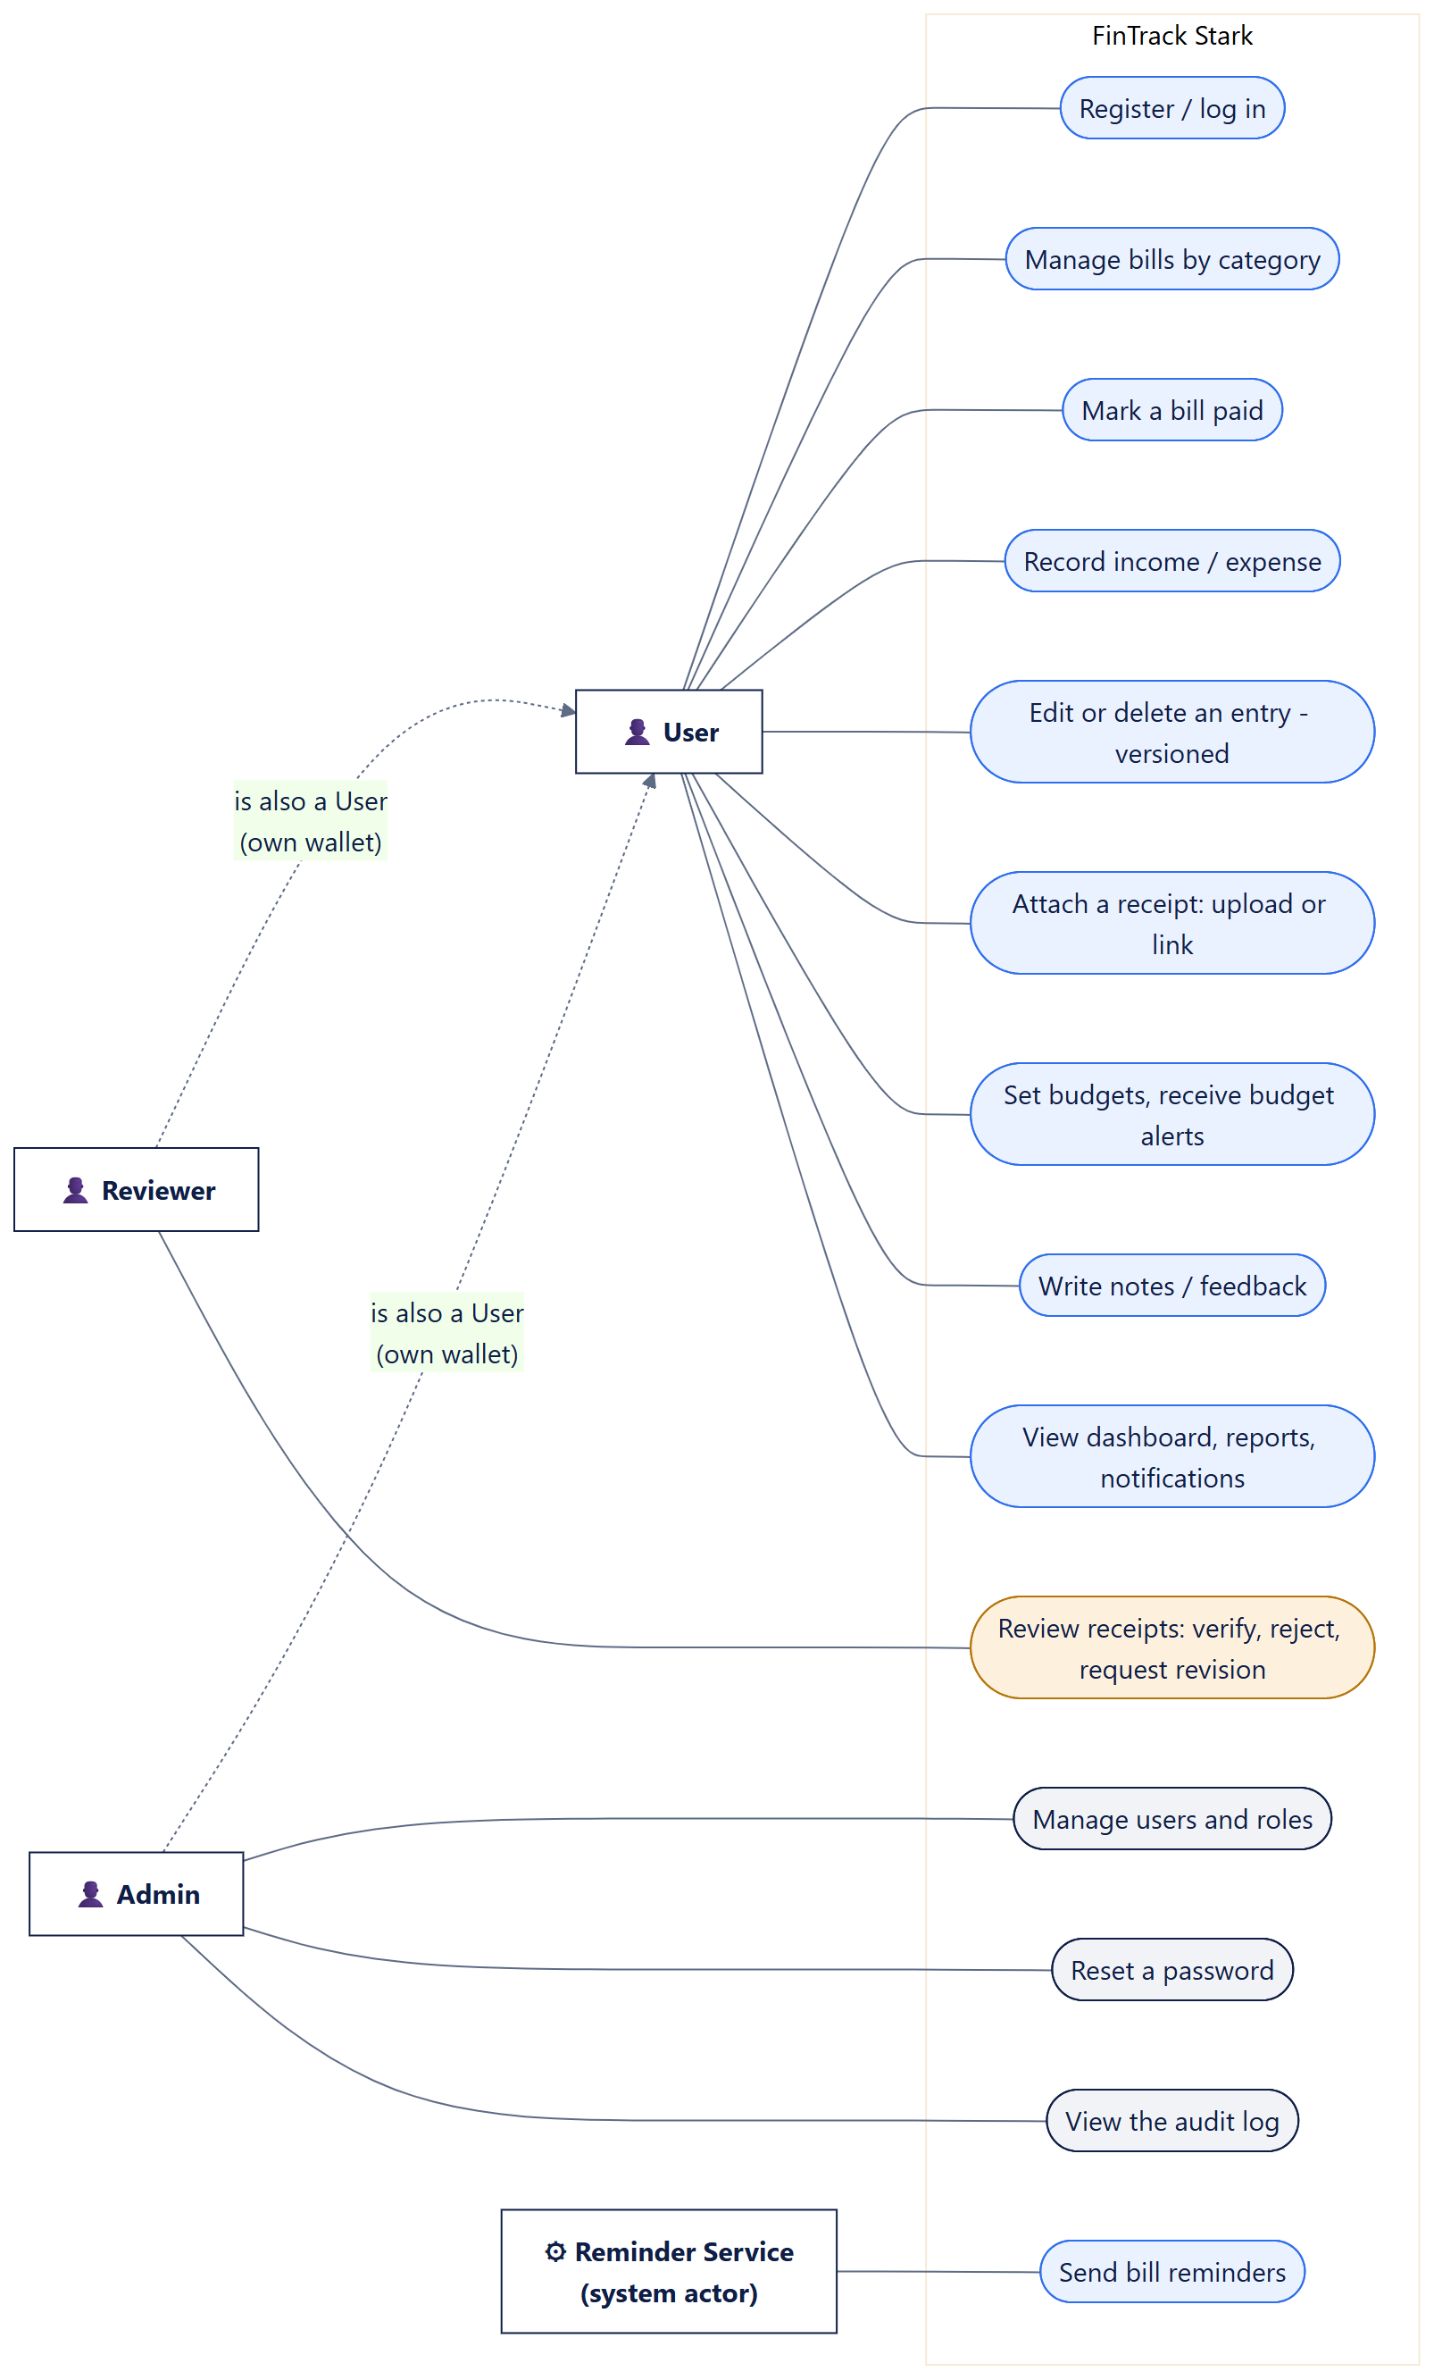
Figure 4. Use-Case Diagram: functions per role
Reviewers and Admins are also Users: each has their own wallet (bills, entries, budgets) on a separate dashboard tab, but neither can read other people's money. The Reviewer's only additional power is deciding on receipts; the Admin's is managing accounts and reading the audit log.

6.2 Context Diagram
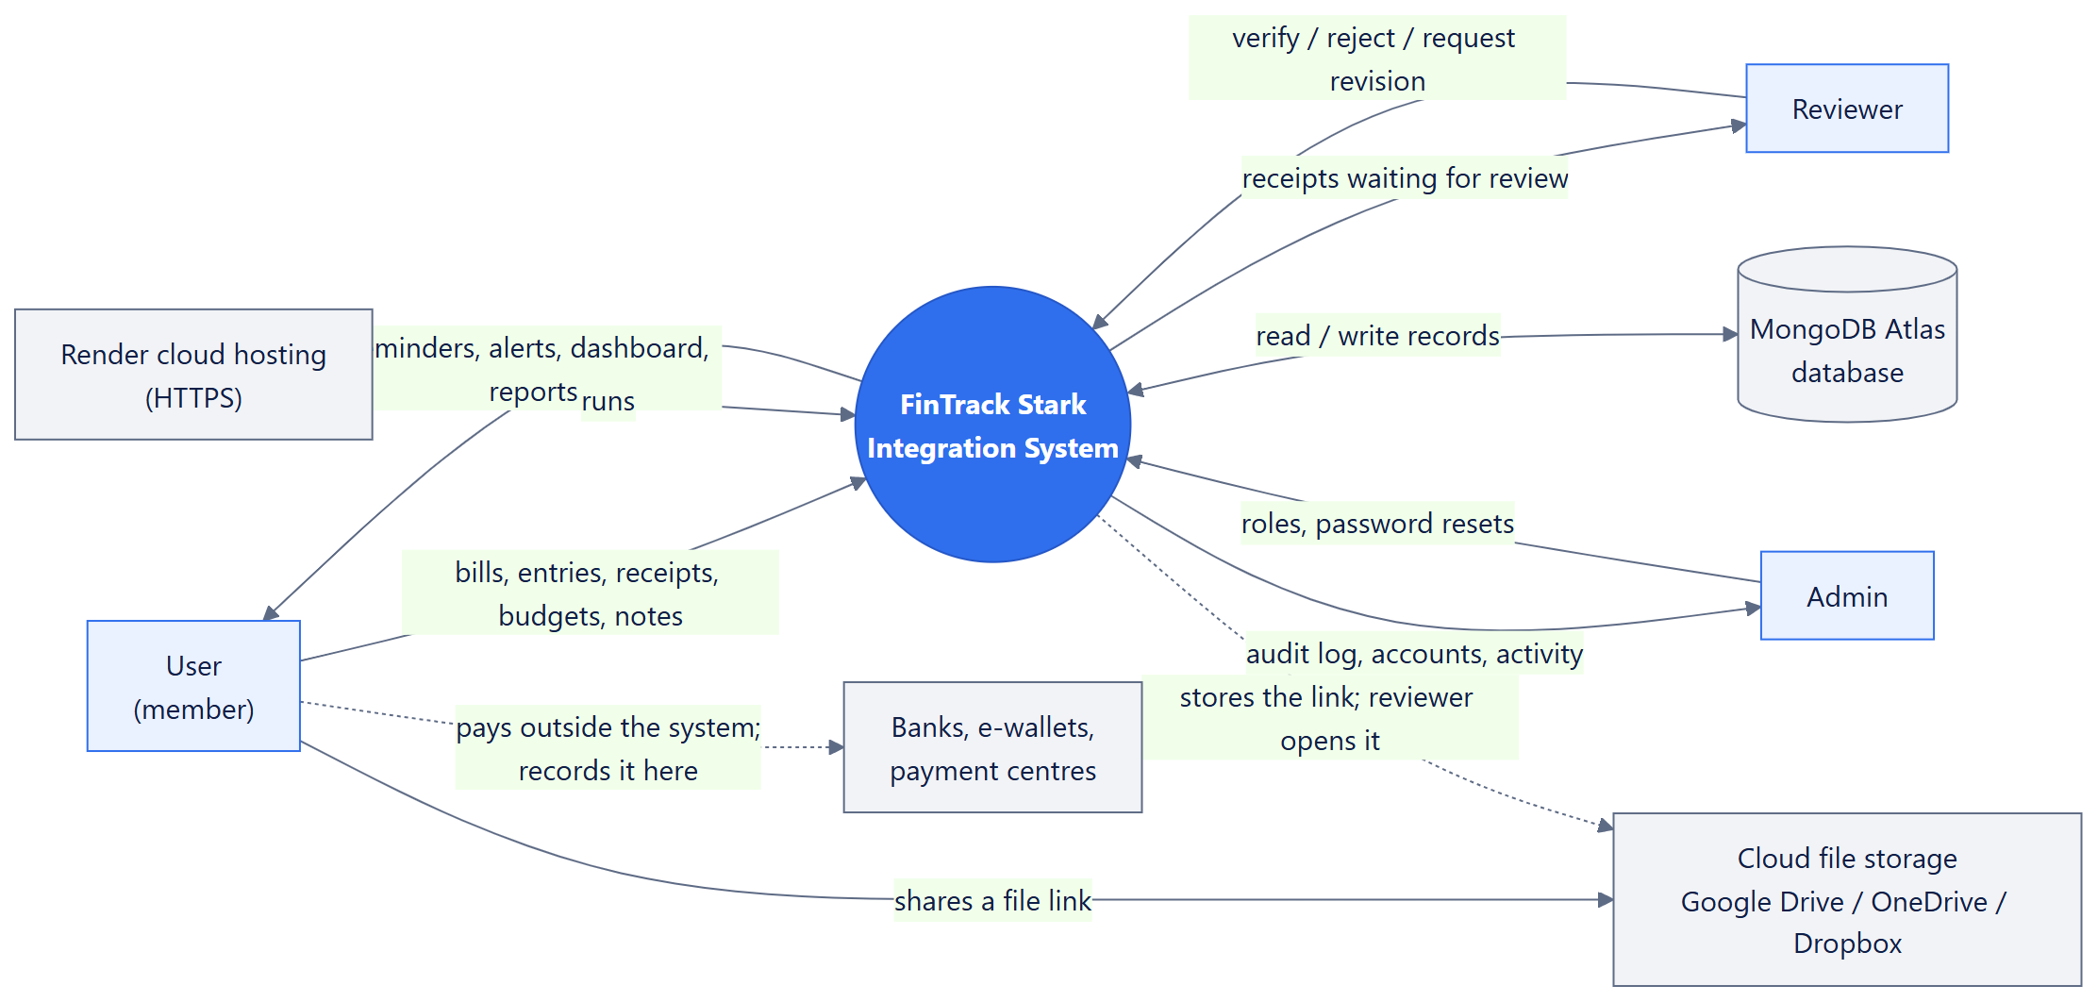
Figure 5. Context Diagram: the system, its users and external systems

6.3 Data-Flow Diagram
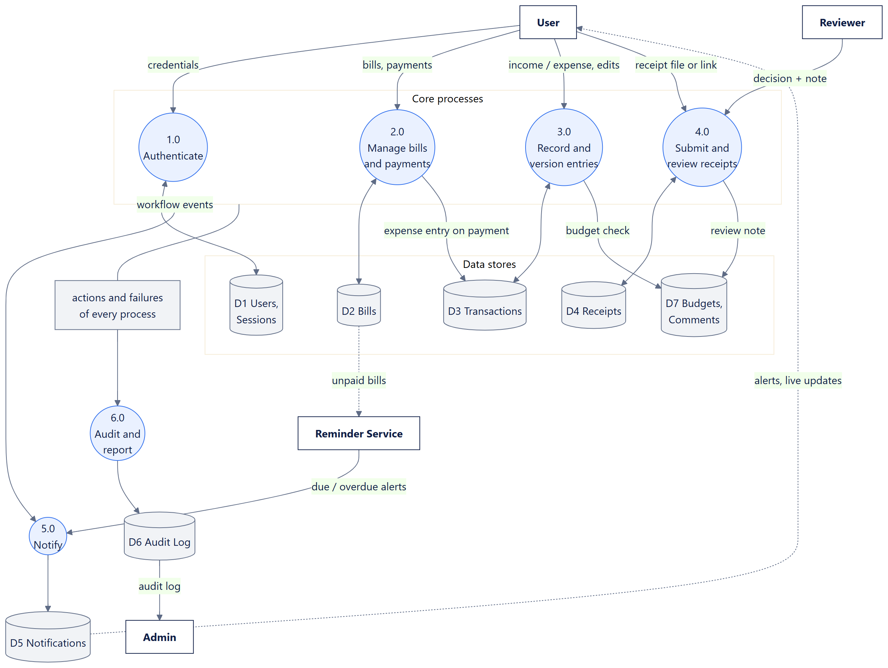
Figure 6. Data-Flow Diagram (Level 1): processes, data stores and flows
Table 16. DFD processes
Process | Description
1.0 | Authenticate: checks credentials against D1, creates a session (hashed token) and returns the token.
2.0 | Manage bills and payments: stores bills in D2; on payment, writes the expense entry to D3 and raises events.
3.0 | Record and version entries: stores entries and versions in D3; checks the month's spending against D7 budgets.
4.0 | Submit and review receipts: stores receipt versions in D4; stores the Reviewer's note in D7 (comments).
5.0 | Notify: turns workflow events and the reminder service's alerts into notifications (D5) and live updates.
6.0 | Audit and report: records every action and failure in D6; produces dashboards and reports from D3.

6.4 Sequence Diagram
The sequence diagram below shows one complete interaction — asset (receipt) submission through to final approval — including a revision round. It is exactly the flow exercised by the automated end-to-end test E2E-02.
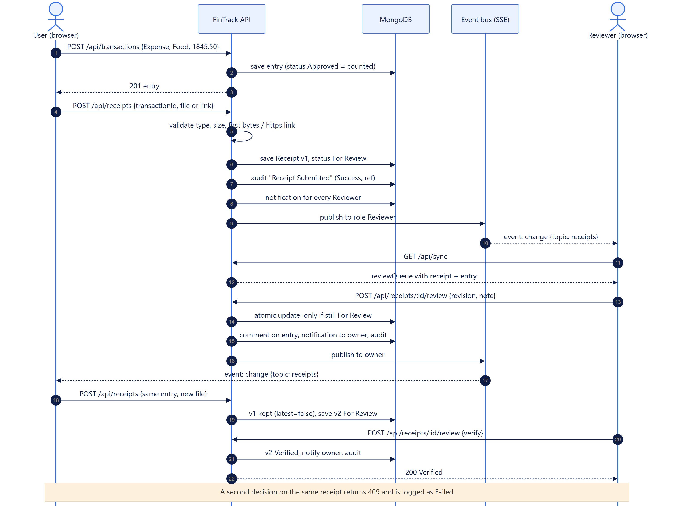
Figure 7. Sequence Diagram: receipt submission, revision request, resubmission (v2) and verification

6.5 Database Design
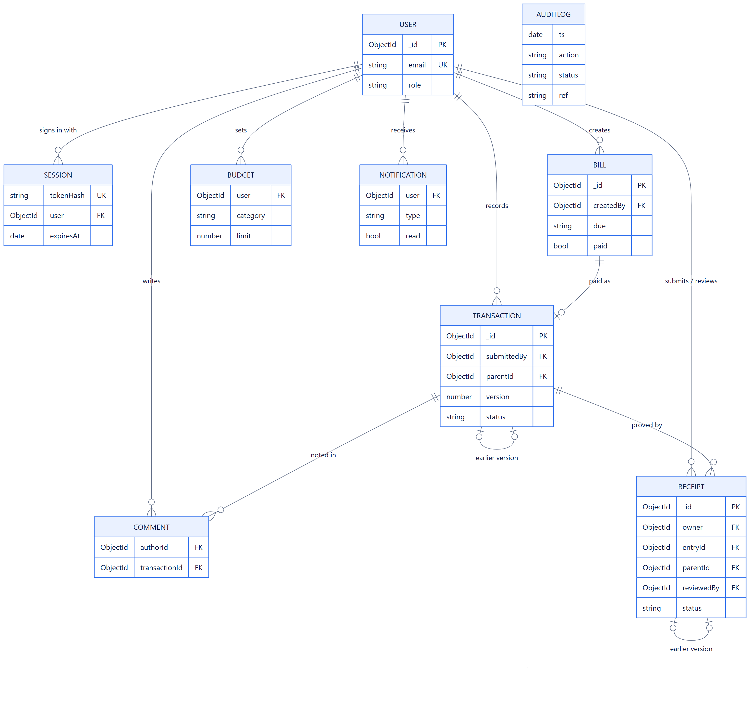
Figure 8. Entity-Relationship Diagram (keys and main fields; every field is listed in the data dictionary below)
MongoDB stores each entity as a collection of documents; relationships are references by ObjectId. Version chains (entries and receipts) are self-references through parentId. The following tables are the data dictionary.
Table 17. Collection users
Field | Type | Rules / meaning
_id | ObjectId | Primary key
firstName, lastName | String ≤ 60 | Required
name | String | Derived full name
email | String ≤ 160 | Required, unique, lower-case
passwordHash | String | scrypt$N$r$p$salt$hash (legacy bcrypt still verified)
role | String | Admin | Reviewer | User
mustChangePassword | Boolean | True after an Admin reset

Table 18. Collection sessions
Field | Type | Rules / meaning
tokenHash | String | SHA-256 of the bearer token; unique
user | ObjectId → users | Owner
name, email, role | String | Copied at login; refreshed on role/profile change
mustChangePassword | Boolean | Limits the session to changing the password
expiresAt | Date | TTL index; 8 hours

Table 19. Collection bills
Field | Type | Rules / meaning
name | String ≤ 120 | Required
category | String | Utilities | Housing | Internet | Credit | Subscription | Other
amount | Number | 0.01 – 1,000,000,000,000
due | String YYYY-MM-DD | Real calendar date
paid, paidOn, paidAmount | Boolean, String, Number | Set atomically by the payment workflow
createdBy | ObjectId → users | Owner
lastRemindedOn | String | Owned by the reminder service
repeat, repeatDay | String, Number | none | monthly; day of month 1–31
previousBill | ObjectId → bills | The bill this one followed

Table 20. Collection transactions
Field | Type | Rules / meaning
type | String | Income | Expense
category | String ≤ 40 | Must match the type's category list
amount | Number | 0.01 – 1,000,000,000,000
date | String YYYY-MM-DD | Real date, not in the future
note | String ≤ 300
status | String | Approved (current, counted) | Superseded | Deleted
version, parentId | Number, ObjectId | Version chain
autoApproved | Boolean | Created by a bill payment
submittedBy | ObjectId → users | Owner
createdAt | Date

Table 21. Collection receipts
Field | Type | Rules / meaning
owner, ownerName | ObjectId → users, String | Submitter
entryId | ObjectId → transactions | Follows the entry's current version
version, parentId, latest | Number, ObjectId, Boolean | Receipt version chain
kind | String | file | link
fileName, mimeType, size, data | String, String, Number, Binary | ≤ 2 MB; JPEG, PNG, WEBP or PDF; data not loaded in lists
url, provider | String ≤ 500, String | https only; Google Drive, OneDrive, Dropbox or Web link
status | String | For Review | Verified | Rejected | Needs Revision | Replaced | Withdrawn
reviewedBy, reviewerName, reviewedAt, reviewNote | ObjectId, String, Date, String ≤ 300 | Set once by the decision

Table 22. Collection budgets
Field | Type | Rules / meaning
user | ObjectId → users | Owner
category | String | Expense category; unique per user
limit | Number | 1 – 1,000,000,000,000

Table 23. Collection comments
Field | Type | Rules / meaning
transactionId | ObjectId → transactions | Null for a personal note
author, authorId | String, ObjectId → users | Writer
title | String ≤ 120 | Optional
text | String ≤ 5000 | Required
ts, editedAt | Date

Table 24. Collection notifications
Field | Type | Rules / meaning
user | ObjectId → users | Addressee
type | String | bill, reminder, overdue, payment, budget, role, receipt, receipt-verified, receipt-revision, receipt-rejected
message | String
read | Boolean
ts | Date

Table 25. Collection auditlogs
Field | Type | Rules / meaning
ts | Date | Indexed
user | String | Person or service name
action | String | e.g. Payment Recorded, Receipt Verified, Failed: POST bills/:id/pay
status | String | Success | Failed
detail | String | What happened; for failures the HTTP status and message
ref | String | Id of the record concerned

6.6 User Interface Design
All twelve screens required by the specification exist in the prototype. The table below maps each one to its screen; the screenshots that follow were captured from the running system with sample data.
Table 26. Required prototype screens
# | Required screen (spec §14) | FinTrack Stark screen | Address
1 | Login Page | Log in / Create account | /login, /register
2 | Dashboard | Home (User), Review Desk (Reviewer), Admin Console (Admin) | /dashboard
3 | Project List | Bill Categories | /categories
4 | Project Details | Category Detail | /categories/:name
5 | Asset or Task Submission Form | Log Income/Expense with receipt | /submit
6 | Asset Version or Revision History | Revision History; receipt versions | /revisions, /entries
7 | Review and Approval Page | Receipt Review | /review
8 | Comment / Feedback Page | Notes / Feedback | /notes
9 | Notification Log Page | Notification Log (Inbox) | /notifications
10 | Audit Log Page | Audit Log | /audit
11 | Reports Page | Reports | /reports
12 | User and Role Management Page | User & Role Mgmt | /users

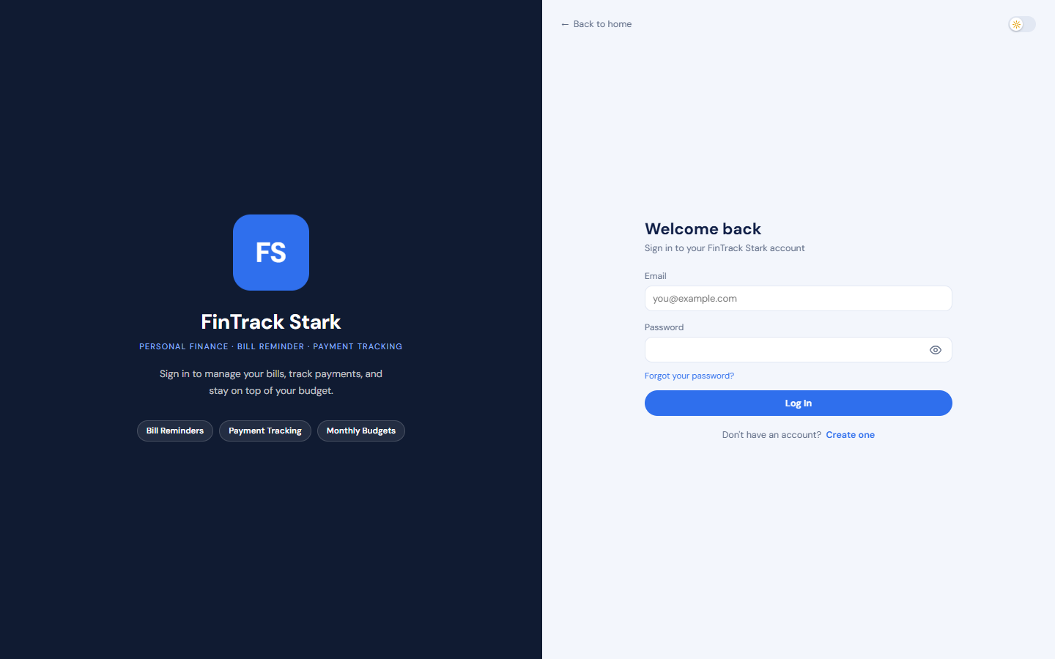
Figure 9. Screen 1 — Login page
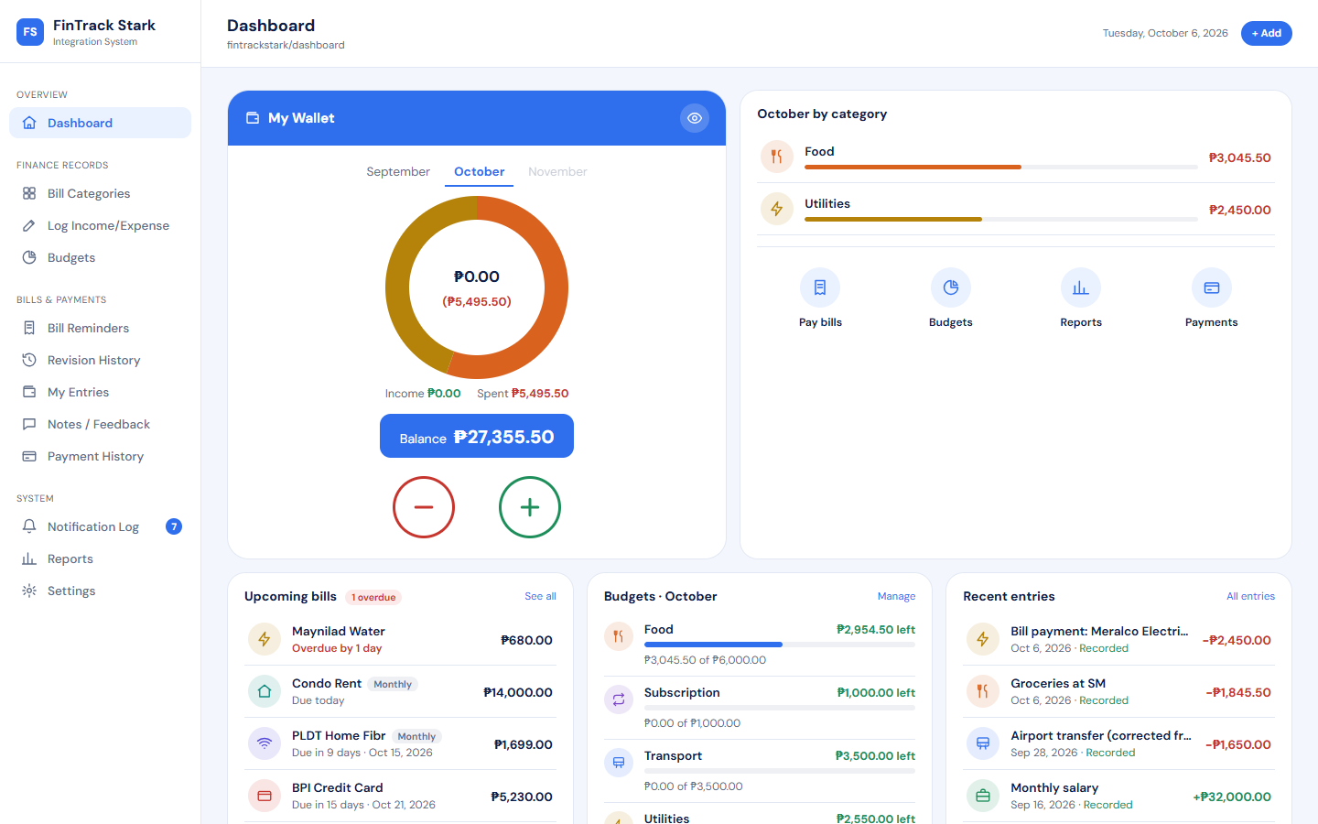
Figure 10. Screen 2 — User dashboard (Home): balance, spending by category, bills and budgets
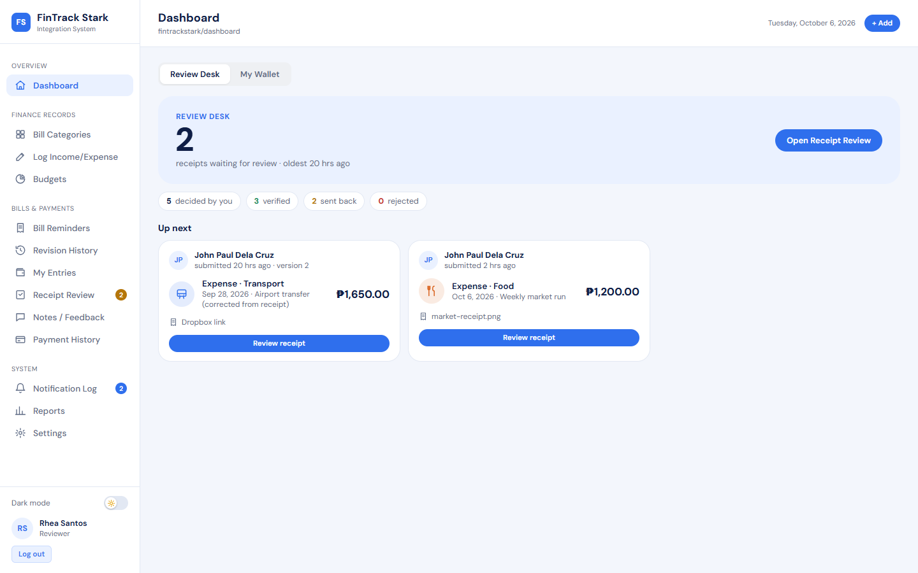
Figure 11. Screen 2 — Reviewer dashboard (Review Desk): receipts waiting and decisions
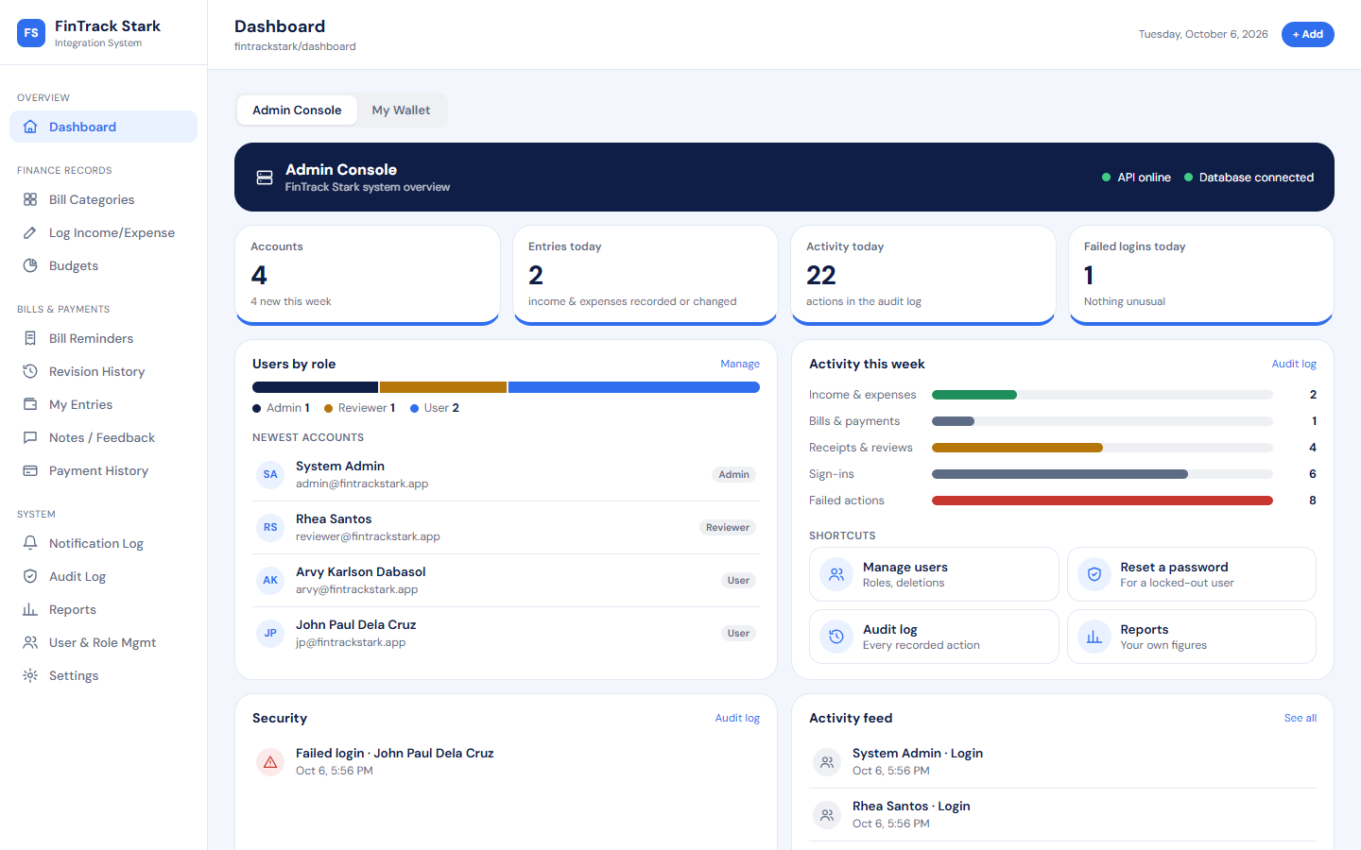
Figure 12. Screen 2 — Admin dashboard (Admin Console): system status, accounts, weekly activity
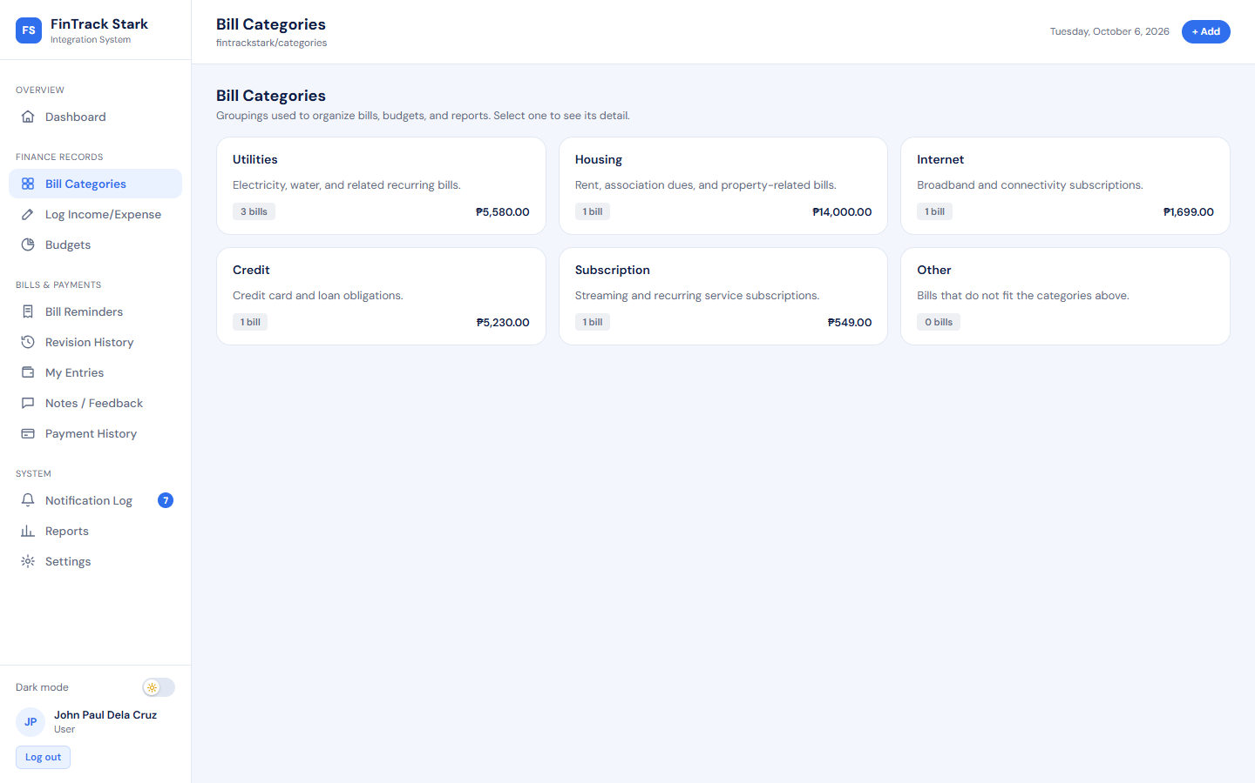
Figure 13. Screen 3 — Project List: Bill Categories
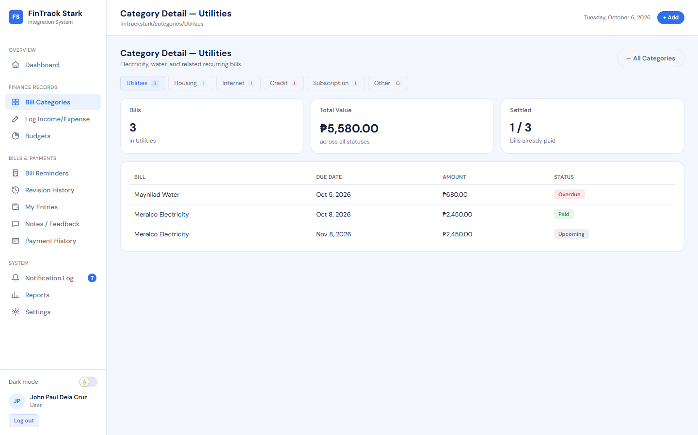
Figure 14. Screen 4 — Project Details: Category Detail (Utilities)
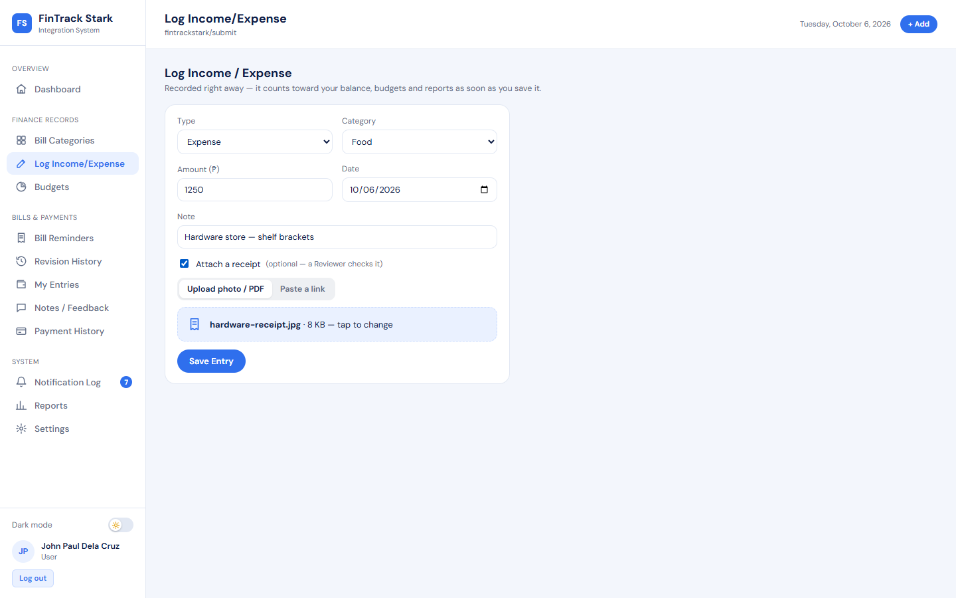
Figure 15. Screen 5 — Submission form: Log Income/Expense with a receipt photo attached
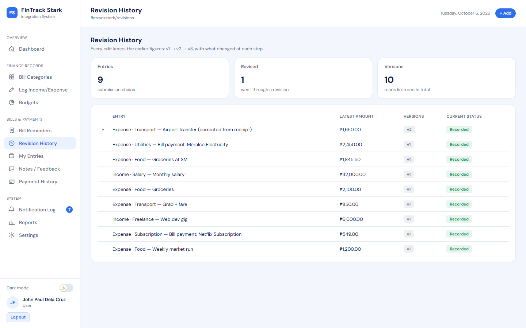
Figure 16. Screen 6 — Revision History: entry versions (v1 → v2)
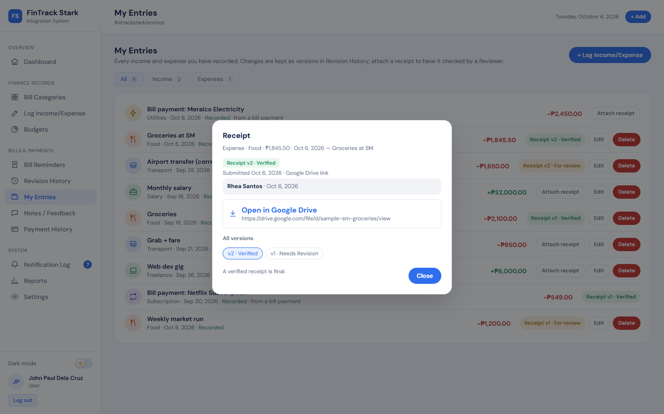
Figure 17. Screen 6 — Receipt versions: v1 Needs Revision, v2 Verified (Google Drive link)
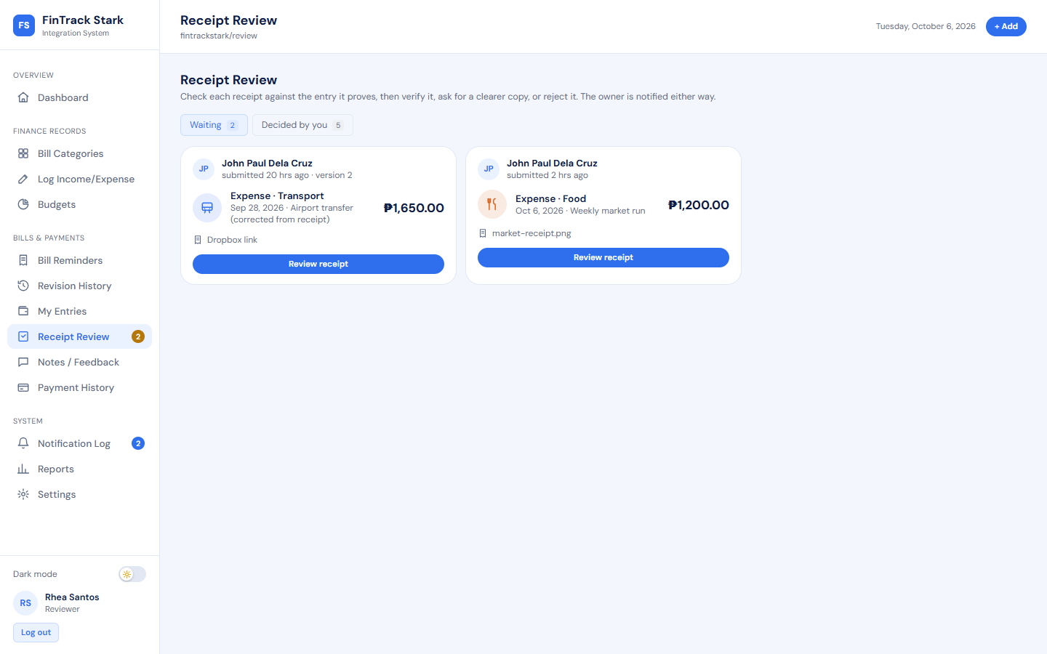
Figure 18. Screen 7 — Review and Approval page: Receipt Review queue
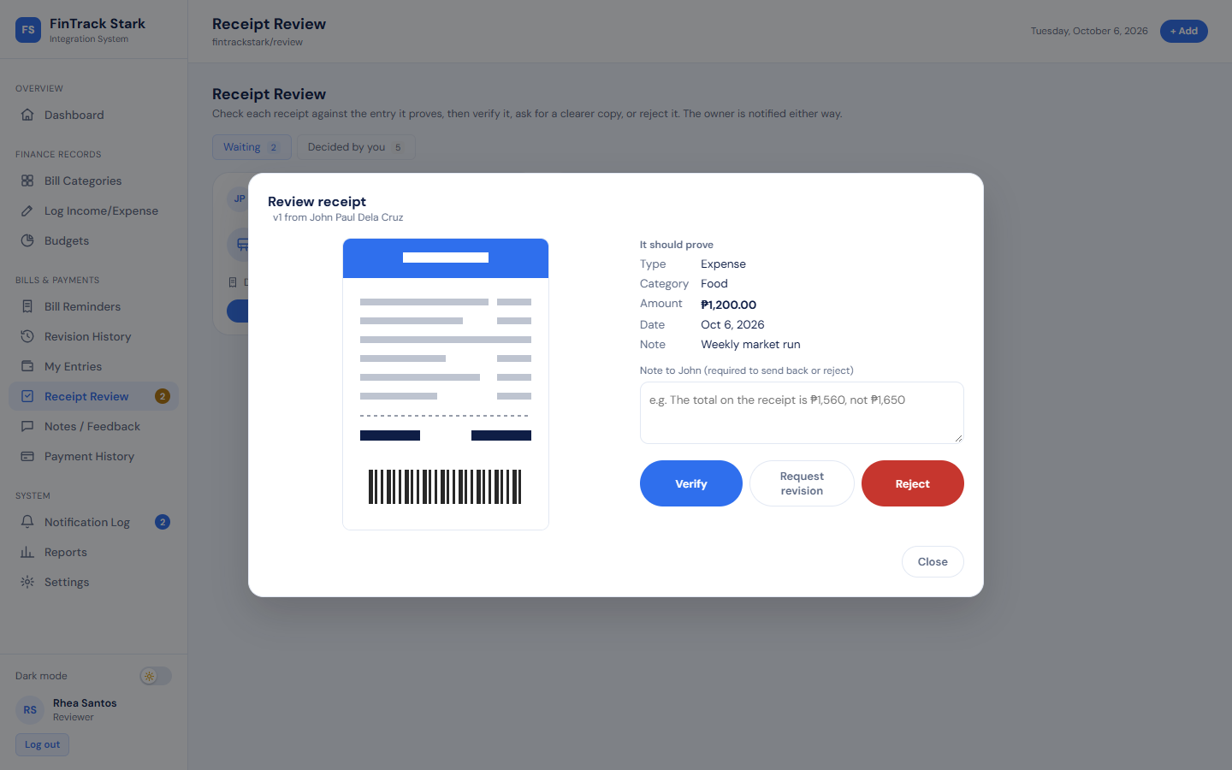
Figure 19. Screen 7 — Reviewing a receipt against its entry: Verify, Request revision, Reject
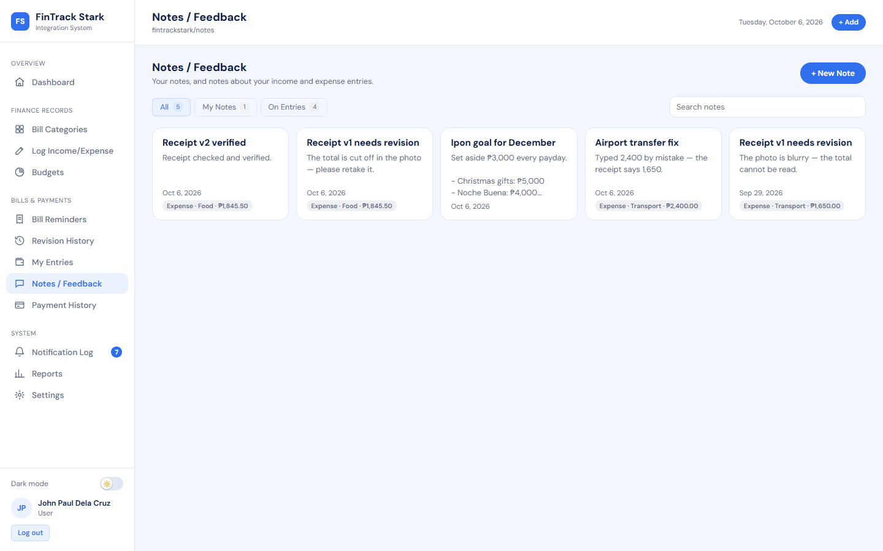
Figure 20. Screen 8 — Comment / Feedback page: Notes / Feedback
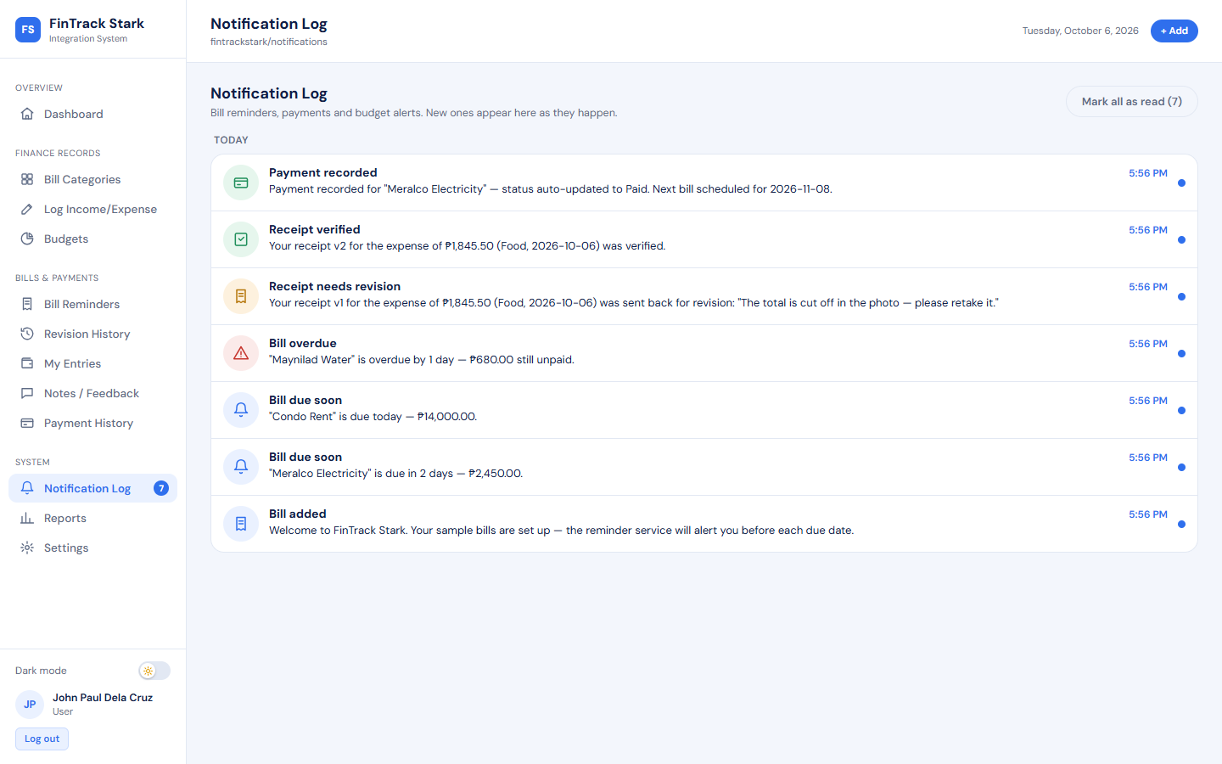
Figure 21. Screen 9 — Notification Log
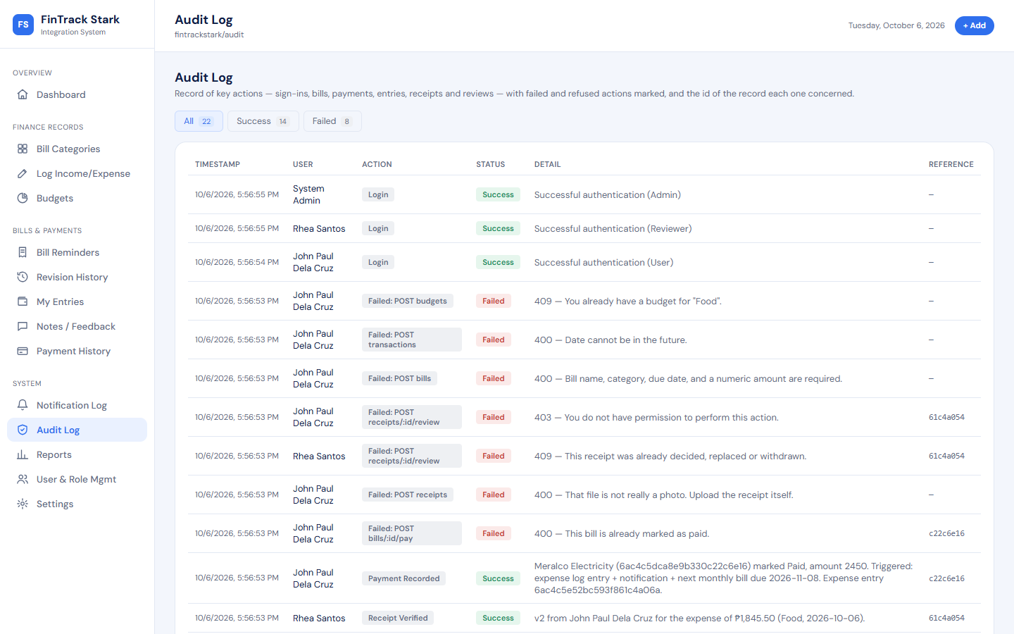
Figure 22. Screen 10 — Audit Log with status and record reference
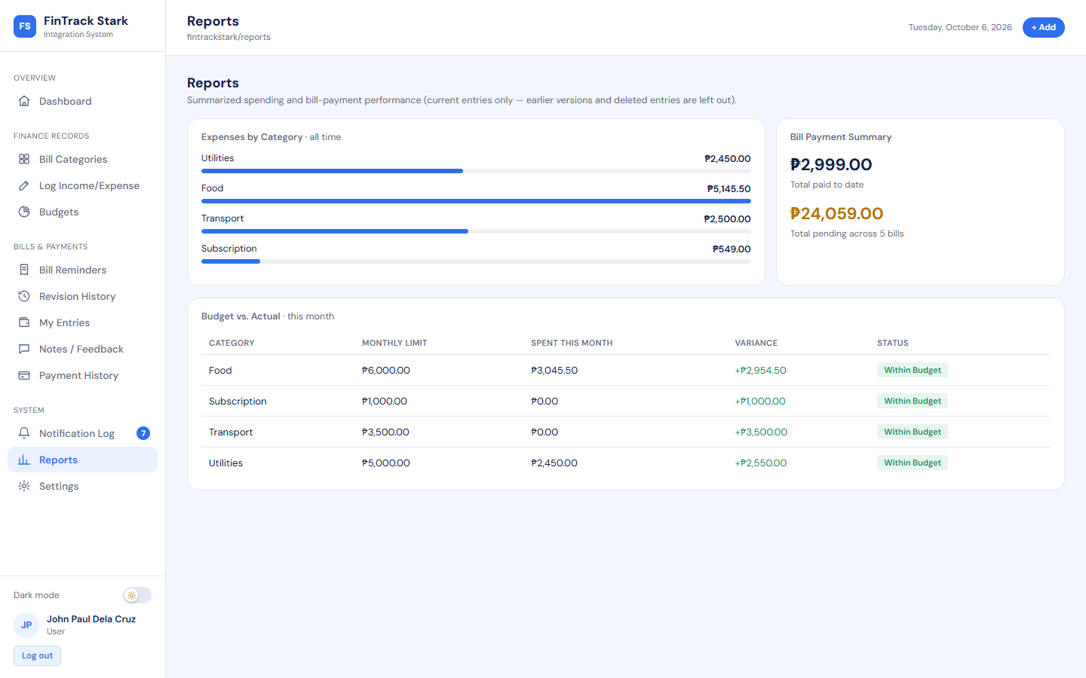
Figure 23. Screen 11 — Reports
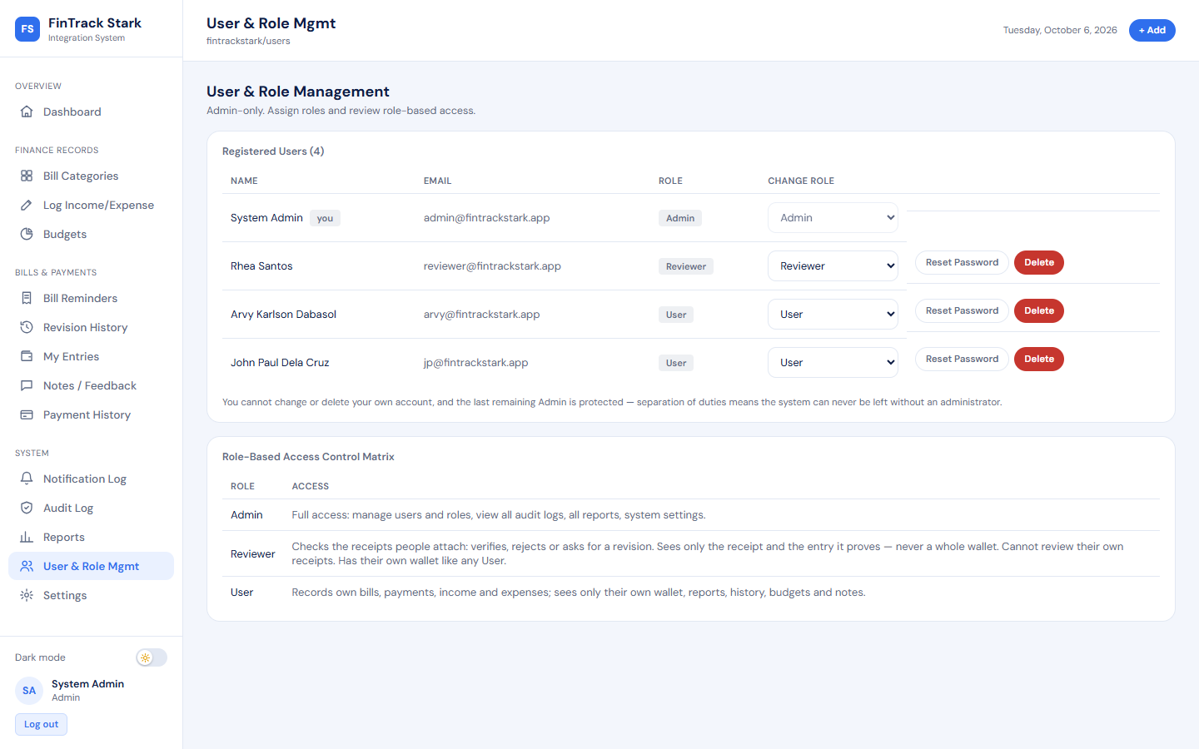
Figure 24. Screen 12 — User and Role Management

7. Integration Design and Implementation

7.1 Integration Scenario
FinTrack Stark integrates six connections. Together they cover five of the specification's integration options: API integration, workflow automation, webhook simulation, messaging simulation and external storage integration simulation.
Table 27. Integrations implemented
# | Integration | What is connected | Spec §6 option | Pattern
I1 | Client ↔ REST API | React client and Express API: 42 endpoints, JSON, Bearer token | API Integration | Point-to-point
I2 | Bill payment cascade | Bills → Transactions → Notifications → Audit → next Bill → Budgets | Workflow Automation, Webhook Simulation | Internal event chain
I3 | Receipt submission and review | Entries → Receipts → Reviewers' queue → decision → Comments, Notifications, Audit | Workflow Automation, Webhook Simulation | Internal event chain
I4 | Live event messaging | API event bus → every open browser of the addressed user or role | Messaging Simulation | Event-driven (SSE)
I5 | Reminder service | Separate scheduled process ↔ bills and notifications | Workflow Automation | Shared database
I6 | Cloud file links | Receipt ↔ Google Drive, OneDrive, Dropbox | External Storage Integration Simulation | Reference by URL

7.2 API / Workflow / Webhook / Messaging Components

I2 — Bill payment cascade (workflow automation and webhook simulation)
One action — Mark Paid — triggers the whole chain shown below. The bill is claimed with an atomic conditional update (paid: false → true), so a double click or a second tab cannot pay it twice; if the expense entry cannot be written, the bill is put back to unpaid so a bill never reads Paid without the payment that paid it.
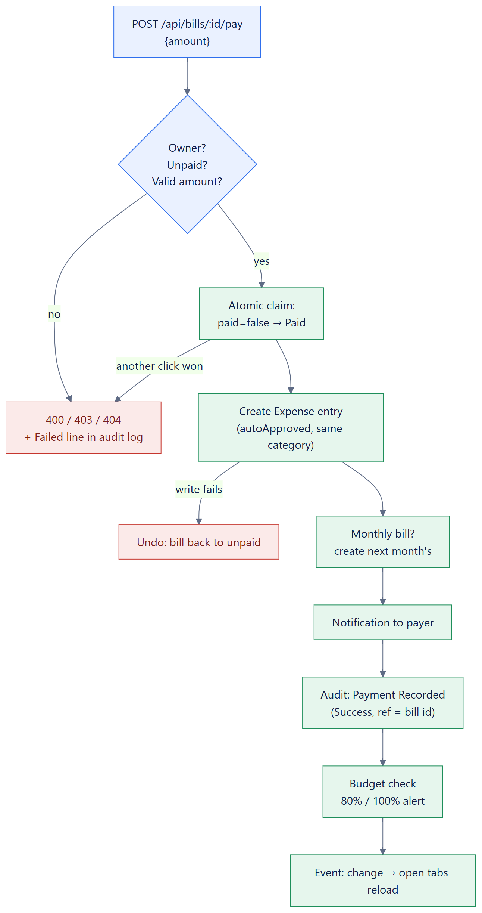
Figure 25. Bill payment cascade (I2)

I3 — Receipt submission and review (workflow automation)
Submitting a receipt automatically sets it to For Review and notifies every Reviewer; each decision automatically notifies the owner, adds the decision as a note on the entry and writes to the audit log. The life cycle of a receipt is:
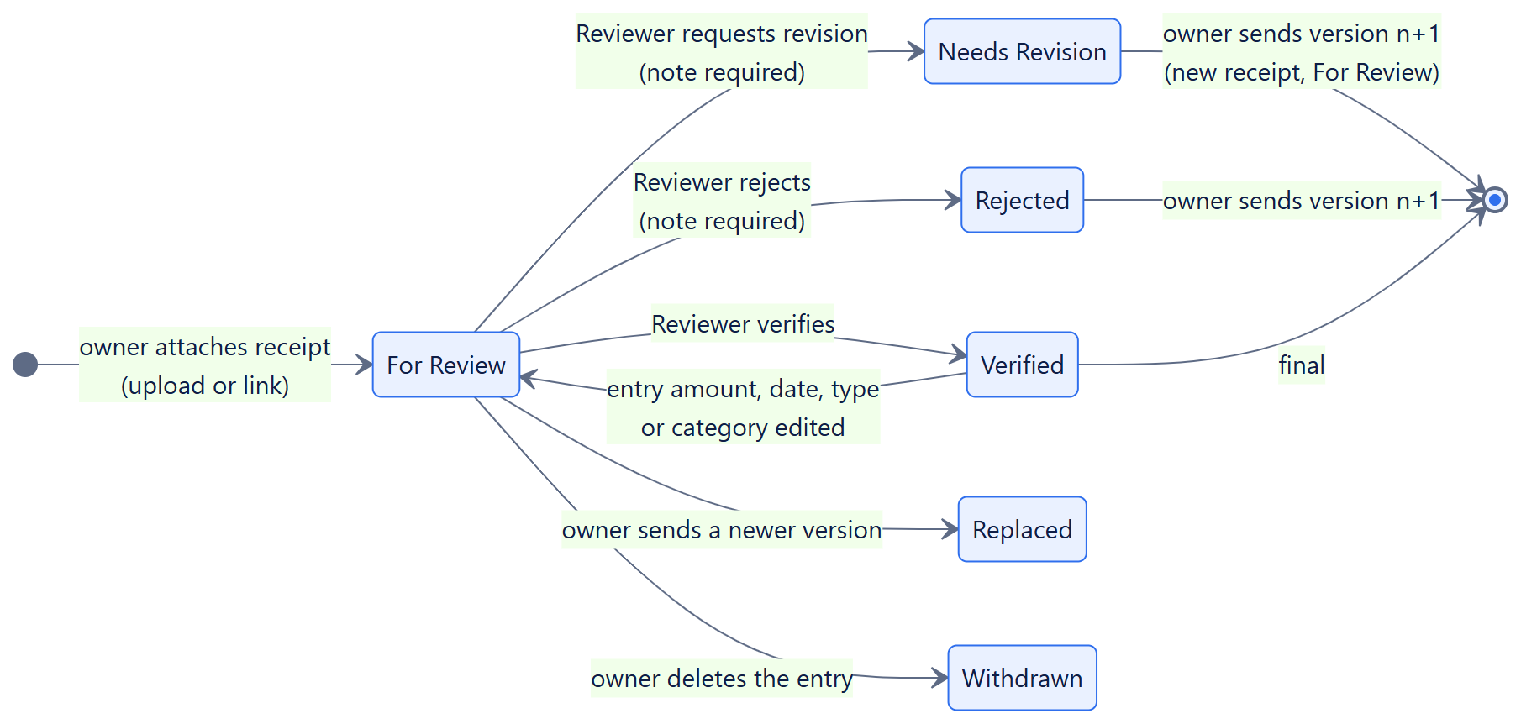
Figure 26. Receipt status life cycle (I3)
- A decision is accepted only while the receipt is still For Review and still the latest version (atomic update); a second decision returns 409 and is logged as Failed.
- Nobody may review their own receipt (separation of duties); a note is required to reject or to request a revision.
- If the entry's type, category, amount or date is edited after verification, the receipt goes back to For Review, because it no longer proves the new figures. Deleting the entry withdraws a receipt still waiting.

I4 — Live event messaging (messaging simulation)
Every change publishes a small event on the API's event bus addressed to a user or a role. Each open browser tab keeps a Server-Sent Events connection (GET /api/events) and, on an event, reloads its data through GET /api/sync. Events carry only a topic — never data — so the authorisation rules of the normal API still decide what each person sees. The stream below was captured from a User's open connection while the workflow in Section 7.4 ran:
Captured event stream (GET /api/events)
retry: 3000
event: ready
data: {}

event: change
data: {"topic":"transactions"}

event: change
data: {"topic":"receipts"}

event: change
data: {"topic":"notifications"}

event: change
data: {"topic":"receipts"}

event: change
data: {"topic":"comments"}

event: change
data: {"topic":"receipts"}

I5 — Reminder service (shared-database integration)
The reminder service is a separate Node.js process (services/reminder, scheduled with node-cron at 08:00 daily); the API runs the same sweep on start-up and on the first request of each Philippine day so that reminders still happen on hosting where only one process runs. Both find unpaid bills due within three days or overdue, claim each bill for the day (lastRemindedOn), insert one notification per bill for its owner, and record the sweep in the audit log. The worker never calls the API.
Reminder service run, captured from the terminal (second run shows no duplicates)
> npm run reminder:once
[db] connected to mongodb://127.0.0.1:27017/fintrack_stark_docs
[reminder] 2026-10-06: raised 2 alert(s) across 1 account(s).

> npm run reminder:once (run again the same day)
[db] connected to mongodb://127.0.0.1:27017/fintrack_stark_docs
[reminder] 2026-10-06: 2 bill(s) in range, none need a new alert.

I1 — Main API endpoints
Table 28. Main REST endpoints used by the integrations (full list in Appendix A)
Method | Path | Who | Purpose
POST | /api/auth/login | Anyone | Sign in; returns a session token
GET | /api/sync | Signed in | Everything the screens show, in one response
GET | /api/events | Signed in | Live event stream (SSE)
POST | /api/transactions | Signed in | Record income or expense
PUT | /api/transactions/:id | Owner | Edit → new version
POST | /api/bills/:id/pay | Owner | Payment cascade (I2)
POST | /api/receipts | Owner of the entry | Submit receipt v1 or a new version (I3)
GET | /api/receipts/:id/file | Owner, Reviewer | Open an uploaded receipt
GET | /api/receipts/review | Reviewer | Review queue
POST | /api/receipts/:id/review | Reviewer | Verify / reject / request revision
GET | /api/audit-log?status=Failed | Admin | Integration log (failed actions)

7.3 Data Mapping Table
Table 29. Mapping: Bill → Expense entry (payment cascade)
Source (bill / request) | Target (transaction) | Rule
— | type | Always "Expense"
bill.category | category | Copied (bill categories are a subset of expense categories, so the budget applies)
request.amount (default bill.amount) | amount | Validated 0.01 – 1e12; also stored as bill.paidAmount
today (Asia/Manila) | date; bill.paidOn | Philippine calendar date, not UTC
bill.name | note | "Bill payment: <name>"
— | status / autoApproved | "Approved" (counted) / true — cannot be edited separately
session user | submittedBy | The payer (always the bill's owner)
bill.repeat = monthly | new bill.due | Same day next month (clamped to month length); previousBill = paid bill

Table 30. Mapping: Receipt submission request → Receipt document
Request field | Receipt field | Rule
transactionId | entryId | Must be the caller's current entry
kind | kind | "file" or "link"
data (base64) | data (binary), size | Decoded; ≤ 2 MB; first bytes must match mimeType
mimeType | mimeType | image/jpeg, image/png, image/webp or application/pdf
fileName | fileName | Path removed; unsafe characters replaced; ≤ 120
url | url, provider | https only; provider derived from the host name
session user | owner, ownerName
previous latest receipt | version, parentId | version = previous + 1; previous.latest = false
— | status | "For Review" (automatic)

Table 31. Mapping: Review decision → records written
Decision field | Target | Value
action | receipt.status | verify → Verified; revision → Needs Revision; reject → Rejected
note | receipt.reviewNote; comment.text | Required for revision and reject; ≤ 300
session user | receipt.reviewedBy, reviewerName; comment.author
receipt.version, decision | comment.title | "Receipt v<n> <status>"
receipt.owner | notification.user | type receipt-verified / receipt-revision / receipt-rejected
all of the above | auditlog | action "Receipt Verified" etc., status Success, ref = receipt id

Table 32. Mapping: Bill → reminder notification (reminder service)
Source (bill) | Target (notification) | Rule
createdBy | user | Addressed to the bill's owner only
due vs. today | type | overdue (past due) or reminder (due within 3 days or today)
name, amount, due | message | e.g. "Meralco Electricity" is due in 2 days — ₱2,450.00.
today | bill.lastRemindedOn | Claim: at most one alert per bill per day

7.4 Sample Payload or Data Format
The following requests and responses were captured from the running system (local server with sample data) on 10/6/2026, 17:56:52 (Philippine time). Response times are the server's actual times.
1. Sign in — request
POST /api/auth/login HTTP/1.1
Content-Type: application/json

{
"email": "jp@fintrackstark.app",
"password": "••••••"
}

1. Sign in — response
HTTP/1.1 200 (315 ms)
Content-Type: application/json

{
"token": "fb1bdb31…(64 hex characters, shown once)",
"user": {
"id": "6ac4c5dca8e9b330c22c6e09",
"name": "John Paul Dela Cruz",
"email": "jp@fintrackstark.app",
"role": "User",
"mustChangePassword": false
}
}

2. Record an expense — request and response
POST /api/transactions HTTP/1.1
Authorization: Bearer <session token>
Content-Type: application/json

{
"type": "Expense",
"category": "Food",
"amount": 1845.5,
"date": "2026-10-06",
"note": "Groceries at SM"
}

HTTP/1.1 201 (25 ms)
Content-Type: application/json

{
"type": "Expense",
"category": "Food",
"amount": 1845.5,
"date": "2026-10-06",
"note": "Groceries at SM",
"status": "Approved",
"version": 1,
"parentId": null,
"autoApproved": false,
"submittedBy": "6ac4c5dca8e9b330c22c6e09",
"reviewedBy": null,
"reviewComment": "",
"_id": "6ac4c5e52bc593f861c4a031",
"createdAt": "2026-10-06T09:56:53.007Z",
"__v": 0
}

3. Submit a receipt (asset submission) — request
POST /api/receipts HTTP/1.1
Authorization: Bearer <session token>
Content-Type: application/json

{
"transactionId": "6ac4c5e52bc593f861c4a031",
"kind": "file",
"fileName": "sm-groceries.jpg",
"mimeType": "image/png",
"data": "iVBORw0KGgoAAAANSUhEUgAAAPAAAAFUCAIAAACV…(base64, 2160 chars)"
}

3. Submit a receipt — response (status set to For Review automatically)
HTTP/1.1 201 (23 ms)
Content-Type: application/json

{
"_id": "6ac4c5e52bc593f861c4a03b",
"owner": "6ac4c5dca8e9b330c22c6e09",
"ownerName": "John Paul Dela Cruz",
"entryId": "6ac4c5e52bc593f861c4a031",
"version": 1,
"parentId": null,
"latest": true,
"kind": "file",
"fileName": "sm-groceries.jpg",
"mimeType": "image/png",
"size": 1618,
"url": "",
"provider": "",
"status": "For Review",
"reviewerName": "",
"reviewedAt": null,
"reviewNote": "",
"submittedAt": "2026-10-06T09:56:53.043Z"
}

4. Reviewer requests a revision — request and response
POST /api/receipts/6ac4c5e52bc593f861c4a03b/review HTTP/1.1
Authorization: Bearer <session token>
Content-Type: application/json

{
"action": "revision",
"note": "The total is cut off in the photo — please retake it."
}

HTTP/1.1 200 (17 ms)
Content-Type: application/json

{
"_id": "6ac4c5e52bc593f861c4a03b",
"owner": "6ac4c5dca8e9b330c22c6e09",
"ownerName": "John Paul Dela Cruz",
"entryId": "6ac4c5e52bc593f861c4a031",
"version": 1,
"parentId": null,
"latest": true,
"kind": "file",
"fileName": "sm-groceries.jpg",
"mimeType": "image/png",
"size": 1618,
"url": "",
"provider": "",
"status": "Needs Revision",
"reviewerName": "Rhea Santos",
"reviewedAt": "2026-10-06T09:56:53.476Z",
"reviewNote": "The total is cut off in the photo — please retake it.",
"submittedAt": "2026-10-06T09:56:53.043Z"
}

5. Owner submits version 2 as a Google Drive link — request and response
POST /api/receipts HTTP/1.1
Authorization: Bearer <session token>
Content-Type: application/json

{
"transactionId": "6ac4c5e52bc593f861c4a031",
"kind": "link",
"url": "https://drive.google.com/file/d/sample-sm-groceries/view"
}

HTTP/1.1 201 (17 ms)
Content-Type: application/json

{
"_id": "6ac4c5e52bc593f861c4a054",
"owner": "6ac4c5dca8e9b330c22c6e09",
"ownerName": "John Paul Dela Cruz",
"entryId": "6ac4c5e52bc593f861c4a031",
"version": 2,
"parentId": "6ac4c5e52bc593f861c4a03b",
"latest": true,
"kind": "link",
"fileName": "",
"mimeType": "",
"size": 0,
"url": "https://drive.google.com/file/d/sample-sm-groceries/view",
"provider": "Google Drive",
"status": "For Review",
"reviewerName": "",
"reviewedAt": null,
"reviewNote": "",
"submittedAt": "2026-10-06T09:56:53.498Z"
}

6. Reviewer verifies version 2 — request and response (excerpt)
POST /api/receipts/6ac4c5e52bc593f861c4a054/review HTTP/1.1
Authorization: Bearer <session token>
Content-Type: application/json

{
"action": "verify",
"note": ""
}

HTTP/1.1 200 (16 ms)
Content-Type: application/json

{
"_id": "6ac4c5e52bc593f861c4a054",
"version": 2,
"status": "Verified",
"reviewerName": "Rhea Santos",
"reviewedAt": "2026-10-06T09:56:53.510Z"
}

7. Pay a bill — the cascade's response (bill, generated expense entry, next monthly bill)
POST /api/bills/6ac4c5dca8e9b330c22c6e16/pay HTTP/1.1
Authorization: Bearer <session token>
Content-Type: application/json

{
"amount": 2450
}

HTTP/1.1 200 (20 ms)
Content-Type: application/json

{
"bill": {
"_id": "6ac4c5dca8e9b330c22c6e16",
"name": "Meralco Electricity",
"category": "Utilities",
"amount": 2450,
"due": "2026-10-08",
"paid": true,
"paidOn": "2026-10-06",
"paidAmount": 2450,
"repeat": "monthly"
},
"transaction": {
"_id": "6ac4c5e52bc593f861c4a06a",
"type": "Expense",
"category": "Utilities",
"amount": 2450,
"date": "2026-10-06",
"note": "Bill payment: Meralco Electricity",
"status": "Approved",
"autoApproved": true
},
"nextBill": {
"name": "Meralco Electricity",
"due": "2026-11-08",
"paid": false,
"repeat": "monthly",
"previousBill": "6ac4c5dca8e9b330c22c6e16"
}
}

8. Notifications created by the workflow (owner's inbox, newest first)
[payment] Payment recorded for "Meralco Electricity" — status auto-updated to Paid. Next bill scheduled for 2026-11-08.
[receipt-verified] Your receipt v2 for the expense of ₱1,845.50 (Food, 2026-10-06) was verified.
[receipt-revision] Your receipt v1 for the expense of ₱1,845.50 (Food, 2026-10-06) was sent back for revision: "The total is cut off in the photo — please retake it."
[overdue] "Maynilad Water" is overdue by 1 day — ₱680.00 still unpaid.
[reminder] "Condo Rent" is due today — ₱14,000.00.
[reminder] "Meralco Electricity" is due in 2 days — ₱2,450.00.

Reviewer's inbox:
[receipt] John Paul Dela Cruz submitted receipt v2 for an expense of ₱1,845.50 (Food, 2026-10-06).
[receipt] John Paul Dela Cruz submitted a receipt for an expense of ₱1,845.50 (Food, 2026-10-06).

7.5 Validation and Error Handling
Validation happens on the server for every write, whatever the client sends; the browser's own checks only make mistakes quicker to fix. Errors return the right HTTP status with a plain-language message, never a stack trace, and failed changes are logged. The table shows real responses captured from the system:
Table 33. Error handling — captured responses
Case | Request | Status | Message returned
Missing data | POST /api/bills | 400 | Bill name, category, due date, and a numeric amount are required.
Invalid data | POST /api/transactions | 400 | Date cannot be in the future.
Invalid file | POST /api/receipts | 400 | That file is not really a photo. Upload the receipt itself.
Duplicate / invalid transition | POST /api/bills/:id/pay | 400 | This bill is already marked as paid.
Duplicate data | POST /api/budgets | 409 | You already have a budget for "Food".
Failed approval (already decided) | POST /api/receipts/:id/review | 409 | This receipt was already decided, replaced or withdrawn.
Unauthorized action | POST /api/receipts/:id/review | 403 | You do not have permission to perform this action.
No session | GET /api/transactions | 401 | Not authenticated. Please log in.
Wrong password | POST /api/auth/login | 401 | Invalid email or password.

Table 34. How missing, invalid, duplicate and failed data are handled
Kind | Mechanism
Missing | Required fields checked in controllers and schemas → 400 with the name of what is missing. Forms keep what was typed.
Invalid | Types checked (text must be text, amounts must be numbers 0.01 – 1e12, dates must be real and not in the future, categories must match the type); uploads checked by type, size and first bytes; links must be https; malformed ids → 400; bodies over the limit → 413; malformed JSON → 400.
Duplicate | Unique indexes (email; budget per category) → 409. Atomic conditional updates stop double payments, double decisions and two simultaneous v2s (tested with 10 simultaneous requests: exactly one succeeds).
Failed | Multi-step workflows undo their first step if a later step fails (bill set back to unpaid; previous receipt version restored; previous entry version restored). Every refused or failed change is written to the audit log as Failed. The client gives up on a request after 60 s and says whether the change may still have been saved; a lost connection shows a message instead of signing the user out.

7.6 Integration Logs
Every action is recorded with a timestamp, the person or service, the action, a status (Success or Failed), a detail and the reference id of the record concerned, so the lines of one workflow run can be traced together. The log below was captured during the workflow in Section 7.4 (newest first):
Table 35. Captured integration / audit log — successful and failed entries
Time (PH) | User | Action | Status | Detail | Ref (last 8)
17:56:53 | John Paul Dela Cruz | Failed: POST budgets | Failed | 409 — You already have a budget for "Food". | —
17:56:53 | John Paul Dela Cruz | Failed: POST transactions | Failed | 400 — Date cannot be in the future. | —
17:56:53 | John Paul Dela Cruz | Failed: POST bills | Failed | 400 — Bill name, category, due date, and a numeric amount are required. | —
17:56:53 | John Paul Dela Cruz | Failed: POST receipts/:id/review | Failed | 403 — You do not have permission to perform this action. | 61c4a054
17:56:53 | Rhea Santos | Failed: POST receipts/:id/review | Failed | 409 — This receipt was already decided, replaced or withdrawn. | 61c4a054
17:56:53 | John Paul Dela Cruz | Failed: POST receipts | Failed | 400 — That file is not really a photo. Upload the receipt itself. | —
17:56:53 | John Paul Dela Cruz | Failed: POST bills/:id/pay | Failed | 400 — This bill is already marked as paid. | c22c6e16
17:56:53 | John Paul Dela Cruz | Payment Recorded | Success | Meralco Electricity (6ac4c5dca8e9b330c22c6e16) marked Paid, amount 2450. Triggered: expense log entry + notification + next monthly bill due 2026-11-08. Expense entry 6ac4c5e52bc593f861c4a06a. | c22c6e16
17:56:53 | Rhea Santos | Receipt Verified | Success | v2 from John Paul Dela Cruz for the expense of ₱1,845.50 (Food, 2026-10-06). | 61c4a054
17:56:53 | John Paul Dela Cruz | Receipt Resubmitted | Success | v2 for expense of ₱1,845.50 (Food, 2026-10-06): Google Drive link. Status set to For Review. | 61c4a054
17:56:53 | Rhea Santos | Receipt Revision Requested | Success | v1 from John Paul Dela Cruz for the expense of ₱1,845.50 (Food, 2026-10-06) — "The total is cut off in the photo — please retake it.". | 61c4a03b
17:56:53 | John Paul Dela Cruz | Receipt Submitted | Success | v1 for expense of ₱1,845.50 (Food, 2026-10-06): sm-groceries.jpg (2 KB). Status set to For Review. | 61c4a03b
17:56:53 | John Paul Dela Cruz | Expense Recorded | Success | Food: 1845.5 on 2026-10-06. | 61c4a031
17:56:52 | John Paul Dela Cruz | Failed Login | Failed | Incorrect password. | c22c6e09
17:56:52 | System Admin | Login | Success | Successful authentication (Admin) | —
17:56:52 | Rhea Santos | Login | Success | Successful authentication (Reviewer) | —
17:56:52 | John Paul Dela Cruz | Login | Success | Successful authentication (User) | —
17:56:45 | Reminder Service | Reminder Sweep | Success | 2026-10-06: scanned 3 unpaid bill(s) within 3 day(s); raised 3 alert(s) (1 overdue). | —
17:56:44 | System | Seed | Success | Sample data initialized for demo. | —

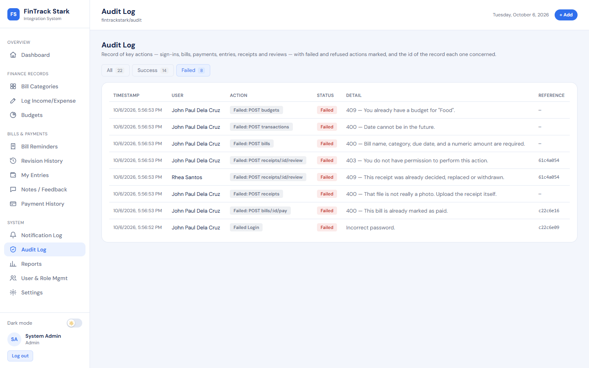
Figure 27. Audit Log screen filtered to Failed: refused and failed integration actions with their error messages

8. Security, Governance, and Risk Management

8.1 Role-Based Access Control Matrix
Access is enforced on the server for every request (requireAuth, requireRole, and ownership checks in each controller). The interface also hides what a role cannot use, but it is not the control.
Table 36. RBAC matrix (✔ allowed, ✖ refused, Own = only their own records)
Function | Visitor | User | Reviewer | Admin | Reminder service
Register / log in | ✔ | — | — | — | —
Bills, entries, budgets, notes, notifications | ✖ | Own | Own | Own | —
Pay a bill | ✖ | Own | Own | Own | ✖
Attach a receipt | ✖ | Own entries | Own entries | Own entries | ✖
Open an uploaded receipt | ✖ | Own | Own + all submitted | Own only | ✖
View review queue; verify / reject / request revision | ✖ | ✖ | ✔ (not own) | ✖ | ✖
View entry version history | ✖ | Own | Own | Own | ✖
View audit / integration log | ✖ | ✖ | ✖ | ✔ | writes only
List users; change roles; delete accounts; reset passwords | ✖ | ✖ | ✖ | ✔ (not self) | ✖
Raise bill reminders | ✖ | ✖ | ✖ | ✖ | ✔
Health check (/api/health) | ✔ | ✔ | ✔ | ✔ | —

8.2 Least Privilege and Separation of Duties
- Registration always creates a User. A role is never chosen at sign-up; only an Admin can assign Reviewer or Admin (ST-03).
- An Admin cannot see anyone else's money or receipts. Administration (accounts, roles, logs) is separated from finance data (RT-05, RT-31, ST-04).
- A Reviewer sees only what a review needs — the receipt and the one entry it proves — never the person's wallet; and cannot review their own receipt (ST-04).
- No self-escalation: an Admin cannot change their own role or delete their own account, and the last Admin cannot be demoted or deleted.
- Payments are owner-only, even for an Admin.
- Temporary passwords issued by an Admin open a session that can do nothing but set a new password, so the Admin never keeps working access to the account (RT-06).
- The database user used by the deployed API has readWrite on its own database only — no admin rights on the cluster.
- The reminder service may write only lastRemindedOn, notifications and its own audit entries.

8.3 Data Privacy and Protection
Table 37. Data protection controls
Data | Protection
Passwords | Never stored; scrypt hash with a random salt per password (old bcrypt hashes are upgraded on next sign-in). Login is rate-limited per address and per account, and an unknown email takes as long to refuse as a wrong password, so attackers cannot tell which emails exist.
Sessions | 32 random bytes; only a SHA-256 hash is stored, so a leaked database gives no working session. Expire after 8 hours; ended by logout, password change (all devices) or account deletion. Kept in sessionStorage, which is cleared when the tab closes.
Financial records and notes | Readable only by their owner (NFR-002), checked on the server for every request.
Receipts | Owner and Reviewers only; files are served with the session token (never a public URL), never cached by the browser, and type-checked on upload. Links are stored as links — the file stays in the owner's Drive.
In transit | HTTPS between browser and server; TLS between server and MongoDB Atlas; HSTS tells browsers to refuse plain HTTP.
In the browser | Content-Security-Policy (scripts only from the site), X-Frame-Options DENY, nosniff, no-referrer, restrictive Permissions-Policy. React escapes all text, so names such as <img onerror> are shown, not run.
Logs | No passwords or tokens are logged; database connection strings are printed with the password masked.
Personal data policy | A Privacy Policy and Terms page explain what is collected, why, and who can see it, in line with the Data Privacy Act of 2012 (RA 10173). Only sample data is used in the project (spec §21.7–8).

8.4 Audit Trail
The audit log records sign-ins and failed sign-ins; account creation, profile and password changes; role changes, password resets and account deletions; bills created, edited, deleted and paid; entries recorded, edited and deleted; receipts submitted, resubmitted, verified, rejected and sent back; reminder sweeps; and every refused or failed change, with its error. Each line has a timestamp, the person or service, the action, the status, the detail and the record reference (see Section 7.6). The Admin Console summarises the week's activity, including failed actions.
Figure 28. Audit Log: every action with status and record reference

8.5 Integration Ownership and Governance
Table 38. Data and module ownership
Data / module | Owning module (writer) | Others may | Accountable team role
Users, roles, sessions | Auth API, Users API | Read own profile | Backend / Integration Developer; QA / Security Lead
Bills | Bills API | Reminder service: set lastRemindedOn only | Backend / Integration Developer
Transactions | Transactions API, payment workflow | Receipts: read the entry | Backend / Integration Developer
Receipts | Receipts API (owner: submit; Reviewer: decide) | — | Backend / Integration Developer
Notifications | Notification service, reminder service | Addressee: mark read | Backend / Integration Developer
Audit log | Audit service, failure-log middleware, reminder service | Admin: read | QA / Security Lead
Event bus (SSE) | events service | Any module: publish a topic | Backend / Integration Developer
API contract (routes) | Routes layer | Client: call | Project Manager / Systems Analyst
Deployment, backups | Render service, backup/restore scripts | — | Project Manager; QA / Security Lead
User interface | React client | — | UI/UX and Multimedia Lead

Governance rules: (1) a collection is changed only by its owning module; (2) cross-module effects go through services (audit, notifications, events), never by one controller writing another module's fields; (3) every change to a route or schema is accompanied by an automated test; (4) changes reach production only through GitHub, which triggers the Render build; (5) a backup is taken before any deployment that changes a schema.

8.6 Risk Register
Table 39. Risk register (likelihood and impact: Low / Medium / High)
# | Risk | Likeli-hood | Impact | Level | Control | Monitoring
R1 | Unauthorized access to another user's records | Low | High | Medium | Server-side owner and role checks on every route; ST-01–ST-04 | Failed (403) lines in the audit log; security tests on every change
R2 | Password guessing / credential stuffing | Medium | High | High | Rate limits per IP and per account; scrypt; same timing for unknown emails | Failed Login lines; Admin Console failed-actions bar
R3 | Malicious or oversized upload | Medium | Medium | Medium | Type allow-list, first-byte check, 2 MB limit, files never executed, CSP | Failed: POST receipts lines (ET-06)
R4 | Double payment or double decision from simultaneous requests | Medium | Medium | Medium | Atomic conditional updates; rollback on partial failure | 409 lines; ET-05, ET-07, RT-02
R5 | Data loss (database failure, mistake) | Low | High | Medium | npm run backup (incl. files) before deploys and weekly; tested restore | Backup files dated; restore drill each release (RT-34)
R6 | Restore run against the live database by mistake | Low | High | Medium | Restore refuses to run without --yes and prints the target first | Operator checklist; RT-34
R7 | Hosting sleeps or is down (free tier) | High | Medium | High | Client shows clear messages and retries; reminders catch up on wake; data in Atlas | /api/health; Render dashboard
R8 | Leaked database credentials | Low | High | Medium | Least-privilege DB user; secrets only in Render env vars; masked in logs | Atlas access logs; rotate password on suspicion
R9 | Shared-database conflict between API and reminder service | Low | Medium | Low | Field ownership; atomic per-bill claim | Reminder Sweep audit lines; IT-06, RT-23
R10 | Sensitive data in receipts seen by the wrong person | Low | High | Medium | Owner + Reviewer only; no Admin access; no public URLs | ST-04; Failed lines for 403 on files
R11 | Regression after a change | Medium | Medium | Medium | 68 automated tests run before every push | Test report (Section 9.6)
R12 | Team members cannot explain the AI-assisted code at the defense | Medium | High | High | Code walkthroughs; this document; comments in the code explain each decision | Practice defense with the demo script (Section 11)

9. Testing and Evaluation

9.1 Test Plan
Table 40. Test plan
Item | Approach
Objective | Show that every functional requirement works, that modules exchange data correctly, that bad input and unauthorized access are refused cleanly, and that one complete workflow runs end to end.
Method | Automated black-box tests with Playwright 1.63 driving Google Chrome through the real user interface, plus direct HTTP calls to the API for access-control and error cases. Each case is named by category and requirement (e.g. FT-03 (FR-003)).
Environment | The real API server started by the test runner, a dedicated database fintrack_stark_test wiped and re-seeded before every run (never the live data), Chrome at 1440 × 900 and phone sizes 320–390 px.
Categories | Functional (FT), Integration (IT), Error-handling (ET), Security / access control (ST), End-to-end (E2E), and Regression (RT) cases kept from three pre-launch audits.
Entry criteria | Code builds; the seed data loads; the API health check answers.
Exit criteria | All cases pass on two consecutive runs; no case is skipped.
Defect handling | Every defect found in audits gets a regression case (RT-xx) that failed before the fix and passes after it.

Table 41. Test coverage against the specification's minimum (§16)
Test type | Required minimum | Implemented | Passed
Functional test cases | 8 | 12 | 12
Integration test cases | 5 | 8 | 8
Error-handling test cases | 5 | 7 | 7
Security / access-control test cases | 3 | 4 | 4
End-to-end test scenario | 1 | 2 | 2
Regression cases (additional) | — | 35 | 35

9.2 Functional Test Cases
Table 42. Functional test cases
ID | Test case | Req. | Expected result | Result
FT-01 | A registered user can sign in through the form | FR-001 | Valid credentials open the dashboard; the session is created | Passed
FT-02 | A user can create a bill record | FR-002 | Bill saved and shown in its category and list | Passed
FT-03 | A user can record an income/expense entry | FR-003 | Entry recorded and counted in the balance at once | Passed
FT-04 | The system tracks entry versions | FR-004 | Editing creates v2 and keeps v1 as an earlier version | Passed
FT-05 | A user can correct and delete their own entries | FR-015 | Owner can edit and delete; deleted entry stops counting and stays in history | Passed
FT-06 | Notes are stored per entry | FR-006 | Note saved against the entry and shown with it | Passed
FT-07 | The dashboard summarises balance, bills and budgets | FR-009 | Dashboard shows balance, bills and budget figures that match the data | Passed
FT-08 | Important actions are written to the audit log | FR-010 | Login and other actions appear with timestamp, user, action, status, detail, reference; Failed filter works | Passed
FT-09 | Every screen has its own address |  | Every screen opens from its own address | Passed
FT-10 | Addresses survive a reload, and the browser's own buttons work |  | Reload keeps the screen; Back/Forward work | Passed
FT-11 | A receipt photo can be attached while recording an entry | FR-003 | Photo attached on the form; entry saved; receipt shows "For review" and opens | Passed
FT-12 | A Reviewer can verify, reject or send back a receipt from the review page | FR-005 | Reviewer opens the receipt with its entry and verifies it; it moves to "Decided by you" | Passed

9.3 Integration Test Cases
Table 43. Integration test cases
ID | Test case (data exchange tested) | Expected result | Result
IT-01 | Paying a bill cascades into an expense, a notification, and an audit entry | One payment creates the Paid bill, an auto expense entry, a notification and an audit line | Passed
IT-02 | A notification reaches an open screen without a refresh | A notification reaches an open screen (toast + badge) without reloading | Passed
IT-03 | Notifications reach only the person they are about | Notifications reach only the bill's owner | Passed
IT-04 | A recorded entry reaches the dashboard at once, without a refresh | A new entry updates an open dashboard without reloading | Passed
IT-05 | Recorded expenses are counted against the matching budget | Budget and Reports screens show the same spent amount as the data | Passed
IT-06 | The reminder service raises overdue alerts on its own schedule | Separate reminder process raises one overdue alert for the owner only; second run adds none | Passed
IT-07 | A receipt moves through review: submitted, sent back, resubmitted as v2, verified | Submit → Reviewers alerted → revision (note on entry) → v2 → verified; all steps audited | Passed
IT-08 | Changing the figures of an entry sends its verified receipt back for review | Note-only edit keeps Verified; amount change sends the receipt back for review | Passed

9.4 Error-Handling Test Cases
Table 44. Error-handling test cases
ID | Test case | Expected result | Result
ET-01 | Missing required fields are rejected with a usable message | 400 with a usable message for each missing field | Passed
ET-02 | Invalid amounts are rejected at the boundary | Zero, negative, non-numeric and huge amounts refused (400) | Passed
ET-03 | Duplicate data is refused and the reason is explained | Duplicate email and duplicate budget refused (409) with the reason | Passed
ET-04 | A malformed record id returns 400, not a crash or a hang | Malformed ids return 400 — no crash, no hang | Passed
ET-05 | An invalid workflow transition is refused | Paying twice, editing an old version, deleting twice refused | Passed
ET-06 | Invalid uploads are refused with a reason, and nothing is saved | Wrong type, fake file, > 2 MB, http/javascript links, deleted entry refused; nothing saved | Passed
ET-07 | A failed review is refused cleanly and written to the log as Failed | Missing note → 400; second decision → 409; verified receipt cannot be replaced; refusal logged as Failed with ref | Passed

Security / access-control test cases
Table 45. Security and access-control test cases
ID | Test case | Expected result | Result
ST-01 | Protected endpoints refuse unauthenticated callers | Every protected endpoint returns 401 without a token | Passed
ST-02 | A user cannot reach another user's records | A user gets 403/404 for another user's records | Passed
ST-03 | Privileges cannot be escalated from a lower role | A User cannot use Admin functions; sign-up cannot request a role; invalid roles refused | Passed
ST-04 | Receipts are seen only by their owner and Reviewers, and nobody reviews their own | Receipt files: owner and Reviewer only (not other users, not Admin); only Reviewers decide; no self-review | Passed

9.5 End-to-End Test Scenario
E2E-02 — a receipt goes from submission to final approval. Two browsers act as two people at the same time; no step uses an API shortcut, and each person sees the other's actions without reloading.
Table 46. E2E-02 steps
# | Who | Action | Expected and observed
1 | User | Log Income/Expense: Expense ₱2,345, tick "Attach a receipt", choose a photo, Save Entry | Entry recorded; toast "receipt sent for review"
2 | Reviewer | Receipt Review page (already open) | The ₱2,345.00 receipt appears live, without reloading
3 | Reviewer | Review receipt → note "Photo is blurry — please retake it" → Request revision | Toast "Sent back for revision"
4 | User | My Entries | Chip shows "Receipt v1 · Needs revision"; dialog shows the note
5 | User | Choose a new photo → Submit for Review | Chip changes to "Receipt v2 · For review"
6 | Reviewer | Card shows "version 2" → Review receipt → Verify | Toast "Receipt verified"
7 | User | (no action) | Chip changes to "Receipt v2 · Verified" live; inbox has a receipt-verified notification

Result: Passed (4.3 s). A second scenario, E2E-01, covers the money side: a new account registers from the landing page, sets a budget, records an expense, corrects it to v2, and the corrected figure reaches the dashboard, the budget and the reports, with every step in the audit log (Passed).

9.6 Test Results Summary
The full suite was run on 10/6/2026, 18:05:16 (Philippine time): 68 test cases, 68 passed, 0 failed, 0 skipped, in 91 seconds. The suite had also passed twice in a row before this run, the exit criterion. Every case is listed with its result in Appendix C.
Table 47. Results summary
Category | Cases | Passed | Failed
FT | 12 | 12 | 0
IT | 8 | 8 | 0
ET | 7 | 7 | 0
ST | 4 | 4 | 0
E2E | 2 | 2 | 0
RT (regression) | 35 | 35 | 0
Total | 68 | 68 | 0

Defects found and fixed during testing (selected). Three pre-launch audits found, among others: double payment when a button was clicked twice; amounts such as true accepted as ₱1; a restore script that could wipe a database without confirmation; the landing page scrolling sideways on 320–360 px phones; an empty ₱0.00 dashboard shown on slow connections before data arrived; requests that could wait forever; and an Admin able to read another person's entry history. Each now has a regression case (RT-01 to RT-35) that failed before its fix.

10. Deployment, Backup, and Recovery

10.1 Deployment Environment
Table 48. Environments
Environment | Where | Details
Production | Render Web Service (Singapore) + MongoDB Atlas M0 (AWS Hong Kong) | https://finstrack-stark.onrender.com — one Node.js service serves the API and the built React app; env vars NODE_ENV=production, TRUST_PROXY=1, MONGO_URI; database user fintrack_app with readWrite on fintrack_stark only; the first Admin was created with npm run create-admin (the demo seed refuses to run in production).
Local / demo | Developer laptop: Node.js 24 + MongoDB 8.3 (local service) | npm run seed loads sample data; npm run dev starts the API (port 4000), the client (port 5173) and the separate reminder worker together.
Test | Same laptop, database fintrack_stark_test | Created, seeded and used only by the automated tests.

10.2 Deployment Evidence
The deployed prototype is available at https://finstrack-stark.onrender.com. On the free tier the service sleeps after a period without visitors; the first visit afterwards takes up to about a minute while it starts. The screenshots below were taken from the live site and from the API's health endpoint.
Before submission: deploy the latest commit (git push origin main), open the live site, and retake these two screenshots so they show the current version with receipt review. [ILAGAY DITO kung may bagong screenshot]
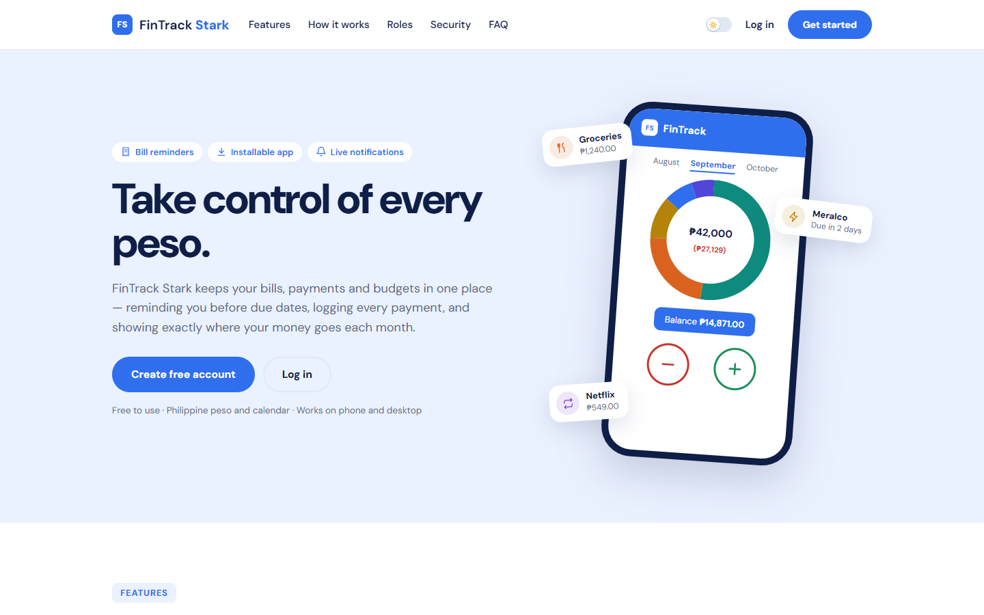
Figure 29. Deployed system — landing page at https://finstrack-stark.onrender.com
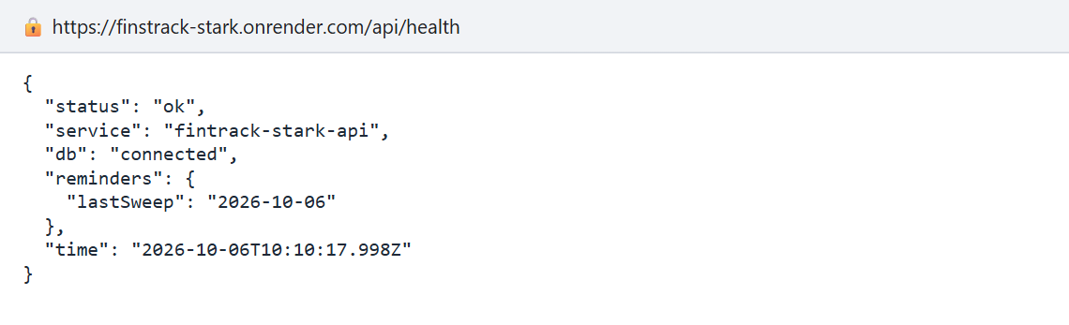
Figure 30. Deployed system — /api/health answering from Render with the database connected
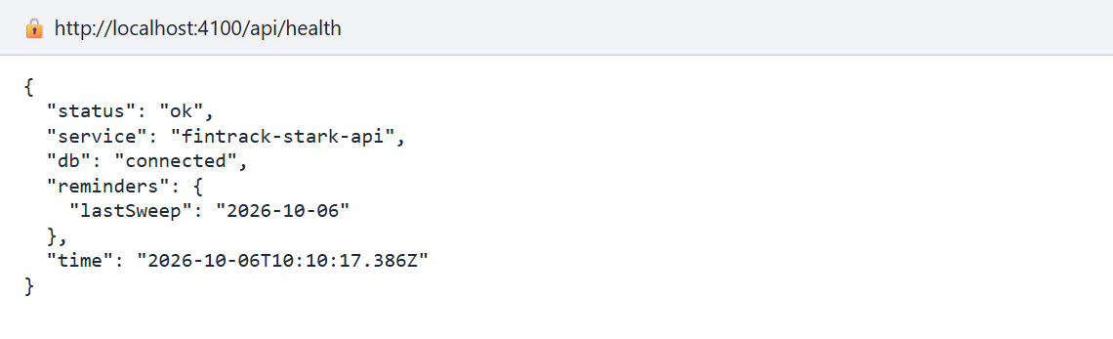
Figure 31. Browser evidence of the API (local server): health endpoint JSON

10.3 Backup Plan
Table 49. What is backed up, how and when
Asset | How | When / where
Source code | Git; every change is pushed to GitHub (jeypydc02-ui/SIA-Final-Project); every member can clone a full copy | On every commit; GitHub + members' laptops
Database | npm run backup writes every collection to one timestamped JSON file, including uploaded receipt files (as base64). Built on the app's own models, so it runs anywhere Node runs | Before every deployment that changes data, and weekly; kept in backups/ and copied to the group's shared drive
Receipt files | Uploaded files are inside the database backup; linked files stay in the owner's cloud storage (Google Drive / OneDrive / Dropbox), which keeps its own copies | With the database backup
Configuration / secrets | Environment variables recorded in Render; the Atlas password kept by the project manager, never in the repository | When changed
Documentation | This document, diagrams and screenshots in the repository's docs/ folder and the group's shared drive | Each version

Backup run, captured from the terminal
> npm run backup -- --out backups/fintrack-stark-2026-10-06.json
[db] connected to mongodb://127.0.0.1:27017/fintrack_stark_docs
[backup] wrote backups/fintrack-stark-2026-10-06.json (34.0 KB)
4 users
8 bills
11 transactions
4 budgets
11 notifications
5 comments
23 auditLogs
7 receipts

10.4 Recovery Plan
Table 50. Failure scenarios and recovery steps
Failure | Recovery steps | Target time
Database lost or corrupted | 1. Point MONGO_URI at the (new) database. 2. npm run restore -- <file> — it shows the target and changes nothing. 3. Check the target, run again with --yes. 4. Everyone signs in again (sessions are not restored). | ≤ 30 minutes
Bad deployment | Roll back to the previous deploy in the Render dashboard (or revert the commit and push); restore a backup if data changed. | ≤ 15 minutes
Render outage | Run locally (npm run build && npm start) against Atlas for the demo; or create a new Render service from the same GitHub repository. | ≤ 30 minutes
Atlas credentials leaked | Change the fintrack_app password in Atlas, update MONGO_URI in Render, redeploy; review the audit log. | ≤ 15 minutes
Admin locked out | npm run create-admin against the database creates a new Admin; or another Admin issues a temporary password. | ≤ 10 minutes
Reminder sweep failed | Logged as Failed in the audit log; the API retries after 5 minutes; npm run reminder:once runs it by hand. Bills already reminded that day are never alerted twice. | Automatic

Recovery drill, captured from the terminal (restore into a new database)
> npm run restore -- backups/fintrack-stark-2026-10-06.json
[restore] source: backups/fintrack-stark-2026-10-06.json
[restore] taken: 2026-10-06T10:05:03.409Z
[restore] target: mongodb://127.0.0.1:27017/fintrack_stark_recovery
[restore] Nothing was changed. A restore DELETES everything in the target
database and replaces it with the backup. Check the target above,
then run the same command again with --yes to go ahead.

> npm run restore -- backups/fintrack-stark-2026-10-06.json --yes
[restore] source: backups/fintrack-stark-2026-10-06.json
[restore] taken: 2026-10-06T10:05:03.409Z
[restore] target: mongodb://127.0.0.1:27017/fintrack_stark_recovery
[db] connected to mongodb://127.0.0.1:27017/fintrack_stark_recovery
4 users
8 bills
11 transactions
4 budgets
11 notifications
5 comments
23 auditLogs
7 receipts
[restore] complete — indexes rebuilt.

11. System Demonstration Guide

11.1 Demo Script
Use two browser windows (one normal, one incognito) so that two people can be signed in at once. Run npm run seed beforehand on the local database for a clean start (about 15 minutes in total).
Table 51. Demo script
# | Account | Do | Point out (spec item)
1 | — | Open the landing page; show it on a phone-sized window; install as an app | Mobile/web; PWA
2 | User (jp@) | Log in; walk through the Home dashboard | Login page; Dashboard (§14.1–2)
3 | User | Bill Categories → Utilities | Project List / Details (§14.3–4)
4 | User | Bill Reminders → Mark Paid on Meralco | Workflow automation / webhook: Paid + expense + notification + audit + next bill (I2)
5 | User | Log Income/Expense: expense with a receipt photo | Asset submission form (§14.5); status For Review automatically
6 | Reviewer (window 2) | Review Desk shows the new receipt without refreshing; open Receipt Review | Messaging / live events (I4); Review page (§14.7)
7 | Reviewer | Request revision with a note | Review and Approval workflow
8 | User | Inbox notification; My Entries → Receipt v1 · Needs revision → attach v2 (Drive link) | Notification log (§14.9); version tracking; external storage link (I6)
9 | Reviewer | Verify v2 | Final approval
10 | User | Notes / Feedback → On Entries shows the Reviewer's note; Revision History shows v1 → v2 of an entry | Comment page (§14.8); revision history (§14.6)
11 | User | Try to pay the same bill again | Error handling: refused
12 | Admin | Admin Console; Audit Log → Failed filter | Audit log (§14.10); integration logs (§7.6)
13 | Admin | User & Role Mgmt: make a user a Reviewer; show Admin cannot open a receipt | User and role management (§14.12); least privilege
14 | User | Reports | Reports page (§14.11)
15 | Terminal | npm run reminder:once, npm run backup, npm run restore (without --yes) | Reminder service (I5); backup and recovery

11.2 Demo Accounts
Table 52. Demo accounts (local sample data only — the seed refuses to run in production)
Role | Email | Password | Name
User | jp@fintrackstark.app | demo123 | John Paul Dela Cruz
User | arvy@fintrackstark.app | demo456 | Arvy Karlson Dabasol
Reviewer | reviewer@fintrackstark.app | review123 | Rhea Santos
Admin | admin@fintrackstark.app | admin123 | System Admin

On the deployed system, accounts are created through sign-up; the Admin account was created with npm run create-admin and assigns the Reviewer role from User & Role Management.

11.3 Sample Data
- Bills (7): Meralco Electricity (monthly), Maynilad Water (overdue), PLDT Home Fibr (monthly), Condo Rent (due today, monthly), Netflix Subscription (paid), BPI Credit Card, and Globe Postpaid for the second user.
- Entries (9): salary, groceries, transport, a freelance payment, the Netflix bill payment, a weekly market run, an allowance for the second user, and an airport-transfer expense corrected from ₱2,400 (v1) to ₱1,650 (v2).
- Budgets (4): Food ₱6,000, Transport ₱3,500, Utilities ₱5,000, Subscription ₱1,000.
- Receipts (5): two Verified (Google Drive and OneDrive links), one uploaded photo For Review, and one chain v1 Needs Revision → v2 For Review (Dropbox).
- Notes: a correction note, a Reviewer's revision note, and a personal savings plan.
- Logs and notifications: a welcome notification, and the reminder service's first sweep, which raises real reminders when the server starts.

12. Limitations and Future Enhancements

12.1 System Limitations
- No real payment integration. Payments are recorded, not made; the system does not connect to banks or e-wallets.
- Notifications are in-app only. There is no e-mail or SMS; a person who does not open the app does not see a reminder. Password recovery needs an Admin.
- No native mobile app. The PWA installs and opens offline, but cannot show push notifications while closed.
- Unverified entries still count. Receipt review checks evidence after the fact; it does not block an entry from the balance.
- Receipts are compared by a person. There is no automatic reading of totals or dates (OCR); uploads are limited to 2 MB.
- Single API instance. Live updates use an in-process event bus; running several API processes would need a shared channel.
- Free hosting. The service sleeps when idle (about a minute to wake), and the free database tier has no automatic backups, so backups are manual.
- Audit log is not tamper-proof. It cannot be changed through the application, but a database administrator could alter it.
- Tested in Chrome on desktop and emulated phones; not yet on Safari/iPhone hardware or under real multi-user load in production.

12.2 Recommended Enhancements
- E-mail/SMS reminders and web push notifications (e.g. via a messaging provider) so reminders reach people who are not in the app.
- OCR-assisted receipt review: read the total and date from the photo and flag mismatches for the Reviewer.
- Direct cloud storage integration (Google Drive / OneDrive APIs) instead of pasted links, and larger files in object storage.
- Import of bank or e-wallet statements (CSV) as an ETL integration, with matching against recorded entries.
- Shared household wallets, where several members record into one budget and a head of household reviews.
- Native Android/iOS client sharing the same API.
- Paid hosting tier with automated database backups, monitoring and alerting; a message broker (or MongoDB change streams) for multi-instance live updates.
- Analytics: month-on-month trends, forecasts of upcoming bills, and savings goals.
- Tamper-evident audit log (hash-chained entries).

13. Individual Contribution
Fill in each member's actual role and specific contribution. Suggested roles from the specification (§17): Project Manager / Systems Analyst; UI/UX and Multimedia Lead; Backend / Integration Developer; QA / Security Lead; Documentation and Presenter.
Table 53. Individual contribution
Member name | Role | Specific contribution
Cain, Akhemee Yujinn | [ILAGAY DITO] | [ILAGAY DITO]
Dabasol, Arvy Karlson | [ILAGAY DITO] | [ILAGAY DITO]
Dela Cruz, John Paul | [ILAGAY DITO] | [ILAGAY DITO]
Heray, Neezar Ivan | [ILAGAY DITO] | [ILAGAY DITO]
Libaton, Jerico | [ILAGAY DITO] | [ILAGAY DITO]

14. References
- Hohpe, G., & Woolf, B. (2003). Enterprise Integration Patterns: Designing, Building, and Deploying Messaging Solutions. Addison-Wesley.
- Richards, M., & Ford, N. (2020). Fundamentals of Software Architecture. O'Reilly Media.
- Nygard, M. (2011). Documenting Architecture Decisions. https://cognitect.com/blog/2011/11/15/documenting-architecture-decisions
- ISO/IEC 25010:2011. Systems and software engineering — System and software quality models.
- The Open Group. The TOGAF Standard (business, data, application and technology architecture domains). https://www.opengroup.org/togaf
- OWASP Foundation. OWASP Top 10 and Cheat Sheet Series (Authentication, Session Management, File Upload, Password Storage). https://cheatsheetseries.owasp.org
- Republic Act No. 10173 — Data Privacy Act of 2012 (Philippines). National Privacy Commission. https://privacy.gov.ph
- MDN Web Docs. Using server-sent events; Content-Security-Policy; Progressive web apps. https://developer.mozilla.org
- WHATWG. HTML Living Standard — Server-sent events. https://html.spec.whatwg.org/multipage/server-sent-events.html
- React documentation. https://react.dev
- React Router documentation. https://reactrouter.com
- Express documentation. https://expressjs.com
- Node.js documentation — crypto (scrypt, randomBytes, timingSafeEqual). https://nodejs.org/api/crypto.html
- MongoDB documentation and MongoDB Atlas documentation. https://www.mongodb.com/docs
- Mongoose documentation. https://mongoosejs.com/docs
- Render documentation — Web Services. https://render.com/docs
- Playwright documentation. https://playwright.dev
- Mermaid documentation (diagrams in this document). https://mermaid.js.org

15. Appendices

Appendix A — Complete API Endpoint List
Table 54. All 40 API endpoints
Method | Path | Access
GET | /api/audit-log | Admin
POST | /api/auth/login | Anyone (rate-limited)
POST | /api/auth/register | Anyone (rate-limited)
GET | /api/auth/me | Signed in
PUT | /api/auth/me | Signed in
PUT | /api/auth/me/password | Signed in
POST | /api/auth/logout | Signed in
GET | /api/bills | Signed in
POST | /api/bills | Signed in
PUT | /api/bills/:id | Signed in
DELETE | /api/bills/:id | Signed in
POST | /api/bills/:id/pay | Signed in
GET | /api/budgets | Signed in
POST | /api/budgets | Signed in
PUT | /api/budgets/:id | Signed in
DELETE | /api/budgets/:id | Signed in
GET | /api/comments | Signed in
POST | /api/comments | Signed in
PUT | /api/comments/:id | Signed in
DELETE | /api/comments/:id | Signed in
GET | /api/events | Signed in
GET | /api/notifications | Signed in
PUT | /api/notifications/read-all | Signed in
PUT | /api/notifications/:id/read | Signed in
GET | /api/receipts | Signed in
POST | /api/receipts | Signed in
GET | /api/receipts/review | Reviewer
GET | /api/receipts/:id/file | Signed in
POST | /api/receipts/:id/review | Reviewer
GET | /api/transactions | Signed in
POST | /api/transactions | Signed in
GET | /api/transactions/:id/versions | Signed in
PUT | /api/transactions/:id | Signed in
DELETE | /api/transactions/:id | Signed in
GET | /api/users | Admin
PUT | /api/users/:id/role | Admin
POST | /api/users/:id/reset-password | Admin
DELETE | /api/users/:id | Admin
GET | /api/sync | Signed in
GET | /api/health | Anyone

Appendix B — Additional Screenshots
Figure 32. Landing page
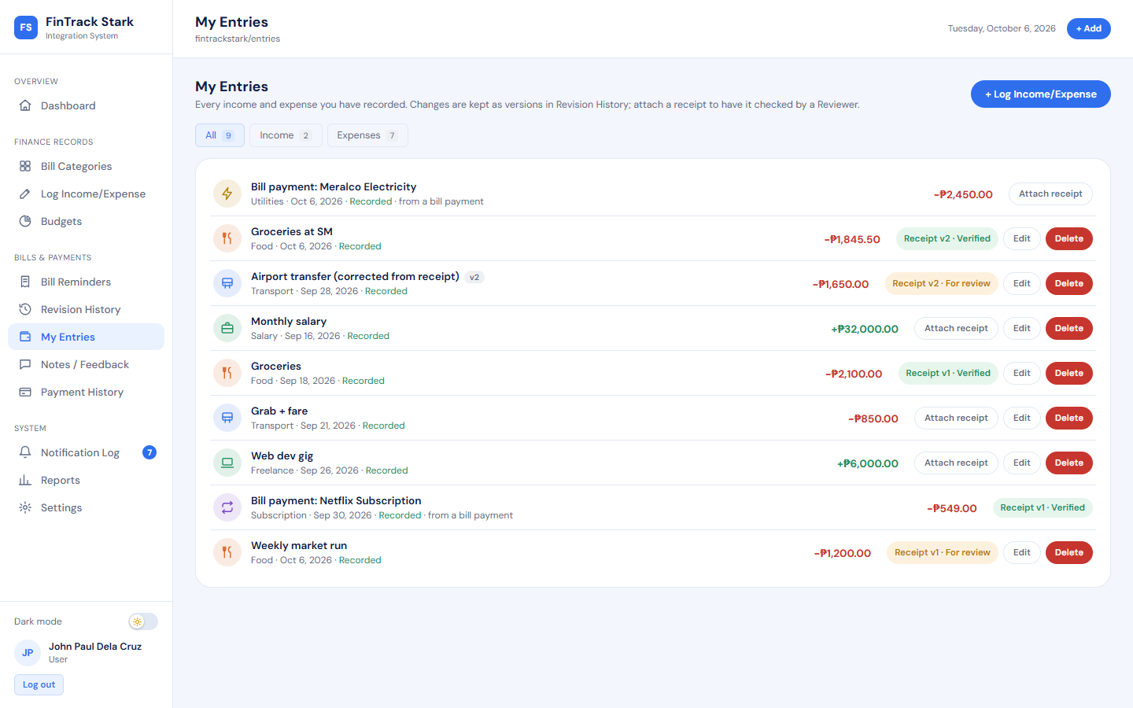
Figure 33. My Entries with receipt statuses
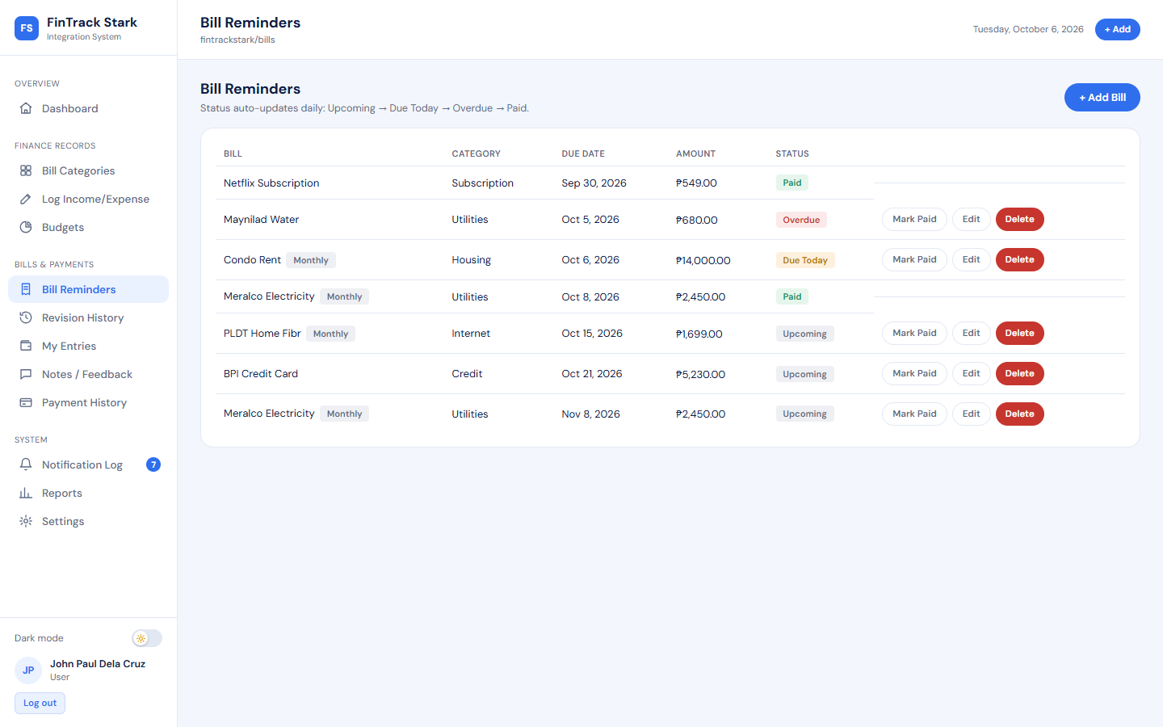
Figure 34. Bill Reminders
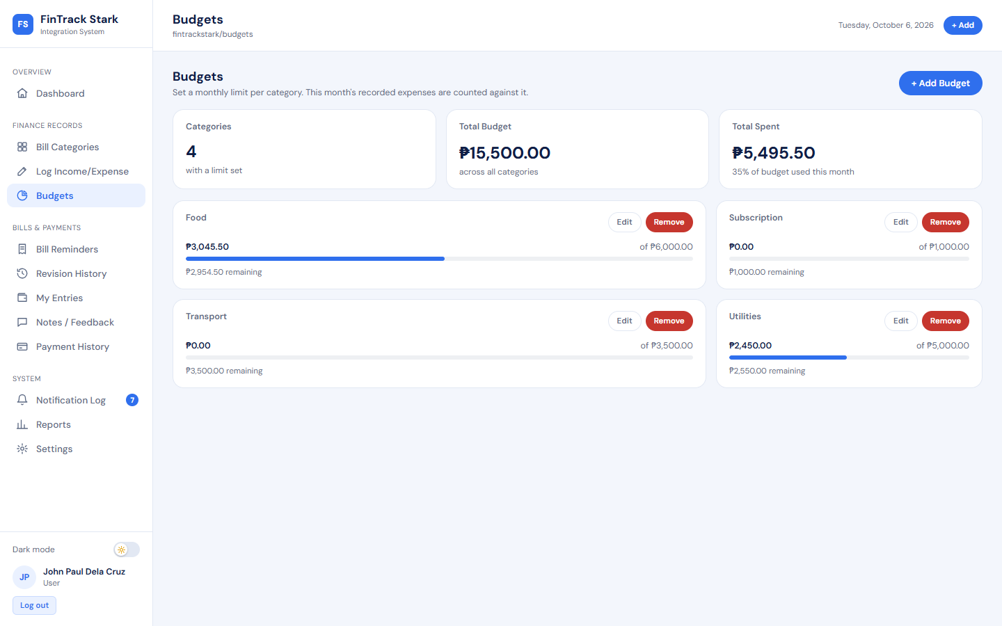
Figure 35. Budgets
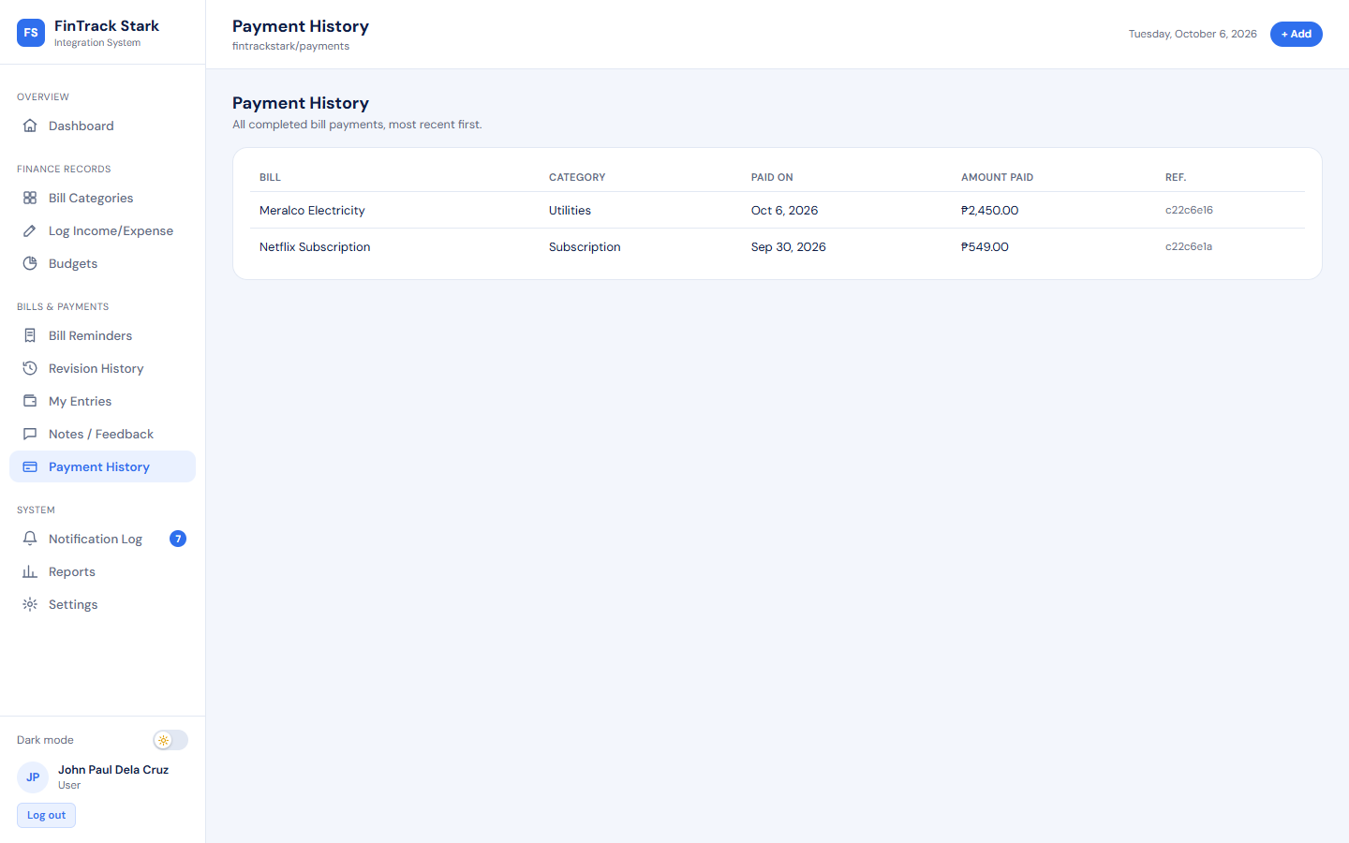
Figure 36. Payment History
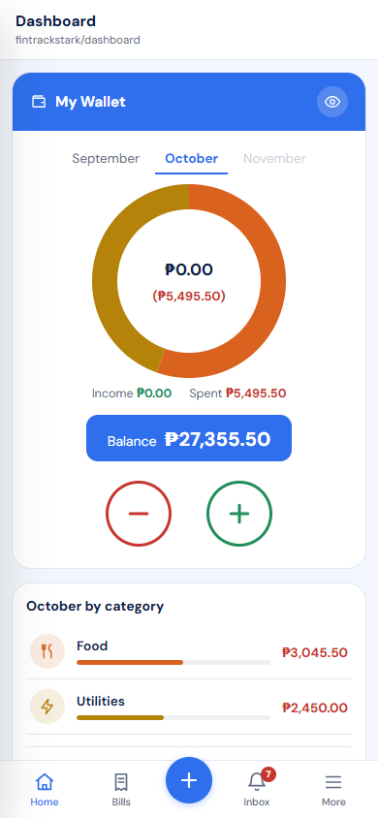
Figure 37. Phone (390 px): Home dashboard with bottom tab bar
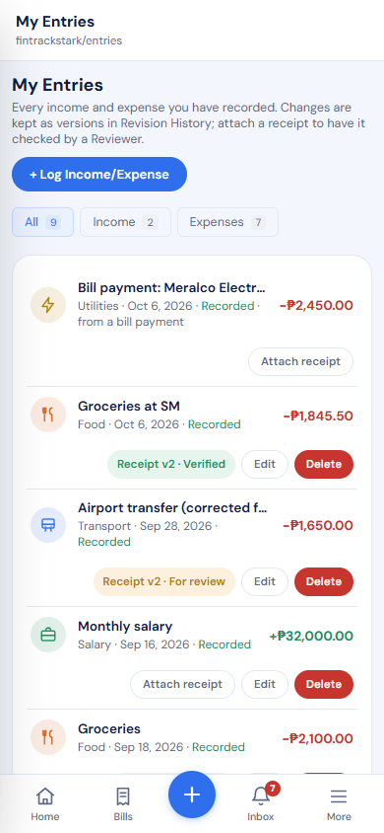
Figure 38. Phone (390 px): My Entries
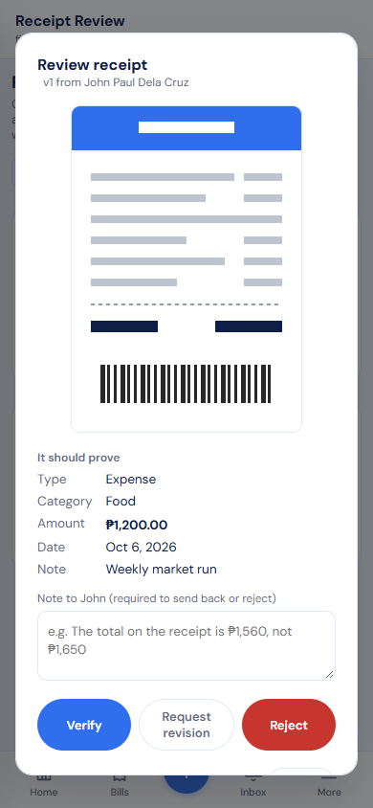
Figure 39. Phone (390 px): Reviewer checking a receipt

Appendix C — Complete Test Results
Table 55. All 68 automated test cases (run 10/6/2026, 18:05:16)
ID | Test case | Result | Time (s)
FT-01 | A registered user can sign in through the form (FR-001) | Passed | 1.8
FT-02 | A user can create a bill record (FR-002) | Passed | 1.5
FT-03 | A user can record an income/expense entry (FR-003) | Passed | 1.9
FT-04 | The system tracks entry versions (FR-004) | Passed | 2.2
FT-05 | A user can correct and delete their own entries (FR-015) | Passed | 2.1
FT-06 | Notes are stored per entry (FR-006) | Passed | 1.7
FT-07 | The dashboard summarises balance, bills and budgets (FR-009) | Passed | 1.1
FT-08 | Important actions are written to the audit log (FR-010) | Passed | 1.5
FT-09 | Every screen has its own address | Passed | 2.8
FT-10 | Addresses survive a reload, and the browser's own buttons work | Passed | 2.8
FT-11 | A receipt photo can be attached while recording an entry (FR-003) | Passed | 1.7
FT-12 | A Reviewer can verify, reject or send back a receipt from the review page (FR-005) | Passed | 1.7
IT-01 | Paying a bill cascades into an expense, a notification, and an audit entry | Passed | 1.6
IT-02 | A notification reaches an open screen without a refresh | Passed | 1.4
IT-03 | Notifications reach only the person they are about | Passed | 0.1
IT-04 | A recorded entry reaches the dashboard at once, without a refresh | Passed | 1.2
IT-05 | Recorded expenses are counted against the matching budget | Passed | 1.3
IT-06 | The reminder service raises overdue alerts on its own schedule | Passed | 2.1
IT-07 | A receipt moves through review: submitted, sent back, resubmitted as v2, verified | Passed | 0.3
IT-08 | Changing the figures of an entry sends its verified receipt back for review | Passed | 0.3
ET-01 | Missing required fields are rejected with a usable message | Passed | 0.0
ET-02 | Invalid amounts are rejected at the boundary | Passed | 0.0
ET-03 | Duplicate data is refused and the reason is explained | Passed | 1.7
ET-04 | A malformed record id returns 400, not a crash or a hang | Passed | 0.0
ET-05 | An invalid workflow transition is refused | Passed | 0.2
ET-06 | Invalid uploads are refused with a reason, and nothing is saved | Passed | 0.3
ET-07 | A failed review is refused cleanly and written to the log as Failed | Passed | 0.1
ST-01 | Protected endpoints refuse unauthenticated callers (NFR-001) | Passed | 0.0
ST-02 | A user cannot reach another user's records (NFR-002) | Passed | 0.2
ST-03 | Privileges cannot be escalated from a lower role (section 8.2) | Passed | 1.9
ST-04 | Receipts are seen only by their owner and Reviewers, and nobody reviews their own (NFR-002, section 8.2) | Passed | 0.2
E2E-01 | A new account records, corrects and reports an expense | Passed | 6.6
E2E-02 | A receipt goes from submission to final approval | Passed | 4.3
RT-01 | A refused edit leaves the entry exactly as it was | Passed | 0.1
RT-02 | A refused payment leaves the bill unpaid and writes nothing | Passed | 0.1
RT-03 | Entries count at once; only receipts go through review | Passed | 0.0
RT-04 | Dates and field types are validated, never a 500 | Passed | 0.1
RT-05 | An Admin sees only their own money | Passed | 0.0
RT-06 | An Admin password reset forces a new password | Passed | 0.5
RT-07 | Security headers and JSON 404s | Passed | 0.0
RT-08 | The login form is not prefilled with an account | Passed | 1.0
RT-09 | A session that ends mid-use asks for the password and keeps the form | Passed | 1.8
RT-10 | A malformed address does not blank the app | Passed | 1.2
RT-11 | A failed save keeps the dialog open with what was typed | Passed | 1.7
RT-12 | The review page is the Reviewer's alone | Passed | 1.3
RT-13 | Each role's dashboard leads with its own work | Passed | 1.9
RT-14 | Phones get a bottom tab bar with quick add | Passed | 2.1
RT-15 | Categories match the entry type everywhere | Passed | 0.2
RT-16 | Income and expenses cannot be dated in the future | Passed | 0.0
RT-17 | Paying a monthly bill schedules next month's | Passed | 0.3
RT-18 | Crossing 80% and 100% of a budget sends a warning | Passed | 0.2
RT-19 | An edit can fix the type, category and date of an entry | Passed | 0.1
RT-20 | One request brings everything a screen needs, and only your own | Passed | 0.1
RT-21 | The app is installable and opens offline | Passed | 1.7
RT-22 | The landing page explains the system and its links work | Passed | 1.5
RT-23 | Bill reminders run inside the API, and never twice | Passed | 0.8
RT-24 | Data from the old review workflow is converted on start-up | Passed | 1.5
RT-25 | Password fields can be shown and hidden | Passed | 1.0
RT-26 | Your own action is confirmed once, not announced back as news | Passed | 3.1
RT-27 | Notes have a title and open in full, like notes on a phone | Passed | 3.0
RT-28 | A note can only be changed by the person who wrote it | Passed | 0.1
RT-29 | The Notification Log reads like a message list | Passed | 1.3
RT-30 | Amounts must be real numbers, and fields of the wrong type are refused in plain words | Passed | 0.1
RT-31 | An Admin cannot read another person's entries through their history | Passed | 0.0
RT-32 | A slow first load shows a loading message, not an empty account | Passed | 4.3
RT-33 | The public pages fit small phones without sideways scrolling | Passed | 3.4
RT-34 | A restore changes nothing unless it is confirmed | Passed | 0.4
RT-35 | One account cannot hold unlimited live connections open | Passed | 0.3

Appendix D — Source Code Excerpts
D.1 A receipt is decided once — atomic conditional update (apps/server/src/controllers/receiptController.js)
// Decided once: the update only matches a receipt still waiting, so two
// Reviewers acting at the same moment cannot both decide it.
const decided = await Receipt.findOneAndUpdate(
{ _id: receipt._id, latest: true, status: "For Review" },
{ $set: { status: decision.status, reviewedBy: req.user.id, reviewerName: req.user.name, reviewedAt: new Date(), reviewNote: text } },
{ new: true }
);
if (!decided) {
return res.status(409).json({ error: "This receipt was already decided, replaced or withdrawn." });
}

D.2 A file is checked by its first bytes, not its name (receiptController.js)
const SIGNATURES = {
"image/jpeg": (b) => b[0] === 0xff && b[1] === 0xd8 && b[2] === 0xff,
"image/png": (b) => b.slice(0, 8).equals(Buffer.from([0x89, 0x50, 0x4e, 0x47, 0x0d, 0x0a, 0x1a, 0x0a])),
"image/webp": (b) => b.slice(0, 4).toString("latin1") === "RIFF" && b.slice(8, 12).toString("latin1") === "WEBP",
"application/pdf": (b) => b.slice(0, 5).toString("latin1") === "%PDF-",
};

D.3 Refused changes become Failed lines in the integration log (apps/server/src/middleware/failureLog.js)
function failureLog(req, res, next) {
if (req.method === "GET") return next();
const json = res.json.bind(res);
res.json = (body) => {
if (res.statusCode >= 400 && res.statusCode !== 401 && req.user) {
// Built from the address itself: by the time a database validation
// error reaches the central error handler, Express has already
// forgotten which router matched. Record ids become ":id".
const route = req.originalUrl.split("?")[0].replace(/^\/api\//, "").replace(/[0-9a-f]{24}/gi, ":id");
const reason = (body && body.error) || `HTTP ${res.statusCode}`;
logFailure(req.user.name, `Failed: ${req.method} ${route}`, `${res.statusCode} — ${reason}`, req.params && req.params.id);
}
return json(body);
};
next();
}

D.4 The reminder service claims each bill once per day (apps/server/src/services/reminderSweep.js)
const toRemind = [];
for (const bill of due) {
if (bill.lastRemindedOn === today) continue;
const claim = await Bill.updateOne(
{ _id: bill._id, paid: false, lastRemindedOn: { $ne: today } },
{ $set: { lastRemindedOn: today } }
);
if (claim.modifiedCount === 1) toRemind.push(bill);
}

D.5 A bill is paid once — atomic claim (apps/server/src/controllers/billController.js)
const claimed = await Bill.findOneAndUpdate(
{ _id: bill._id, paid: false },
{ $set: { paid: true, paidOn, paidAmount: amount } },
{ new: true }
);
if (!claimed) {
return res.status(400).json({ error: "This bill is already marked as paid." });
}

Appendix E — Project Folder Structure
Repository layout (main folders)
SIA-Final-Project/
apps/
client/
public/
src/
index.html
package.json
vite.config.js
server/
src/
package.json
server.js
docs/
appendices/
sample-database-backup.json
diagrams/
screenshots/
DEPLOYMENT.md
FinTrack_Stark_Final_Project.docx
FinTrack_Stark_Final_Project.pdf
scripts/
backup.js
create-admin.js
restore.js
sample-receipt.js
seed.js
services/
reminder/
index.js
package.json
tests/
end-to-end.spec.js
error-handling.spec.js
functional.spec.js
global-setup.js
helpers.js
integration.spec.js
receipt-helpers.js
regression.spec.js
security.spec.js
package-lock.json
package.json
playwright.config.js
README.md

