

毕 业 设 计（论 文）
英 文 翻 译
课题名称 | 基于python的文件分享社区
 | 设计与实现
系 部 | 电信系
专 业 | 电子信息工程
班 级 | 电信142
学 号 | 201401157
姓 名 | 陆鉴鑫
指导教师 | 张涛
 | - 年 4 月 1 日

使用AJAX和Python快速开发Web

摘要
我们讨论了使用现代AJAX技术和Python语言为CMS实验开发大规模数据发现服务的快速发展。为了实现一个能够适应DBS数据库的不同版本的灵活接口，我们使用了“堆栈”方法。异步JavaScript和XML（AJAX）以及SQL抽象层，模板引擎，代码生成工具和动态查询为构建大量数据的交互界面提供了强大的工具。我们展示了如何在现代脚本语言中快速开发使用这些工具，从而提高了不同用户社区的搜索界面的可伸缩性和可用性。

1.简介
一些最显着和成功的信息检索系统可通过网络浏览器获得。最近，异步JavaScript和XML（或AJAX）显着改进了用户与Web界面的交互方式。Google地图服务是AJAX如何改进用户与大量数据之间交互的极好例子。
数据簿记系统（DBS）^{[1]}已经开发用于对所有CMS数据进行分类，包括蒙特卡罗和探测器来源。模拟和探测器每年将产生大约5PB，所有这些都应该可以被物理学家使用。DBS代表着一项服务，其主要职责是回答关于数据存在，CMS的特性，描述和位置的问题。我们开发了一种叫做数据发现的网络服务^{[2]}，它为物理学家提供了与DBS通信的前端接口。它充当专门的搜索引擎来查找CMS数据。在这里，我们展示了基于一堆用python编写的软件组件并使用AJAX技术进行修饰的细节，以提高前端界面的可用性。

2.搜索任务
CMS事件数据模型（EDM）^{[3]}表示为处理，传输和存储而优化的数据对象的层次结构。在EDM的最高级别，主要数据集是触发器流的分类或蒙特卡罗类型，它是单个数据集的来源。每个数据集包含类似文件的块，其中块是数据传输的主要实体。不同站点上的块副本具有相同的逻辑文件名。当一个块由处理链的一个步骤创建时，从RAW到DIGI，SIM和RECO，它被分配一个同名的数据层。这些文件中的每一个都在创建时与检测器条件，创建它的应用程序的版本，处理的配置参数等相关联。数据管理的分布式性质和数据的复杂性流量为普通用户带来障碍。这种复杂性促使我们开始开发单一的数据发现服务。
我们确定了用户访问该服务的三个主要角色：物理学家，生产经理和运行经理^{[4]}。物理学家可能会问，“我想找到一个包含特定软件版本为生产蒙特卡洛数据样品。”一位生产经理会看到在DBS数据集作为一个成功的工作流程的痕迹。这些物理碰撞和算法或分布式计算的心智模型与事件数据模型非常具体和非常不同。
搜索界面的表示模型在这两者之间进行调解。这个接口的实现是开发周期中最复杂的任务。我们探索了各种布局来展示DBS中的大量信息。搜索界面为每个角色提供不同的搜索策略，既有新手形式，也有高级形式。有一种格式是针对每个角色的主要用例精确定制的，例如包含位置的物理学家的数据集摘要，事件数量，文件数量和逻辑文件名称。此外，生产经理还会看到制作数据集的人员有联系人信息链接以及创建或修改数据集时的时间戳。还有一种不那么直接的搜索形式，形成对DBS的更多任意查询。
一方面，我们有EDM的复杂性和语义的持续变化。另一方面，我们有一个用户组，其地理距离使得难以直接测试界面。在最初的焦点小组和几次采访之后，大多数用户体验数据必须来自日志分析和有用的电子邮件。缺乏确定性和搜索任务的复杂性给开发环境带来压力。

3.Python和AJAX
使用python和AJAX进行快速Web开发的想法是由两个主要因素驱动的：快速转变，包括用户界面，用例，数据库模式等变化; 并支持用户与DBS的互动。Python有一套很好的工具来适应我们的任务。在众多可能性中，我们选择以下组件（见图1）：
SQLAlchemy ^{[5]}，python SQL工具包和Object Relational Mapper作为SQL抽象层，它为我们提供了对不同DB后端（ORACLE，MySQL，SQLite）的透明访问; 1
CherryPy ^{[6]}，python web应用程序框架;
打开RICO框架^{[7]}，一个JavaScript库，它服务于Web服务器和数据库后端之间的所有AJAX通信;
真正的简单历史记录（RSH）JavaScript库框架^{[8]}，用于基于会话的JavaScript用户调用历史记录;
Cheetah模板框架^{[9]}，用python编写的网页表示层。
值得一提的是，这些组件已经被其他开源python web开发框架所使用^{[10,11,12]}。这些Web应用程序框架旨在满足所有用户需求，包括数据管理。在我们的案例中，数据模型是独立设计和开发的，数据发现被设计为只读服务。当采用一个或另一个Web应用程序框架是可行的时，我们倾向于重新使用各个软件组件。
这一堆软件组件非常适合模型 - 视图 - 控制器（MVC）架构，我们将数据模型与表示层分开。正如我们已经提到的，我们使用了一个SQL抽象层。尽管取决于实现，它可以
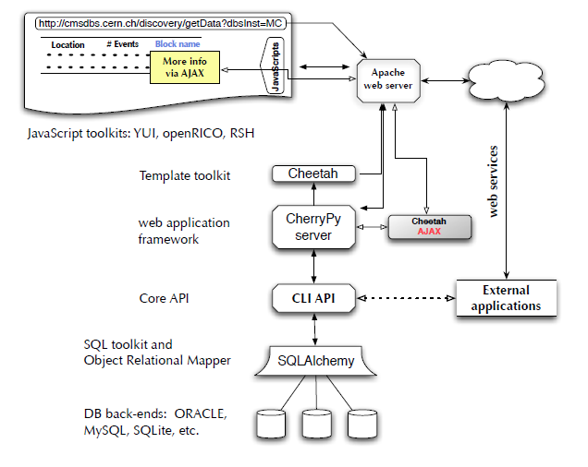
在普通的数据库访问方面速度慢，我们的访问模式不是太高。如果我们考虑CMS协作的规模和分布性，我们预计每个用户在工作日内的访问数不会超过几百次，每个时区有大约 100个用户。SQLAlchemy还负责管理数据库连接。尽管我们还没有提出查询缓存，但它可以非常容易地完成。我们还从后端数据库自动加载数据库模式，这不仅通过频繁更改数据库模式简化了我们的生活，还允许我们创建动态高级查询界面，如下所述。
在表示层，由于用户需求和用例的快速变化，模板引擎的使用变得非常重要。我们能够每天重新设计整个页面布局。另外，基于python的工具为这一层提供了一个完整的语言语义支持。例如，我们可以从核心API字典和列表中传递，并在模板中对它们进行操作，就像它是普通的Python代码一样。这些能力被用来创建AJAX页面，这些页面用其他AJAX调用构建了其他页面。将来，我们希望允许每个用户定制搜索和数据演示页面^{[13]}。
在数据发现工具中，我们可以通过AJAX调用集成不同的CMS Web服务，例如参见图2，数据表示页面使用AJAX异步加载相关生产请求的状态。然而，有时候，AJAX技术的广泛使用会导致用户很大的困惑。例如，最初我们使用AJAX来实现对DBS的所有呼叫。虽然这个成功构建了带有工作菜单和链接的页面，但浏览器工具栏中的“返回”按钮不再有效。因为用户是
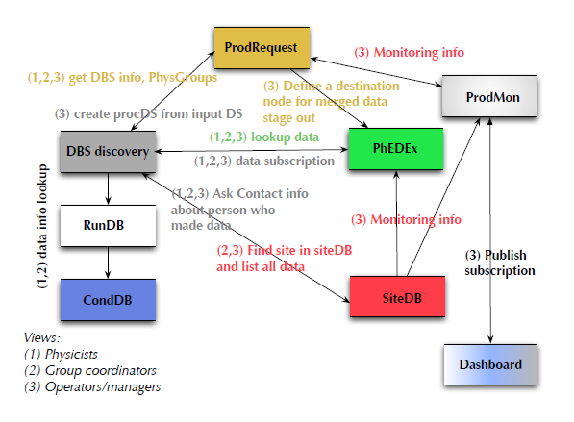
习惯于浏览器按钮，我们不得不重新设计我们如何实现呼叫。在很大一部分开发周期中，我们通过认真应用让用户满意AJAX调用。一个成功的例子是使用真正简单历史记录（RSH）工具在页面上保存JavaScript调用的会话历史记录。一旦用户找到数据集，我们就会在网页上记录他们的交互，例如查看数据集详细信息。另一个例子是能够查看相同数据集的“摘要”和“细节”视图。紧凑视图“摘要”代表数据集信息的快照，足以缩短足以帮助用户理解它是否代表某种兴趣，如果是这样，只需轻轻点击一下“详细”视图（感谢AJAX）。
在图3中，我们展示了数据发现和运行摘要CMS服务之间的AJAX调用的一个真实示例。一旦用户使用运行信息加载页面，就会为页面上显示的所有运行形成相应的请求，并将其发送到外部运行摘要数据库。它返回包含运行摘要信息的单个响应，该响应放置在适当的表格单元格中。这些信息的外观很短。在某些情况下，请求无法完成。有几种可能的原因，包括网络问题，运行摘要数据库服务器关闭等。
CMS数据发现服务是基于众所周知的用例开发的，例如通过选择软件发布来查找数据集或查找给定站点的数据的能力。尽管这些预定义的查询涵盖了大部分用例，但是希望能够放置任意查询来探索如此复杂的数据簿记系统。为了适应两种情况，我们开发了几个搜索界面 总的来说，我们最终有五个独立的界面：“Navigator”，一个菜单驱动的界面; “Finder”，一个任意的查询界面; “分析”，一个
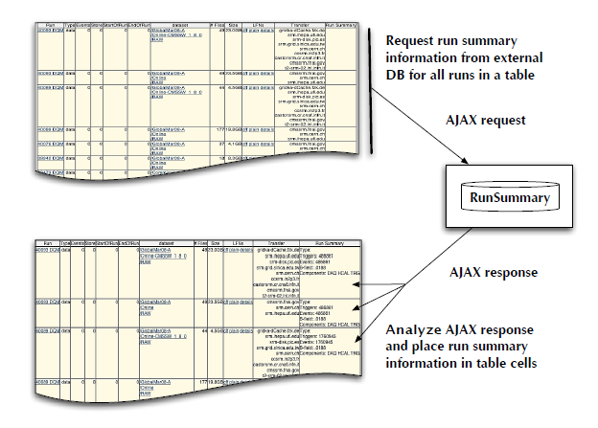

图3 显示了Data Discovery和Run Summary服务之间的AJAX调用的具体示例。数据发现服务查找从DBS运行，并将包含摘要表的页面返回给用户。同时，它还向运行摘要数据库发送AJAX调用以检索有关运行条件的信息以填充相应的表格单元格。
以分析为中心的界面; “网站”是一个特定于网站的界面; 和“运行”，一个运行特定的界面。这里我们将讨论在这些接口中使用python和AJAX的好处。
第一个称为“导航器”，代表菜单驱动的方法，其中网页包含一组分层菜单。在我们的例子中，它是：物理组，数据层，软件版本，数据类型，触发流，站点。我们根据物理学家如何搜索数据的用例分析来选择此顺序。如果不根据用户选择缩小可能性，简单的菜单层次结构就不能很好地工作。通过使用AJAX调用，我们在菜单中提供了这种功能。例如，所有菜单都有“Any”作为默认选项。一旦用户做出选择，底层菜单就会随时更新，缩小子菜单中的结果。
“Finder”代表一个相反的搜索界面。我们没有通过一系列选择来指导用户，而是向他们展示了DBS架构的相关部分，并提供了一个界面来进行数据选择。为了完成这个任务，我们使用了一个抽象SQL层（通过用python编写的SQLAlchemy），通过在我们的应用程序中自动加载底层数据库模式。这种方法有几个优点，例如独立于模式更改并对数据库后端透明。在Tier0,1和Tier 1,2分别使用ORACLE和MySQL。我们在这里应该强调，由于查询率相对较低，我们没有任何性能问题。使用AJAX技术，我们通过树视图控件将自动加载的模式推送到网页，并允许用户构建任意查询，
在引擎盖下，我们使用自动加载架构的外键在用户请求中建立选定表列之间的最短路径。一旦查询被构造和执行，结果页面就以表格格式呈现给用户，并且能够放置另一个查询，例如查找结果页面中的已处理和分析数据集。
“分析”界面是最不确定的界面，仍在开发中。在开发周期中，用户需求的快速周转是必要的。因此使用Python和模板引擎的好处很明显。
“运行”界面代表了来自不同CMS CMS Web服务的数据检索组合。最初我们向用户展示了存储在DBS中的信息，但随着时间的推移，很明显，仅仅满足用户需求是不够的，特别是对于运营经理而言。这组用户需要在发现页面上提供监控功能，可以同时提供来自DBS，运行汇总DB和PhEDEx CMS系统的信息。运行总结和PhEDEx信息通过构建一个关于从DBS检索到的运行的单个AJAX调用来检索。两个响应都被独立处理并放置在页面上的适当HTML标签中。
用户的查询也保存在一个单独的数据库中供以后使用，并且还在页面上呈现用于检索用户查询的界面。另外，我们添加了一个具有相同功能的命令行工具，其中用户创建了一个输入XML或文本文件，指定他们想要在DBS中查找的内容。使用XML-RPC调用，这样的请求转到同一个Web服务中，并且结果以XML形式返回，并为用户解析。这允许用户在命令行和其他python应用程序中使用这种技术。
AJAX技术的优势使我们能够构建查询界面和交互式结果页面，这些页面能够解释查询结果并根据用户请求放置另一个查询。
我们很高兴地看到，随着数据发现的成功，其他CMS web工具被迁移到使用相同的模型^{[14]}。为了创建一个框架，我们又迈出了一步，在这个框架中，单个服务（如数据发现或站点数据库）能够在单个服务器中注册。同样显而易见的是，通过使用AJAX技术，网页的个性化变得可行。自动加载模式的能力以及我们的算法根据需要构建任意查询的能力在CMS协作中受到其他Web开发人员的极大兴趣，并且可以应用于任何数据库和模式。
从图2中可以看出，数据发现服务与其他CMS Web服务非常好地集成，其中包括运行汇总数据库，PhEDEx，生产请求系统和SiteDB。一些信息在页面加载时自动被请求，例如检索传输状态和运行摘要信息，例如运行类型，触发信息和在该运行期间使用的磁场值。其他信息仅在用户采取行动时才被要求。例如，在数据集输出页面上，我们提供了生产请求系统中数据集检索状态的链接。每个数据集或页面上显示的所有数据集均请求状态字段。在这种情况下，单个或多个AJAX请求被发送到生产请求系统。与此同时，数据发现服务也为其他CMS应用程序提供服务。例如，生产请求系统询问数据发现哪些软件版本可用，并且AJAX有助于建立两个子系统之间的通信通道。值得一提的是，生产请求系统，数据发现和SiteDB是在一个单独的小框架下统一的，这个小框架在别处讨论^{[15]}。
正如我们在前面的讨论中看到的那样，python和AJAX的使用帮助我们跟上了用户界面的变化，我们对用户角色，架构和变化的理解以及用户与系统的交互。它还在数据发现搜索界面中做出重大改进。数据发现搜索界面与临时网页搜索完全不同，因为对用户角色和用户的数据模型有清晰的了解，以及常见的由于用户可预测的一系列选择，AJAX有助于将大量信息汇集到网页上的可管理大小。

4.结论
我们讨论了使用python和AJAX技术进行快速Web开发。它被证明是CMS数据发现服务的一个非常高效的串联。python的简单性，灵活性和强大功能使我们能够专注于服务的可用性，通过在我们的软件模型中重新编写不同的堆栈组件。现代的AJAX技术为我们的用户提供了类似于应用程序的Web界面行为，并且可以集成多个CMS Web服务，如生产请求系统，站点数据库，运行质量和汇总数据库，条件数据库和PhEDEx。我们的最终目标是满足CMS用户的需求，并为他们提供快速查找所需数据的能力。数据发现服务提供菜单驱动的，特定于应用程序的任意搜索。

5.致谢
我们要感谢Chris Jones和Dan Riley对涉及CMS数据模型和数据管理的各种用例进行了广泛的讨论。我们也感谢Lee Lueking，Anzar Ajaq，Vijay Sekhri对数据发现要求的宝贵讨论。这项工作得到了国家科学基金会和能源部的支持。

参考
[1] A. Afaq，et。人。“CMS数据集记帐服务”，请参阅本次会议的进行情况。[2] http://cmsdbs.cern.ch/DBS2发现/
[3] https://twiki.cern.ch/twiki/bin/view/CMS/SWGuideFrameWork
[4] A. Dolgert，L. Gibbons，V. Kuznetsov，CD Jones，D. Riley“关于CMS数据的数据检索的多维观点”，见本次会议的进展。
[5] http://www.sqlalchemy.org/
[6] http://www.cherrypy.org/
[7] http://www.openrico.org/
[8] http://www.onjava.com/pub/a/onjava/2005/10/26/ajax-handling-bookmarks-and-back-button.html
[9] http://www.cheetahtemplate.org/
[10] http://www.turbogears.com
[11] http://pylonshq.com/
[12] http://www.djangoproject.com/
[13] F. Yang，J. Shanmugasundaram，M. Riedewald，J. Gehrke，A. Demers，“Hilda：A High-Level Language for Data-Driven Web Applications”，ICDE Con​​ference，2006年4月
[14] M.西蒙等人。al。，“CMS离线网络工具”，请参阅本次会议的进行。

Rapid web development using AJAX and Python

A. Dolgert, L. Gibbons, V. Kuznetsov
Cornell University, Ithaca, NY 14853, USA
E-mail: vkuznet@gmail.com

Abstract
We discuss the rapid development of a large scale data discovery service for the
CMS experiment using modern AJAX techniques and the Python language. To implement a flexible interface capable of accommodating several different versions of the DBS database, we used a “stack” approach. Asynchronous JavaScript and XML (AJAX) together with an SQL abstraction layer, template engine, code generation tool and dynamic queries provide powerful tools for constructing interactive interfaces to large amounts of data. We show how the use of these tools, with rapid development in a modern scripting language, improved the scalability and usability of the the search interface for different user communities.

1.Introduction
Some of the most visible and successful information retrieval systems are available through web browsers. Recently Asynchronous JavaScript and XML, or AJAX, significantly improved how users interact with web interfaces. The Google maps service is an excellent example of how AJAX improves interaction between users and large amounts of data.
The Data Bookkeeping System (DBS) [1] has been developed to catalog all CMS data, including Monte Carlo and detector sources. Simulations and the detector will create about 5 PB a year, all of which should be accessible to physicists. The DBS represents a service whose primary responsibility is to answer questions about data existence, their characteristics, description and location in CMS. We developed a web service, called data discovery [2], which provides a front-end interface for physicists to communicate with DBS. It serves as a specialized search engine to lookup CMS data. Here we present details of its implementation based on a stack of software components written in python and decorated with AJAX technology to improve usability of the front-end interface.

2.The search task
The CMS Event Data Model (EDM) [3] represents a hierarchy of data objects optimized for processing, transfer and storage. At the highest level of the EDM, the Primary Dataset is a classification for the trigger stream or Monte Carlo type that is the source of individual Datasets. Each Dataset contains Blocks of similar files, where Blocks are the primary entity for data transfer. Copies of Blocks on different sites have the same Logical File Name. When a Block is created by a step of the processing chain, from RAW to DIGI, SIM, and RECO, it is assigned a Data Tier of the same name. Each of these files is linked to the detector conditions during its creation, the version of the application that created it, the configuration parameters for its processing, and more. The distributed nature of data management and complexity of data

flow introduce a barrier for average users. Such complexity motivated us to start developing a single data discovery service.
We identified three main roles of users to access the service: Physicists, Production Managers, and Run Managers [4]. A Physicist might ask, “I would like to find Monte Carlo data produced with a certain software release for the t¯ sample.” A Production Manager would see datasets in the DBS as traces of a successful workflow. These mental models, of physics collisions and algorithms or of distributed computing, are very specific and very different from the Event Data Model.
The presentation model of the search interface mediates between these two. The implementation of this interface was the most complex task during the development cycle. We explored a variety of layouts to show the enormous amount of information in the DBS. The search interface presents different search strategies to each role, in both a novice and advanced form. There is one format that is tailored precisely to the main use case of each role, such as dataset summaries for Physicists containing the location, number of events, number of files, and logical filenames. Production Managers see, in addition, the person who made the dataset with a link to contact information and a time stamp of when the dataset was created or modified. There is also a less directed form of search which forms more arbitrary queries of the DBS.
On the one hand, we have the complexity of the EDM and ongoing changes in its semantics. On the other, we have a user group whose geographical distance makes it difficult to do direct testing of the interface. After initial focus groups and a few interviews, most user experience data has to come from log analysis and helpful emails. Lack of certainty and the complexity of the search task put pressure on the development environment.
- Python and Ajax
The idea of rapid web development using python and AJAX was driven by two main factors: a fast turn around with changes, including user interface, use cases, DB schema, etc.; and support of user interaction with the DBS. Python had a great set of tools to accommodate our tasks. Among a large number of possibilities we choose the following components (see Fig. 1):
  - SQLAlchemy [5], the python SQL toolkit and Object Relational Mapper, as SQL abstraction layer, which provides us transparent access to different DB back-ends (ORACLE, MySQL, SQLite);1
  - CherryPy [6], the python web application framework;
  - Open RICO framework [7], a JavaScript libraries which served all AJAX communications between web server and DB back-end;
  - Really Simple History (RSH) JavaScript library framework [8], for session based history of JavaScripts user calls;
  - Cheetah template framework [9], written in python for presentation layer of web pages.
It is worthwhile to mention that those components were already used in other open source python web development frameworks [10, 11, 12]. Those web application frameworks were designed to accomotate all user needs, including data management. In our case the data model was designed and developed independently and data discovery was designed to be a read-only service. When it was feasible to adopt one or another web application framework we leaned towards re-using individual software components.
This stack of software components fits very well in the model-view-controller (MVC) architecture where we separated our data model from presentation layer. As we mentioned already, we used an SQL abstraction layer. Even though, depending on implementaion, it can
















Figure 1. Data discovery stack of software components.
http://cmsdbs.cern.ch/discovery/getData?dbsInst=MC

Location# EventsBlock name
More info via AJAX
Apache
web server
JavaScript toolkits: YUI, openRICO, RSH
Template toolkit
Cheetah
web application
framework
CherryPy
server

Cheetah
AJAX
Core API
CLI API
External
applications
SQL toolkit and
Object Relational Mapper
SQLAlchemy
DB back-ends: ORACLE,
MySQL, SQLite, etc.

be slow with respect to plain DB access, our access pattern was not too high. If we take the size and distributed nature of CMS collaboration we would expect not more then a few hundred access calls during a working day per user, with ∼100 users per time zone. The SQLAlchemy also took care of pooling database connections. Even though we did not yet come up with a query cache it can be done very easily. We also auto-load the DB schema from back-end DB which not only simplifies our life with frequent DB schema changes, but allows us to create a dynamic advanced query interface, discussed below.
At the presentation layer the usage of template engine was a big plus due to fast changes in user requirements and use cases. We were able to redesign the entire page layout on a daily basis. In addition, python-based tools provide a whole language semantics support to this layer. For example, we were able to pass from the core API dictionaries and lists and manipulate them in templates as if it were normal python code. Such abilities were used to create AJAX pages on a fly which constructed other pages with other AJAX calls. In the future, we would like to allow each user to customize both the search and data presentation pages [13].
In the context of the data discovery tool we were able to integrate different CMS web services via AJAX calls, see Fig. 2 for instance, the data presentation page uses AJAX to asynchronously load the status of related production requests. Sometimes, however, extensive use of AJAX technology leads to great confusion for the user. For example, originally we used AJAX to implement all calls to the DBS. While this successfully constructed pages with working menus and links, the “Back” button in the browser toolbar no longer worked. Because users are

(1,2,3) get DBS info, PhysGroups

(3) create procDS from input DS
(3) Monitoring info








- Define a destination node for merged data stage out

ProdRequest

ProdMon

DBS discovery
(1,2,3) lookup data
(1,2,3) data subscription

PhEDEx

RunDB
(1,2) data info lookup
(1,2,3) Ask Contact info about person who made data

  - Monitoring info

(2,3) Find site in siteDB and list all data

(3) Publish subscription

SiteDB

CondDB

Views:
    - Physicists
    - Group coordinators
    - Operators/managers

Dashboard

Figure 2. Integration of different CMS web services.

accustomed to the browser button, we were forced to redesign how we implemented the calls. For a large part of the development cycle, we kept users happy by careful application of
AJAX calls. One sucessfull example was keeping a session history of JavaScript calls on a page using the Really Simple History (RSH) tool [8]. Once the user found datasets, we recorded their interactions, such as viewing dataset details, on a web page. Another example is the ability to see “summary” and “details” views for the same dataset. A compact view, “summary”, represents a snapshot of information about dataset short enough to help users to understand if it represents some interest and, if so, a “detailed” view was just one click away (thanks to AJAX).
In Fig. 3, we present a real example of AJAX calls between the Data Discovery and Run Summary CMS services. Once users load the page with run information, the appropriate request is formed for all runs shown on the page and sent to the external Run Summary Database. It returns a single response containing the run summary information, which is placed into the appropriate table cells. There is a short latency in appearance of the information. In some cases, requests cannot be completed. There are several possible causes, including network problems, the Run Summary DB server is down, etc.
The CMS Data discovery service [2] was developed based on well-known use cases, such as the ability to lookup datasets by selecting software releases, or lookup data for a given site. Even though those predefined queries cover a majority of use cases, the ability to place arbitrary query was desired to explore such a complex data bookkeeping system. To accommodate both scenarios we developed several search interfaces. In total we end up with five separate interfaces: “Navigator”, a menu-driven interface; “Finder”, an arbitrary query interface; “Analysis”, an

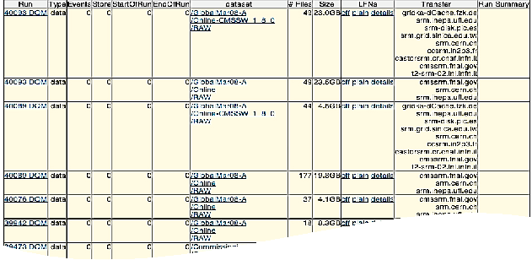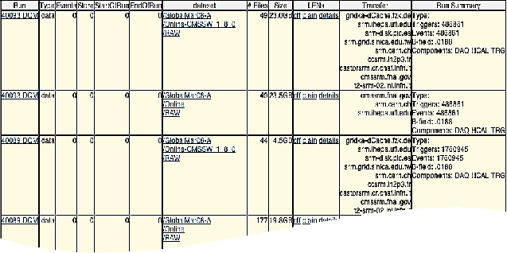

RunSummary
Request run summary
information from external DB for all runs in a table
AJAX request
AJAX response
Analyze AJAX response
and place run summary information in table cells

Figure 3. This shows a specific example of AJAX calls between the Data Discovery and Run Summary services. The Data Discovery service lookup runs from the DBS and returns the page with the summary table to the user. At the same time, it also sent an AJAX call to Run Summary DB to retrieve the information about run conditions to fill the appropriate table cells.
analysis-centric interface; “Sites”, a site-specific interface; and “Runs”, a run-specific interface. Here we will discuss the benefits of using python and AJAX in those interfaces.
The first one, called “Navigator”, represents a menu-driven approach where a web page contains a set of hierarchical menus. In our case it was: Physics group, Data tier, Software release, Data types, Trigger Stream, Sites. We chose this order based on use case analysis of how physicists search for data. A simple hierarchy of menus does not work well if it does not narrow possibilities based on user choice. By using AJAX calls we provided this ability in menus. For instance all menus had “Any” as a default choice. Once the user makes a selection, underlying menus were updated on a fly, narrowing the results in submenus.
The “Finder” represents an opposite search interface. Instead of guiding users through a set of selections we expose a relevant part of the DBS schema to them and provided an interface to make a data selection. To accomplish this task we used an abstract SQL layer (via SQLAlchemy [5] written in python) by auto-loading the underlying DB schema in our application. This approach has several advantages, such as being independent from schema changes and being transparent to the DB back-end. ORACLE and MySQL were used at Tier0,1 and Tier 1,2, respectively. We should stress here that we have not had any performance issues due to the relatively low rate of queries. Using AJAX technology we push the auto-loaded schema to the web page via a treeview control and allow users to construct arbitrary queries, by selecting table columns and placing query constrains, without knowing SQL language and schema relationships.

Under the hood, we used foreign keys of auto-loaded schema to establish a shortest path between selected table columns from a user request. Once the query was constructed and executed, the resulting page was presented to the user in a table format with the ability to place another query, such as lookup a processed and analysis dataset of out the results page.
The “Analysis” interface is the most uncertain one and still under development. A fast turnaround with user requirements was necessary in development cycle. Therefore the benefit of using python and template engine was clear.
The “Runs” interface represents a mix of data retrieval from different CMS web services. Originally we showed users the information stored in DBS, but with time it became clear that it was not enough to satisfy users needs, especially for Run managers. This group of users required a monitoring capability on the discovery page where information from DBS, Run summary DB and PhEDEx CMS system could be presented simulteneously. The Run summary and PhEDEx information were retrieved by constructing a single AJAX call to their web services about runs retrieved from DBS. Both responses were treated independently and placed into appropriate HTML tags on a page.
The user’s query was also saved in a separate DB for later usage, and an interface to retrieve user’s queries was presented on the page as well. In addition, we added a command-line tool with the same functionality where users created an input XML or text file specifying what they want to lookup in DBS. Using an XML-RPC call, such a request went to the same web service and results were returned back in an XML form which were parsed back for users. This allows users to use this technique in command-line and other python applications.
The advantage of AJAX techniques allows us to build a query interface and interactive results pages which were able to interpret query results and place another query upon user request.
We were pleased to see that with success of data discovery the other CMS web tools were migrated to use the same model [14]. An additional step forward was done to create a framework, where individual services, such as data discovery or Site DB, were able to register within a single server. It is also apparent that personalization of web pages becomes feasible by using AJAX technology. The ability to auto-load schema and the ability of our algorithm to construct arbitrary queries on demand were perceived with great interest by other web developers in CMS collaboration and can be applied to any DB and schema.
As can be seen from Fig. 2 the Data Discovery service was very well integrated with the rest of CMS web services, among them the Run summary DB, PhEDEx, Production request system, and SiteDB. Some information was automatically requested upon page load, for instance retrieval of transfer status and Run summary information such as run type, trigger information and the magnetic field value used during this run. And other information was only requested upon user action. For example, on the dataset output page we provide a link to the retrieval status of a dataset in the Production request system. The status fields were requested per single dataset or for all datasets shown on a page. In this case either single or multiple AJAX requests were sent to the Production request system. At the same time Data Discovery service also serves other CMS applications. For example, the Production request system asks Data Discovery which software releases are available, and AJAX helps to establish a communication channel between two subsystems. It is worth mentioning that the Production request system, Data Discovery and SiteDB were unified under a single mini-framework which is discussed elsewhere [14].
As we saw from the previous discussion, the usage of python and AJAX helped us to keep up with changes in user interfaces, our understanding of user roles, schema and changes and user interaction with a system. It also makes significant improvements in the data discovery search interface. The data discovery search interface is quite different from casual web page searches due to a clear understanding of user roles and the user’s model of the data, as well as common

search patterns. Given a predictable set of choices by the user, AJAX helps funnel a large set of information into a manageable size on a web page.

4.Conclusions
We discussed rapid web development using python and AJAX technology. It has proven to be a very productive tandem for the CMS data discovery service. The simplicity, flexibility and power of python allowed us to concentrate on the usability of the service, by re-writing different stack components in our software model. The modern AJAX technology gave our users an application-like behaviour of web interface and the ability to integrate multiple CMS web services, such as Production Request system, Site DB, run quality and summary DB, Condition DB and PhEDEx. Our final goal was to satisfy CMS users and provide them with the ability to quickly locate their desired data. The data discovery service provides menu-driven, application specific, arbitrary searches.

5.Acknowledgements
We would like to thank Chris Jones and Dan Riley for extensive discussions of various use cases involved in the CMS data model and data management. We also thank Lee Lueking, Anzar Ajaq, Vijay Sekhri for valuable discussions about data discovery requirements.This work was supported by National Science Foundation and Department Of Energy.

References
[1] A. Afaq, et. al. “The CMS Dataset Bookkeeping Service”, see proceeding of this conference.
[2] http://cmsdbs.cern.ch/DBS2 discovery/
[3] https://twiki.cern.ch/twiki/bin/view/CMS/SWGuideFrameWork
[4] A. Dolgert, L. Gibbons, V. Kuznetsov, C. D. Jones, D. Riley “A multi-dimentional view on data retrieval of CMS data”, see proceeding of this conference.
[5] http://www.sqlalchemy.org/
[6] http://www.cherrypy.org/
[7] http://www.openrico.org/
[8] http://www.onjava.com/pub/a/onjava/2005/10/26/ajax-handling -bookmarks-and-back-button.html
[9] http://www.cheetahtemplate.org/
[10] http://www.turbogears.com
[11] http://pylonshq.com/
[12] http://www.djangoproject.com/
[13] F. Yang, J. Shanmugasundaram, M. Riedewald, J. Gehrke, A. Demers, “Hilda: A High-Level Language for Data-Driven Web Applications”, ICDE Conference, April 2006
[14] M. Simon et. al., “CMS Offline Web Tools”, see proceeding of this conference.

指导老师批阅（手写）：

签名：
日期：

