Satellite Monitoring System
Geospatial Earth Observation
Project Domain | Target Scope | Core Tech Stack
Satellite Remote Sensing | Reserve Forest Protection & Mineral Transit | React 18, Node.js, Express, MongoDB, GEE
1. Problem Statement
Preserving ecologically sensitive forest reserves, protected catchment basins, and regulated mineral extraction leases faces acute challenges in environmental law enforcement. Terrestrial patrolling across expansive, rugged terrain is severely constrained by manpower shortages, logistical bottlenecks, and communication blackouts. Consequently, unlawful logging, unauthorized quarrying, and encroachment into state forest compartments are often detected weeks or months after irreversible damage has occurred.
Compounding this issue is the operational disconnect between orbital satellite data and field-level enforcement. While Earth Observation (EO) satellites continuously collect optical and radar imagery, ground checkpoints lack direct digital access to automated change alerts, electronic transit permits (e-passes), and weighbridge reconciliation tools. Overloaded commercial mineral vehicles and unauthorized timber carriers evade roadside inspection. A unified software ecosystem is urgently needed to connect automated multi-satellite change detection, local air-gapped GeoTIFF raster processing, cryptographic role-based access control, and roadside enforcement.
2. Objectives
- Automated Multi-Source Earth Observation Ingestion: Acquire and normalize optical (Sentinel-2 10m, Landsat 8/9 30m) and radar (Sentinel-1 SAR C-band) imagery via Google Earth Engine and offline local GeoTIFF ingestion.
- Dual-Engine Bi-Temporal Change Detection: Deliver both a cloud-backed Earth Engine pipeline for planetary surveillance and a secure local offline raster engine (NDVI differencing, adaptive thresholding) to compute land loss in hectares.
- Hierarchical Role-Based Security: Implement JWT authentication with strict server-side and client-side RBAC across 7 roles (Super Admin, Admin, Forest Officer, Mining Officer, Checkpoint Officer, Field Officer, Viewer).
- Integrated Field Checkpoint Enforcement: Provide cryptographic QR code verification for transit e-passes, weighbridge mass discrepancy audits, vehicle/driver tracking, and automatic incident escalation.
- Interactive Geospatial Command Workstation: Provide a high-performance React 18 GIS console with interactive Leaflet maps, curtain swipe raster sliders, analytical KPI tracking, and one-click PDF/CSV report generation.

3. System Design & Workflow
The Satellite Monitoring System adopts a modular, 4-tier Service-Oriented Architecture (SOA) ensuring operational resilience, air-gapped reliability, and role-governed data segregation:
• 1. Presentation Tier (React 18 SPA): TypeScript, Tailwind CSS, and Vite. Implements role-protected route guards, interactive React-Leaflet GIS layers, and HTML5 canvas curtain swipe sliders for bi-temporal visual change inspections.
• 2. API & Security Layer (Express Gateway): REST API providing JWT token issuance, bcrypt credential hashing, CORS policy isolation, Helmet security headers, and granular role/permission RBAC enforcement.
• 3. Processing & Analytics Engine: GEE Multi-Source Ingestion Service, Offline GeoTIFF Raster Service (affine matrix parsing, EPSG/UTM geodesic projection, NDVI differencing), and an automated cron scheduler for continuous area scans.
• 4. Persistence Layer (MongoDB / Mongoose): Document database indexing monitored compartments, satellite metadata, baseline rasters, change records, alerts, transit e-passes, and security audit logs.
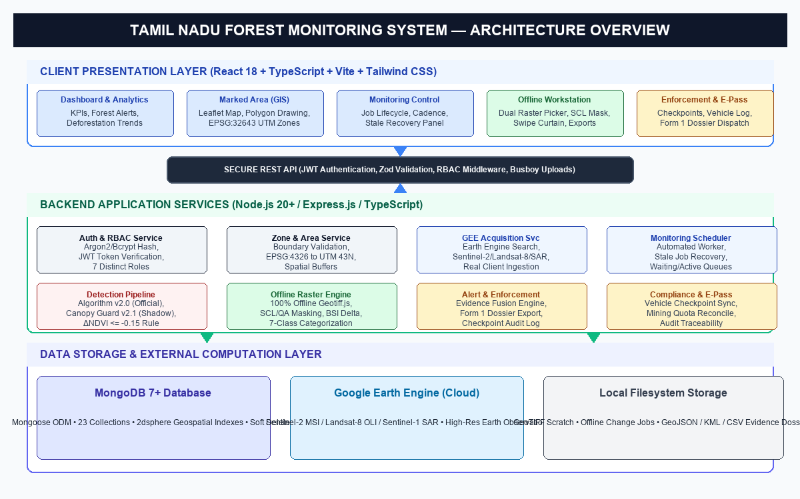
Figure 1: High-Level System Architecture and Layered Service Topology
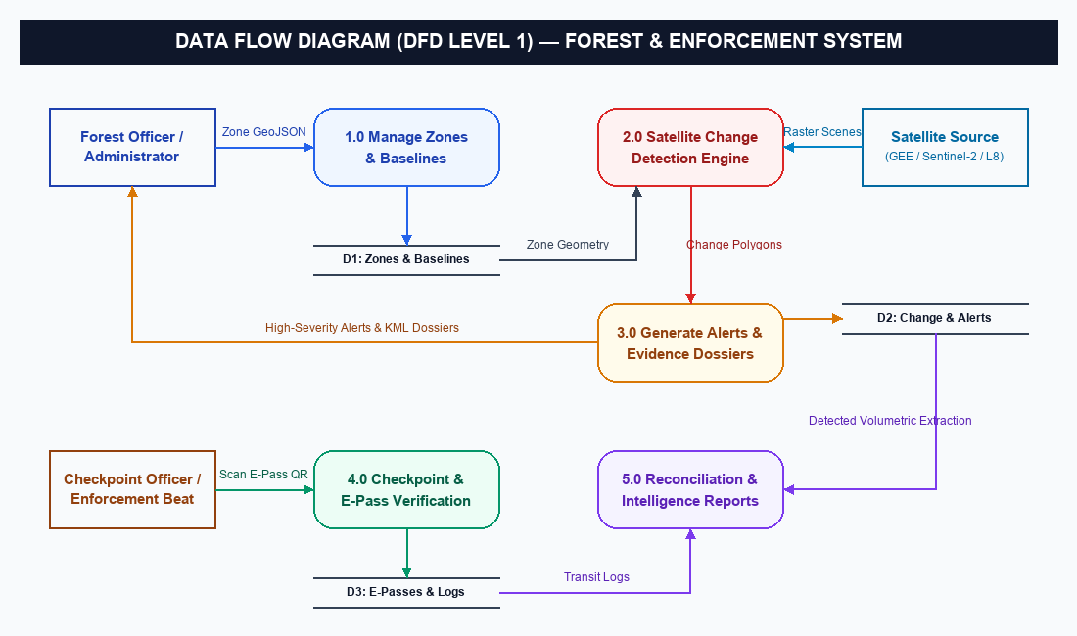
Figure 2: End-to-End Pipeline Workflow: Satellite Ingestion to Field Enforcement

4. Sample Code & Implementation Highlights
Key implementation excerpts from the active codebase demonstrating authentication, RBAC enforcement, client route protection, and affine georeferencing math:
Snippet 1: JWT Authentication Middleware (server/src/middleware/authMiddleware.ts)
export async function requireAuth(req: Request, _res: Response, next: NextFunction): Promise<void> {
try {
const authHeader = req.headers.authorization;
let token = authHeader?.startsWith('Bearer ') ? authHeader.split(' ')[1] : req.query?.token;
if (!token) throw new AppError('Authentication required. Missing token.', HTTP_STATUS.UNAUTHORIZED);
const payload = verifyToken(token);
const user = await userRepository.findById(payload.userId);
if (!user || user.status !== UserStatus.ACTIVE) throw new AppError('Account inactive or revoked.', 401);
req.user = { id: user._id.toString(), email: user.email, role: user.role, permissions: user.permissions };
next();
} catch (error) { next(error); }
}
Explanation: Intercepts API requests, extracts bearer tokens from headers or query params (used for streaming raster tiles), cryptographically validates claims, and populates req.user context.
Snippet 2: Granular RBAC Permission Guard (server/src/middleware/roleMiddleware.ts)
export function requirePermission(...permissions: Permission[]) {
return (req: Request, _res: Response, next: NextFunction): void => {
if (!req.user) return next(new AppError('Authentication required', HTTP_STATUS.UNAUTHORIZED));
if (req.user.role === UserRole.SUPER_ADMIN) return next(); // Master bypass
const hasPermission = permissions.every((p) => req.user?.permissions.includes(p));
if (!hasPermission) return next(new AppError('Forbidden. Insufficient permissions.', HTTP_STATUS.FORBIDDEN));
next();
};
}
Explanation: Enforces least-privilege security per route. Verifies that the caller possesses all required permission flags, while granting system-level override to Super Admin.
Snippet 3: Client-Side Route Protection Component (client/src/components/common/ProtectedRoute.tsx)
const ProtectedRoute: React.FC<ProtectedRouteProps> = ({ requiredRole, requiredPermission }) => {
const { user, isAuthenticated, isLoading } = useAuth();
if (isLoading) return <Loading message="Verifying session..." />;
if (!isAuthenticated || !user) return <Navigate to="/login" replace />;
if (requiredRole && user.role !== 'SUPER_ADMIN' && user.role !== requiredRole) return <Navigate to="/unauthorized" replace />;
if (requiredPermission && user.role !== 'SUPER_ADMIN' && !user.permissions.includes(requiredPermission)) return <Navigate to="/unauthorized" replace />;
return <Outlet />;
};
Explanation: Protects client UI route trees prior to view rendering. Directs unauthenticated visitors to /login and blocks unauthorized officers from accessing off-limits modules.
Snippet 4: Geodesic & Affine Pixel Area Computation (OfflineChangeDetectionService.ts)
export function computePixelAreaHectares(affineTransform: number[], crsCode: string): number {
// 2D Affine Determinant |ad - bc| computes exact ground footprint
const det = Math.abs(affineTransform[0] * affineTransform[4] - affineTransform[1] * affineTransform[3]);
if (isProjectedInMeters(crsCode)) return det / 10000.0; // 1 Hectare = 10,000 m^2
if (isGeographicCRS(crsCode)) { // WGS84 EPSG:4326 ground projection
const latM = 111320.0, lonM = 111320.0 * Math.cos(centerLat * Math.PI / 180.0);
return (det * latM * lonM) / 10000.0;
}
throw new AppError(`Unsupported CRS georeferencing: ${crsCode}`, 422);
}
Explanation: Computes exact ground resolution from raster affine metadata without guessing. Supports UTM projected grids and geographic ellipsoidal transformations.

5. Application Screenshots & User Interface
Real interface captures of the running platform illustrating core modules and officer workstations:
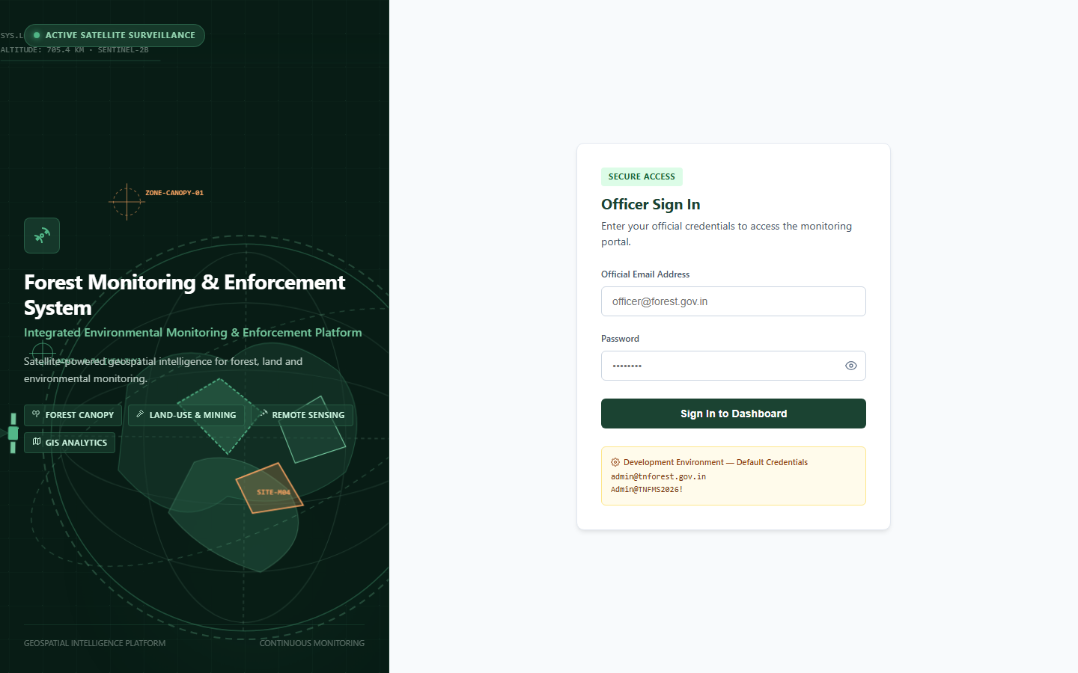  Figure 3: Multi-Role Secure Login Portal | 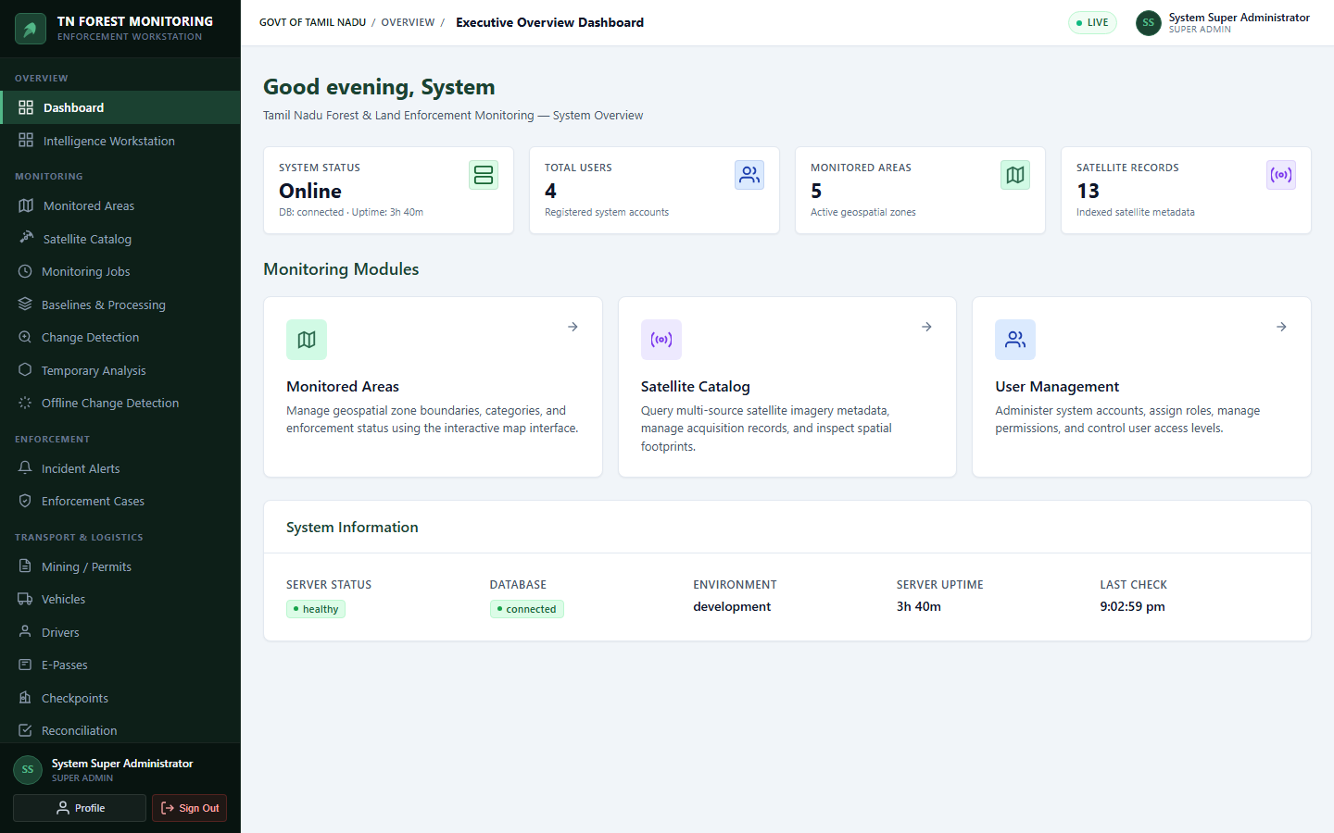  Figure 4: Executive Command Dashboard
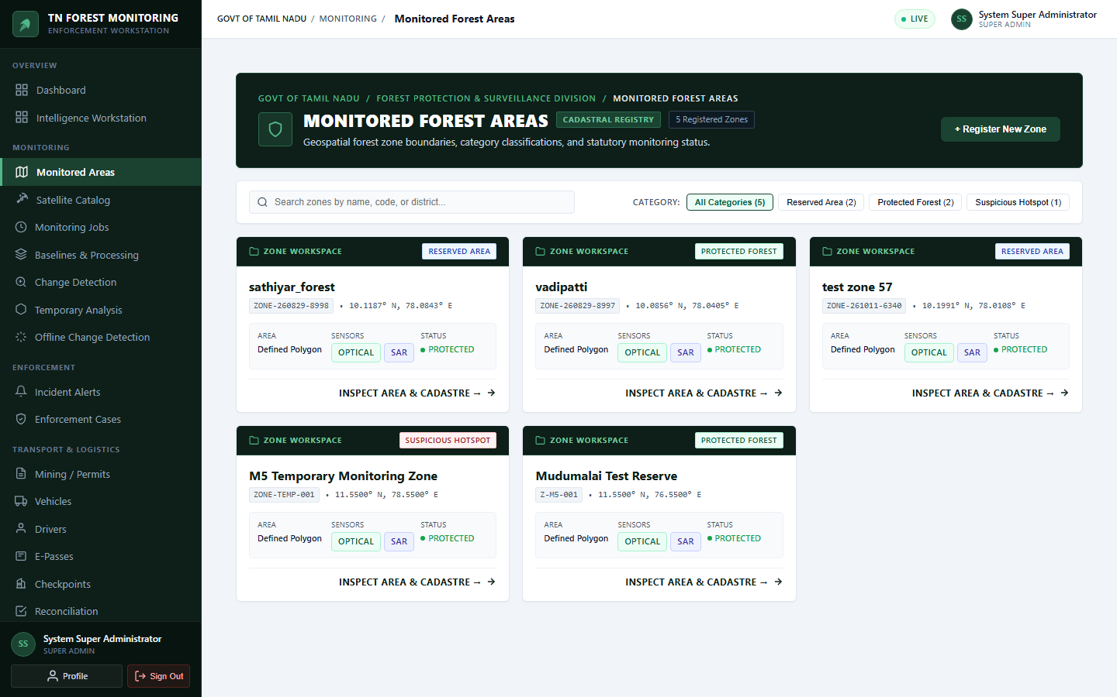  Figure 5: Monitored Areas GIS Map | 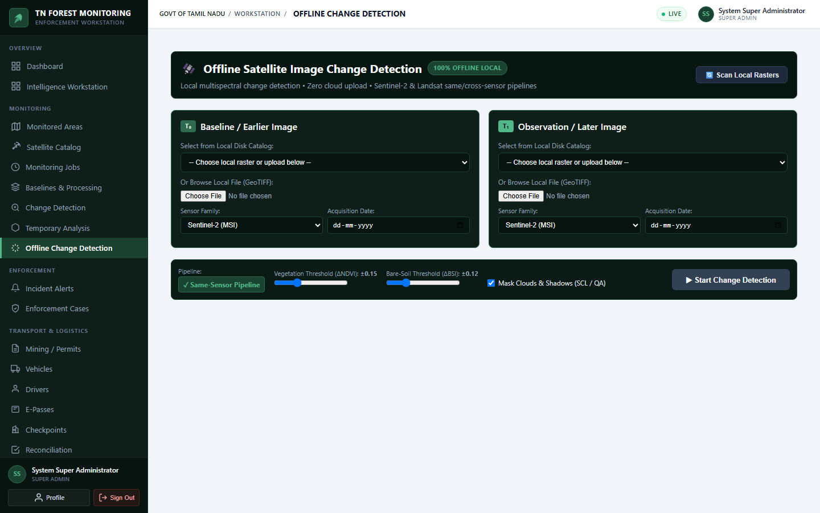  Figure 6: Offline Change Detection Workstation
Module Overview: Figure 3 shows the secure multi-role authentication portal with role credentials. Figure 4 displays real-time monitoring metrics across active forest reserves, acquisition jobs, and incident alerts. Figure 5 depicts the interactive Leaflet GIS console with vector reserve boundaries and mining lease boundaries. Figure 6 presents the offline change detection workstation with local GeoTIFF selection, NDVI curtain swipe slider, and calculated hectare loss metrics.

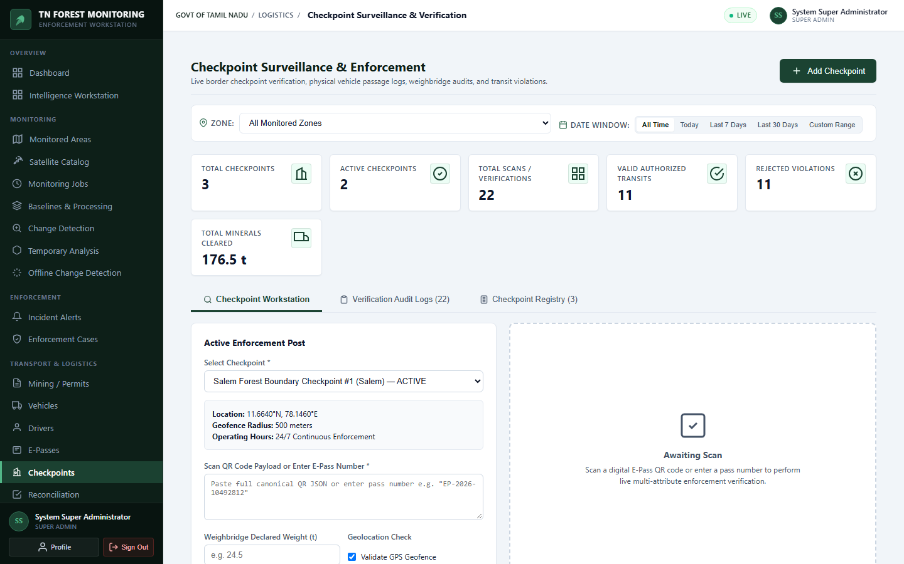
Figure 7: Roadside Checkpoint Enforcement & E-Pass Verification Terminal
Checkpoint Console: Figure 7 illustrates the field checkpoint terminal for QR-code transit e-pass scanning, vehicle tare/gross mass capture, and automated overload warning detection.

