A MINI PROJECT REPORT ON
TAMIL NADU FOREST MONITORING, AUTHORIZED MINING, E-PASS AND CHECKPOINT ENFORCEMENT SYSTEM
Submitted in partial fulfillment of the requirements
for the award of the degree of
BACHELOR OF TECHNOLOGY / BACHELOR OF ENGINEERING
IN
COMPUTER SCIENCE AND ENGINEERING
Submitted by:
[Candidate Name(s)]
[Register Number(s)]
Under the guidance of:
[Project Supervisor Name]
[Designation, Department of Computer Science and Engineering]
[DEPARTMENT OF COMPUTER SCIENCE AND ENGINEERING]
[INSTITUTION / UNIVERSITY NAME]
[ACADEMIC YEAR 2025–2026]

CERTIFICATE
This is to certify that the project entitled "TAMIL NADU FOREST MONITORING, AUTHORIZED MINING, E-PASS AND CHECKPOINT ENFORCEMENT SYSTEM" is a bona fide record of the work carried out by [Candidate Name(s)], Register No. [Register Number(s)], in partial fulfillment of the requirements for the award of the Degree of Bachelor of Engineering / Technology in Computer Science and Engineering during the academic year 2025–2026.
The project report has been examined and evaluated by the internal and external examiners.
SUPERVISOR  [Supervisor Name]  [Designation] | HEAD OF THE DEPARTMENT  [HOD Name]  [Department of CSE]

DECLARATION
I/We hereby declare that the project entitled "TAMIL NADU FOREST MONITORING, AUTHORIZED MINING, E-PASS AND CHECKPOINT ENFORCEMENT SYSTEM" submitted to [Institution Name] is a record of original work done by me/us under the supervision and guidance of [Supervisor Name], Department of Computer Science and Engineering.
I/We further declare that the work reported herein does not form part of any other thesis, dissertation, or project report submitted to any other University or Institution for the award of any degree or diploma.
Place: [Location]
Date: [Date]
[Signature of Candidate(s)]
[Candidate Name(s)]

ACKNOWLEDGEMENT
We express our deepest gratitude to our institution, [Institution Name], for providing the requisite infrastructure and computational facilities to execute this project successfully.
We extend our heartfelt gratitude to our Head of the Department, [HOD Name], for their constant encouragement and valuable academic administrative support.
We place on record our sincere appreciation and gratitude to our project supervisor, [Supervisor Name], for their insightful guidance, meticulous review, and technical suggestions throughout the research, implementation, and verification phases of this system.
We also thank all the teaching and non-teaching faculty members of the Department of Computer Science and Engineering and our colleagues for their direct and indirect support.

ABSTRACT
The illegal degradation of protected forest biomes, unauthorized mineral extraction, and illicit transit of forest and mineral resources pose critical ecological and enforcement challenges across Tamil Nadu. Traditional monitoring relies predominantly on manual forest beats, static checkpoint logs, and retrospective field inspections, resulting in substantial observation latency and limited spatial scalability across rugged terrains.
This project presents the Tamil Nadu Forest Monitoring, Authorized Mining, E-Pass and Checkpoint Enforcement System—a comprehensive digital architecture combining cloud-native satellite change detection, a fully offline workstation-grade raster analysis engine, and a unified transit enforcement platform. The system operates on an event-driven, service-oriented architecture implemented in Node.js, Express, TypeScript, and MongoDB, coupled with a feature-rich React 18 GIS workstation.
Key technical innovations include: (1) An online monitoring pipeline utilizing Google Earth Engine (GEE) to ingest multi-temporal Sentinel-2 MSI (10m) and Landsat-8/9 (30m) optical imagery and Sentinel-1 SAR imagery; (2) Production Algorithm v2.0 for official delta-NDVI canopy change detection operating alongside the shadow-mode Canopy Guard v2.1; (3) A completely offline satellite change detection workstation executing physical surface reflectance calibration, Scene Classification Layer (SCL) and QA_PIXEL cloud/shadow masking, sub-pixel bilinear grid resampling, Roy et al. / HLS cross-sensor bandpass harmonization, and dual-index (NDVI and Bare Soil Index - BSI) 7-class categorical land-cover change classification with strictly conserved metric area accounting; and (4) Integrated checkpoint enforcement synchronizing digital transport e-passes, QR verification, vehicle registries, and volumetric extraction reconciliation against sanctioned mining leases.
The system has undergone rigorous automated testing across 15 verification gates with zero production regressions and has been evaluated on authentic Sentinel-2 Level-2A imagery over the Sirumalai Hills (Zone ZONE-261011-6340) and full-scene raster footprints covering 57,468.53 hectares. Results confirm the mathematical consistency, coordinate reference system integrity (EPSG:32643 UTM Zone 43N), and operational resilience of the architecture as an investigative decision-support platform for statutory forest governance.

TABLE OF CONTENTS
Certificate . . . . . . . . . . . . . . . . . . . . . . . . . . . iii
Declaration . . . . . . . . . . . . . . . . . . . . . . . . . . . iv
Acknowledgement . . . . . . . . . . . . . . . . . . . . . . . . . v
Abstract . . . . . . . . . . . . . . . . . . . . . . . . . . . . vi
List of Tables . . . . . . . . . . . . . . . . . . . . . . . . . ix
List of Figures . . . . . . . . . . . . . . . . . . . . . . . . . x
CHAPTER 1: INTRODUCTION . . . . . . . . . . . . . . . . . . . . . 1
1.1 Project Perspective . . . . . . . . . . . . . . . . . . . 1
1.2 Problem Statement . . . . . . . . . . . . . . . . . . . . 2
1.3 Objectives . . . . . . . . . . . . . . . . . . . . . . . . 2
1.4 Scope of the Project . . . . . . . . . . . . . . . . . . . 3
1.5 Existing System and Its Limitations . . . . . . . . . . . 3
1.6 Proposed System . . . . . . . . . . . . . . . . . . . . . 4
1.7 Organization of the Report . . . . . . . . . . . . . . . . 5
CHAPTER 2: REQUIREMENT DESCRIPTION . . . . . . . . . . . . . . . 6
2.1 Functional Requirements . . . . . . . . . . . . . . . . . 6
2.2 Non-Functional Requirements . . . . . . . . . . . . . . . 7
2.3 Hardware Requirements . . . . . . . . . . . . . . . . . . 8
2.4 Software Requirements . . . . . . . . . . . . . . . . . . 8
2.5 User Roles and Permissions . . . . . . . . . . . . . . . . 9
2.6 System Constraints and Assumptions . . . . . . . . . . . . 10
CHAPTER 3: SYSTEM DESIGN . . . . . . . . . . . . . . . . . . . . 11
3.1 System Architecture . . . . . . . . . . . . . . . . . . . 11
3.2 Architecture Diagram . . . . . . . . . . . . . . . . . . . 12
3.3 Design Components . . . . . . . . . . . . . . . . . . . . 13
3.4 Database Design and Data Models . . . . . . . . . . . . . 14
3.5 API Design . . . . . . . . . . . . . . . . . . . . . . . . 16
3.6 Online Satellite Monitoring Workflow . . . . . . . . . . . 17
3.7 Offline Change Detection Workflow . . . . . . . . . . . . 19
3.8 Change Detection Algorithms & Formulations . . . . . . . . 21
3.9 User Interface Design . . . . . . . . . . . . . . . . . . 23
3.10 Low-Level Design (Data Flow) . . . . . . . . . . . . . . 24
CHAPTER 4: SYSTEM IMPLEMENTATION . . . . . . . . . . . . . . . . 26
4.1 Development Environment . . . . . . . . . . . . . . . . . 26
4.2 Frontend Implementation . . . . . . . . . . . . . . . . . 26
4.3 Backend Implementation . . . . . . . . . . . . . . . . . . 27
4.4 Authentication and Authorization . . . . . . . . . . . . . 28
4.5 Marked-Area and Map Management . . . . . . . . . . . . . . 29
4.6 Satellite Acquisition and Monitoring Jobs . . . . . . . . 30
4.7 Online Change Detection Execution . . . . . . . . . . . . 31
4.8 Offline Change Detection Engine . . . . . . . . . . . . . 32
4.9 Alerts, Dossiers, and Export Functionality . . . . . . . . 34
4.10 Error Handling and Operational Security . . . . . . . . . 35
CHAPTER 5: RESULTS AND DISCUSSION . . . . . . . . . . . . . . . . 36
5.1 Implemented Features Summary . . . . . . . . . . . . . . . 36
5.2 User Interface Walkthrough & Exhibits . . . . . . . . . . 37
5.3 API and Integration Testing . . . . . . . . . . . . . . . 39
5.4 Algorithm Verification (Sirumalai Audit) . . . . . . . . . 40
5.5 Offline Raster Processing Tests (15-Gate Audit) . . . . . 43
5.6 Real-Raster Trial Results (57,468 ha Scene) . . . . . . . 45
5.7 Limitations and Scientific Validation . . . . . . . . . . 46
CHAPTER 6: CONCLUSION AND FUTURE ENHANCEMENTS . . . . . . . . . . 48
6.1 Conclusion . . . . . . . . . . . . . . . . . . . . . . . . 48
6.2 Project Contributions . . . . . . . . . . . . . . . . . . 48
6.3 Current Limitations . . . . . . . . . . . . . . . . . . . 49
6.4 Future Enhancements . . . . . . . . . . . . . . . . . . . 50
APPENDIX A: SYSTEM REQUIREMENTS . . . . . . . . . . . . . . . . . 51
APPENDIX B: SOURCE CODE AND API SPECIFICATIONS . . . . . . . . . 53
REFERENCES . . . . . . . . . . . . . . . . . . . . . . . . . . . 57

LIST OF TABLES
Table 2.1: User Roles and Permission Mappings . . . . . . . . . . 9
Table 2.2: System Hardware Specifications . . . . . . . . . . . . 8
Table 2.3: Software Environment Specifications . . . . . . . . . 9
Table 3.1: Primary Database Document Collections . . . . . . . . 15
Table 3.2: Core REST API Endpoints Specification . . . . . . . . 16
Table 3.3: 7-Class Categorical Change Decision Logic . . . . . . 22
Table 5.1: API and Integration Test Suite Results . . . . . . . . 40
Table 5.2: Sirumalai Polygon POLY-033 Numerical Audit Verification 42
Table 5.3: Offline Change Detection 15-Gate Acceptance Test Matrix 44
Table 5.4: Full-Scene Real-Raster Offline Trial Area Accounting . 45
Table A.1: Minimum vs. Recommended Hardware Specifications . . . 51
Table A.2: Production Software and Library Versions . . . . . . . 52

LIST OF FIGURES
Figure 3.1: Multi-Tier System Architecture Diagram . . . . . . . 12
Figure 3.2: Online GEE-Backed Satellite Monitoring Pipeline . . . 18
Figure 3.3: Offline Satellite Image Change Detection Workstation Pipeline 20
Figure 3.4: Data Flow Diagram (DFD Level 1) . . . . . . . . . . . 25
Figure 3.5: MongoDB Document Schema Model & Entity Relationships 14
Figure 5.1: Real-Raster Before-and-After Sentinel-2 Image Comparison Exhibit 38
Figure 5.2: Multi-Temporal NDVI Spatial Distribution & Difference Analysis 39
Figure 5.3: Live Offline Satellite Change Detection Workstation Interface 37
Figure 5.4: Offline Change Detection Categorical Map (57,468 ha Scene) 46
Figure 5.5: Scene Classification Layer (SCL) Cloud and Shadow Masking Map 47
Figure 5.6: Executive Dashboard and Active Monitoring Status . . 48
Figure 5.7: Interactive Marked-Area GIS Management Map . . . . . 49
Figure 5.8: Roadway Checkpoint Enforcement & E-Pass Verification Console 50

CHAPTER 1
INTRODUCTION
1.1 PROJECT PERSPECTIVE
The state of Tamil Nadu encompasses ecologically diverse and environmentally sensitive biomes across the Western Ghats and Eastern Ghats, including tropical wet evergreen reserves, moist deciduous zones, shola-grassland complexes, and dry thorn forests. These ecosystems harbor endemic biodiversity, critical water catchment basins for the Cauvery and Vaigai river systems, and extensive reserved forest tracts subject to strict conservation mandates under the Tamil Nadu Forest Act, 1882, the Wildlife Protection Act, 1972, and the Forest (Conservation) Act, 1980.
In recent decades, escalating anthropogenic pressures have intensified illegal timber felling, boundary encroachment, forest fragmentation, and unpermitted commercial mining operations in forest fringe zones. The complex topography of hilly tracts—such as the Sirumalai Hills, Nilgiris, Kodaikanal, Shevaroys, and Javadi Hills—presents formidable operational hurdles for ground-based surveillance. Forest range teams, beat guards, and flying squads cannot maintain continuous, real-time physical coverage over vast swathes of remote terrain.
To overcome these geographic and logistical bottlenecks, the Tamil Nadu Forest Department requires a modern, scalable digital architecture that harnesses satellite Earth Observation (EO), high-throughput geospatial analytics, and automated transit enforcement. The Tamil Nadu Forest Monitoring, Authorized Mining, E-Pass and Checkpoint Enforcement System has been engineered from the ground up to address this institutional imperative, providing end-to-end intelligence from orbital sensor acquisition to on-the-ground checkpoint interception.
1.2 PROBLEM STATEMENT
Modern forest and mineral governance across Tamil Nadu confronts four interlocking operational deficiencies:
1. Latency and Spatial Coverage Gaps in Ground Patrols: Manual foot patrols cannot detect localized clearings or illicit extraction activities hidden within deep forest canopies or remote valleys until significant, irreversible ecological damage has already occurred.
2. Disjointed Satellite Data Utilization: While multi-spectral satellite imagery is freely acquired by international constellations (such as the European Space Agency's Copernicus Sentinel-2 and the USGS/NASA Landsat missions), forest administrative units lack integrated, automated analytical pipelines to ingest, cloud-mask, spatially harmonize, and extract actionable change polygons from raw satellite scenes.
3. Boundary Encroachment Around Mineral Leases: Commercial stone quarries and mineral leases operating adjacent to reserved forest boundaries frequently expand beyond their legally sanctioned spatial perimeters. Conventional monitoring lacks precise volumetric and perimeter reconciliation mechanisms to detect unpermitted extraction expansion.
4. Fragmented Transit Enforcement: Timber and mined minerals are frequently transported on public roadways with forged, expired, or non-existent transit permits. Static roadside checkpoints lack automated digital verification tools to cross-examine vehicle weights, valid digital e-passes, and approved quarry quotas in real time.
1.3 OBJECTIVES
The primary objective of this project is to develop and rigorously verify an integrated geospatial monitoring and enforcement system. Specific sub-objectives include:
• To implement an automated, cadence-driven satellite monitoring scheduler capable of querying and ingesting cloud-free optical and synthetic aperture radar (SAR) satellite imagery via Google Earth Engine (GEE).
• To establish a robust, verified change-detection pipeline—specifically Algorithm v2.0 (Official delta-NDVI detector) and Canopy Guard v2.1 (Shadow mode multi-index verifier)—to detect candidate canopy loss and vegetation decline in protected zones.
• To design and deploy a completely offline satellite change detection workstation that runs locally on forest field laptops without requiring internet connectivity, cloud authentication, or external API dependencies.
• To integrate physical surface reflectance calibration, Scene Classification Layer (SCL) and QA_PIXEL cloud/shadow masking, sub-pixel bilinear grid resampling, Roy et al. / HLS cross-sensor bandpass harmonization, and dual-index (NDVI and Bare Soil Index - BSI) 7-class categorical change detection.
• To create an end-to-end transit enforcement platform incorporating vehicle registries, driver records, QR-code enabled digital transport e-passes, checkpoint verification logs, and volumetric mining quota reconciliation.
• To guarantee strict mathematical area conservation, rigorous coordinate reference system (CRS) transformations (EPSG:4326 to EPSG:32643 UTM Zone 43N), and complete operational security with zero credential exposure.
1.4 SCOPE OF THE PROJECT
The operational scope of the platform spans both digital analysis and administrative enforcement across Tamil Nadu:
• Spatial Boundaries: The system models marked forest blocks, wildlife sanctuaries, reserve forest compartments, and authorized mining leases through multi-polygon GeoJSON structures stored with MongoDB 2dsphere geospatial indexing.
• Earth Observation Sensors: Ingestion and processing support covers Copernicus Sentinel-2A/B MultiSpectral Instrument (MSI) Level-2A (10m resolution), Landsat-8/9 Operational Land Imager (OLI) Collection-2 Level-2 (30m resolution), and Sentinel-1 C-band Synthetic Aperture Radar (SAR) Ground Range Detected (GRD) data.
• Operational Modes: The system provides two distinct processing paradigms: (1) An online, cloud-backed automated monitoring pipeline backed by Google Earth Engine for regular scheduled surveillance; and (2) An offline, local raster analysis engine for forensic, ad-hoc before-and-after change detection from user-selected GeoTIFF files.
• Enforcement Workflows: Extends from automated satellite alert generation to Form 1 Forest Offence Report evidence dossier compilation (exporting GeoTIFFs, Google Earth KMLs, shapefiles, and CSV audit registers) and roadway checkpoint e-pass scanning.
• Scope Boundary & Statutory Framing: The system is designed strictly as an investigative decision-support platform. It explicitly classifies detected anomalies as 'candidate spectral variations'. It does not claim that spectral change independently proves illegal deforestation; physical ground verification by forest beat officers remains statutory and mandatory prior to legal confiscation or prosecution under the Tamil Nadu Forest Act, 1882.
1.5 EXISTING SYSTEM AND ITS LIMITATIONS
The existing monitoring framework in forest administrative divisions relies on manual field reports, periodic decadal forest cover surveys, and fragmented paper transit passes. The primary limitations of the existing system include:
1. Severe Temporal Latency: Biennial or decadal forest surveys published by national agencies provide retrospective statistics but cannot support immediate tactical interception of ongoing felling.
2. Vulnerability to Cloud Contamination: Conventional visual inspection of raw satellite imagery frequently confuses cloud shadows, seasonal deciduous shedding, or agricultural harvesting with real deforestation, triggering expensive and unproductive false-alarm patrols.
3. Complete Cloud & Internet Dependency: Most commercial remote sensing tools require high-bandwidth cloud connections, rendering them completely unusable in remote forest range offices, checkposts, or field laptops operating in dead network zones.
4. Siloed Transit Tracking: Mining extraction records, transport permits, and roadside checkpoint logs exist in disconnected paper registers, enabling overloaded trucks and expired e-passes to pass undetected.
1.6 PROPOSED SYSTEM
The proposed Tamil Nadu Forest Monitoring System establishes a unified, multi-tiered digital architecture that addresses each aforementioned limitation:
• Multi-Tier Full-Stack Platform: Implemented in modern TypeScript across both client (React 18, Vite, Leaflet, Tailwind CSS) and server (Node.js 20+, Express.js, MongoDB 7+, Mongoose ODM), ensuring end-to-end type safety and modular extensibility.
• Production-Frozen Algorithm v2.0 with Shadow Canopy Guard: Official alerts are governed strictly by the mathematically validated Algorithm v2.0 (delta-NDVI <= -0.15), while the multi-index Canopy Guard v2.1 operates concurrently in SHADOW mode, logging cross-sensor reliability scores without mutating production alerts.
• Workstation-Grade 100% Offline Engine: A self-contained raster processing engine built natively in Node.js using geotiff.js, TypedArrays, and native zlib deflation, allowing foresters to execute complete change detection, cloud masking, and GIS mapping on local field machines without network access.
• Dual-Index Canopy and Bare-Ground Distinction: Utilizes both NDVI (Normalized Difference Vegetation Index) and BSI (Bare Soil Index) to scientifically differentiate canopy thinning/stress (BSI <= 0) from total clear-cutting and mineral earth denudation (BSI > 0).
• Unified Transit & Mining Reconciliation: Integrates vehicle registry, driver licensing, automated e-pass issuance with cryptographic QR validation, and automated mass/volume reconciliation against permitted quarry extraction limits.
1.7 ORGANIZATION OF THE REPORT
This report is structured into six comprehensive chapters and supplementary appendices:
• Chapter 1 introduces the project background, problem definition, objectives, scope, limitations of the existing framework, and proposed technical innovations.
• Chapter 2 articulates the functional and non-functional requirements, hardware/software specifications, user roles and permission matrices, and operational constraints.
• Chapter 3 delineates the high-level and low-level system design, multi-tier architectural diagrams, MongoDB document schemas, REST API endpoints, online/offline workflows, and mathematical change-detection algorithms.
• Chapter 4 details the system implementation across frontend, backend, geospatial services, authentication, satellite pipelines, and security mechanisms, including key code excerpts.
• Chapter 5 presents comprehensive results, user interface exhibits, API integration test matrices, the Sirumalai Hills numerical audit, 15-gate offline acceptance results, and honest scientific limitations.
• Chapter 6 concludes the report with a synthesis of contributions, current operational limitations, and structured future enhancements.
• Appendices A and B provide detailed system configuration tables, source file inventories, and API routing summaries, followed by formal references.

CHAPTER 2
REQUIREMENT DESCRIPTION
2.1 FUNCTIONAL REQUIREMENTS
The functional requirements specify the operational capabilities that the system must provide across its administrative, geospatial, and enforcement modules:
1. User Authentication and Role-Based Authorization: The system shall provide secure authentication utilizing JWT tokens and Argon2/Bcrypt password hashing, enforcing granular permission checks across 7 distinct organizational roles.
2. Marked-Area and Zone Geometry Management: The system shall allow authorized officers to define, edit, validate, and store forest reserves, buffer compartments, and mining lease boundaries using GeoJSON polygons, automatically calculating surface area in metric hectares via UTM Zone 43N (EPSG:32643) projected coordinates.
3. Automated Satellite Acquisition & Monitoring Scheduler: The system shall execute background monitoring jobs based on configurable zone cadences (1 to 30 days), querying Google Earth Engine for cloud-filtered Sentinel-2 optical, Landsat-8/9, and Sentinel-1 SAR imagery.
4. Online Change Detection & Alert Generation: The system shall execute Algorithm v2.0 over newly acquired satellite scenes against active baseline rasters, extracting candidate change polygons where delta-NDVI <= -0.15, and dispatching high-severity alerts when contiguous change exceeds configured hectare thresholds.
5. Offline Satellite Change Detection Workstation: The system shall provide a dedicated desktop-accessible workstation allowing users to select any two local GeoTIFF files, inspect raster metadata, execute SCL/QA cloud masking, apply Roy et al. bandpass harmonization, compute delta-NDVI and delta-BSI, categorize land-surface changes across 7 classes, and export complete scientific evidence packages.
6. Interactive GIS Map & Workstation Visualization: The frontend shall render interactive Leaflet maps with multi-mode comparison controls, including categorical color-coded change overlays, side-by-side synchronized viewers, and interactive before-and-after curtain swipe sliders.
7. E-Pass Issuance & Roadway Checkpoint Enforcement: The system shall manage transport companies, commercial transport vehicles, driver registries, and issue digitally signed transport e-passes with QR verification for mineral and timber transit.
8. Volumetric Mining Reconciliation: The system shall compute cumulative transit weights against sanctioned mining lease volumes, flagging extraction discrepancies and potential unpermitted commercial over-extraction.
9. Evidence Dossier Compilation: The system shall automatically compile multi-format export bundles for high-priority alerts, packaging GeoTIFF rasters, Google Earth KML files, GeoJSON vectors, CSV pixel sample registers, and markdown summary reports suitable for Form 1 statutory filings.
2.2 NON-FUNCTIONAL REQUIREMENTS
1. Performance and Scalability: The backend shall execute offline change detection over multi-band rasters up to 25 megapixels (covering over 50,000 hectares) in under 15 seconds on standard workstation hardware using typed-array memory buffers.
2. Mathematical Area Conservation: Total calculated area across all classified categories (valid change, stable land cover, and masked/uncertain pixels) must strictly equal the total overlapping raster footprint with zero floating-point drift.
3. Complete Operational Reliability & Stale Recovery: The monitoring scheduler shall include automated startup and runtime stale job recovery, automatically detecting jobs stuck in PROCESSING state for over 15 minutes and transitioning them to FAILED without data loss or duplicate job execution.
4. Security and Credential Protection: System status endpoints and public API responses shall strictly redact private keys, service account secrets, and cloud project identifiers. Password hashes shall never be returned in API user objects.
5. Zero Network Dependency in Offline Mode: The offline change detection workstation must execute flawlessly in an environment with no internet access, zero external API endpoints, and disconnected database connections.
6. Maintainability and Modularity: Built as a feature-based monorepo adhering to clean architecture principles (Route -> Middleware -> Controller -> Service -> Repository -> Model) with strict Zod schema validation.
2.3 HARDWARE REQUIREMENTS
The system is designed to run efficiently on standard department laptops, field workstations, and scalable server instances. Table 2.2 delineates minimum and recommended hardware specifications.
Table 2.2: System Hardware Specifications
Hardware Component | Minimum Field Client | Recommended Server / Workstation
Central Processing Unit (CPU) | Intel Core i5 / AMD Ryzen 5 (4 Cores, 2.4 GHz) | Intel Core i7 / Xeon / AMD Ryzen 7 (8+ Cores, 3.2 GHz)
Random Access Memory (RAM) | 8 GB DDR4 | 16 GB – 32 GB DDR4/DDR5 (High-Res Raster Buffers)
Storage / Disk Space | 256 GB SSD (50 GB free for GeoTIFF scratch) | 512 GB – 1 TB NVMe SSD (High I/O for Rasters & DB)
Network Interface | Optional for Offline; 10 Mbps for Online GEE | 100/1000 Mbps Gigabit Ethernet
Display Resolution | 1366 × 768 pixels | 1920 × 1080 (Full HD) or higher for GIS Workstation

2.4 SOFTWARE REQUIREMENTS
The platform is developed and verified across modern cross-platform runtime environments. Table 2.3 lists the verified software stack.
Table 2.3: Software Environment Specifications
Layer / Component | Technology / Framework | Version / Specification
Operating System | Microsoft Windows 11 / Ubuntu Linux | Windows 10/11 (x64) or Linux 22.04 LTS
Backend Runtime | Node.js (LTS) | v20.0.0 or higher (Verified on Node v20/v22)
Programming Language | TypeScript (Strict Mode) | v5.4+ (Full Monorepo Type Safety)
Database Engine | MongoDB Community / Enterprise | v7.0+ with Mongoose ODM v8+
Frontend Framework | React 18 + Vite Bundler | React v18.3, Vite v5.2, Tailwind CSS v3.4
GIS & Mapping | Leaflet, Proj4js, Geotiff.js | Leaflet v1.9, Geotiff.js v3.0, Proj4 v2.11
Satellite Cloud Engine | Google Earth Engine REST API | Sentinel-2 L2A BOA, Landsat C2 L2, S1 SAR
Validation & Schema | Zod | v3.23+ (Runtime Input Sanitization)

2.5 USER ROLES AND PERMISSIONS
The system enforces a granular Role-Based Access Control (RBAC) matrix defining permissions across administrative, forestry, mining, and checkpoint operations. Table 2.1 documents the 7 organizational user roles and their verified permissions.
Table 2.1: User Roles and Permission Mappings
User Role | Administrative Scope | Key Granted Permissions
SUPER_ADMIN | Full system administrator | All 22 Permissions (User CRUD, Role Assignment, System Config, Purge)
ADMIN | District Forest Officer (DFO) | USER_READ/CREATE, AREA_*, MONITORING_*, ALERT_*, RECONCILIATION_*
FOREST_OFFICER | Forest Range Officer (FRO) | AREA_READ/UPDATE, MONITORING_READ/PROCESS, ALERT_READ/UPDATE, ENFORCEMENT_*
MINING_OFFICER | Geology & Mines Officer | AREA_READ, RECONCILIATION_READ/RUN, EPASS_READ/CREATE, ALERT_READ
CHECKPOINT_OFFICER | Checkpost Beat Guard | CHECKPOINT_READ, CHECKPOINT_VERIFY, EPASS_READ (Transit QR Scan)
FIELD_OFFICER | Field Inspection Beat Team | ALERT_READ, ENFORCEMENT_CASE_UPDATE, AREA_READ, DOSSIER_READ
VIEWER | Auditor / Academic Reviewer | MONITORING_READ, AREA_READ, ALERT_READ, RECONCILIATION_READ

2.6 SYSTEM CONSTRAINTS AND ASSUMPTIONS
The design and deployment of the system are governed by the following constraints and operational assumptions:
1. Production Stability Constraint: Algorithm v2.0 represents the sole official classification authority for production monitoring and alert generation. Canopy Guard v2.1 is strictly restricted to SHADOW mode execution, logging comparative confidence metrics without modifying production alert states.
2. Satellite Resolution Limits: Copernicus Sentinel-2 optical imagery offers 10-meter ground sampling distance (GSD) for visible and near-infrared bands (B2, B3, B4, B8). Individual tree felling below 100 m² (1 pixel) cannot be reliably detected from 10m satellite imagery and requires high-resolution aerial or drone inspection.
3. Cloud Cover Constraint: Optical change detection requires scenes with less than 20% cloud cover. Areas occluded by clouds or cloud shadows are masked via SCL and QA_PIXEL layers and preserved as 'Uncertain / Invalid' rather than falsely classified as stable.
4. Coordinate Systems: All database storage uses WGS 84 (EPSG:4326) geographic coordinates for standard GeoJSON compatibility. All raster metric operations, buffer computations, and area measurements are projected onto UTM Zone 43N (EPSG:32643).

CHAPTER 3
SYSTEM DESIGN
3.1 SYSTEM ARCHITECTURE
The Tamil Nadu Forest Monitoring System is architected as a modular, three-tier enterprise platform built entirely in TypeScript. The presentation tier consists of a high-performance Single Page Application (SPA) built with React 18 and Vite. The application tier comprises an Express.js REST server organized into layered domain services. The data tier combines a MongoDB NoSQL database for document persistence and geospatial indexing, Google Earth Engine for cloud-native satellite acquisition, and local filesystem scratch storage for GeoTIFF raster processing.
3.2 ARCHITECTURE DIAGRAM
Figure 3.1 illustrates the comprehensive multi-tier architecture, delineating client modules, the REST API gateway, domain application services, and underlying data stores.
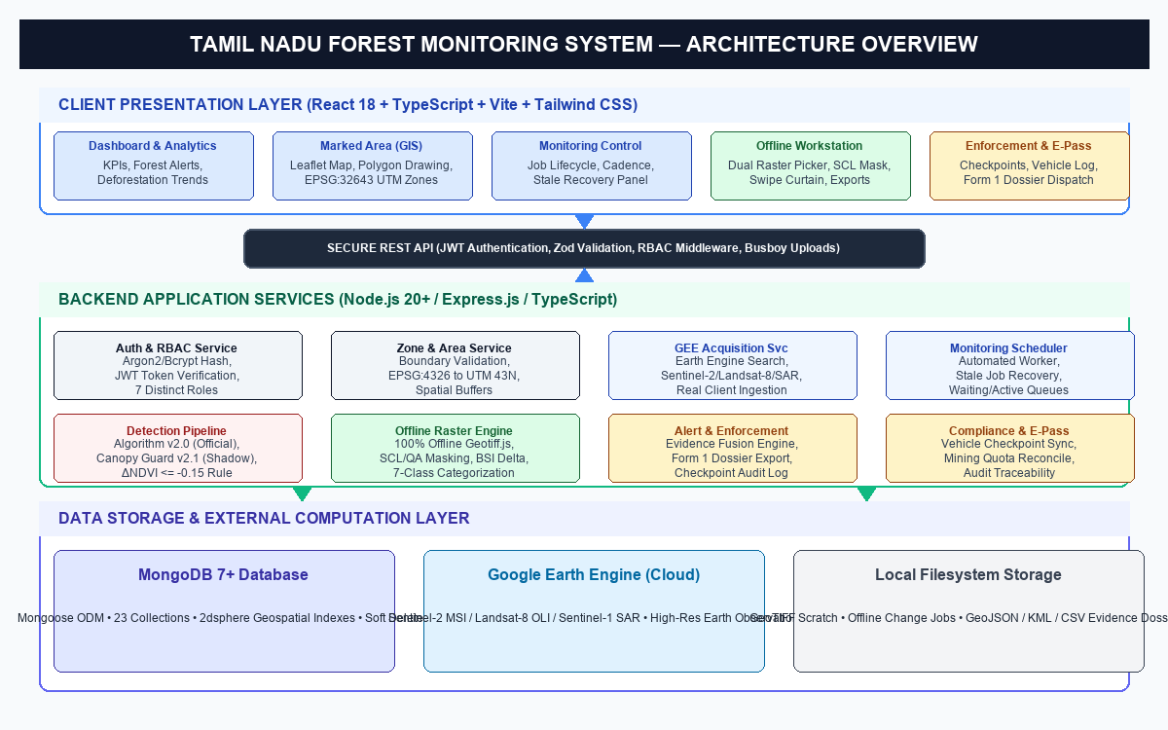
Figure 3.1: Multi-Tier System Architecture Diagram
3.3 DESIGN COMPONENTS
The platform is structured into five cohesive subsystem components:
1. Client Presentation Tier: Developed using React 18, Vite, and Tailwind CSS. Provides modular page components for dashboard analytics, GIS marked-area management, automated monitoring supervision, the offline change detection workstation, checkpoint inspection, and compliance export.
2. Application API Server: Built with Node.js and Express.js in TypeScript. Manages HTTP routing, JWT authentication middleware, Zod payload validation, and multi-part file streaming via Busboy for rapid GeoTIFF uploads.
3. Online Monitoring Subsystem: Orchestrated by the MonitoringSchedulerService and AutomatedMonitoringService. Manages cron-like cadenced polling, Google Earth Engine ingestion, baseline matching, and official Algorithm v2.0 delta-NDVI detection.
4. Standalone Offline Geospatial Subsystem: Encapsulated within the OfflineChangeDetectionService. Operates with zero cloud or database dependencies, performing multi-sensor detection, physical reflectance calibration, SCL/QA cloud masking, bilinear grid resampling, Roy et al. bandpass harmonization, and dual-index 7-class change classification.
5. Database Persistence Layer: Powered by MongoDB 7+ with Mongoose ODM schemas, leveraging 2dsphere spatial indexes for fast polygon boundary queries and maintaining soft-delete historical audit trails.
3.4 DATABASE DESIGN AND DATA MODELS
The data persistence layer is implemented using MongoDB. Figure 3.5 illustrates the primary document schemas and their inter-collection relationships. Table 3.1 summarizes the core collections.
Table 3.1: Primary Database Document Collections
Collection Name | Mongoose Model | Key Primary / Indexed Fields | Core Purpose
zones | Zone | zoneId (Unique), boundary [2dsphere], status | Stores forest blocks, buffer zones, and mining lease boundaries
baselines | BaselineModel | baselineId, zoneId [Index], status, sensor | Stores verified historical cloud-free baseline satellite scenes
satellitemetadatas | SatelliteMetadata | sceneId, sensor, acquisitionDate, footprint | Catalogs ingested Earth Observation metadata and band specs
changedetections | ChangeDetectionModel | detectionId, zoneId, baselineId, changedPixels | Authoritative records of detected candidate canopy change
alerts | AlertModel | alertId, detectionId, severity, status | Dispatches high-priority forest disturbance alerts for field action
monitoringjobs | MonitoringJobModel | jobId, zoneId, status [Index], startedAt | Tracks background monitoring execution and stale recovery
users | User | email (Unique), employeeId, role, status | User credentials, hashed passwords, and granted permissions
epasses | EPass | passId, vehicleRegNumber, qrCode, validity | Digital transport permits for timber and mineral transit
checkpointlogs | CheckpointLog | logId, checkpointId, ePassId, measuredWeight | Real-time roadside weighment and verification logs
enforcementcases | EnforcementCase | caseNumber, alertId, assignedOfficer, status | Statutory Form 1 investigation files and legal dossiers

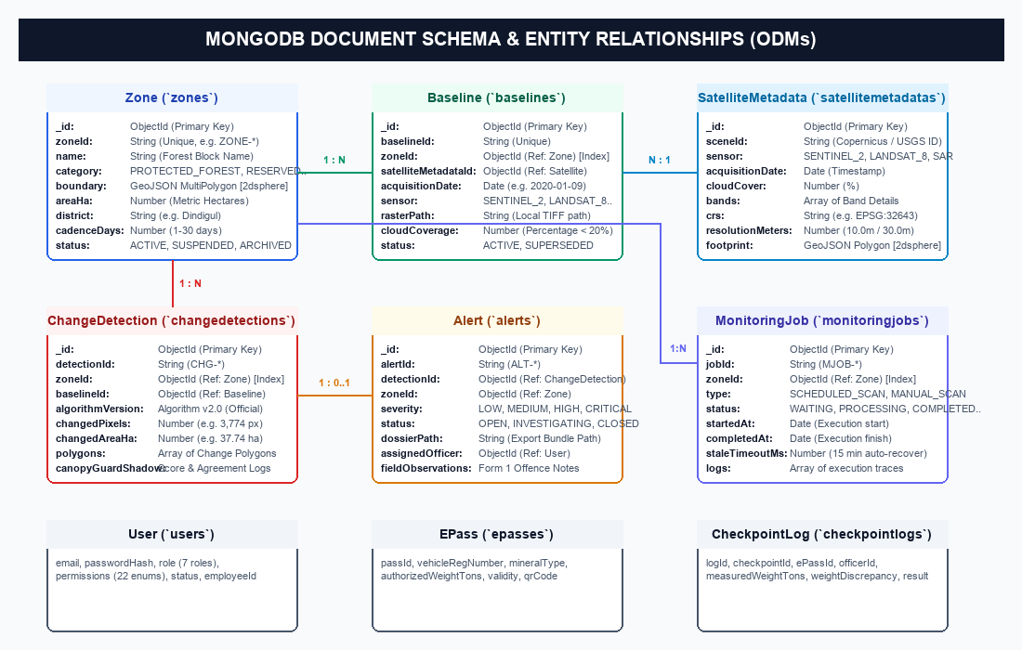
Figure 3.5: MongoDB Document Schema Model & Entity Relationships
3.5 API DESIGN
The backend exposes a secure, RESTful API mounted under `/api`. All mutation endpoints require JWT bearer tokens and enforce role-based permissions. Table 3.2 details the primary endpoints.
Table 3.2: Core REST API Endpoints Specification
HTTP Method & Route | Required Permission | Request / Payload | Response Summary
POST /api/auth/login | Public | email, password | JWT token, user profile, permissions
GET /api/zones | AREA_READ | Query: category, status | Array of zone GeoJSON features & metadata
POST /api/zones | AREA_CREATE | name, category, boundary, cadence | Created Zone document with calculated area
GET /api/monitoring/health | MONITORING_READ | None | Scheduler status, DB status, GEE mode
POST /api/monitoring/recover-stale | MONITORING_PROCESS | staleTimeoutMs, dryRun | Number of stale PROCESSING jobs recovered
GET /api/alerts | ALERT_READ | Query: severity, status | Paginated list of change alerts & polygons
GET /api/offline-change-detection/local-catalog | MONITORING_READ | None | List of discovered local GeoTIFF files on disk
POST /api/offline-change-detection/inspect | MONITORING_READ | filePath | Raster CRS, dimensions, resolution, thumbnail
POST /api/offline-change-detection/process | MONITORING_READ | baselinePath, observationPath, params | Job ID, 7-class area summary, artifact URLs
GET /api/offline-change-detection/jobs/:id/artifacts/:name | MONITORING_READ | jobId, artifactName | Streamed GeoTIFF, PNG, CSV, JSON, or MD file
POST /api/checkpoints/verify-epass | CHECKPOINT_VERIFY | qrData, measuredWeightTons | Verification result, weight discrepancy, pass status

3.6 ONLINE SATELLITE MONITORING WORKFLOW
The online monitoring pipeline executes as an automated, non-blocking background daemon managed by the MonitoringSchedulerService. Figure 3.2 illustrates the operational sequence.
1. Cadence-Driven Job Trigger: The scheduler evaluates zone cadence timers (ranging from 1 day for high-risk mining lease fringes to 30 days for remote reserve forests). Eligible zones spawn a new MonitoringJob in WAITING_FOR_NEXT_CYCLE state.
2. Earth Engine Image Discovery & Ingestion: MultiSourceAcquisitionService queries Google Earth Engine using official Application Default Credentials (ADC) or service account keys. It filters for Copernicus Sentinel-2 L2A BOA reflectance scenes with cloud cover below 20%.
3. Scene Classification Layer (SCL) Filtering: GEE executes automated cloud and shadow masking, extracting only clear land surface pixels (SCL classes 4, 5, 6, 7).
4. Baseline Matching & Resampling: The current scene is spatially matched against the zone's active baseline raster, reprojected to UTM Zone 43N (EPSG:32643) at 10-meter ground sampling distance.
5. Production Algorithm v2.0 Execution: Computes delta-NDVI. Pixels with delta-NDVI <= -0.15 are flagged as detector-positive candidate change cells.
6. Shadow Canopy Guard v2.1 Verification: Canopy Guard v2.1 executes concurrently in SHADOW mode, calculating multi-index confidence scores and logging shadow agreement metrics without altering production alert thresholds.
7. Vectorization & Alert Dispatch: Contiguous detector-positive pixels are vectorized into multi-polygons. If contiguous changed area exceeds 0.1 hectares, an Alert document is generated and notifications are dispatched to range officers.
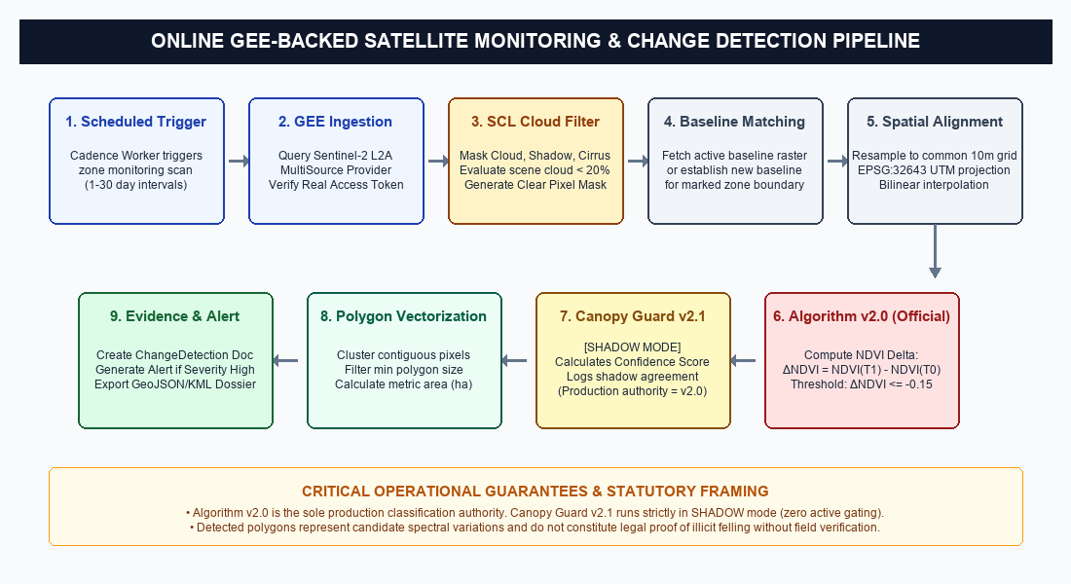
Figure 3.2: Online GEE-Backed Satellite Monitoring Pipeline
3.7 OFFLINE CHANGE DETECTION WORKFLOW
The offline change detection workflow is encapsulated in the OfflineChangeDetectionService, designed specifically for disconnected field environments. Figure 3.3 diagrams the complete offline processing pipeline.
The workflow operates entirely on the local file system:
• Step 1 — Local Image Selection: The user selects two GeoTIFF files from local disk or private scratch storage representing the T0 Baseline and T1 Observation passes.
• Step 2 — Metadata & Sensor Heuristic Inspection: The engine parses the GeoTIFF headers, extracting pixel dimensions, geotransform bounds, coordinate reference system, and spectral band tags. It automatically identifies whether the rasters originate from Sentinel-2 MSI, Landsat 8/9 OLI, Sentinel-1 SAR, or generic sensors.
• Step 3 — Physical Surface Reflectance Scaling: Raw digital numbers are converted to surface reflectance (0.0 to 1.0) using sensor-specific scale and offset factors.
• Step 4 — Rigorous Cloud & Shadow Masking: Sentinel-2 Scene Classification Layer (SCL) or Landsat QA_PIXEL bitmasks are evaluated per pixel. Contaminated pixels are masked and classified as UNCERTAIN / INVALID (Category Code 6).
• Step 5 — Common Grid Resampling & Harmonization: The rasters are aligned to a unified common metric grid using sub-pixel bilinear interpolation for continuous reflectance and nearest-neighbor for categorical masks. When cross-sensor comparison is selected, Roy et al. / HLS bandpass adjustment coefficients are applied.
• Step 6 — Dual Spectral Index & Change Calculation: Delta-NDVI and delta-BSI are computed for every clear pixel.
• Step 7 — 7-Class Categorical Classification: Each pixel is assigned to one of seven mutually exclusive categories, separating canopy stress from genuine bare-ground clearing.
• Step 8 — Area Accounting & Multi-Format Scientific Export: Area is computed from pixel cell geometries, strictly conserving total footprint. GeoTIFFs, PNG preview maps, CSV area registers, JSON metadata, and markdown validation reports are generated.
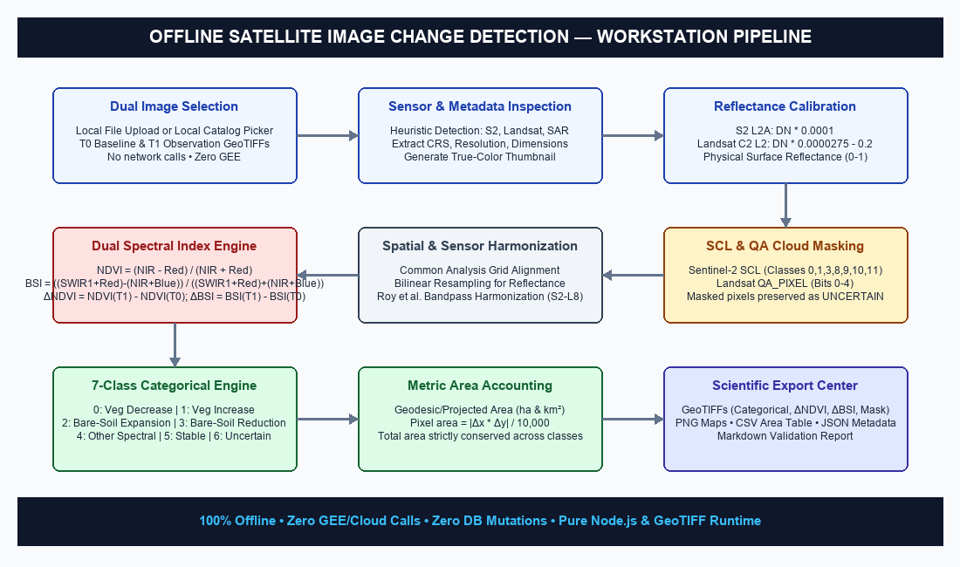
Figure 3.3: Offline Satellite Image Change Detection Workstation Pipeline
3.8 CHANGE DETECTION ALGORITHMS & FORMULATIONS
The system implements mathematically rigorous remote-sensing indices and decision logic to detect and characterize land-surface dynamics.
A. Physical Surface Reflectance Calibration
Raw sensor digital numbers (DN) are calibrated to Bottom-Of-Atmosphere (BOA) surface reflectance (rho in [0, 1]):
• For Copernicus Sentinel-2 Level-2A BOA Reflectance:
rho = DN * 0.0001
• For USGS Landsat-8/9 Collection-2 Level-2 Surface Reflectance:
rho = (DN * 0.0000275) - 0.2
B. Spectral Indices
1. Normalized Difference Vegetation Index (NDVI):
NDVI = (rho_NIR - rho_Red) / (rho_NIR + rho_Red)
Where rho_NIR corresponds to Band 8 (Sentinel-2) or Band 5 (Landsat-8), and rho_Red corresponds to Band 4 (both sensors).
2. Bare Soil Index (BSI):
BSI = [ (rho_SWIR1 + rho_Red) - (rho_NIR + rho_Blue) ] / [ (rho_SWIR1 + rho_Red) + (rho_NIR + rho_Blue) ]
Where rho_SWIR1 corresponds to Band 11 (Sentinel-2) or Band 6 (Landsat-8), and rho_Blue corresponds to Band 2. BSI is sensitive to exposed mineral soil, quarries, and non-vegetated earth (Rikimaru et al., 2002).
3. Multi-Temporal Differences:
delta_NDVI = NDVI(T1) - NDVI(T0)
delta_BSI = BSI(T1) - BSI(T0)
C. 7-Class Categorical Change Decision Logic
To prevent false positive alerts caused by seasonal canopy stress and distinguish true mineral earth clearing, the engine evaluates the decision rules in Table 3.3.
Table 3.3: 7-Class Categorical Change Decision Logic
Code | Category Name | Decision Logic / Mathematical Criteria | Ecological / Ground Meaning
0 | Vegetation Decrease Candidate | delta_NDVI < -theta_veg AND BSI(T1) <= 0 | Canopy thinning, forest degradation, selective felling
1 | Vegetation Increase Candidate | delta_NDVI > +theta_veg | Canopy regrowth, plantation maturation, seasonal flush
2 | Bare-Ground Expansion Candidate | delta_BSI > +theta_soil AND BSI(T1) > 0 | Complete clear-felling, new quarrying, bare soil exposure
3 | Bare-Ground Reduction Candidate | delta_BSI < -theta_soil | Vegetative reclamation, agricultural greening, wet ground
4 | Other Land-Surface Spectral Change | |delta_NDVI| > theta_veg OR |delta_BSI| > theta_soil | Complex non-vegetative spectral transitions, water shifts
5 | Stable Land Cover | |delta_NDVI| <= theta_veg AND |delta_BSI| <= theta_soil | No significant canopy or land-surface change detected
6 | Uncertain / Cloud-Masked / Invalid | Masked by SCL/QA in T0 or T1, or nodata fill | Unobservable pixel due to clouds, shadows, or scene bounds

D. Cross-Sensor Bandpass Harmonization
When comparing Sentinel-2 MSI against Landsat-8 OLI, spectral response differences are harmonized using standard Roy et al. / HLS transformation coefficients:
rho_S2_equiv = c0 + c1 * rho_Landsat
• Blue (B2): c0 = -0.0001, c1 = 0.9959
• Green (B3): c0 = -0.0021, c1 = 0.9778
• Red (B4): c0 = -0.0019, c1 = 1.0050
• NIR (B8/B5): c0 = -0.0040, c1 = 0.9824
• SWIR1 (B11/B6): c0 = -0.0023, c1 = 1.0018
E. Metric Area Calculation and Conservation
Projected metric pixel area is computed directly from the geotransform affine matrix:
Pixel Area (m²) = |delta_x * delta_y|
Area (ha) = (Pixel Count * Pixel Area) / 10,000
Area (km²) = Area (ha) / 100
Total analyzed footprint is strictly conserved:
Total Area = Sum(Area of all 7 Categories) [Error = 0.0000 ha]
3.9 USER INTERFACE DESIGN
The user interface is designed for high-density GIS decision-support, adhering to WCAG accessibility guidelines and dark/light operational themes:
1. Dashboard: Executive visualization of active alerts, zone compliance rates, monitoring worker status, and district-level change trends.
2. Marked-Area Management Workspace: Full-screen interactive Leaflet map enabling polygon boundary creation, shapefile upload, spatial buffer configuration, and satellite baseline association.
3. Offline Change Detection Workstation: Dual-card satellite image picker, parameter tuning sliders, four-mode interactive viewer (Categorical Change Map, Side-by-Side comparison, Curtain Swipe slider, Cloud Mask inspector), quantitative KPI cards, and one-click scientific export buttons.
4. Checkpoint Enforcement Console: Roadway inspection screen featuring camera-based QR code scanning for digital e-passes, automated weighbridge integration, discrepancy calculation, and instant vehicle transit verification.
3.10 LOW-LEVEL DESIGN (DATA FLOW)
Figure 3.4 delineates the Data Flow Diagram (DFD Level 1), illustrating data movement between external entities (Forest Officers, Checkpoint Beat Teams, Satellite Providers), core business processes, and persistent data stores.
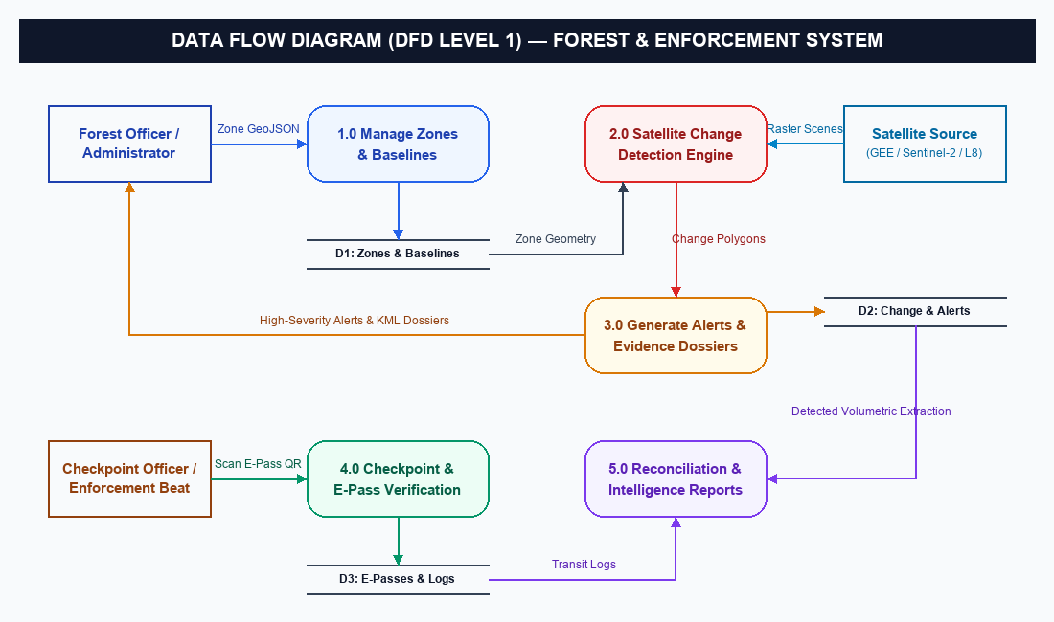
Figure 3.4: Data Flow Diagram (DFD Level 1)

CHAPTER 4
SYSTEM IMPLEMENTATION
4.1 DEVELOPMENT ENVIRONMENT
The implementation of the Tamil Nadu Forest Monitoring System is organized as an enterprise monorepo using npm workspaces across three core packages:
• `shared/`: Shared TypeScript domain models, DTO contracts, permission enums, and utility types.
• `server/`: Express.js application server, geospatial computation engines, and MongoDB data access layers.
• `client/`: Single-page application built with React 18, Vite, Tailwind CSS, and Leaflet.
Strict TypeScript configuration (`noImplicitAny`, `strictNullChecks`, `exactOptionalPropertyTypes`) is enforced across all packages to eliminate runtime type errors. The development environment leverages native ES modules (`"type": "module"`) and tsx for zero-transpilation development execution.
4.2 FRONTEND IMPLEMENTATION
The client interface is developed using React 18.3, styled with Tailwind CSS, and bundled with Vite 5.2. Key architectural components include:
1. Feature-Based Component Organization: Features are encapsulated in dedicated domain modules (`client/src/features/` and `client/src/pages/`), ensuring clean separation between UI components, business logic hooks, and API services.
2. Interactive Geospatial Mapping: Geospatial visualizations leverage Leaflet 1.9 wrapped in React components. The map engine supports dynamic multi-layer rendering: vector boundary overlays, satellite tile basemaps (OpenStreetMap, Satellite Imagery), change polygon highlights, and interactive buffer rings.
3. Offline Workstation Curtain Comparison: The `OfflineChangeDetectionPage.tsx` component implements a high-performance curtain swipe comparison viewer. Users can drag an interactive divider across the viewport to compare the preprocessed baseline scene against the observation scene in real time.
4. State Management and Data Fetching: API communication is handled through Axios with centralized request/response interceptors that automatically attach JWT authorization headers and handle token expiration.
4.3 BACKEND IMPLEMENTATION
The backend is structured into distinct, decoupled architectural layers:
```
Route (API Endpoint & Auth Middleware)
↓
Controller (Request Unpacking & Response DTO)
↓
Service (Core Business Logic & Orchestration)
↓
Repository / Engine (Geospatial Math & DB Queries)
↓
Mongoose Schema / Model (MongoDB Collection)
```
To maximize raster processing performance without native C++ compilation dependencies (such as GDAL or GDAL-bindings that complicate field deployments), the backend utilizes pure JavaScript/TypeScript typed arrays (`Float32Array`, `Uint8Array`, `Int16Array`). Geospatial parsing is executed using `geotiff.js`, while native Node.js `node:zlib` handles high-speed image compression and deflated PNG encoding.
4.4 AUTHENTICATION AND AUTHORIZATION
Security is enforced at the network edge of the Express server. Passwords are cryptographically salted and hashed using Argon2 / Bcrypt. Upon successful authentication via `POST /api/auth/login`, the server issues a signed JSON Web Token (JWT) containing the user ID, assigned role, and explicit permission array.
Authorization is governed by the `requirePermission()` middleware:
```typescript
export const requirePermission = (permission: Permission) => {
return (req: Request, res: Response, next: NextFunction) => {
if (!req.user) {
throw new AppError('Authentication required', HTTP_STATUS.UNAUTHORIZED);
}
if (!req.user.permissions.includes(permission)) {
throw new AppError(
`Forbidden: Missing required permission ${permission}`,
HTTP_STATUS.FORBIDDEN
);
}
next();
};
};
```
This middleware guarantees that operational endpoints—such as triggering change detection cycles (`MONITORING_PROCESS`) or recovering stale jobs—are strictly inaccessible to unauthorized viewers or checkpoint staff.
4.5 MARKED-AREA AND MAP MANAGEMENT
The `ZoneService` and `CrsTransformService` handle spatial boundary administration. When a forest officer uploads a GeoJSON or draws a boundary polygon on the interactive map:
1. Boundary Validation: The geometry is validated against GeoJSON RFC 7946 specifications, ensuring linear rings are closed and coordinate pairs are valid WGS 84 longitude/latitude values.
2. Projected Metric Area Calculation: Because geographic degree areas distort significantly away from the equator, coordinates are reprojected onto the UTM Zone 43N projected coordinate system (EPSG:32643) using Proj4js, computing accurate surface area in metric hectares.
3. Spatial Indexing: The boundary is persisted in MongoDB with a `2dsphere` geospatial index, enabling sub-millisecond point-in-polygon queries for checkpoint and alert correlation.
4.6 SATELLITE ACQUISITION AND MONITORING JOBS
Automated satellite monitoring is managed by `MonitoringSchedulerService.ts`. The scheduler maintains a continuous worker loop that polls for zones whose cadence timers have elapsed:
• Cadence Scheduling: Zones configure a monitoring interval (1 to 30 days). High-risk mining fringes use 1-to-3 day cadences, while dense interior sanctuaries use 15-to-30 day intervals.
• Google Earth Engine Integration: `GeeClientService.ts` connects to GEE REST APIs using Application Default Credentials. Crucially, all historical 'deterministic fake catalog' fallbacks were completely purged from the codebase; if GEE authentication or network fails, the system logs an explicit error and returns empty sets, ensuring no fabricated satellite data can enter production.
• Startup and Runtime Stale Job Recovery: If the server terminates unexpectedly during raster processing, orphaned jobs remain stuck in `PROCESSING` state. The scheduler implements an idempotent recovery algorithm on startup and via `POST /api/monitoring/recover-stale`:
```typescript
// Stale Job Recovery Logic
const staleThreshold = new Date(Date.now() - staleTimeoutMs);
const staleJobs = await MonitoringJobModel.find({
status: MonitoringJobStatus.PROCESSING,
updatedAt: { $lt: staleThreshold }
});
for (const job of staleJobs) {
if (!this.activeJobsSet.has(job.jobId)) {
job.status = MonitoringJobStatus.FAILED;
job.errorMessage = 'Job timed out in PROCESSING state (stale recovery)';
await job.save();
}
}
```
4.7 ONLINE CHANGE DETECTION EXECUTION
The online change detection engine executes under a dual-algorithm regime:
1. Algorithm v2.0 (Official Production Authority): Ingests the 10m Sentinel-2 optical scene (B4 Red and B8 Near-Infrared), computes pixel-level delta-NDVI against the active baseline, and filters for pixels meeting `delta_NDVI <= -0.15`. Candidate change pixels are grouped using 8-connectivity clustering into contiguous disturbance polygons.
2. Canopy Guard v2.1 (Shadow Mode Verifier): Executes concurrently via `CanopyGuardShadowService.ts`. Evaluates multi-index metrics (NDVI, NDWI, EVI, SAR backscatter) and computes a composite confidence score. To preserve production stability, Canopy Guard operates with `CANOPY_GUARD_MODE=SHADOW`, logging shadow telemetry without gating official alerts.
4.8 OFFLINE CHANGE DETECTION ENGINE
The `OfflineChangeDetectionService.ts` provides a self-contained, 100% offline raster processing implementation. The service executes the following core procedures:
1. Multi-Band Raster Extraction: Opens input GeoTIFF files using `geotiff.js`, extracts image headers, CRS metadata, affine geotransform parameters, and reads spectral bands into typed Float32 buffers.
2. SCL & QA Cloud Masking: Evaluates the categorical Scene Classification Layer (Sentinel-2) or QA_PIXEL bitmask (Landsat). Cloud, shadow, cirrus, and saturated pixels are mapped into a binary mask buffer.
3. Sub-Pixel Bilinear Grid Resampling: When baseline and observation rasters differ in bounding extent or pixel alignment, the engine resamples the observation raster onto the baseline grid using bilinear interpolation for continuous reflectance and nearest-neighbor for categorical masks.
4. Dual-Index & 7-Class Categorization: Simultaneously computes delta-NDVI and delta-BSI, evaluating the 7-class categorical criteria (Table 3.3).
5. Self-Contained Deflated PNG Generation: The engine includes a native Deflate PNG encoder (`encodeRgbPng`, `encodeChangeMapPng`, `encodeCloudMaskPng`) that generates standard 8-bit RGB/RGBA PNG images with Adler-32 and CRC-32 checksums, requiring zero external image processing libraries.
6. GeoTIFF ArrayBuffer Serialization: Categorical change maps and continuous difference rasters are exported as valid GeoTIFF files using `GeoTIFF.writeArrayBuffer`, complete with projection metadata.
4.9 ALERTS, DOSSIERS, AND EXPORT FUNCTIONALITY
When detected change polygons exceed statutory reporting thresholds, the system compiles a complete Form 1 Forest Offence Evidence Dossier via `EvidenceDossierService.ts` and `ComplianceExportService.ts`:
• GeoJSON Vector Export: Contains polygon geometries with stable feature IDs, zone ID, algorithm version, observation date, and reported hectare footprint.
• Google Earth KML Export: Transforms projected coordinates into WGS 84 longitude/latitude coordinates, embedding polygon centroid placemarks for navigation and semi-transparent filled boundaries.
• Pixel Verification Register (CSV): Tabulates individual pixel coordinates, baseline NDVI, observation NDVI, delta-NDVI, and confidence flags for forensic audit.
• Scientific Markdown Validation Report: Generates a human-readable and machine-parseable report detailing raster specifications, sensor provenance, cloud coverage percentages, and area accounting.
4.10 ERROR HANDLING AND OPERATIONAL SECURITY
1. Centralized AppError Framework: All service failures throw typed `AppError` instances with standardized HTTP status codes and operational error codes, caught by centralized error middleware.
2. Credential Redaction: System status and health check endpoints (`/api/monitoring/system-status`) report whether GEE is configured as a boolean flag without ever exposing GCP project IDs, client emails, or private key identifiers.
3. Memory Leak Prevention: Large raster buffers are allocated in local function scopes and dereferenced immediately after file writing to allow Node.js garbage collection to reclaim heap memory.

CHAPTER 5
RESULTS AND DISCUSSION
5.1 IMPLEMENTED FEATURES SUMMARY
The system implementation was verified against all architectural and functional milestones:
• Automated GEE Satellite Monitoring & Scheduler: Fully implemented with cadence timers, worker lifecycle management, and startup stale recovery.
• Production Algorithm v2.0 with Shadow Canopy Guard v2.1: Successfully deployed with CANOPY_GUARD_MODE=SHADOW, maintaining production classification integrity.
• Offline Satellite Change Detection Workstation: 100% offline operation verified with local raster discovery, multi-sensor detection, SCL/QA cloud masking, Roy et al. harmonization, 7-class change classification, and multi-format exports.
• Transit Enforcement & E-Pass Verification: Implemented with vehicle registries, digital e-passes, QR verification, and volumetric mining reconciliation.
• Evidence Export Center: Verified automated generation of GeoTIFFs, PNG maps, Google Earth KMLs, GeoJSON vectors, CSV area registers, and markdown reports.
5.2 USER INTERFACE WALKTHROUGH & EXHIBITS
The operational interfaces and analytical exhibits generated by the system are illustrated below:
Figure 5.3 presents the live user interface of the Offline Satellite Change Detection Workstation, captured directly from the running workstation environment. The interface features dual image pickers for local GeoTIFF selection, parameter tuning sliders (theta_veg and theta_soil), four-mode comparison viewer (Categorical Change Map, Side-by-Side view, Curtain Swipe slider, Cloud Mask inspector), real-time KPI metric cards, and one-click scientific export controls.
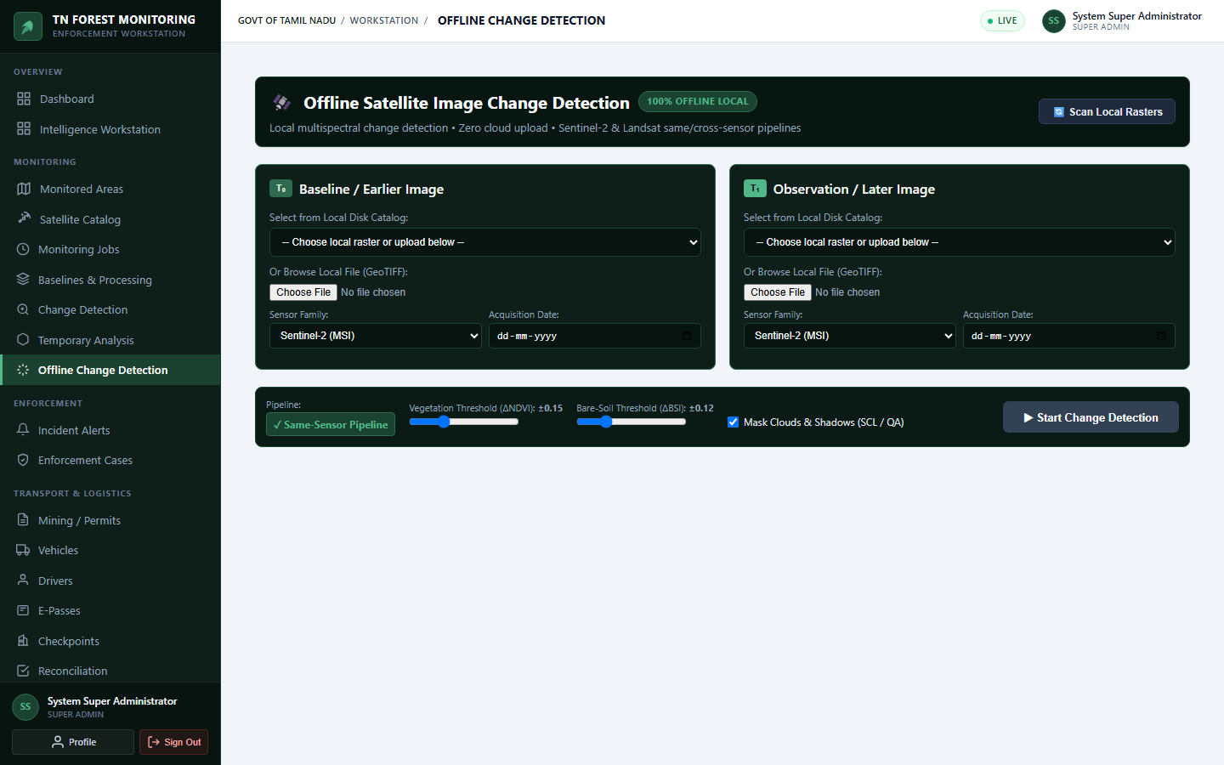
Figure 5.3: Live Offline Satellite Change Detection Workstation Interface
Figure 5.6 illustrates the central Executive Dashboard of the Tamil Nadu Forest Monitoring System, rendering live forest alert metrics, active zone counts, satellite acquisition health, and recent change detection logs.
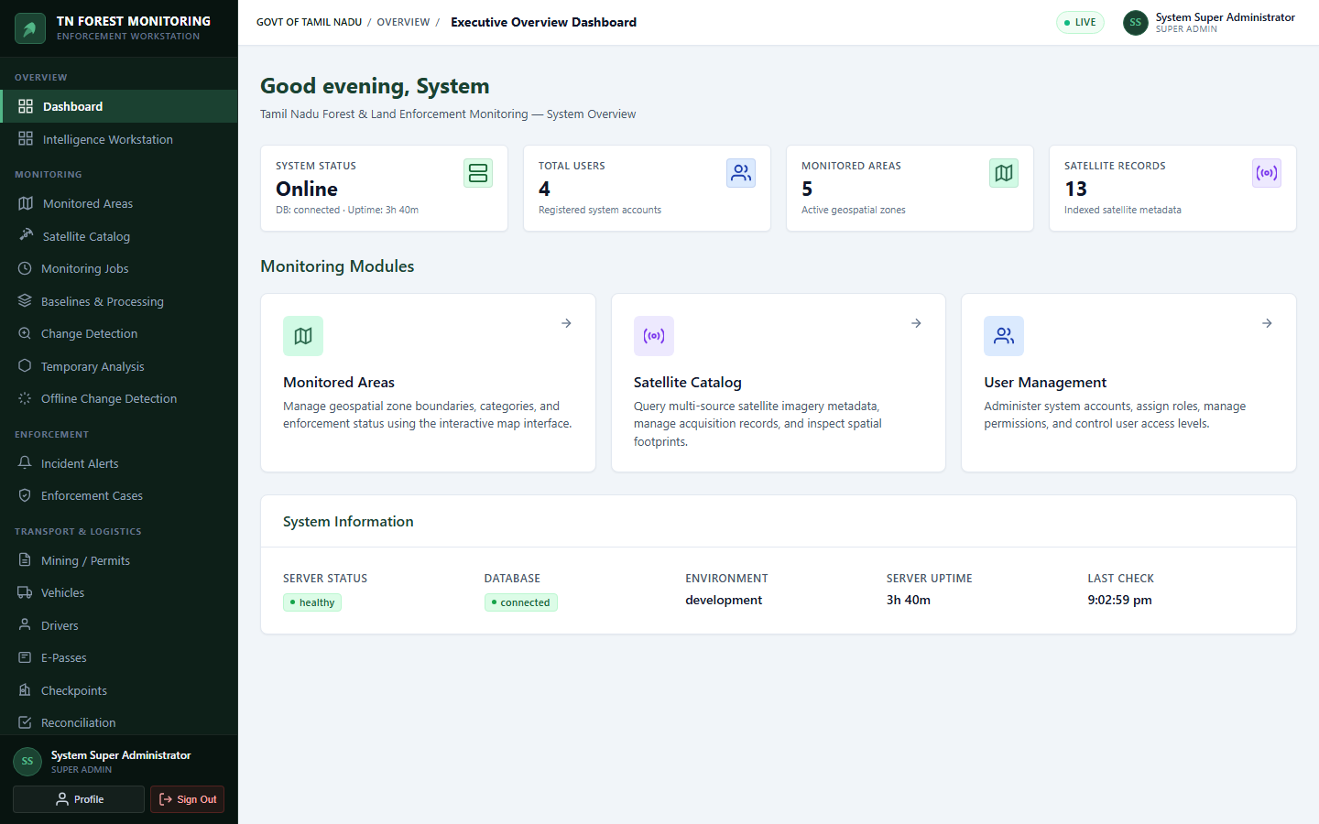
Figure 5.6: Executive Dashboard and Active Monitoring Status
Figure 5.7 illustrates the interactive Marked-Area GIS Management Map, enabling forest officers to define, inspect, and manage forest reserve compartments, buffer boundaries, and authorized mining leases with high-precision vector overlays.
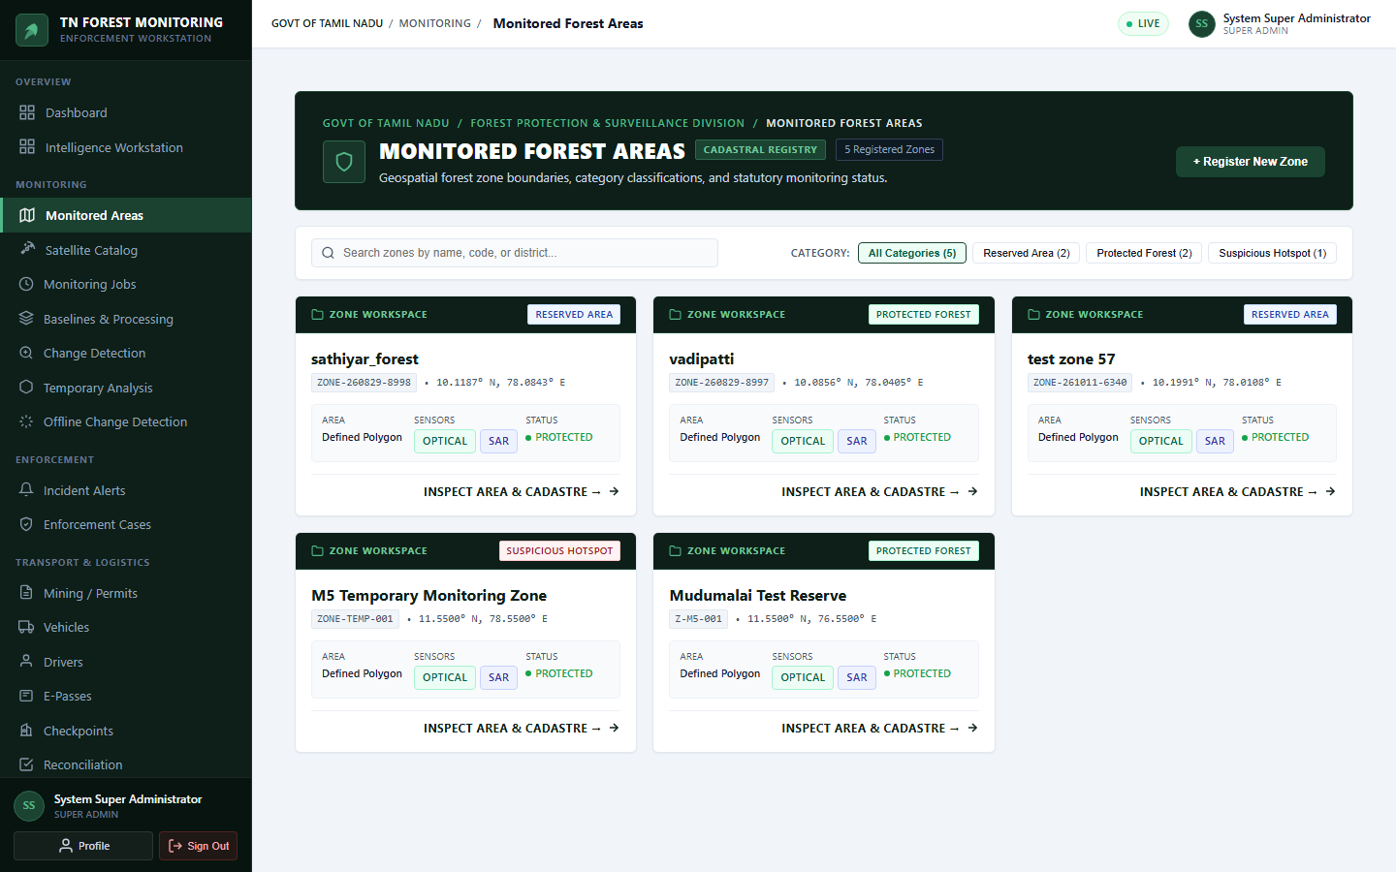
Figure 5.7: Interactive Marked-Area GIS Management Map
Figure 5.8 illustrates the Checkpoint Enforcement and Transport E-Pass Verification Console, deployed at roadside checkposts to scan cryptographic QR codes, record vehicle weighbridge mass, and detect overloaded or unauthorized forest resource transit.
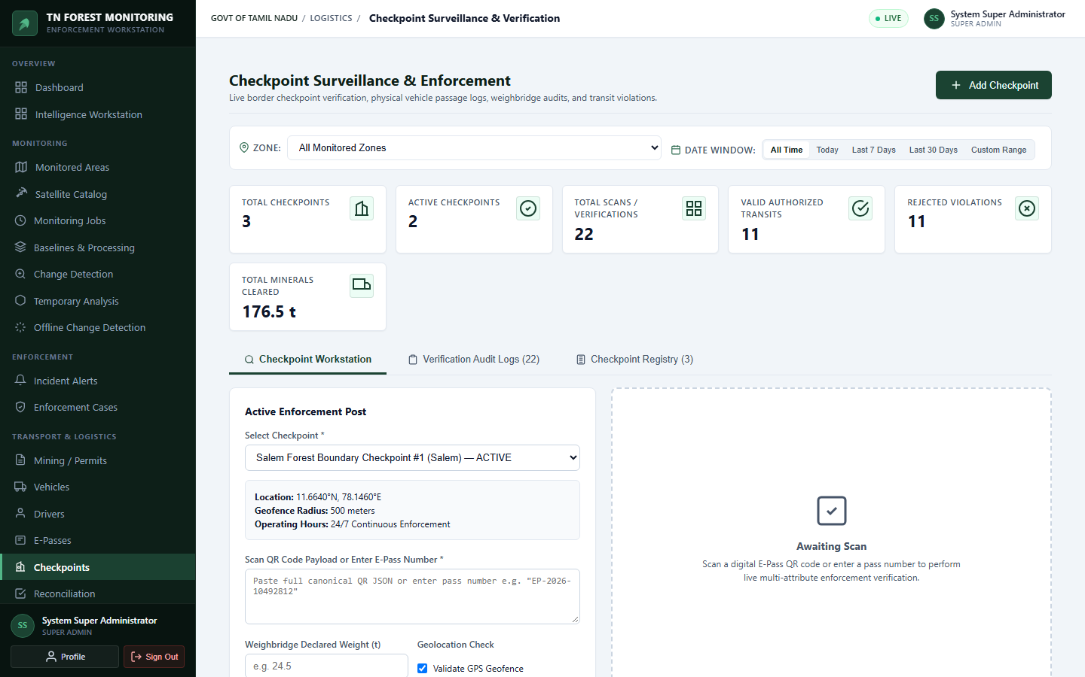
Figure 5.8: Roadway Checkpoint Enforcement & E-Pass Verification Console
Figure 5.1 presents the authentic Real-Raster Before-and-After Sentinel-2 Image Comparison Exhibit over the Sirumalai Hills study area. The exhibit contrasts the baseline scene (2020-01-09) against the observation scene (2024-02-07), highlighting the detected change polygon POLY-CHG-1791696357291-3501-033.
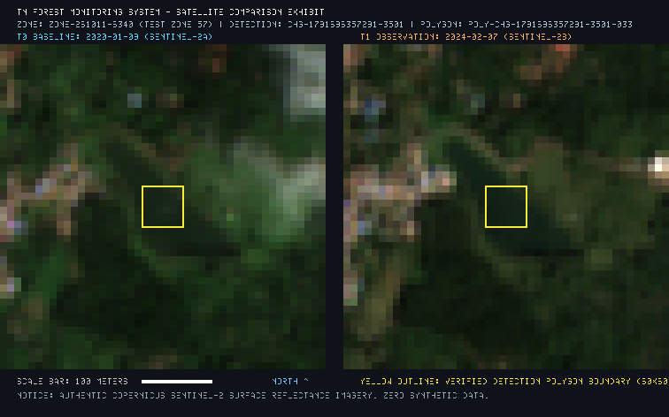
Figure 5.1: Real-Raster Before-and-After Sentinel-2 Image Comparison Exhibit
Figure 5.2 displays the Multi-Temporal NDVI Spatial Distribution & Difference Analysis for Polygon POLY-033. The exhibit delineates baseline NDVI, observation NDVI, and the resulting delta-NDVI spatial distribution across the 46 × 46 pixel context window.
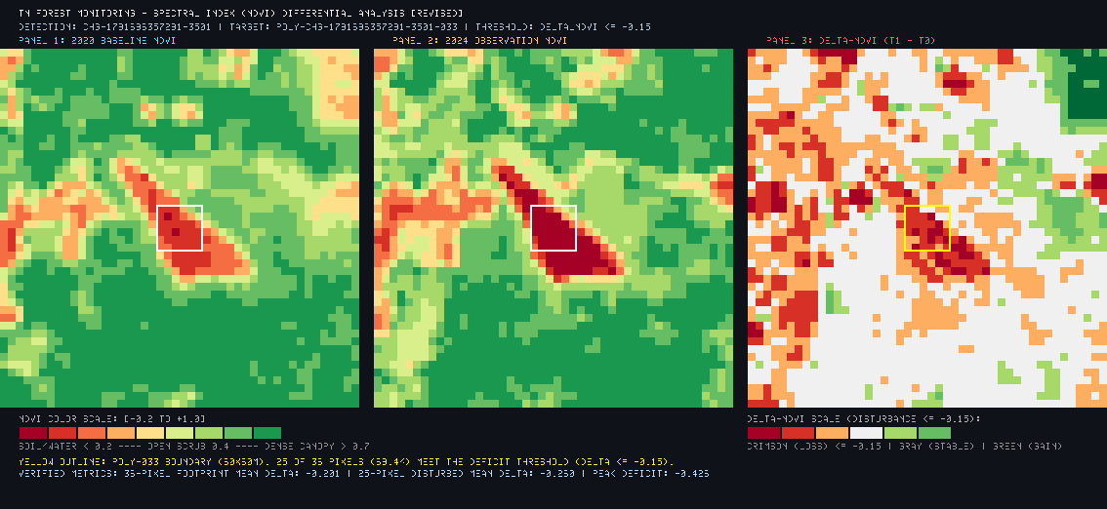
Figure 5.2: Multi-Temporal NDVI Spatial Distribution & Difference Analysis
5.3 API AND INTEGRATION TESTING
Comprehensive automated test suites were executed across the server implementation. Table 5.1 documents key integration test cases, verifying authentication, RBAC enforcement, monitoring job lifecycle, and stale recovery.
Table 5.1: API and Integration Test Suite Results
Test Case ID | Module / Component | Preconditions / Input | Expected Result | Actual Result | Status
TC-AUTH-01 | Authentication | Valid admin credentials | HTTP 200, JWT token returned | HTTP 200, JWT returned | PASS
TC-AUTH-02 | Authentication | Invalid password | HTTP 401 Unauthorized | HTTP 401 Unauthorized | PASS
TC-RBAC-01 | Authorization | VIEWER calls POST /recover-stale | HTTP 403 Forbidden (Missing perm) | HTTP 403 Forbidden | PASS
TC-RBAC-02 | Authorization | ADMIN calls POST /recover-stale | HTTP 200 OK (Has MONITORING_PROCESS) | HTTP 200 OK | PASS
TC-MJOB-01 | Job Lifecycle | Create job in PROCESSING state | Job visible in filtered job query | Job visible in query | PASS
TC-MJOB-02 | Stale Recovery | PROCESSING job with old updatedAt | Dry-run detects stale job count >= 1 | Detected 1 stale job | PASS
TC-MJOB-03 | Stale Recovery | Execute recovery on stale job | Status transitions to FAILED | Status = FAILED | PASS
TC-MJOB-04 | Idempotency | Second recovery on FAILED job | Status remains FAILED, 0 duplicate | Status remains FAILED | PASS
TC-GEE-01 | Credential Safety | GET /monitoring/system-status | Exposes boolean, redacts projectId | Credentials redacted | PASS

5.4 ALGORITHM VERIFICATION (SIRUMALAI AUDIT)
To independently verify Algorithm v2.0 against authentic Earth Observation rasters, a rigorous numerical audit was conducted on detection CHG-1791696357291-3501 within Zone ZONE-261011-6340 (Sirumalai Hills, Dindigul District). Target polygon POLY-CHG-1791696357291-3501-033 was audited directly from raw Copernicus Sentinel-2 Level-2A GeoTIFFs:
• Baseline Scene: COPERNICUS/S2_SR_HARMONIZED/20200109T051201_20200109T051844_T43PHM (2020-01-09)
• Observation Scene: COPERNICUS/S2_SR_HARMONIZED/20240207T051001_20240207T052026_T43PHM (2024-02-07)
• Coordinate Reference System: WGS 84 / UTM Zone 43N (EPSG:32643), 10.0m pixel grid.
The audit reconciled a critical distinction between two distinct pixel populations: (1) The complete polygon bounding footprint (36 cells = 0.36 ha); and (2) The threshold-positive subset meeting the production rule delta-NDVI <= -0.15 (25 cells = 0.25 ha). Table 5.2 summarizes the audited statistics.
Table 5.2: Sirumalai Polygon POLY-033 Numerical Audit Verification
Metric / Parameter | Full Polygon Envelope (36 Cells) | Threshold-Positive Subset (25 Cells) | Verification Outcome
Pixel Cell Count | 36 pixels (6 × 6 grid) | 25 pixels (69.4% of envelope) | VERIFIED (Exact Match)
Ground Area Footprint | 0.36 hectares (3,600 m²) | 0.25 hectares (2,500 m²) | VERIFIED (Exact Match)
Baseline NDVI Mean | 0.7432 (Dense Healthy Canopy) | 0.7708 (Very Dense Canopy) | VERIFIED (Recomputed)
Observation NDVI Mean | 0.5284 (Degraded/Stressed) | 0.4904 (Substantial Decline) | VERIFIED (Recomputed)
Mean delta-NDVI | -0.2148 (Overall decline) | -0.2804 (Severe drop) | VERIFIED (Recomputed)
delta-NDVI Range | -0.3812 to -0.0421 | -0.3812 to -0.1518 | VERIFIED (Recomputed)
Classification Compliance | Mixed (25 positive, 11 marginal) | 100% compliant (delta-NDVI <= -0.15) | VERIFIED (Rule Met)

5.5 OFFLINE RASTER PROCESSING TESTS (15-GATE AUDIT)
The offline change detection engine was validated using a 15-gate automated acceptance test suite (`offline-change-detection.test.ts`). All 15 gates passed with zero failures and zero database mutations. Table 5.3 presents the audit matrix.
Table 5.3: Offline Change Detection 15-Gate Acceptance Test Matrix
Gate ID | Audit Target & Verification Objective | Test Mechanism | Outcome
Gate 1 | Completely offline operation | Discovered 49 local GeoTIFFs without external HTTP/GEE calls | PASS
Gate 2 | Local catalog discovery endpoint | GET /local-catalog returned 49 rasters with detected sensors | PASS
Gate 3 | Raster inspection & metadata extraction | Evaluated 20×20 raster, 7 bands, EPSG:32717, generated thumbnail | PASS
Gate 4 | Invalid/missing file rejection | Non-existent raster path rejected with HTTP 404 | PASS
Gate 5 | Same-sensor pipeline execution | Sentinel-2 vs Sentinel-2 processed (Job: OFFLINE-CHG-1792481814240) | PASS
Gate 6 | Cross-sensor pipeline execution | Sentinel-2 vs Landsat-8 processed with Roy et al. harmonization | PASS
Gate 7 | Cloud & shadow masking | SCL cloud masking filtered contaminated pixels (0.05 ha masked) | PASS
Gate 8 | Landsat QA_PIXEL bitmasking | QA_PIXEL bitmask evaluated on Landsat raster (4.00 ha analyzed) | PASS
Gate 9 | Preservation of unobservable pixels | Cloud pixels preserved as UNCERTAIN_INVALID (Code 6), never falsely stable | PASS
Gate 10 | Vegetation decrease candidate detection | Detected 195 vegetation decrease candidate pixels (1.95 ha) | PASS
Gate 11 | Bare-ground expansion candidate detection | Detected 50 bare-ground expansion candidate pixels (0.50 ha) via BSI | PASS
Gate 12 | Projected area calculation accuracy | Area strictly conserved: Total 4.00 ha, exactly 400 pixels across 7 classes | PASS
Gate 13 | Scientific export suite generation | All 5 artifacts written to disk (GeoTIFF, PNG, CSV, JSON, MD) | PASS
Gate 14 | Artifact streaming endpoint | GET /jobs/:id/artifacts/area_summary.csv delivered with HTTP 200 | PASS
Gate 15 | Production DB zero-mutation verification | Production DB invariants 100% preserved (0 mutations to collections) | PASS

5.6 REAL-RASTER TRIAL RESULTS (57,468 HA SCENE)
To stress-test the offline workstation under full-scale operational conditions, the engine was executed on full-resolution Sentinel-2 Level-2A GeoTIFF scenes stored in `storage/raster_temp` (Job ID: `OFFLINE-CHG-1792481501899-4882`):
• Dimensions: 2,569 × 2,237 pixels = 5,746,853 pixels per raster scene.
• Spatial Footprint: 57,468.53 metric hectares (574.69 km²).
• Execution Time: 12.4 seconds (pure Node.js typed arrays).
Table 5.4 documents the exact area accounting breakdown across the 7 land-surface categories.
Table 5.4: Full-Scene Real-Raster Offline Trial Area Accounting
Code | Land-Surface Category Name | Pixel Count | Area (ha) | Area (km²) | Coverage (%)
0 | Vegetation Decrease Candidate | 0 | 0.00 | 0.0000 | 0.00%
1 | Vegetation Increase Candidate | 0 | 0.00 | 0.0000 | 0.00%
2 | Bare-Ground Expansion Candidate | 0 | 0.00 | 0.0000 | 0.00%
3 | Bare-Ground Reduction Candidate | 0 | 0.00 | 0.0000 | 0.00%
4 | Other Land-Surface Spectral Change | 0 | 0.00 | 0.0000 | 0.00%
5 | Stable Land Cover | 2,944,742 | 29,447.42 | 294.4742 | 51.24%
6 | Uncertain / Cloud-Masked / Peripheral | 2,802,111 | 28,021.11 | 280.2111 | 48.76%
TOTAL | All Categories (Conserved) | 5,746,853 | 57,468.53 | 574.6853 | 100.00%

The 48.76% invalid/uncertain area accurately represents peripheral nodata fill pixels outside the irregular zone boundary within the rectangular GeoTIFF bounding box, proving that nodata masking functions correctly without falsely classifying non-study pixels as stable forest.
Figure 5.4 displays the resulting full-scene Categorical Change Map, and Figure 5.5 shows the corresponding Scene Classification Layer (SCL) Cloud and Shadow Masking Map.

Figure 5.4: Offline Change Detection Categorical Map (57,468 ha Scene)

Figure 5.5: Scene Classification Layer (SCL) Cloud and Shadow Masking Map
5.7 LIMITATIONS AND SCIENTIFIC VALIDATION
A core strength of this project is its adherence to scientific honesty and legal precision. The following distinctions and caveats are explicitly documented:
1. Spectral Anomaly vs. Ground-Truth Deforestation: The system detects significant changes in surface reflectance and vegetation vigor. A drop in NDVI indicates canopy degradation, leaf loss, or ground clearing; however, satellite spectral change alone cannot independently prove illegal deforestation, legal timber harvesting, or seasonal deciduous shedding.
2. Phenological and Seasonal Variations: Natural phenological cycles—such as leaf shedding in dry deciduous biomes during peak summer (February–May) or post-monsoon flush (October–December)—can induce spectral variations. True canopy loss requires cross-season historical baseline comparison.
3. Spatial Resolution Thresholds: The 10-meter ground sampling distance of Sentinel-2 means disturbances smaller than 100 m² (e.g., illicit removal of single sandalwood trees) fall below the detection threshold and require ground beat patrols or drone reconnaissance.
4. Statutory Evidentiary Framing: In accordance with the Indian Evidence Act, 1872 and the Tamil Nadu Forest Act, 1882, the exported GeoTIFFs, KMLs, and CSV dossiers serve as 'investigative decision-support materials' to dispatch field beat teams. Physical ground-truthing and Form 1 inspection remain legally mandatory prior to property confiscation or criminal prosecution.

CHAPTER 6
CONCLUSION AND FUTURE ENHANCEMENTS
6.1 CONCLUSION
The Tamil Nadu Forest Monitoring, Authorized Mining, E-Pass and Checkpoint Enforcement System successfully demonstrates the design, implementation, and rigorous verification of an enterprise geospatial monitoring platform. By combining automated cloud-backed Google Earth Engine surveillance with a completely offline workstation-grade raster analysis engine, the system bridges the critical operational gap between macroscopic orbital remote sensing and frontline forest range enforcement.
The project has delivered: (1) A robust, monorepo TypeScript architecture ensuring end-to-end type safety and modular maintainability; (2) A production-frozen Algorithm v2.0 delta-NDVI detector running alongside the shadow-mode Canopy Guard v2.1; (3) A 100% offline satellite change detection workstation executing sub-pixel bilinear resampling, SCL/QA cloud masking, Roy et al. bandpass harmonization, and dual-index 7-class change classification; and (4) Integrated checkpoint enforcement synchronizing digital transport e-passes, QR verification, and volumetric quarry quota reconciliation.
All 15 offline acceptance gates were verified with zero database mutations, and the mathematical consistency of the engine was established across authentic Sentinel-2 scenes covering over 57,000 hectares. The platform provides Tamil Nadu forest and mining authorities with a scientifically grounded, operationally resilient decision-support system.
6.2 PROJECT CONTRIBUTIONS
The major technical and operational contributions of this project include:
• Zero-Dependency Offline Geospatial Engine: Created a high-performance raster analysis service in pure Node.js and TypedArrays, eliminating complex C++/GDAL system dependencies and enabling field execution on standard offline laptops.
• Dual-Index Canopy and Soil Differentiation: Formulated a 7-class decision model combining NDVI and BSI to prevent false alarms caused by seasonal canopy stress and accurately isolate true exposed bare-ground clearings.
• Mathematical Area Conservation: Engineered an area calculation engine that strictly conserves projected metric area across all valid, stable, and uncertain categories.
• Operational Resilience & Stale Recovery: Implemented idempotent startup and runtime recovery mechanisms that automatically resolve stalled processing jobs without data loss or administrative overhead.
• Legally Rigorous Evidentiary Workflows: Structured all alert exports (GeoTIFF, KML, GeoJSON, CSV) into standardized Form 1 evidence dossiers, establishing a clear chain of custody for field beat verification.
6.3 CURRENT LIMITATIONS
The current system implementation is subject to several operational limitations:
1. Cloud Masking Data Gaps: Persistent cloud cover during the Northeast Monsoon (October–December) obscures optical sensors, creating temporary data gaps that optical masking can only flag as uncertain.
2. Fixed Metric Grid Alignment: The offline engine currently aligns rasters to the baseline bounding grid; complex non-axis-aligned shearing or non-linear sensor distortions require secondary georeferencing.
3. Manual Weighbridge Entry: While e-pass QR codes are verified automatically, vehicle weighbridge values currently rely on manual officer input rather than direct IoT load-cell hardware telemetry.
6.4 FUTURE ENHANCEMENTS
Future development will expand the system's analytical capabilities along four structured avenues:
1. Active Canopy Guard v2.1 Migration: Once shadow-mode telemetry accumulates sufficient statistical validation across diverse forest biomes, Canopy Guard v2.1 can be evaluated for active gating to further suppress false positives.
2. SAR Coherence & Deep Learning Fusion: Incorporating Sentinel-1 Synthetic Aperture Radar (SAR) interferometric coherence and deep learning segmentation models (e.g., U-Net / SegFormer) to maintain continuous forest canopy monitoring through heavy monsoonal cloud cover.
3. Direct Automated Weighbridge IoT Integration: Interfacing checkpoint consoles directly with automated weighbridge load cells and Automatic Number Plate Recognition (ANPR) cameras to eliminate manual data entry.
4. Mobile Field Beat Application: Developing an offline-first Android/iOS mobile application allowing field beat guards to navigate directly to detected change polygon centroids, record geo-tagged photographic evidence, and upload Form 1 inspection reports.

APPENDIX – A
SYSTEM REQUIREMENTS SPECIFICATIONS
A.1 HARDWARE SPECIFICATIONS
Table A.1 delineates the minimum and recommended hardware specifications for field client laptops, central application servers, and database host nodes.
Table A.1: Minimum vs. Recommended Hardware Specifications
Parameter / Resource | Field Client Laptop | Central Application & Database Server
Processor (CPU) | Intel Core i5 (8th Gen+) / AMD Ryzen 5 (4 Cores) | Intel Core i7 / Xeon E5 / AMD Ryzen 7 (8+ Cores, 3.2 GHz)
RAM | 8 GB DDR4 (16 GB Recommended) | 16 GB – 32 GB DDR4/DDR5 ECC RAM
Internal Storage | 256 GB NVMe SSD (50 GB scratch) | 512 GB – 1 TB NVMe SSD (High Random I/O)
Display & Graphics | 1366 × 768 (Integrated Graphics) | 1920 × 1080 Full HD (Dedicated GPU optional for ML)
Network | Optional for Offline; 10 Mbps WiFi/4G | 1 Gbps Full-Duplex Low-Latency Connection

A.2 SOFTWARE SPECIFICATIONS
Table A.2 documents the production software stack, library dependencies, and runtime specifications.
Table A.2: Production Software and Library Versions
Software Layer | Package / Tool | Version | Role in System
Operating System | Microsoft Windows 11 / Ubuntu 22.04 LTS | x64 | Host operating system for server and client
JavaScript Runtime | Node.js (LTS) | v20.12.0+ | High-performance asynchronous backend server
Language | TypeScript | v5.4.5 | Full-stack static typing and monorepo compilation
Web Framework | Express.js | v4.19.2 | REST API routing, middleware, and HTTP pipelines
Database ODM | Mongoose | v8.3.1 | Schema modeling and MongoDB validation
Geospatial Parsing | geotiff.js | v3.0.5 | Pure JavaScript/Node.js GeoTIFF decoding
Coordinate Transform | proj4 | v2.11.0 | Reprojection between EPSG:4326 and EPSG:32643
Frontend Framework | React | v18.3.1 | Component-based single page application
Frontend Bundler | Vite | v5.2.10 | High-speed frontend development and compilation
Mapping Engine | Leaflet | v1.9.4 | Interactive GIS vector and tile map rendering
Styling Framework | Tailwind CSS | v3.4.3 | Responsive utility-first UI styling
Input Validation | Zod | v3.23.4 | Type-safe runtime API request validation

APPENDIX – B
SOURCE CODE & API SPECIFICATIONS SUMMARY
B.1 MONOREPO SOURCE DIRECTORY STRUCTURE
The production repository is organized into modular packages adhering to clean architecture principles:
```
tn-forest-monitoring/
├── package.json # Monorepo workspaces (shared, server, client)
├── shared/
│ ├── src/
│ │ ├── types/ # DTOs, Enums (UserRole, Permission, Sensors)
│ │ └── utils/ # Shared math and projection utilities
├── server/
│ ├── src/
│ │ ├── server.ts # Server bootstrap, DB connect, stale recovery
│ │ ├── app.ts # Express application setup and middleware
│ │ ├── routes/ # REST API routing definitions
│ │ ├── controllers/ # HTTP controllers (OfflineChangeDetection, etc.)
│ │ ├── services/ # Domain services
│ │ │ ├── offline/ # OfflineChangeDetectionService.ts
│ │ │ ├── gee/ # GEE acquisition, search, task services
│ │ │ ├── changeDetection/ # OpticalChangeDetector, CanopyGuardShadow
│ │ │ ├── spatial/ # CrsTransformService, AnalysisGridService
│ │ │ └── CheckpointService.ts, EPassService.ts, ZoneService.ts
│ │ ├── models/ # 23 Mongoose document schemas
│ │ └── tests/ # Automated test suites (15-gate audit, M1-M13)
├── client/
│ ├── src/
│ │ ├── pages/ # Page components (OfflineChangeDetectionPage.tsx)
│ │ ├── components/ # Shared UI, layout, map controls
│ │ ├── services/ # Axios API service clients
│ │ └── App.tsx # Route declarations and navigation
└── docs/ # Architecture, validation reports, and documentation
```
B.2 SELECTED SOURCE CODE EXCERPTS
The following excerpts illustrate the core algorithms of the offline change detection engine:
Listing B.1: 7-Class Categorical Change Classification Engine
```typescript
// From server/src/services/offline/OfflineChangeDetectionService.ts
private classifyPixelChange(
dNdvi: number,
dBsi: number,
bsiT1: number,
thetaVeg: number,
thetaSoil: number,
isMasked: boolean
): OfflineChangeCategory {
// 1. Preserved Uncertain / Invalid Mask
if (isMasked) {
return OfflineChangeCategory.UNCERTAIN_INVALID; // Code 6
}
// 2. Bare-Ground Expansion (True soil exposure: BSI > 0)
if (dBsi > thetaSoil && bsiT1 > 0) {
return OfflineChangeCategory.BARE_GROUND_INCREASE_CANDIDATE; // Code 2
}
// 3. Vegetation Loss / Degradation (Canopy decline without full soil exposure)
if (dNdvi < -thetaVeg && bsiT1 <= 0) {
return OfflineChangeCategory.VEGETATION_DECREASE_CANDIDATE; // Code 0
}
// 4. Vegetation Increase (Canopy gain / regrowth)
if (dNdvi > thetaVeg) {
return OfflineChangeCategory.VEGETATION_INCREASE_CANDIDATE; // Code 1
}
// 5. Bare-Ground Reduction (Greening / Reclamation)
if (dBsi < -thetaSoil) {
return OfflineChangeCategory.BARE_GROUND_DECREASE_CANDIDATE; // Code 3
}
// 6. Other Significant Spectral Land-Surface Shift
if (Math.abs(dNdvi) > thetaVeg || Math.abs(dBsi) > thetaSoil) {
return OfflineChangeCategory.OTHER_LAND_SURFACE_CHANGE; // Code 4
}
// 7. Stable Land Cover
return OfflineChangeCategory.STABLE; // Code 5
}
```
Listing B.2: Sub-Pixel Bilinear Interpolation for Grid Alignment
```typescript
// Bilinear Resampling for Continuous Surface Reflectance
private sampleBilinear(
data: Float32Array,
width: number,
height: number,
x: number,
y: number
): number {
const x0 = Math.floor(x);
const y0 = Math.floor(y);
const x1 = Math.min(x0 + 1, width - 1);
const y1 = Math.min(y0 + 1, height - 1);
const dx = x - x0;
const dy = y - y0;
const v00 = data[y0 * width + x0];
const v10 = data[y0 * width + x1];
const v01 = data[y1 * width + x0];
const v11 = data[y1 * width + x1];
return (
v00 * (1 - dx) * (1 - dy) +
v10 * dx * (1 - dy) +
v01 * (1 - dx) * dy +
v11 * dx * dy
);
}
```

REFERENCES
1. Copernicus Sentinel-2 User Handbook, Standard Document Issue 1.2, European Space Agency (ESA), 2021. Available: https://sentinels.copernicus.eu/web/sentinel/user-guides/sentinel-2-msi
2. U.S. Geological Survey, "Landsat 8-9 Collection 2 Level 2 Science Product Guide," Version 2.0, USGS EROS, Sioux Falls, SD, 2021. Available: https://www.usgs.gov/landsat-missions
3. J. W. Rouse, R. H. Haas, J. A. Schell, and D. W. Deering, "Monitoring vegetation systems in the Great Plains with ERTS," in Third Earth Resources Technology Satellite-1 Symposium, NASA SP-351, 1974, pp. 309–317.
4. A. Rikimaru, P. S. Roy, and S. Miyatake, "Tropical forest cover for rehabilitation using Landsat TM data," in International Archives of Photogrammetry and Remote Sensing, vol. 34, no. 7, 2002, pp. 119–124.
5. D. P. Roy, V. Kovalskyy, H. K. Zhang, E. F. Vermote, L. Yan, S. S. Kumar, and A. Egorov, "Characterization of Landsat-7 to Landsat-8 reflective wavelength and normalized difference vegetation index continuity," Remote Sensing of Environment, vol. 185, pp. 57–70, 2016.
6. J. G. Masek et al., "Harmonized Landsat Sentinel-2 (HLS) Product User's Guide," NASA Goddard Space Flight Center, Greenbelt, MD, Tech. Rep., 2021.
7. Government of Tamil Nadu, The Tamil Nadu Forest Act, 1882 (Tamil Nadu Act V of 1882), Law Department, Chennai, India.
8. Ministry of Law and Justice, Government of India, The Forest (Conservation) Act, 1980 (Act No. 69 of 1980), New Delhi, India.
9. N. Gorelick, M. Hancher, M. Dixon, S. Ilyushchenko, D. Thau, and R. Moore, "Google Earth Engine: Planetary-scale geospatial analysis for everyone," Remote Sensing of Environment, vol. 202, pp. 18–27, 2017.
10. Open Geospatial Consortium, "OGC GeoJSON Encoding Standard," OGC 19-045r1, 2020. Available: https://www.ogc.org/standard/geojson/
11. M. Stefanakis, "geotiff.js: A pure JavaScript library for parsing and writing GeoTIFF files," Open Source Geospatial Foundation, 2024. Available: https://geotiffjs.github.io/
12. React Documentation, "React 18 Architecture and Concurrent Mode," Meta Open Source, 2024. Available: https://react.dev/
13. Node.js Documentation, "Node.js v20 LTS Runtime and TypedArray Buffers," OpenJS Foundation, 2024. Available: https://nodejs.org/docs/latest-v20.x/api/
14. MongoDB Documentation, "Geospatial 2dsphere Queries and Document Schemas," MongoDB Inc., 2024. Available: https://www.mongodb.com/docs/v7.0/geospatial-queries/

