CHAPTER 1

INTRODUCTION

1.1 PROJECT PERSPECTIVE
Forest ecosystems in Tamil Nadu are important for biodiversity conservation, environmental stability, and water-resource protection. However, forest areas and their surrounding regions may face challenges such as unauthorized land clearing, forest encroachment, illegal mining, and unregulated transportation of extracted materials.
Traditional monitoring methods depend heavily on physical inspections, periodic surveys, and manually maintained records. These methods can make it difficult to monitor extensive and remote areas continuously. Satellite imagery, geospatial analysis, and digital enforcement systems provide opportunities to improve monitoring and support timely investigation.
The Tamil Nadu Forest Monitoring, Authorized Mining, E-Pass and Checkpoint Enforcement System is designed as an integrated digital platform combining satellite-based forest monitoring, offline raster analysis, geospatial visualization, mining-lease monitoring, digital transport permits, and checkpoint verification.
1.2 OBJECTIVE
The primary objective is to develop a digital decision-support system for forest monitoring and mining-transport enforcement.
The specific objectives are:
- To monitor forest areas using satellite imagery and geospatial analysis.
- To identify candidate vegetation and land-surface changes using NDVI and Bare Soil Index.
- To support online satellite monitoring and offline raster processing.
- To manage forest zones, marked areas, and mining-lease boundaries.
- To support digital e-pass generation and QR-code-based checkpoint verification.
- To maintain vehicle, driver, and transport-related records.
- To provide map visualization, alerts, and exportable evidence dossiers.
- To improve monitoring efficiency while retaining the requirement for field verification.
1.3 SCOPE
The system covers satellite-based monitoring, vegetation-change analysis, offline geospatial processing, mining-boundary monitoring, transport-permit management, and checkpoint enforcement.
It supports online processing through Google Earth Engine and local processing of selected raster datasets. The platform integrates geospatial visualization, database services, user authentication, and reporting functions.
The system is intended to support investigation and administrative decision-making. Satellite-detected changes are candidate anomalies and must not be treated as independent proof of illegal activity. Physical verification by authorized personnel remains necessary.
CHAPTER 2

REQUIREMENT DESCRIPTION

2.1 FUNCTIONAL REQUIREMENTS
The major functional requirements are:
- User Authentication: Authenticate users and enforce role-based access permissions.
- Forest-Zone Management: Maintain geographical information about forest zones and marked areas.
- Satellite Monitoring: Support the acquisition and analysis of satellite imagery through the documented monitoring workflow.
- Change Detection: Calculate vegetation indices and identify candidate land-surface changes.
- Offline Processing: Process compatible local raster files without requiring a continuous internet connection.
- GIS Visualization: Display monitoring results, mapped areas, and detected change regions.
- Mining Management: Maintain mining-lease and authorized extraction information.
- E-Pass Management: Support digital transport permits and QR-code verification.
- Checkpoint Enforcement: Verify permit information and support vehicle and transport-record checks.
- Alerts and Exports: Generate alerts and export supported geospatial and investigation-related records.
- Database Management: Store application records using the documented MongoDB architecture.
- Audit and Validation: Support testing, processing validation, and traceable results.
2.2 NON-FUNCTIONAL REQUIREMENTS
The non-functional requirements are:
- Performance: The application should process supported datasets efficiently and provide usable map and record interfaces.
- Reliability: Processing failures and invalid inputs should be handled without silently presenting incorrect results.
- Security: Authentication and role-based authorization should protect restricted functions and records.
- Maintainability: The modular TypeScript architecture should support code maintenance and future development.
- Portability: The offline processing component should operate on compatible local workstations with the required runtime and resources.
- Usability: The interface should allow authorized personnel to access monitoring, permit, and reporting functions clearly.
- Data Integrity: Database records, geospatial measurements, and processing outputs should remain consistent.
- Operational Resilience: Online monitoring and offline processing should provide complementary workflows where supported by the implementation.
CHAPTER 3

SYSTEM DESIGN

3.1 ARCHITECTURE DESIGN
The system uses a multi-tier architecture consisting of a frontend interface, backend services, database storage, satellite-data processing, and enforcement modules.
The frontend is developed using React 18, Vite, TypeScript, Leaflet, and Tailwind CSS. The backend uses Node.js 20+, Express.js, TypeScript, MongoDB 7+, and Mongoose.
Google Earth Engine supports the online satellite-monitoring workflow. A separate local raster-processing engine uses Node.js, geotiff.js, TypedArrays, and native zlib functionality to perform offline analysis.
The architecture connects monitoring outputs with geospatial visualization, alerts, administrative records, and transport-enforcement functions.

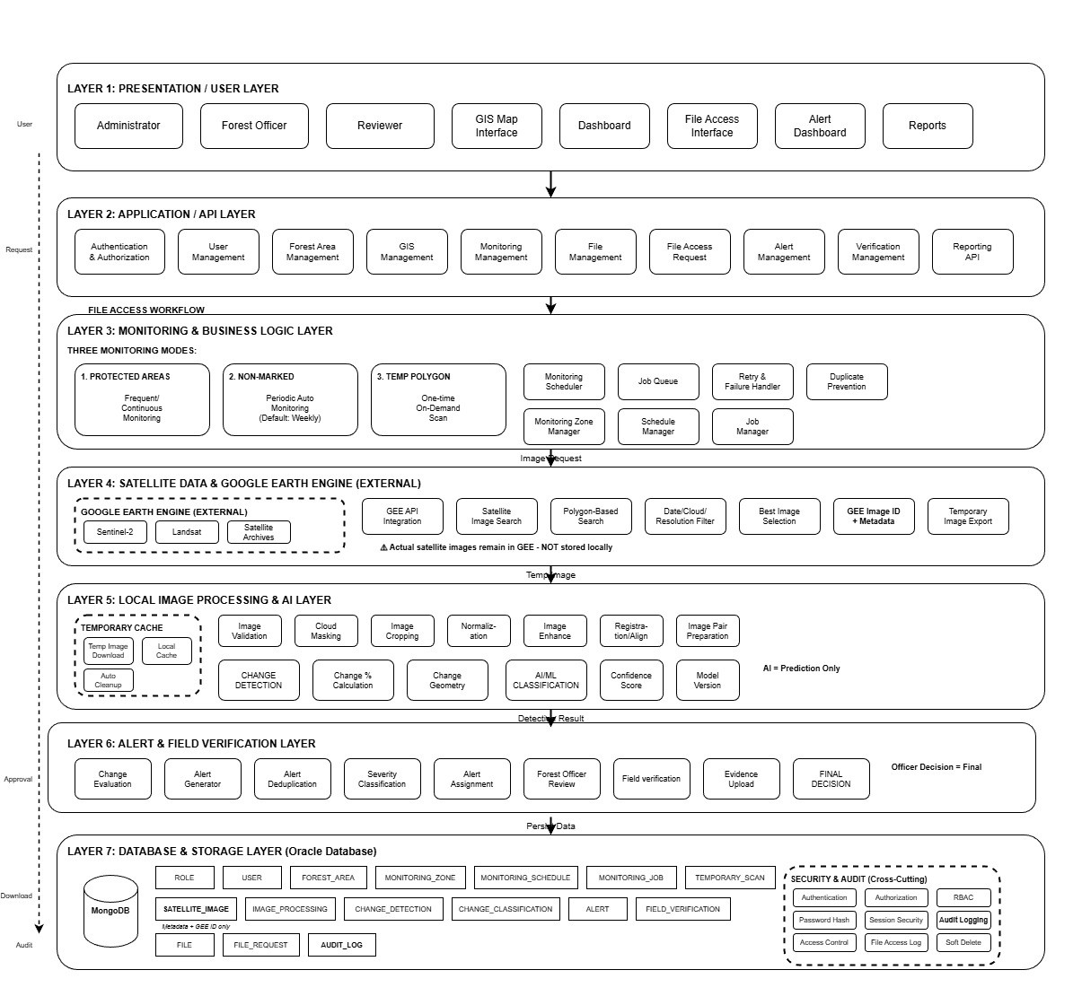

Figure 3.1: Multi-Tier System Architecture
DATA FLOW DIAGRAM

Figure 3.2: Data Flow Diagram
3.2 DESIGN COMPONENTS
3.2.1 Frontend Module:
Provides the user interface, map visualization, forms, monitoring views, and administrative workflows.
3.2.2 Backend Module:
Handles application requests, business logic, API routing, authentication, and communication with the database.
3.2.3 Database Module:
Maintains application records relating to users, geographical areas, monitoring activities, and enforcement operations according to the implemented schema.
3.2.4 Online Monitoring Module:
Uses the documented Google Earth Engine workflow to support satellite-image analysis.
3.2.5 Offline Processing Module:
Processes local raster datasets using cloud and shadow masking, raster alignment, index calculations, and change classification.
3.2.6 Mining and E-Pass Module:
Supports mining-related records, transport permits, QR verification, and checkpoint workflows.
3.2.7 Alert and Export Module:
Provides documented alerting and export functions for investigation and reporting.
3.3 DATABASE DESCRIPTION
The database uses MongoDB with Mongoose as the object data modelling layer. It stores structured application information used by the monitoring and enforcement modules.
Relevant entities include user and access-control records, forest zones, monitoring records, mining-related records, vehicles, drivers, and transport permits where implemented. The database schema must preserve the relationships and validation rules defined by the existing application.
<< COLLECTIONS AND FIELDS SCHEMA>>
Table 3.1: Collection Description
Attribute Name | Type | Constraint(s) | Description
User / Access Control | MongoDB document | Role-based access; exact schema not supplied | User identity and access-control records.
Forest Zone | MongoDB document | Exact schema not supplied | Geographical information about forest zones and marked areas.
Monitoring Record | MongoDB document | Exact schema not supplied | Satellite monitoring activities and candidate change information.
Mining Record | MongoDB document | Exact schema not supplied | Mining-lease and authorized extraction information.
Vehicle / Driver | MongoDB document | Exact schema not supplied | Vehicle and driver records used in transport enforcement.

<< DATABASE SCHEMA >>

Figure 3.3: Database Schema and Entity Relationships
3.4 LOW-LEVEL DESIGN
3.4.1 Authentication
The user submits login credentials through the frontend. The backend validates the credentials and checks the user's permissions before allowing access to authorized functions. Invalid credentials or insufficient permissions should result in an appropriate error response.
Table 3.2: Login Details
Files used | << To be filled from the project source files >>
Short Description | Authenticates the user and enforces role-based access permissions
Arguments | Login credentials submitted through the frontend
Return | Access to authorized functions, or an error response
Post-Condition | The functions permitted by the user's assigned role become accessible
Exception | Invalid credentials or insufficient permissions
Actor | Authorized user

3.4.2 Satellite Change Detection
The monitoring workflow obtains compatible satellite imagery, prepares the data, calculates vegetation indices, compares observations, and identifies candidate changes. The resulting information is processed into geospatial outputs for visualization and investigation.
The documented production alert algorithm uses a delta-NDVI threshold of -0.15 or lower. Canopy Guard v2.1 operates in shadow mode and does not independently modify production alerts.
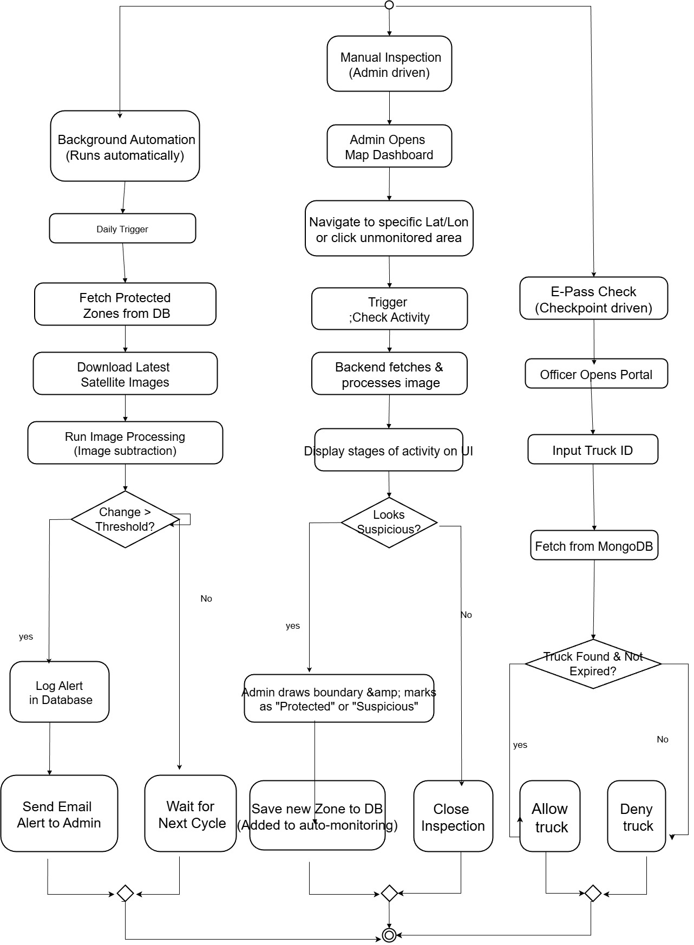
Figure 3.4: Online Satellite Monitoring Workflow
3.4.3 Offline Raster Processing
The offline workflow accepts supported local raster files, validates their compatibility, aligns the input datasets, masks cloud and shadow contamination where supported, calculates the required indices, and classifies changes.
The output includes spatially referenced change information and area summaries for further examination. The workflow is designed to operate without continuous network access.
<< WORKFLOW DIAGRAM HERE >>

Figure 3.5: Offline Raster Processing Workflow
3.4.4 E-Pass and Checkpoint Verification
The enforcement workflow associates transport permits with the relevant transport records. A QR code is used to retrieve or verify permit information at a checkpoint. The system supports checks involving vehicle details, permit validity, and documented extraction or transport limits.
3.4.5 Alerts and Evidence Exports
The system presents candidate changes and relevant monitoring information to authorized users. Supported export formats include geospatial and tabular outputs such as GeoTIFF, KML, shapefiles, and CSV, as documented in the implementation.
3.5 USER INTERFACE DESIGN
The user interface provides access to the system's monitoring and enforcement functions. Its design includes map-based visualization, monitoring results, administrative records, permit workflows, and reporting features.
3.5.1 Map-Based Visualization
Figure 3.6 provides the interface for map-based visualization.
<< INSERT SCREENSHOT OF MAP-BASED VISUALIZATION INTERFACE HERE >>

Figure 3.6: Map-Based Visualization Interface
3.5.2 Monitoring Results
Figure 3.7 provides the interface for monitoring results.
<< INSERT SCREENSHOT OF MONITORING RESULTS INTERFACE HERE >>

Figure 3.7: Monitoring Results Interface
3.5.3 Administrative Records
Figure 3.8 provides the interface for administrative records.
<< INSERT SCREENSHOT OF ADMINISTRATIVE RECORDS INTERFACE HERE >>

Figure 3.8: Administrative Records Interface
3.5.4 Permit Workflow
Figure 3.9 provides the interface for permit workflow.
<< INSERT SCREENSHOT OF PERMIT WORKFLOW INTERFACE HERE >>

Figure 3.9: Permit Workflow Interface
3.5.5 Reporting Features
Figure 3.10 provides the interface for reporting features.
<< INSERT SCREENSHOT OF REPORTING FEATURES INTERFACE HERE >>

Figure 3.10: Reporting Features Interface
CHAPTER CONCLUSION
This chapter described the architecture, design components, database approach, and principal workflows of the forest monitoring and enforcement system. The design combines geospatial processing with administrative and checkpoint functions to support coordinated monitoring and investigation.
CHAPTER 4

SYSTEM IMPLEMENTATION

4.1 LOGIN AND AUTHENTICATION IMPLEMENTATION
The frontend collects the user's login details and submits them to the backend. The backend validates the credentials and enforces the configured authorization rules. Authorized users can access the functions permitted by their assigned roles.
Authentication failures and unauthorized requests are handled according to the implemented security mechanisms.
4.2 FOREST ZONE AND MARKED-AREA MANAGEMENT
The system supports geographical monitoring through forest-zone and marked-area information. These geographical references provide the context needed to examine satellite observations and determine whether candidate changes occur within areas requiring attention.
The implementation uses the project's existing geospatial data structures and map-based interface.
4.3 SATELLITE MONITORING AND CHANGE DETECTION
The online monitoring pipeline uses Google Earth Engine and the supported satellite datasets to obtain and analyse observations.
The processing workflow includes image preparation, quality masking, vegetation-index calculation, temporal comparison, and candidate-change identification. The production-frozen Algorithm v2.0 uses a delta-NDVI threshold of -0.15 or lower for official alerts.
Canopy Guard v2.1 operates in shadow mode, recording additional reliability information without changing production alert decisions.
4.4 OFFLINE CHANGE DETECTION IMPLEMENTATION
The offline engine is implemented using Node.js, geotiff.js, TypedArrays, and native zlib functionality. It allows compatible local raster datasets to be analysed without continuous internet access.
The workflow includes input validation, raster alignment, cloud and shadow masking where supported, index computation, and seven-class change classification using NDVI and BSI.
NDVI provides information about vegetation conditions, while BSI helps distinguish exposed soil from other surface changes. Combining the indices supports differentiation between vegetation stress and possible clearing or exposed ground.
The output provides mapped candidate changes and area-accounting information for further review.
4.5 E-PASS AND CHECKPOINT ENFORCEMENT
The enforcement module integrates transport-related records with digital permit verification. QR-code validation assists checkpoint personnel in checking the corresponding e-pass information.
The system also supports vehicle and driver records and reconciliation of documented extraction quantities against permitted mining limits, according to the implemented workflows.
4.6 ALERTS, EVIDENCE DOSSIERS, AND EXPORTS
The system provides monitoring alerts and supporting geospatial outputs. Supported exports include GeoTIFF, KML, shapefiles, and CSV records.
These outputs help authorized personnel examine candidate changes and organize supporting information for field investigation. Exported results are decision-support materials rather than independent legal proof of an offence.
CHAPTER 5

RESULTS AND DISCUSSION

5.1 TEST CASES AND RESULTS
Testing covers authentication, API integration, satellite-processing workflows, offline raster analysis, and checkpoint-related operations. Table 5.1 records the test cases and their outcomes.
<< INSERT DOCUMENTED TEST CASES AND VERIFIED RESULTS FROM THE PROJECT DOCUMENT INTO TABLE 5.1 >>
Table 5.1: Functional Test Cases
Test Case ID | Test Description | Expected Result | Actual Result | Status
TC-01 | Authentication and access control | Valid credentials allow access according to assigned role. | Not specified in supplied report. | Not documented
TC-02 | Forest-zone operations | Forest-zone and marked-area information can be accessed and managed. | Not specified in supplied report. | Not documented
TC-03 | Online satellite monitoring | Supported satellite observations are processed for candidate changes. | Not specified in supplied report. | Not documented
TC-04 | Offline raster processing | Compatible local rasters are processed without continuous network access. | 15 offline acceptance gates are reported as verified; individual outcomes are not listed. | Partially documented
TC-05 | E-pass / QR verification | Permit information can be checked at a checkpoint. | Not specified in supplied report. | Not documented
TC-06 | Geospatial and tabular exports | Supported outputs include GeoTIFF, KML, shapefiles, and CSV. | Formats are documented; individual test outcomes are not supplied. | Partially documented

5.2 FUNCTIONAL TESTING
Functional testing examines whether the implemented modules perform their documented tasks.
The test categories include authentication and access control, forest-zone operations, satellite monitoring, offline raster processing, database interaction, e-pass verification, and supported export functions.
For each test performed, the input, expected behaviour, observed behaviour, and actual status are recorded in Table 5.1.
5.3 SATELLITE CHANGE DETECTION RESULTS
The system compares satellite observations and calculates changes in vegetation indices to identify candidate areas requiring investigation. Cloud and shadow masking and cross-sensor harmonization help improve the consistency of comparisons.
The project's documented real-raster evaluation covers a scene of approximately 57,468 hectares. Table 5.2 and Figure 5.1 present the corresponding area-accounting results and change-classification output.
<< INSERT AREA-ACCOUNTING MEASUREMENTS FROM THE PROJECT DOCUMENT INTO TABLE 5.2 >>
Table 5.2: Real-Raster Area Accounting
Change Class | Area (ha) | Share of Scene (%) | Remarks
Scene evaluated | 57,468 (approx.) | 100 (approx.) | Approximate real-raster scene size stated in the report; not a change-class area.
No-change class | Not reported | Not reported | Per-class area measurements are not included in the supplied report.
Vegetation decrease | Not reported | Not reported | Per-class area measurements are not included in the supplied report.
Exposed soil / BSI change | Not reported | Not reported | Per-class area measurements are not included in the supplied report.
Other change classes | Not reported | Not reported | Seven-class classification is mentioned, but class-wise values are not supplied.
Unclassified / masked | Not reported | Not reported | Per-class area measurements are not included in the supplied report.
Total classified area | Not reported | Not reported | Cannot be calculated without the class-wise raster measurements.

<< INSERT CHANGE-CLASSIFICATION OUTPUT FIGURE FROM THE PROJECT DOCUMENT HERE >>

Figure 5.1: Change-Classification Output for the Real-Raster Scene
Detected spectral differences must be interpreted carefully because seasonal vegetation cycles and other environmental factors can produce changes unrelated to illegal activity.
5.4 OFFLINE RASTER PROCESSING RESULTS
The offline engine was evaluated using the documented acceptance tests and real-raster processing workflow.
The project document reports 15 offline acceptance gates verified with zero database mutations. The acceptance-test matrix is presented in Table 5.3.
<< >>
Table 5.3: Offline Acceptance-Test Matrix
Gate No. | Acceptance Gate | Expected Result | Actual Result | Status
1 | Offline acceptance suite | 15 documented acceptance gates are verified. | Report states 15 gates verified with zero database mutations; individual gate results not supplied. | Aggregate result reported
2 | Individual gate details | Gate-specific expected result. | Not specified in supplied report. | Not documented
3 | Individual gate details | Gate-specific expected result. | Not specified in supplied report. | Not documented
4 | Individual gate details | Gate-specific expected result. | Not specified in supplied report. | Not documented
5 | Individual gate details | Gate-specific expected result. | Not specified in supplied report. | Not documented
6 | Individual gate details | Gate-specific expected result. | Not specified in supplied report. | Not documented

The processing outputs support local examination of compatible raster datasets without continuous network access.
5.5 DISCUSSION AND LIMITATIONS
The system integrates online satellite monitoring, offline raster analysis, geospatial visualization, and transport enforcement within a common application architecture.
Its offline processing capability is useful where network availability is limited. Combining NDVI and BSI provides additional information for interpreting vegetation and exposed-ground changes.
However, satellite imagery has finite spatial resolution. Small disturbances may not be detected reliably. Cloud contamination, seasonal variation, image-registration errors, and differences between sensors can also affect results.
Automated detection identifies candidate anomalies rather than conclusively proving illegal deforestation or mining. Field inspections and appropriate official verification remain necessary.
CHAPTER 6

CONCLUSION AND FUTURE ENHANCEMENTS

6.1 CONCLUSION
The Tamil Nadu Forest Monitoring, Authorized Mining, E-Pass and Checkpoint Enforcement System demonstrates an integrated approach to geospatial monitoring and administrative enforcement.
The platform combines a TypeScript-based web architecture with online satellite monitoring, offline raster processing, vegetation and bare-soil indices, geospatial outputs, and digital transport verification.
The offline engine provides a local processing option, while the monitoring and enforcement modules support the organization and review of relevant records. Documented validation results provide evidence of the tested capabilities.
The system is intended to support authorized personnel in identifying areas requiring investigation and improving the coordination of monitoring and checkpoint operations. Human verification remains essential before regulatory or legal action is taken.
6.2 FUTURE ENHANCEMENTS
Potential future enhancements include:
- Improving automated differentiation between seasonal changes and genuine land disturbance.
- Integrating additional satellite datasets and higher-resolution imagery where available.
- Enhancing field reporting and ground-truth verification workflows.
- Improving monitoring dashboards and historical change comparisons.
- Expanding reporting, analytics, and audit capabilities.
- Strengthening operational monitoring and performance measurement.
- Improving usability in remote areas with limited connectivity.
- Integrating additional authorized data sources where appropriate.
APPENDIX – A
SYSTEM REQUIREMENTS
HARDWARE REQUIREMENT:
SOFTWARE REQUIREMENT:
Frontend : | React 18, Vite, TypeScript, Leaflet, Tailwind CSS
Backend : | Node.js 20+, Express.js, TypeScript
Database : | MongoDB 7+ and Mongoose
Geospatial processing : | geotiff.js, TypedArrays, native zlib functionality
Online satellite processing : | Google Earth Engine
Mapping : | Leaflet and supported geospatial data formats

APPENDIX – B
SOURCE CODE
Authentication and Authorization
<< INSERT SOURCE CODE EXCERPT FROM THE PROJECT SOURCE FILES HERE >>

Satellite Change-Detection Calculations
<< INSERT SOURCE CODE EXCERPT FROM THE PROJECT SOURCE FILES HERE >>

Offline Raster-Processing Functions
<< INSERT SOURCE CODE EXCERPT FROM THE PROJECT SOURCE FILES HERE >>

NDVI and BSI Calculations
<< INSERT SOURCE CODE EXCERPT FROM THE PROJECT SOURCE FILES HERE >>

Change-Classification Logic
<< INSERT SOURCE CODE EXCERPT FROM THE PROJECT SOURCE FILES HERE >>

E-Pass and QR Verification
<< INSERT SOURCE CODE EXCERPT FROM THE PROJECT SOURCE FILES HERE >>

Relevant API Routes
<< INSERT SOURCE CODE EXCERPT FROM THE PROJECT SOURCE FILES HERE >>

REFERENCES
<< INSERT THE REFERENCES CITED IN THE ORIGINAL PROJECT DOCUMENT (SATELLITE DATASETS, GOOGLE EARTH ENGINE, GEOSPATIAL LIBRARIES, TECHNICAL ALGORITHMS, APPLICABLE LEGAL FRAMEWORKS) >>
1.
2.
3.
4.
5.

