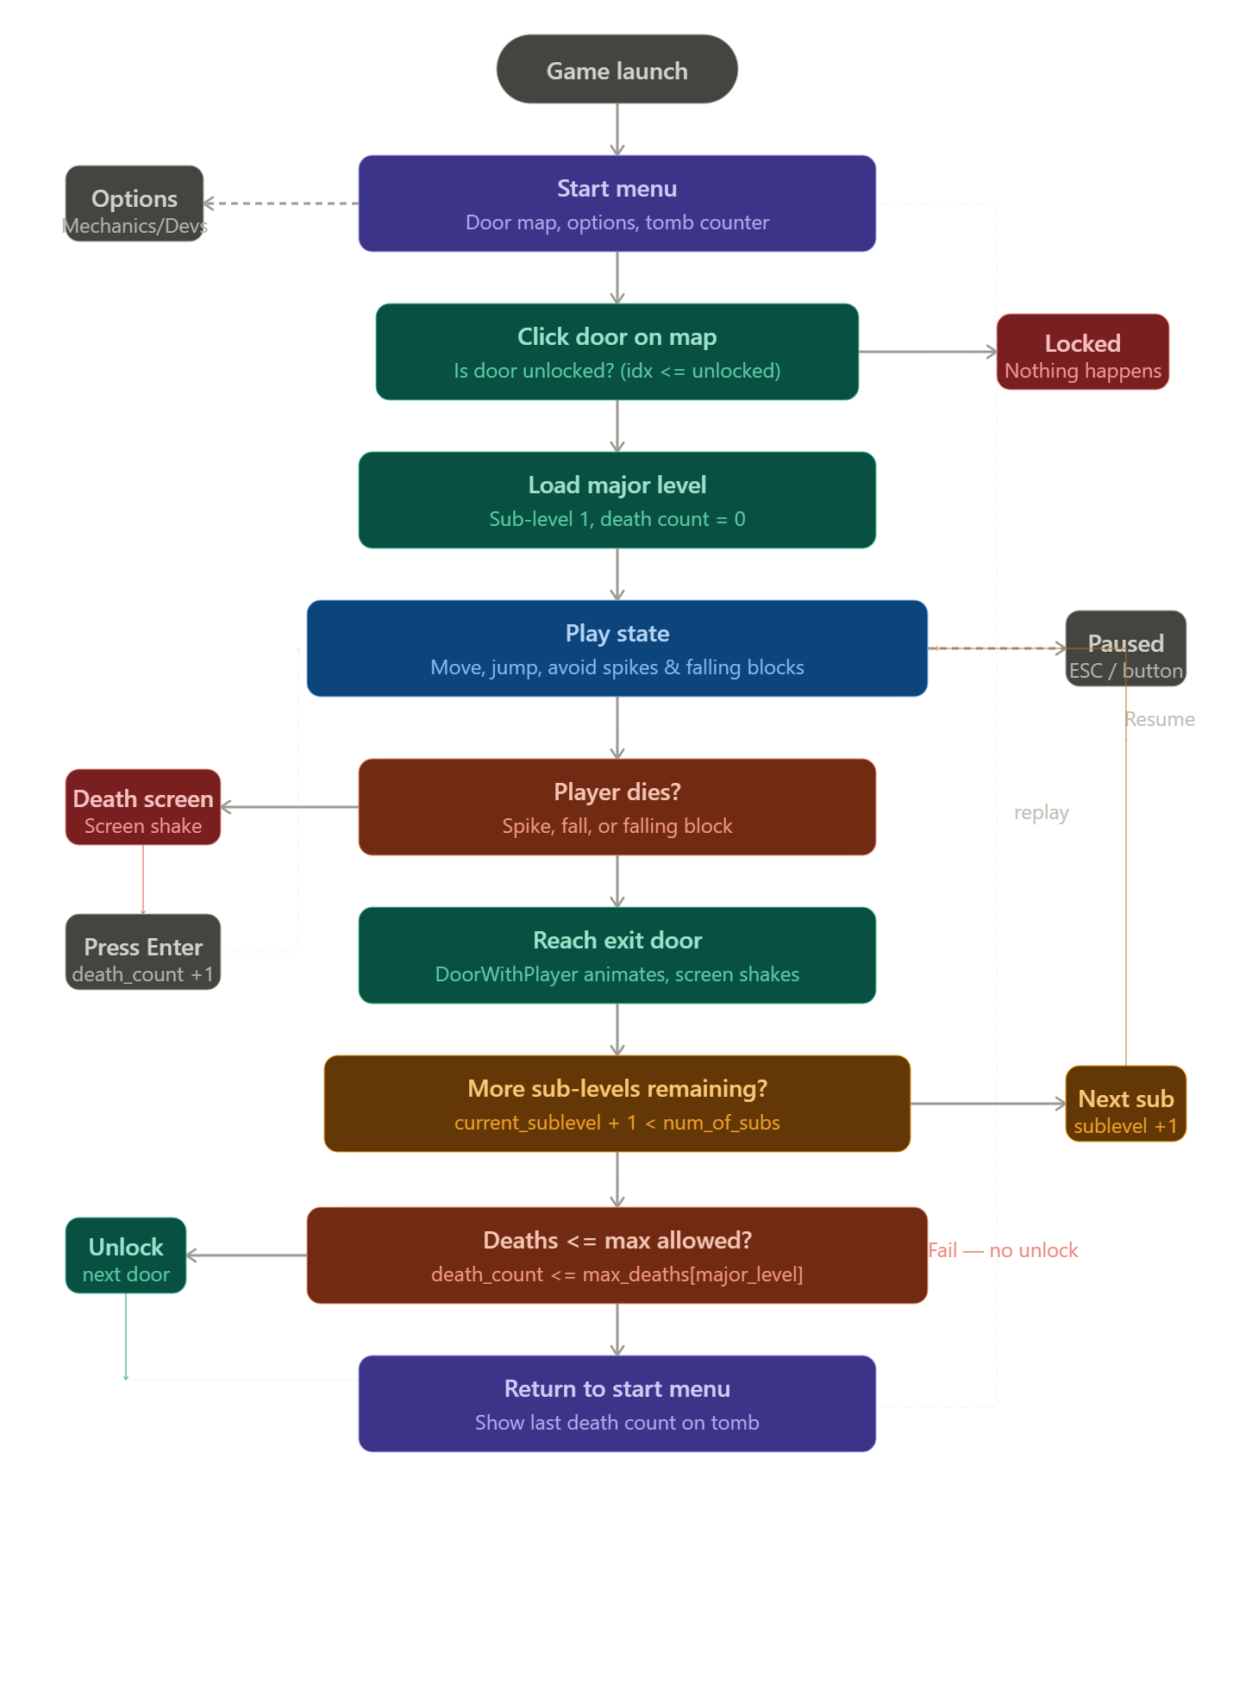

Executive Summary
“Not A Trap” is a platformer game designed to trick players with unexpected obstacles, including falling floors, spikes, and other traps scattered across each level. It is inspired by “Level Devil” by Unept and requires players to avoid both the visible and non-visible traps in order to reach the goal and advance to the next level. Targeted for PC or Web platforms

A unique feature of the game is its death-count system, which tracks the number of player deaths and determines progression through levels. The game’s core goal is to challenge the players while encouraging a trial-and-error style of gameplay that tests their patience, reflexes, and adaptability.

- Game Overview
The game consists of 8 major levels, each split into 3 sub-levels. Players begin at the start menu, which displays the pathway map containing all level doors. As the game requires to be completed in sequence, only the first door is initially unlocked, requiring players to complete levels in order. Players must successfully finish all the sub-levels while maintaining the minimum required number of deaths to advance to the next level. Deaths are counted across all 3 sub-levels and can only reset after completing a full major level, regardless of whether the player advances or not.

- Mechanics and Gameplay
- Player Controls:
Left and Right Arrows: Left and Right Movement
Space: Jump
Enter/Return: Reset
- Physics:

