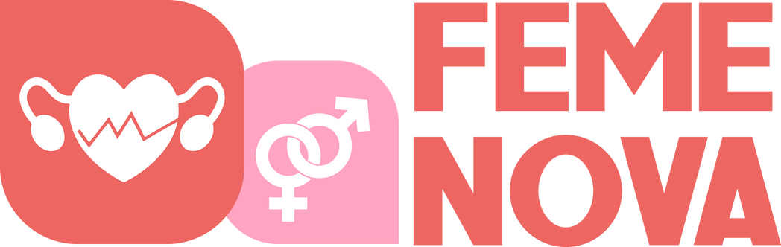

FemeNova Health Impact Report

**2023-2024**

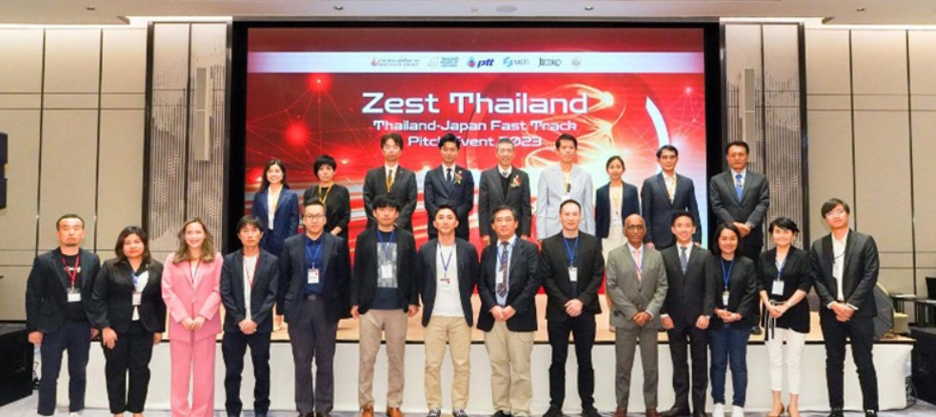

In front of more than 300 participants (more than 170 in-person and more than 130 online), 17 startups from Japan, Thailand, and other regions presented their proposals on the open innovation challenges provided by the 7 challenge owners, including Japanese companies and the PTT group companies.

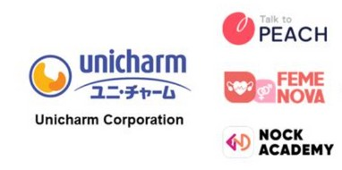

FemeNova Health was part of Top 17 startups from 110 startups who applied for the business challenges provided by the 7 challenge owners, including Japanese companies and the PTT group companies.

FemeNova Health was one of the Top 3 Finalists in the Unicharm Corporation’s Business Challenge on menstrual health education & services.

# Press Release by the The Beat Asia & Vritimes

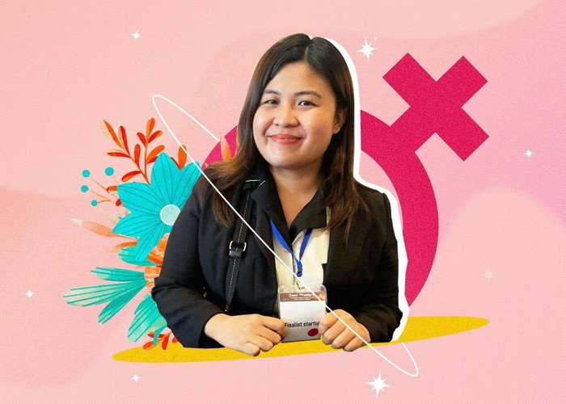

**https://thebeat.asia/venture/careers/female-entrepreneurs-in-asia-inspiring- inclusion-in-business-beyond?**

## Female Entrepreneurs in Asia Inspiring Inclusion in Business & Beyond

FemeNova Health is honored to be featured among the visionary leaders in The Beat Asia's International Women's Day special. Our founder, Camille Cosare, has been recognized for her pioneering work in female-oriented healthcare and her unwavering commitment to improving women's health outcomes through innovation and empowerment.

**EmpowerHER: Nurturing Wellness, Inspiring strength**

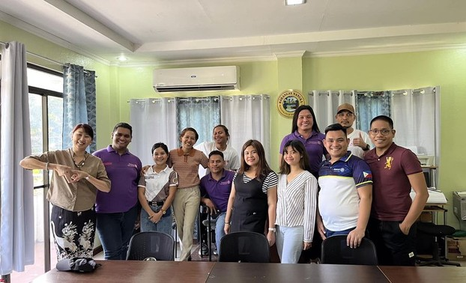

EmpowHER - Embracing Magnificent Power of Women's Health Education & Response served as a catalyst for positive change in women's health awareness and empowerment. Through collaborative partnerships and dedicated advocacy efforts, the event provided a platform for women to prioritize their health and well-being.

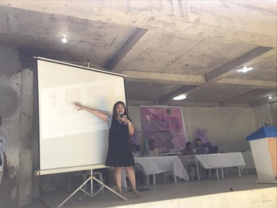

Camille Cosare's contribution as a guest speaker, sharing her insights on Cervical Awareness and Prevention, shedding light on crucial aspects of women's health, further amplified the impact of the event, inspiring attendees to take proactive steps towards a healthier future.

# Free Cervical Cancer Awareness and Screening Event

### Event Overview:

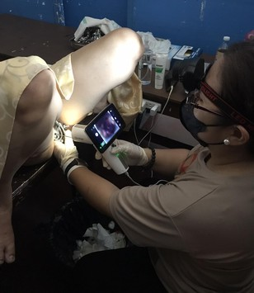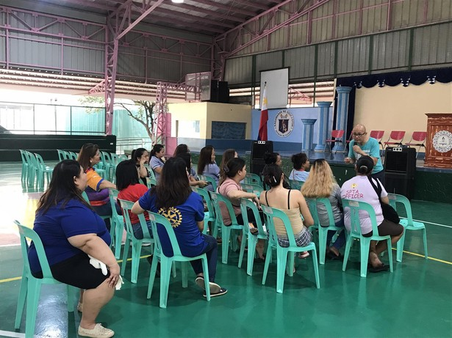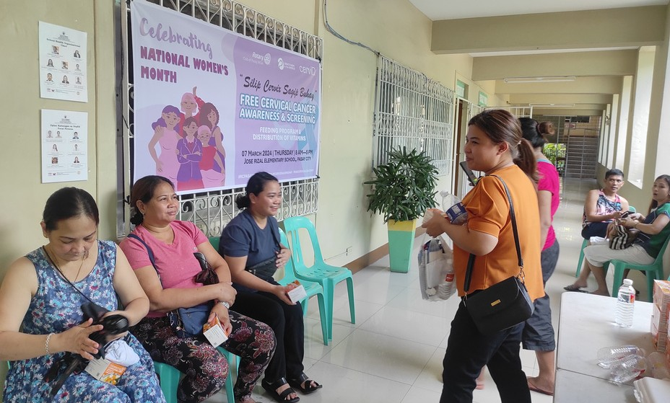

In commemoration of International Women's Day 2024, CerviQ, in partnership with the Rotary Club of Tondo, organized a Free Cervical Cancer Awareness and Screening event for the teachers of Tondo High School. This initiative, known as the **"Silip Cervix Sagip Buhay"** program, aimed to raise awareness about cervical cancer and provide accessible screening services to women in the community.

### FemeNova Health's Participation:

FemeNova Health had the privilege of

collaborating with CerviQ as part of the Silip Cervix Sagip Buhay program. As a participant, FemeNova Health contributed its expertise and resources to support the initiative's goals of promoting cervical cancer awareness and early detection among women.

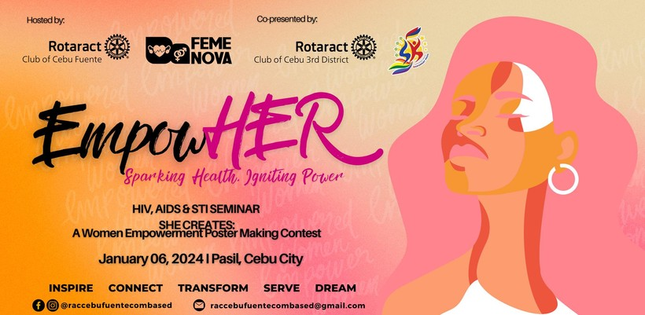

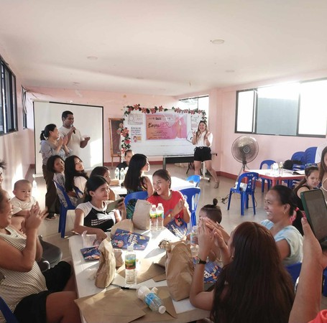In collaboration with the Rotaract Club of Cebu Fuente and the Rotaract Club of Cebu 3rd District, FemeNova Health conducted a Women Empowerment and Reproductive Health Education initiative in Barangay Pasil, Cebu City. This initiative aimed to empower women, particularly those from poor and overpopulated urban communities, by providing them with essential knowledge and support regarding reproductive health issues, including HIV/AIDS awareness.

### Key Activities and Outcomes:

The initiative targeted 25 women aged 15-25 years old from Barangay Pasil, a marginalized community facing challenges related to reproductive health.

A comprehensive session on Women Empowerment and HIV/AIDS awareness was conducted, focusing on educating participants about reproductive health, preventive measures against HIV/AIDS, and the importance of empowerment.

Through interactive discussions and information-sharing, participants gained valuable insights into reproductive health and were equipped with knowledge to make informed decisions about their well-being.

The initiative fostered a supportive community environment where women felt empowered to address reproductive health issues openly and seek necessary support and resources.

## FemeNova Health Emerges as Top 10 Finalist in Smart Cities Hackathon

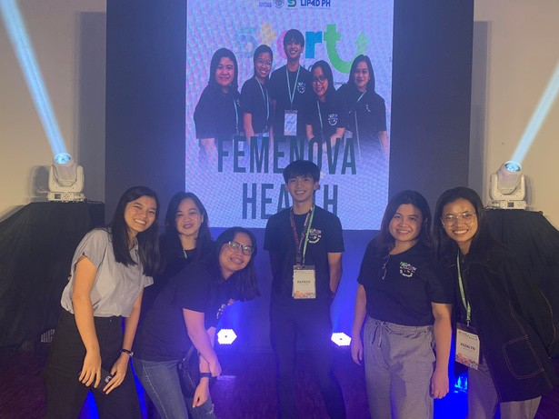

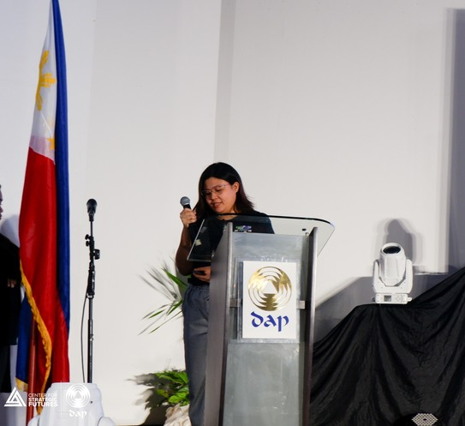FemeNova Health proudly participated in the Smart Cities Hackathon held in Tagaytay City, marking another milestone in our commitment to driving innovation in healthcare. We are thrilled to announce that we have been selected as one of the top 10 finalists to present smart city solutions for Malolos City.

At the hackathon, FemeNova Health presented JuanHealth, our innovative healthcare solution designed to enhance primary healthcare initiatives

**Empowering Youth: Symposium on Health and Environmental Awareness**

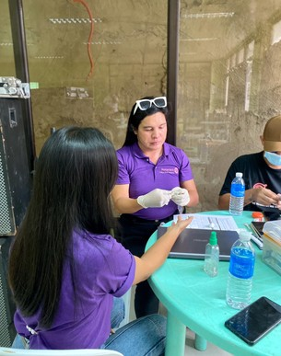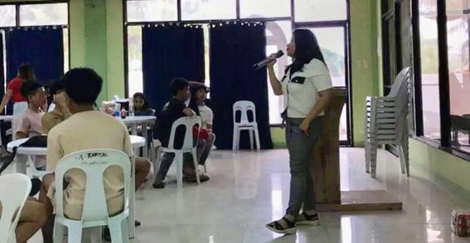

**Key Indicator Activity / Project Data / Outcome**

Teenage Pregnancy Rate

Youth Engagement

Community Collaboration

Teenage Pregnancy Talk conducted by Camille Osias Cosare

Symposium on Health and Environmental Awareness organized by FemeNova Health

Collaborative efforts between FemeNova Health, Rotaract Club of Cebu 3rd District, LGBTQ Balamban, Rotaract Club of Cebu Fuente - University of San Carlos, and Sangguniang Kabataan- Brgy.

Poblacion, Asturias to organize symposiums and workshops on health and environmental awareness.

Increased knowledge on reproductive health and aim to decrease in the number of teenage pregnancies within the community

Increased participation and engagement of youth in health awareness activities

Strengthened partnerships and collaboration among organizations and stakeholders

# Next Steps

FemeNova aims to effectively address the problem statement by providing a comprehensive solution to the barriers and challenges women face in accessing reliable information, support, and community engagement for their sexual health needs. By offering a user-friendly platform with diverse resources and interactive features, FemeNova empowers women to overcome stigma, misinformation, and lack of access to care.

**No. 01**

**No. 02**

### Comprehensive Information Hub

From contraception methods and

menstrual wellness to STI prevention, our platform provides accurate, up-to-date information to educate and empower women.

**No. 03**

**Community Support** Our platform fosters a supportive online community where women can connect with like-minded individuals, share experiences, ask questions, and find encouragement and solidarity.

### Interactive Workshops and Webinars

Participants have the opportunity to

interact with presenters, ask questions, and engage in discussions with fellow participants.

**No. 04**

**Expert Consultations** FemeNova offers confidential consultations with qualified sexual health professionals for personalized guidance and support.

**FemeNova Health — SDG Progress Report 2023-2024**