**DOCUMENTATION**

1. **INTRODUCTION**
2. **Project Purpose**

* This document will give an overview for the requirements of the LoyaLeadsta project. LoyaLeadsta is a system that will be built primarily to monitor the overall product movement of external sales channels including distributors and dealers down to the end customers. This will be done by providing them two mobile applications - LoyaLeadsta POS and LoyaLeadsta CRM.

1. **Business Overview**

* Firstly, the distributor orders the products from an agent, which will be processed by the head office and warehouse. The distributor then finds its dealers who are able to sell the products to the target end customers - the farmers. In this way, the farmers and the general public would be able to access the products and services.

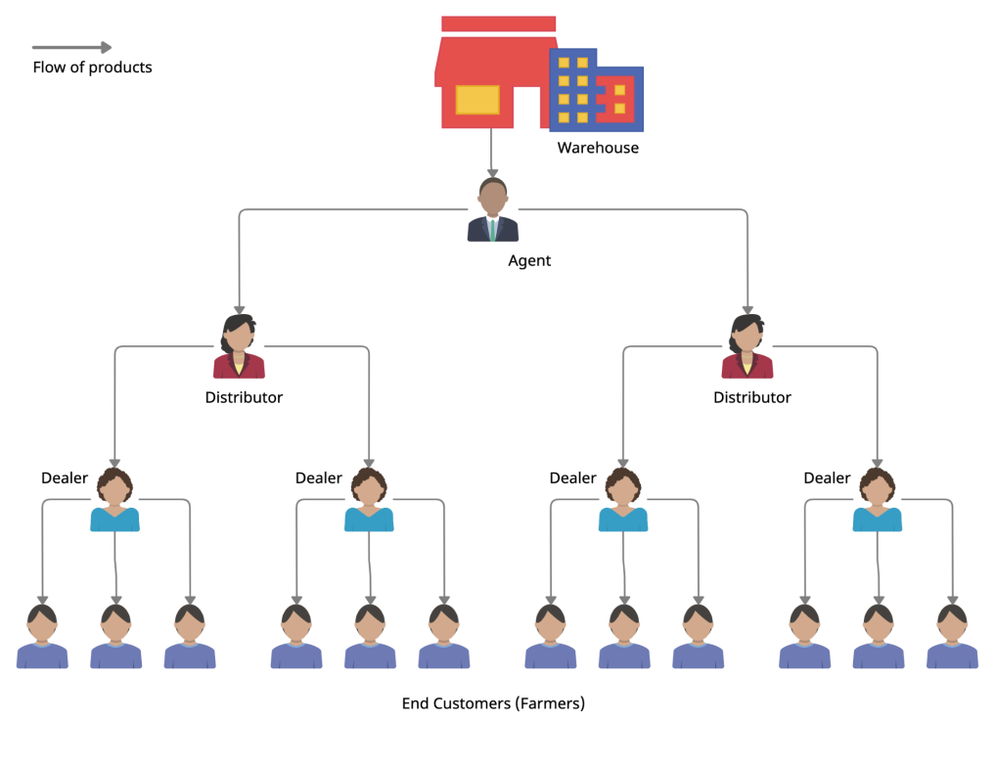

1. **Main Objectives**

* The main objective of the project is to monitor the product movement of the company down to the end customers. Additionally, the project also aims to do the following:

1. To automate incentive computation and request process
2. To collect and organize customer/channels database
3. To improve traceability of products sales and marketing
4. To provide access to prospective customers and clients
5. **SYSTEM OVERVIEW**
6. **System Architecture**

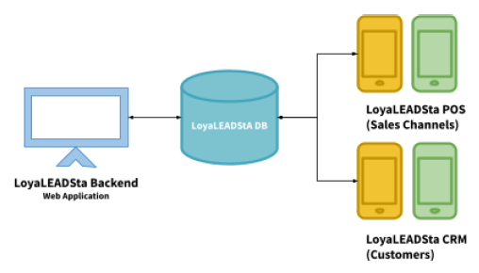

1. LoyaLeadsta POS

* This application will be used by the sales channels as a point-of-sale to record sales transactions, product inventory, and reward incentives.

1. LoyaLeadsta CRM

* This application will be used by all customers and sales channels as a customer portal to access services and purchase products online.

1. **System Functions**

|  |  |
| --- | --- |
| * Account Registration - POS | * Payment Gateways |
| * Account Registration - CRM | * Receivable Collections |
| * Role-based Access | * Payment Management |
| * Approval Process | * Purchase Rebates |
| * Sales Channels | * Delivery Booking |
| * Billing and Order - POS | * Return Booking |
| * Billing and Order - CRM | * Automated Notifications |
| * Transaction Discounts | * Channels Geotagging |
| * Tax Administration | * Customer Geotagging |
| * Transactions Monitoring - POS | * Product Geotagging |
| * Transactions Monitoring - CRM | * Channels Linking |
| * Product Inventory | * Product Review |
| * Stock Adjustment | * Referral Program |
| * Announcement Alerts | * Incentive Program |
| * Purchase Order | * Rewards Computation |
| * PO Tracking | * Quotation Creation |
| * Sales Order | * Technical Support |
| * SO Tracking | * Ticket Management |
| * Stock Transfers | * Dynamic Dashboard |
| * Product Returns | * Analytics and Reports |
| * Pricing Configuration |  |

1. **User Roles**
2. Super Admin
3. Employee Admin
4. Channel Admin
5. Channel Cashier
6. End Customer
7. **Specific Functions**
8. **Account Registration – POS**
9. **General Overview**

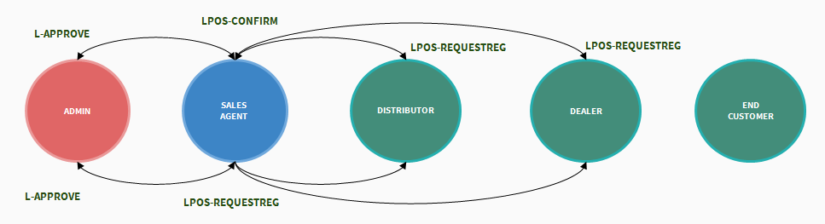

1. **Process Workflow**

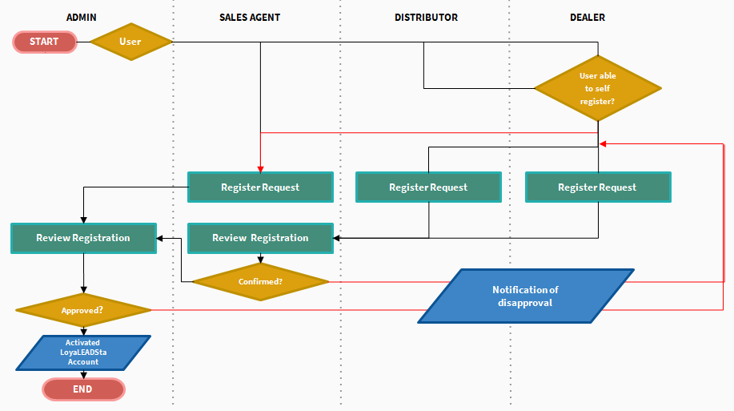

1. **Specific Requirements:**

* User should be able to access the sign up page and input information in the form.
* User should be able to check his sign up status whether it is pending, approved, or rejected.
* User should be notified regarding the account sign up status whether it is approved or rejected, with remarks.
* User can choose to provide a mobile number or email address as verification for log in or sign up.
* Admin should be able to create a POS account from the web application to the mobile application.

1. **Form Fields – User Sign Up:**

* These are the form fields for both mobile application and web application sign up. Kindly follow the approved design for the mobile application and provide a design for the web application.

**Step 1: Business Information**

Business Details

* Business Name
* Business Type (Dropdown: Single Proprietorship, Partnership, Corporation)
* SEC/DTI Reg. No.
* Nature of Business
* TIN
* VAT No.
* Date Established

Business Address

* Province
* City/Municipality
* Barangay
* Room/Floor/Unit No.
* Building Name
* House/Lot/Block No.
* Street Name
* Subdivision/Village

Contact Details

* Email Address
* Contact No.
* Telephone No.
* Fax No.

**Step 2: Seller Information**

Personal Details

* First Name
* Middle Name
* Last Name
* Suffix Name
* Birthday
* Age
* Civil Status

Seller Address

* Province
* City/Municipality
* Barangay
* Room/Floor/Unit No.
* Building Name
* House/Lot/Block No.
* Street Name
* Subdivision/Village

Contact Details

* Contact No.
* Email Address

**Step 3: File Attachments**

* Customer Information Sheet
* Signature Card
* Memorandum of Agreement
* Mayor's Permit
* FPA permit
* BIR 2303
* 2 Valid IDs
* DTI Permit
* Remarks

**Step 4: Account Password**

* Password
* Confirm Password

1. **Form Fields – User Log In:**

* These are the form fields for both mobile application and web application log in. Kindly follow the approved design for the mobile application and provide a design for the web application.
* Email Address
* Contact Number
* Password
* Forget Password

1. **Account Registration – CRM**
2. **General Overview**

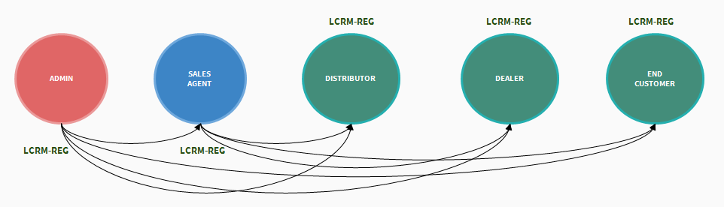

1. **Process Workflow**

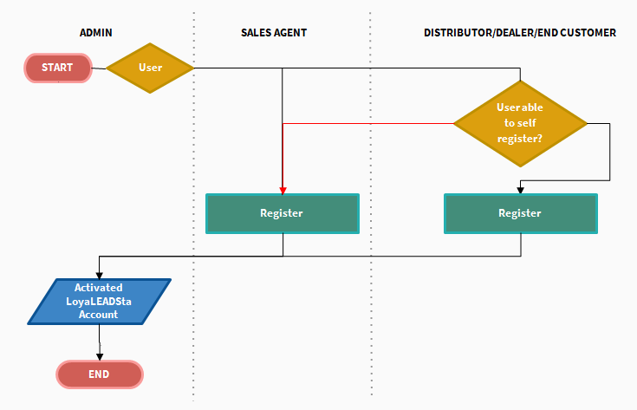

1. **Specific Requirements**

* User should be able to access the sign up page and input information in the form.
* User can choose to provide a mobile number or email address as verification for log in or sign up.
* Admin should be able to create a POS account from the web application to the mobile application.

1. **Form Fields – User Sign Up:**

* These are the form fields for both mobile application and web application sign up. Kindly follow the approved design for the mobile application and provide a design for the web application.

**Step 1: Account Information**

* Email Address
* Contact No.
* Referred By
* Password
* Confirm Password

**Step 2: Personal Information**

Personal Details

* First Name
* Middle Name
* Last Name
* Suffix Name
* Birthday
* Age

Home Address

* Province
* City/Municipality
* Barangay
* Room/Floor/Unit No.
* Building Name
* House/Lot/Block No.
* Street Name
* Subdivision/Village

1. **Form Fields – User Log In:**

* These are the form fields for both mobile application and web application log in. Kindly follow the approved design for the mobile application and provide a design for the web application.
* Email Address
* Contact Number
* Password
* Forget Password