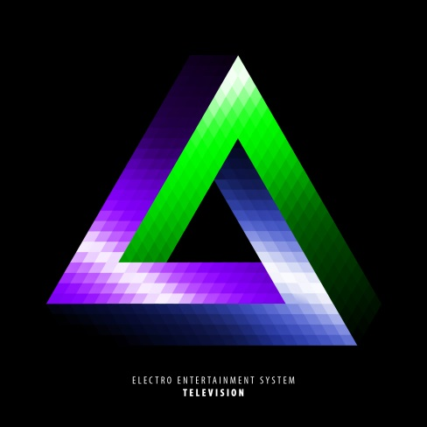Electro Entertainment System releases Television EP

Electronic music just turned bigger with the release of Electro Entertainment System’s debut EP. This Extended Play was released in the end of the last summer, and features four Experimental Urban House tracks. Produced by the Brazilian DJ and Producer Jezz Lucena, the EP is available in digital stores like iTunes, Spotify, and for free via Torrent and SoundCloud.

The producer explains that this debut intends to show different types of House in each song. “The idea is to offer a range of songs that are rich in references to the House and Electro music of the last decades, just for, at the end of it all, deliver the message: ‘What if I told you I’ve been to a million houses, but none of them just made me feel like Home?’. It’s about the sensation of never being satisfied with any song. Not feeling home with any ‘house’.

The purpose of the EP is to deliver electronic music that intrigues in a positive way. An uncommon sound, hard to fit in one rhythm, but very clear in its references. “The songs intend to wake up kinesthetic feeling within the listener. Each piece of sound was chosen with the intention to sharpen all senses. I want the EP to be impossible to explain with the terms that are commonly used in music”, Jezz highlights. The DJ still emphasizes that this sound is for Electronic Music fans who listen to this rhythm outsite of the nightclubs: “It’s not the type of music that is going to hit the clubs. The technology enthusiasts, travelers and gamers will feel familiarity with the “chiptune” style.

The four tracks of the EP were produced between February and July of 2014. The mixing and mastering process was done in Sao Paulo, Brazil, by Cello Zero and Felipe Rossi, respectively. Electro Entertainment System also has a hotsite (<http://electroentertainmentsystem.com>) where it’s possible to watch to some animations especially produced for this EP.

The Project

Electro Entertainment System is an electronic music project that started out with DJ mixes and sets, and evolved into creating its own original music. The name is inspired in the Nintendo Entertainment System (NES), a popular videogame console of the 80’s. The inspiration comes from Kraftwerk and Daft Punk to the 90’s-ish House of Haddaway and the newcomer Kiesza.

Jezz Lucena (23) is a Brazilian DJ and producer. Having created the project in Summer 2014, he just moved to Boston, where he’ll make a Game Development master’s degree and search for ways of turning Electro Entertainment System into an international project.

Links

Official Website – <http://electroentertainmentsystem.com/>

iTunes Store – <https://itunes.apple.com/en/album/television-ep/id897675996>

Facebook Page – <http://facebook.com/ElectroEntSys>

Soundcloud – <http://soundcloud.com/ElectroEntSys>

Youtube Channel – <http://youtube.com/ElectroEntSys>

Contact

Contact Form – <https://electroentertainmentsystem.wufoo.com/forms/contact/>

Project’s Email – [contact@electroentertainmentsystem.com](mailto:contact@electroentertainmentsystem.com)

Jezz Lucena’s Facebook – <http://fb.me/jezzlucena>

Jezz Lucena’s Email – [jesielsoueu@gmail.com](mailto:jesielsoueu@gmail.com)