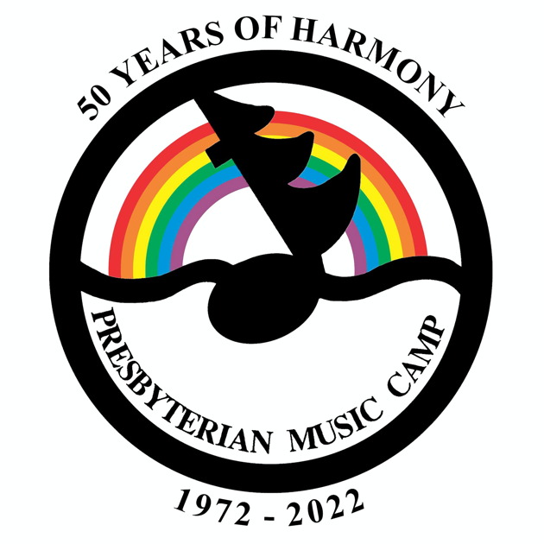

PMC 2022

Vaccination

50 Years of Harmony

Kitchen Parties

Live Auction

Home Movies

Photos for Scanning

# **WE’RE BACK FOR PMC 2022!!!**

IT’S OFFICIAL – PMC 2022 will be IN PERSON[1]

We have over 100 registered campers as of writing, with more expected. The program is shaping up well, and we are working on the finishing touches for a great experience.

Dates: **August 21-28**

For information on the Theme, please see previous summaries.

If you haven’t registered yet, **what are you waiting for?** Go directly to the[website registration page](https://www.presbyterianmusiccamp.ca/register.html).

**Vaccination** for Covid-19 will be required to attend PMC in 2022 (with medical exemptions, of course). Children under 5 will not be required to be vaccinated (since they can’t be yet). If vaccination becomes available for this group before camp, we’ll figure out how it applies.

Discussions at the June meeting will focus on our Covid rules and restrictions. We’ll have more information about those in the next summary.

# **50 YEARS OF HARMONY**

Did you know?

The Dean for the first PMC in 1972 was Dr. William Irwin McElwain.

## Kitchen Parties

Here are the dates again, in case you missed them. Times and other details coming soon!

Kingston area: June 25

KW/Guelph/Cambridge area: July 9

Toronto area: July 16

Ottawa Valley: July 23 (with overnight!)

## Live Auction

Confirmed date and time for this Zoom event is June 16, 6:30 pm until the last item sells.

Auctioneer is Carrie Pilgrim!!

Now we need auction items. They can be things you buy (Spruce beer, tickets, cars), things you make (jewellry, afghans, houses), or services you provide (babysitting for 4 hours, dinner for 6 people, grocery shopping for a year). Be creative. No reasonable offer refused.

To donate an item or service to be auctioned, please contact MJ at [presbyterianmusiccamp@gmail.com](mailto:presbyterianmusiccamp@gmail.com).

For donated things: bring it to camp so we don’t have to worry about shipping charges or damage.

For donated services: (e.g., babysitting, dinner for 4, planting a garden) specify your radius of travel.

## Home Movies

The 50th anniversary committee is still looking for your home movies to show at camp. Digital is preferred, but we aren’t picky. Contact MJ at [presbyterianmusiccamp@gmail.com](mailto:presbyterianmusiccamp@gmail.com).

## 

## Photos for Scanning

We’ll be scanning old camp photos at camp this year. Please curate your photos – bring the best, leave the rest – and please make a note of who is in the photo (if you remember). Photos can be scanned and given back at camp, or scanned and delivered to you after camp.

1. The fine print – you know, that there could be a natural disaster or an act of God. We reserve the right to change our minds at any time and revert to the Refund Policy.