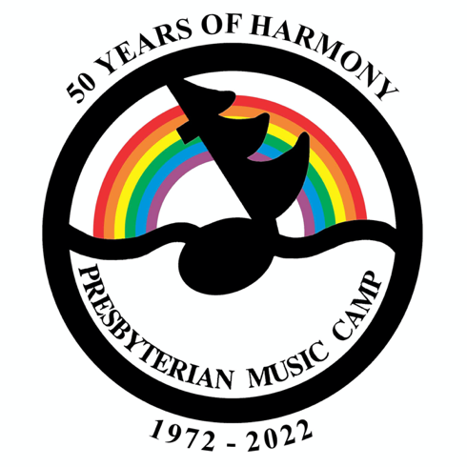PMC 2022

Volunteers Needed

50 Years of Harmony

# **PMC 2022**

2 MONTHS TILL CAMP!!

Dates (in case you don’t know yet): **August 21-28**

**Vaccination** for Covid-19 will be required to attend PMC in 2022 (with medical exemptions, of course). For children under 5: vaccination for this group is not yet approved in Canada. If vaccination becomes available for this group before camp, we’ll figure out how it applies.

We are thrilled to see large numbers of people registering for PMC; lots of returning campers and a number of new campers too! At this point, cabin space is very, very limited. If you requested a solo cabin for just yourself, but might be willing to share with one or two others, would you please email Cathy Whiteside at [pmcregistrar@gmail.com](mailto:pmcregistrar@gmail.com) and let her know? You can even choose your cabin mate(s). Thanks in advance!

## Visitors

Visitors WILL be permitted at camp (Hurray!) provided they:

* Are fully vaccinated
* Can minimize possible exposure to Covid in the week before the visit
* Have a negative rapid test 5 days before the visit and again the day of the visit
* Plan to remain on site for the duration of the visit

Contact Cathy Whiteside ([pmcregistrar@gmail.com](mailto:pmcregistrar@gmail.com)) ahead of time to confirm arrangements for your visit.

Try to plan your visit for Saturday if possible – for the Concert, 50th Anniversary Birthday Party, and the Auction.

## New Camper Meet & Greet

If you are a new camper, or know someone who is new, make sure they know about the New Camper Meet & Greet, on the first day of camp, probably right before dinner.

## Tuckets

Inflation has hit PMC – tuckets will be $0.50 each this year. Prices of tuck items are being adjusted to reflect the new tucket price.

# Volunteers Needed

Please send a message to [presbyterianmusiccamp@gmail.com](mailto:presbyterianmusiccamp@gmail.com) if you can help with 1 or more of the following:

* At Camp: Evening worship (one day), Teen counsellors, Bible Study
* Transportation of things from Toronto to camp (merchandise, hand drums)
* Board members for the 2022-2023 Board

# 

# **50 YEARS OF HARMONY**

## Circle of Love – Our 50th Anniversary Song

If you missed the World Premiere at General Assembly, check out the [YouTube link](Here's%20the%20link:%20https:/www.youtube.com/watch?v=p3eiQ6BnKAg) to see the video and hear the song. And don’t worry – you’ll have lots more chances to hear it at camp!

## Kitchen Parties

Here are the dates again, in case you missed them.

KW/Guelph/Cambridge area: July 9

Toronto area: July 16

Ottawa Valley: July 23 (with overnight!)

See the PMC Discord site, or the last email, for details.

## Auction

You haven’t missed it!

The auction will be on Saturday afternoon at camp, with our auctioneer Carrie Pilgrim.

We can still accommodate auction items. They can be things you buy, things you make, or services you provide.

To donate an item or service to be auctioned, please contact MJ at [presbyterianmusiccamp@gmail.com](mailto:presbyterianmusiccamp@gmail.com).

For donated services: (e.g., babysitting, dinner for 4, planting a garden) specify your radius of travel.

## Home Movies

The 50th anniversary committee is still looking for your home movies to show at camp. Digital is preferred, but we aren’t picky. Contact MJ at [presbyterianmusiccamp@gmail.com](mailto:presbyterianmusiccamp@gmail.com).

## 

## Photos for Scanning

We’ll be scanning old camp photos at camp this year. Please curate your photos – bring the best, leave the rest – and please make a note of who is in the photo (if you remember). Photos can be scanned and given back at camp, or scanned and delivered to you after camp.