

HALMAC API
User Manual

Rev. 1.00g
27 Mar 2018

 | Realtek Semiconductor Corp.  No. 2, Innovation Road II, Hsinchu Science Park, Hsinchu 300, Taiwan  Tel.: +886-3-578-0211. Fax: +886-3-577-6047  www.realtek.com

History 8
Modification 8
Overall Description 9
Design Goal 9
Software Architecture 9
How to Use 10
Platform Dependent Header Files 10
Control Hardware 12
APIs Prototype 13
APIs Initialization 13
IO functions 13
HCI relate function 13
PCIE 13
USB 17
SDIO 17
Common 18
Chip System Initialization 21
Init HALMAC 21
Dbcc_enable 25
Port function 26
AP/MBSSID mode 27
Firmware Download 33
mac_romdl 33
mac_enable_cpu 34
mac_disable_cpu 34
mac_fwdl 34
mac_fwredl 35
Association, de-association Related 36
Role Related 36
BA CAM Entry Setting 46
TRX Related 47
Build TX Desc 47
Parse RX Desc 49
H2C for Outsrc team Usage 51
Process C2H packet 51
RX Forwarding 52
Drop Packet 53
Select HW or SW Tx mode 56
RX filter Related 57
AMSDU Related 63
Header Conversion Related 65
TCP/IP Checksum Offload 67
Security Related 68
Sounding related 70
Get_csi_buffer_index 70
Set_csi_buffer_index 71
Get_snd_sts_index 72
Set_snd_sts_index 73
Init_snd_mer 74
Init_snd_mee 75
CSI_force_rate 76
CSI_RRSC 77
Set_mu_table 77
Set sounding parameter 78
Set_csi_para_reg 79
Set_csi_para_cctl 80
HW_SND_pause_releas 82
Bypass_SND_status 83
Common Settings 83
CMAC Table Setting 84
DMAC Table Setting 84
Shortcut MAC Header Setting 85
HW reg get value 86
HW reg Setting 92
Config PPDU status/Channel info/DFS reports 102
Config FW log 103
GPIO 104
eFuse Access 106
mac_dump_efuse_map_wl 106
mac_dump_efuse_map_bt 107
mac_write_efuse 108
mac_read_efuse 108
mac_get_efuse_avl_size 109
mac_get_efuse_avl_size_bt 109
mac_dump_log_efuse 110
mac_read_log_efuse 111
mac_write_log_efuse 111
mac_dump_log_efuse_bt 112
mac_read_log_efuse_bt 113
mac_write_log_efuse_bt 113
mac_pg_efuse_by_map 114
mac_pg_efuse_by_map_bt 115
mac_mask_log_efuse 116
mac_pg_sec_data_by_map 116
mac_cmp_sec_data_by_map 117
mac_get_efuse_info 117
mac_read_hidden_rpt 118
mac_check_efuse_autoload 119
mac_pg_simulator 119
mac_checksum_update 120
mac_checksum_rpt 120
Debug Package 121
FW command loopback 121
Power Saving Related 122
Configure LPS 122
LPS Power State 123
Check leave LPS 124
Frame Exchange Related 124
Sta init setting 124
Mu frame exchange setting 125
Ru frame exchange setting 126
UL frame exchange setting 127
Fix mode setting 128
Ru frame exchange setting 129
UL frame exchange setting 129
Fix mode setting 130
Firmware Offload Related 131
Reset FW offload state machine 131
Check if FW offload request is done 132
Clear write offload requests 132
Add write offload request 132
Send write offload request 133
Clear read offload requests 134
Add read offload request 134
Send read offload request 135
Read results of read offload 136
Clear config offload requests 136
Add config offload request 137
Send config offload request 137
Offload a packet to FW 138
Delete an offloaded packet 139
Read an offloaded packet from FW 139
Read offload packet sent by FW 140
Send ids of general packets to FW 141
Wowlan Related 141
Keep alive setting 142
Disconnect detect setting 142
Wowlan remote wakeup setting 143
GTK offload setting 144
ARP offload setting 145
NDP offload setting 146
NDP offload setting 147
MCC Related 147
Reset MCC group state machine 148
Reset MCC request state machine 148
Add a MCC role 149
Start a MCC group 149
Stop a MCC group 150
Delete a MCC group 151
Request TSF values 152
Send macid bitmap to a MCC role 152
Sync TSF value of two MCC roles 153
Change duration of a MCC role 154
Read status report of a MCC group 155
Read requested TSF values 155
Check if add MCC done 156
Check if start MCC done 157
Check if stop MCC done 157
Check if delete MCC group done 158
Check if request MCC tsf done 158
Check if set MCC bitmap done 159
Check if enable MCC sync tsf done 159
Check if set MCC duration done 160
Flow Chart 160
Flow Chart - Insert Driver Flow 160
Flow Chart – AP/MBSSID mode init flow 161
Flow Chart - Mac_Hal_Init 162
Flow Chart - Mac_Hal_Deinit 163
Flow Chart – Power Switch Flow 164
Flow Chart – System Initialization Flow 164
Flow Chart – TRX Initialization Flow 164
Flow Chart – mac_port_init Flow 165
Flow Chart – mac_send_bcn_h2c 166
Flow Chart – mac_dbcc_enable Flow 167
Flow chart - mac_romdl 167
Flow chart - mac_fwdl 168
Flow Chart – Dump Wifi eFuse Map 169
Flow Chart – Dump bt eFuse Map 170
Flow Chart – eFuse Write 170
Flow Chart – eFuse Read 171
Flow Chart – Get Available Size of Wifi eFuse 171
Flow Chart – Get Available Size of BT eFuse 171
Flow Chart – Dump Wifi Logical eFuse 172
Flow Chart – Read Wifi Logical eFuse 172
Flow Chart – Write Wifi Logical eFuse 173
Flow Chart – Dump bt Logical eFuse 173
Flow Chart – Read bt Logical eFuse 173
Flow Chart – Write bt Logical eFuse 173
Flow Chart – Program eFuse by Map 174
Flow Chart – Logical eFuse Mask 174
Flow Chart – Program Secure Data by Map 174
Flow Chart – Compare Secure Data by Map 175
Flow Chart – Security add key 175
Flow Chart – Security Del Key 176
Flow Chart – Setting HWAMSDU 177
Flow Chart –Setting RX-AMSDU 177
Flow Charder t –HeaConversion 178
Flow Chart- HW Sequence Number 178
Flow Chart- HW AES IV 179
Flow Chart –TCP/IP checksum 179
Flow Chart- add role 179
Flow Chart- change role 181
Flow Chart- remove role 181
Flow Chart – Security Search key index 182
Flow Chart –H2C for Outsrc team Usage 183
Flow Chart – Process C2H packet 184
Flow Chart – Fill TXDESC 184
Flow Chart – Parse RXDESC 185
Flow Chart – Config GPIO UART TX 186
Flow Chart – Config GPIO UART RX 186
Flow Chart –CMAC/DMAC Table Setting 186
Flow Chart –Setting HW REG value 187
Flow Chart – FW command non-burst loopback 187
Flow Chart – FW command burst loopback 187
Flow Chart –Configure LPS 188
Flow Chart –LPS power state 189
Flow Chart –Check leave LPS 190
Flow Chart –Enable LPS 191
Flow Chart –Disable LPS 192
Flow Chart – Init BA CAM 193
Graph 193
Graph – TXDESC Format 193
Graph – RXDESC Format 194
Graph- CMAC TABLE format 194
Graph- DMAC TABLE format 195
Graph – BA CAM Format 195
State Machine 196
State machine – download FW 196
State machine – Read/write/config offload request buffer 196
State machine – Write/config offload and add/delete offload packet H2C 196
State machine – Read offload and read offload packet H2C 197
State machine – MCC group 198
State machine – MCC request 198

History

Modification

Version | Date | Author | Change
1.00 | 2019/11/17 | kkbomb | First draft
1.01 | 2020/03/09 | kkbomb | Modify outline and structure
1.02 | 2020/05/13 | daniel | Update HCI related API prototype
1.03 | 2020/08/28 | soartu | Update Get/Set HW value API

Overall Description

Design Goal

Halmac provides simple and intuitive APIs to operate hardware. It can prevent users control circuit by setting register directly, which may cause improper use due to hardware design change and no longer suitable for new design.
By halmac APIs, we can also use it to verify hardware or duplicate issues in our verification tool. While bugs are fixed, patch code will be released officially and then users update APIs to resolve issues. That can improve the effectiveness of debug significantly.

Software Architecture
Realtek halmac software architecture is shown in Figure 1.
HDR-COMMON is shared header file between driver and halmac.
HDR-HALMAC is only used in halmac.
HALMAC_11AX is halmac API which the driver should use it to control hardware.

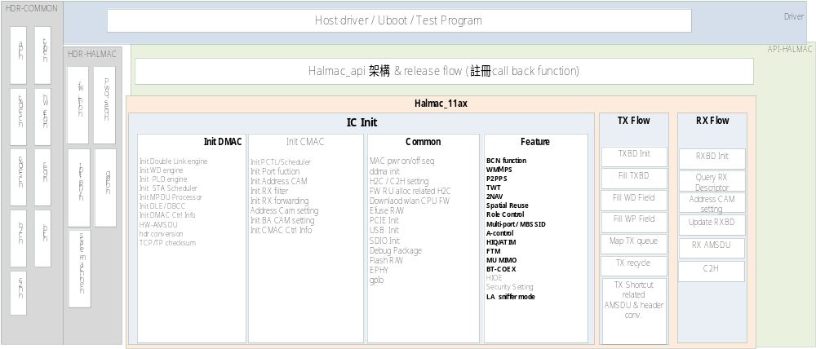
Figure 1. Halmac Software Architecture

Here is the detail of each block shown in Figure 1.
HDR-COMMON
- hw_cfg.h shows supported ICs. The driver can select single IC or multiple ICs support by this file.
- type.h includes APIs prototype and variable type which provide a communication interface between driver and halmac.
- Mac_reg.h, bit.h, txdesc.h, rxdesc.h, h2c.h and c2h.h supply all kinds of macros. Driver and halmac should use these macros to read and write any register and fill TRX DESCRIPTOR/h2c/c2h content.
HDR-HALMAC
- fwcmd.h is a shared header file between halmac and FW, which is used to sync fw version or h2c/c2h handshake information.
- pwr.h is used in power sequence parser.
- gpio.h is used in gpio function parser.
- state_mach.h controls halmac APIs state which includes h2c/c2h state, power state, FW download state, .etc.

How to Use

Platform Dependent Header Files

The driver should maintain two header files, halmac_2_platform.h and halmac_hw_cfg.h.
Halmac_2_platform.h relates to platform features. For example, it is u16 in Linux platform, while it is unsigned short in windows platform. Moreover, it is unsigned int in some embedded platforms. The driver should maintain this file based on each platform property. Please refer Halmac_2_platform_tmp.h shown in Figure 2 or modify it for different platforms accordingly.

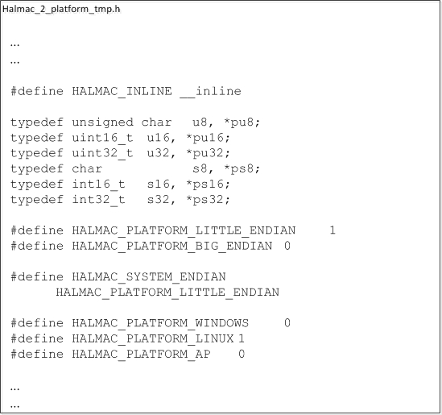
Figure 2. Halmac_2_platform_tmp.h

Halmac_hw_cfg.h is used to select supported ICs. The driver can enable one IC or all supported ICs. Please refer Halmac_hw_cfg_tmp.h in Fig 3. or modify it for different platforms accordingly.
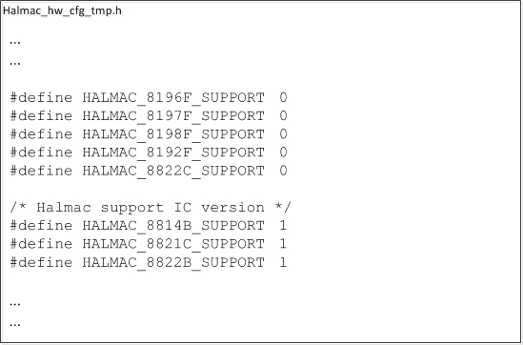
Figure 3. Halmac_hw_cfg_tmp.h

Control Hardware

The driver should include halmac_api.h. After including the header file(s) in, the interface between driver and halmac is constructed. Then driver should initialize halmac.

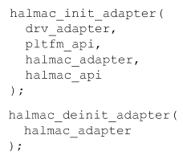
Figure 4. Halmac APIs initialization

It uses halmac_init_adapter and halmac_deinit_adapter API to initialize and de-initialize halmac. The following are parameters descriptions.
- drv_adapter: Halmac uses pointer of driver adapter when using platform dependent APIs (pltfm_api).
- pltfm_api: Halmac is platform independent module. Therefore, driver should provide platform related functions, register read/write, packet transmit/receive, msg print, memory copy, mutex, .etc to halmac.
- halmac_a papter: Halmac returns adapter address. The driver should forward it when using other halmac APIs.
- halmac_api: Driver can use all functions in this structure to control hardware.

After halmac APIs initialization, the driver can use APIs to control circuit. Please refer to APIs Initialization for more details in APIs Initialization

APIs Prototype

APIs Initialization
For driver setting halmac ops in initialize stage
Description | Switch for each power state
Synopsis | mac_ax_ops_init(void *drv_adapter, struct mac_ax_pltfm_cb *pltfm_cb,  enum mac_ax_intf intf,  struct mac_ax_adapter **mac_adapter,  struct mac_ax_ops **mac_ops)
Arguments | drv_adapter (IN)  pltfm_cb (IN) platfm_cb for message print  intf(IN) HCI interface  mac_adapter (OUT) mac_adapter  mac_ops (OUT) halmac ops for driver use
Returns  (Error Code) | MACPFCB 1 /* Callback of platform is null */  MACPFED 2 /* Endian of platform error */  MACADAPTER 7 /* Can not get MAC adapter */
Returns  (Status Code) | return 0 Successful operation.
API Flow chart | Flow Chart - Insert Driver Flow
State Machine | None
Test scenario | None

The driver should initialize MAC in these halmac APIs sequence, here are the flow chart for the currently Bitfile & FW. (20191120)

IO functions

HCI relate function
PCIE

pcie_pre_init
PCIe pre initial settings
Description | - PCIe related workaround  - Debug function enable  - TRX mode settings  - Initialize TRX BD  - Reset BD RAM  - Enable DMA CH12  - Enable TRX DMA master switch
Synopsis | u32 pcie_pre_init(struct mac_ax_adapter *adapter, void *param);
Arguments | adapter (IN)  mac_ax_adapter  info (IN)  mac_ax_intf_info
Returns  (Error Code) | MACPOLLTO  Polling time out  MACNPTR  Pointer is null  MACNOITEM  Invalid item  MACCHIPID  Chip ID is undefined  MACBADDR  Invalid base address  MACFUNCINPUT  Invalid function input  MACHWNOSUP  Hw not support
Returns  (Status Code) | MACSUCCESS  Successful operation.
API Flow chart
State Machine | None
Test scenario | None

pcie_init
PCIe initial settings
Description | - Handle TX BD truncate mode  - Enable TX channels
Synopsis | u32 pcie_init(struct mac_ax_adapter *adapter, void *param);
Arguments | adapter (IN)  mac_ax_adapter  info (IN)  mac_ax_intf_info
Returns  (Error Code) | MACNPTR  Pointer is null
Returns  (Status Code) | MACSUCCESS  Successful operation.
API Flow chart
State Machine | None
Test scenario | None

pcie_deinit
PCIe de-initial settings
Description | - PCIE enter L1 workaround for 8852A A-cut  - Disable TRX DMA master switch  - Clear TRX BD RW pointer
Synopsis | u32 pcie_deinit(struct mac_ax_adapter *adapter, void *param);
Arguments | adapter (IN)  mac_ax_adapter  info (IN)  void
Returns  (Error Code) | MACNPTR  Pointer is null
Returns  (Status Code) | MACSUCCESS  Successful operation.
API Flow chart
State Machine | None
Test scenario | None

ltr_set_pcie
PCIe set LTR value
Description | - LTR function enable  - Set LTR space  - Set LTR idle timer  - Set LTR rx0/rx1 threshold  - Set LTR idle latency  - Set LTR active latency
Synopsis | u32 ltr_set_pcie(struct mac_ax_adapter *adapter,  struct mac_ax_pcie_ltr_param *param);
Arguments | adapter (IN)  mac_ax_adapter  param (IN)  mac_ax_pcie_ltr_param  sugetion setting:  struct mac_ax_pcie_ltr_param ltr_param = {  1,  0,  MAC_AX_PCIE_DEFAULT,  MAC_AX_PCIE_LTR_SPC_DEF,  MAC_AX_PCIE_LTR_IDLE_TIMER_DEF,  {MAC_AX_PCIE_DEFAULT, 0x28},  {MAC_AX_PCIE_DEFAULT, 0x28},  {MAC_AX_PCIE_ENABLE, 0xXXXXXXXX},  {MAC_AX_PCIE_ENABLE, 0xXXXXXXXX}  };
Returns  (Error Code) | MACCMP  Failed compare result
Returns  (Status Code) | MACSUCCESS  Successful operation.
API Flow chart
State Machine | None
Test scenario | None

ltr_sw_trigger
PCIe SW trigger LTR
Description | PCIe SW trigger LTR.
Synopsis | u32 ltr_sw_trigger(struct mac_ax_adapter *adapter,  enum mac_ax_pcie_ltr_sw_ctrl ctrl);
Arguments | adapter (IN)  mac_ax_adapter  ctrl (IN)  enum mac_ax_pcie_ltr_sw_ctrl  MAC_AX_PCIE_LTR_SW_ACT  MAC_AX_PCIE_LTR_SW_IDLE
Returns  (Error Code) | MACFUNCINPUT  Invalid function input
Returns  (Status Code) | MACSUCCESS  Successful operation.
API Flow chart
State Machine | None
Test scenario | None

pcie_trx_mit
PCIe set TRX mitigation value
Description | Set PCIe TRX mitigation for TRX interrupt
Synopsis | u32 pcie_trx_mit(struct mac_ax_adapter *adapter, struct mac_ax_pcie_trx_mitigation *mit_info);
Arguments | adapter (IN)  mac_ax_adapter  param (IN)  mac_ax_pcie_trx_mitigation  - txch_map: Select the channels to join TX mitigation. Value is MAC_AX_PCIE_DISABLE or MAC_AX_PCIE_ENABLE  - tx_timer_unit: Select TX mitigation timer unit.  - tx_timer: Set TX mitigation timer value. The actually timer is calculated by tx_timer * tx_timer_unit.  - tx_counter: Set TX mitigation counter value.  - rxch_map: Select the channels to join RX mitigation. Value is MAC_AX_PCIE_DISABLE or MAC_AX_PCIE_ENABLE  - rx_timer_unit: Select RX mitigation timer unit.  - rx_timer: Set RX mitigation timer value. The actually timer is calculated by rx_timer * rx_timer_unit.  - rx_counter: Set RX mitigation counter value.  Note: If someone wants close PCIe TX mitigation, just sets both tx_timer and tx_counter to 0. Same with PCIe RX mitigation.
Returns
(Error Code)
Returns  (Status Code) | MACSUCCESS  Successful operation.
API Flow chart
State Machine | None
Test scenario | None
USB

usb_pre_init
USB pre initial settings
Description | - USB related workaround  - Check USB endpoint number
Synopsis | u32 usb_pre_init(struct mac_ax_adapter *adapter, void *param);
Arguments | adapter (IN)  mac_ax_adapter  info (IN)  mac_ax_intf_info
Returns
(Error Code)
Returns  (Status Code) | MACSUCCESS  Successful operation.
API Flow chart
State Machine | None
Test scenario | None

usb_init
USB initial settings
Description | - USB related workaround  - Get USB max wd number  - Set PLD bulk size
Synopsis | u32 usb_init(struct mac_ax_adapter *adapter, void *param);
Arguments | adapter (IN)  mac_ax_adapter  info (IN)  mac_ax_intf_info
Returns
(Error Code)
Returns  (Status Code) | MACSUCCESS  Successful operation.
API Flow chart
State Machine | None
Test scenario | None

usb_flush_mode
USB flush mode
Description | USB flush mode enable/USB flush mode disable
Synopsis | u32 usb_flush_mode(struct mac_ax_adapter *adapter, u8 mode);
Arguments | adapter (IN)  mac_ax_adapter  mode (IN)  MAC_AX_FUNC_DIS/ MAC_AX_FUNC_EN
Returns  (Error Code) | MACLV1STEPERR=71  Polling timeout.
Returns  (Status Code) | MACSUCCESS  Successful operation.
API Flow chart
State Machine | None
Test scenario | None

usb_init
USB initial settings
Description | - USB related workaround  - Get USB max wd number  - Set PLD bulk size
Synopsis | u32 usb_init(struct mac_ax_adapter *adapter, void *param);
Arguments | adapter (IN)  mac_ax_adapter  info (IN)  mac_ax_intf_info
Returns
(Error Code)
Returns  (Status Code) | MACSUCCESS  Successful operation.
API Flow chart
State Machine | None
Test scenario | None

u2u3_switch
USB2.0/USB3.0 switch
Description | USB2.0/USB3.0 switch
Synopsis | u32 u2u3_switch(struct mac_ax_adapter *adapter)
Arguments | adapter (IN)  mac_ax_adapter
Returns
(Error Code)
Returns  (Status Code) | MACSUCCESS  Successful operation.
API Flow chart | In USB2.0 switch to USB3.0.  In USB3.0 switch to USB2.0.
State Machine | None
Test scenario | None

get_usb_mode
Get USB mode
Description | Check USB1.1/USB2.0/USB3.0
Synopsis | u32 get_usb_mode(struct mac_ax_adapter *adapter)
Arguments | adapter (IN)  mac_ax_adapter
Returns
(Error Code)
Returns  (Status Code) | USB11 0x1  USB2 0x2  USB3 0x3
API Flow chart
State Machine | None
Test scenario | None

get_usb_mode
Get USB mode
Description | Check USB1.1/USB2.0/USB3.0
Synopsis | u32 get_usb_mode(struct mac_ax_adapter *adapter)
Arguments | adapter (IN)  mac_ax_adapter
Returns
(Error Code)
Returns  (Status Code) | USB11 0x1  USB2 0x2  USB3 0x3
API Flow chart
State Machine | None
Test scenario | None

get_usb_support_ability
Get USB support ability
Description | Check USB force or switch mode
Synopsis | u32 get_usb_support_ability(struct mac_ax_adapter *adapter)
Arguments | adapter (IN)  mac_ax_adapter
Returns
(Error Code)
Returns  (Status Code) | SWITCHMODE 0x2  FORCEUSB3MODE 0x1  FORCEUSB2MODE 0x0
API Flow chart
State Machine | None
Test scenario | None

usb_tx_agg_cfg
Set USB txagg num
Description | Set USB txagg number
Synopsis | u32 usb_tx_agg_cfg(struct mac_ax_adapter *adapter,  struct mac_ax_usb_tx_agg_cfg *agg)
Arguments | adapter (IN)  mac_ax_adapter  mac_ax_usb_tx_agg_cfg  u8 *pkt;  u32 agg_num;
Returns
(Error Code)
Returns  (Status Code) | MACSUCCESS  Successful operation.
API Flow chart
State Machine | None
Test scenario | None

usb_tx_agg_cfg
Set USB txagg num
Description | Set USB txagg number
Synopsis | u32 usb_tx_agg_cfg(struct mac_ax_adapter *adapter,  struct mac_ax_usb_tx_agg_cfg *agg)
Arguments | adapter (IN)  mac_ax_adapter  mac_ax_usb_tx_agg_cfg  u8 *pkt;  u32 agg_num;
Returns
(Error Code)
Returns  (Status Code) | MACSUCCESS  Successful operation.
API Flow chart
State Machine | None
Test scenario | None

usb_rx_agg_cfg
Set USB rxagg config
Description | Set USB rxagg config
Synopsis | u32 usb_rx_agg_cfg(struct mac_ax_adapter *adapter,  struct mac_ax_rx_agg_cfg *cfg)
Arguments | adapter (IN)  mac_ax_adapter  mac_ax_rx_agg_cfg  enum mac_ax_rx_agg_mode mode;  MAC_AX_RX_AGG_MODE_NONE,  MAC_AX_RX_AGG_MODE_DMA,  MAC_AX_RX_AGG_MODE_USB,  struct mac_ax_rx_agg_thold thold;  u8 drv_define;  u8 timeout= rxagg timeout value  u8 size = rxagg max szie  u8 pkt_num = rxagg packet number
Returns
(Error Code)
Returns  (Status Code) | MACSUCCESS  Successful operation.
API Flow chart
State Machine | None
Test scenario | None

set_usb_wowlan
Set USB WOWLan config
Description | Set USB WOWLan config
Synopsis | u32 set_usb_wowlan(struct mac_ax_adapter *adapter,  enum mac_ax_wow_ctrl w_c)
Arguments | adapter (IN)  mac_ax_adapter  mac_ax_wow_ctrl  MAC_AX_WOW_ENTER,  MAC_AX_WOW_LEAVE
Returns  (Error Code) | MACFUNCINPUT=46  /* invalid function input */
Returns  (Status Code) | MACSUCCESS  Successful operation.
API Flow chart
State Machine | None
SDIO

tx_allow_sdio
SDIO allow tx with enough space
Description | Check free space is enough or not for requested page number calculated from mac_ax_sdio_tx_info.
Synopsis | u32 tx_allow_sdio(struct mac_ax_adapter *adapter,  struct mac_ax_sdio_tx_info *info);
Arguments | adapter (IN)  mac_ax_adapter  info (IN)  mac_ax_sdio_tx_info
Returns
(Error Code)
Returns  (Status Code) | MACSUCCESS  Successful operation.
API Flow chart
State Machine | None
Test scenario | None

tx_cmd_addr_sdio
Get command address for tx
Description | Get command address with mac_ax_sdio_tx_info to transmit.
Synopsis | u32 tx_cmd_addr_sdio(struct mac_ax_adapter *adapter,  struct mac_ax_sdio_tx_info *info,  u32 *cmd_addr);
Arguments | adapter (IN)  mac_ax_adapter  info (IN)  mac_ax_sdio_tx_info  cmd_addr (OUT)  command address
Returns
(Error Code)
Returns  (Status Code) | MACSUCCESS  Successful operation.
API Flow chart
State Machine | None
Test scenario | None

reg_read_n_sdio
Read value with assigned size
Description | Read value with assigned size and address by command 53.
Synopsis | u32 reg_read_n_sdio(struct mac_ax_adapter *adapter, u32 adr,  u32 size,  u8 *val);
Arguments | adapter (IN)  mac_ax_adapter  adr (IN)  register address  size (IN)  assign size of output val  val (OUT)  Read value
Returns
(Error Code)
Returns  (Status Code) | MACSUCCESS  Successful operation.
API Flow chart
State Machine | None
Test scenario | None
Common

reg_read8_sdio/usb/pcie
Read 1 byte value
Description | Read 1 byte value with assigned address.
Synopsis | u8 reg_read8_sdio/usb/pcie (  struct mac_ax_adapter *adapter,  u32 adr);
Arguments | adapter (IN)  mac_ax_adapter  adr (IN)  register address
Returns
(Error Code)
Returns  (Status Code) | val8  read value
API Flow chart
State Machine | None
Test scenario | None

reg_write8_sdio/usb/pcie
Write 1 byte value
Description | Write 1 byte value with assigned address.
Synopsis | void reg_write8_sdio/usb/pcie (  struct mac_ax_adapter *adapter,  u32 adr,  u8 val);
Arguments | adapter (IN)  mac_ax_adapter  adr (IN)  register address  val (IN)  write value
Returns
(Error Code)
Returns
(Status Code)
API Flow chart
State Machine | None
Test scenario | None

reg_read16_sdio/usb/pcie
Read 2 bytes value
Description | Read 2 bytes value with assigned address.
Synopsis | u16 reg_read16_sdio/usb/pcie (  struct mac_ax_adapter *adapter,  u32 adr);
Arguments | adapter (IN)  mac_ax_adapter  adr (IN)  register address
Returns
(Error Code)
Returns  (Status Code) | val16  read value
API Flow chart
State Machine | None
Test scenario | None

reg_write16_sdio/usb/pcie
Write 2 bytes value
Description | Write 2 bytes value with assigned address.
Synopsis | void reg_write16_sdio/usb/pcie (  struct mac_ax_adapter *adapter,  u32 adr,  u16 val);
Arguments | adapter (IN)  mac_ax_adapter  adr (IN)  register address  val (IN)  write value
Returns
(Error Code)
Returns
(Status Code)
API Flow chart
State Machine | None
Test scenario | None

reg_read32_sdio/usb/pcie
Read 4 bytes value
Description | Read 4 bytes value with assigned address.
Synopsis | u32 reg_read32_sdio/usb/pcie (  struct mac_ax_adapter *adapter,  u32 adr);
Arguments | adapter (IN)  mac_ax_adapter  adr (IN)  register address
Returns
(Error Code)
Returns  (Status Code) | val32  read value
API Flow chart
State Machine | None
Test scenario | None

reg_write32_sdio/usb/pcie
Write 4 bytes value
Description | Write 4 bytes value with assigned address.
Synopsis | void reg_write32_sdio/usb/pcie (  struct mac_ax_adapter *adapter,  u32 adr,  u16 val);
Arguments | adapter (IN)  mac_ax_adapter  adr (IN)  register address  val (IN)  write value
Returns
(Error Code)
Returns
(Status Code)
API Flow chart
State Machine | None
Test scenario | None

Chip System Initialization
Init HALMAC

mac_hal_init
For Power on / off sequence
Description | Switch for each power state
Synopsis | u32 mac_hal_init(struct mac_ax_adapter *adapter,  struct mac_ax_trx_info *trx_info,  struct mac_ax_fwdl_info *fwdl_info,  struct mac_ax_intf_info *intf_info);
Arguments | adapter (IN)  mac_ax_adapter  mac_ax_trx_info (IN)  enum mac_ax_trx_mode trx_mode;  enum mac_ax_qta_mode qta_mode;  mac_ax_fwdl_info (IN)  u8 fw_en;  u8 dlrom_en;  u8 dlram_en;  u8 *rom_buff;  u32 rom_addr;  u32 rom_size;  u8 *ram_buff;  u32 ram_size;  mac_ax_intf_info (IN)  u8 rsvd;
Returns  (Error Code) | MACALRDYON 47 /* MAC has already powered on */  MACNOITEM 11 /* Invalid item / [ERR]cut version or [ERR]interface  MACPWRSW 13 /* Power switch fail */
Returns  (Status Code) | return 0 Successful operation.
API Flow chart | Flow Chart - Mac_Hal_Init
State Machine | None
Test scenario | None

mac_hal_deinit
For Power on / off sequence
Description | Switch for each power state
Synopsis | u32 mac_hal_deinit(struct mac_ax_adapter *adapter)
Arguments | adapter (IN)  mac_ax_adapter  u8 (IN)  on: for power on / off selection
Returns  (Error Code) | MACNOITEM 11 /* Invalid item / [ERR]cut version or [ERR]interface  MACPWRSW 13 /* Power switch fail */
Returns  (Status Code) | return 0 Successful operation.
API Flow chart | Flow Chart - Mac_Hal_Deinit
State Machine | None
Test scenario | None

Power switch flow

For Power on / off sequence
Description | Switch for each power state
Synopsis | u32 mac_pwr_switch  (struct mac_ax_adapter *adapter, u8 on);
Arguments | adapter (IN)  mac_ax_adapter  u8 (IN)  on: for power on / off selection
Returns  (Error Code) | MACALRDYON 47 /* MAC has already powered on */  MACNOITEM 11 /* Invalid item / [ERR]cut version or [ERR]interface  MACPWRSW 13 /* Power switch fail */
Returns  (Status Code) | return 0 Successful operation.
API Flow chart | Flow Chart – Power Switch Flow
State Machine | None
Test scenario | 待補充

System init flow

Init DMAC/CMAC function for all settings
Description | DMAC/CMAC function initialization
Synopsis | u32 mac_sys_init  (struct mac_ax_adapter *adapter)
Arguments | adapter (IN)  Halmac adapter.
Returns  (Error Code) | None
Returns  (Status Code) | return 0 Successful operation
API Flow chart | Flow Chart – System Initialization Flow
State Machine | None
Test scenario | 待補充

TRX init flow

Init TRX settings
Description | TRX initialization.
Synopsis | u32 mac_trx_init (struct mac_ax_adapter *adapter, struct mac_ax_trx_info *info)
Arguments | adapter (IN)  Halmac adapter.  Info (IN)  trx_mode :  MAC_AX_TRX_NORMAL,  MAC_AX_TRX_LOOPBACK,  qta_mode  MAC_AX_QTA_SCC, //for PCIE payload on host & USB & SDIO  MAC_AX_QTA_DBCC, //for PCIE payload on host & USB & SDIO  MAC_AX_QTA_SCC_WD128, //for PCIE payload on host with WD page unit 128 bytes  MAC_AX_QTA_DBCC_WD128, //for PCIE payload on host with WD page unit 128 bytes  MAC_AX_QTA_SCC_STF, //for PCIE STF mode  MAC_AX_QTA_DBCC_STF, //for PCIE STF mode  MAC_AX_QTA_SU_TP //for test only  u32 macid_band0_31: macid index for 0~31  u32 macid_band32_63: macid index for 32~63  u32 macid_band64_95: macid index for 64~95  u32 macid_band96_127 : macid index for 96~127
Returns
(Error Code)
Returns  (Status Code) | return 0 : Successful operation  return !=0 : Fail operation
Flow Chart | Flow Chart – TRX Init flow
State Machine | None

Dbcc_enable
Dynamic enable/disable DBCC mode
Description | Dynamic enable/disable DBCC flow
Synopsis | u32 mac_dbcc_enable(  struct mac_ax_adapter *adapter,  struct mac_ax_trx_info *info, u8 dbcc_en)
Arguments | adapter (IN)  Halmac adapter.  Info (IN)  trx_mode :  MAC_AX_TRX_NORMAL,  MAC_AX_TRX_LOOPBACK,  qta_mode  MAC_AX_QTA_SCC, //for PCIE payload on host & USB & SDIO  MAC_AX_QTA_DBCC, //for PCIE payload on host & USB & SDIO  MAC_AX_QTA_SCC_WD128, //for PCIE payload on host with WD page unit 128 bytes  MAC_AX_QTA_DBCC_WD128, //for PCIE payload on host with WD page unit 128 bytes  MAC_AX_QTA_SCC_STF, //for PCIE STF mode  MAC_AX_QTA_DBCC_STF, //for PCIE STF mode  MAC_AX_QTA_SU_TP //for test only  u32 macid_band0_31: macid index for 0~31  u32 macid_band32_63: macid index for 32~63  u32 macid_band64_95: macid index for 64~95  u32 macid_band96_127 : macid index for 96~127  Dbcc_en (IN)  1 : enable DBCC mode  0 : disable DBCC mode
Returns  (Error Code) | None
Returns  (Status Code) | return 0 : Successful operation  return !=0 : Fail operation
Flow Chart | Flow Chart – mac_dbcc_enable Flow
State Machine | None
Test scenario | 待補充

Port function
Init port related control register
Description | Init port related control register
Synopsis | u32 mac_port_init(  struct mac_ax_adapter *adapter,  struct mac_ax_port_init_para *para)
Arguments | adapter (IN)  Halmac adapter.  para (IN)  net_type :  MAC_AX_NO_LINK,  MAC_AX_ADHOC,  MAC_AX_INFRA,  MAC_AX_AP  hiq_win : hiq window time (TU)  dtim_period : bcn dtim period  mbid_num : port0 MBSSID number (0~15)  bcn_interval: the interval of beacon  port_idx  MAC_AX_PORT_0 = 0,  MAC_AX_PORT_1 = 1,  MAC_AX_PORT_2 = 2,  MAC_AX_PORT_3 = 3,  MAC_AX_PORT_4 = 4,  band_idx  MAC_AX_BAND_0 = 0,  MAC_AX_BAND_1 = 1,
Returns  (Error Code) | None
Returns  (Status Code) | return 0 : Successful operation
Flow Chart | Flow Chart – mac_port_init Flow
State Machine | None
Test scenario | 待補充

AP/MBSSID mode

Add role - AP
Add Role
Description | Function: for driver to prepare connection.  When to use:  - STA: After TRX initialization, add a role with NET_TYPE = NO_LINK and which will be changed to NET_TYPE = INFRA by using mac_change_role later.  - AP: add role when there is a STA connected.
Synopsis | u32 (*mac_add_role)(  struct mac_ax_adapter *adapter,  struct mac_ax_role_info *info  )
Arguments | adapter (IN)  mac_ax_adapter  info (IN)  struct mac_ax_role_info  u8 macid;  - Description: The role corresponds to which macid.  - Value: 8 bit, 0x0 ~0x7F  u8 band;  - Description: 1 bit, the role corresponds to band0 or band1.  - Value: band0 = 0x0, band1 = 0x1  u8 wmm;  - Description: The role corresponds to which wmm.  - Value: 2 bits, 0x0 ~0x3  u8 net_type;  - Description: The role is NO_LINK, AD_HOC, INFRA or AP.  - Value: 2bits, NO_LINK =0x 0, AD_HOC = 0x1, INFRA = 0x2, AP = 0x3.  u8 self_mac[6];  - Description: The role’s mac address.  - Value: 48bits.  u8 target_mac[6];  - Description: The mac address of which the role connected with.  - Value: 48bits.  u8 bssid[6];  - Description: The BSSID of which the role within.  - Value: 48bit.  u8 bss_color;  - Description: The role corresponds to which bss color.  - Value: 6 bit, 0~63  u8 bcn_hit_cond;  - Description: RX beacon or probe response address compare rule for the role.  - Value: 2 bits,  - beacon hit rule:  0x0: A3 hit.  0x1: A2 hit.  0x2: A2 & A3 hit.  0x 3: A2 | A3 hit.  - Probe response hit rule:  0x0: A1 & A3 hit.  0x1: A1 & A2 hit.  0x2: A1 & A2 & A3 hit.  0x 3: A1 & (A2 | A3) hit.  u8 hit_rule;  - Description: RX packet (except beacon and probe response) address compare rule for the role.  - Value: 2 bits,  0: A1 & A2 hit.  1: A1 & A3 hit.  u8 port_int;  - Description:  Trigger interrupt to PORT 0x0~0x4.  note: HW will ignore PORT 0x5~0x7.  note: PORT_INT can different with TSF_SYNC.  - Value: 3 bits, 0x0~0x4  u8 tsf_sync;  - Description:  Sync TSF to PORT 0x0~0x4.  note: HW will ignore PORT 0x5~0x7.  note: TSF_SYNC can different with PORT_INT.  - Value: 3 bits, 0x0~0x4  u8 trigger;  - Description:  Indicate whether this role supports TF and TRS or not.  - Value: 1 bit, 1: Support, 0: Not support.  u8 lsig_txop;  - Description:  Indicate whether this role supports LSIG_TXOP or not.  - Value: 1 bit, 1: Support, 0: Not support.  u8 tgt_ind;  - Description:  Determine which target the received packet will send to. Only valid when FRM_TARGET_IND != 0.  - Value: 3 bits,  Bit0: Send to the host driver. 0x1: Enable, 0x0: Disable.  Bit1: Send to WLAN CPU. 0x1: Enable, 0x0: Disable.  Bit2: Send to the driver. 0x1: Enable, 0x0: Disable.  u8 frm_tgt_ind;  - Description:  Indicate the target of the received packet according to the frame type. See TGT_IND to know the target.  - Value: 3 bits,  Bit0: Management packet. 0x1: Depend on TGT_IDC, 0x0: Don't care (Depend on the register).  Bit1: Control packet. 0x1: Depend on TGT_IDC, 0x0: Don't care (Depend on the register).  Bit2: Data packet. 0x1: Depend on TGT_IDC, 0x0: Don't care (Depend on the register).  u8 wol_pattern;  - Description: Indicate pattern match function of WOL is enabled or not.  - Value: 1 bit, 0: Disable, 1: Enable  u8 wol_uc;  - Description: Indicate unicast packet function of WOL is enabled or not.  - Value: 1 bit, 0: Disable, 1: Enable  u8 wol_magic;  - Indicate magic packet function of WOL is enabled or not.  - Value: 1 bit, 0: Disable, 1: Enable  u8 sec_ent_mode;  - Description: Indicate SEC_ENT0~SEC_ENT5 definition.  - Value: 2 bits,  0x1: SEC_ENT0~SEC_ENT6.  0x 2: Unicast -- SEC_ENT0~SEC_ENT1,  Group -- SEC_ENT2~SEC_ENT4,  BIP -- SEC_ENT5~SEC_ENT6  0x 3: Unicast -- SEC_ENT0~SEC_ENT1,  Group -- SEC_ENT2~SEC_ENT5  BIP -- SEC_ENT6  u16 aid;  - Description: Indicate aid of the role.  - Value: 16 bits. 0x0~ 0xFFFF.  struct mac_ax_addr_cam_info a_info;  - Description: the structure maintains info of address cam entry for the role, which should not be directly modified by driver. For example, if driver want to specify hit_rule of the role, driver should set role_info.hit_rule = hit_rule rather than set role_info.a_info.hit_rule = hit_rule.  struct mac_ax_bssid_cam_info b_info;  - Description: the structure maintains info of bssid cam entry for the role, which should not directly modify by driver. For example, if driver want to specify bssid of the role, driver should set role_info.bssid[6] = bssid[6] rather than set role_info.b_info.bssid[6] = bssid[6].  struct mac_ax_sec_cam_info s_info;  - Description: the structure maintains info of security cam entry for the role. The usage of sec cam entry can reference to security cam entry related API
Returns  (Error Code) | return MACNOITEM: Role info is null.  return MACSAMACID: Existing macid.  return MACMACIDFL: Full macid.  return MACROLEINITFL: Role init failed.  return MACADDRCAMFL: ADDRESS CAM full.  return MACBSSIDCAMFL: BSSID CAM full.  return MACBUFALLOC: Buffer allocate full.
Returns  (Status Code) | return MACSUCCESS: Successful operation.
API Flow chart | Flow chart- Add role
State Machine | None
Test scenario | None

Send offload Beacon to FW
mac_pkt_ofld_packet
Description | Send the Beacon to FW by H2C
Synopsis | u32 mac_send_bcn_h2c(struct mac_ax_adapter *adapter,  struct mac_ax_bcn_info *info)
Arguments | adapter (IN)  mac_ax_adapter  info (IN)  u8 port;  u8 mbssid;  u8 band;  u8 grp_ie_ofst;  u8 macid;  u8 ssn_sel;  u8 ssn_mode;  u16 rate_sel;  u8 txpwr;  u8 txinfo_ctrl_en;  u8 ntx_path_en;  u8 path_map_a;  u8 path_map_b;  u8 path_map_c;  u8 path_map_d;  u8 antsel_a;  u8 antsel_b;  u8 antsel_c;  u8 antsel_d;  u8 sw_tsf;  u8 *pld_buf;  u16 pld_len;
Returns  (Error Code) | MACNPTR 5 /* Pointer is null */  - Malloc fail  MACNOBUF 9 /* Buffer space is not enough */  - h2cb_alloc()fail  MACFWNONRDY 80 /* FW not ready h2c error*/  - MAC FW not ready for H2C, send H2C fail
Returns  (Status Code) | return 0 Successful operation.
API Flow chart | Flow Chart – mac_send_bcn_h2c
State Machine
Test scenario | None

Port init – AP mode
Init port related control register
Description | Init AP mode and MBSSID flow
Synopsis | u32 mac_port_init(  struct mac_ax_adapter *adapter,  struct mac_ax_port_init_para *para)
Arguments | adapter (IN)  Halmac adapter.  para (IN)  net_type :  MAC_AX_NO_LINK,  MAC_AX_ADHOC,  MAC_AX_INFRA,  MAC_AX_AP  hiq_win : hiq window time (TU)  dtim_period : bcn dtim period  mbid_num : port0 MBSSID number (0~15)  bcn_interval: the interval of beacon  port_idx  MAC_AX_PORT_0 = 0,  MAC_AX_PORT_1 = 1,  MAC_AX_PORT_2 = 2,  MAC_AX_PORT_3 = 3,  MAC_AX_PORT_4 = 4,  band_idx  MAC_AX_BAND_0 = 0,  MAC_AX_BAND_1 = 1,
Returns  (Error Code) | None
Returns  (Status Code) | return 0 : Successful operation
Flow Chart | Flow Chart – mac_port_init Flow
State Machine | None
Test scenario | 待補充

Firmware Download

mac_romdl

Download ROM code
Description | Use filter mode to write FW ROM code to IROM
Synopsis | u32 mac_romdl(struct mac_ax_adapter *adapter, u8 *ROM, u32 ROM_addr, u32 len)
Arguments | adapter (IN)  Halmac adapter.  ROM (IN)  Pointer to FW ROM code buffer  ROM_addr (IN)  Physical start address of IROM  len (IN)  Total length of FW ROM code
Returns  (Error Code) | MACMEMRO  IROM is read-only.
Returns  (Status Code) | MACSUCCESS  Successful operation.
Flow Chart | Flow Chart – mac_romdl
State Machine | None

mac_enable_cpu
Enable FW CPU
Description | Set FW boot reason and enable FW CPU
Synopsis | u32 mac_enable_cpu(struct mac_ax_adapter *adapter, u8 boot_reason, u8 dlfw)
Arguments | adapter (IN)  Halmac adapter.  boot_reason (IN)  The reason of FW booting, current available reasons:  AX_BOOT_REASON_PWR_ON: chip power on  AX_BOOT_REASON_WDT: chip is reset by watchdog timer  AX_BOOT_REASON_LPS: FW leaves PG-LPS  dlfw (IN)  ROM code enters DL FW flow is the value of dlfw is not zero.
Returns  (Error Code) | MACCPUSTATE  CPU has been enabled.  MACPROCERR  DL FW state machine is in incorrect state.
Returns  (Status Code) | MACSUCCESS  Successful operation.
Flow Chart | None
State Machine | State machine – download FW

mac_disable_cpu
Disable FW CPU
Description | Reset DL FW state machine and disable FW CPU
Synopsis | u32 mac_disable_cpu(struct mac_ax_adapter *adapter)
Arguments | adapter (IN)  Halmac adapter.
Returns  (Error Code) | None
Returns  (Status Code) | MACSUCCESS  Successful operation.
Flow Chart | None
State Machine | State machine – download FW

mac_fwdl
Download FW to chip
Description | Load FW binary and download FW to chip
Synopsis | u32 mac_fwdl(struct mac_ax_adapter *adapter, u8 *fw, u32 len)
Arguments | adapter (IN)  Halmac adapter.  fw (IN)  Pointer to FW binary buffer.  len (IN)  Total length of FW binary.
Returns  (Error Code) | MACFWBIN  FW binary length does not equal total section length in FW header  MACPROCERR  FW DL state machine is in incorrect state  MACPOLLTO  Wait H2C path/DLFW path/FW initial ready timeout  MACNPTR  MACNOBUF  Memory allocation is fail  MACFWCHKSUM  FW checksum fail  MACFWSECBOOT  FW secure boot fail  MACFWCUT  FW cut id in FW header does not match chip cut id
Returns  (Status Code) | MACSUCCESS  Successful operation.
Flow Chart | Flow chart - mac_fwdl
State Machine | State machine – download FW

mac_fwredl
Download FW power off sections to chip
Description | Load FW binary and download power off sections to chip
Synopsis | u32 mac_fwredl(struct mac_ax_adapter *adapter, u8 *fw, u32 len)
Arguments | adapter (IN)  Halmac adapter.  fw (IN)  Pointer to FW binary buffer.  len (IN)  Total length of FW binary.
Returns  (Error Code) | MACFWBIN  FW binary length does not equal total section length in FW header  MACPROCERR  FW DL state machine is in incorrect state  MACPOLLTO  Wait H2C path/DLFW path/FW initial ready timeout  MACNPTR  MACNOBUF  Memory allocation is fail  MACFWCHKSUM  FW checksum fail  MACFWSECBOOT  FW secure boot fail  MACFWCUT  FW cut id in FW header does not match chip cut id
Returns  (Status Code) | MACSUCCESS  Successful operation.
Flow Chart | Flow chart - mac_fwdl
State Machine | State machine – download FW

Association, de-association Related

Note: Wifi 6 series Halmac should use Role control during Association, -de-association
Driver could flow Flow Chart - Insert Driver Flow to setup connection.
Role Related

Add role
Add Role
Description | Function: for driver to prepare connection.  When to use:  - STA: After TRX initialization, add a role with NET_TYPE = NO_LINK and which will be changed to NET_TYPE = INFRA by using mac_change_role later.  - AP: add role when there is a STA connected.
Synopsis | u32 (*mac_add_role)(  struct mac_ax_adapter *adapter,  struct mac_ax_role_info *info  )
Arguments | adapter (IN)  mac_ax_adapter  info (IN)  struct mac_ax_role_info  u8 macid;  - Description: The role corresponds to which macid.  - Value: 8 bit, 0x0 ~0x7F  u8 band;  - Description: 1 bit, the role corresponds to band0 or band1.  - Value: band0 = 0x0, band1 = 0x1  u8 wmm;  - Description: The role corresponds to which wmm.  - Value: 2 bits, 0x0 ~0x3  u8 net_type;  - Description: The role is NO_LINK, AD_HOC, INFRA or AP.  - Value: 2bits, NO_LINK =0x 0, AD_HOC = 0x1, INFRA = 0x2, AP = 0x3.  u8 self_mac[6];  - Description: The role’s mac address.  - Value: 48bits.  u8 target_mac[6];  - Description: The mac address of which the role connected with.  - Value: 48bits.  u8 bssid[6];  - Description: The BSSID of which the role within.  - Value: 48bit.  u8 bss_color;  - Description: The role corresponds to which bss color.  - Value: 6 bit, 0~63  u8 bcn_hit_cond;  - Description: RX beacon or probe response address compare rule for the role.  - Value: 2 bits,  - beacon hit rule:  0x0: A3 hit.  0x1: A2 hit.  0x2: A2 & A3 hit.  0x 3: A2 | A3 hit.  - Probe response hit rule:  0x0: A1 & A3 hit.  0x1: A1 & A2 hit.  0x2: A1 & A2 & A3 hit.  0x 3: A1 & (A2 | A3) hit.  u8 hit_rule;  - Description: RX packet (except beacon and probe response) address compare rule for the role.  - Value: 2 bits,  0: A1 & A2 hit.  1: A1 & A3 hit.  u8 port_int;  - Description:  Trigger interrupt to PORT 0x0~0x4.  note: HW will ignore PORT 0x5~0x7.  note: PORT_INT can different with TSF_SYNC.  - Value: 3 bits, 0x0~0x4  u8 tsf_sync;  - Description:  Sync TSF to PORT 0x0~0x4.  note: HW will ignore PORT 0x5~0x7.  note: TSF_SYNC can different with PORT_INT.  - Value: 3 bits, 0x0~0x4  u8 trigger;  - Description:  Indicate whether this role supports TF and TRS or not.  - Value: 1 bit, 1: Support, 0: Not support.  u8 lsig_txop;  - Description:  Indicate whether this role supports LSIG_TXOP or not.  - Value: 1 bit, 1: Support, 0: Not support.  u8 tgt_ind;  - Description:  Determine which target the received packet will send to. Only valid when FRM_TARGET_IND != 0.  - Value: 3 bits,  Bit0: Send to the host driver. 0x1: Enable, 0x0: Disable.  Bit1: Send to WLAN CPU. 0x1: Enable, 0x0: Disable.  Bit2: Send to the driver. 0x1: Enable, 0x0: Disable.  u8 frm_tgt_ind;  - Description:  Indicate the target of the received packet according to the frame type. See TGT_IND to know the target.  - Value: 3 bits,  Bit0: Management packet. 0x1: Depend on TGT_IDC, 0x0: Don't care (Depend on the register).  Bit1: Control packet. 0x1: Depend on TGT_IDC, 0x0: Don't care (Depend on the register).  Bit2: Data packet. 0x1: Depend on TGT_IDC, 0x0: Don't care (Depend on the register).  u8 wol_pattern;  - Description: Indicate pattern match function of WOL is enabled or not.  - Value: 1 bit, 0: Disable, 1: Enable  u8 wol_uc;  - Description: Indicate unicast packet function of WOL is enabled or not.  - Value: 1 bit, 0: Disable, 1: Enable  u8 wol_magic;  - Indicate magic packet function of WOL is enabled or not.  - Value: 1 bit, 0: Disable, 1: Enable  u8 sec_ent_mode;  - Description: Indicate SEC_ENT0~SEC_ENT5 definition.  - Value: 2 bits,  0x1: SEC_ENT0~SEC_ENT6.  0x 2: Unicast -- SEC_ENT0~SEC_ENT1,  Group -- SEC_ENT2~SEC_ENT4,  BIP -- SEC_ENT5~SEC_ENT6  0x 3: Unicast -- SEC_ENT0~SEC_ENT1,  Group -- SEC_ENT2~SEC_ENT5  BIP -- SEC_ENT6  u16 aid;  - Description: Indicate aid of the role.  - Value: 16 bits. 0x0~ 0xFFFF.  struct mac_ax_addr_cam_info a_info;  - Description: the structure maintains info of address cam entry for the role, which should not be directly modified by driver. For example, if driver want to specify hit_rule of the role, driver should set role_info.hit_rule = hit_rule rather than set role_info.a_info.hit_rule = hit_rule.  struct mac_ax_bssid_cam_info b_info;  - Description: the structure maintains info of bssid cam entry for the role, which should not directly modify by driver. For example, if driver want to specify bssid of the role, driver should set role_info.bssid[6] = bssid[6] rather than set role_info.b_info.bssid[6] = bssid[6].  struct mac_ax_sec_cam_info s_info;  - Description: the structure maintains info of security cam entry for the role. The usage of sec cam entry can reference to security cam entry related API
Returns  (Error Code) | return MACNOITEM: Role info is null.  return MACSAMACID: Existing macid.  return MACMACIDFL: Full macid.  return MACROLEINITFL: Role init failed.  return MACADDRCAMFL: ADDRESS CAM full.  return MACBSSIDCAMFL: BSSID CAM full.  return MACBUFALLOC: Buffer allocate full.
Returns  (Status Code) | return MACSUCCESS: Successful operation.
API Flow chart | Flow chart- Add role
State Machine | None
Test scenario | None

Change role
Change Role
Description | Function: for driver to change the info of the role which was added previous.  When to use:  - STA received a beacon or probe response from which intend to connect with, STA then call this API to change some fields in role info. e.g. NET_TYPE = NO_LINK to NET_TYPE = INFRA.  - Any time when role info is changed.
Synopsis | u32 (*mac_change_role)(  struct mac_ax_adapter *adapter,  struct mac_ax_role_info *info)
Arguments | adapter (IN)  mac_ax_adapter  info (IN)  struct mac_ax_role_info  u8 macid;  - Description: The role corresponds to which macid.  - Value: 8 bit, 0x0 ~0x7F  u8 band;  - Description: 1 bit, the role corresponds to band0 or band1.  - Value: band0 = 0x0, band1 = 0x1  u8 wmm;  - Description: The role corresponds to which wmm.  - Value: 2 bits, 0x0 ~0x3  u8 net_type;  - Description: The role is NO_LINK, AD_HOC, INFRA or AP.  - Value: 2bits, NO_LINK =0x 0, AD_HOC = 0x1, INFRA = 0x2, AP = 0x3.  u8 self_mac[6];  - Description: The role’s mac address.  - Value: 48bits.  u8 target_mac[6];  - Description: The mac address of which the role connected with.  - Value: 48bits.  u8 bssid[6];  - Description: The BSSID of which the role within.  - Value: 48bit.  u8 bss_color;  - Description: The role corresponds to which bss color.  - Value: 6 bit, 0~63  u8 bcn_hit_cond;  - Description: RX beacon or probe response address compare rule for the role.  - Value: 2 bits,  - beacon hit rule:  0x0: A3 hit.  0x1: A2 hit.  0x2: A2 & A3 hit.  0x 3: A2 | A3 hit.  - Probe response hit rule:  0x0: A1 & A3 hit.  0x1: A1 & A2 hit.  0x2: A1 & A2 & A3 hit.  0x 3: A1 & (A2 | A3) hit.  u8 hit_rule;  - Description: RX packet (except beacon and probe response) address compare rule for the role.  - Value: 2 bits,  0: A1 & A2 hit.  1: A1 & A3 hit.  u8 port_int;  - Description:  Trigger interrupt to PORT 0x0~0x4.  note: HW will ignore PORT 0x5~0x7.  note: PORT_INT can different with TSF_SYNC.  - Value: 3 bits, 0x0~0x4  u8 tsf_sync;  - Description:  Sync TSF to PORT 0x0~0x4.  note: HW will ignore PORT 0x5~0x7.  note: TSF_SYNC can different with PORT_INT.  - Value: 3 bits, 0x0~0x4  u8 trigger;  - Description:  Indicate whether this role supports TF and TRS or not.  - Value: 1 bit, 1: Support, 0: Not support.  u8 lsig_txop;  - Description:  Indicate whether this role supports LSIG_TXOP or not.  - Value: 1 bit, 1: Support, 0: Not support.  u8 tgt_ind;  - Description:  Determine which target the received packet will send to. Only valid when FRM_TARGET_IND != 0.  - Value: 3 bits,  Bit0: Send to the host driver. 0x1: Enable, 0x0: Disable.  Bit1: Send to WLAN CPU. 0x1: Enable, 0x0: Disable.  Bit2: Send to the driver. 0x1: Enable, 0x0: Disable.  u8 frm_tgt_ind;  - Description:  Indicate the target of the received packet according to the frame type. See TGT_IND to know the target.  - Value: 3 bits,  Bit0: Management packet. 0x1: Depend on TGT_IDC, 0x0: Don't care (Depend on the register).  Bit1: Control packet. 0x1: Depend on TGT_IDC, 0x0: Don't care (Depend on the register).  Bit2: Data packet. 0x1: Depend on TGT_IDC, 0x0: Don't care (Depend on the register).  u8 wol_pattern;  - Description: Indicate pattern match function of WOL is enabled or not.  - Value: 1 bit, 0: Disable, 1: Enable  u8 wol_uc;  - Description: Indicate unicast packet function of WOL is enabled or not.  - Value: 1 bit, 0: Disable, 1: Enable  u8 wol_magic;  - Indicate magic packet function of WOL is enabled or not.  - Value: 1 bit, 0: Disable, 1: Enable  u8 sec_ent_mode;  - Description: Indicate SEC_ENT0~SEC_ENT5 definition.  - Value: 2 bits,  0x1: SEC_ENT0~SEC_ENT6.  0x2: Unicast -- SEC_ENT0~SEC_ENT1,  Group -- SEC_ENT2~SEC_ENT4,  BIP -- SEC_ENT5~SEC_ENT6  0x3: Unicast -- SEC_ENT0~SEC_ENT1,  Group -- SEC_ENT2~SEC_ENT5  BIP -- SEC_ENT6  u16 aid;  - Description: Indicate aid of the role.  - Value: 16 bits. 0x0~ 0xFFFF.  struct mac_ax_addr_cam_info a_info;  - Description: the structure maintains info of address cam entry for the role, which should not be directly modified by driver. For example, if driver want to specify hit_rule of the role, driver should set role_info.hit_rule = hit_rule rather than set a_info.hit_rule = hit_rule.  struct mac_ax_bssid_cam_info b_info;  - Description: the structure maintains info of bssid cam entry for the role, which should not directly modify by driver. For example, if driver want to specify bssid of the role, driver should set role_info.bssid[6] = bssid[6] rather than set b_info.bssid[6] = bssid[6].  struct mac_ax_sec_cam_info s_info;  - Description: the structure maintains info of security cam entry for the role. The usage of sec cam entry can reference to security cam entry related API
Returns  (Error Code) | return MACNOITEM: Role info is null or Role is not existed.  return MACROLEINITFL: Role change failed.  return MACBSSIDCAMFL: BSSID CAM full.  return MACNPTR: h2cb_alloc return: null pointer.  return MACNOBUF: h2cb_put return: Buffer space is not enough.
Returns  (Status Code) | return MACSUCCESS: Successful operation.
API Flow chart | Flow Chart- Change role
State Machine | None
Test scenario | None

Remove role
Remove Role
Description | Function: for driver to remove a role.  When to use:  - Disconnection.
.Synopsis | u32 mac_remove_role(  struct mac_ax_adapter *adapter,  u8 macid)
Arguments | adapter (IN)  mac_ax_adapter  macid (IN)  u8: the removed role’s macid.
Returns  (Error Code) | return MACNOITEM: Role is not existed..
Returns  (Status Code) | return MACSUCCESS: Successful operation.
API Flow chart | Flow Chart- Remove role
State Machine | None
Test scenario | None

Get mac address of role
Remove Role
Description | Function: for MP driver to get mac address of the specific role.  When to use:  - MP driver
.Synopsis | u32 mac_get_macaddr(  struct mac_ax_adapter *adapter,  struct mac_ax_macaddr *macaddr,  u8 role_idx)
Arguments | adapter (IN)  mac_ax_adapter  macaddr (OUT)  struct mac_ax_macaddr  u8 macaddr[6];  - Description: mac address of the specific role.  - Value: 48 bits  u8 (IN)  role_idx  - Description: indicate which role’s mac address want to get. Start from 0 to 127. For example, if we want to get the mac address of first role then, role_idx should specify to 0.  - Value:8bits.
Returns  (Error Code) | return MACNOITEM: Role is not existed.  return MACFUNCINPUT: mac_ax_macaddr is null or role_idx exceed 127
Returns  (Status Code) | return MACSUCCESS: Successful operation.
API Flow chart | None
State Machine | None
Test scenario | None

BA CAM Entry Setting

mac_bacam_info
Description | Set BA CAM standard entry
Synopsis | u32 mac_bacam_info(struct mac_ax_adapter *adapter,  struct mac_ax_bacam_info *info)
Arguments | adapter (IN)  mac_ax_adapter  struct mac_ax_bacam_info *info(IN),  BA CAM std entry parameters
Returns  (Error Code) | MACNPTR 5 /* Pointer is null */  - h2cb_alloc fail  - h2c_pkt_set_hdr fail  - h2c_pkt_build_txd fail  MACPTMTXFAIL 63 /*platform TX fail*/
Returns  (Status Code) | return 0 Successful operation.
API Flow chart | Flow Chart – Init BA CAM
Table format | Graph – BA CAM Format
Test scenario | None

TRX Related

Build TX Desc

mac_build_txdesc
Description | Build txdesc for DATA/MGNT/H2C via TX info
Synopsis | u32 mac_build_txdesc(struct mac_ax_adapter *adapter,  struct mac_ax_txpkt_info *info, u8 *buf, u32 len)
Arguments | adapter (IN)  mac_ax_adapter  struct mac_ax_txpkt_info *info (IN)  tx info for filling txdesc  u8 *buf (OUT)  mac_ax_adapter  u32 len (IN)  mac_ax_adapter  mac_ax_txpkt_info :  u16 wifi_seq;  u8 hw_ssn_sel;  u8 hw_seq_mode;  u8 chk_en;  u8 hw_amsdu;  u8 shcut_camid;  u8 headerwllc_len;  u8 smh_en;  u8 wp_offset;  u8 wdinfo_en;  u8 hw_aes_iv;  u8 hdr_len;  u8 ch;  u8 macid;  u8 agg_en;  u8 bk;  u8 max_agg_num;  u8 bmc;  u8 lifetime_sel;  u8 ampdu_density;  u8 userate;  u16 data_rate;  u8 data_bw;  u8 er_bw;  u8 data_gi_ltf;  u8 data_er;  u8 data_dcm;  u8 data_stbc;  u8 data_ldpc;  u8 hw_sec_en;  u8 sec_cam_idx;  u8 sec_type;  u8 dis_data_fb;  u8 dis_rts_fb;  u8 tid;  u8 rts_en;  u8 cts2self;  u8 cca_rts;  u8 hw_rts_en;  u8 ndpa;  u8 snd_pkt_sel;  u8 sifs_tx;  u8 tx_cnt_lmt_sel;  u8 tx_cnt_lmt;  u16 ndpa_dur;  u8 nav_use_hdr;  u8 multiport_id;  u8 mbssid;  u8 null_0;  u8 null_1;  u8 tri_frame;  u8 ack_ch_info;  u8 pkt_offset;  u8 a_ctrl_bsr;  u8 rtt;  u8 ht_data_snd;
Returns  (Error Code) | MACNPTR 5 /* Pointer is null */  - h2cb_alloc fail  - h2c_pkt_set_hdr fail  - h2c_pkt_build_txd fail  MACPTMTXFAIL 63 /*platform TX fail*/
Returns  (Status Code) | return 0 Successful operation.
API Flow chart | Flow Chart- Fill TXDESC
TX Desc format | Graph-TXDESC
scenario | None

Parse RX Desc

mac_parse_rxdesc
Description | Parsing RX packet and fill rxpkt_info for returning value
Synopsis | u32 mac_parse_rxdesc(struct mac_ax_adapter *adapter,  struct mac_ax_rxpkt_info *info, u8 *buf, u32 len)
Arguments | adapter (IN)  mac_ax_adapter  struct mac_ax_rxpkt_info *info(OUT)  u8 *buf (IN)  u32 len (IN)  mac_ax_rxpkt_info:  enum mac_ax_pkt_t type;  u16 rxdlen;  u8 drvsize;  u8 shift;  u32 pktsize;  union {  struct mac_ax_rpkt_data data;  struct mac_ax_rpkt_ppdu ppdu;  } u;  mac_ax_rpkt_data:  u8 crc_err;  u8 icv_err;  struct mac_ax_rpkt_ppdu  u8 mac_info;
Returns  (Error Code) | MACNPTR 5 /* Pointer is null */  - h2cb_alloc fail  - h2c_pkt_set_hdr fail  - h2c_pkt_build_txd fail  MACPTMTXFAIL 63 /*platform TX fail*/
Returns  (Status Code) | return 0 Successful operation.
API Flow chart | Flow Chart – Parse RXDESC
RX Desc format | Graph-RXDESC
Test scenario | None

H2C for Outsrc team Usage

outsrc_h2c_common
Description | Outsrc common h2c for BB/RF/BTC
Synopsis | u32 mac_outsrc_h2c_common(struct mac_ax_adapter *adapter,struct rtw_g6_h2c_hdr *hdr, u32 *pvalue)
Arguments | adapter (IN)  mac_ax_adapter  rtw_g6_h2c_hdr (IN)  u8 h2c_class: //0x0~0x7: Phydm; 0x8~0xF: RF; 0x10~0x17: BTC  u8 seq_valid:1;  u8 seq:3;  u8 seq_stop:1;  u8 rsvd1:3; //0:cmd ; 1:cmd+data ; 2:cmd+long data  u16 content_len:12;  u16 rec_ack:1; //Ack when receive H2C  u16 done_ack:1; //Ack when FW execute H2C cmd done  u16 rsvd2:2;  pvalue (IN)  h2c content
Returns  (Error Code) | MACNPTR 5 /* Pointer is null */  - h2cb_alloc fail  - h2c_pkt_set_hdr fail  - h2c_pkt_build_txd fail  MACPTMTXFAIL 63 /*platform TX fail*/
Returns  (Status Code) | return 0 Successful operation.
API Flow chart | Flow Chart –H2C for Outsrc team Usage
State Machine | None
Test scenario | None

Process C2H packet

process_c2h
Description | Process C2H packets from FW
Synopsis | u32  process_c2h(  struct mac_ax_adapter *adapter,  u8 *buf,  u32 len,  u8 *ret  )
Arguments | adapter (IN)  mac_ax_adapter  buf (IN)  The buffer pointer of the packet (including RX descriptor)  len (IN)  The length of the packet  ret (OUT)  The pointer of the pre-allocated struct rtw_c2h_info structure
Returns  (Error Code) | MACNOITEM  Wrong packet type;The C2H packet is not supported  MACNPTR  NULL pointer  MACCMP  The length compares fail; The contents compare fail;
Returns  (Status Code) | MACSUCCESS  Successful operation.
API Flow chart | Flow Chart – Process C2H packet  Flow Chart – FW command non-burst loopback  Flow Chart – FW command burst loopback
State Machine | None
Test scenario | None

RX Forwarding

mac_set_rx_forwarding
Description | Set RX forwarding rule
Synopsis | u32 mac_set_rx_forwarding(struct mac_ax_adapter *adapter,struct rx_forwarding_ctrl_t *rf_ctrl_p)
Arguments | adapter (IN)  mac_ax_adapter  rx_forwarding_ctrl_t (IN)  struct pm_cam_ctrl_t pm_cam_ctrl;  u32 pld_mask0;  u32 pld_mask1;  u32 pld_mask2;  u32 pld_mask3;  u8 entry_index;  u8 valid;  u8 type;  u8 subtype;  u8 skip_mac_iv_hdr;  u8 target_ind;  u8 crc16;  struct af_ud_ctrl_t af_ud_ctrl;  u8 index;  u8 fwd_tg;  u8 category;  u8 action_field;  u8 type;  u8 frame;
Returns  (Error Code) | MACNOITEM 11 /* Invalid item */  MACPOLLTO 12 /* Polling timeout */  MACRFPMCAM 42 /* RX forwarding PM CAM access fail */
Returns  (Status Code) | return 0 Successful operation.
API Flow chart | None
State Machine | None
Test scenario | None

Drop Packet

pkt_drop
Description | Drop packet
Synopsis | u32 mac_wde_pkt_drop(struct mac_ax_adapter *adapter,  struct mac_ax_pkt_drop_info *info)
Arguments | adapter (IN)  mac_ax_adapter  info (IN)  enum mac_ax_pkt_drop_sel sel;  MAC_AX_PKT_DROP_SEL_MACID_BE_ONCE,  Drop BE packet in MAC Tx buffer of the MACID  MAC_AX_PKT_DROP_SEL_MACID_BK_ONCE,  Drop BK packet in MAC Tx buffer of the MACID  MAC_AX_PKT_DROP_SEL_MACID_VI_ONCE,  Drop VI packet in MAC Tx buffer of the MACID  MAC_AX_PKT_DROP_SEL_MACID_VO_ONCE,  Drop VO packet in MAC Tx buffer of the MACID  MAC_AX_PKT_DROP_SEL_MACID_ALL,  Drop AC packet in MAC Tx buffer of the MACID  Drop AC & Mgnt packet from HCI of the MACID until calling “MAC_AX_PKT_DROP_SEL_REL_MACID” or call mac_add_role(MACID)  MAC_AX_PKT_DROP_SEL_MG0_ONCE,  Drop all of packets in Mgnt0 in MAC Tx buffer  MAC_AX_PKT_DROP_SEL_HIQ_ONCE,  Drop all of packets in HI in MAC Tx buffer  MAC_AX_PKT_DROP_SEL_HIQ_PORT,  Drop the selected port pkt until calling “MAC_AX_PKT_DROP_SEL_REL_HIQ_PORT” or mac_port_init()  MAC_AX_PKT_DROP_SEL_HIQ_MBSSID,  Drop the selected MBSSID pkt until calling “MAC_AX_PKT_DROP_SEL_REL_HIQ_MBSSID” or mac_port_init()  MAC_AX_PKT_DROP_SEL_BAND,  Drop AC & Mgnt & HiQ & BCN packet in MAC Tx buffer of the MACID  Drop AC & Mgnt packet from HCI of the MACID  MAC_AX_PKT_DROP_SEL_BAND_ONCE  Drop AC & Mgnt & HiQ & BCN packet in MAC Tx buffer of the MACID  MAC_AX_PKT_DROP_SEL_REL_MACID,  Do not drop AC & Mgnt packet from HCI of the MACID  MAC_AX_PKT_DROP_SEL_REL_HIQ_PORT,  Do not drop packets in HI of the port  MAC_AX_PKT_DROP_SEL_REL_HIQ_MBSSID,  Do not drop packets in HI of the MBSSID  macid (IN)  the target MACID  band (IN)  the target Band  port (IN)  the target port  mbssid (IN)  the target mbssid  if enum mac_ax_pkt_drop_sel sel ==  MAC_AX_PKT_DROP_SEL_MACID_BE_ONCE  MAC_AX_PKT_DROP_SEL_MACID_BK_ONCE  MAC_AX_PKT_DROP_SEL_MACID_VI_ONCE  MAC_AX_PKT_DROP_SEL_MACID_VO_ONCE  MAC_AX_PKT_DROP_SEL_MACID_ALL  MAC_AX_PKT_DROP_SEL_REL_MACID  Need to input: macid  if enum mac_ax_pkt_drop_sel sel ==  MAC_AX_PKT_DROP_SEL_BAND  MAC_AX_PKT_DROP_SEL_BAND_ONCE  MAC_AX_PKT_DROP_SEL_HIQ_ONCE  MAC_AX_PKT_DROP_SEL_MG0_ONCE  Need to input: band  if enum mac_ax_pkt_drop_sel sel ==  MAC_AX_PKT_DROP_SEL_HIQ_PORT  MAC_AX_PKT_DROP_SEL_REL_HIQ_PORT  Need to input: band, port  if enum mac_ax_pkt_drop_sel sel ==  MAC_AX_PKT_DROP_SEL_HIQ_MBSSID  Need to input: band, port, mbssid  if enum mac_ax_pkt_drop_sel sel ==  MAC_AX_PKT_DROP_SEL_REL_HIQ_MBSSID  Need to input: band, mbssid
Returns
(Error Code)
Returns  (Status Code) | return MACSUCCESS: Successful operation.
API Flow chart | TBD
State Machine | None
Test scenario | None

Select HW or SW Tx mode

tx_mode_sel
Description | Select HW or SW Tx mode
Synopsis | void mac_tx_mode_sel(struct mac_ax_adapter *adapter,  struct mac_ax_mac_tx_mode_sel *mode_sel)
Arguments | adapter (IN)  mac_ax_adapter  mode_sel (IN)  u8 sw_mode_band0_en;  enable SW Tx mode (only band 0)  1: enable  0: disable  u8 txop_rot_wmm0_en;  enable Tx multiple MACID in one TXOP for WMM0  u8 txop_rot_wmm1_en;  enable Tx multiple MACID in one TXOP for WMM1  u8 txop_rot_wmm2_en;  enable Tx multiple MACID in one TXOP for WMM2  u8 txop_rot_wmm3_en;  enable Tx multiple MACID in one TXOP for WMM3
Returns  (Error Code) | None
Returns  (Status Code) | None
API Flow chart | TBD
State Machine | None
Test scenario | None

RX filter Related

Get RX filter option
mac_get_rx_fltr_opt
Description | Function: Get setting of MAC filter PLCP filter of RX filter.
Synopsis | u32 (*mac_get_rx_fltr_opt) (  struct mac_ax_adapter *adapter,  struct mac_ax_rx_fltr_ctrl_t *fltr_opt,  u8 band)
Arguments | adapter (IN)  struct *mac_ax_adapter  fltr_opt (IN)  struct *mac_ax_rx_fltr_ctrl : the RX filter setting will be save in the structure which this pointer point to when function return.  band (IN)  u8: Specify CMAC0 or CMAC1 of RX filter setting to get.  0x0: band0 0x1:band1;
Returns  (Error Code) | None
Returns  (Status Code) | return MACSUCCESS: Successful operation.
API Flow chart | None
State Machine | None
Test scenario | None

Set RX filter option
mac_set_rx_fltr_opt
Description | Function: Setup RX filter circuit in different scenario. Setting options are divided into two parts: MAC filter option, PLCP filter option.  When to use:  - Initialization: setup RX filter circuit to a specify mode (e.g. sniffer mode, accept a1 match pkt …).  - Driver dynamically setup RX filter circuit according to different scenario.
Synopsis | u32 (*mac_set_rx_fltr_opt) (  struct mac_ax_adapter *adapter,  struct mac_ax_rx_fltr_ctrl_t *fltr_opt,  struct mac_ax_rx_fltr_ctrl_t *msk,  u8 band)
Arguments | adapter (IN)  struct *mac_ax_adapter  fltr_opt (IN)  struct *mac_ax_rx_fltr_ctrl_t {  // mac related filter  u8 sniffer_mode;  - sniffer mode(0x1) or normal mode(0x0).  u8 acpt_a1_match_pkt;  - 0x0: Accept  - 0x1: If a1_match = 1 depends on uc_pkt_chk_cam_match  Else drop.  u8 acpt_bc_pkt;  - 0x0: Accept  - 0x1: Depends on bc_pkt_chk_cam_match  u8 acpt_mc_pkt;  - 0x0: Accept  - 0x1: Depends on mc_pkt_chk_cam_match  u8 uc_pkt_chk_cam_match;  Determine whether HW need to check AddrCAM hit when receiving UC packets. Only valid when acpt_a1_match_pkt =1.  - 0x1: If AddrCAM hit, this packet should be received; otherwise, drop this packet.  - 0x0: No need to check AddrCAM hit or not when receiving UC packets  u8 bc_pkt_chk_cam_match;  Determine whether HW need to check AddrCAM hit when receiving BC packets. Only valid when acpt_bc_pkt = 1.  - 0x1: If AddrCAM hit, this packet should be received; otherwise, drop this packet.  - 0x0: No need to check AddrCAM hit or not when receiving BC packets  u8 mc_pkt_white_lst_mode;  Receive specific MC packets. Only valid when acpt_mc_pkt = 1.  - 0x1: Whitelist. If AddrCAM hit, this MC packet should be received;otherwise, drop this packet.  - 0x0: Blacklist. If AddrCAM hit, this MC packet should be droped; otherwise, receive this packet.  u8 bcn_chk_en;  Determine whether HW needs to check bcn_chk_rule when receiving beacon or probe response.  - 0x1: Need to check  - 0x0: No need to check  u8 bcn_chk_rule;  Beacon or probe response check rule. Only valid when bcn_chk_en =1  - 0x0: A3 hit  - 0x1: A2 hit  - 0x2: A2 & A3 hit  - 0x3: A2 | A3 hit.  u8 acpt_pwr_mngt_pkt;  Accept Power Management Packet. This bit determines to accept or reject packets with the power management bit set to 1.  - 0x1: Accept  - 0x0: Reject t.  u8 acpt_crc32_err_pkt;  Accept CRC32 Error packets.  - 0x1: Accept  - 0x0: Reject  u8 acpt_unsupport_pkt;  Accept unsupported packets type packets.  - 0x1: Accept  - 0x0: Reject  u8 acpt_mac_hdr_content_err_pkt;  Accept error packets. Protocol Version set to nonzero or encrypted pkts IV to short.  - 0x1: Accept  - 0x0: Reject  u8 acpt_ftm_req_pkt;  Accept FTMREQ/FTM  0x1: Accept  0x0: Reject  u8 pkt_len_fltr;  RX packets upper limit. The unit is 512 bytes. Set to“0x0", no RX limit is forced.  // plcp related filter  u8 cck_crc_chk_enable;  Check CRC field of SIGA.  - 0x1: Check  - 0x0: No check.  u8 siga_crc_chk_enable;  Check CRC field of SIGA.  - 0x1: Check  - 0x0: No check  u8 vht_su_sigb_crc_chk_enable  Check CRC field of SIGB of VHT SU.  - 0x1: Check  - 0x0: No check  u8 vht_mu_sigb_crc_chk_enable;  Check CRC field of SIGB of VHT MU.  - 0x1: Check  - 0x0: No check  u8 he_sigb_crc_chk_enable;  Check CRC field of SIGB of HE.  - 0x1: Check  - 0x0: No check  }  fltr_opt_msk (IN)  struct *mac_ax_rx_fltr_ctrl  band (IN)  u8: Specify CMAC0 or CMAC1 of RX filter setting to get.  0x0: band0 0x1:band1;
Returns  (Error Code) | None
Returns  (Status Code) | return MACSUCCESS: Successful operation.
API Flow chart | None
State Machine | None
Test scenario | None

Set RX filter mac header type filter option
mac_set_type_fltr_opt
Description | Function: Setup RX filter circuit how to forward the certain type of 802.11 pkts to host, wlan cpu or just drop.  When to use:  - When HALMAC call rx_fltr_init function: rx_fltr_init function will use this API to setup pkt type forwarding rules of RX filter circuit.  - Driver dynamically setup RX filter circuit according to different scenario.
Synopsis | u32 mac_set_type_fltr_opt(  struct mac_ax_adapter *adapter,  enum mac_ax_machdr_frame_type type,  enum mac_ax_fwd_target fwd_target,  u8 band)
Arguments | adapter (IN)  mac_ax_adapter  type (IN)  enum mac_ax_machdr_frame_type {  MAX_AX_MGNT = 0,  MAX_AX_CTRL = 1,  MAX_AX_DATA = 2,  }  fwd_target (IN)  enum mac_ax_fwd_target fwd_target {  MAC_AX_FWD_DONT_CARE = 0,  MAC_AX_FWD_TO_HOST = 1,  MAC_AX_FWD_TO_WLAN_CPU = 2  }  band (IN)  0x0: band0  0x1:band1;
Returns  (Error Code) | return MACNOITEM : Set RX filter fwd target err or Set rx filter fwd target err.
Returns  (Status Code) | return MACSUCCESS: Successful operation.
API Flow chart | None
State Machine | None
Test scenario | None

Set RX filter mac header type subtype filter option
mac_set_typstyp_fltr_opt
Description | Function: Setup RX filter circuit how to forward the certain type and subtype of 802.11 pkts to host, wlan cpu or just drop its.  When to use:  - Driver dynamically setup RX filter circuit according to different scenario.
Synopsis | u32 mac_set_typstyp_fltr_opt (  struct mac_ax_adapter *adapter,  enum mac_ax_machdr_frame_type type,  u8 subtype,  enum mac_ax_fwd_target fwd_target,  u8 band)
Arguments | adapter (IN)  mac_ax_adapter  type (IN)  enum mac_ax_machdr_frame_type {  MAX_AX_MGNT = 0,  MAX_AX_CTRL = 1,  MAX_AX_DATA = 2,  }  Subtype (IN)  4bits, value:0x0~0xf;  fwd_target (IN)  enum mac_ax_fwd_target fwd_target {  MAC_AX_FWD_DONT_CARE = 0,  MAC_AX_FWD_TO_HOST = 1,  MAC_AX_FWD_TO_WLAN_CPU = 2  }  band (IN)  0x0: band0  0x1:band1;
Returns  (Error Code) | return MACNOITEM : Set RX filter fwd target err or Set rx filter fwd target err.
Returns  (Status Code) | return MACSUCCESS: Successful operation.
API Flow chart | None
State Machine | None
Test scenario | None

AMSDU Related

HWAMSDU enable Setting
enable_hwmasdu
Description | Enable/disable HWAMSDU, and function setting
Synopsis | u32 (*enable_hwmasdu)(struct mac_ax_adapter *adapter,  u8 enable,  u32 macid,  enum mac_ax_amsdu_pkt_num max_num,  u8 en_single_amsdu,  u8 en_last_amsdu_padding);
Arguments | adapter (IN)  mac_ax_adapter  enable (IN)  0 : disable, 1 : enable  macid (IN)  macid (temporary useless)  mac_ax_amsdu_pkt_num max_num (IN)  enum mac_ax_amsdu_pkt_num {  MAC_AX_AMSDU_AGG_NUM_1 = 0,  MAC_AX_AMSDU_AGG_NUM_2 = 1,  MAC_AX_AMSDU_AGG_NUM_3 = 2,  MAC_AX_AMSDU_AGG_NUM_4 = 3,  MAC_AX_AMSDU_AGG_NUM_MAX  };  en_single_amsdu (IN)  enable single AMSDU  en_last_amsdu_padding (IN)  enable last amsdu padding
Returns  (Error Code) | MACNOITEM 11 /* Invalid item */  MACNOTSUP 82 /* The function is NOT supported */
Returns  (Status Code) | return 0 Successful operation.
API Flow chart | Flow Chart –Setting HWAMSDU
State Machine | None
Test scenario | None

AMSDU_CUT enable Setting
enable_cut_hwamsdu
Description | Enable/disable HWAMSDU, and function setting
Synopsis | u32 (*enable_cut_hwamsdu)(struct mac_ax_adapter *adapter,  u8 enable,  u8 low_th,  u16 high_th,  enum mac_ax_ex_shift aligned);
Arguments | adapter (IN)  mac_ax_adapter  enable (IN)  0 : disable, 1 : enable  low_th (IN)  remained data smaller than low_th will be dropped  high_th (IN)  enum mac_ax_amsdu_pkt_num {  MAC_AX_AMSDU_AGG_NUM_1 = 0,  MAC_AX_AMSDU_AGG_NUM_2 = 1,  MAC_AX_AMSDU_AGG_NUM_3 = 2,  MAC_AX_AMSDU_AGG_NUM_4 = 3,  MAC_AX_AMSDU_AGG_NUM_MAX  };  aligned (IN)  payload alignment  enum mac_ax_ex_shift {  MAC_AX_NO_SHIFT = 0,  MAC_AX_BYTE_ALIGNED_4 = 1,  MAC_AX_BYTE_ALIGNED_8 = 2  };
Returns  (Error Code) | MACNOITEM 11 /* Invalid item */  MACNOTSUP 82 /* The function is NOT supported */
Returns  (Status Code) | return 0 Successful operation.
API Flow chart | Flow Chart –Setting RX _CUT_AMSDU
State Machine | None
Test scenario | None

Header Conversion Related

Header conversion

mac_hdr_conv
Description | Convert 802.3 header to 802.11 header
Synopsis | u32 mac_hdr_conv(struct mac_ax_adapter *adapter, u8 en_hdr_conv)
Arguments | adapter (IN)  mac_ax_adapter  en_hdr_conv (IN)  1: enable header conversion  0: disable header conversion
Returns  (Error Code) | MACSUCCESS 0
Returns  (Status Code) | return 0 Successful operation.
API Flow chart | Flow Chart- header conversion
State Machine | None
Test scenario | None

HW SEQ

N/A
Description | Hardware auto update sequence number
Synopsis | N/A
Arguments
Returns  (Error Code) | Need to update the following WD_Body  WD_Body.EN_HWSEQ_MODE  WD_Body.HW_SSN_SEL  Please reference document http://dtdinfo/svn/CN/CN-WLNIC-FW/trunk/Work/WiFi/Design Spec/MAC/DMAC/PKTIN/RTL8852A_Hardware_Sequence_Number.doc
Returns
(Status Code)
API Flow chart | Flow Chart- HW Sequence Number
State Machine | None
Test scenario | None

mac_set_hwseq_reg
Description | Hardware auto update sequence number by register value
Synopsis | u32 mac_set_hwseq_reg(struct mac_ax_adapter *adapter, u8 idx, u16 val)
Arguments | adapter (IN)  mac_ax_adapter  idx (IN)  register index of B_AX_HW_SEQ (index: 0-3)  val (IN)  sequence number
Returns  (Error Code) | MACNOITEM 11
Returns  (Status Code) | MACSUCCESS 0
API Flow chart | Flow Chart- HW Sequence Number
State Machine | None
Test scenario | None

HW AES IV

N/A
Description | Hardware auto update AES IV value
Synopsis | N/A
Arguments | Set WD_Body.HW_AES_IV.  Please reference http://dtdinfo/svn/CN/CN-WLNIC-FW/trunk/Work/WiFi/Design Spec/MAC/DMAC/MPDU_processor/RTL8852A_HW_AES_IV.doc
Returns
(Error Code)
Returns
(Status Code)
API Flow chart | Flow Chart- HW AES IV
State Machine | None
Test scenario | None

TCP/IP Checksum Offload

mac_tcpip_chksum_ofd
Description | Enable or disable TX or RX TCP/IP checksum offload
Synopsis | u32 mac_tcpip_chksum_ofd(struct mac_ax_adapter *adapter, u8 en_tx_chksum_ofd, u8 en_rx_chksum_ofd)
Arguments | adapter (IN)  mac_ax_adapter  en_tx_chksum_ofd (IN)  1: enable TX checksum offload  0: disable TX checksum offload  en_rx_chksum_ofd (IN)  1: enable RX checksum offload  0: disable RX checksum offload
Returns  (Error Code) | MACNOTSUP 82 /* The function is NOT supported*/
Returns  (Status Code) | return 0 Successful operation.
API Flow chart | Flow Chart –TCP/IP checksum
State Machine | None
Test scenario | None

mac_chk_rx_tcpip_chksum_ofd
Description | check RX TCP/IP checksum offload result
Synopsis | u32 mac_chk_rx_tcpip_chksum_ofd(struct mac_ax_adapter *adapter, u8 chksum_status)
Arguments | adapter (IN)  mac_ax_adapter  chksum_status (IN)  1: enable RX checksum offload  0: disable RX checksum offload
Returns  (Error Code) | None
Returns  (Status Code) | MAC_AX_CHKSUM_OFD_IPV4_TCP_OK = 0,  MAC_AX_CHKSUM_OFD_IPV6_TCP_OK = 1,  MAC_AX_CHKSUM_OFD_IPV4_UDP_OK = 2,  MAC_AX_CHKSUM_OFD_IPV6_UDP_OK = 3,  MAC_AX_CHKSUM_OFD_CHKSUM_ERR = 4,  MAC_AX_CHKSUM_OFD_HW_NO_SUPPORT = 5,  MAC_AX_CHKSUM_OFD_INVALID = 6,
API Flow chart | Flow Chart –TCP/IP checksum
State Machine | None
Test scenario | None

Security Related

Sta_add_key
mac_sta_add_key
Description | Set HW key for TRX Encrypt/Decrypt
Synopsis | u32 mac_sta_add_key(struct mac_ax_adapter *adapter, struct mac_ax_sec_cam_info *sec_cam_info, u8 mac_id, u8 key_id, u8 key_type)
Arguments | adapter (IN)  mac_ax_adapter  mac_ax_sec_cam_info (IN)  u8 sec_cam_idx;  u8 len;  u8 type : 4;  u8 ext_key : 1;  u8 spp_mode : 1;  u32 key[4];  u8 mac_id  u8 key_id;  u8 key_type;
Returns  (Error Code) | MACNOBUF 9 /* Buffer space is not enough */  MACWNGKEYTYPE 57 /* Sec cam wrong key type*/  MACSECCAMFL 59 /* SEC CAM full*/  MACNOROLE 61 /* no this role */
Returns  (Status Code) | return 0 Successful operation.
API Flow chart | Flow Chart – Security Add Key
State Machine | None
Test scenario | None

Sta_del_key

mac_sta_del_key
Description | Del HW key for TRX encrypt/Decrypt
Synopsis | u32 mac_sta_del_key(struct mac_ax_adapter *adapter, u8 mac_id, u8 key_id, u8 key_type)
Arguments | adapter (IN)  mac_ax_adapter  u8 mac_id  u8 key_id;  u8 key_type;
Returns  (Error Code) | MACWNGKEYTYPE 57 /* Sec cam wrong key type*/  MACKEYNOTEXT 58 /* Delete key , key not exist*/  MACNOROLE 61 /* no this role */
Returns  (Status Code) | return 0 Successful operation.
API Flow chart | Flow Chart – Security Del Key
State Machine | None
Test scenario | None

Sta_search_key_idx
mac_sta_search_key_idx
Description | Search key index for Filling to WD.Info
Synopsis | u32 mac_sta_search_key_idx(struct mac_ax_adapter *adapter, u8 mac_id, u8 key_id, u8 key_type)
Arguments | adapter (IN)  mac_ax_adapter  u8 mac_id  u8 key_id;  u8 key_type;
Returns  (Error Code) | MACNOKEYINDEX 255 /* no key in security cam */
Returns  (Status Code) | Return security cam index (Successful operation.)
API Flow chart | Flow Chart – Security_search_key_idx
State Machine | None
Test scenario | None

Sounding related

Get_csi_buffer_index

mac_get_csi_buffer_index
Description | Get CSI buffer index
Synopsis | u32 mac_get_csi_buffer_index(struct mac_ax_adapter *adapter, u8 band, u8 csi_buffer_id)
Arguments | adapter (IN)  mac_ax_adapter  u8 band (IN)  0: band0 1:band1  u8 csi_buffer_id  csi_buffer_id : 0x0~0xE
Returns  (Error Code) | MACNOITEM 11 /* Invalid item */  MACHWNOTEN 62 /* hw module not enable*/  MACCSIBUFIDERR 83 /* CSI buffer index is NOT supported */
Returns
(Status Code)
API Flow chart | None
Table format | None
Test scenario | None

Set_csi_buffer_index

mac_set_csi_buffer_index
Description | Set CSI buffer index
Synopsis | u32 mac_set_csi_buffer_index(struct mac_ax_adapter *adapter, u8 band, u8 macid, u16 csi_buffer_id, u16 buffer_idx)
Arguments | adapter (IN)  mac_ax_adapter  u8 band (IN)  0: band0 1:band1  u8 macid  MACID  u8 csi_buffer_id  csi_buffer_id : 0x0~0xE  u8 buffer_idx  Buffer index of BB CSI location
Returns  (Error Code) | MACNOITEM 11 /* Invalid item */  MACHWNOTEN 62 /* hw module not enable*/  MACCSIBUFIDERR 83 /* CSI buffer index is NOT supported */
Returns  (Status Code) | MACSUCCESS 0 /* Success return value */
API Flow chart | None
Table format | None
Test scenario | None

Get_snd_sts_index

mac_get_snd_sts_index
Description | Get sounding status index
Synopsis | u32 mac_get_snd_sts_index(struct mac_ax_adapter *adapter, u8 band, u8 index)
Arguments | adapter (IN)  mac_ax_adapter  u8 band (IN)  0: band0 1:band1  u8 index  0~15: SU 16~21:MU
Returns  (Error Code) | MACNOITEM 11 /* Invalid item */  MACHWNOTEN 62 /* hw module not enable*/  MACSNDSTSIDERR 84 /* Sounding status ID is NOT supported */
Returns  (Status Code) | 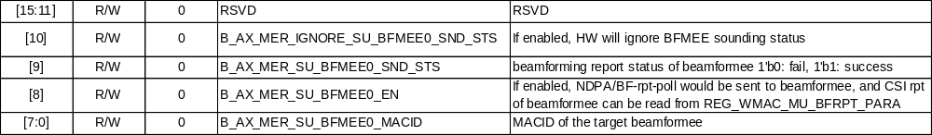
API Flow chart | None
Table format | None
Test scenario | None

Set_snd_sts_index

mac_set_snd_sts_index
Description | Set sounding status index
Synopsis | u32 mac_set_snd_sts_index(struct mac_ax_adapter *adapter, u8 band, u8 macid, u8 index)
Arguments | adapter (IN)  mac_ax_adapter  u8 band (IN)  0: band0 1:band1  u8 macid  MACID  u8 index  0~15: SU 16~21:MU
Returns  (Error Code) | MACNOITEM 11 /* Invalid item */  MACHWNOTEN 62 /* hw module not enable*/  MACSNDSTSIDERR 84 /* Sounding status ID is NOT supported */
Returns  (Status Code) | MACSUCCESS 0 /* Success return value */
API Flow chart | None
Table format | None
Test scenario | None

Init_snd_mer

mac_init_snd_mer
Description | Init sounding Mer
Synopsis | u32 mac_init_snd_mer(struct mac_ax_adapter *adapter, u8 band)
Arguments | adapter (IN)  mac_ax_adapter  u8 band (IN)  0: band0 1:band1
Returns  (Error Code) | MACNOITEM 11 /* Invalid item */  MACHWNOTEN 62 /* hw module not enable*/
Returns  (Status Code) | MACSUCCESS 0 /* Success return value */
API Flow chart | None
Table format | None
Test scenario | None

Init_snd_mee

mac_init_snd_mee
Description | Init sounding Mee
Synopsis | u32 mac_init_snd_mee(struct mac_ax_adapter *adapter, u8 band)
Arguments | adapter (IN)  mac_ax_adapter  u8 band (IN)  0: band0 1:band1
Returns  (Error Code) | MACNOITEM 11 /* Invalid item */  MACHWNOTEN 62 /* hw module not enable*/
Returns  (Status Code) | MACSUCCESS 0 /* Success return value */
API Flow chart | None
Table format | None
Test scenario | None

CSI_force_rate

mac_csi_force_rate
Description | CSI force rate
Synopsis | u32 mac_csi_force_rate(struct mac_ax_adapter *adapter, u8 band, u8 ht_rate, u8 vht_rate, u8 he_rate)
Arguments | adapter (IN)  mac_ax_adapter  u8 band (IN)  0: band0 1:band1  u8 ht_rate (IN)  u8 vht_rate (IN)  u8 he_rate (IN)
  7 | 6 | 5 | 4 | 3 | 2 | 1 | 0
  RSVD |  |  | Rate: HT MCS0~31
  RSVD | SS |  |  | VHT Rate MCS0~9
  RSVD |  |  |  | HE Rate MCS0~11
Returns  (Error Code) | MACNOITEM 11 /* Invalid item */  MACHWNOTEN 62 /* hw module not enable*/
Returns  (Status Code) | MACSUCCESS 0 /* Success return value */
API Flow chart | None
Table format | None
Test scenario | None
CSI_RRSC

mac_csi_rrsc
Description | CSI rrsc
Synopsis | u32 mac_csi_force_rate(struct mac_ax_adapter *adapter, u8 band, u8 ht_rate, u8 vht_rate, u8 he_rate)
Arguments | adapter (IN)  mac_ax_adapter  u8 band (IN)  0: band0 1:band1  U32 rrsc (IN)  BMap to indicate the CSI frame rate in this BSS. Each B is mapped as the following:  B[0:7] = {6M, 9M, 12M, 18M, 24M, 36M, 48M, 54M}  B[8:15] = HT MCS0~MCS7  B[16:23] = VHT 1SSMCS0~MCS7  B[24:31] = HE 1SSMCS0~MCS7
Returns  (Error Code) | MACNOITEM 11 /* Invalid item */  MACHWNOTEN 62 /* hw module not enable*/
Returns  (Status Code) | MACSUCCESS 0 /* Success return value */
API Flow chart | None
Table format | None
Test scenario | None

Set_mu_table

mac_set_mu_table
Description | Set mu table
Synopsis | u32 mac_set_mu_table(struct mac_ax_adapter *adapter,  struct mac_mu_table *mu_table)
Arguments | adapter (IN)  mac_ax_adapter  u8 mu_table (IN)  u32 mu_score_tbl_ctrl;  u32 mu_score_tbl_0;  u32 mu_score_tbl_1;  u32 mu_score_tbl_2;  u32 mu_score_tbl_3;  u32 mu_score_tbl_4;  u32 mu_score_tbl_5; 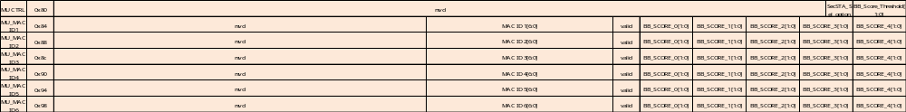
Returns  (Error Code) | None
Returns  (Status Code) | MACSUCCESS 0 /* Success return value */
API Flow chart | None
Table format | None
Test scenario | None

Set sounding parameter

mac_set_snd_para
Description | Set Soundnig parameter
Synopsis | u32 mac_set_snd_para(struct mac_ax_adapter *adapter,  struct mac_ax_fwcmd_snd *snd_info)
Arguments | adapter (IN)  mac_ax_adapter  snd_info (IN)  u32 frexgtype: 6;  u32 mode: 2;  u32 bfrp0_user_num: 3;  u32 bfrp1_user_num: 3;  u32 rsvd: 18;  u8 macid[8];  struct mac_ax_ndpa_para pndpa;  struct mac_ax_bfrp_para pbfrp;  struct mac_ax_snd_wd_para wd[5];  struct mac_ax_snd_f2P f2p[2];
Returns  (Error Code) | MACNPTR 5 /* Pointer is null */  MACNOBUF 9 /* Buffer space is not enough */  MACBUFSZ 10 /* Buffer size error */  MACNOITEM 11 /* Invalid item */  MACFWNONRDY 80 /* FW not ready h2c error*/
Returns  (Status Code) | MACSUCCESS 0 /* Success return value */
API Flow chart | None
Table format | None
Test scenario | None

Set_csi_para_reg
mac_set_csi_para_reg
Description | Set CSI para register
Synopsis | u32 mac_set_csi_para_reg(struct mac_ax_adapter *adapter,struct mac_reg_csi_para *csi_para)
Arguments | adapter (IN)  mac_ax_adapter  csi_para (IN)  mac_reg_csi_para
  BF | 1: CSI enable BF 0:CSI disable BF
  STBC | 1: CSI enable STBC 0:CSI disable STBC
  LDPC | 1: CSI enable LDPC 0:CSI disable LDPC
  CS | coefficient size
  CB | HT: CB有2bit  FB TYPE=SU,  CB=0 =>codebook{ϕ,ψ}={3,1}  CB=1 =>codebook{ϕ,ψ}={4,2}  CB=2 =>codebook{ϕ,ψ}={5,3}  CB=3 =>codebook{ϕ,ψ}={6,4}  VHT/HE: CB只有1bit  FB TYPE=SU,  CB=0 =>codebook{ϕ,ψ}={4,2}  CB=1 =>codebook{ϕ,ψ}={6,4}  VHT/HE: CB只有1bit  FB TYPE=MU,  CB=0 =>codebook{ϕ,ψ}={7,5}  CB=1 =>codebook{ϕ,ψ}={9,7}
  NG | 0:AC NG=1  1:AC NG=2  2:AC NG=4  3:RSVD
  NR | Nr index-1
  NC | Nc index-1
  PORTSEL | 0: port 0; 1: port 1~4
  BAND | 0: band0; 1:band 1
Returns  (Error Code) | MACNOITEM 11 /* Invalid item */  MACHWNOTEN 62 /* hw module not enable*/
Returns  (Status Code) | MACSUCCESS 0 /* Success return value */
API Flow chart | None
Table format | None
Test scenario | None

Set_csi_para_cctl
mac_set_csi_para_cctl
Description | Set CSI para in CMAC ctrl table
Synopsis | u32 mac_set_csi_para_cctl(struct mac_ax_adapter *adapter, struct mac_cctl_csi_para *csi_para)
Arguments | adapter (IN)  mac_ax_adapter  csi_para (IN)  mac_reg_csi_para
  BW | 0:20M 1:40M 2:80M
  GID_SEL | 1 : csi group id=0  0 : csi group id=63
  GI_LTF | GI_LTF
  RATE | RATE
  BF | 1: CSI enable BF 0:CSI disable BF
  STBC | 1: CSI enable STBC 0:CSI disable STBC
  LDPC | 1: CSI enable LDPC 0:CSI disable LDPC
  CS | coefficient size
  CB | HT: CB有2bit  FB TYPE=SU,  CB=0 =>codebook{ϕ,ψ}={3,1}  CB=1 =>codebook{ϕ,ψ}={4,2}  CB=2 =>codebook{ϕ,ψ}={5,3}  CB=3 =>codebook{ϕ,ψ}={6,4}  VHT/HE: CB只有1bit  FB TYPE=SU,  CB=0 =>codebook{ϕ,ψ}={4,2}  CB=1 =>codebook{ϕ,ψ}={6,4}  VHT/HE: CB只有1bit  FB TYPE=MU,  CB=0 =>codebook{ϕ,ψ}={7,5}  CB=1 =>codebook{ϕ,ψ}={9,7}
  NG | 0:AC NG=1  1:AC NG=2  2:AC NG=4  3:RSVD
  NR | Nr index-1
  NC | Nc index-1
  BAND | 0: band0; 1:band 1
  MACID | MACID
Returns  (Error Code) | MACNPTR 5 /* Pointer is null */  MACNOBUF 9 /* Buffer space is not enough */  MACBUFSZ 10 /* Buffer size error */  MACNOITEM 11 /* Invalid item */  MACFWNONRDY 80 /* FW not ready h2c error*/
Returns  (Status Code) | MACSUCCESS 0 /* Success return value */
API Flow chart | None
Table format | None
Test scenario | None

HW_SND_pause_releas

mac_hw_snd_pause_release
Description | Set pause and release
Synopsis | u32 mac_hw_snd_pause_release(struct mac_ax_adapter *adapter, u8 band, u8 pr)
Arguments | adapter (IN)  mac_ax_adapter  bnad (IN)  0: band 0 ; 1:band 1  Pr (IN)  0: pause; 1:release
Returns  (Error Code) | MACNOITEM 11 /* Invalid item */  MACHWNOTEN 62 /* hw module not enable*/
Returns  (Status Code) | MACSUCCESS 0 /* Success return value */
API Flow chart | None
Table format | None
Test scenario | None

Bypass_SND_status

mac_bypass_snd_sts
Description | Bypass sounding status
Synopsis | u32 mac_bypass_snd_sts(struct mac_ax_adapter *adapter)
Arguments | adapter (IN)  mac_ax_adapter
Returns
(Error Code)
Returns  (Status Code) | MACSUCCESS 0 /* Success return value */
API Flow chart | None
Table format | None
Test scenario | None

mac_deinit_mee

mac_bypass_snd_sts
Description | u32 mac_deinit_mee(struct mac_ax_adapter *adapter, u8 band)
Synopsis | u32 mac_bypass_snd_sts(struct mac_ax_adapter *adapter)
Arguments | adapter (IN)  mac_ax_adapter
Returns
(Error Code)
Returns  (Status Code) | MACSUCCESS 0 /* Success return value */
API Flow chart | None
Table format | None
Test scenario | None

Common Settings

CMAC Table Setting

mac_upd_cctl_info
Description | Setting CMAC table
Synopsis | u32 mac_upd_dctl_info(struct mac_ax_adapter *adapter,struct mac_ax_cctl_info *info,  struct mac_ax_cctl_info *mask, u8 macid, u8 operation)
Arguments | adapter (IN)  mac_ax_adapter  struct mac_ax_dctl_info *info,  if write operation, value to be write into CMAC table  struct mac_ax_dctl_info *mask,  if write operation, mask value to which would be write  u8 macid,  macid of operation  u8 operation  1: write operation  0: read operation
Returns  (Error Code) | MACNPTR 5 /* Pointer is null */  - h2cb_alloc fail  - h2c_pkt_set_hdr fail  - h2c_pkt_build_txd fail  MACPTMTXFAIL 63 /*platform TX fail*/
Returns  (Status Code) | return 0 Successful operation.
API Flow chart | Flow Chart –CMAC/DMAC Table Setting
Table format | CMAC TABLE format
Test scenario | None

DMAC Table Setting

mac_upd_dctl_info
Description | Setting DMAC table
Synopsis | u32 mac_upd_dctl_info(struct mac_ax_adapter *adapter,struct mac_ax_dctl_info *info,  struct mac_ax_dctl_info *mask, u8 macid, u8 operation)
Arguments | adapter (IN)  mac_ax_adapter  struct mac_ax_dctl_info *info,  if write operation, value to be write into DMAC table  struct mac_ax_dctl_info *mask,  if write operation, mask value to which would be write  u8 macid,  macid of operation  u8 operation  1: write operation  0: read operation
Returns  (Error Code) | MACNPTR 5 /* Pointer is null */  - h2cb_alloc fail  - h2c_pkt_set_hdr fail  - h2c_pkt_build_txd fail  MACPTMTXFAIL 63 /*platform TX fail*/
Returns  (Status Code) | return 0 Successful operation.
API Flow chart | Flow Chart –CMAC/DMAC Table Setting
Table format | DMAC TABLE format
Test scenario | None

Shortcut MAC Header Setting

mac_upd_shcut_mhdr
Description | Update shortcut mac header table entry
Synopsis | u32 mac_upd_shcut_mhdr(struct mac_ax_adapter *adapter,struct mac_ax_shcut_mhdr *info, u8 shcut_camid)
Arguments | adapter (IN)  mac_ax_adapter  mac_ax_shcut_mhdr (IN)  whole shortcut mac header entry according shortcut cam id  shcut_camid (IN)  shortcut cam id
Returns  (Error Code) | MACNPTR 5 /* Pointer is null */  - h2cb_alloc fail  - h2c_pkt_set_hdr fail  - h2c_pkt_build_txd fail  MACPTMTXFAIL 63 /*platform TX fail*/
Returns  (Status Code) | return 0 Successful operation.
API Flow chart
State Machine | None
Test scenario | None

HW reg get value

mac_get_hw_value
Description | Get HW REG value
Synopsis | u32 mac_get_hw_value(struct mac_ax_adapter *adapter,  enum mac_ax_hw_id hw_id, void *val)
Arguments | adapter (IN)  mac_ax_adapter  mac_ax_hw_id hw_id (IN)  enum case to choose which REG to read  MAC_AX_HW_MAPPING = 0x00,  MAC_AX_HW_SDIO_MON_INT,  MAC_AX_HW_SDIO_MON_CNT,  MAC_AX_HW_GET_ID_PAUSE,  MAC_AX_HW_SDIO_TX_AGG_SIZE,  MAC_AX_HW_GET_AMPDU_CFG,  MAC_AX_HW_GET_EDCA_PARAM,  MAC_AX_HW_GET_MUEDCA_PARAM,  MAC_AX_HW_GET_MUEDCA_TIMER,  MAC_AX_HW_GET_TBPPDU_CTRL,  MAC_AX_HW_GET_SCH_TXEN_STATUS,  MAC_AX_HW_GET_MUEDCA_CTRL,  MAC_AX_HW_GET_DELAYTX_CFG,  MAC_AX_HW_GET_TX_CNT,  MAC_AX_HW_GET_SS_WMM_TBL,  val (OUT)  value read from HW reg
Returns  (Error Code) | MACNOITEM 11 /* Invalid item */  MACFUNCINPUT 46 /* invalid function input */
Returns  (Status Code) | return 0 Successful operation.
API Flow chart
State Machine | None
Test scenario | None

hw_id | Arguments | Description
MAC_AX_HW_GET_ID_PAUSE | Macid (IN)  The target MACID  Pause (OUT)  0: pause  1: release | Get MACID pause status
MAC_AX_HW_GET_SCH_TXEN_STATUS | Band (IN)  The target band  tx_en (OUT)  tx enable for each path  1: enable  0: disable | Get MAC Tx enable status
MAC_AX_HW_GET_AMPDU_CFG | Band (IN)  The target band  wdbk_mode (OUT)  MAC_AX_WDBK_MODE_SINGLE_BK  Break if WD.BK = 1  MAC_AX_WDBK_MODE_GRP_BK  Break if WD.BK changed  rty_bk_mode (OUT)  MAC_AX_RTY_BK_MODE_AGG  Always aggregate  MAC_AX_RTY_BK_MODE_RATE_FB  Break if rate != initial rate  MAC_AX_RTY_BK_MODE_BK  Break if WD.TX_CNT = 0  max_agg_num (OUT)  max AMPDU packet number  max_agg_time_32us (OUT)  max AMPDU duration (unit: 32 us) | Get global setting of AMPDU
MAC_AX_HW_GET_EDCA_PARAM | Band (IN)  The target band  Path (IN)  The target Tx path  txop_32us (OUT)  max TXOP duration (unit: 32 us)  ecw_max (OUT)  ECWmax  ecw_min (OUT)  ECWmin  aifs_us (OUT)  AIFS (unit: 1 us) | Get EDCA parameter
MAC_AX_HW_GET_MUEDCA_PARAM | Band (IN)  The target band  ac (IN)  The target AC  muedca_timer_32us (OUT)  MUEDCATimer (unit: 32 us)  ecw_max (OUT)  ECWmax  ecw_min (OUT)  ECWmin  aifs_us (OUT)  AIFS (unit: 1 us)  If this param is 0, it means AIFSN = 0 | Get MUEDCA parameter
MAC_AX_HW_GET_MUEDCA_TIMER | Band (IN)  The target band  ac (IN)  The target AC  muedca_timer_32us (OUT)  MUEDCATimer (unit: 32 us) | Get MUEDCA Timer
MAC_AX_HW_GET_MUEDCA_CTRL | Band (IN)  The target band  wmm_sel (OUT)  the WMM that the MACID stand in  countdown_en (OUT)  enable HW countdown MUEDCA timer  1: enable  0: disable  tb_update_en (OUT)  enable HW update MUEDCA timer when response TB PPDU successfully  1: enable  0: disable | Get MUEDCA HW behavior
MAC_AX_HW_GET_TBPPDU_CTRL | Band (IN)  The target band  pri_ac (OUT)  The AC with 1st priority in TB PPDU Tx  be_dis (OUT)  do not Tx BE packet in TB PPDU  1: do not Tx  0: allow Tx  bk_dis (OUT)  do not Tx BK packet in TB PPDU  vi_dis (OUT)  do not Tx VI packet in TB PPDU  vo_dis (OUT)  do not Tx VO packet in TB PPDU | Get TB PPDU Tx behavior
MAC_AX_HW_GET_DELAYTX_CFG | En (OUT)  Enable delay Tx function  MAC_AX_DELAY_TX_DIS  disable  MAC_AX_DELAY_TX_B0  Enable band 0  MAC_AX_DELAY_TX_B1  Enable band 1  MAC_AX_DELAY_TX_BOTH  Enable band 0 & 1  vovi_to_b0 (OUT)  band 0 VO & VI timeout  bebk_to_b0 (OUT)  band 0 BE & BK timeout  vovi_to_b1 (OUT)  band 1 VO & VI timeout  bebk_to_b1 (OUT)  band 1 BE & BK timeout  vovi_len_b0 (OUT)  band 0 VO & VI length threshold  bebk_len_b0 (OUT)  band 0 BE & BK length threshold  vovi_len_b1 (OUT)  band 1 VO & VI length threshold  bebk_len_b1 (OUT)  band 1 BE & BK length threshold | Get delay Tx parameter
MAC_AX_HW_GET_SS_WMM_TBL | Wmm (IN)  The target WMM  wmm_mapping (OUT)  MAC_AX_SS_WMM_TBL_C0_WMM0  Belong to band0 WMM0  MAC_AX_SS_WMM_TBL_C0_WMM1  Belong to band0 WMM1  MAC_AX_SS_WMM_TBL_C1_WMM0  Belong to band1 WMM0  MAC_AX_SS_WMM_TBL_C1_WMM1  Belong to band1 WMM1 | Get WMM mapping
MAC_AX_HW_GET_CH_STAT_CNT | Band (IN)  The target band  Busy_cnt (OUT)  Channel busy counter (us)  Idle_cnt (OUT)  Channel idle counter (us) | Get channel busy/idle counter
MAC_AX_HW_SDIO_TX_AGG_SIZE | Unit: byte | Get SDIO Tx agg alignment size
MAC_AX_HW_GET_CH_STAT_CNT | Band (IN)  The target band  busy_cnt (OUT)  channel busy time (unit: 1us)  idle_cnt (OUT)  channel idle time (unit: 1us) | Channel idle/busy
MAC_AX_HW_GET_LIFETIME_CFG | Band (IN)  The target band  En (OUT)  acq_en  1: enable WMM+AC  mgq_en  1: enable MGQ0 and MGQ1  Val (OUT)  acq_val_1  acq_val_2  acq_val_3  acq_val_4  mgq_val  lifetime threshold  (unit: 256 us) | Packet lifetime drop function
MAC_AX_HW_GET_TX_CNT | Band (IN)  The target band  Txcnt (OUT)  The array store different types tx count.  MAC_AX_TX_LCCK [0]  MAC_AX_TX_SCCK [1]  MAC_AX_TX_OFDM [2]  MAC_AX_TX_HT [3]  MAC_AX_TX_HTGF [4]  MAC_AX_TX_VHTSU [5]  MAC_AX_TX_VHTMU [6]  MAC_AX_TX_HESU [7]  MAC_AX_TX_HEERSU [8]  MAC_AX_TX_HEMU [9]  MAC_AX_TX_HETB [10] | Get Mac TX PPDU Counter

HW reg Setting

mac_set_hw_value
Description | Setting HW REG value
Synopsis | u32 mac_set_hw_value(struct mac_ax_adapter *adapter,  enum mac_ax_hw_id hw_id, void *val)
Arguments | adapter (IN)  mac_ax_adapter  mac_ax_hw_id hw_id (IN)  enum case to choose which REG to write  MAC_AX_HW_SETTING = 0x60,  MAC_AX_HW_SDIO_INFO,  MAC_AX_HW_SDIO_TX_MODE,  MAC_AX_HW_SDIO_RX_AGG,  MAC_AX_HW_SDIO_TX_AGG,  MAC_AX_HW_SDIO_AVAL_PAGE,  MAC_AX_HW_SDIO_MON_WT,  MAC_AX_HW_SDIO_MON_CLK,  MAC_AX_HW_PCIE_AUTOK,  MAC_AX_HW_PCIE_RST_BDRAM,  MAC_AX_HW_SET_ID_PAUSE,  MAC_AX_HW_SET_AMPDU_CFG,  MAC_AX_HW_SET_EDCA_PARAM,  MAC_AX_HW_SET_MUEDCA_PARAM,  MAC_AX_HW_SET_TBPPDU_CTRL,  MAC_AX_HW_SET_SCH_TXEN_CFG,  MAC_AX_HW_SET_MUEDCA_TIMER,  MAC_AX_HW_SET_HOST_RPR,  MAC_AX_HW_SET_MUEDCA_CTRL,  MAC_AX_HW_SET_DELAYTX_CFG,  val (IN)  value to write into HW reg
Returns  (Error Code) | MACNOITEM 11 /* Invalid item */  MACFUNCINPUT 46 /* invalid function input */
Returns  (Status Code) | return 0 Successful operation.
API Flow chart | Flow Chart –Setting HW REG value
State Machine | None
Test scenario | None

hw_id | Arguments | Description
MAC_AX_HW_SET_ID_PAUSE | Macid (IN)  The target MACID  Pause (IN)  0: pause  1: release | Control MACID pause
MAC_AX_HW_SET_SCH_TXEN_CFG | Band (IN)  The target band  tx_en (IN)  tx enable for each path  1: enable  0: disable  tx_en_mask (IN)  mask of Tx enable control  1: control  0: do not control | Control MAC Tx enable
MAC_AX_HW_SET_AMPDU_CFG | Band (IN)  The target band  wdbk_mode (IN)  MAC_AX_WDBK_MODE_SINGLE_BK  Break if WD.BK = 1  MAC_AX_WDBK_MODE_GRP_BK  Break if WD.BK changed  rty_bk_mode (IN)  MAC_AX_RTY_BK_MODE_AGG  Always aggregate  MAC_AX_RTY_BK_MODE_RATE_FB  Break if rate != initial rate  MAC_AX_RTY_BK_MODE_BK  Break if WD.TX_CNT = 0  max_agg_num (IN)  max AMPDU packet number  max_agg_time_32us (IN)  max AMPDU duration (unit: 32 us) | Control global setting of AMPDU
MAC_AX_HW_SET_EDCA_PARAM | Band (IN)  The target band  Path (IN)  The target Tx path  txop_32us (IN)  max TXOP duration (unit: 32 us)  ecw_max (IN)  ECWmax  ecw_min (IN)  ECWmin  aifs_us (IN)  AIFS (unit: 1 us) | Control EDCA parameter
MAC_AX_HW_SET_MUEDCA_PARAM | Band (IN)  The target band  ac (IN)  The target AC  muedca_timer_32us (IN)  MUEDCATimer (unit: 32 us)  ecw_max (IN)  ECWmax  ecw_min (IN)  ECWmin  aifs_us (IN)  AIFS (unit: 1 us)  If AIFSN = 0, this param should be set to 0 | Control MUEDCA parameter
MAC_AX_HW_SET_MUEDCA_TIMER | Band (IN)  The target band  ac (IN)  The target AC  muedca_timer_32us (IN)  MUEDCATimer (unit: 32 us) | Control MUEDCA Timer
MAC_AX_HW_SET_MUEDCA_CTRL | Band (IN)  The target band  wmm_sel (IN)  the WMM that the MACID stand in  countdown_en (IN)  enable HW countdown MUEDCA timer  1: enable  0: disable  tb_update_en (IN)  enable HW update MUEDCA timer when response TB PPDU successfully  1: enable  0: disable | Control MUEDCA HW behavior
MAC_AX_HW_SET_TBPPDU_CTRL | Band (IN)  The target band  pri_ac (IN)  The AC with 1st priority in TB PPDU Tx  be_dis (IN)  do not Tx BE packet in TB PPDU  1: do not Tx  0: allow Tx  bk_dis (IN)  do not Tx BK packet in TB PPDU  vi_dis (IN)  do not Tx VI packet in TB PPDU  vo_dis (IN)  do not Tx VO packet in TB PPDU | Control TB PPDU Tx behavior
MAC_AX_HW_SET_DELAYTX_CFG | En (IN)  Enable delay Tx function  MAC_AX_DELAY_TX_DIS  disable  MAC_AX_DELAY_TX_B0  Enable band 0  MAC_AX_DELAY_TX_B1  Enable band 1  MAC_AX_DELAY_TX_BOTH  Enable band 0 & 1  vovi_to_b0 (IN)  band 0 VO & VI timeout  bebk_to_b0 (IN)  band 0 BE & BK timeout  vovi_to_b1 (IN)  band 1 VO & VI timeout  bebk_to_b1 (IN)  band 1 BE & BK timeout  vovi_len_b0 (IN)  band 0 VO & VI length threshold  bebk_len_b0 (IN)  band 0 BE & BK length threshold  vovi_len_b1 (IN)  band 1 VO & VI length threshold  bebk_len_b1 (IN)  band 1 BE & BK length threshold | Control delay Tx parameter
MAC_AX_HW_SET_CH_BUSY_STAT_CFG | Band (IN)  The target band  cnt_ctrl (IN)  MAC_AX_CH_BUSY_CNT_CTRL_CNT_REF  Config reference signal  MAC_AX_CH_BUSY_CNT_CTRL_CNT_BUSY_RST  Reset busy counter to 0  MAC_AX_CH_BUSY_CNT_CTRL_CNT_IDLE_RST  Reset idle counter to 0  MAC_AX_CH_BUSY_CNT_CTRL_CNT_EN  Enable counter  MAC_AX_CH_BUSY_CNT_CTRL_CNT_DIS  Disable counter  Ref (IN)  1: busy state refer to the signal | Control channel idle/busy time counter
MAC_AX_HW_SDIO_INFO | sdio_4byte (IN)  MAC_AX_SDIO_4BYTE_MODE_DISABLE  Sdio IO support size < 4 bytes  MAC_AX_SDIO_4BYTE_MODE_RW  Sdio IO do not support size < 4 bytes  tx_mode (IN)  don’t care  spec_ver  SDIO 2.0 or 3.0  block_size  SDIO block size (unit: byte)  tx_seq  don’t care  tx_align_size  don’t care | Config SDIO information
MAC_AX_HW_SDIO_TX_MODE | MAC_AX_SDIO_TX_MODE_AGG  Always agg mode  MAC_AX_SDIO_TX_MODE_DUMMY_BLOCK  Always dummy mode  MAC_AX_SDIO_TX_MODE_DUMMY_AUTO  Block mode: dummy mode  Byte mode: agg mode | Config SDIO Tx CMD53 format
MAC_AX_HW_SDIO_RX_AGG | Mode (IN)  MAC_AX_RX_AGG_MODE_NONE  Disable Rx agg  MAC_AX_RX_AGG_MODE_DMA  Enable Rx agg  MAC_AX_RX_AGG_MODE_USB  SDIO do not use this mode  Threshold (IN)  drv_define  1: set the following parameter  0: the parameter is config by halmac setting  Timeout  Rx agg timeout (unit: 1 us)  Size  Rx agg length threshold (unit: 1K bytes)  pkt_num  packet number threshold | Config SDIO Rx agg behavior
MAC_AX_HW_SDIO_TX_AGG | En (IN)  Enable SW config Tx agg alignment size  1: enable  0: disable  align_size (IN)  alignment size = 2^(align_size) bytes | Config SDIO Tx agg alignment size
MAC_AX_HW_SDIO_AVAL_PAGE | TBD | TBD
MAC_AX_HW_SDIO_MON_WT | 1: enable  0: disable | Enable CMD53 write interval counter
MAC_AX_HW_SDIO_MON_CLK | Mon  Monitor period  Cycle  User defined monitor period | Start to count SDIO clock
MAC_AX_HW_SET_CH_BUSY_STAT_CFG | Band (IN)  The target band  cnt_ctrl (IN)  MAC_AX_CH_BUSY_CNT_CTRL_CNT_REF  Update reference signal to “ref”  MAC_AX_CH_BUSY_CNT_CTRL_CNT_BUSY_RST  Reset “busy” counter  MAC_AX_CH_BUSY_CNT_CTRL_CNT_IDLE_RST  Reset “idle” counter  MAC_AX_CH_BUSY_CNT_CTRL_CNT_EN  Enable counter  MAC_AX_CH_BUSY_CNT_CTRL_CNT_DIS  Disable counter  Ref (IN)  basic_nav  intra_nav  data_on  edcca_p20  cca_p20  cca_s20  cca_s40  cca_s80  1: enable; 0: disable | Channel busy/idle counter
MAC_AX_HW_SET_LIFETIME_CFG | Band (IN)  The target band  En (IN)  acq_en  1: enable WMM+AC  mgq_en  1: enable MGQ0 and MGQ1  Val (IN)  acq_val_1  acq_val_2  acq_val_3  acq_val_4  mgq_val  lifetime threshold  (unit: 256 us) | Packet lifetime drop function
MAC_AX_HW_SET_USR_EDCA_PARAM | Idx (IN)  update user defined EDCA to memory 0~3  Enable (IN)  1: follow tx_rpt to update EDCA  0: update EDCA to aggressive when receiving H2C “USR_EDCA”  Band (IN)  The target band  wmm (IN)  the target WMM  ac (IN)  The target AC  Aggressive (IN)  The Aggressive EDCA parameter (FW update EDCA to this value when receiving TXRPT.sw_define == 1, TXRPT.sw_define is from WD.sw_define)  txop_32us  max TXOP duration (unit: 32 us)  ecw_max  ECWmax  ecw_min  ECWmin  aifs_us  AIFS (unit: 1 us)  Moderate (IN)  The Moderate EDCA parameter (FW update EDCA to this value when receiving TXRPT.sw_define == 2, TXRPT.sw_define is from WD.sw_define)  txop_32us  max TXOP duration (unit: 32 us)  ecw_max  ECWmax  ecw_min  ECWmin  aifs_us  AIFS (unit: 1 us) | User defined EDCA parameter

Config PPDU status/Channel info/DFS reports
cfg_phy_rpt
Description | Config PPDU status/Channel info/DFS report setting
Synopsis | u32 cfg_phy_rpt(  struct mac_ax_adapter *adapter,  struct mac_ax_phy_rpt_cfg *cfg  )
Arguments | adapter (IN)  mac_ax_adapter  cfg (IN)  The settings of the report:  - type: The report to be set  - en: Enable the report, 0: disable, 1: enable  - dest: The destination of the report, 0: host, 1: WLCPU  - ppdu (for PPDU status)  - band: The band to be set  - bmp_append_info: The bitmap of appended information, bmp_append_info[1] = MAC Info, bmp_append_info[2] = RX Counter, bmp_append_info[3] = PLCP heard  - bmp_filter: The bitmap of PPDU status filter, bmp_filter[4] = Has A1 match, bmp_filter[5] = Has CRC OK  - dup2fw_en: Enable duplicated PPDU status to WLCPU  - dup2fw_len: The length of the duplicated PPDU status  - chif (for Channel info)  - trigger: The condition of triggering Channel info, 0: MAC ID match, 1: MAC ID and NDP, 2: MAC ID and Sounding PPDU, 3: MAC ID and response RX  - macid: The MAC ID  - bmp_filter: The bitmap of Channel info filter, bmp_filter[0] = If CRC fail, HW still trigger Channel info, bmp_filter[1] = Trigger Channel info if the PPDU has data frame, bmp_filter[2] = Trigger Channel info if the PPDU has control frame, bmp_filter[3] = Trigger Channel info if the PPDU has management frame,  - dis_to: Disable channel info timeout  - seg_size: The segment size of Channel info, 0: 128 bytes, 1: 256 bytes, 2: 512 bytes, 3 1024 bytes  - dfs (for DFS report)  - num_th: The threshold of the DFS report, 0: 29 DFS reports, 1: 61 DFS reports, 2: 93 DFS reports, 3: 125 DFS reports  - en_timeout: Enable DFS report timeout
Returns  (Error Code) | MACFUNCINPUT  Invalid argument  MACPOLLTO  Polling timeout for disabling Channel info/DFS report
Returns  (Status Code) | MACSUCCESS  Successful operation.
API Flow chart | None
State Machine | None
Test scenario | None

Config FW log
fw_log_cfg
Description | Config FW log
Synopsis | u32 fw_log_cfg(  struct mac_ax_adapter *adapter,  struct mac_ax_fw_log *log_cfg  )
Arguments | adapter (IN)  mac_ax_adapter  log_cfg (IN)  The settings of the FW log  - level: The level of the FW log, 0: disable FW log, 1: Critical, 2: Serious, 3: Warning, 4: Loud, 5: Trace  - output: The output destination of FW log, output[0] = UART, output[1] = C2H packet, output[2] = Sniffer mode  - comp: The lower-32-byte component of the log  - comp_ext: The higher-32-byte component of the log
Returns  (Error Code) | MACNPTR  NULL pointer
Returns  (Status Code) | MACSUCCESS  Successful operation.
API Flow chart | None
State Machine | None
Test scenario | None

GPIO

Set GPIO function
pinmux_set_func
Description | Set GPIO function
Synopsis | u32 pinmux_set_func(  struct mac_ax_adapter *adapter,  enum mac_ax_gpio_func func  )
Arguments | adapter (IN)  mac_ax_adapter  func (IN)  The GPIO function
Returns  (Error Code) | MACGPIOUSED  The GPIO is used  MACNOITEM  Invalid argument
Returns  (Status Code) | MACSUCCESS  Successful operation.
API Flow chart | Flow Chart – Config GPIO UART TX  Flow Chart – Config GPIO UART RX
State Machine | None
Test scenario | None

Set GPIO function
pinmux_free_func
Description | Free GPIO function
Synopsis | u32 pinmux_free_func(  struct mac_ax_adapter *adapter,  enum mac_ax_gpio_func func  )
Arguments | adapter (IN)  mac_ax_adapter  func (IN)  The GPIO function
Returns  (Error Code) | MACGPIOUSED  The GPIO is used  MACNOITEM  Invalid argument
Returns  (Status Code) | MACSUCCESS  Successful operation.
API Flow chart | None
State Machine | None
Test scenario | None

Select UART TX GPIO
sel_uart_tx_pin
Description | Select UART TX GPIO
Synopsis | u32 sel_uart_tx_pin (  struct mac_ax_adapter *adapter,  enum mac_ax_uart_tx_pin uart_pin  )
Arguments | adapter (IN)  mac_ax_adapter  uart_pin (IN)  The UART TX GPIO
Returns  (Error Code) | MACNOITEM  Invalid argument
Returns  (Status Code) | MACSUCCESS  Successful operation.
API Flow chart | Flow Chart – Config GPIO UART TX
State Machine | None
Test scenario | None

Select UART RX GPIO
sel_uart_rx_pin
Description | Select UART RX GPIO
Synopsis | u32 sel_uart_tx_pin (  struct mac_ax_adapter *adapter,  enum mac_ax_uart_rx_pin uart_pin  )
Arguments | adapter (IN)  mac_ax_adapter  uart_pin (IN)  The UART RX GPIO
Returns  (Error Code) | MACNOITEM  Invalid argument
Returns  (Status Code) | MACSUCCESS  Successful operation.
API Flow chart | Flow Chart – Config GPIO UART RX
State Machine | None
Test scenario | None

eFuse Access

mac_dump_efuse_map_wl
Dump physical wifi efuse map
Description | Dump physical wifi efuse map. Driver can choose efuse dump by firmware or driver (IO). Efuse dump by firmware which is more efficiency but needs firmware download and receives c2h packet.
Synopsis | u32 mac_dump_efuse_map_wl(  struct mac_ax_adapter *adapter,  enum mac_ax_efuse_read_cfg cfg,  u8 *efuse_map)
Arguments | adapter (IN)  Halmac adapter.  cfg (IN)  - MAC_AX_EFUSE_R_AUTO: halmac determines efuse dump by firmware or driver.  - MAC_AX_EFUSE_R_DRV: dump efuse by driver (IO method)  - MAC_AX_EFUSE_R_FW: dump efuse by firmware (C2H packet method)  efuse_map (OUT)  Physical efuse
Returns
(Error Code)
Returns  (Status Code) | MACSUCCESS  Successful operation.
Flow Chart | Flow Chart – Dump Wifi eFuse Map
State Machine
Test scenario

mac_dump_efuse_map_bt
Dump physical bt efuse map
Description | Dump physical bt efuse map. Only support driver dump (IO).
Synopsis | u32 mac_dump_efuse_map_bt(  struct mac_ax_adapter *adapter,  enum mac_ax_efuse_read_cfg cfg,  u8 *efuse_map)
Arguments | adapter (IN)  Halmac adapter.  cfg (IN)  - MAC_AX_EFUSE_R_AUTO: halmac determines efuse dump by firmware or driver.  - MAC_AX_EFUSE_R_DRV: dump efuse by driver (IO method)  - MAC_AX_EFUSE_R_FW: dump efuse by firmware (C2H packet method)  efuse_map (OUT)  Physical efuse
Returns
(Error Code)
Returns  (Status Code) | MACSUCCESS  Successful operation.
Flow Chart | Flow Chart – Dump bt eFuse Map
State Machine
Test scenario

mac_write_efuse
Write 1 byte physical efuse
Description | Write 1 byte physical efuse.
Synopsis | u32 mac_write_efuse(  struct mac_ax_adapter *adapter,  u32 addr,  u8 val,  enum mac_ax_efuse_bank bank)
Arguments | adapter (IN)  Halmac adapter.  addr (IN)  Physical efuse offset.  value (IN)  Physical efuse value.  bank (IN)  - MAC_AX_EFUSE_BANK_WIFI  - MAC_AX_EFUSE_BANK_BT
Returns
(Error Code)
Returns  (Status Code) | MACSUCCESS  Successful operation.
Flow Chart | Flow Chart – eFuse Write
State Machine
Test scenario

mac_read_efuse
Read physical efuse
Description | Read physical efuse.
Synopsis | u32 mac_read_efuse(  struct mac_ax_adapter *adapter,  u32 addr,  u32 size,  u8 *val,  enum mac_ax_efuse_bank bank)
Arguments | adapter (IN)  Halmac adapter.  addr (IN)  Physical efuse offset.  size (IN)  Physical efuse size.  value (IN)  Physical efuse value.  bank (IN)  - MAC_AX_EFUSE_BANK_WIFI  - MAC_AX_EFUSE_BANK_BT
Returns
(Error Code)
Returns  (Status Code) | MACSUCCESS  Successful operation.
Flow Chart | Flow Chart – eFuse Read
State Machine
Test scenario

mac_get_efuse_avl_size
Get wifi physical efuse available size
Description | Get wifi physical efuse available size meaning how many writable memories can be used.
Synopsis | u32 mac_get_efuse_avl_size(  struct mac_ax_adapter *adapter,  u32 *size)
Arguments | adapter (IN)  Halmac adapter.  size (OUT)  Wifi physical efuse available size
Returns
(Error Code)
Returns  (Status Code) | MACSUCCESS  Successful operation.
Flow Chart | Flow Chart – Get Available Size of eFuse
State Machine
Test scenario

mac_get_efuse_avl_size_bt
Get bt physical efuse available size
Description | Get bt physical efuse available size meaning how many writable memories can be used.
Synopsis | u32 mac_get_efuse_avl_size_bt(  struct mac_ax_adapter *adapter,  u32 *size)
Arguments | adapter (IN)  Halmac adapter.  size (OUT)  Wifi physical efuse available size
Returns
(Error Code)
Returns  (Status Code) | MACSUCCESS  Successful operation.
Flow Chart | Flow Chart – Get Available Size of eFuse
State Machine
Test scenario

mac_dump_log_efuse
Dump wifi logical efuse map/mask
Description | Dump wifi logical efuse map/mask. Driver can choose efuse dump by firmware or driver (IO). Efuse dump by fimware is more efficiency but need firmware download and receive c2h packet.
Synopsis | u32 mac_dump_log_efuse(  struct mac_ax_adapter *adapter,  enum mac_ax_efuse_parser_cfg parser_cfg,  enum mac_ax_efuse_read_cfg cfg,  u8 *efuse_map,  bool is_limit)
Arguments | adapter (IN)  Halmac adapter.  parser_cfg (IN)  - MAC_AX_EFUSE_PARSER_MAP: dump efuse map  - MAC_AX_EFUSE_PARSER_MASK: dump efuse mask  cfg (IN)  - MAC_AX_EFUSE_R_AUTO: halmac determines efuse dump by firmware or driver.  - MAC_AX_EFUSE_R_DRV: dump efuse by driver (IO method)  - MAC_AX_EFUSE_R_FW: dump efuse by firmware (C2H packet method)  efuse_map (OUT)  Logical efuse  is_limit (IN)  - 0: dump logical efuse in limited size  - 1: dump logical efuse in full size
Returns
(Error Code)
Returns  (Status Code) | MACSUCCESS  Successful operation.
Flow Chart | Flow Chart – Dump Wifi Logical eFuse
State Machine
Test scenario

mac_read_log_efuse
Read wifi logical efuse value
Description | Read wifi logical efuse value.
Synopsis | u32 mac_read_log_efuse(  struct mac_ax_adapter *adapter,  u32 addr,  u32 size,  u8 *val)
Arguments | adapter (IN)  Halmac adapter.  addr (IN)  Wifi logical efuse offset.  size (IN)  Wifi logical efuse size.  value (OUT)  Wifi logical efuse value.
Returns
(Error Code)
Returns  (Status Code) | MACSUCCESS  Successful operation.
Flow Chart | Flow Chart – Read Wifi Logical eFuse
State Machine
Test scenario

mac_write_log_efuse
Write 1byte wifi logical efuse value
Description | Write 1byte wifi logical efuse value.
Synopsis | u32 mac_write_log_efuse(  struct mac_ax_adapter *adapter,  u32 addr,  u8 val)
Arguments | adapter (IN)  Halmac adapter.  addr (IN)  Wifi logical efuse offset.  value (OUT)  Wifi logical efuse value.
Returns
(Error Code)
Returns  (Status Code) | MACSUCCESS  Successful operation.
Flow Chart | Flow Chart – Write Wifi Logical eFuse
State Machine
Test scenario

mac_dump_log_efuse_bt
Dump bt logical efuse map/mask
Description | Dump bt logical efuse map/mask. Only support driver dump (IO).
Synopsis | u32 mac_dump_log_efuse_bt(  struct mac_ax_adapter *adapter,  enum mac_ax_efuse_parser_cfg parser_cfg,  enum mac_ax_efuse_read_cfg cfg,  u8 *efuse_map)
Arguments | adapter (IN)  Halmac adapter.  parser_cfg (IN)  - MAC_AX_EFUSE_PARSER_MAP: dump efuse map  - MAC_AX_EFUSE_PARSER_MASK: dump efuse mask  cfg (IN)  - MAC_AX_EFUSE_R_AUTO: halmac determines efuse dump by firmware or driver.  - MAC_AX_EFUSE_R_DRV: dump efuse by driver (IO method)  - MAC_AX_EFUSE_R_FW: dump efuse by firmware (C2H packet method)  efuse_map (OUT)  Logical efuse
Returns
(Error Code)
Returns  (Status Code) | MACSUCCESS  Successful operation.
Flow Chart | Flow Chart – Dump bt Logical eFuse
State Machine
Test scenario

mac_read_log_efuse_bt
Read bt logical efuse value
Description | Read bt logical efuse value.
Synopsis | u32 mac_read_log_efuse_bt(  struct mac_ax_adapter *adapter,  u32 addr,  u32 size,  u8 *val)
Arguments | adapter (IN)  Halmac adapter.  addr (IN)  Logical bt efuse offset.  size (IN)  Logical bt efuse size.  value (OUT)  Logical bt efuse value.
Returns
(Error Code)
Returns  (Status Code) | MACSUCCESS  Successful operation.
Flow Chart | Flow Chart – Read bt Logical eFuse
State Machine
Test scenario

mac_write_log_efuse_bt
Write 1byte bt logical efuse value
Description | Write 1byte bt logical efuse value.
Synopsis | u32 mac_write_log_efuse_bt(  struct mac_ax_adapter *adapter,  u32 addr,  u8 val)
Arguments | adapter (IN)  Halmac adapter.  addr (IN)  Logical bt efuse offset.  value (IN)  Logical bt efuse value.
Returns
(Error Code)
Returns  (Status Code) | MACSUCCESS  Successful operation.
Flow Chart | Flow Chart – Write bt Logical eFuse
State Machine
Test scenario

mac_pg_efuse_by_map
Program efuse according map
Description | Program efuse according map.
Synopsis | u32 mac_pg_efuse_by_map(  struct mac_ax_adapter *adapter,  struct mac_ax_pg_efuse_info *info,  enum mac_ax_efuse_read_cfg cfg,  bool part,  bool is_limit)
Arguments | adapter (IN)  Halmac adapter.  info (IN)  - efuse_map: efuse map.  - efuse_map_szie: efuse map size.  - efuse_mask: efuse mask.  - efuse_mask_size: efuse mask size.  cfg (IN)  - MAC_AX_EFUSE_R_AUTO: halmac determines efuse dump by firmware or driver.  - MAC_AX_EFUSE_R_DRV: dump efuse by driver (IO method)  - MAC_AX_EFUSE_R_FW: dump efuse by firmware (C2H packet method)  part (IN)  Program part of efuse addresses where the values are not 0xFF and regardless of mask  is_limit (IN)  - 0: pg efuse in limited size  - 1: pg efuse in full size
Returns
(Error Code)
Returns  (Status Code) | MACSUCCESS  Successful operation.
Flow Chart | Flow Chart – Program eFuse by Map
State Machine
Test scenario

mac_pg_efuse_by_map_bt
Program efuse according map
Description | Program efuse according map.
Synopsis | u32 mac_pg_efuse_by_map(  struct mac_ax_adapter *adapter,  struct mac_ax_pg_efuse_info *info,  enum mac_ax_efuse_read_cfg cfg)
Arguments | adapter (IN)  Halmac adapter.  info (IN)  - efuse_map: efuse map.  - efuse_map_szie: efuse map size.  - efuse_mask: efuse mask.  - efuse_mask_size: efuse mask size.  cfg (IN)  - MAC_AX_EFUSE_R_AUTO: halmac determines efuse dump by firmware or driver.  - MAC_AX_EFUSE_R_DRV: dump efuse by driver (IO method)  - MAC_AX_EFUSE_R_FW: dump efuse by firmware (C2H packet method)
Returns
(Error Code)
Returns  (Status Code) | MACSUCCESS  Successful operation.
Flow Chart | Flow Chart – Program eFuse by Map
State Machine
Test scenario

mac_mask_log_efuse
Get logical efuse map with mask
Description | Get logical efuse map with mask. Driver should input efuse map & efuse mask, halmac will update efuse map according mask information.
Synopsis | u32 mac_mask_log_efuse(  struct mac_ax_adapter *adapter,  struct mac_ax_pg_efuse_info *info)
Arguments | adapter (IN)  Halmac adapter.  info (IN/OUT)  - efuse_map: efuse map.  - efuse_map_szie: efuse map size.  - efuse_mask: efuse mask.  - efuse_mask_size: efuse mask size.
Returns
(Error Code)
Returns  (Status Code) | MACSUCCESS  Successful operation.
Flow Chart | Flow Chart – Logical eFuse Mask
State Machine
Test scenario

mac_pg_sec_data_by_map
Program secure data according map
Description | Program secure data according map.
Synopsis | u32 mac_pg_sec_data_by_map(  struct mac_ax_adapter *adapter,  struct mac_ax_pg_efuse_info *info)
Arguments | adapter (IN)  Halmac adapter.  info (IN/OUT)  - efuse_map: efuse map.  - efuse_map_szie: efuse map size.  - efuse_mask: efuse mask.  - efuse_mask_size: efuse mask size.
Returns
(Error Code)
Returns  (Status Code) | MACSUCCESS  Successful operation.
Flow Chart | Flow Chart – Program Secure Data by Map
State Machine
Test scenario

mac_cmp_sec_data_by_map
Compare secure data according map
Description | Compare secure data according map.
Synopsis | u32 mac_cmp_sec_data_by_map(  struct mac_ax_adapter *adapter,  struct mac_ax_pg_efuse_info *info)
Arguments | adapter (IN)  Halmac adapter.  info (IN/OUT)  - efuse_map: efuse map.  - efuse_map_szie: efuse map size.  - efuse_mask: efuse mask.  - efuse_mask_size: efuse mask size.
Returns
(Error Code)
Returns  (Status Code) | MACSUCCESS  Successful operation.
Flow Chart | Flow Chart – Compare Secure Data by Map
State Machine
Test scenario

mac_get_efuse_info
Get efuse information according type ID
Description
Synopsis | u32 mac_get_efuse_info(  struct mac_ax_adapter *adapter,  u8 *efuse_map,  enum mac_ax_efuse_info_type id,  void *value,  u32 length,  u8 *autoload_status)
Arguments | adapter (IN)  Halmac adapter.  efuse_map (IN)  Physical efuse map.  id (IN)  Information type ID.  value (IN/OUT)  Infomation value.  length (IN)  Buffer length.  Autoload_status (IN)  Status of autoload.
Returns
(Error Code)
Returns  (Status Code) | MACSUCCESS  Successful operation.
Flow Chart
State Machine
Test scenario

mac_read_hidden_rpt
Get efuse hidden report
Description | Get efuse hidden zone report with firmware.
Synopsis | u32 mac_read_hidden_rpt(  struct mac_ax_adapter *adapter,  u32 *rpt)
Arguments | adapter (IN)  Halmac adapter.  rpt (IN/OUT)  Hidden efuse report.  - rx_spatial_stream  - bandwidth  - tx_spatial_stream  - protocol_80211  - NIC_router  - wl_func_support  - hw_special_type:  4b'1111 : General  4b'1110: RTL8832AU-VF1-CG for USB  4b'1100: FB  4b'0000: RSVD  - uuid
Returns
(Error Code)
Returns  (Status Code) | MACSUCCESS  Successful operation.
Flow Chart
State Machine
Test scenario

mac_check_efuse_autoload
Check efuse autoload status register
Description
Synopsis | u32 mac_check_efuse_autoload(  struct mac_ax_adapter *adapter,  u8 *autoload_status)
Arguments | adapter (IN)  Halmac adapter.  Autoload_status (IN/OUT)  Status of autoload.
Returns
(Error Code)
Returns  (Status Code) | MACSUCCESS  Successful operation.
Flow Chart
State Machine
Test scenario

mac_pg_simulator
Simulator of programing efuse
Description | Simulation of programing efuse with the same information needed in mac_pg_efuse_by_map.
Synopsis | u32 mac_pg_simulator(  struct mac_ax_adapter *adapter,  struct mac_ax_pg_efuse_info *info,  u8 *phy_map)
Arguments | adapter (IN)  Halmac adapter.  info (IN/OUT)  - efuse_map: efuse map.  - efuse_map_szie: efuse map size.  - efuse_mask: efuse mask.  - efuse_mask_size: efuse mask size.  phy_map (IN/OUT)  Physical efuse map for simulation.
Returns
(Error Code)
Returns  (Status Code) | MACSUCCESS  Successful operation.
Flow Chart
State Machine
Test scenario

mac_checksum_update
Update the checksum in efuse
Description | Calculate the checksum of instant efuse map and write the result in assigned address.
Synopsis | u32 mac_pg_simulator(  struct mac_ax_adapter *adapter)
Arguments | adapter (IN)  Halmac adapter.
Returns
(Error Code)
Returns  (Status Code) | MACSUCCESS  Successful operation.
Flow Chart
State Machine
Test scenario

mac_checksum_rpt
Calculate then compare checksum after reset
Description | Calculate the checksum of efuse map after power on (reset) and compare with the checksum already written in map
Synopsis | u32 mac_pg_simulator(  struct mac_ax_adapter *adapter,  u16 *chksum)
Arguments | adapter (IN)  Halmac adapter.  chksum (IN/OUT)  Checksum of efuse map after power on
Returns
(Error Code)
Returns  (Status Code) | MACSUCCESS  Successful operation.
Flow Chart
State Machine
Test scenario

Debug Package

FW command loopback
fwcmd_lb
Description | FW command loopback
Synopsis | u32 fwcmd_lb(  struct mac_ax_adapter *adapter,  u32 len,  u8 burst  )
Arguments | adapter (IN)  mac_ax_adapter  len (IN)  The length of loopback packet  burst (IN)  The burst mode of loopback
Returns  (Error Code) | MACWQBUSY  The previous packet is still processing  MACNPTR  NULL pointer  MACBUFALLOC  The work queue in halmac is fill
Returns  (Status Code) | MACSUCCESS  Successful operation.
API Flow chart | Flow Chart – FW command non-burst loopback  Flow Chart – FW command burst loopback
State Machine | None
Test scenario | None

Power Saving Related

Configure LPS
mac_cfg_lps
Description | Send PS H2C to enable/disable LPS or WMMPS, to set listen beacon interval.
Synopsis | u32 mac_cfg_lps(struct mac_ax_adapter *adapter, u8 macid, enum mac_ax_ps_mode ps_mode, void *lps_info)
Arguments | adapter (IN)  mac_ax_adapter  macid (IN)  ps_mode (IN)  Requested power save mode.  Option:  - MAC_AX_PS_MODE_ACTIVE = 0  - MAC_AX_PS_MODE_LEGACY = 1  - MAC_AX_PS_MODE_WMMPS = 2  lps_info (IN)  Other LPS setting. Structs are different according to ps_mode.  (1) If ps_mode = MAC_AX_PS_MODE_ACTIVE,  lps_info = 0.  (2) If ps_mode = MAC_AX_PS_MODE_LEGACY,  lps_info = struct mac_ax_lps_info.  struct mac_ax_lps_info:  enum mac_ax_listern_bcn_mode listen_bcn_mode;  u8 awake_interval;  enum mac_ax_smart_ps_mode smart_ps_mode;  (3) If ps_mode = MAC_AX_PS_MODE_WMMPS,  lps_info = struct mac_ax_wmmps_info.  struct mac_ax_wmmps_info:  enum mac_ax_listern_bcn_mode listen_bcn_mode;  u8 awake_interval;  u8 vo_uapsd_en: 1;  u8 vi_uapsd_en: 1;  u8 be_uapsd_en: 1;  u8 bk_uapsd_en: 1;  u8 rsvd: 4;
Returns  (Error Code) | MACNOITEM 11 /* Invalid item */
Returns  (Status Code) | return 0 Successful operation.
API Flow chart | Flow Chart –Configure LPS  Flow Chart –Enable LPS  Flow Chart –Disable LPS
State Machine | None
Test scenario | None

LPS Power State
mac_lps_pwr_state
Description | Send RPWM to set requested power state, or check CPWM value to know power state is already change or not.
Synopsis | u32 mac_lps_pwr_state(struct mac_ax_adapter *adapter, enum mac_ax_pwr_state_action action,  enum mac_ax_rpwm_req_pwr_state req_pwr_state)
Arguments | adapter (IN)  mac_ax_adapter  action (IN)  Set power state or check power state.  Option:  - MAC_AX_PWR_STATE_ACT_REQ = 0  - MAC_AX_PWR_STATE_ACT_CHK = 1  req_pwr_state (IN)  Requested power state.  Option:  - MAC_AX_RPWM_REQ_PWR_STATE_ACTIVE = 0  - MAC_AX_RPWM_REQ_PWR_STATE_BAND0_RFON = 1  - MAC_AX_RPWM_REQ_PWR_STATE_BAND1_RFON = 2  - MAC_AX_RPWM_REQ_PWR_STATE_BAND0_RFOFF = 3  - MAC_AX_RPWM_REQ_PWR_STATE_BAND1_RFOFF = 4  - MAC_AX_RPWM_REQ_PWR_STATE_CLK_GATED = 5  - MAC_AX_RPWM_REQ_PWR_STATE_PWR_GATED = 6  - MAC_AX_RPWM_REQ_PWR_STATE_HIOE_PWR_GATED = 7
Returns  (Error Code) | MACNOITEM 11 /* Invalid item */  MACCPWMSEQERR 67 /*CPWM sequence mismatch*/  MACCPWMSTATERR 68 /*CPWM state mismatch*/
Returns  (Status Code) | return 0 Successful operation.
API Flow chart | Flow Chart –LPS power state  Flow Chart –Enable LPS  Flow Chart –Disable LPS
State Machine | None
Test scenario | None

Check leave LPS
mac_chk_leave_lps
Description | Check already leave protocol power saving.
Synopsis | u32 mac_chk_leave_lps(struct mac_ax_adapter *adapter, u8 macid)
Arguments | adapter (IN)  mac_ax_adapter  macid (IN)
Returns  (Error Code) | MACNOITEM 11 /* Invalid item */  MACPSSTATFAIL 70 /*protocol power state check fail*/
Returns  (Status Code) | return 0 Successful operation.
API Flow chart | Flow Chart –Check leave LPS  Flow Chart –Disable LPS
State Machine | None
Test scenario | None

Frame Exchange Related

Sta init setting
mac_h2c_join_info
Description | Setting sta info  When to use:  - Connection, this function should be called by “add role”  - Disconnection, this function should be called by “delete role”
Synopsis | u32 mac_h2c_join_info(struct mac_ax_adapter *adapter, struct mac_ax_role_info *info, u8 opmode)
Arguments | adapter (IN)  mac_ax_adapter  struct mac_ax_role_info *info  mu decision related para  opmode  connect:1  disconnect:0
Returns  (Error Code) | MACNPTR 5 /* Pointer is null */  - h2cb_alloc fail  - h2c_pkt_set_hdr fail  - h2c_pkt_build_txd fail  MACPTMTXFAIL 63 /*platform TX fail*/
Returns  (Status Code) | return 0 Successful operation.
API Flow chart
Usage note | detail field setting reference to H2C doc
Test scenario | None

Mu frame exchange setting
mac_upd_mudecision_para
Description | Setting FW DL TX decision - MU decision related para
Synopsis | u32 mac_upd_mudecision_para(struct mac_ax_adapter *adapter, struct mac_ax_mudecision_para *info)
Arguments | adapter (IN)  mac_ax_adapter  struct mac_ax_mudecision_para *info  mu decision related para
Returns  (Error Code) | MACNPTR 5 /* Pointer is null */  - h2cb_alloc fail  - h2c_pkt_set_hdr fail  - h2c_pkt_build_txd fail  MACPTMTXFAIL 63 /*platform TX fail*/
Returns  (Status Code) | return 0 Successful operation.
API Flow chart
Usage note | struct mac_ax_tbl_hdr tbl_hdr; // filed “offset” need to set to macid detail field setting reference to H2C doc
Test scenario | None

mac_mu_sta_upd
Description | Update for mu member info in FW
Synopsis | u32 mac_mu_sta_upd(struct mac_ax_adapter *adapter,  struct mac_ax_mu_sta_upd *info)
Arguments | adapter (IN)  mac_ax_adapter  struct mac_ax_mu_sta_upd *info  mu sta info update
Returns  (Error Code) | MACNPTR 5 /* Pointer is null */  - h2cb_alloc fail  - h2c_pkt_set_hdr fail  - h2c_pkt_build_txd fail  MACPTMTXFAIL 63 /*platform TX fail*/
Returns  (Status Code) | return 0 Successful operation.
API Flow chart
Usage note | detail field setting reference to H2C doc  attention: mu pair (STA1,STA2) or (STA2,STA1) is the same mu group for FW decision
Test scenario | None

Ru frame exchange setting
mac_ss_dl_grp_upd
Description | Update RU group member
Synopsis | u32 mac_ss_dl_grp_upd(struct mac_ax_adapter *adapter, struct mac_ax_ss_dl_grp_upd *info)
Arguments | adapter (IN)  mac_ax_adapter  struct mac_ax_ss_dl_grp_upd *info  ru group member info
Returns  (Error Code) | MACNPTR 5 /* Pointer is null */  - h2cb_alloc fail  - h2c_pkt_set_hdr fail  - h2c_pkt_build_txd fail  MACPTMTXFAIL 63 /*platform TX fail*/
Returns  (Status Code) | return 0 Successful operation.
API Flow chart
Usage note | detail field setting reference to H2C doc
Test scenario | None

UL frame exchange setting
mac_ss_ul_grp_upd
Description | Update UL group member
Synopsis | u32 mac_ss_ul_grp_upd(struct mac_ax_adapter *adapter, struct mac_ax_ss_ul_grp_upd *info)
Arguments | adapter (IN)  mac_ax_adapter  struct mac_ax_ss_ul_grp_upd *info  ul group member info
Returns  (Error Code) | MACNPTR 5 /* Pointer is null */  - h2cb_alloc fail  - h2c_pkt_set_hdr fail  - h2c_pkt_build_txd fail  MACPTMTXFAIL 63 /*platform TX fail*/
Returns  (Status Code) | return 0 Successful operation.
API Flow chart
Usage note | detail field setting reference to H2C doc
Test scenario | None

Fix mode setting

mac_set_fixmode_mib
Description | Setting fixmode fw mib
Synopsis | u32 mac_set_fixmode_mib(struct mac_ax_adapter *adapter, struct mac_ax_fixmode_para *info)
Arguments | adapter (IN)  mac_ax_adapter  struct mac_ax_fixmode_para *info  fix mode info
Returns  (Error Code) | MACNPTR 5 /* Pointer is null */  - h2cb_alloc fail  - h2c_pkt_set_hdr fail  - h2c_pkt_build_txd fail  MACPTMTXFAIL 63 /*platform TX fail*/
Returns  (Status Code) | return 0 Successful operation.
API Flow chart
Usage note | detail field setting reference to H2C doc  you can set 2 kinds of fix mib/para by this h2c:  tx type su/mu/ru fix  DL/ UL frame exchange fix  About DL/ UL frame exchange fix, If you want to set frame exchange protect type, you don’t need to set fix_frame_seq_xxxx except SU. If you want to fix response type, you need to set fix_frame_seq_xxxx. Followings are some examples:  setting tx su frame exchange protection type(this will apply to all macid):  fix_fe_su_en =1, fix_frame_seq_su=1, prot_type_su= protect type value  setting tx he mu frame exchange protection type:  fix_fe_hemu_en = 1, mugrpid =mu gid, prot_type_hemu = protect type value  fix he mu frame exchange ack type  fix_fe_hemu_en = 1, fix_frame_seq_hemu = 1,mugrpid =mu gid, resp_type_hemu = ack type value
Test scenario | None

Ru frame exchange setting
mac_ss_dl_grp_upd
Description | Update RU group member
Synopsis | u32 mac_ss_dl_grp_upd(struct mac_ax_adapter *adapter, struct mac_ax_ss_dl_grp_upd *info)
Arguments | adapter (IN)  mac_ax_adapter  struct mac_ax_ss_dl_grp_upd *info  ru group member info
Returns  (Error Code) | MACNPTR 5 /* Pointer is null */  - h2cb_alloc fail  - h2c_pkt_set_hdr fail  - h2c_pkt_build_txd fail  MACPTMTXFAIL 63 /*platform TX fail*/
Returns  (Status Code) | return 0 Successful operation.
API Flow chart
Usage note | detail field setting reference to H2C doc
Test scenario | None

UL frame exchange setting
mac_ss_ul_grp_upd
Description | Update UL group member
Synopsis | u32 mac_ss_ul_grp_upd(struct mac_ax_adapter *adapter, struct mac_ax_ss_ul_grp_upd *info)
Arguments | adapter (IN)  mac_ax_adapter  struct mac_ax_ss_ul_grp_upd *info  ul group member info
Returns  (Error Code) | MACNPTR 5 /* Pointer is null */  - h2cb_alloc fail  - h2c_pkt_set_hdr fail  - h2c_pkt_build_txd fail  MACPTMTXFAIL 63 /*platform TX fail*/
Returns  (Status Code) | return 0 Successful operation.
API Flow chart
Usage note | detail field setting reference to H2C doc
Test scenario | None

Fix mode setting

mac_set_fixmode_mib
Description | Setting fixmode fw mib
Synopsis | u32 mac_set_fixmode_mib(struct mac_ax_adapter *adapter, struct mac_ax_fixmode_para *info)
Arguments | adapter (IN)  mac_ax_adapter  struct mac_ax_fixmode_para *info  fix mode info
Returns  (Error Code) | MACNPTR 5 /* Pointer is null */  - h2cb_alloc fail  - h2c_pkt_set_hdr fail  - h2c_pkt_build_txd fail  MACPTMTXFAIL 63 /*platform TX fail*/
Returns  (Status Code) | return 0 Successful operation.
API Flow chart
Usage note | detail field setting reference to H2C doc  you can set 2 kinds of fix mib/para by this h2c:  tx type su/mu/ru fix  DL/ UL frame exchange fix  About DL/ UL frame exchange fix, If you want to set frame exchange protect type, you don’t need to set fix_frame_seq_xxxx except SU. If you want to fix response type, you need to set fix_frame_seq_xxxx. Followings are some examples:  setting tx su frame exchange protection type(this will apply to all macid):  fix_fe_su_en =1, fix_frame_seq_su=1, prot_type_su= protect type value  setting tx he mu frame exchange protection type:  fix_fe_hemu_en = 1, mugrpid =mu gid, prot_type_hemu = protect type value  fix he mu frame exchange ack type  fix_fe_hemu_en = 1, fix_frame_seq_hemu = 1,mugrpid =mu gid, resp_type_hemu = ack type value
Test scenario | None

Firmware Offload Related

Reset FW offload state machine
mac_reset_fwofld_state
Description | Clear write offload request buffer
Synopsis | u32 mac_reset_fwofld_state(struct mac_ax_adapter *adapter, u8 op)
Arguments | adapter (IN)  mac_ax_adapter  u8 op (IN)  Indicate which FW offload state machine should be reset
Returns  (Error Code) | MACNOITEM 11 /* Invalid item */  - Input op is invalid
Returns  (Status Code) | return 0 Successful operation.
API Flow chart
State Machine | State machine – Request  State machine – H2C
Test scenario | None

Check if FW offload request is done
mac_check_fwofld_done
Description | Check if FW offload request is done
Synopsis | u32 mac_check_fwofld_done(struct mac_ax_adapter *adapter, u8 op)
Arguments | adapter (IN)  mac_ax_adapter  u8 op (IN)  Indicate which FW offload state machine should be check
Returns  (Error Code) | MACNOITEM 11 /* Invalid item */  - Input op is invalid
Returns  (Status Code) | return 0 Successful operation.
API Flow chart
State Machine | State machine – Request  State machine – H2C
Test scenario | None

Clear write offload requests
mac_clear_write_request
Description | Clear write offload request buffer
Synopsis | u32 mac_clear_write_request(struct mac_ax_adapter *adapter)
Arguments | adapter (IN)  mac_ax_adapter
Returns  (Error Code) | MACPROCERR 24 /* state machine error */  - Change write offload state fail
Returns  (Status Code) | return 0 Successful operation.
API Flow chart
State Machine | State machine – Request  State machine – H2C
Test scenario | None

Add write offload request
mac_add_write_request
Description | Add a write offload request to buffer
Synopsis | u32 mac_add_write_request(struct mac_ax_adapter *adapter, struct mac_ax_write_req *req, u8 *value, u8 *mask)
Arguments | adapter (IN)  mac_ax_adapter  struct mac_ax_write_req *req  write offload request  u8 *value  pointer to write value  u8 *mask  pointer to write mask
Returns  (Error Code) | MACPROCERR 24 /* state machine error */  - Write offload is in incorrect state or change state fail  MACNPTR 5 /* pointer is null */  - Malloc write request buffer fail  - Input mask or value is null  MACNOBUF 9 /* Buffer space is not enough */  - Free buffer size is not enough for a write request
Returns  (Status Code) | return 0 Successful operation.
API Flow chart
State Machine | State machine – Request  State machine – H2C
Test scenario | None

Send write offload request
mac_write_ofld
Description | Send write offload requests to FW
Synopsis | u32 mac_write_ofld(struct mac_ax_adapter *adapter)
Arguments | adapter (IN)  mac_ax_adapter
Returns  (Error Code) | MACPROCERR 24 /* state machine error */  - Write offload is in incorrect state or change state fail  MACNOFW 22 /* There is no FW */  - FW is not downloaded  MACBUFSZ 10 /* Buffer size error */  - Write request size is larger than 2000 bytes  MACNPTR 5 /* Pointer is null */  - h2cb_alloc fail  - h2c_pkt_set_hdr fail  - h2c_pkt_build_txd fail  MACPTMTXFAIL 63 /*platform TX fail*/
Returns  (Status Code) | return 0 Successful operation.
API Flow chart
State Machine | State machine – Request  State machine – H2C
Test scenario | None

Clear read offload requests
mac_clear_read_request
Description | Clear read offload request buffer
Synopsis | u32 mac_clear_read_request(struct mac_ax_adapter *adapter)
Arguments | adapter (IN)  mac_ax_adapter
Returns  (Error Code) | MACPROCERR 24 /* state machine error */  - Change read offload state fail
Returns  (Status Code) | return 0 Successful operation.
API Flow chart
State Machine | State machine – Request  State machine – H2C
Test scenario | None

Add read offload request
mac_add_read_request
Description | Add a read offload request to buffer
Synopsis | u32 mac_add_read_request(struct mac_ax_adapter *adapter, struct mac_ax_read_req *req)
Arguments | adapter (IN)  mac_ax_adapter  struct mac_ax_read_req *req  read offload request
Returns  (Error Code) | MACPROCERR 24 /* state machine error */  - Read offload is in incorrect state or change state fail  MACNPTR 5 /* pointer is null */  - Malloc read request buffer fail  MACNOBUF 9 /* Buffer space is not enough */  - Free buffer size is not enough for a read request
Returns  (Status Code) | return 0 Successful operation.
API Flow chart
State Machine | State machine – Request  State machine – H2C
Test scenario | None

Send read offload request
mac_read_ofld
Description | Send read offload requests to FW
Synopsis | u32 mac_read_ofld(struct mac_ax_adapter *adapter)
Arguments | adapter (IN)  mac_ax_adapter
Returns  (Error Code) | MACPROCERR 24 /* state machine error */  - Read offload is in incorrect state or change state fail  MACNOFW 22 /* There is no FW */  - FW is not downloaded  MACBUFSZ 10 /* Buffer size error */  - Read request size is larger than 2000 bytes  MACNPTR 5 /* Pointer is null */  - h2cb_alloc fail  - h2c_pkt_set_hdr fail  - h2c_pkt_build_txd fail  MACPTMTXFAIL 63 /*platform TX fail*/
Returns  (Status Code) | return 0 Successful operation.
API Flow chart
State Machine | State machine – Request  State machine – H2C
Test scenario | None

Read results of read offload
mac_read_ofld_value
Description | Read results of read offload
Synopsis | u32 mac_read_ofld_value(struct mac_ax_adapter *adapter, u8 **val_buf, u16 *val_len)
Arguments | adapter (IN)  mac_ax_adapter  u8 **val_buf (OUT)  address of pointers to buffer for read value  u16 *val_len (OUT)  address of read value length
Returns  (Error Code) | MACPROCERR 24 /* state machine error */  - Read offload is in incorrect state  MACBUFALLOC 14 /* Buffer allocation fail */  - Malloc read value buffer fail
Returns  (Status Code) | return 0 Successful operation.
API Flow chart
State Machine | State machine – Request  State machine – H2C
Test scenario | None

Clear config offload requests
mac_clear_conf_request
Description | Clear config offload request buffer
Synopsis | u32 mac_clear_conf_request(struct mac_ax_adapter *adapter)
Arguments | adapter (IN)  mac_ax_adapter
Returns  (Error Code) | MACPROCERR 24 /* state machine error */  - Change write offload state fail
Returns  (Status Code) | return 0 Successful operation.
API Flow chart
State Machine | State machine – Request  State machine – H2C
Test scenario | None

Add config offload request
mac_add_conf_request
Description | Add a config offload request to buffer
Synopsis | u32 mac_add_conf_request(struct mac_ax_adapter *adapter, struct mac_ax_conf_ofld_req *req)
Arguments | adapter (IN)  mac_ax_adapter  struct mac_ax_conf_ofld_req *req  config offload request
Returns  (Error Code) | MACPROCERR 24 /* state machine error */  - Config offload is in incorrect state or change state fail  MACNPTR 5 /* pointer is null */  - Malloc config request buffer fail  MACNOBUF 9 /* Buffer space is not enough */  - Free buffer size is not enough for a config request
Returns  (Status Code) | return 0 Successful operation.
API Flow chart
State Machine | State machine – Request  State machine – H2C
Test scenario | None

Send config offload request
mac_conf_ofld
Description | Send config offload requests to FW
Synopsis | u32 mac_conf_ofld(struct mac_ax_adapter *adapter)
Arguments | adapter (IN)  mac_ax_adapter
Returns  (Error Code) | MACPROCERR 24 /* state machine error */  - Config offload is in incorrect state or change state fail  MACNOFW 22 /* There is no FW */  - FW is not downloaded  MACBUFSZ 10 /* Buffer size error */  - Config request size is larger than 2000 bytes  MACNPTR 5 /* Pointer is null */  - h2cb_alloc fail  - h2c_pkt_set_hdr fail  - h2c_pkt_build_txd fail  MACPTMTXFAIL 63 /*platform TX fail*/
Returns  (Status Code) | return 0 Successful operation.
API Flow chart
State Machine | State machine – Request  State machine – H2C
Test scenario | None

Offload a packet to FW
mac_add_pkt_ofld
Description | Offload a packet to FW
Synopsis | u32 mac_add_pkt_ofld(struct mac_ax_adapter *adapter, u8 *pkt, u16 len, u8 *id)
Arguments | adapter (IN)  mac_ax_adapter  u8 *pkt (IN)  pointer to offload packet content  u16 len (IN)  length of offload packet  u8 *id (OUT)  pointer to the offload packet id
Returns  (Error Code) | MACNOFW 22 /* There is no FW */  - FW is not downloaded  MACPROCERR 24 /* state machine error */  - Packet offload is in incorrect state  MACNOBUF 9 /* Buffer space is not enough */  - No free packet id  MACNPTR 5 /* Pointer is null */  - h2cb_alloc fail  - h2c_pkt_set_hdr fail  - h2c_pkt_build_txd fail  MACPTMTXFAIL 63 /*platform TX fail*/
Returns  (Status Code) | return 0 Successful operation.
API Flow chart
State Machine | State machine – Request  State machine – H2C
Test scenario | None

Delete an offloaded packet
mac_del_pkt_ofld
Description | Delete a offloaded packet
Synopsis | u32 mac_del_pkt_ofld(struct mac_ax_adapter *adapter, u8 id)
Arguments | adapter (IN)  mac_ax_adapter  u8 id (IN)  The packet id of deleted packet
Returns  (Error Code) | MACNOFW 22 /* There is no FW */  - FW is not downloaded  MACPROCERR 24 /* state machine error */  - Packet offload is in incorrect state  MACNOITEM 11 /* Invalid item */  - The packet id is not used  MACNPTR 5 /* Pointer is null */  - h2cb_alloc fail  - h2c_pkt_set_hdr fail  - h2c_pkt_build_txd fail  MACPTMTXFAIL 63 /*platform TX fail*/
Returns  (Status Code) | return 0 Successful operation.
API Flow chart
State Machine | State machine – Request  State machine – H2C
Test scenario | None

Read an offloaded packet from FW
mac_read_pkt_ofld
Description | Read an offloaded packet from FW
Synopsis | u32 mac_read_pkt_ofld(struct mac_ax_adapter *adapter, u8 id)
Arguments | adapter (IN)  mac_ax_adapter  u8 id (IN)  The packet id of read packet
Returns  (Error Code) | MACNOFW 22 /* There is no FW */  - FW is not downloaded  MACPROCERR 24 /* state machine error */  - Packet offload is in incorrect state  MACNOITEM 11 /* Invalid item */  - The packet id is not used  MACNPTR 5 /* Pointer is null */  - h2cb_alloc fail  - h2c_pkt_set_hdr fail  - h2c_pkt_build_txd fail  MACPTMTXFAIL 63 /*platform TX fail*/
Returns  (Status Code) | return 0 Successful operation.
API Flow chart
State Machine | State machine – Request  State machine – H2C
Test scenario | None

Read offload packet sent by FW
mac_pkt_ofld_packet
Description | Read offload packet sent by FW
Synopsis | u32 mac_pkt_ofld_packet(struct mac_ax_adapter *adapter, u8 **pkt_buf, u16 *pkt_len, u8 *pkt_id)
Arguments | adapter (IN)  mac_ax_adapter  u8 **pkt_buf (OUT)  address of pointers to buffer for read packet  u16 *pkt_len (OUT)  address of read packet length  u8 *pkt_id (OUT)  address of read packet id
Returns  (Error Code) | MACPROCERR 24 /* state machine error */  - Read offload is in incorrect state  MACBUFALLOC 14 /* Buffer allocation fail */  - Malloc read packet buffer fail
Returns  (Status Code) | return 0 Successful operation.
API Flow chart
State Machine | State machine – Request  State machine – H2C
Test scenario | None

Send ids of general packets to FW
mac_general_pkt_ids
Description | Send ids of general packets to FW
Synopsis | u32 mac_general_pkt_ids(struct mac_ax_adapter *adapter, struct mac_ax_general_pkt_ids *ids)
Arguments | adapter (IN)  mac_ax_adapter  struct mac_ax_general_pkt_ids *ids (IN)  structure includes all general packet ids
Returns  (Error Code) | MACNOFW 22 /* There is no FW */  - FW is not downloaded  MACNPTR 5 /* Pointer is null */  - h2cb_alloc fail  - h2c_pkt_set_hdr fail  - h2c_pkt_build_txd fail  MACPTMTXFAIL 63 /*platform TX fail*/
Returns  (Status Code) | return 0 Successful operation.
API Flow chart
State Machine | State machine – Request  State machine – H2C
Test scenario | None

Wowlan Related

Keep alive setting
mac_cfg_keep_alive
Description | Configure keep alive
Synopsis | u32 mac_cfg_keep_alive(struct mac_ax_adapter *adapter, u8 macid, struct mac_ax_keep_alive_info *keep_alive_info)
Arguments | adapter (IN)  mac_ax_adapter  macid (IN)  mac id  struct mac_ax_keep_alive_info *keep_alive_info  keep alive info
Returns  (Error Code) | MACNPTR 5 /* Pointer is null */  - h2cb_alloc fail  - h2c_pkt_set_hdr fail  - h2c_pkt_build_txd fail  MACNOBUF 9 /* Buffer space is not enough */  MACNOFW 22 /* There is no FW */  - FW is not downloaded  MACPTMTXFAIL 63 /*platform TX fail*/
Returns  (Status Code) | return 0 Successful operation.
API Flow chart
Usage note | detail field setting reference to H2C doc
Test scenario | None

Disconnect detect setting
mac_cfg_disconnect_det
Description | Configure disconnect detect
Synopsis | u32 mac_cfg_disconnect_det (struct mac_ax_adapter *adapter, u8 macid, struct mac_ax_disconnect_det_info * disconnect_det_info)
Arguments | adapter (IN)  mac_ax_adapter  macid (IN)  mac id  struct mac_ax_disconnect_det_info * disconnect_det_info (IN)  disconnect detect info
Returns  (Error Code) | MACNPTR 5 /* Pointer is null */  - h2cb_alloc fail  - h2c_pkt_set_hdr fail  - h2c_pkt_build_txd fail  MACNOBUF 9 /* Buffer space is not enough */  MACNOFW 22 /* There is no FW */  - FW is not downloaded  MACPTMTXFAIL 63 /*platform TX fail*/
Returns  (Status Code) | return 0 Successful operation.
API Flow chart
Usage note | detail field setting reference to H2C doc
Test scenario | None

Wowlan remote wakeup setting
mac_cfg_wow_wake
Description | Configure wowlan remote wakeup
Synopsis | u32 mac_cfg_wow_wake (struct mac_ax_adapter *adapter, u8 macid, struct mac_ax_wow_wake_info * wow_wake_info, struct _remotectrl_info_parm_ * premotectrl_info_content)
Arguments | adapter (IN)  mac_ax_adapter  macid (IN)  mac id  struct mac_ax_wow_wake_info * wow_wake_info (IN)  wowlan remote waekup info  struct mac_ax_remotectrl_info_parm_ *premotectrl_info_content (IN)  remote control info rsvd page
Returns  (Error Code) | MACNPTR 5 /* Pointer is null */  - h2cb_alloc fail  - h2c_pkt_set_hdr fail  - h2c_pkt_build_txd fail  MACNOBUF 9 /* Buffer space is not enough */  MACNOFW 22 /* There is no FW */  - FW is not downloaded  MACPTMTXFAIL 63 /*platform TX fail*/
Returns  (Status Code) | return 0 Successful operation.
API Flow chart
Usage note | detail field setting reference to H2C doc
Test scenario | None

GTK offload setting
mac_cfg_gtk_ofld
Description | Configure gtk offload
Synopsis | u32 mac_cfg_gtk_ofld(struct mac_ax_adapter *adapter,  u8 macid,  struct mac_ax_gtk_ofld_info *gtk_ofld_info,  struct mac_ax_gtk_info_parm_ *pgtk_info_content)
Arguments | adapter (IN)  mac_ax_adapter  macid (IN)  mac id  struct mac_ax_gtk_ofld_info * gtk_ofld_info (IN)  wowlan gtk offload info  struct mac_ax_gtk_info_parm_ * pgtk_info_content (IN)  gtk offload info rsvd page
Returns  (Error Code) | MACNPTR 5 /* Pointer is null */  - h2cb_alloc fail  - h2c_pkt_set_hdr fail  - h2c_pkt_build_txd fail  MACNOBUF 9 /* Buffer space is not enough */  MACNOFW 22 /* There is no FW */  - FW is not downloaded  MACPTMTXFAIL 63 /*platform TX fail*/
Returns  (Status Code) | return 0 Successful operation.
API Flow chart
Usage note | detail field setting reference to H2C doc
Test scenario | None

ARP offload setting
mac_cfg_arp_ofld
Description | Configure arp offload (Address Resolution Protocol)
Synopsis | u32 mac_cfg_arp_ofld(struct mac_ax_adapter *adapter,  u8 macid,  struct mac_ax_arp_ofld_info *arp_ofld_info,  void *parp_info_content)
Arguments | adapter (IN)  mac_ax_adapter  macid (IN)  mac id  struct mac_ax_arp_ofld_info *arp_ofld_info (IN)  wowlan arp offload info  void *parp_info_content (IN)  un-used ,reserved
Returns  (Error Code) | MACNPTR 5 /* Pointer is null */  - h2cb_alloc fail  - h2c_pkt_set_hdr fail  - h2c_pkt_build_txd fail  MACNOBUF 9 /* Buffer space is not enough */  MACNOFW 22 /* There is no FW */  - FW is not downloaded  MACPTMTXFAIL 63 /*platform TX fail*/
Returns  (Status Code) | return 0 Successful operation.
API Flow chart
Usage note | detail field setting reference to H2C doc
Test scenario | None

NDP offload setting
mac_cfg_ndp_ofld
Description | Configure ndp offload (Neighbor Discovery Protocol)
Synopsis | u32 mac_cfg_ndp_ofld(struct mac_ax_adapter *adapter,  u8 macid,  struct mac_ax_ndp_ofld_info *ndp_ofld_info,  struct mac_ax_ndp_info_parm_ *pndp_info_content)
Arguments | adapter (IN)  mac_ax_adapter  macid (IN)  mac id  struct mac_ax_ndp_ofld_info *ndp_ofld_info (IN)  wowlan ndp offload info  struct mac_ax_ndp_info_parm_ * pndp_info_content (IN)  ndp offload info rsvd page
Returns  (Error Code) | MACNPTR 5 /* Pointer is null */  - h2cb_alloc fail  - h2c_pkt_set_hdr fail  - h2c_pkt_build_txd fail  MACNOBUF 9 /* Buffer space is not enough */  MACNOFW 22 /* There is no FW */  - FW is not downloaded  MACPTMTXFAIL 63 /*platform TX fail*/
Returns  (Status Code) | return 0 Successful operation.
API Flow chart
Usage note | detail field setting reference to H2C doc
Test scenario | None

NDP offload setting
mac_cfg_ndp_ofld
Description | Configure ndp offload (Neighbor Discovery Protocol)
Synopsis | u32 mac_cfg_ndp_ofld(struct mac_ax_adapter *adapter,  u8 macid,  struct mac_ax_ndp_ofld_info *ndp_ofld_info,  struct mac_ax_ndp_info_parm_ *pndp_info_content)
Arguments | adapter (IN)  mac_ax_adapter  macid (IN)  mac id  struct mac_ax_ndp_ofld_info *ndp_ofld_info (IN)  wowlan ndp offload info  struct mac_ax_ndp_info_parm_ * pndp_info_content (IN)  ndp offload info rsvd page
Returns  (Error Code) | MACNPTR 5 /* Pointer is null */  - h2cb_alloc fail  - h2c_pkt_set_hdr fail  - h2c_pkt_build_txd fail  MACNOBUF 9 /* Buffer space is not enough */  MACNOFW 22 /* There is no FW */  - FW is not downloaded  MACPTMTXFAIL 63 /*platform TX fail*/
Returns  (Status Code) | return 0 Successful operation.
API Flow chart
Usage note | detail field setting reference to H2C doc
Test scenario | None

MCC Related

Reset MCC group state machine
mac_reset_mcc_group
Description | Reset mcc group state from error to empty
Synopsis | u32 mac_reset_mcc_group(struct mac_ax_adapter *adapter, u8 group)
Arguments | adapter (IN)  mac_ax_adapter  u8 group (IN)  group id
Returns  (Error Code) | MACPROCERR 24 /* state machine error */  - State machine is in incorrect state  MACNPTR 5 /* Pointer is null */  - Allocate H2C fail  MACNOBUF 9 /* Buffer space is not enough */  - Enqueue H2C fail  MACNOITEM 11 /* Invalid item */  - Group id is larger than 3
Returns  (Status Code) | return 0 Successful operation.
API Flow chart
State Machine | State machine – MCC Group
Test scenario | None

Reset MCC request state machine
mac_reset_mcc_request
Description | Reset MCC request state machine
Synopsis | u32 mac_reset_mcc_request (struct mac_ax_adapter *adapter, u8 group)
Arguments | adapter (IN)  mac_ax_adapter  u8 group (IN)  group id
Returns  (Error Code) | MACPROCERR 24 /* state machine error */  - State machine is in incorrect state  MACNOITEM 11 /* Invalid item */  - Group id is larger than 3
Returns  (Status Code) | return 0 Successful operation.
API Flow chart
State Machine | State machine – MCC Request
Test scenario | None

Add a MCC role
mac_add_mcc
Description | Add a MCC role to a specific group
Synopsis | u32 mac_add_mcc(struct mac_ax_adapter *adapter, struct mac_ax_mcc_role *info)
Arguments | adapter (IN)  mac_ax_adapter  info (IN)  parameters of the role
Returns  (Error Code) | MACPROCERR 24 /* state machine error */  - State machine is in incorrect state  MACNPTR 5 /* Pointer is null */  - Allocate H2C fail  MACNOBUF 9 /* Buffer space is not enough */  - Enqueue H2C fail
Returns  (Status Code) | return 0 Successful operation.
API Flow chart
State Machine | State machine – MCC Group
Test scenario | None

Start a MCC group
mac_start_mcc
Description | Start a specific MCC group
Synopsis | u32 mac_start_mcc(struct mac_ax_adapter *adapter,  u8 group, u8 macid, u32 tsf_high, u32 tsf_low, u8 btc_in_group)
Arguments | adapter (IN)  mac_ax_adapter  group (IN)  group id  macid (IN)  macid  tsf_high (IN)  MCC starts at the specific tsf of macid  tsf_low (IN)  MCC starts at the specific tsf of macid  btc_in_group (IN)  coexist with BT
Returns  (Error Code) | MACPROCERR 24 /* state machine error */  - State machine is in incorrect state  MACNPTR 5 /* Pointer is null */  - Allocate H2C fail  MACNOBUF 9 /* Buffer space is not enough */  - Enqueue H2C fail  MACNOITEM 11 /* Invalid item */  - Group id is larger than 3
Returns  (Status Code) | return 0 Successful operation.
API Flow chart
State Machine | State machine – MCC Group
Test scenario | None

Stop a MCC group
mac_stop_mcc
Description | Stop a specific MCC group
Synopsis | u32 mac_stop_mcc(struct mac_ax_adapter *adapter, u8 group, u8 macid)
Arguments | adapter (IN)  mac_ax_adapter  group (IN)  group id  macid (IN)  MCC stops when the macid duration is started
Returns  (Error Code) | MACPROCERR 24 /* state machine error */  - State machine is in incorrect state  MACNPTR 5 /* Pointer is null */  - Allocate H2C fail  MACNOBUF 9 /* Buffer space is not enough */  - Enqueue H2C fail  MACNOITEM 11 /* Invalid item */  - Group id is larger than 3
Returns  (Status Code) | return 0 Successful operation.
API Flow chart
State Machine | State machine – MCC Group
Test scenario | None

Delete a MCC group
mac_del_mcc_group
Description | Delete all MCC roles in a specific group
Synopsis | u32 mac_del_mcc_group(struct mac_ax_adapter *adapter, u8 group)
Arguments | adapter (IN)  mac_ax_adapter  group (IN)  group id
Returns  (Error Code) | MACPROCERR 24 /* state machine error */  - State machine is in incorrect state  MACNPTR 5 /* Pointer is null */  - Allocate H2C fail  MACNOBUF 9 /* Buffer space is not enough */  - Enqueue H2C fail  MACNOITEM 11 /* Invalid item */  - Group id is larger than 3
Returns  (Status Code) | return 0 Successful operation.
API Flow chart
State Machine | State machine – MCC Group
Test scenario | None

Request TSF values
mac_mcc_request_tsf
Description | Request TSF values of two macids in the same group
Synopsis | u32 mac_mcc_request_tsf(struct mac_ax_adapter *adapter, u8 group, u8 macid_x, u8 macid_y)
Arguments | adapter (IN)  mac_ax_adapter  group (IN)  group id  macid_x (IN)  requested macid  macid_y (IN)  requested macid
Returns  (Error Code) | MACPROCERR 24 /* state machine error */  - State machine is in incorrect state  MACNPTR 5 /* Pointer is null */  - Allocate H2C fail  MACNOBUF 9 /* Buffer space is not enough */  - Enqueue H2C fail  MACNOITEM 11 /* Invalid item */  - Group id is larger than 3
Returns  (Status Code) | return 0 Successful operation.
API Flow chart
State Machine | State machine – MCC Request
Test scenario | None

Send macid bitmap to a MCC role
mac_mcc_macid_bitmap
Description | Send macid bitmap to a specific MCC role
Synopsis | u32 mac_mcc_macid_bitmap(struct mac_ax_adapter *adapter, u8 group, u8 macid, u8 *bitmap, u8 len)
Arguments | adapter (IN)  mac_ax_adapter  group (IN)  group id  macid (IN)  macid  bitmap (IN)  pointer to the bitmap  len (IN)  length of bitmap
Returns  (Error Code) | MACPROCERR 24 /* state machine error */  - State machine is in incorrect state  MACNPTR 5 /* Pointer is null */  - Allocate H2C fail  MACNOBUF 9 /* Buffer space is not enough */  - Enqueue H2C fail  MACNOITEM 11 /* Invalid item */  - Group id is larger than 3
Returns  (Status Code) | return 0 Successful operation.
API Flow chart
State Machine | State machine – MCC Request
Test scenario | None

Sync TSF value of two MCC roles
mac_mcc_sync_enable
Description | Sync TSF values of two specific MCC role in the same group
Synopsis | u32 mac_mcc_sync_enable(struct mac_ax_adapter *adapter, u8 group, u8 source, u8 target, u8 offset)
Arguments | adapter (IN)  mac_ax_adapter  group (IN)  group id  source (IN)  Use TSF value of source macid to sync  target (IN)  TSF value of target macid will be sync  offset (IN)  offset value in TU
Returns  (Error Code) | MACPROCERR 24 /* state machine error */  - State machine is in incorrect state  MACNPTR 5 /* Pointer is null */  - Allocate H2C fail  MACNOBUF 9 /* Buffer space is not enough */  - Enqueue H2C fail  MACNOITEM 11 /* Invalid item */  - Group id is larger than 3
Returns  (Status Code) | return 0 Successful operation.
API Flow chart
State Machine | State machine – MCC Request
Test scenario | None

Change duration of a MCC role
mac_mcc_set_duration
Description | Change the value of duration of a MCC rule
Synopsis | u32 mac_mcc_set_duration(struct mac_ax_adapter *adapter, u8 group, u8 macid, u32 duration)
Arguments | adapter (IN)  mac_ax_adapter  group (IN)  group id  macid (IN)  macid  duration (IN)  duration value in TU
Returns  (Error Code) | MACPROCERR 24 /* state machine error */  - State machine is in incorrect state  MACNPTR 5 /* Pointer is null */  - Allocate H2C fail  MACNOBUF 9 /* Buffer space is not enough */  - Enqueue H2C fail  MACNOITEM 11 /* Invalid item */  - Group id is larger than 3
Returns  (Status Code) | return 0 Successful operation.
API Flow chart
State Machine | State machine – MCC Request
Test scenario | None

Read status report of a MCC group
mac_get_mcc_status_rpt
Description | Read the latest status report of a MCC group
Synopsis | u32 mac_get_mcc_status_rpt(struct mac_ax_adapter *adapter, u8 group, u8 *status, u64 *tsf)
Arguments | adapter (IN)  mac_ax_adapter  group (IN)  group id  status (OUT)  status value  tsf (OUT)  TSF value when the report is generated
Returns  (Error Code) | MACPROCERR 24 /* state machine error */  - State machine is in incorrect state  MACNOITEM 11 /* Invalid item */  - Group id is larger than 3
Returns  (Status Code) | return 0 Successful operation.
API Flow chart
State Machine
Test scenario | None

Read requested TSF values
mac_get_mcc_tsf_rpt
Description | Read requested TSF value by mac_mcc_request_tsf
Synopsis | u32 mac_get_mcc_tsf_rpt(struct mac_ax_adapter *adapter, u8 group, u64 *tsf_x, u64 *tsf_y)
Arguments | adapter (IN)  mac_ax_adapter  group (IN)  group id  tsf_x (OUT)  TSF value of macid_x  tsf_y (OUT)  TSF value of macid_y
Returns  (Error Code) | MACPROCERR 24 /* state machine error */  - State machine is in incorrect state  MACNOITEM 11 /* Invalid item */  - Group id is larger than 3
Returns  (Status Code) | return 0 Successful operation.
API Flow chart
State Machine | State machine – MCC Request
Test scenario | None

Check if add MCC done
mac_check_add_mcc_done
Description | Check if add MCC done
Synopsis | u32 mac_check_add_mcc_done(struct mac_ax_adapter *adapter, u8 group);
Arguments | adapter (IN)  mac_ax_adapter  group (IN)  MCC group id
Returns  (Error Code) | MACPROCBUSY 23 /* Process is busy */  - Add MCC is not done
Returns  (Status Code) | return 0 Successful operation.
API Flow chart
State Machine | State machine – MCC Group
Test scenario | None

Check if start MCC done
mac_check_start_mcc_done
Description | Check if add MCC done
Synopsis | u32 mac_check_start_mcc_done(struct mac_ax_adapter *adapter, u8 group);
Arguments | adapter (IN)  mac_ax_adapter  group (IN)  MCC group id
Returns  (Error Code) | MACPROCBUSY 23 /* Process is busy */  - start MCC is not done
Returns  (Status Code) | return 0 Successful operation.
API Flow chart
State Machine | State machine – MCC Group
Test scenario | None

Check if stop MCC done
mac_check_stop_mcc_done
Description | Check if stop MCC done
Synopsis | u32 mac_check_stop_mcc_done(struct mac_ax_adapter *adapter, u8 group);
Arguments | adapter (IN)  mac_ax_adapter  group (IN)  MCC group id
Returns  (Error Code) | MACPROCBUSY 23 /* Process is busy */  - stop MCC is not done
Returns  (Status Code) | return 0 Successful operation.
API Flow chart
State Machine | State machine – MCC Group
Test scenario | None

Check if delete MCC group done
mac_check_del_mcc_group_done
Description | Check if add MCC done
Synopsis | u32 mac_check_del_mcc_group_done(struct mac_ax_adapter *adapter, u8 group);
Arguments | adapter (IN)  mac_ax_adapter  group (IN)  MCC group id
Returns  (Error Code) | MACPROCBUSY 23 /* Process is busy */  - delete MCC group is not done
Returns  (Status Code) | return 0 Successful operation.
API Flow chart
State Machine | State machine – MCC Group
Test scenario | None

Check if request MCC tsf done
mac_check_del_mcc_group_done
Description | Check if request MCC tsf done
Synopsis | u32 mac_check_mcc_request_tsf_done(struct mac_ax_adapter *adapter, u8 group);
Arguments | adapter (IN)  mac_ax_adapter  group (IN)  MCC group id
Returns  (Error Code) | MACPROCBUSY 23 /* Process is busy */  - request MCC tsf is not done
Returns  (Status Code) | return 0 Successful operation.
API Flow chart
State Machine | State machine – MCC Request
Test scenario | None

Check if set MCC bitmap done
mac_check_del_mcc_group_done
Description | Check if set MCC bitmap done
Synopsis | u32 mac_check_mcc_macid_bitmap_done (struct mac_ax_adapter *adapter, u8 group);
Arguments | adapter (IN)  mac_ax_adapter  group (IN)  MCC group id
Returns  (Error Code) | MACPROCBUSY 23 /* Process is busy */  - set MCC bitmap is not done
Returns  (Status Code) | return 0 Successful operation.
API Flow chart
State Machine | State machine – MCC Request
Test scenario | None

Check if enable MCC sync tsf done
mac_check_mcc_sync_enable_done
Description | Check if enable MCC sync tsf done
Synopsis | u32 mac_check_mcc_sync_enable_done (struct mac_ax_adapter *adapter, u8 group);
Arguments | adapter (IN)  mac_ax_adapter  group (IN)  MCC group id
Returns  (Error Code) | MACPROCBUSY 23 /* Process is busy */  - enable MCC sync tsf is not done
Returns  (Status Code) | return 0 Successful operation.
API Flow chart
State Machine | State machine – MCC Request
Test scenario | None

Check if set MCC duration done
Check if set MCC duration done
Description | Check if enable MCC sync tsf done
Synopsis | u32 mac_check_mcc_set_duration_done (struct mac_ax_adapter *adapter, u8 group);
Arguments | adapter (IN)  mac_ax_adapter  group (IN)  MCC group id
Returns  (Error Code) | MACPROCBUSY 23 /* Process is busy */  - set MCC duration is not done
Returns  (Status Code) | return 0 Successful operation.
API Flow chart
State Machine | State machine – MCC Request
Test scenario | None

Flash Related

Flash erase
enable_hwmasdu
Description | Erase flash
Synopsis | u32 (*flash_erase)(struct mac_ax_adapter *adapter,  u32 addr,  u32 length,  u32 timeout  );
Arguments | adapter (IN)  mac_ax_adapter  addr (IN)  flash address。(Note: Do not use CPU virtual address, such as 0xb0000000)  length (IN)  bytes for erase, do not exceed flash size, can be set to 1<=length<=flash_size  timeout (IN)  if timeout set to 0, flash_erase will be block until erase_done C2H has been received.  Timeout value depends on erase size and h2c/c2h, make sure the function has enough time to receive erase_done_c2h packet
Returns  (Error Code) | MACFLASHFAIL 91 /* FW auto test fail */
Returns  (Status Code) | return 0 Successful operation.
API Flow chart
State Machine | None
Test scenario | None

Flash write
enable_hwmasdu
Description | write flash
Synopsis | u32 (*flash_write)(struct mac_ax_adapter *adapter,  u32 addr,  u32 length,  u32 timeout  );
Arguments | adapter (IN)  mac_ax_adapter  addr (IN)  flash address。(Note: Do not use CPU virtual address, such as 0xb0000000)  length (IN)  bytes for write, do not exceed flash size, can be set to 1<=length<=flash_size  timeout (IN)  if timeout set to 0, flash_write will be block until write done C2H has been received.  Timeout value depends on write size and h2c/c2h, make sure the function has enough time to receive write_done_c2h packet per 1984 byte write.
Returns  (Error Code) | MACFLASHFAIL 91 /* FW auto test fail */
Returns  (Status Code) | return 0 Successful operation.
API Flow chart
State Machine | None
Test scenario | None

Flash read
enable_hwmasdu
Description | Erase flash by addr/length
Synopsis | u32 (*flash_read)(struct mac_ax_adapter *adapter,  u32 addr,  u32 length,  u8* buffer,  u32 timeout  );
Arguments | adapter (IN)  mac_ax_adapter  addr (IN)  flash address。(Note: Do not use CPU virtual address, such as 0xb0000000)  length (IN)  byte length for read, do not exceed 1984, can be set to 1<=length<=1984.  The length limit cause by c2h packet size  buffer (IN)  buffer fot read data  timeout (IN)  if timeout set to 0, flash_write will be block until write done C2H has been received.  Timeout value depends on read size and h2c/c2h, make sure the function has enough time to receive read_done_c2h packet
Returns  (Error Code) | MACFLASHFAIL 91 /* FW auto test fail */
Returns  (Status Code) | return 0 Successful operation.
API Flow chart
State Machine | None
Test scenario | None

Flow Chart

Flow Chart - Insert Driver Flow
This flowchart is used to initialize halmac ops & Insert Driver
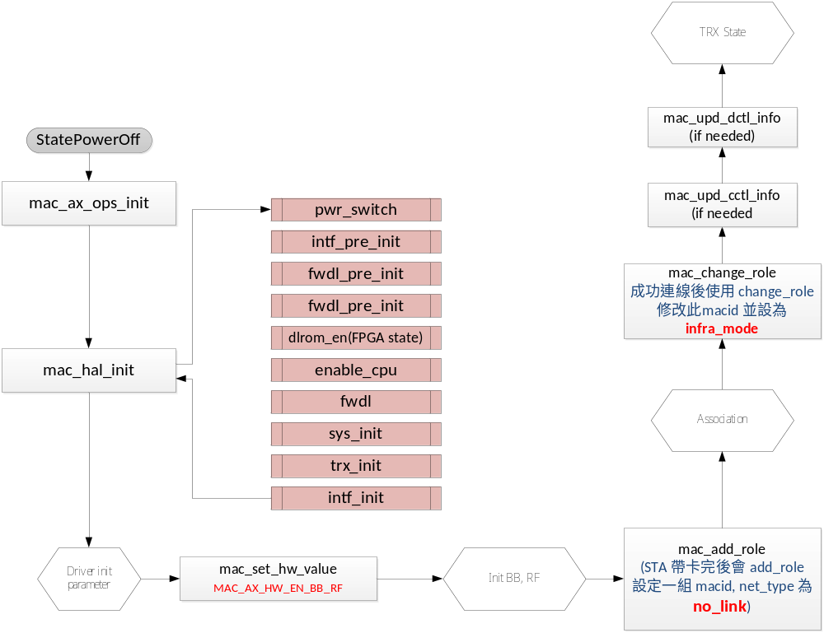

Flow Chart – AP/MBSSID mode init flow
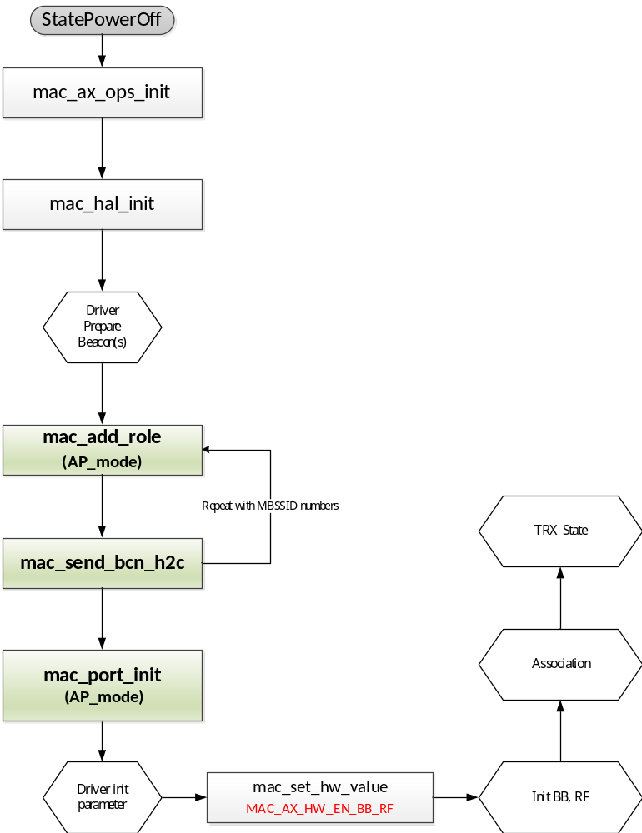

Flow Chart - Mac_Hal_Init
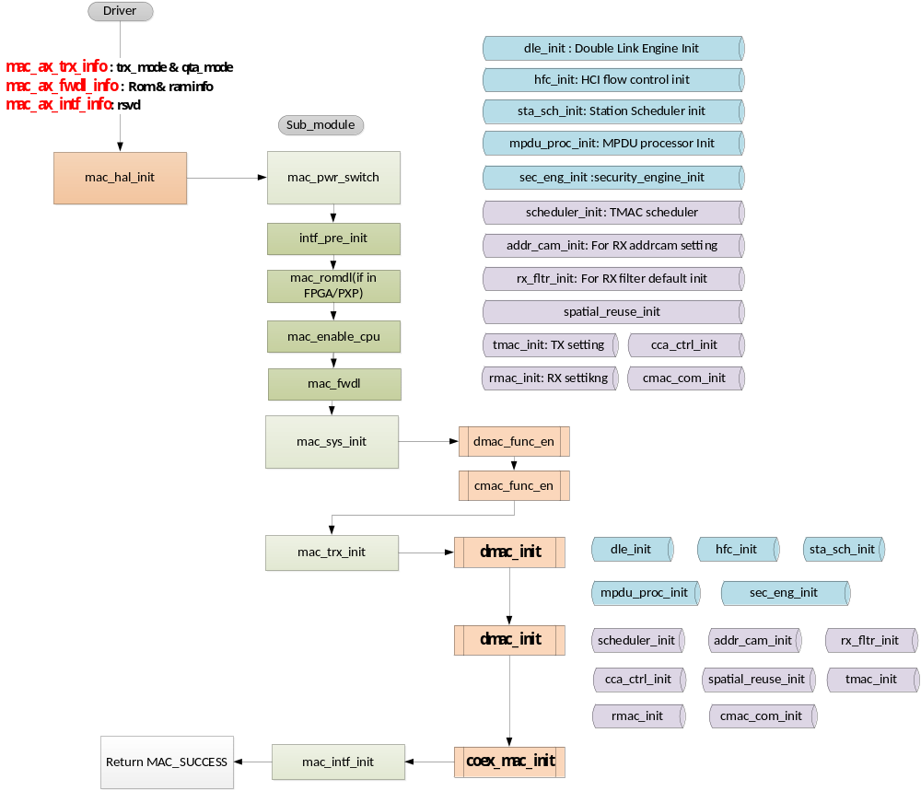

Flow Chart - Mac_Hal_Deinit
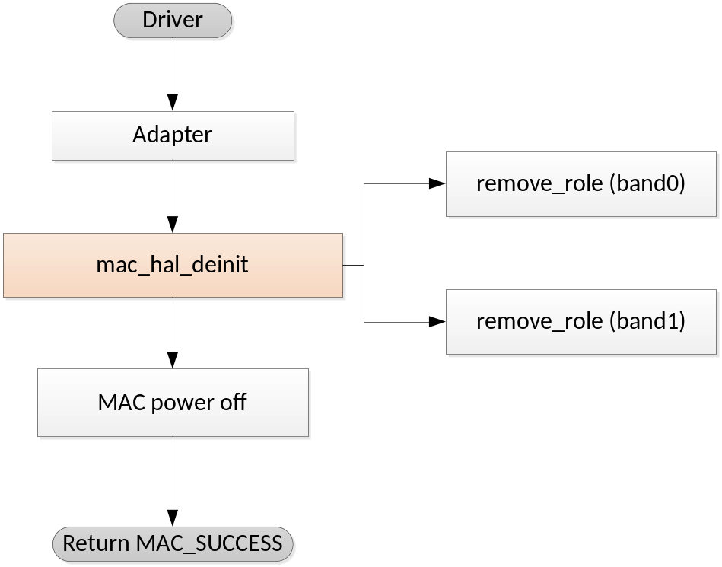

Flow Chart – Power Switch Flow
This flowchart is used to initialize Power Switch sequence
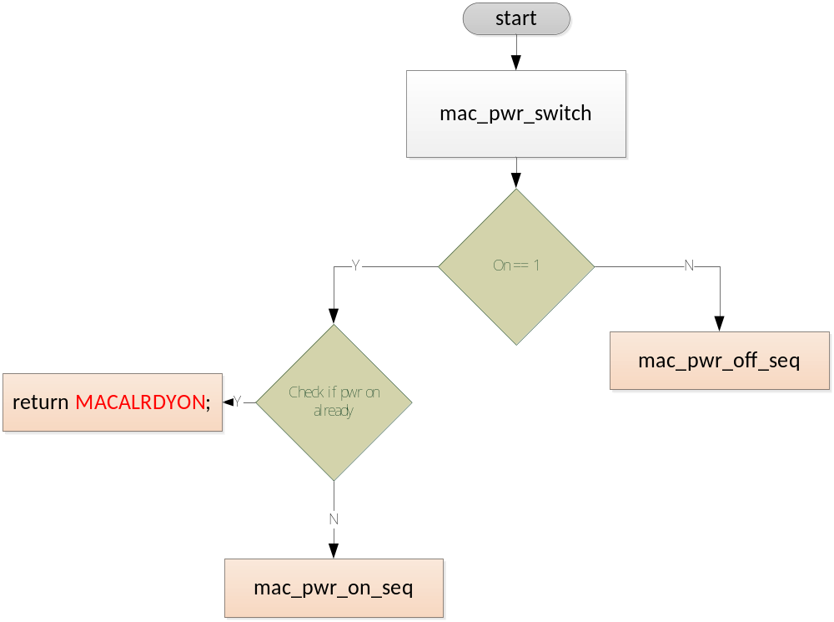

Flow Chart – System Initialization Flow
This flowchart is System init sequence include DMAC/CMAC init.
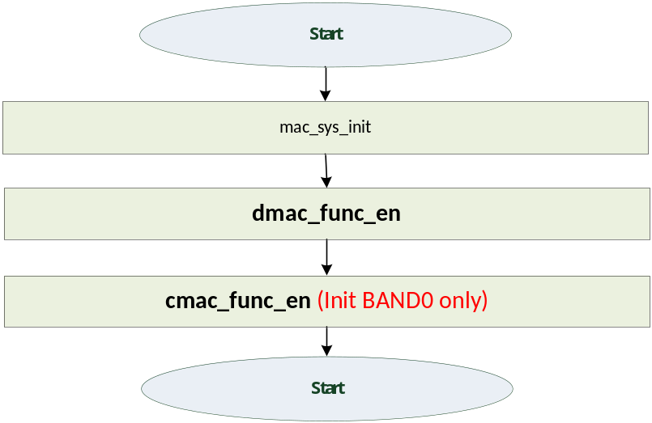

Flow Chart – TRX Initialization Flow

Flow Chart – mac_port_init Flow
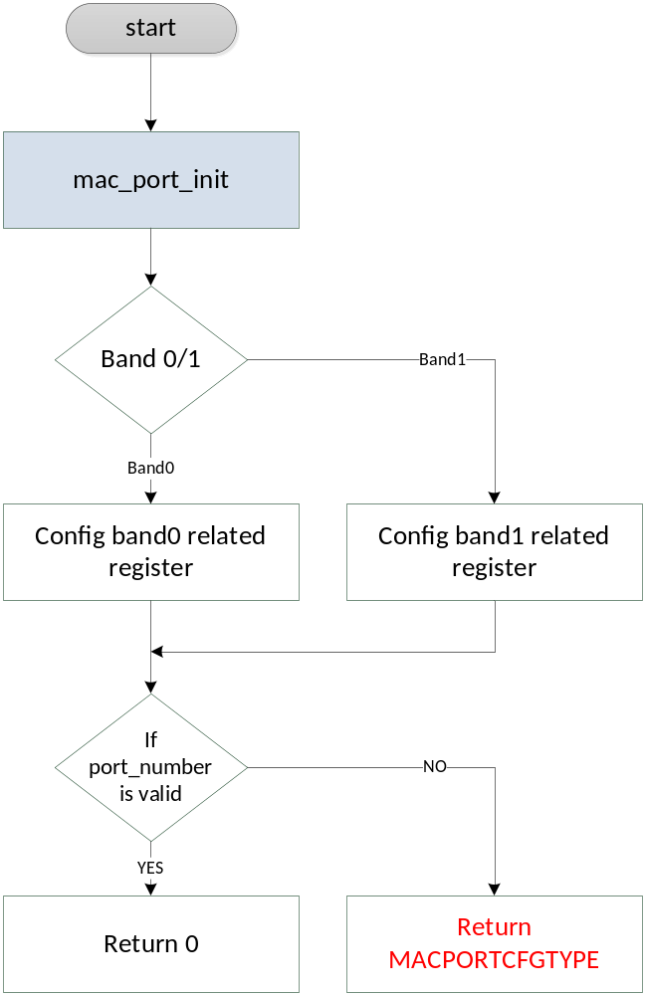

Flow Chart – mac_send_bcn_h2c
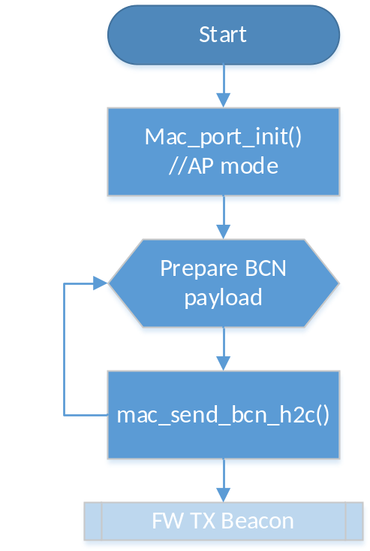

Flow Chart – mac_dbcc_enable Flow

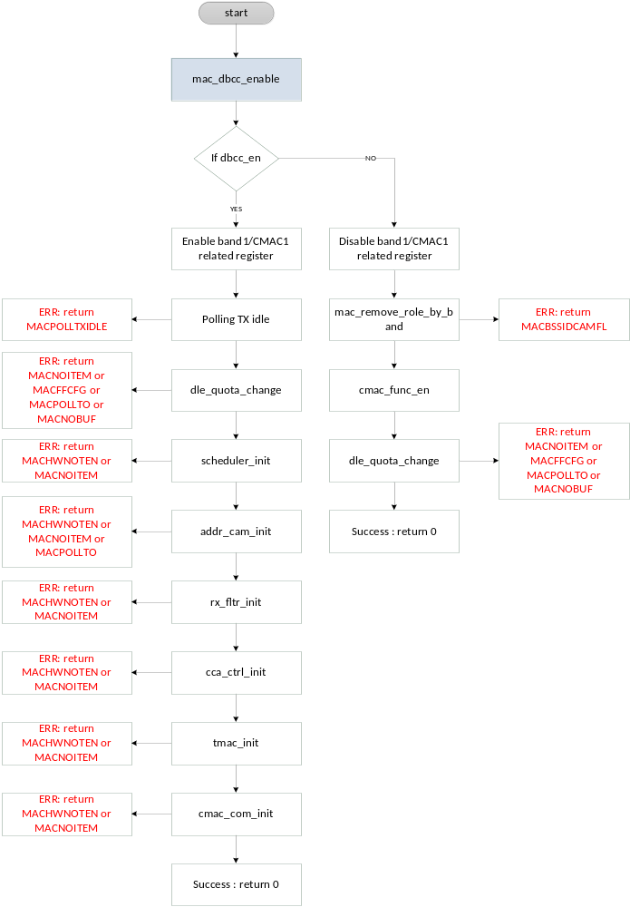

Flow chart - mac_romdl
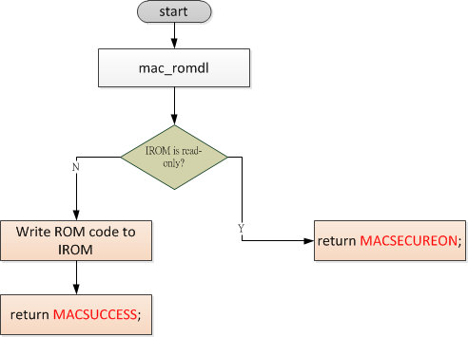

Flow chart - mac_fwdl
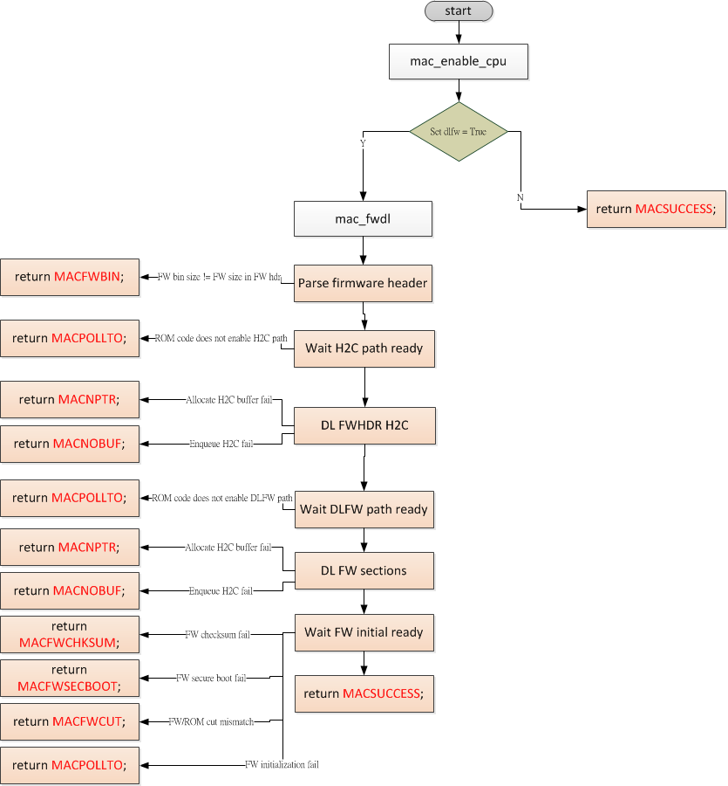

Flow Chart – Dump Wifi eFuse Map

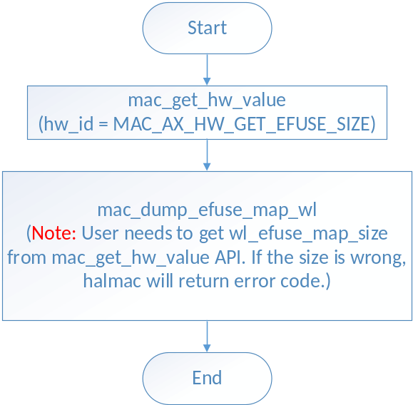

Flow Chart – Dump bt eFuse Map
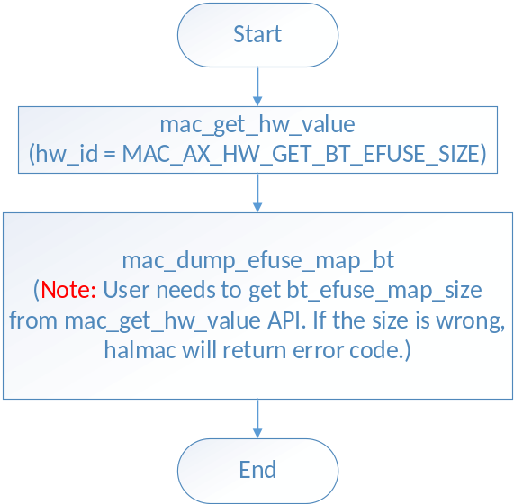

Flow Chart – eFuse Write
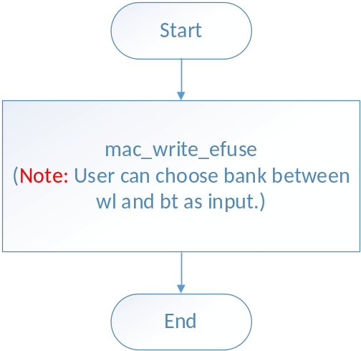

Flow Chart – eFuse Read
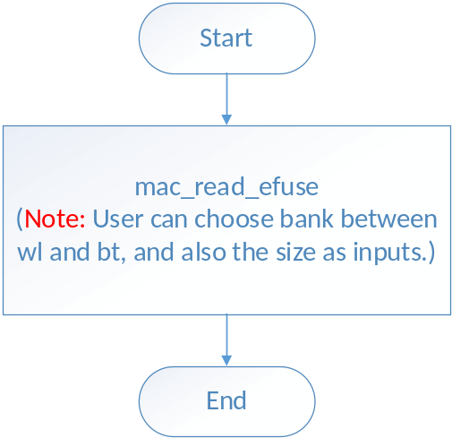

Flow Chart – Get Available Size of Wifi eFuse
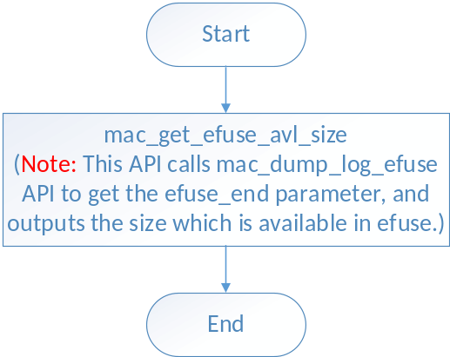

Flow Chart – Get Available Size of BT eFuse
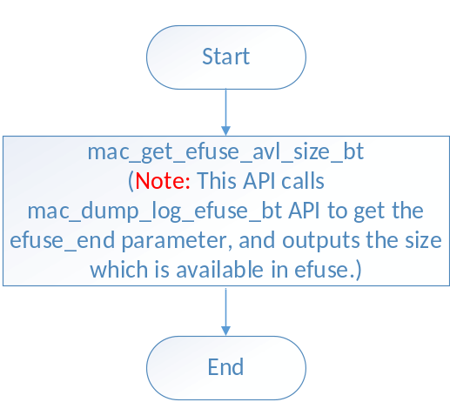

Flow Chart – Dump Wifi Logical eFuse
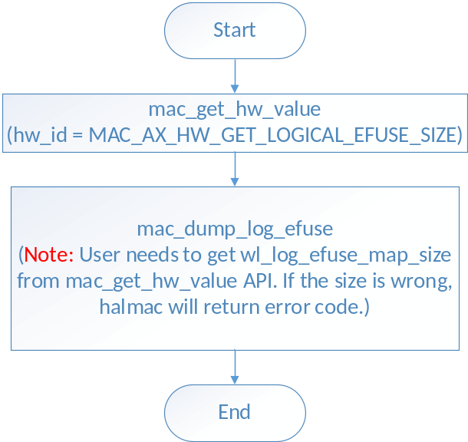

Flow Chart – Read Wifi Logical eFuse

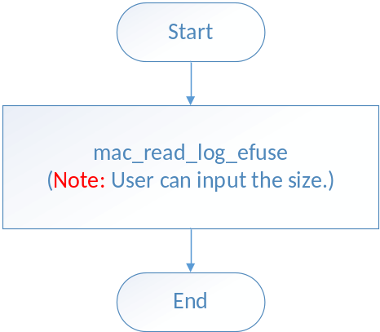

Flow Chart – Write Wifi Logical eFuse

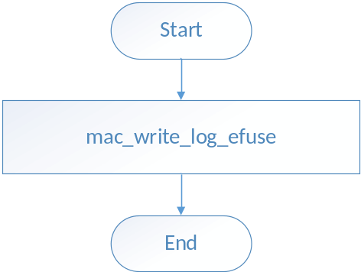

Flow Chart – Dump bt Logical eFuse

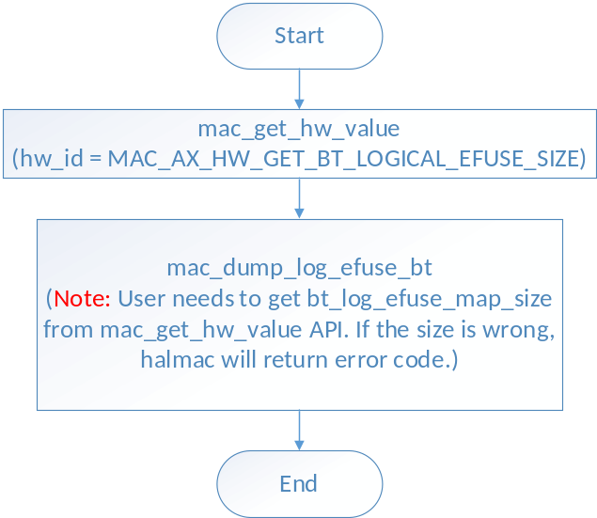

Flow Chart – Read bt Logical eFuse

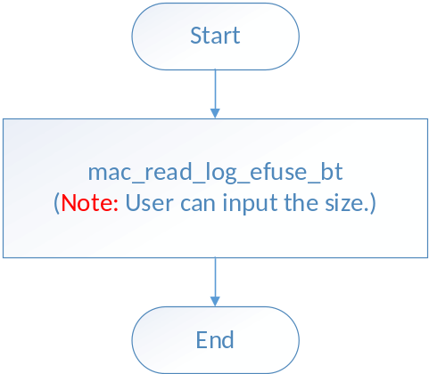

Flow Chart – Write bt Logical eFuse

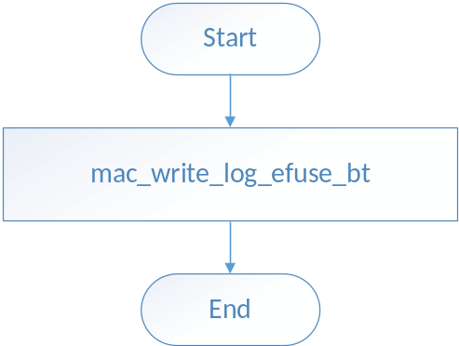

Flow Chart – Program eFuse by Map

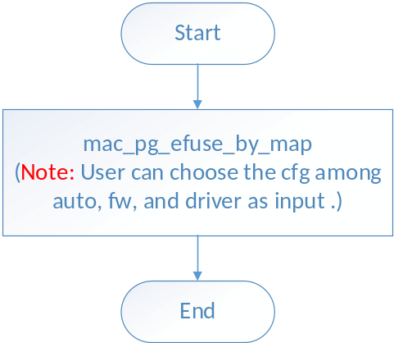

Flow Chart – Logical eFuse Mask

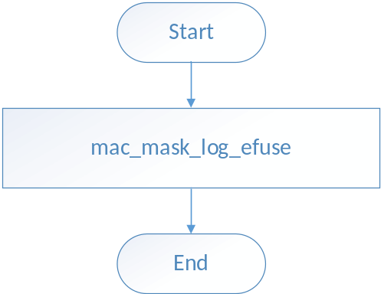

Flow Chart – Program Secure Data by Map

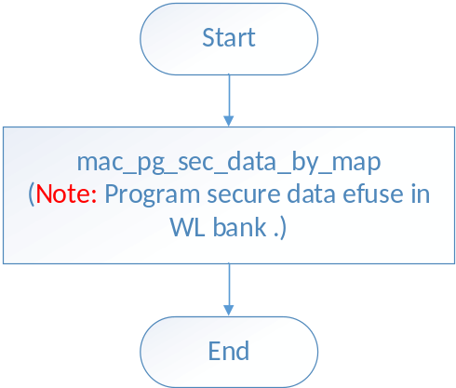

Flow Chart – Compare Secure Data by Map

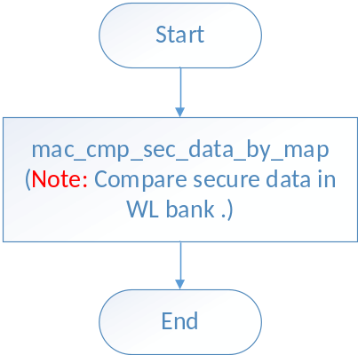

Flow Chart – Security add key

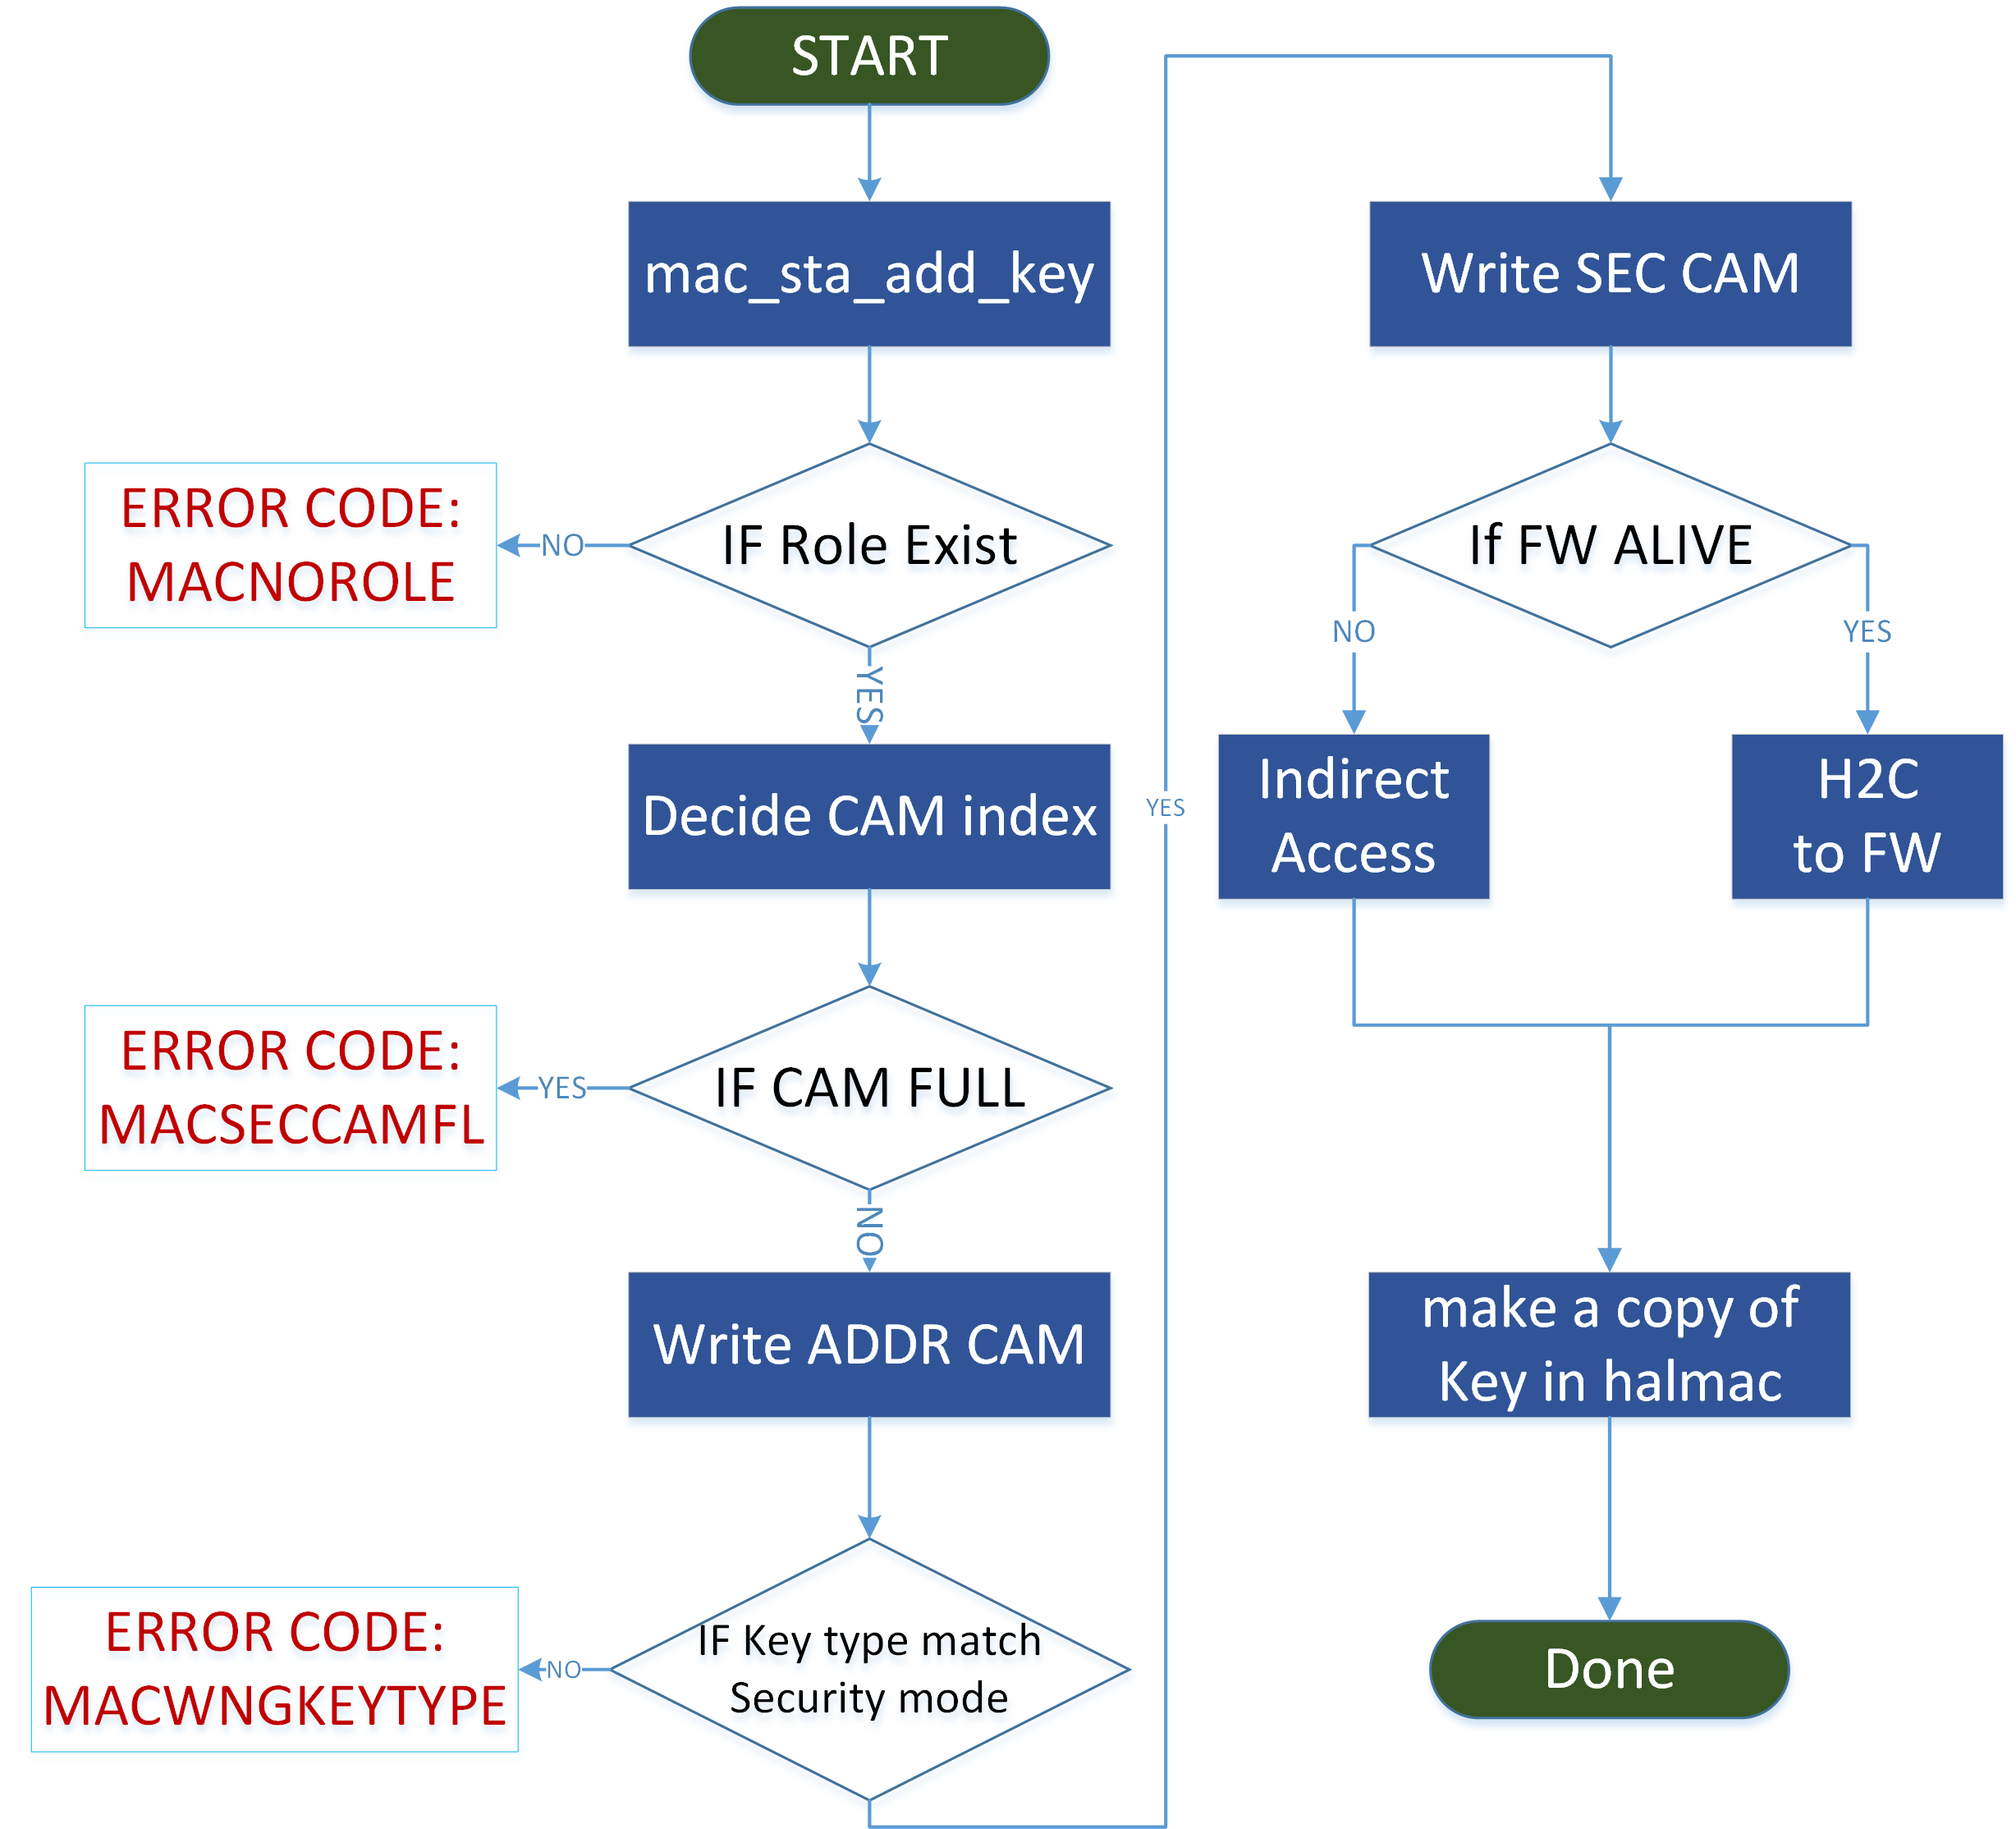

Flow Chart – Security Del Key

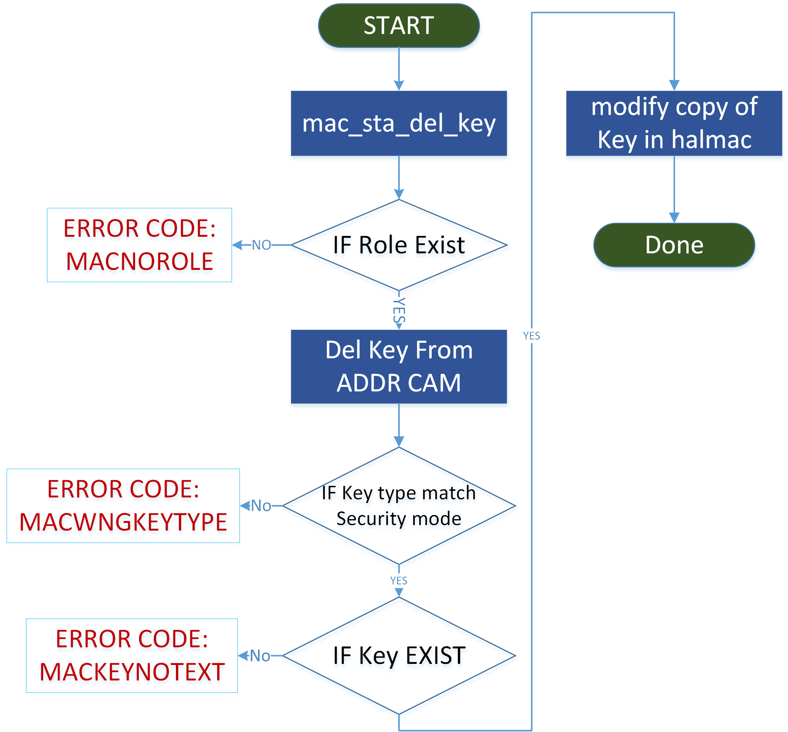

Flow Chart – Setting HWAMSDU
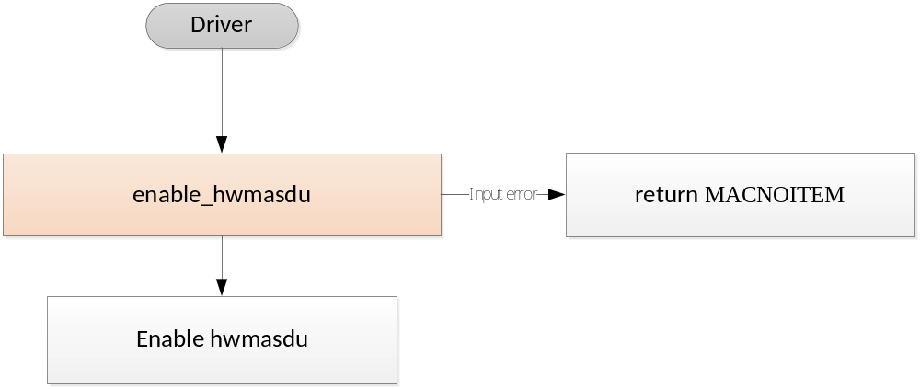

Flow Chart –Setting RX-AMSDU
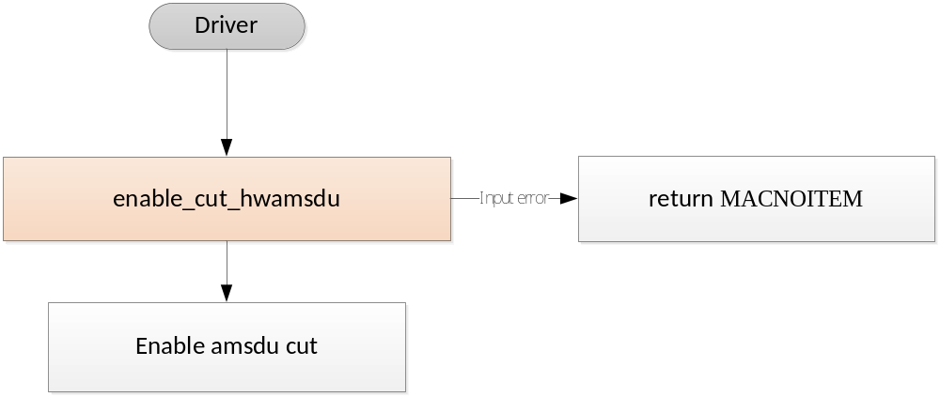

Flow Charder t –HeaConversion
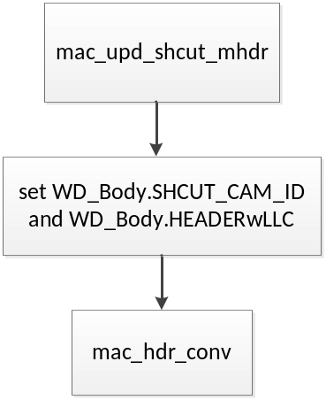

Flow Chart- HW Sequence Number
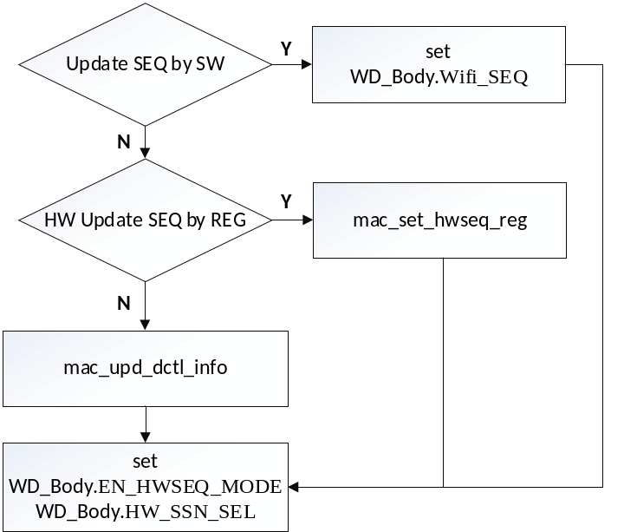

Flow Chart- HW AES IV
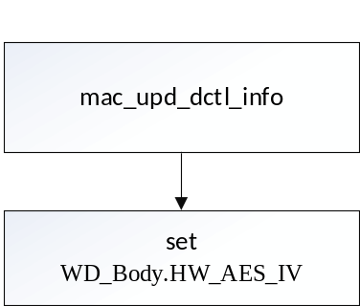

Flow Chart –TCP/IP checksum

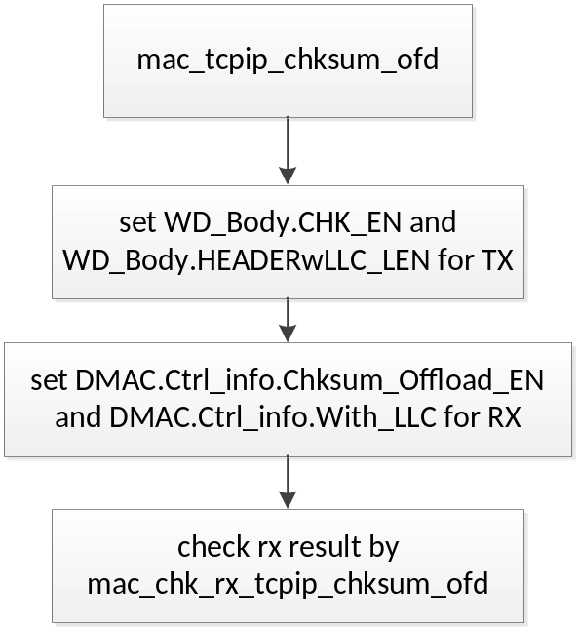

Flow Chart- add role
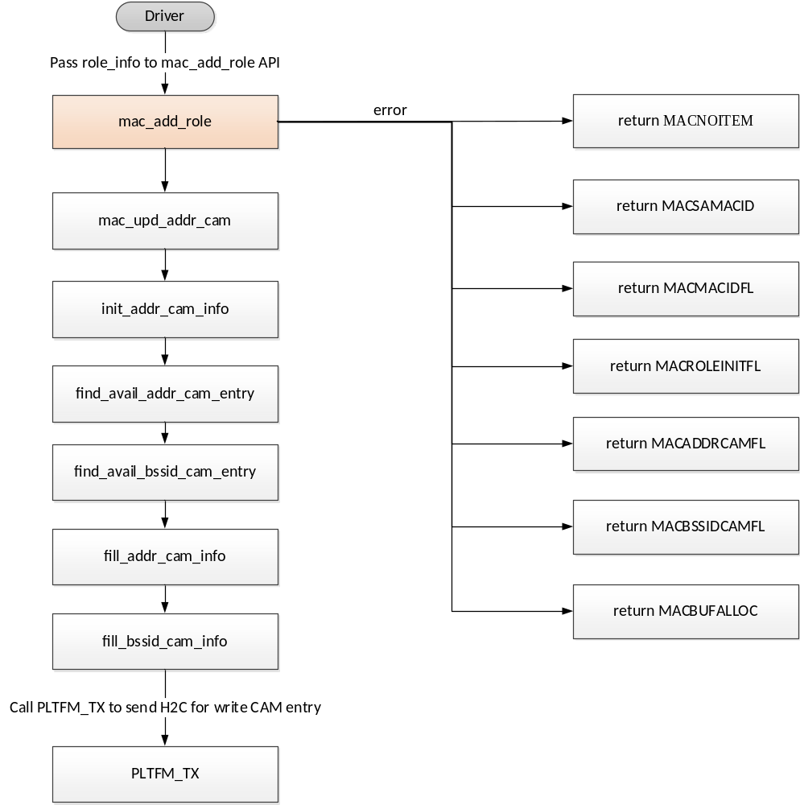

Flow Chart- change role
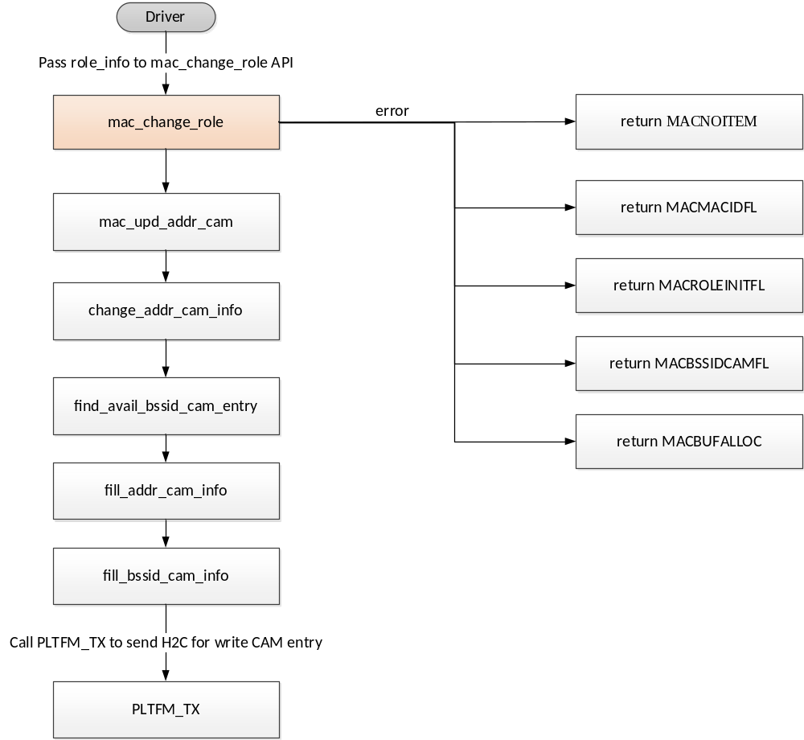

Flow Chart- remove role

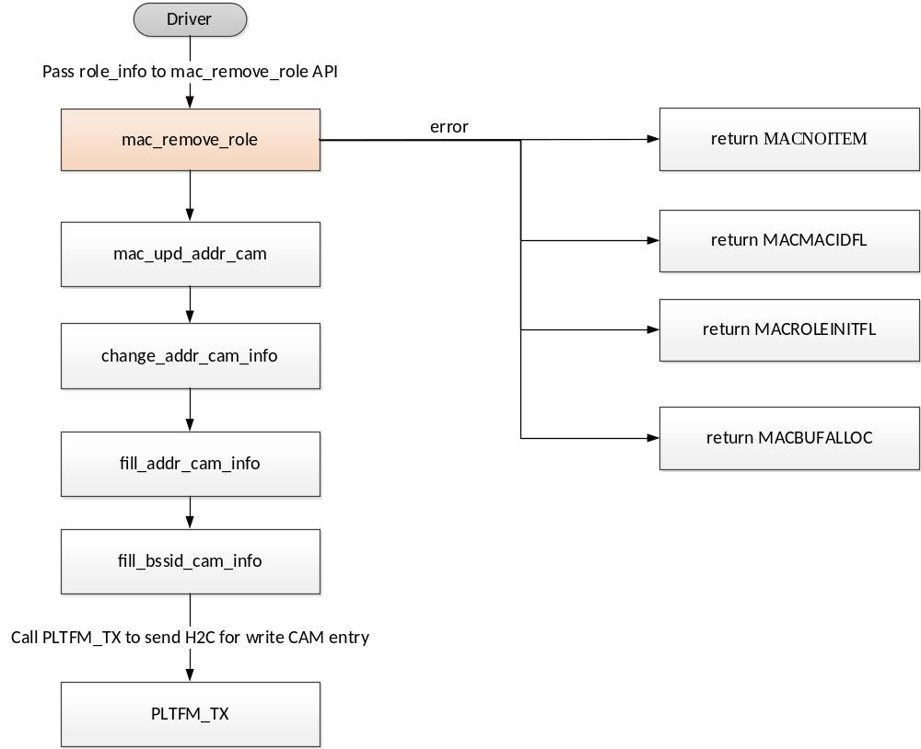

Flow Chart – Security Search key index

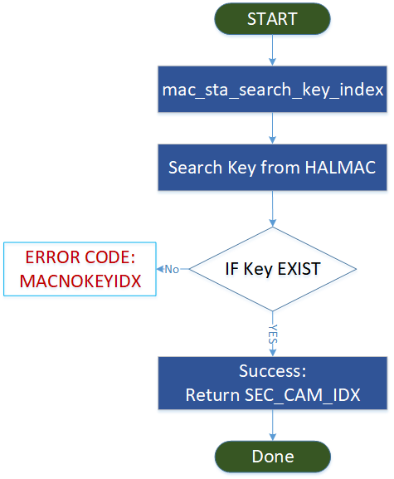

Flow Chart –H2C for Outsrc team Usage
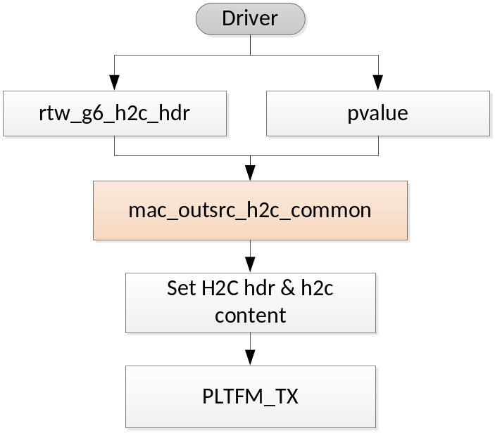

Flow Chart – Process C2H packet
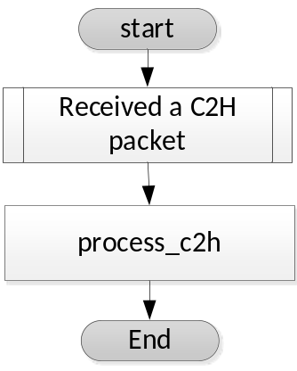

Flow Chart – Fill TXDESC
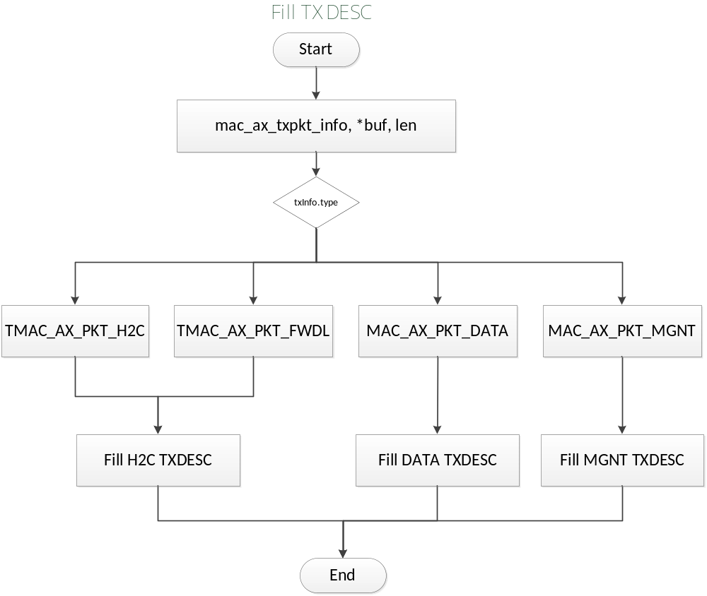

Flow Chart – Parse RXDESC
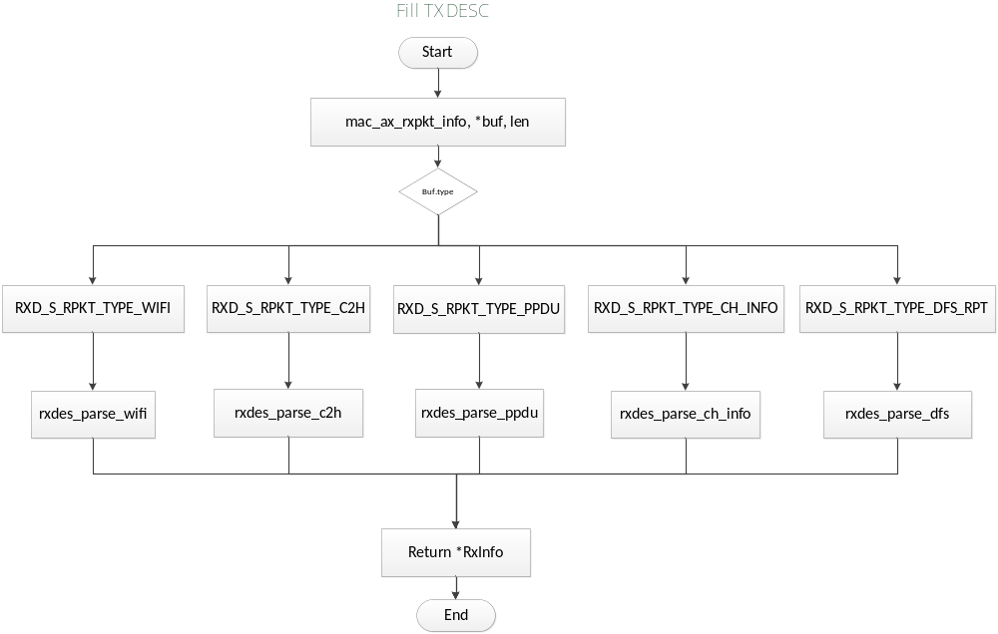

Flow Chart – Config GPIO UART TX
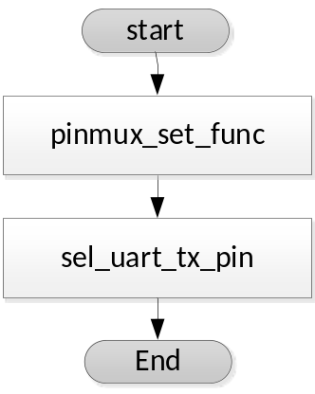

Flow Chart – Config GPIO UART RX
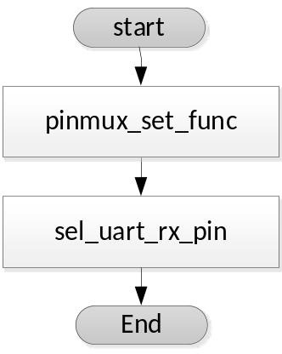

Flow Chart –CMAC/DMAC Table Setting
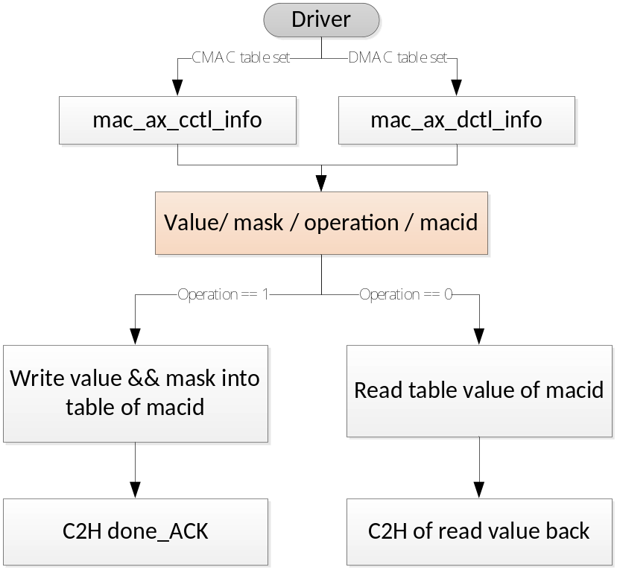

Flow Chart –Setting HW REG value
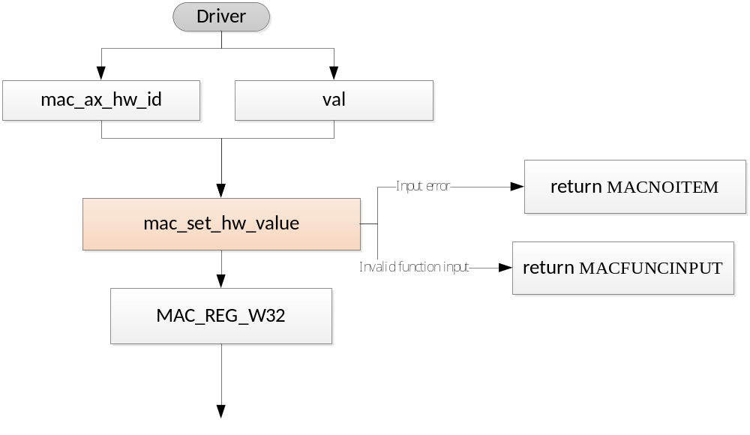

Flow Chart – FW command non-burst loopback
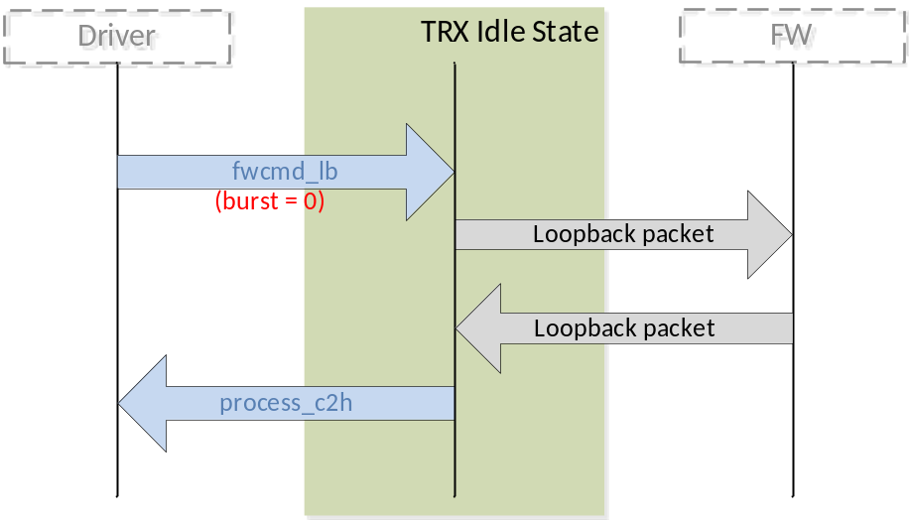

Flow Chart – FW command burst loopback

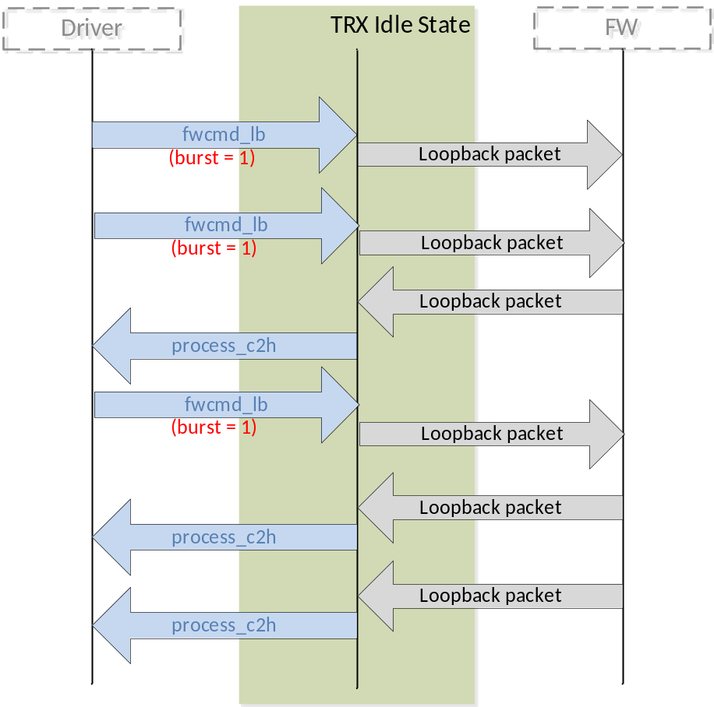

Flow Chart –Configure LPS
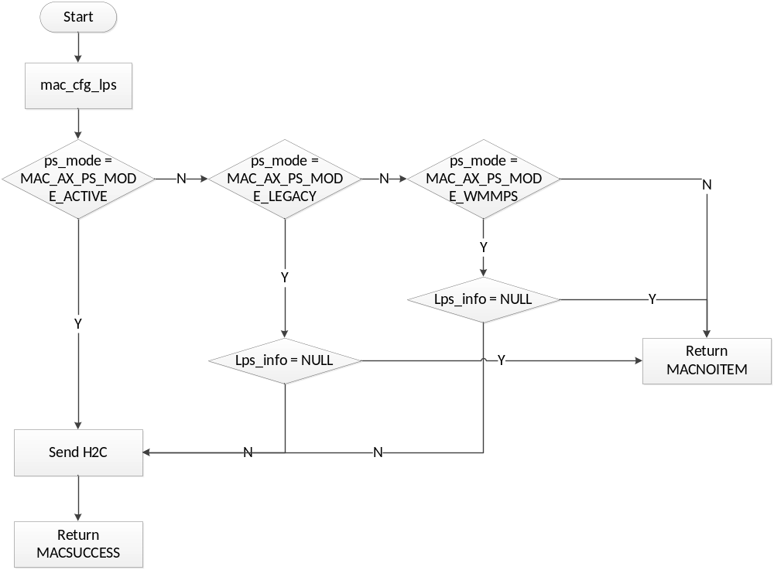

Flow Chart –LPS power state
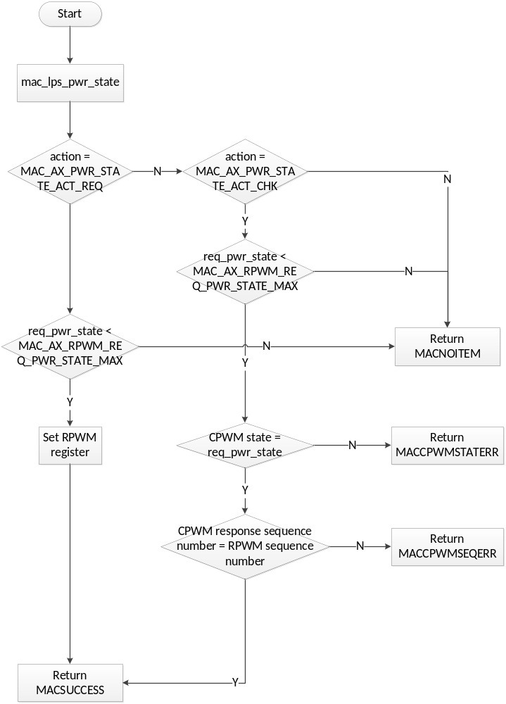

Flow Chart –Check leave LPS
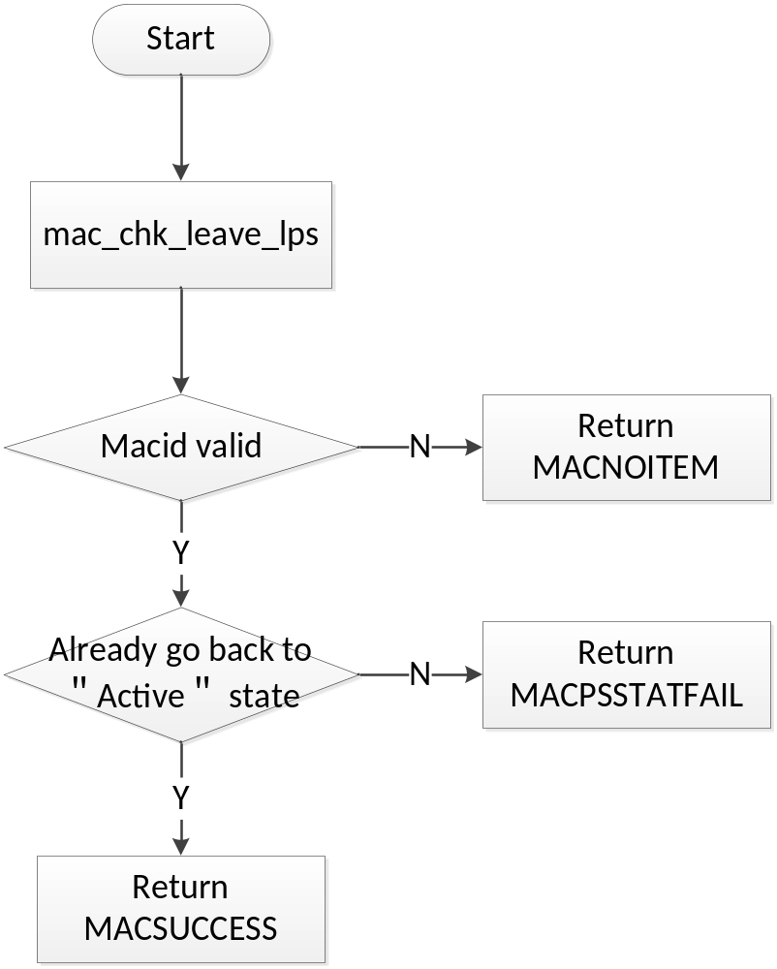

Flow Chart –Enable LPS
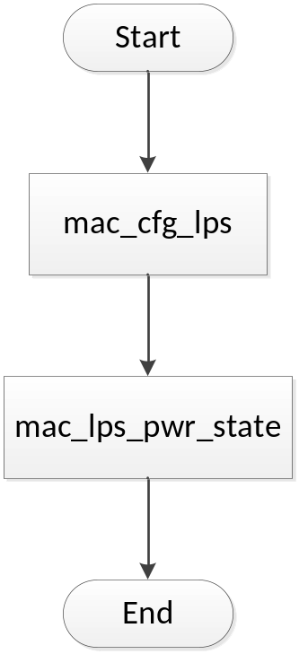

Flow Chart –Disable LPS
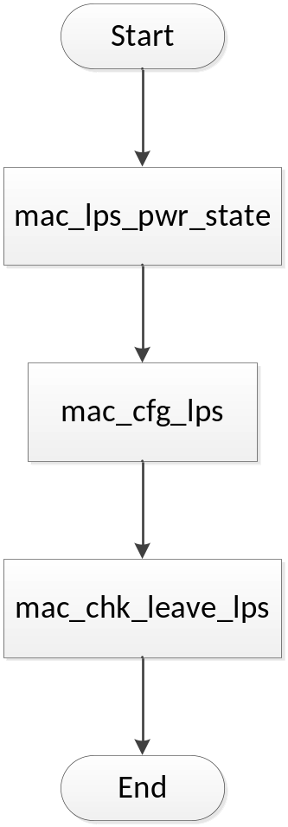

Flow Chart – Init BA CAM
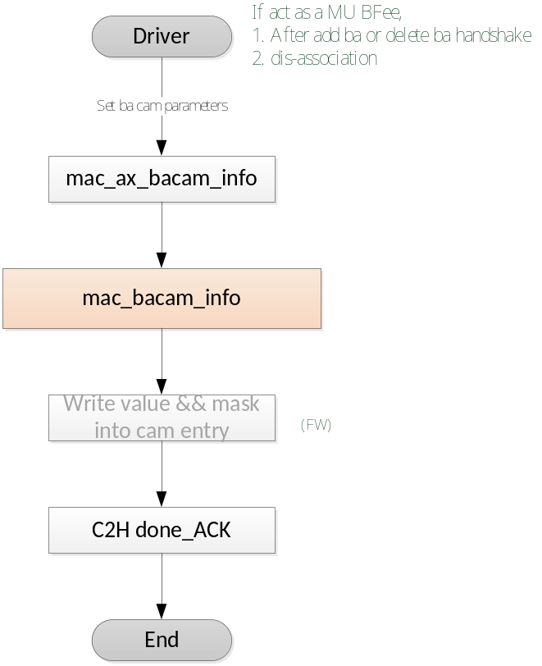

Graph

Graph – TXDESC Format
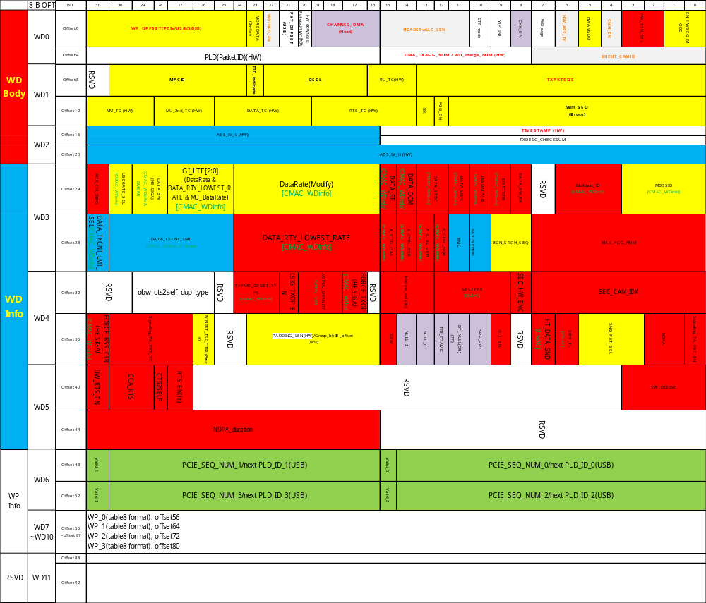

Graph – RXDESC Format

Graph- CMAC TABLE format
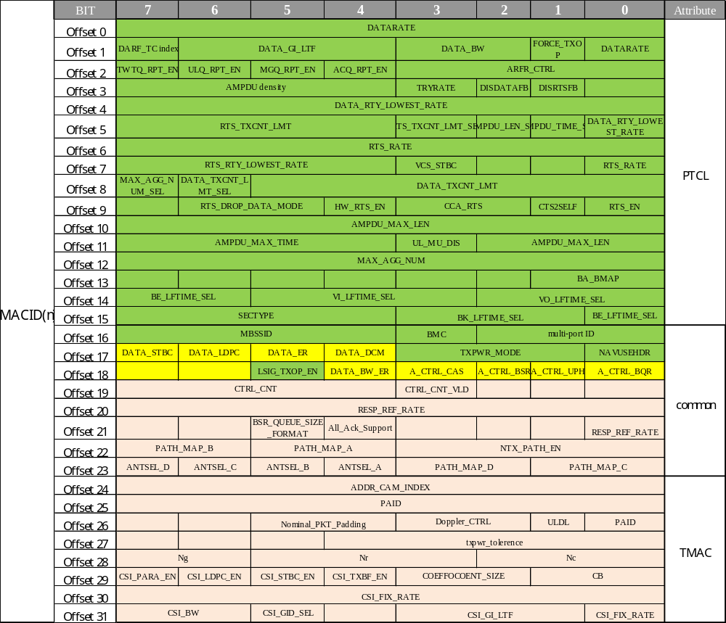

Graph- DMAC TABLE format
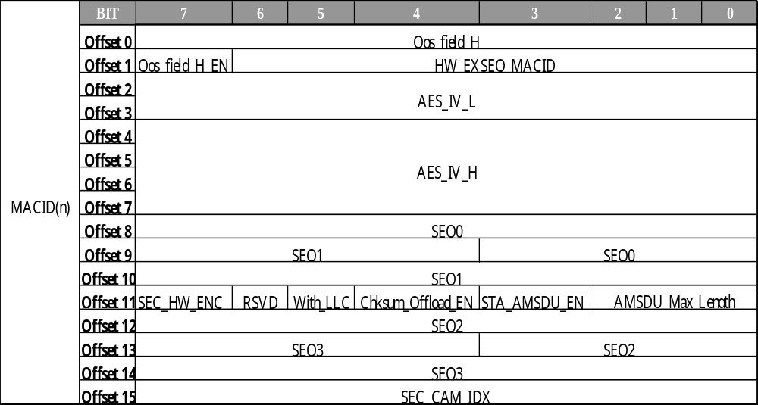

Graph – BA CAM Format
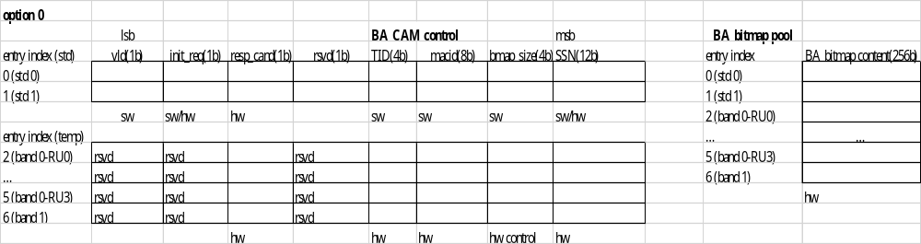

State Machine

State machine – download FW
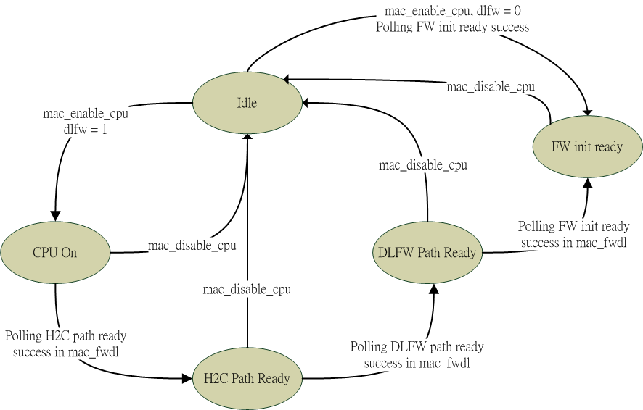

State machine – Read/write/config offload request buffer
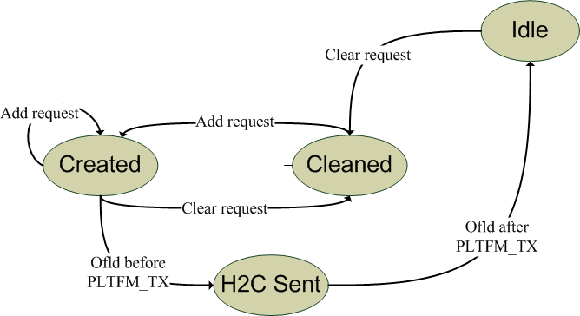

State machine – Write/config offload and add/delete offload packet H2C
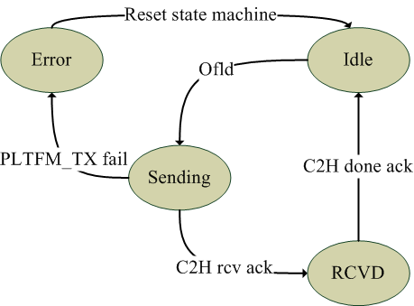

State machine – Read offload and read offload packet H2C
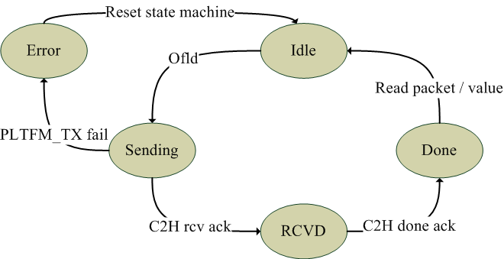

State machine – MCC group
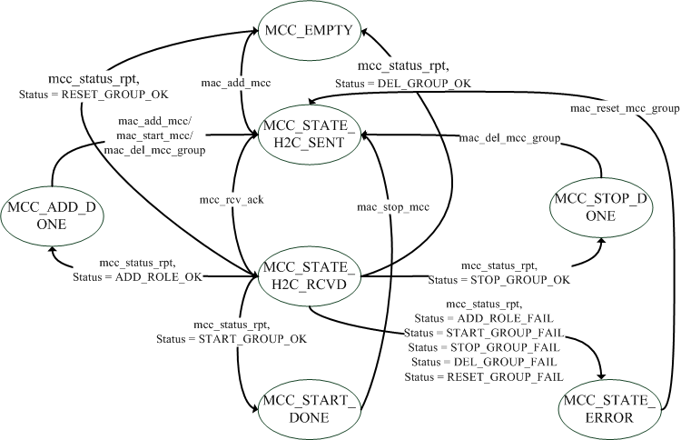

State machine – MCC request
