

The University of Hong Kong

Faculty of Engineering

Department of Computer Science

ICOM6034 Website Engineering

Group Project

By **Team**

Xia JianFeng,Jack (UID: 3035751581)

Kwan Ho Tin, Joseph (UID: 3035751828)

Date:25/4/2021

***Website Topic and overview***

Amid covid-19 pandemic, many physical business processes are being interrupted such as face-to-face meetings, physical hiring, sales and marketing events and many more due to the government closure orders or people safety concerns. This drives businesses’ to significantly invest in technologies. According to the survey conducted by Harvey Nash/KPMG, companies spent around 15 million dollars extra for a week for the technologies’ investment. Simultaneously, this pandemic accelerates the digital transformation for the enterprises by hiring more technology professionals for the process automation, AI, machine learning, cloud computing architecting etc. To help facilitate the businesses to embrace the benefits the technologies bring, we are proposing a (LCAP) Low code application platform in a Platform as a service (PAAS) way with a Laravel administrative interface that could help companies’ developers to build a CRUD backend with low/no-code with efficiency and effectiveness. Companies no longer need to invest heavily whether the massive cost on I.T infrastructure or a lot of time to develop applications but are able to focus more on providing value to the businesses by leveraging the powerful platform.

In this project, we built a customer relationship system with the Laravel admin panel as an example.

Value that the platform could provide as below:

1. ***Shorten the software development lifecycle***
   1. From requirements analysis to implementation, the processes could be shortened as the development becomes more streamlined and straightforward. The ideas or business process raised by the business users could be easily transformed into automated processes or applications in order to launch the services/products in a timely fashion.
2. ***Close the gap between the users’ expectations and application reality***
   1. As the development becomes easier, users could get hugely involved in the development or even could participate in development themselves by dragging and dropping or using some form/CRUD generators. Eventually, the final products could be closely fulfilled to the users’ expectations.
3. ***Foster the technologies advancement for the companies***
   1. Because of the low/no-code environment, some development tasks could be given to the business users. For I.T developers, they could minimize the time on development. Instead, they could concentrate more on exploring new technologies and system architectures to help drive companies’ s digital transformations.

***Details of the web APIs used***

In this application, five web APIs are used as follows:

|  |  |  |  |  |
| --- | --- | --- | --- | --- |
| ***No*** | ***Web API*** | ***Description*** | ***Usage*** | ***Reference*** |
| 1 | Tencent Cloud Object Storage | This api is used to store objects from the client side to the Tencent Cloud Object Storage. | When creating users in the user management page, there is a function for uploading the avatar. The photo will be stored on Tencent Cloud once uploaded. | https://intl.cloud.tencent.com/product/cos |
| 2 | Tencent Cloud Text Translate API | This api is used to translate the text instantly to different languages. | When creating a new customer in the customer page, the company name input by the user could be translated instantly by clicking the dropdown list with selected language e.g.: Traditional Chinese, simplified Chinese or Japanese. | https://intl.cloud.tencent.com/document/product/607/15228 |
| 3 | Google Map API | This api is used to display the map with a specific location selected. | When checking tasks in the task management, there is a column to show the location. A map will be shown as in a modal when being clicked. | https://developers.google.com/maps |
| 4 | Market Stack API | This api is used to get the latest stock quote in the US Stock Market. | The end of date stock data and the stock symbol are retrieved for each customer in order to let user to understand the current market price of the customer and the symbol to further research on the company. | https://marketstack.com/documentation |
| 5 | Media Stack API | This api is used to retrieve the latest news from different source providers. | A list of sources such as Bloomberg, Times, BBC and articles from different sources are retrieved in order to build for the index page to let user to catch up with the latest news around the world to explore more potentials business opportunities. | https://mediastack.com/ |

***Technologies used***

In this project, the core backbone was mainly built on the PHP framework Laravel with the MVC design pattern. The below are the breakdowns of the technologies used.

|  |  |  |
| --- | --- | --- |
| ***No*** | ***Technologies*** | ***Details*** |
| 1 | Laravel | The foundation of the application is built based on the Laravel framework. With the detailed documents provided by the Laravel, we could easily build a web application according to the guidance. |
| 2 | Composer | With the dependencies and libraries management, we could easily install, update, and remove the necessary packages or libraries for building our services. |
| 3 | MySQL | My SQL is used to be our database layer to store data and even manage our webpages. |
| 4 | Github | The online version controlling system is used by us in order to collaborate together to complete the project. |
| 5 | Tabler | The open-source user interface is used to build our website such as tables, navigation bar, modal, form elements etc. |
| 6 | Apexcharts | The open-source chart is used to build the dashboards. |
| 7 | Chart JS | The open-source chart is used to build the dashboards. |
| 8 | JSONEditor JS | The open-source JSONEditor is used to for us to generate pages |

***Functional Specifications***

**General user perspective**

1. Account creation
   1. Password reset.
2. Review the market news only.
   1. Latest news around the world
   2. Latest technology news
   3. Business Insider news
   4. Latest business news
3. Review the existing customer list only.
4. Review the own user profile.

**Admin user perspective**

1. Account Management
   1. Password Reset
   2. Profile review
   3. Role-based access control
      1. Ability to create/update/delete users.
      2. Ability to assign the read access to different pages.
2. Model construction
   1. Able to
      1. Create entity name and attributes for the models.
      2. Freely add new attributes for the model, label, data type (e.g., varchar, int, json), front type (e.g., text, select, image)
      3. Extend attributes’ front type by template function,
         1. Extend template view for <input>, <button>, model grid, model form. e.g. view('input',['field':'col-md-8','label':'Title','type':'text','name':'title'])
         2. Use google map open api for displaying location
         3. Use Tencent Cloud Object Storage open api for image upload
3. Auto Generate CRUD(Create/Read/Update/Delete) Backend Model code
   1. Use data_type and label in Entity (travel ideas) and Model/Migrate/Controller template to Auto Generate code
   2. Use front_type and label in Entity (travel ideas) to Auto Generate form view (index/show/edit/create.blade.php)
   3. Search function for Grid, admin can set Search fields in Entity Attributes
   4. Data validations for Form, admin can set field validations in Entity Attributes
4. Report
   1. Statistic for each model created.
   2. Charts for important model.
5. Index page
   1. Construct a page to contain news.
      1. Latest news around the world
      2. Latest technology news
      3. Business Insider news
      4. Latest business news

***System Design***

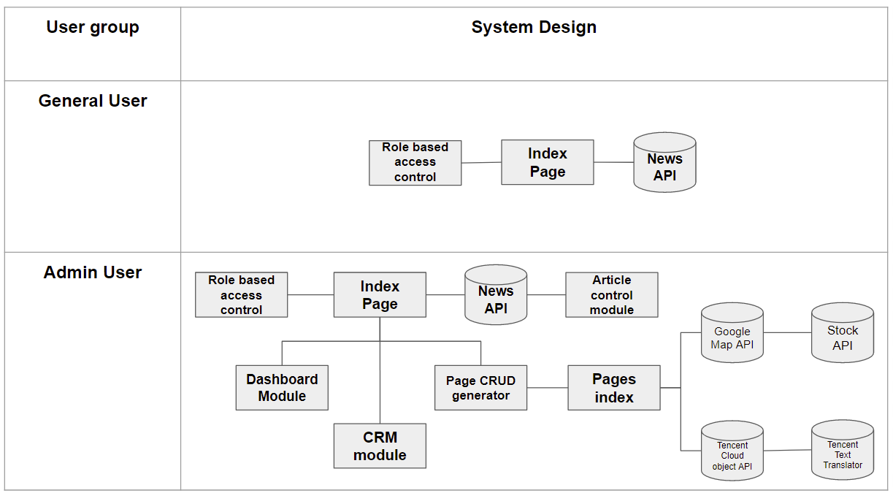

***Database Design***

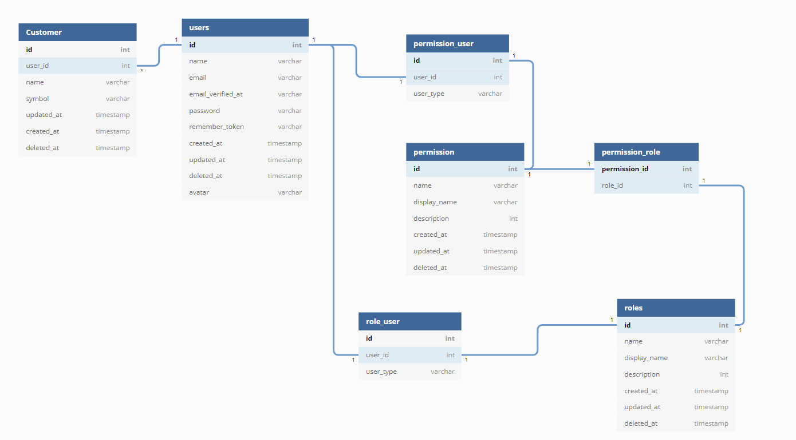

For the key tables, they include users, customers, permission, roles, role user and permission user in order to build on the role and access.

**User - Customer**

For simplicity, the users table has a one-to-many relationships with the customer table meaning that a user can have one or more than one customer.

**Permission – permission user**

The permission has one-to-one relationship with permission user implying that a user has only one permission.

**Roles – role user**

The roles table has one-to-one relationship with role user table meaning that a user has only one role.

**User – permission user**

The users table has one-to-one relationship with permission user table meaning that a user has only one permission.

**User – role user**

The users table has one-to-one relationship with permission user table meaning that a user has only one permission.

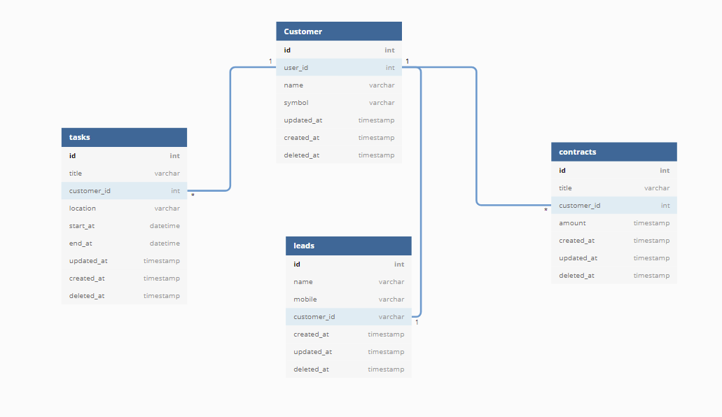

For CRM, there are four tables to be constructed, customer, tasks, contracts, and leads.

**Customer – Tasks**

For simplicity, the customer table has a one-to-many relationship with the tasks table meaning that a customer could have one or more than one task.

**Customer – Leads**

The customer table has a one-to-one relationship with the leads table as the one potential customer could become the only customer.

**Customer – Contracts**

The customer table has one-to-many relationship with the contracts table as many contracts could be signed by one customer.

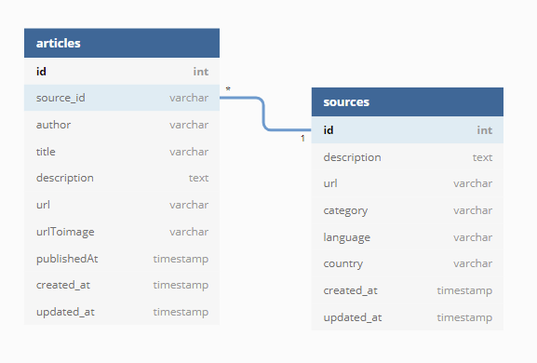

For the index page, it is built with these two tables, sources, and articles.

**Sources – articles**

The sources table has one-to-many relationship with the articles table as one source could publish one or many articles.

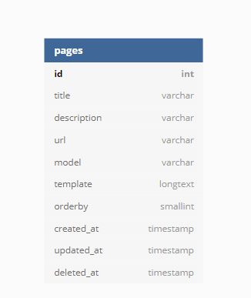

For pages, there is no relationship with others as this is used to generate pages for the website.

|  |  |  |  |
| --- | --- | --- | --- |
| **No** | **Modules** | **Jack** | **Joseph** |
| 1 | The View Layout by Tabler Template |  |  |
| 2 | User Login and Register | 90 | 10 |
| 3 | Page Management and CRUD Generator | 90 | 10 |
| 4 | Role-Based Access Control Management by Laratrust | 100 |  |
| 5 | File Upload Widget in Form by using Tencent Cloud COS API | 100 |  |
| 6 | Text Translate Input Widget by using Tencent Cloud TextTranslate API | 100 |  |
| 7 | Customer Relationship Management by using Module 1-6 | 90 | 10 |
| 8 | Profile Read and Update |  | 100 |
| 9 | NewsAPI API integration |  | 100 |
| 10 | Task management add-on function with google map api | 10 | 90 |
| 11 | Task details module with stock API and google map api |  | 100 |
| 12 | Dashboard module |  | 100 |
| 13 | Group report | 50 | 50 |