Magento Theme Instruction

We are extremely happy to present Holiday Magento theme to you, it is designed and developed by highly qualified Designer & Developers in a way that make it usable for any type of E-Commerce store.
我们非常高兴地呈现假日Magento主题，它的设计和开发的高素质的设计师和开发的方式，使得它可用于任何类型的电子商务商店。
_____________________________________________________________________________________________
Features

Highlights
- Responsive behaviour
- Configurable Home page Banner Slider
- Custom AJAX Add to Cart
- Custom Mega Menu
- Home page Latest + featured + Sale Product Slider
- Touch enabled sliders
- CSS3 Hover effects
- Cloud Zoom ( Product Images )
- 2 - 3 - 4 Column Product List layout
- Horizontal / Vertical /custom1 /custom2 Product detail Layout
- Custom Background, Pattern, Fonts ( Admin Configurable )
- Ajax based Navigation in Category Page
- Blog
- Iconic Fonts ( Change Icon to any color through CSS )

General
- Compatible with Magento 1.6.x.x, 1.7.x.x
- PSD, Fonts files supplied
- Cross Browser Support

Installation & Configuration
Thank you very much for purchasing! In this document you will find all the information about how to setup and configure this theme in your Magento Installation.

System Requirements
Holiday only supports Magento Community Edition 1.6.x.x and 1.7.x.x which can be downloaded from http://www.magentocommerce.com/download.
It does not support Magento Enterprise Edition and Magento GO. Before downloading Magento, make sure you meet the system requirements and test the compatibility of your server.
For help with installing Magento, please refer to the following links:
- Magento System Requirements
- Server Compatibility Check
- Magento Installation Guide

Uploading Holiday
Before you begin the installation process, we recommend to backup your Magento installation and database.

- Unzip downloaded folder “Holiday”.
- Upload / Copy all files / folders from folder “Magento Files” to your Magento root directory, if you are using Mac, please make sure you are merging and not replacing Magento directory.

Make “Holiday” your theme
- Login to the Magento Admin Panel.
- Go To: 'System → Configuration' Click on Design on the left menu
  - Under Package Tab put “holiday” into current package name
  - Under Header tab put “images/logo.png” into 'Logo image Src' Field
  - You can also enter the Image alter text and Default Welcome Text
- Scroll back to the top of the page and click the Save Config button
- Next, go to 'System > Cache Management' from the top navigation menu. You will need to clear the store cache and all cookies.
- Click the following buttons (in orange): Flush Magento Cache, Flush Cache Storage, Flush JavaScript/CSS Cache, and Flush Catalog Images Cache (optional). Now you are ready to add content to your website.

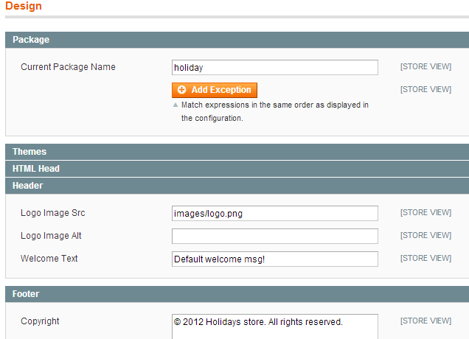
Home Page Setup
Homepage requires some static blocks to be added. Below are all the details about home page block
- Banner Slideshow
  - Go to: “Banner Slider → Manage Banners” and click on Add Banner
  - Set Below fields for each banner
    - Title > title for banner
    - Store View > Select your store to display banner
    - Image File > select Banner Image which you want to display
    - Status > set status to 'Enabled'
    - Sorting Order > set ordering for banner
    - Web Url > set URL you want user to be redirected when clicking on Read More Button
    - Content > Description / Text for banner

Click on Save Banner

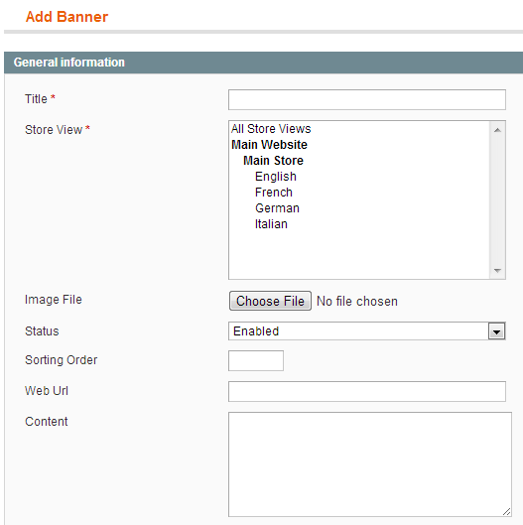

- Banner Settings
  - Go to: “System → Configuration” and click on ‘Banner Slider’ from left menu
  - Set Below options as per your requirement

- Banner Slider Settings

- Enable Banner > set ‘yes’ if you want to display banner slider on home page
      - Slider Interval > Set timing for banner interval
      - Show description > Set 'yes ' or 'no' do display description
      - Easing effect > Select easing effect
      - Slide Mode > Select slide mode

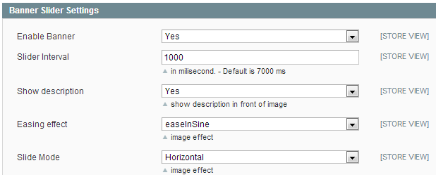

- Custom Block for Home Page
  - Go to: 'CMS → Static Blocks’ click on “Add New Block” from Right Corner
Set “home-block” into 'Identifier' & 'Block Title' Field
Set Store View => All Store View
Status => Enabled
Put the following code in to Content area
<div class="home-top-block">
<div class="top-block"><span class="icon-truck">&nbsp;</span>
<h2 class="medium">FREE SHIPPING</h2>
<p>ON ORDER OF ABOVE $200</p>
</div>
<div class="top-block"><span class="icon-star">&nbsp;</span>
<h2 class="medium">CHRISTMAS OFFER</h2>
<p>ON ORDER OF ABOVE $200</p>
</div>
<div class="top-block"><span class="icon-group">&nbsp;</span>
<h2 class="medium">UPTO 20% OFF</h2>
<p>ON ORDER OF ABOVE $200</p>
</div>
<div class="top-block last"><span class="icon-leaf">&nbsp;</span>
<h2 class="medium">GO GREEN. GO LIVE.</h2>
<p>ON ORDER OF ABOVE $200</p>
</div>
</div>

- Custom Block for Home Left Sidebar

  - Go to: 'CMS → Static Blocks’ click on “Add New Block” from Right Corner
Set “home-left-sidebar” into 'Identifier' & 'Block Title' Field
Set Store View => All Store View
Status => Enabled
Put the following code in to Content area
<div class="customized">
<h3 class="medium">Customized Area</h3>
<div class="best_theme">
<h4 class="medium">Looking for the best theme?</h4>
<div class="theme_image"><img src="{{media url="wysiwyg/category-banner/home-left.jpg"}}" alt="" /></div>
<a class="button" title="best theme" href="#"><span class="small">View More</span></a></div>
</div>

- Custom Block for Home Right Sidebar

  - Go to: 'CMS → Static Blocks’ click on “Add New Block” from Right Corner
Set “home-right-sidebar” into 'Identifier' & 'Block Title' Field
Set Store View => All Store View
Status => Enabled
Put the following code in to Content area
<div class="customized">
<h3 class="medium">Customized Area</h3>
<div class="best_theme">
<h4 class="medium">Looking for the best theme?</h4>
<div class="theme_image"><img src="{{media url="wysiwyg/category-banner/home-right.jpg"}}" alt="" /></div>
<a class="button" title="best theme" href="#"><span class="small">View More</span></a></div>
</div>

- Featured Products

You need to set 'Yes' in fields “Featured” for the products you want to display as Featured Product on home page

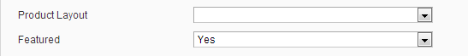

Note: for Featured product first off all you need to create an attribute.

- Step for creating attribute

Go to: 'Catalog → Attributes → manage Attributes’ click on “Add New Attribute” from Right Corner

Set the following option under 'Attribute Properties' Tab

Attribute code > promotion
Scope > Global
Catalog input type for store owner > yes/No
Apply To > all product types
After that click on “Manage Label/Options” from left corner

Set following option under 'manage Titles' tab

Admin > Featured(you can set anything as you want to display)

After that click on “Save Attribute” from the top of the page

- Step for apply attribute to attribute set

Go to: 'Catalog → Attributes → manage Attributes Sets’ click on “Default ” Attribute set from the Display list

After that drag the 'promotion' attribute from the right 'Unassigned Attribute' list to under the 'General' tab

Then click on “Save Attribute Set” from top-right corner.

Note: if you want to display 'Featured' option to any other Attribute set then assigns promotion attribute to other attribute set.

For More Information visit to belove link:http://inchoo.net/ecommerce/magento/promotion-and-random/
- Footer Block

  - Go to: 'CMS → Static Blocks’ click on “Add New Block” from Right Corner
Set “footer-block” into 'Identifier' & 'Block Title' Field
Set Store View => All Store View
Status => Enabled
Put the following code in to Content area

<div class="footer-logo"><img src="{{media url="wysiwyg/category-banner/logo_footer.png"}}" alt="" /></div>
<div class="footer_top_link">
<ul>
<li class="x-small" title="HOME"><a href="#">HOME</a><span>&nbsp;</span></li>
<li class="x-small" title="MEN"><a href="#">MEN</a><span>&nbsp;</span></li>
<li class="x-small" title="WOMEN"><a href="#">WOMEN</a><span>&nbsp;</span></li>
<li class="x-small" title="KIDS"><a href="#">KIDS</a><span>&nbsp;</span></li>
<li class="x-small" title="ACCESSORIES"><a href="#">ACCESSORIES</a><span>&nbsp;</span></li>
<li class="x-small" title="FURNITURE"><a href="#">FURNITURE</a><span>&nbsp;</span></li>
<li class="x-small last" title="GIFTS"><a href="#">GIFTS</a></li>
</ul>
</div>

- Footer Page Links
  - Go to: 'CMS → Static Blocks’ click on “Footer Links” Which is Already Existing there.
Change the following code in to Content area

<ul class="about-links">
<li class="x-small"><a href="{{store direct_url="about-magento-demo-store"}}">About Us</a></li>
<li class="x-small"><a href="{{store direct_url="customer-service"}}">Customer Service</a></li>
<li class="last privacy x-small"><a href="{{store direct_url="privacy-policy-cookie-restriction-mode"}}">Privacy Policy</a></li>
</ul>
- Follow Us Block

  - Go to: 'CMS → Static Blocks’ click on “Add New Block” from Right Corner
Set “followus” into 'Identifier' & 'Block Title' Field
Set Store View => All Store View
Status => Enabled
Put the following code in to Content area

<div class="follow_button"><a class="btn btn_follow btn_follow_twiter" title="Twitter" href="#">&nbsp;</a><a class="btn btn_follow btn_follow_fb" title="Facebook" href="#">&nbsp;</a><a class="btn btn_follow btn_follow_msg" title="Pinterest" href="#">&nbsp;</a><a class="btn btn_follow btn_follow_in" title="In" href="#">&nbsp;</a></div>

Now, Add Content to your homepage

- Under 'CMS > Pages', click on the Home page.
- In the left-hand menu, click Content.
- Click the Show / Hide Editor button to leave WYSIWYG mode and open the content editor.
Put the following code in to Content area

<div>{{block type="bannerslider/bannerslider" template="bannerslider/bannerslider.phtml"}}</div>
<div>{{block type="cms/block" block_id="home-block"}}</div>

- Select Design from the left-hand menu. The following page will appear

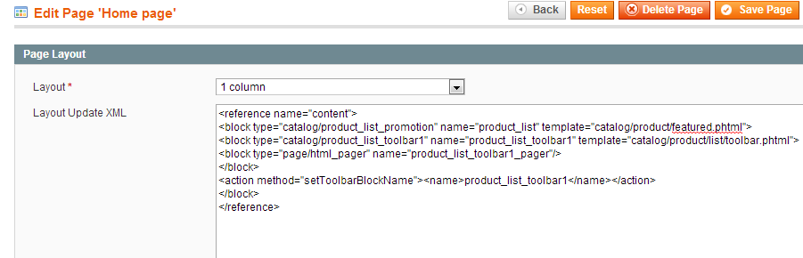

- Select 1 column from the Layout drop-down menu

And paste The Following Code into 'Layout Update XML' area

<reference name="content">
<block type="catalog/product_list_promotion" name="product_list" template="catalog/product/featured.phtml">
<block type="catalog/product_list_toolbar1" name="product_list_toolbar1" template="catalog/product/list/toolbar.phtml">
<block type="page/html_pager" name="product_list_toolbar1_pager"/>
</block>
<action method="setToolbarBlockName"><name>product_list_toolbar1</name></action>
</block>
</reference>

Click the Save Page button

Other Custom Block Setup

- Category Block
  - If you want to add a Custom HTML block to your category / product listing page you need to

  - Go to: 'CMS → Static Blocks’ click on “Add New Block” from Right Corner
Set “categoryname-block”* into 'Identifier' & 'Block Title' Field
Set Store View => All Store View
Status => Enabled
Put the following code in to Content area

<p><img src="{{media url="wysiwyg/category-banner/clothing_banner.jpg"}}" alt="" /></p>

To apply this block to category
  - Go to: ' Catalog → Manage Categories’ click on categoryname* from left menu and under ‘Display Settings’
Set Display Mode > Static Block And Products
CMS Block > categoryname-block

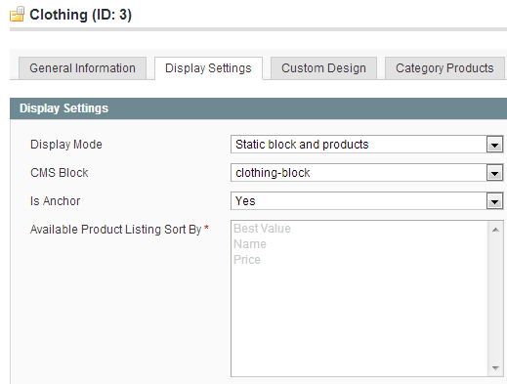

Note: “category name” is a name of category. You need to replace it with actual category name
E.g. Add block with identifier as “Clothes-block” and set it as CMS Block for category ‘Clothes’

- Custom Menu Block
  - If you want to add a Custom HTML block to your Menu you need to

  - Go to: 'CMS → Static Blocks’ click on “Add New Block” from Right Corner
Set “wp_custom_menu_35_w291”* into 'Identifier' & 'Block Title' Field
Set Store View => All Store View
Status => Enabled
Put the following code in to Content area

<div class="menu-img"><img src="{{media url="wysiwyg/category-banner/clothing_banner.jpg"}}" alt="" /></div>
<div class="menu-block">
<h2 class="medium">Custom Block</h2>
<p>Lorem ipsum dolor sit amet, consectetuer adipiscing elit. Nam cursus. Morbi ut mi. Nullam enim leo, egestas id, condimentum at, laoreet mattis, massa. Sed eleifend nonummy diam. Praesent mauris ante, elementum et, bibendum at, posuere sit amet.</p>
</div>

Note: “35” is a ID of your category. You need to replace it with your actual category ID
“291” is a width of the block. You need to replace with your requirement. If you don’t want use width then category name is only “wp_custom_menu_35”
This block is only valid if you enable Custom Menu

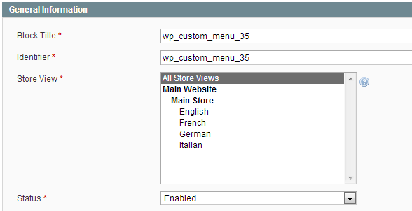

- You can see your custom block as like below screenshot when you hover on category.

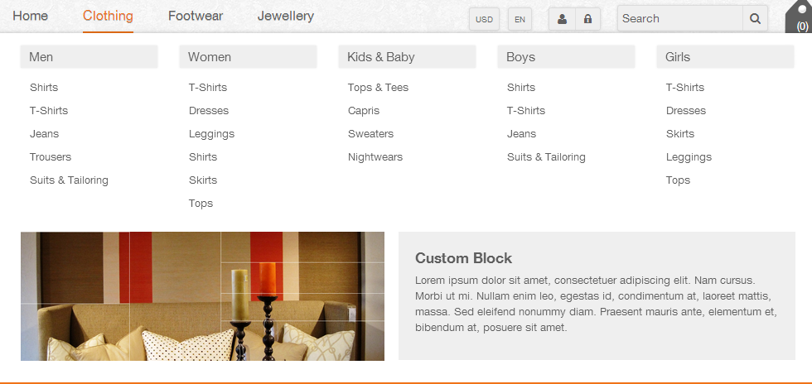

- Product View Sidebar block
  - If you want to add a Custom HTML block to your product Detail page you need to
  - Go to: 'CMS → Static Blocks’ click on “Add New Block” from Right Corner
Set “detail-block1” into 'Identifier' & 'Block Title' Field
Set Store View => All Store View
Status => Enabled

Put the following code in to Content area

<div class="customized">
<h3 class="medium">Customized Area</h3>
<div class="best_theme">
<h4 class="medium">Looking for the best theme?</h4>
<div class="theme_image"><img src="{{media url="wysiwyg/category-banner/detail_banner.jpg"}}" alt="" /></div>
<a class="button" title="best theme" href="#"><span class="small">Click to know more</span></a></div>
</div>

Note: This block will displayed only when product detail page layout is set as ‘default’ or ‘vertical’

- Product View Custom block

  - If you want to add a Custom HTML block to end of the product Detail page you need to
  - Go to: 'CMS → Static Blocks’ click on “Add New Block” from Right Corner
Set “detail-block2” into 'Identifier' & 'Block Title' Field
Set Store View => All Store View
Status => Enabled

Put the following code in to Content area

<div class="detail-block">
<h3 class="medium">Custom Block Here</h3>
<p>Lorem ipsum dolor sit amet, consectetuer adipiscing elit. Nam cursus. Morbi ut mi. Nullam enim leo, egestas id, condimentum at, laoreet mattis, massa. Sed eleifend nonummy diam. Praesent mauris ante, elementum et, bibendum at, posuere sit amet, nibh. Duis tincidunt lectus quis dui viverra vestibulum. Suspendisse vulputate aliquam dui.Nulla elementum dui ut augue. Aliquam vehicula mi at mauris. Maecenas placerat, nisl at consequat rhoncus, sem nunc gravida justo, quis eleifend arcu velit quis lacus.</p>
</div>

- Detail Layout For Each Product

- First you need to create Attribute “product layout” to set product layout for each product(*Required)

- Step for creating attribute

Go to: 'Catalog → Attributes → manage Attributes’ click on “Add New Attribute” from Right Corner

Set the following option under 'Attribute Properties' Tab

Attribute code > productlayout
Scope > Store View
Catalog input type for store owner > Dropdown
Apply To > all product types

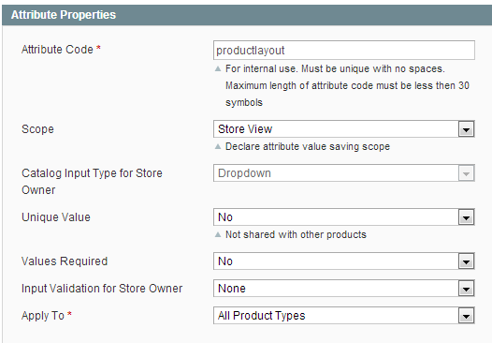

After that click on “Manage Label/Options” from left corner

Set following option under 'manage Titles' tab

Admin > Product Layout

Set following option under 'manage Options' tab
Click on “Add Option” Button

Admin > default , Position > 1
Admin > horizontal , Position > 2
Admin > vertical , Position > 3
Admin > custom1 , Position > 4
Admin > custom2 , Position > 5

After that click on “Save Attribute” from the top of the page

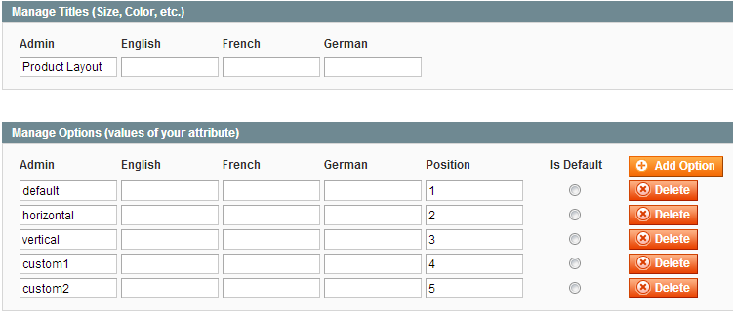

- Step for apply attribute to attribute set

Go to: 'Catalog → Attributes → manage Attributes Sets’ click on “Default ” Attribute set from the Display list

After that drag the 'Product Layout' attribute from the right 'Unassigned Attribute' list to under the 'General' tab

Then click on “Save Attribute Set” from top-right corner.

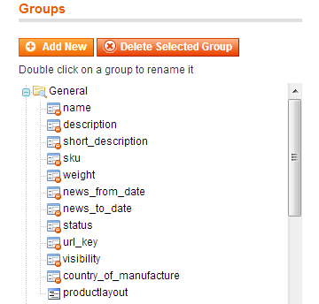

Note: if you want to display 'Product Layout' option to any other Attribute set then assigns ‘Product Layout’ attribute to other attribute set

- At the time of inserting product you see below option. set any layout if you want to set each layout for each product

Settings
Functionalities / Widget Settings

Theme Settings

- Colors
  - Go to: ‘System → Configuration’ click on “Theme Options” from Left Menu
  - Set Below options under ‘Colors’
    - Primary Color > Select Color for Change Theme Color
    - Secondary Color > Select Color for change theme Light Color
    - Button Color > Select Color for button BG Color
    - Button Hover Color > Select Color for button Hover BG
    - Border Color > Select Color for border color
    - Table BG Color > Select color for table background

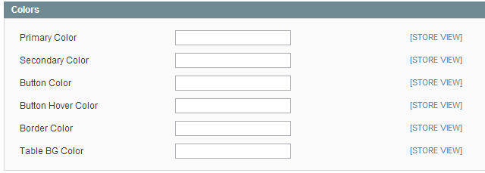
- Menu

  - Go to: ‘System → Configuration’ click on “Theme Options” from Left Menu
  - Set Below options under ‘Menu’

    - Menu Background > Select Color for menu background
    - Menu Fonts > Change font family for menu
    - menu Fonts Color > Select Color for menu fonts
    - menu Fonts Hover Color > Select hovercolor for menu fonts
    - menu FontsHover BG Color > Select bgColor for menu fontshover
    - Display Home Link > Select 'yes' to display

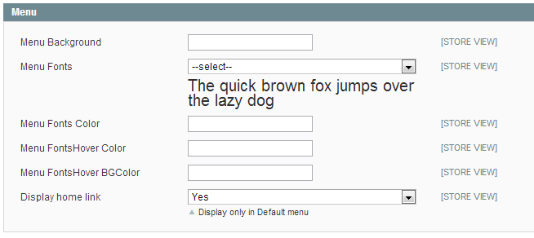

- Sidebar

  - Go to: ‘System → Configuration’ click on “Theme Options” from Left Menu
  - Set Below options under Sidebar’

    - Sidebar Background Color > Select Color for Sidebar background
    - Sidebar Title Fonts > Change font family for Sidebar Title fonts
    - Sidebar Title Fonts Color > Select Color for sidebar title fonts
    - Sidebar FontsHover BG Color > Select Color for fontshover background
    - Sidebar Fonts Color > Select Color for fonts
    - Sidebar Separator Color > Select Color for separator

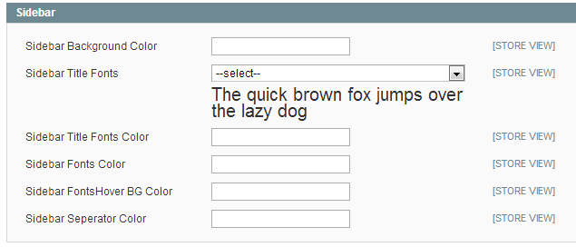

- Header

  - Go to: ‘System → Configuration’ click on “Theme Options” from Left Menu
  - Set Below options under ‘Header’

    - Display Sticky Header > Set ‘yes’ for display sticky header

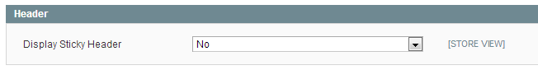

- Home Page

  - Go to: ‘System → Configuration’ click on “Theme Options” from Left Menu
  - Set Below options under ‘Header’

    - Number of products to be shown : > Select number of products to display on home page
    - Ajax Product Loader : > Select ajax product loader
    - Display Home Sidebar To > select position for display custom block to home page

- Footer

  - Go to: ‘System → Configuration’ click on “Theme Options” from Left Menu
  - Set Below options under ‘Footer’
    - Footer Link Font Color > change color for footer link
    - Footer Link Font hover Color > change color for footer link hover

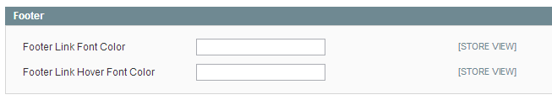

- Background Options

  - Go to: ‘System → Configuration’ click on “Theme Options” from Left Menu

    - Set Below options under ‘Background Options’ tab
      - Main Container BG Color > select color for main background
      - Background-color > select color from color picker
      - Background-Pattern > select background pattern
      - Background-image > select background image

Note: Background options are conditional; you can apply one at a time. All 3 will not work simultaneously.
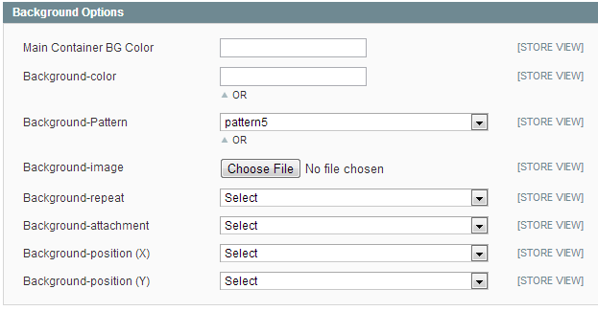

- Product List Page

  - Go to: ‘System → Configuration’ click on “Theme Options” from Left Menu
  - Set Below options under ‘Product List Page’

    - Products per row > select 2 or 3 or 4
    - Product Detail Layout > select Default, Horizontal , Vertical , custom1 , custom2
    - Ajaxcart > Select ‘Enable’ for product add to cart using ajax
Select ‘Enable with Quickview’ for display Quickview button on product
Select ‘Desable’ for use default magento add to cart functionality.
- Product Hover GrayScale(ON/OFF) > Set yes for display grayscale on product hover
    - Display New / Sale Icon on Product > Set ‘yes’ for new/sale icon on product
    - Product BG > Set ‘Color’ for Product Background

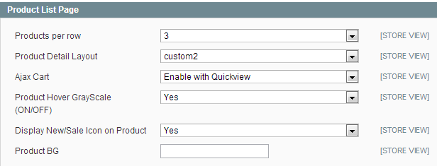

- Category Sidebar

  - Go to: ‘System → Configuration’ click on “Theme Options” from Left Menu
  - Set Below options under ‘category sidebar Page’

    - Display Category Sidebar > Choose option to display category sidebar

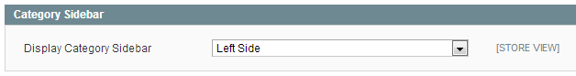

- Extra Settings

  - Go to: ‘System → Configuration’ click on “Theme Options” from Left Menu
  - Set Below options under ‘extra settings Page’

    - Enable Back to Top Butoon > Set ‘yes’ for display back to top button
    - Display InStock Label > set ‘yes’ for display instock label
    - Enable Responsiveness > set ‘yes’ for display theme in mobile version

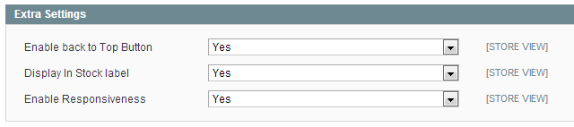

- Theme Fonts Settings

  - Go to: ‘System → Configuration’ click on “Theme Options” from Left Menu
  - Set Below options under ‘Theme Fonts Settings Page’

    - Title Fonts Color > Set color for title fonts
    - Title Fonts Size > Set size for title fonts
    - Title Fonts > Set font for title fonts
    - Body Fonts Color > Set color for body fonts
    - Body Fonts Size > Set size for body fonts
    - Body Fonts > Set font for body fonts

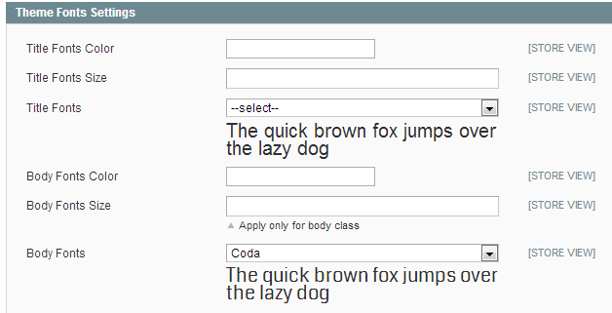

- Custom Menu

  - Go to: ‘System → Configuration’ click on “'Custom Menu” from Left Menu
  - Set Below options

    - Enable > Set ‘yes’ enable Custom Menu
    - Set other options as per your requirement

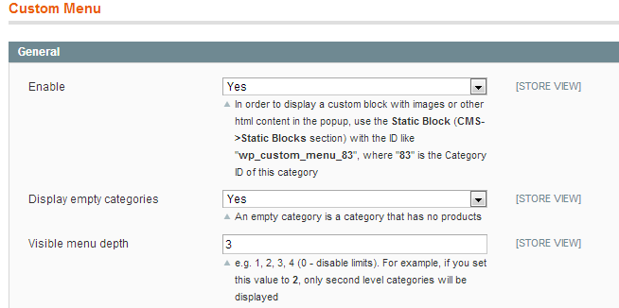

- Category Sidebar Navigation

  - Go to: ‘System → Configuration’ click on “'Category Sidebar Navigation” from Left Menu
  - Set Below options
    - Enable > Set ‘yes’ for display vertical menu on left sidebar
    - Set other options as per your requirement

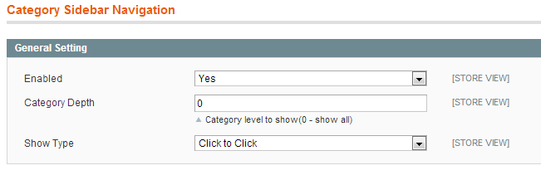

- Sharing Tool

  - Go to: ‘System → Configuration’ click on “'Sharing Tool” from Left Menu
  - Set Below options
    - Display Tool > Set ‘Enable’ for display sharing icon on detail page
    - Button Style > Choose style for sharing icon
    - Set other options as per your requirement

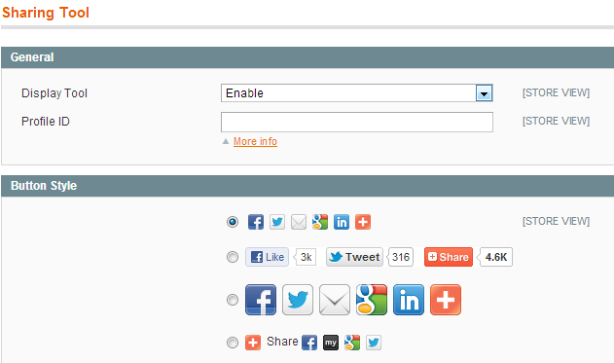

- Cloud Zoom
  - Go to: ‘System → Configuration’ click on “Moo Product Gallery Clould zoom” from Left Menu
  - Set Below options
    - Enable ClouldZoom > set yes if you want zoom effects on product detail page
    - Set other options as per your requirement

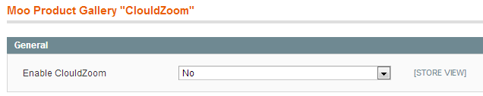

- One page Checkout

Go to: ‘System → Configuration’ click on “'One page Checkout” from Left Menu
  - Set Below options Under General Tab

      - Enabled > Select 'yes' for enable onepage checkout
      - Set other options as per your requirement

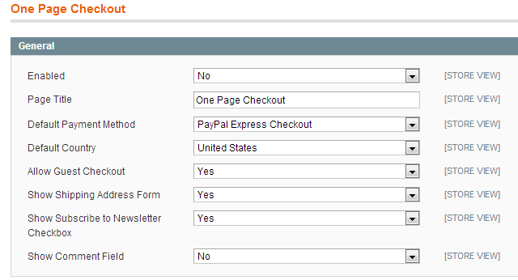

- Pascal System

Go to: ‘System → Configuration’ click on “catalog Ajax” from Left Menu

  - Set Below code Under 'css selectors' Tab

- Enable Catalog Ajax > Set ‘yes’ for working with ajax to category page
- Limiter > .toolbar .sorter .limiter a

    - Navigation Clear > .block-layered-nav .block-content .actions a

    - Note: Nothing to change in other option
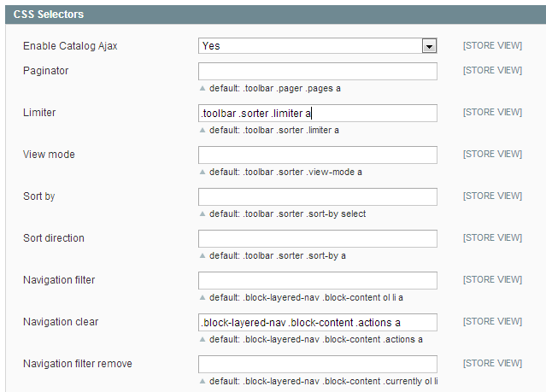

Troubleshooting & Support

1. I'm getting 404 not found when trying to open theme admin pages.
Log out from Magento admin panel, clear the store cache under var/cache, and log
in again.

2. After the extension installation the store gives an error, or blank page. Log out from Magento admin panel. Change the owner of the extracted extension files to the web server user and set 775 permissions on them. Clear the store cache and try again.

3. My configuration changes do not appear on the frontend.
Clear the store cache under var/cache, clear all browser cookies for your store domain and refresh the page in your browser.

4. If you have any question / issue you can contact us any time by sending us an email on peerforest@gmail.com or ask your question at our support forum http://www.magentothemestudio.com/support
Using Magento
Helpful Resources
There are tutorials, articles, forums and screencasts to help you learn how to use Magento and its features. This section provides helpful links to instructions on commonly used Magento features, but you can learn even more by exploring these resources

- Knowledge Base
- Screencasts
- Magento Wiki
- Magento Forum

