Computer Vision HW1 Report
Student ID: B11201024
Name: 蔡平樂
Part 1.
- Visualize the DoG images of 1.png.
 | DoG Image (threshold = 5) |  | DoG Image (threshold = 5)
DoG1-1.png |  | DoG2-1.png
DoG1-2.png |  | DoG2-2.png
DoG1-3.png |  | DoG2-3.png
DoG1-4.png |  | DoG2-4.png

- Use three thresholds (1,2,3) on 2.png and describe the difference.
Threshold | Image with detected keypoints on 2.png
0.5
1.0
5.0
(describe the difference)

Part 2.
- Report the cost for each filtered image.
Gray Scale Setting | Cost (1.png)
cv2.COLOR_BGR2GRAY
R*0.0+G*0.0+B*1.0
R*0.0+G*1.0+B*0.0
R*0.1+G*0.0+B*0.9
R*0.1+G*0.4+B*0.5
R*0.8+G*0.2+B*0.0
Gray Scale Setting | Cost (2.png)
cv2.COLOR_BGR2GRAY
R*0.1+G*0.0+B*0.9
R*0.2+G*0.0+B*0.8
R*0.2+G*0.8+B*0.0
R*0.4+G*0.0+B*0.6
R*1.0+G*0.0+B*0.0

- Show original RGB image / two filtered RGB images and two grayscale images with highest and lowest cost.
Original RGB image (1.png) | Filtered RGB image and Grayscale image of  Highest cost | Filtered RGB image and Grayscale image of  Lowest cost
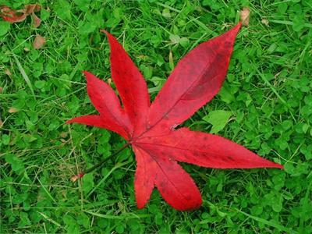
(Describe the difference between those two grayscale images)

Original RGB image (2.png) | Filtered RGB image and Grayscale image of  Highest cost | Filtered RGB image and Grayscale image of  Lowest cost
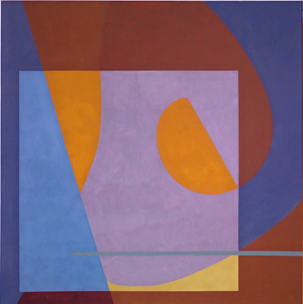
(Describe the difference between those two grayscale images)

- Describe how to speed up the implementation of bilateral filter.

