Computer Vision HW1 Report
Student ID: B11201024
Name: 蔡平樂
Part 1.
- Visualize the DoG images of 1.png.
 | DoG Image (threshold = 5) |  | DoG Image (threshold = 5)
DoG1-1.png | 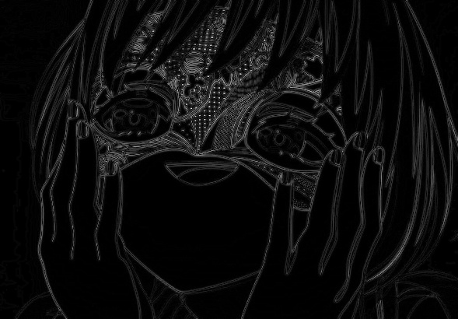 | DoG2-1.png | 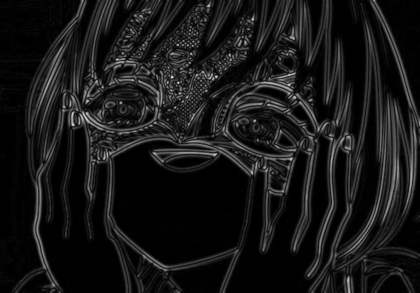
DoG1-2.png | 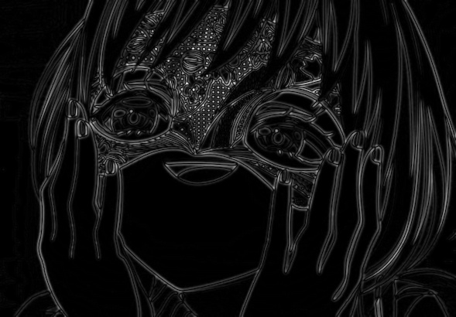 | DoG2-2.png | 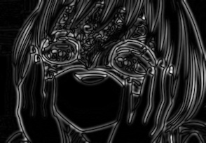
DoG1-3.png |  | DoG2-3.png | 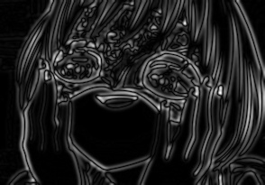
DoG1-4.png |  | DoG2-4.png | 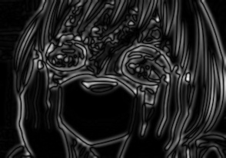
Images are normalized by ${Img}^{'} :=\frac{255}{\max{(abs(Img))}}×abs(Img)$

- Use three thresholds (1,2,3) on 2.png and describe the difference.
Threshold | Image with detected keypoints on 2.png
0.5 | 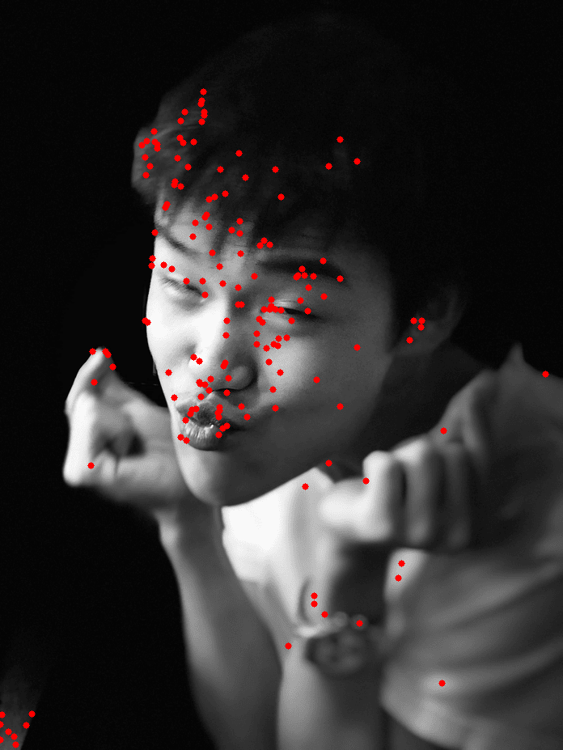
1.0 | 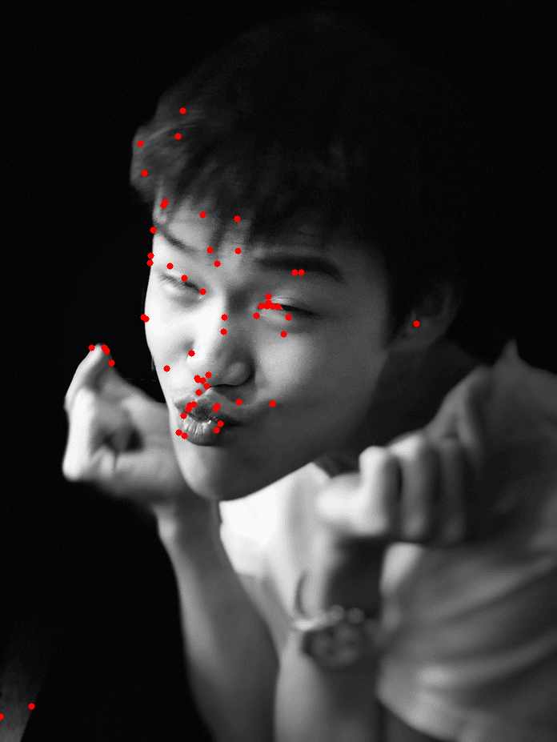
5.0 | 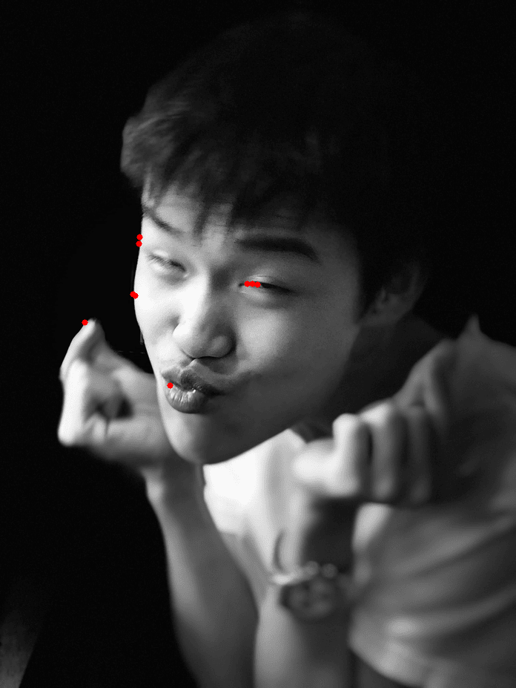
(describe the difference)
As the threshold increase, the number of feature points is decreasing, and more focus on the feature of the image.

Part 2.
- Report the cost for each filtered image.
Gray Scale Setting | Cost (1.png)
cv2.COLOR_BGR2GRAY | 1207799
R*0.0+G*0.0+B*1.0 | 1439568
R*0.0+G*1.0+B*0.0 | 1305961
R*0.1+G*0.0+B*0.9 | 1393620
R*0.1+G*0.4+B*0.5 | 1279697
R*0.8+G*0.2+B*0.0 | 1127913
Gray Scale Setting | Cost (2.png)
cv2.COLOR_BGR2GRAY | 183851
R*0.1+G*0.0+B*0.9 | 77884
R*0.2+G*0.0+B*0.8 | 86023
R*0.2+G*0.8+B*0.0 | 188019
R*0.4+G*0.0+B*0.6 | 128341
R*1.0+G*0.0+B*0.0 | 110862

- Show original RGB image / two filtered RGB images and two grayscale images with highest and lowest cost.
Original RGB image (1.png) | Filtered RGB image and Grayscale image of  Highest cost | Filtered RGB image and Grayscale image of  Lowest cost
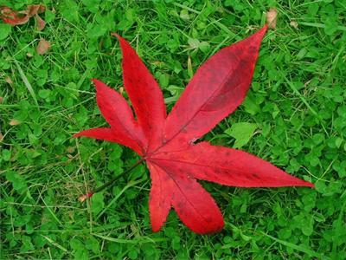 | 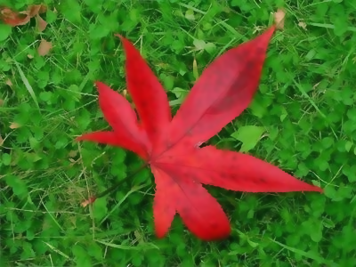 | 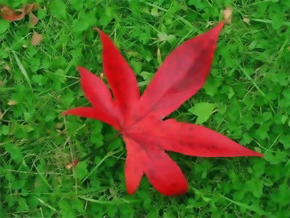
 | 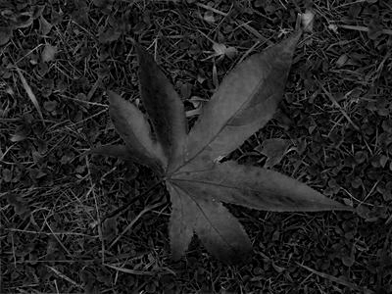 | 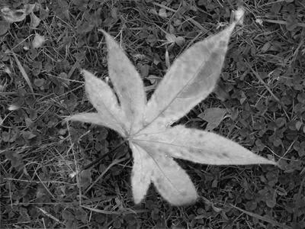
(Describe the difference between those two grayscale images)

In the gray-scale image of the highest cost, both the ground and the leaf are dark, causing the filter hard to distinguish the leaf and the ground. In the gray-scale image of the lowest cost, the ground is dark but the leaf is light in contrast, encouraging the filter to attribute larger weight on the region of same color and smaller weight on the region of different color, which make the filtered image clear.

Original RGB image (2.png) | Filtered RGB image and Grayscale image of  Highest cost | Filtered RGB image and Grayscale image of  Lowest cost
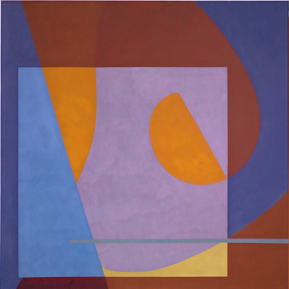 | 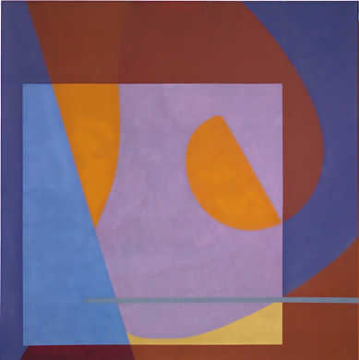 | 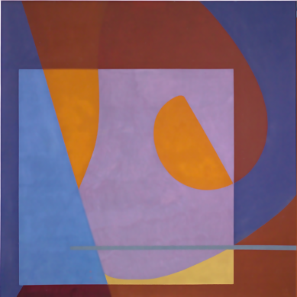
 | 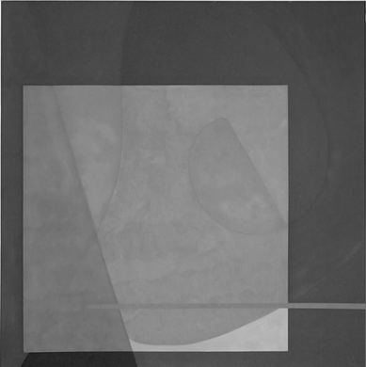 | 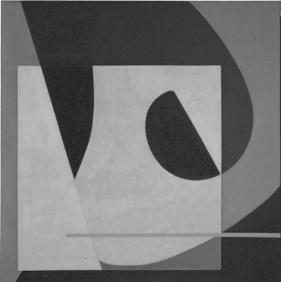
(Describe the difference between those two grayscale images)

Similar as result in 1.jpg, the gray-scale image of the highest cost mixed the grange and purple, causing the filter cannot distinguish the region of different color. The gray-scale image of the smallest cost separate colors clearly, which make the filter perform better weighting.

- Describe how to speed up the implementation of bilateral filter.
由於numpy底層由c++實作，對於相同的矩陣操作(如矩陣相加、常量相乘)，使用numpy ndarray操作能夠大幅提升速度，因此加速的方式為盡量使用矩陣操作進行計算。
比起原始使用pixelwise的計算，我們以偏移量進行分類操作。
可以發現，在偏移量固定為$dy, dx$時，每個pixel $I_{xy}$的spatial kernel都相同，且range kernel都是與$I_{x-dx,y-dy}$的差。我們能夠以整個矩陣為單位計算這兩者，因此能封裝為單一矩陣操作，透過呼叫numpy大幅節省運算時間。 除此之外，我也透過gemini改寫程式碼，在迴圈外宣告陣列以減少記憶體重複宣告。

上述方式實作後，以10次執行平均後得出對於ex.png的處理速度約為658.9ms

另外由於$\left(dx,dy\right)$與$(-dx, -dy)$實際上是以同樣的方式計算矩陣差，因此調整計算的index後便可在同一個iteration進行計算。使用上述方式能將迴圈數在減少兩倍，然而實際執行10次平均後得出速度為$620.26$ms，僅加快約$38$ms。

