**Weighted Gene Co-expression Network Analysis (WGCNA) methods, results, and discussion associated with Manuscript “*Transcriptomic changes associated with maternal care in the brain of mouthbrooding cichlid Astatotilapia burtoni reflect adaptation to self-induced metabolic stress*”**

**Methods**

Gene co-expression networks were built using WGCNA v1.69 in R-Studio. VST count tables, exported using DESeq2, were used as WGCNA input. From the initial 25572 expressed genes, 469 were removed due to low expression for a total of 25103 input gene counts. Sample clustering did not reveal outliers, so all brain transcriptomes were used in subsequent analysis.

To build a signed network, or a network that only accounts for positive correlations between genes, scale-free analysis was conducted to determine an optimal soft-thresholding power. A power of 12 was chosen because it was the lowest power with a Scale Free Topology Model Fit above 0.90 and a Mean Connectivity below 100. The deep split parameter was set to 0 and all other parameters were left at default values. A signed network was preferred over an unsigned network for simpler interpretation of module eigengene values used in downstream statistics.

Following network construction, module-trait relationships were examined using specific time-points and a binary brooding vs release state for traits. In addition, module eigengenes were used in follow-up LRT analysis to determine which modules showed significant variation between any pair of timepoints with the lmtest R package v0.9-38, and post-hoc pairwise comparisons between timepoints were conducted using the contrasts function from the emmeans R package v1.5.3. GO enrichment analysis was performed using BiNGO, as described in the main article methods section, for each network module to determine their potential functions.

**Results**

The signed co-expression network built with WGCNA contained 49 modules (Fig S1), with only 7 genes falling in the gray (ME0) module, indicating they fail to group with other genes. A module-trait relationship heatmap highlights 8 modules with expression that significantly correlates with a specific time-point or general brooding state (Fig S2). Modules 20, 43, and 47 correlate with B02, modules 9, 10, 29, and 36 correlate with R02, and module 34 correlates with the binary release vs. brooding maternal states.

LRT results are more stringent than Fisher’s asymptotic p-values listed in the correlation heatmap. No modules showed significant differences between timepoints at a significance threshold of Pr(>Chisq) < 0.05. Three modules (9, 34, and 47), however, approach significance with Pr(>Chisq) < 0.1, all of which were identified as correlated with specific time-points in module-trait relationships (Figs S3, S4, S5).

Pairwise time-point contrasts for ME9 reveal that R02 samples have higher expression than B02 at P < 0.1 (Fig S3) and significantly higher expression than B14 and R14 at P < 0.05. This module is enriched for GO terms including ‘neuropeptide hormone activity’ and ‘feeding behavior’ with an FDR < 0.25. These enriched terms include a number of DE and DE-trending genes, such as *pituitary adenylate cyclase-activating polypeptide*, *pro-opiomelanocortin B-like*, *cholecystokinin-like*, and more. ME34 is significantly higher in R02 than B14 and approaches significance in R02 relative to B02. In addition, R14 approaches significance in contrast with lower expression B14 (Fig S4). Several top enriched terms for this module are ‘hormone activity’ and ‘response to hormone stimulus’, which contain notable DE and DE-trending genes including *androgen receptor*, *isotocin-neurophysin IT1*, *gonadotropin subunit beta-1-like*, *glycoprotein hormone beta-5-like*, *glycoprotein hormones alpha polypeptide*, and *prolactin receptor-like*. Pairwise contrasts for ME47 show that expression in B02 is significantly higher than in R02 and approaches significance (P < 0.1) in comparison with B14 and R14 (Fig S5). This module does not yield any enriched GO terms, but the DE and DE-trending genes within this module are slightly enriched for terms like ‘anatomical structure development’ and ‘developmental process’, which both contain 9/11 genes in this subset.

**Discussion**

Because several significant modules are enriched with behavior and hormone related terms, this might suggest some candidates that regulate feeding behavior. However, the direction of expression changes and what is known about their orexigenic or anorexogenic properties of the DE genes they contain instead suggest that these modules are responding to diet after the resumption of feeding post-release of fry. In ME34, for example, 9/13 genes annotated with the enriched GO term ‘hormone activity’ are also annotated under enriched terms such as ‘response to endogenous stimulus’ and/or ‘response to carbohydrate’. Behavioral candidates like neurotensin, galanin, and other co-expressed genes discussed in the main MS text fall within ME 17. Overall, the expression pattern of this module shows steadily decreasing expression from B02 to R14 even though no time-points significantly differ from each other.

Modules enriched with GO terms related to oxygen transportation, respiration, and ATP production show expected eigengene expression patterns related to member DE globin genes, but the modules themselves show no significant differences between time-points via pairwise contrasts. DE globin genes are divided between modules 2, 4, and 5, genes that respond to starvation, such as *pdk2*, *pdk4* are found in modules 1 and 6, respectively, and *hypoxia-inducible factor 1-alpha-like* is found in module 2.

The observation that DE and DE trending genes are split across a wide variety of modules, most of which show no significant differences across time points using eigengenes to represent expression, suggests that major behavioral and metabolic changes experienced in maternal *A. burtoni* likely result from large expression changes in a small number of genes or more minor expression changes in larger gene networks, or a combination of such trends. Alternatively, unsigned networks that include genes with positive and negative correlations of expression may better define the complex interactive gene networks in the brain, although downstream statistics to examine an unsigned module’s relevance across maternal time-points would not directly correlate to associated parental behaviors or physiological changes.

**Tables**

*Table 1. LRT and post-hoc pairwise contrasts between time-points for WGCNA module eigengenes that trend towards differential expression via LRT with Pr(>Chisq) < 0.1.*

|  |  |  |  |  |  |  |  |  |  |
| --- | --- | --- | --- | --- | --- | --- | --- | --- | --- |
|  | **LRT results** | | **Pairwise contrast results** | **B02 - B14** | **B02 - R02** | **B02 - R14** | **B14 - R02** | **B14 - R14** | **R02 - R14** |
| **ME9** | *LogLik* | 6.449 | *estimate* | 0.0701 | -0.2203 | 0.0534 | -0.2904 | -0.0167 | 0.2737 |
| *df* | 3 | *df* | 18 | 18 | 18 | 18 | 18 | 18 |
| *Chisq* | 7.328 | *t.ratio* | 0.58 | -1.746 | 0.442 | -2.403 | -0.145 | 2.265 |
| *Pr(>Chisq)* | 0.062 | *p.value* | 0.5691 | 0.0979 | 0.6639 | 0.0273 | 0.8864 | 0.0361 |
| **ME34** | *LogLik* | 6.370 | *estimate* | 0.0359 | -0.2228 | -0.1852 | -0.2587 | -0.2211 | 0.0376 |
| *df* | 3 | *df* | 18 | 18 | 18 | 18 | 18 | 18 |
| *Chisq* | 7.170 | *t.ratio* | 0.296 | -1.759 | -1.528 | -2.133 | -1.912 | 0.31 |
| *Pr(>Chisq)* | 0.067 | *p.value* | 0.7708 | 0.0955 | 0.144 | 0.0469 | 0.0719 | 0.7602 |
| **ME47** | *LogLik* | 6.480 | *estimate* | 0.2257 | 0.32 | 0.2395 | 0.0943 | 0.0138 | -0.0805 |
| *df* | 3 | *df* | 18 | 18 | 18 | 18 | 18 | 18 |
| *Chisq* | 7.389 | *t.ratio* | 1.87 | 2.539 | 1.985 | 0.782 | 0.12 | -0.667 |
| *Pr(>Chisq)* | 0.060 | *p.value* | 0.0778 | 0.0206 | 0.0626 | 0.4446 | 0.9059 | 0.513 |

*Table 2. GO enrichment results summary for three WGCNA modules that trend towards differential expression via LRT with Pr(>Chisq) < 0.1. These results include the top ten significantly enriched GO terms for the full sets of genes within each module, and subsets of genes that trend towards differential expression via DESeq2 results with an unadjusted p < 0.05. The total number of genes passing WGCNA filters and assigned to modules was 25,103, although only 22,924 genes had associated GO information.*

|  |  |  |  |  |  |  |  |  |  |
| --- | --- | --- | --- | --- | --- | --- | --- | --- | --- |
| **Module** | **Gene set** | **GO-ID** | **p-value** | **corr p-value** | **annot genes in module** | **total genes in module** | **annot genes in bg set** | **total genes in bg set** | **Description** |
| **ME9** | *All genes* | 19226 | 1.73E-06 | 6.02E-03 | 76 | 647 | 1549 | 22924 | transmission of nerve impulse |
| 21879 | 2.54E-06 | 6.02E-03 | 11 | 647 | 67 | 22924 | forebrain neuron differentiation |
| 1829 | 2.87E-06 | 6.02E-03 | 8 | 647 | 33 | 22924 | trophectodermal cell differentiation |
| 7154 | 8.44E-06 | 1.33E-02 | 101 | 647 | 2333 | 22924 | cell communication |
| 7268 | 1.55E-05 | 1.96E-02 | 64 | 647 | 1315 | 22924 | synaptic transmission |
| 5184 | 1.95E-05 | 2.05E-02 | 8 | 647 | 42 | 22924 | neuropeptide hormone activity |
| 7631 | 3.09E-05 | 2.78E-02 | 18 | 647 | 210 | 22924 | feeding behavior |
| 7267 | 5.10E-05 | 3.95E-02 | 78 | 647 | 1764 | 22924 | cell-cell signaling |
| 21953 | 5.64E-05 | 3.95E-02 | 26 | 647 | 392 | 22924 | central nervous system neuron differentiation |
| 51591 | 7.48E-05 | 4.71E-02 | 14 | 647 | 147 | 22924 | response to cAMP |
| *DE*  *trending* | 48176 | 1.22E-05 | 7.06E-03 | 2 | 78 | 2 | 22194 | regulation of hepatocyte growth factor biosynthetic process |
| 48178 | 1.22E-05 | 7.06E-03 | 2 | 78 | 2 | 22194 | negative regulation of hepatocyte growth factor biosynthetic process |
| 32646 | 1.22E-05 | 7.06E-03 | 2 | 78 | 2 | 22194 | regulation of hepatocyte growth factor production |
| 51799 | 3.65E-05 | 1.58E-02 | 2 | 78 | 3 | 22194 | negative regulation of hair follicle development |
| 46879 | 6.81E-05 | 1.59E-02 | 5 | 78 | 121 | 22194 | hormone secretion |
| 1553 | 7.03E-05 | 1.59E-02 | 3 | 78 | 23 | 22194 | luteinization |
| 22602 | 7.65E-05 | 1.59E-02 | 5 | 78 | 124 | 22194 | ovulation cycle process |
| 42698 | 8.25E-05 | 1.59E-02 | 5 | 78 | 126 | 22194 | ovulation cycle |
| 61097 | 8.25E-05 | 1.59E-02 | 5 | 78 | 126 | 22194 | regulation of protein tyrosine kinase activity |
| 21879 | 9.15E-05 | 1.59E-02 | 4 | 78 | 67 | 22194 | forebrain neuron differentiation |
| **ME34** | *All genes* | 5179 | 4.76E-09 | 1.70E-05 | 13 | 164 | 213 | 22924 | hormone activity |
| 5615 | 8.72E-08 | 1.56E-04 | 45 | 164 | 2786 | 22924 | extracellular space |
| 16913 | 1.43E-06 | 1.71E-03 | 3 | 164 | 4 | 22924 | follicle-stimulating hormone activity |
| 5102 | 2.12E-06 | 1.90E-03 | 46 | 164 | 3222 | 22924 | receptor binding |
| 71495 | 4.07E-06 | 2.91E-03 | 22 | 164 | 1023 | 22924 | cellular response to endogenous stimulus |
| 9719 | 1.47E-05 | 8.75E-03 | 25 | 164 | 1369 | 22924 | response to endogenous stimulus |
| 5576 | 2.70E-05 | 1.32E-02 | 66 | 164 | 5869 | 22924 | extracellular region |
| 9755 | 3.17E-05 | 1.32E-02 | 8 | 164 | 170 | 22924 | hormone-mediated signaling pathway |
| 32870 | 3.53E-05 | 1.32E-02 | 17 | 164 | 763 | 22924 | cellular response to hormone stimulus |
| 44421 | 3.68E-05 | 1.32E-02 | 62 | 164 | 5438 | 22924 | extracellular region part |
| *DE*  *trending* | 34446 | 4.11E-05 | 4.03E-02 | 4 | 27 | 161 | 22194 | substrate adhesion-dependent cell spreading |
| 9719 | 1.58E-04 | 4.22E-02 | 8 | 27 | 1369 | 22194 | response to endogenous stimulus |
| 71495 | 1.71E-04 | 4.22E-02 | 7 | 27 | 1023 | 22194 | cellular response to endogenous stimulus |
| 42221 | 1.82E-04 | 4.22E-02 | 13 | 27 | 3775 | 22194 | response to chemical stimulus |
| 9725 | 2.54E-04 | 4.22E-02 | 7 | 27 | 1091 | 22194 | response to hormone stimulus |
| 32870 | 2.58E-04 | 4.22E-02 | 6 | 27 | 763 | 22194 | cellular response to hormone stimulus |
| 70887 | 3.84E-04 | 5.37E-02 | 10 | 27 | 2455 | 22194 | cellular response to chemical stimulus |
| 7625 | 5.67E-04 | 6.72E-02 | 2 | 27 | 29 | 22194 | grooming behavior |
| 1568 | 6.23E-04 | 6.72E-02 | 7 | 27 | 1265 | 22194 | blood vessel development |
| 1944 | 7.06E-04 | 6.72E-02 | 7 | 27 | 1292 | 22194 | vasculature development |
| **ME47** | *All genes* | NA | NA | NA | NA | NA | NA | NA | NA |
| *DE*  *trending* | 21503 | 2.48E-03 | 2.21E-01 | 1 | 11 | 5 | 22194 | neural fold bending |
| 22 | 2.97E-03 | 2.21E-01 | 1 | 11 | 6 | 22194 | mitotic spindle elongation |
| 51231 | 3.46E-03 | 2.21E-01 | 1 | 11 | 7 | 22194 | spindle elongation |
| 48246 | 3.96E-03 | 2.21E-01 | 1 | 11 | 8 | 22194 | macrophage chemotaxis |
| 3100 | 4.45E-03 | 2.21E-01 | 1 | 11 | 9 | 22194 | regulation of systemic arterial blood pressure by endothelin |
| 90327 | 5.93E-03 | 2.21E-01 | 1 | 11 | 12 | 22194 | negative regulation of locomotion involved in locomotory behavior |
| 90325 | 6.43E-03 | 2.21E-01 | 1 | 11 | 13 | 22194 | regulation of locomotion involved in locomotory behavior |
| 48856 | 6.51E-03 | 2.21E-01 | 9 | 11 | 8987 | 22194 | anatomical structure development |
| 14826 | 6.92E-03 | 2.21E-01 | 1 | 11 | 14 | 22194 | vein smooth muscle contraction |
| 1842 | 6.92E-03 | 2.21E-01 | 1 | 11 | 14 | 22194 | neural fold formation |

**Figures**

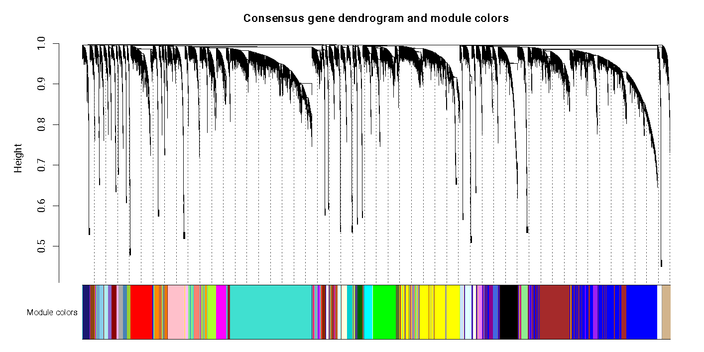

*Figure 1. Gene dendrogram produced by WGCNA showing signed co-expression patterns and module membership.*

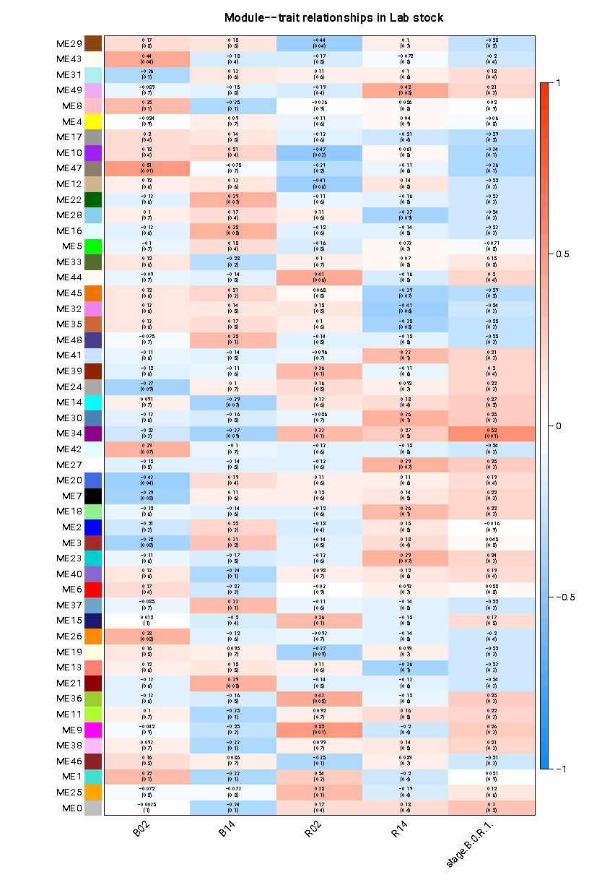

*Figure 2. Module-trait relationship heatmap showing correlations between eigengenes and individual time-points or time-points grouped by associated brooding or release behavior. The first number within each cell indicated the direction and strength of correlation and the second number in parentheses are p-values indicating significance of correlation. For the column representing time-points grouped by stage, positive correlations indicate expression is higher in release stages than brooding stages, and vice versa.*

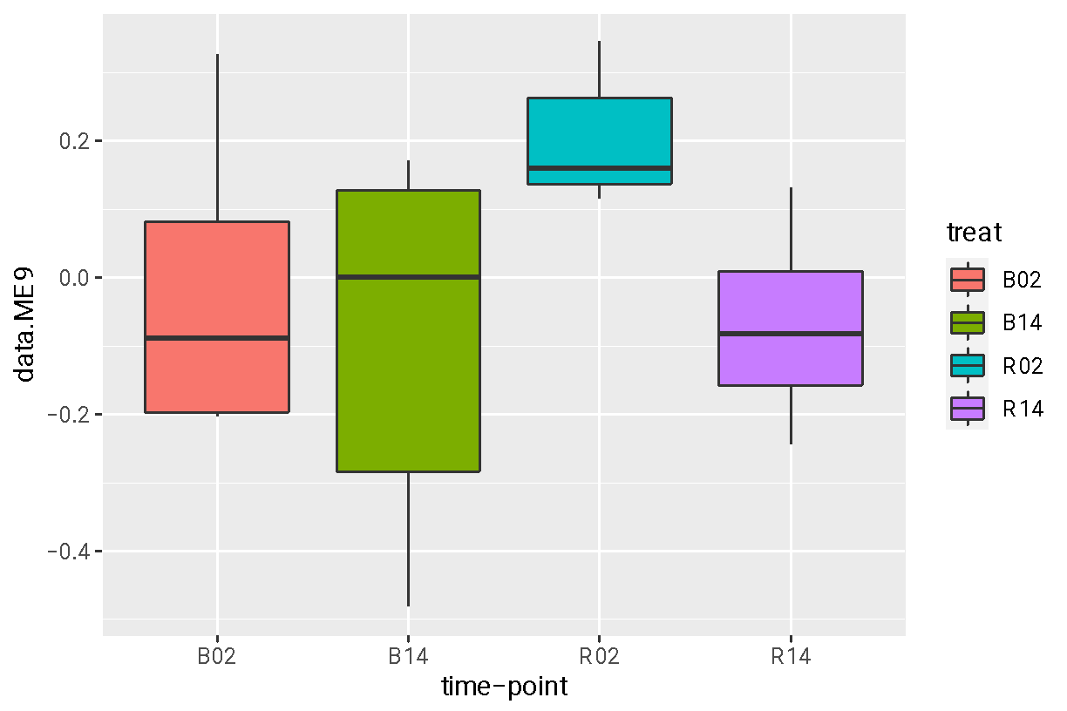

*Figure 3. Boxplot of ME9 eigengene values grouped by time-point for all samples.*

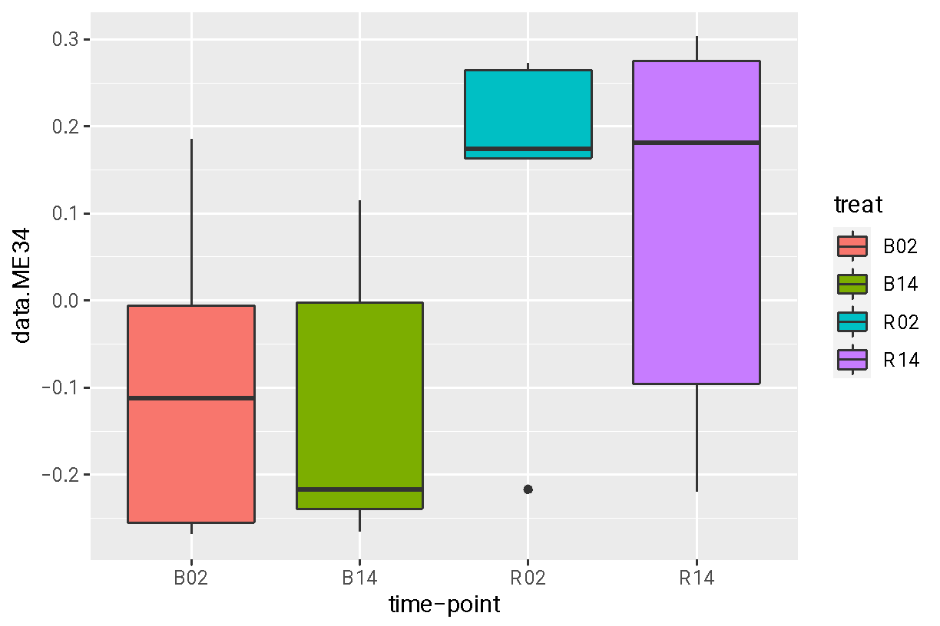

*Figure 4. Boxplot of ME34 eigengene values grouped by time-point for all samples.*

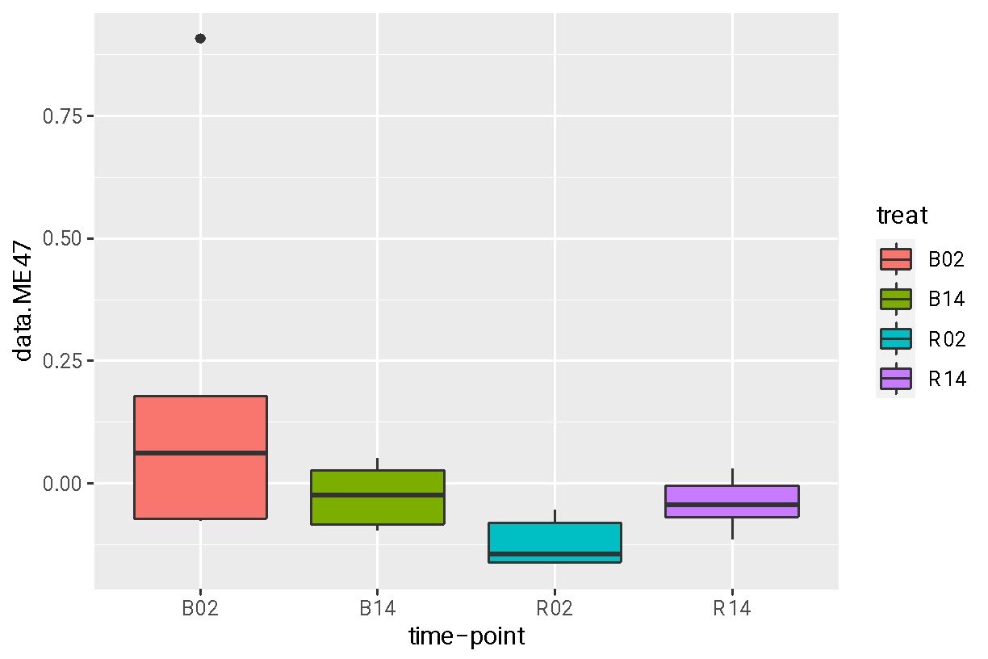

*Figure 5. Boxplot of ME47 eigengene values grouped by time-point for all samples.*