

Undergraduate SSP Participants Worksheet

Name: | Date:
Module: 2 | Part: C

Professor Comments:

1 - What Is Simulation?
Answer (1-2 sentences each):
- What is simulation?

- Why is it used before fabrication?

2 - Simulation vs. Real Hardware
Fill in at least 3 differences:

Simulation | Real Hardware

3 - Basic Simulation Thinking
You are testing a simple system: “If button = 1 → LED = ON.” Create a simple test plan:

Time Step | Input (Button – 0 or 1) | Expected Output (LED – On or Off)
t0
t1
t2

4 - Debugging Scenario: Simulation Analysis
You are given the following simulation waveform for an inverter:
- Input signal: a
- Output signal: y

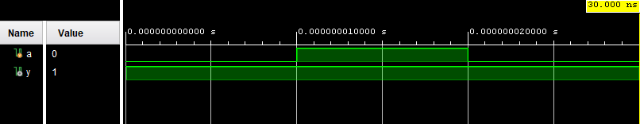

Questions
- Based on the waveform, describe what is wrong with the system behavior?

- Give a possible reason why the output is incorrect (HINT: think about how the logic might be implemented).

- How does the waveform help you identify the problem?

- What should the correct waveform look like for this system? (You may describe it in words or sketch it)

