Descriptive Statistics – New religious Sermon Dataset

The descriptive statistics below include the two following variables:
- Absolute coverage: The raw number of sermons coming from a certain feature

- Relative Coverage: Represents the percentage of observations in each category relative to the total number of observations across all categories.

- Relative Coverage adjusted: The Adjusted Relative coverage is the proportion of observations in a category, adjusted by that category’s population share. For example, relative coverage for each U.S. state is calculated by dividing the state’s Relative coverage by its proportion of the total U.S. population.

Note: Both the relative coverages are expressed as percentages.

Table of Contents
Descriptive Statistics – New religious Sermon Dataset 1
1 Coverage Variables 3
1.1 Coverage by Year 3
1.2 Coverage by State 4
1.3 Coverage by Denomination of Sermon 5
1.4 Coverage by Religious Family 6
2 Tabulation of Variables 10
2.1 Tabulation of star rating: 10
2.2 Tabulation of Binned Views: 10
2.3 Tabulation of Binned Sermons Contributed: 10
3 Exhibits: 11
3.1 State: Relative Coverage 11
3.2 State: Adjusted Relative Coverage 11
3.3 Election-Related Words 12
3.4 Presidential Election Candidates’ Mentions 17
3.5 RDD-Style Graphs: Sermon Count and View Count 21
4 Pastor-Level Controls 24
4.1 Married0 24
4.2 Children0: 25
4.3 Edu theology0: 32
4.4 Edu theological0: 34
4.5 Edu0: 35
4.6 Denom_index: 37
4.7 Family_index: 38
4.8 Exp bin: 38

Coverage Variables

Coverage by Year

Year | Absolute Coverage | Relative Coverage
2000 | 2470 | 1.488
2001 | 6776 | 4.104
2002 | 8295 | 5.133
2003 | 8084 | 4.953
2004 | 7413 | 4.514
2005 | 8207 | 5.001
2006 | 9043 | 5.572
2007 | 11006 | 6.698
2008 | 9708 | 5.934
2009 | 8392 | 5.117
2010 | 6682 | 4.085
2011 | 7100 | 4.333
2012 | 6381 | 3.879
2013 | 6046 | 3.698
2014 | 6312 | 3.821
2015 | 5447 | 3.293
2016 | 4945 | 2.988
2017 | 4245 | 2.582
2018 | 5252 | 3.176
2019 | 4942 | 2.987
2020 | 4868 | 2.975
2021 | 5574 | 3.383
2022 | 8417 | 5.091
2023 | 5331 | 3.234
2024 | 3197 | 1.954

The highest absolute (and relative) coverage of sermons is from the year 2007, while the lowest percentage of sermons is from the year 2000.

Coverage by State

State | Absolute Coverage | Relative Coverage | Adjusted Relative Coverage (Relative coverage / Percent population in state)
Alabama | 5275 | 3.214 | 2.034
Alaska | 629 | 0.383 | 1.72
Arizona | 4025 | 2.452 | 1.345
Arkansas | 3272 | 1.994 | 2.099
California | 6073 | 3.7 | 0.307
Colorado | 2111 | 1.286 | 0.842
Connecticut | 317 | 0.193 | 0.16
Delaware | 189 | 0.115 | 0.414
Florida | 10161 | 6.191 | 1.09
Georgia | 6904 | 4.205 | 1.446
Hawaii | 164 | 0.1 | 0.232
Idaho | 412 | 0.251 | 0.546
Illinois | 6745 | 4.109 | 0.931
Indiana | 7589 | 4.624 | 2.14
Iowa | 1759 | 1.072 | 1.031
Kansas | 3751 | 2.285 | 2.392
Kentucky | 5144 | 3.134 | 2.182
Louisiana | 4736 | 2.885 | 1.817
Maine | 325 | 0.198 | 0.437
Maryland | 2862 | 1.744 | 0.926
Massachusetts | 1272 | 0.775 | 0.344
Michigan | 4653 | 2.835 | 0.803
Minnesota | 926 | 0.564 | 0.323
Mississippi | 2726 | 1.661 | 1.643
Missouri | 3749 | 2.284 | 1.149
Montana | 49 | 0.03 | 0.093
Nebraska | 211 | 0.129 | 0.211
Nevada | 1109 | 0.676 | 0.952
New Hampshire | 97 | 0.059 | 0.135
New Jersey | 1133 | 0.688 | 0.23
New Mexico | 2471 | 1.505 | 2.329
New York | 3471 | 2.114 | 0.314
North Carolina | 4631 | 2.821 | 0.986
North Dakota | 206 | 0.126 | 0.55
Ohio | 7352 | 4.477 | 1.11
Oklahoma | 6205 | 3.78 | 3.083
Oregon | 1691 | 1.03 | 0.847
Pennsylvania | 5488 | 3.344 | 0.766
Rhode Island | 34 | 0.021 | 0.056
South Carolina | 7306 | 4.451 | 3.122
South Dakota | 745 | 0.453 | 1.69
Tennessee | 7936 | 4.835 | 2.392
Texas | 14746 | 8.984 | 1.213
Utah | 95 | 0.058 | 0.073
Vermont | 39 | 0.024 | 0.11
Virginia | 4670 | 2.845 | 1.131
Washington | 2888 | 1.758 | 0.84
West Virginia | 3093 | 1.884 | 2.933
Wisconsin | 2215 | 1.35 | 0.708
Wyoming | 483 | 0.294 | 1.677

The highest absolute (and relative) coverage of sermons is in the state of Texas, and the lowest absolute coverage of sermons is in Vermont and Rhode Island.
By using US state census data from 2000, the highest adjusted relative coverage of sermons is found to be in Oklahoma, while the lowest adjusted relative coverage is in Rhode Island.

Coverage by Denomination of Sermon
Index | Denomination | Absolute Coverage | Relative Coverage
1 | *Other | 3262 | 1.991
2 | Adventist | 182 | 0.155
3 | Anglican | 486 | 0.296
4 | Apostolic | 646 | 0.445
5 | Assembly Of God | 6911 | 4.395
6 | Baptist | 54723 | 33.607
7 | Bible Church | 803 | 0.49
8 | Brethren | 456 | 0.278
9 | Calvary Chapel | 1974 | 1.205
10 | Catholic | 1867 | 1.186
11 | Charismatic | 1423 | 0.886
12 | Christian Church | 2063 | 1.262
13 | Christian Missionary Alliance | 1280 | 0.78
14 | Christian/Church Of Christ | 17288 | 10.562
15 | Church Of God | 4509 | 2.765
16 | Congregational | 831 | 0.506
17 | Disciples Of Christ | 88 | 0.054
18 | Episcopal | 207 | 0.126
19 | Episcopal/Anglican | 230 | 0.14
20 | Evangelical Free | 1296 | 0.796
21 | Evangelical/Non-Denominational | 18825 | 11.587
22 | Foursquare | 981 | 0.6
23 | Free Methodist | 845 | 0.515
24 | Friends | 285 | 0.174
25 | Grace Brethren | 15 | 0.009
26 | Holiness | 1547 | 0.957
27 | Independent Bible | 6927 | 4.226
28 | Lutheran | 5436 | 3.341
29 | Mennonite | 243 | 0.148
30 | Methodist | 5437 | 3.319
31 | Nazarene | 2896 | 1.764
32 | Orthodox | 577 | 0.352
33 | Pentecostal | 7789 | 5.024
34 | Presbyterian/Reformed | 5253 | 3.266
35 | Salvation Army | 741 | 0.507
36 | Seventh-Day Adventist | 222 | 0.178
37 | United Methodist | 3348 | 2.067
38 | Vineyard | 322 | 0.197
39 | Wesleyan | 1905 | 1.161

The highest absolute and relative coverage of sermons is in the Baptist denomination and the lowest absolute coverage is in the Disciples of Christ denomination.

Coverage by Religious Family

To explore coverage using a broader grouping of religious denominations, a new variable for religious family was created. The table below shows how each denomination (as listed in the table under Section 1.3) is categorized into its corresponding religious family, based on the classification provided by ARDA.

Note: The denominations labelled 'Evangelical/Non-Denominational' and 'Independent Bible' were classified as 'Other groups' because the characteristics of the denominations did not fit into other families.

Denomination | Family (ARDA)
*Other | Other Groups Family
Adventist | Adventist Family
Anglican | Anglican/Episcopal Family
Apostolic | Pentecostal Family
Assembly of God | Pentecostal Family
Baptist | Baptist Family
Bible Church | Pentecostal Family
Brethren | Friends/Brethren Family
Calvary Chapel | Pentecostal Family
Catholic | Catholic Liturgical Family
Charismatic | Pentecostal Family
Christian Church | Restorationists Family
Christian/Church of Christ | Restorationists Family
Christian Missionary Alliance | Holiness Family
Church of God | Pentecostal Family
Congregational | Congregationalists (United Church of Christ) Family
Disciples of Christ | Restorationists Family
Episcopal | Anglican/Episcopal Family
Episcopal/Anglican | Anglican/Episcopal Family
Evangelical Free | Methodist Family
Evangelical/Non-Denominational | Other Groups Family
Foursquare | Pentecostal Family
Free Methodist | Holiness Family
Friends | Friends/Brethren Family
Grace Brethren | Friends/Brethren Family
Holiness | Holiness Family
Independent Bible | Other Groups Family
Lutheran | Lutheran Family
Mennonite | Mennonite/Amish Family
Methodist | Methodist Family
Nazarene | Froehlich Churches Family
Orthodox | Eastern Liturgical (Orthodox) Family
Pentecostal | Pentecostal Family
Presbyterian/Reformed | Presbyterian/Reformed Family
Salvation Army | Holiness Family
Seventh-day Adventist | Adventist Family
United Methodist | Methodist Family
Vineyard | Pentecostal Family
Wesleyan | Holiness Family

The absolute and relative coverages of the religious families can be found below. The Adjusted Relative coverage by family is calculated as the relative coverage divided by the number of adherents per religious family (according to the ARDA 2020 data).
Adherents, according to the definition by the USRC, are defined as the most complete count of individuals affiliated with a congregation, including members, children of members, other attendees who are not members.

Index | Family (ARDA) | Absolute Coverage | Relative Coverage | Adjusted Relative Coverage (Relative coverage / adherents per religious family)
1 | Adventist Family | 404 | 0.246 | 0.082
2 | Anglican/Episcopal Family | 923 | 0.562 | 0.519
3 | Baptist Family | 54724 | 33.341 | 2.017
4 | Catholic Liturgical Family | 1867 | 1.137 | 0.027
5 | Congregationalists (United Church of Christ) Family | 831 | 0.506 | 0.762
6 | Eastern Liturgical (Orthodox) Family | 577 | 0.352 | 0.439
7 | Friends/Brethren Family | 758 | 0.461 | 3.113
8 | Froehlich Churches Family | 2896 | 1.764 | 97.501
9 | Holiness Family | 6323 | 3.849 | 2.384
10 | Lutheran Family | 5436 | 3.312 | 0.86
11 | Mennonite/Amish Family | 243 | 0.148 | 0.358
12 | Methodist Family | 10082 | 6.142 | 0.908
13 | Other Groups Family | 29014 | 17.677 | 1.207
14 | Pentecostal Family | 25363 | 15.45 | 3.837
15 | Presbyterian/Reformed Family | 5253 | 3.2 | 1.899
16 | Restorationists Family | 19439 | 11.843 | 5.382

In terms of absolute coverage and the relative coverage, the highest representation of sermons is in the Baptist Family, while the lowest is in the Mennonite/Amish Family.
Regarding the adjusted relative coverage (based on the number of adherents per family), the Froehlich Churches Family has the highest representation, while the Catholic Liturgical Family has the lowest.

Tabulation of Variables

Tabulation of star rating:
Stars | Freq. | Percent | Cum.
0 | 3 | 0.00 | 0.00
1 | 705 | 0.43 | 0.43
2 | 2305 | 1.40 | 1.84
3 | 84860 | 51.70 | 53.54
4 | 61014 | 37.17 | 90.71
5 | 15246 | 9.29 | 100.00
Total | 164133 | 100.00

Tabulation of Binned Views:
 | Freq. | Percent | Cum.
0-25 | 149855 | 91.30 | 91.30
25-50 | 6229 | 3.80 | 95.10
50-100 | 1858 | 1.13 | 96.23
100-500 | 2216 | 1.35 | 97.58
500-1000 | 3975 | 2.42 | 100.00
Total | 164133 | 100.00

Tabulation of Binned Sermons Contributed:
 | Freq. | Percent | Cum.
0-25 | 22800 | 13.89 | 13.89
25-50 | 14284 | 8.70 | 22.59
50-100 | 18712 | 11.40 | 33.99
100-500 | 62261 | 37.93 | 71.93
500-1514 | 46076 | 28.07 | 100.00
Total | 164133 | 100.00

Exhibits:

State: Relative Coverage

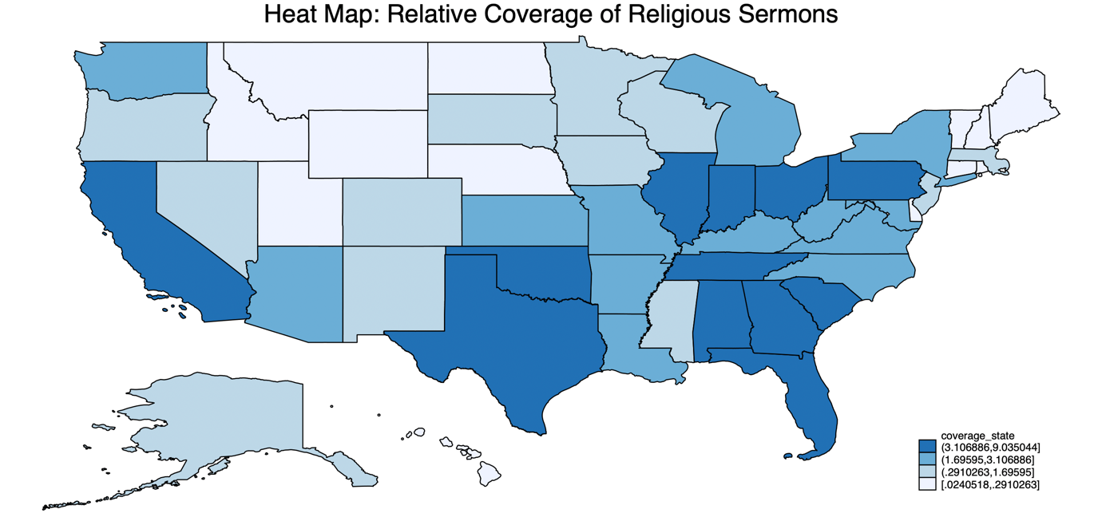

State: Adjusted Relative Coverage

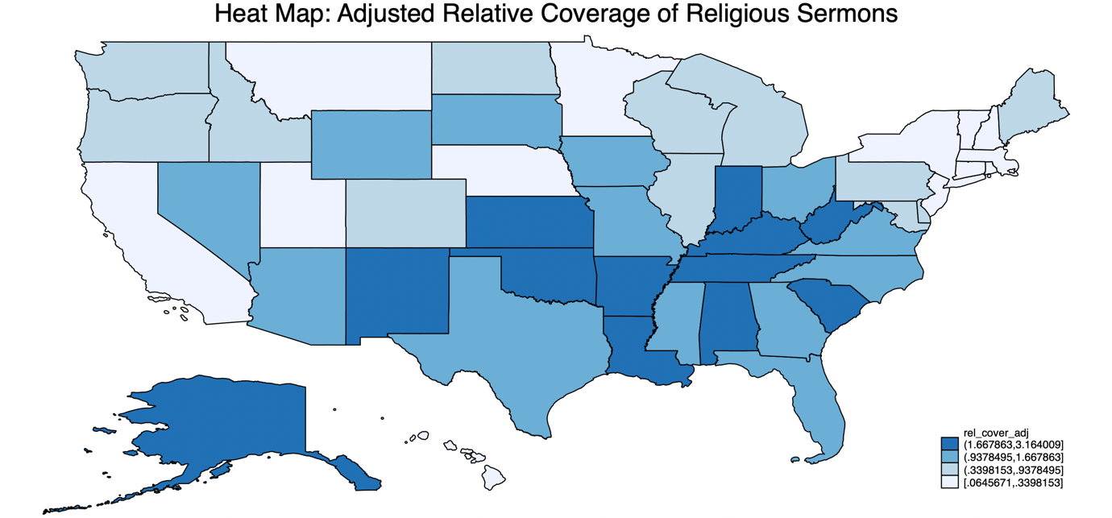

Election-Related Words
The words screened in religious sermons include: vote, voted, voting, ballot, candidate, nominate, elect, president, politician, politicians, re-vote.

RDD Style Graphs

Overlapping Graphs for All Election years: 12 months before & after election

Overlapping Graphs for All Election years: 4 weeks before & after election

Overlapping Graphs for Non-Election years: 4 weeks before & after the Tuesday between 2nd and 8th November

2004 Election: George Bush and John Kerry

2008 Election: John McCain and Barack Obama

2012 Election: Mitt Romney and Barack Obama

2016 Election: Donald Trump and Hilary Clinton

2020 Election: Donald Trump and Joe Biden

Word Count Graph

Presidential Election Candidates’ Mentions
The words screened include: George W. Bush, John Kerry, George Bush, kerry, george bush, Barack Obama, John McCain, obama, john mccain, John Mccain, President obama, barack, Mitt Romney, mitt romney, romney, Donald Trump, Hillary Clinton, Clinton, hillary, donald, Joe Biden, biden, President Bush, President Obama, President Trump, President Biden

RDD style graphs

Overlapping Graphs for All Election years: 12 months before & after election

Overlapping Graphs for All Election years: 4 weeks before & after an election

Overlapping Graphs for Non-Election years: 4 weeks before & after Tuesday between 2nd and 8th November.

2004 Election: George Bush and John Kerry

2008 Election: John McCain and Barack Obama

2012 Election: Mitt Romney and Barack Obama

2016 Election: Donald Trump and Hilary Clinton

2020 Election: Donald Trump and Joe Biden

Word Count Graph

RDD-Style Graphs: Sermon Count and View Count

Count of Sermons: 4 weeks before and after the nearest election

Count of Sermons: 12 months before and after the nearest election

Total Views of Sermons: 4 weeks before and after the nearest election

Total Views of Sermons: 12 months before and after the nearest election

Pastor-Level Controls

Variables | Obs | Mean | Std. Dev. | Min | Max | p1 | p99 | Skew. | Kurt.
married0 | 163056 | 0.487 | 0.5 | 0 | 1 | 0 | 1 | 0.052 | 1.003
married | 83097 | 0.955 | 0.208 | 0 | 1 | 0 | 1 | -4.381 | 20.195
children0 | 140606 | 1.117 | 1.71 | 0 | 9 | 0 | 7 | 1.475 | 4.659
children | 57918 | 2.737 | 1.654 | 0 | 9 | 0 | 8 | 0.562 | 3.858
edu theology0 | 163761 | 0.107 | 0.309 | 0 | 1 | 0 | 1 | 2.541 | 7.455
edu theology | 103345 | 0.167 | 0.373 | 0 | 1 | 0 | 1 | 1.79 | 4.204
edu theological0 | 163761 | 0.283 | 0.451 | 0 | 1 | 0 | 1 | 0.962 | 1.925
edu theological | 103345 | 0.446 | 0.497 | 0 | 1 | 0 | 1 | 0.218 | 1.047
edu0 | 144946 | 1.675 | 1.533 | 0 | 4 | 0 | 4 | 0.069 | 1.41
edu | 84542 | 2.872 | 0.768 | 1 | 4 | 1 | 4 | -0.104 | 2.355
denom index | 164133 | 15.923 | 10.728 | 1 | 39 | 1 | 39 | 0.536 | 1.904
family index | 164133 | 9.547 | 5.178 | 1 | 16 | 3 | 16 | -0.298 | 1.363
exp bin | 8765 | 26.826 | 12.317 | 10 | 60 | 10 | 50 | 0.409 | 2.332
The explanation behind the variables and their construction can be explained below:

Married0
Married0 is a binary (dummy) variable that takes the value 1 if the pastor is married and 0 if the pastor is not married.
To construct this variable, the following steps were followed:

Step 1: Identifying Relevant Text Fields
To determine a pastor’s marital status, text from the following variables was screened:
- 'family'
- 'whatmyspousereallythinksofmyserm'
- 'experience'
Step 2: Keyword Matching
The classification was based on specific keywords found in these text fields:
Indications of being married (assigned 1):
Words searched in sermons: wife, husband, married, spouse, helpmate, marriage, casado
Indications of being unmarried (assigned 0):
Words searched in sermons: widow, widower, girlfriend, I am single

Step 3: Handling Missing Data
Pastors who did not respond to 'whatmyspousereallythinksofmyserm' and ‘family’ were automatically classified as unmarried (coded as 0).

Step 4: Manual Review & Adjustments
Following the automated classification, a manual review was conducted to validate and refine the variable. A random sample of 10 observations from pastors whose marital status remained unclassified (i.e., not coded as 0 or 1) was drawn. These observations were individually examined to assess whether they were correctly left unclassified. Where appropriate, pastors were manually recoded as married (1), unmarried (0), or missing (.). This process involved using the strpos string function to identify relevant keywords in the text fields and ensure more accurate classification. After reviewing the initial 10 observations, the process was repeated iteratively 20 times.

Married: The 'married' variable is the same as the 'married0' variable except that pastors who do not respond to the 'whatmyspousereallythinksofmyserm' variable are treated as missing observations instead of being coded as unmarried (coded as '.').

Step 5: Plotting Married0 and Married against ‘week_to_nearest_election’

Children0:
Children0 is a variable for the number of children a pastor has, ranging from 0 to 9.
To construct this variable, the following steps were followed:

Step 1: Identifying Relevant Text Fields
To determine the number of children a pastor has, information was extracted from the ‘family’ variable.

Step 2: Keyword Matching
The classification was based on specific keywords found in these text fields, by using commonly used phrases to describe number of children to build the variable.

Indication that a pastor has no kids (assigned children = 0):
Words searched in sermons:
- we don’t have children, we don't have any children, i don’t have children, i don't have any children
- no kids, no children
- just me and my wife, just me and my husband, just my wife and me, just my husband and me, it’s just the two of us, just my wife, just my husband, just my parents

Indication that a pastor has one child (assigned children = 1):
Words searched in sermons:
- one child, 1 child, one kid, 1 kid
- one grown child, 1 grown child, one grown kid, 1 grown kid, one adult child, 1 adult child, one adult kid, 1 adult kid, one married child, 1 married child, one married kid, 1 married kid, one beautiful child, 1 beautiful child, one beautiful kid, 1 beautiful kid, one wonderful child, 1 wonderful child, one wonderful kid, 1 wonderful kid, one great child, 1 great child, one great kid, 1 great kid, one terrific kid, 1 terrific kid
- one son, 1 son, one boy, 1 boy, one daughter, 1 daughter, one girl, 1 girl, our only child, first and only child, our one child, our 1 child
- one adult son, 1 adult son, one adult daughter, 1 adult daughter, one married son, 1 married son, one married daughter, 1 married daughter, one grown son, 1 grown son, one grown daughter, 1 grown daughter, one beautiful son, 1 beautiful son, one beautiful daughter, 1 beautiful daughter, one wonderful son, 1 wonderful son, one wonderful daughter, 1 wonderful daughter, one amazing son, 1 amazing son, one amazing daughter, 1 amazing daughter, one great son, 1 great son, one great daughter, 1 great daughter, one terrific son, 1 terrific son, one terrific daughter, 1 terrific daughter
- 1 stepson, one stepson, 1 stepdaughter, one stepdaughter

Indication that a pastor has two children (assigned children = 2):
Words searched in sermons:
- two children, 2 children, two kids, 2 kids
- two grown children, 2 grown children, , two grown kids, 2 grown kids, two adult children, 2 adult children, two adult kids, 2 adult kids, two married children, 2 married children, two married kids, 2 married kids, two beautiful children, 2 beautiful children, two beautiful kids, 2 beautiful kids, two wonderful children, 2 wonderful children, two wonderful kids, 2 wonderful kids, two amazing children, 2 amazing children, two amazing kids, 2 amazing kids, two great children, 2 great children, two great kids, 2 great kids, two terrific children, 2 terrific children, two terrific kids, 2 terrific kids
- two sons, 2 sons, two boys, 2 boys, two daughters, 2 daughters, two girls, 2 girls, one son and one daughter, a son and a daughter, 1 son and 1 daughter, one daughter and one son, a daughter and a son, 1 daughter and 1 son
- two adult sons, 2 adult sons, two adult daughters, 2 adult daughters, two married sons, 2 married sons, two married daughters, 2 married daughters, two grown-up sons, 2 grown-up sons, two grown-up daughters, 2 grown-up daughters, two beautiful sons, 2 beautiful sons, two beautiful daughters, 2 beautiful daughters, two wonderful sons, 2 wonderful sons, two wonderful daughters, 2 wonderful daughters, two amazing sons, 2 amazing sons, two amazing daughters, 2 amazing daughters, two great sons, 2 great sons, two great daughters, 2 great daughters, two terrific sons, 2 terrific sons, two terrific daughters, 2 terrific daughters
- two stepchildren, 2 stepchildren

Indication that a pastor has three children (assigned children = 3):
Words searched in sermons:
- three children, 3 children, three kids, 3 kids
- three grown children, 3 grown children, , three grown kids, 3 grown kids, three adult children, 3 adult children, three adult kids, 3 adult kids, three married children, 3 married children, three married kids, 3 married kids, three beautiful children, 3 beautiful children, three beautiful kids, 3 beautiful kids, three wonderful children, 3 wonderful children, three wonderful kids, 3 wonderful kids, three amazing children, 3 amazing children, three amazing kids, 3 amazing kids, three great children, 3 great children, three great kids, 3 great kids, three terrific children, 3 terrific children, three terrific kids, 3 terrific kids
- three sons, 3 sons, three boys, 3 boys, three daughters, 3 daughters, three girls, 3 girls, one son and two daughters, 1 son and 2 daughters, a son and two daughters, a son and 2 daughters, two sons and one daughter, 2 sons and 1 daughter, two sons and a daughter, 2 sons and a daughter, one daughter and two sons, 1 daughter and 2 sons, a daughter and two sons, a daughter and 2 sons, two daughters and one son, 2 daughters and 1 son, two daughters and a son, 2 daughters and a son
- three adult sons, 3 adult sons, three adult daughters, 3 adult daughters, three married sons, 3 married sons, three married daughters, 3 married daughters, three grown-up sons, 3 grown-up sons, three grown-up daughters, 3 grown-up daughters, three beautiful sons, 3 beautiful sons, three beautiful daughters, 3 beautiful daughters, three wonderful sons, 3 wonderful sons, three wonderful daughters, 3 wonderful daughters, three amazing sons, 3 amazing sons, three amazing daughters, 3 amazing daughters, three great sons, 3 great sons, three great daughters, 3 great daughters, three terrific sons, 3 terrific sons, three terrific daughters, 3 terrific daughters
- three stepchildren, 3 stepchildren

Indication that a pastor has four children (assigned children = 4):
Words searched in sermons:
- four children, 4 children, four kids, 4 kids
- four grown children, 4 grown children, , four grown kids, 4 grown kids, four adult children, 4 adult children, four adult kids, 4 adult kids, four married children, 4 married children, four married kids, 4 married kids, four beautiful children, 4 beautiful children, four beautiful kids, 4 beautiful kids, four wonderful children, 4 wonderful children, four wonderful kids, 4 wonderful kids, four amazing children, 4 amazing children, four amazing kids, 4 amazing kids, four great children, 4 great children, four great kids, 4 great kids, four terrific children, 4 terrific children, four terrific kids, 4 terrific kids
- four sons, 4 sons, four boys, 4 boys, four daughters, 4 daughters, four girls, 4 girls, one son and three daughters, 1 son and 3 daughters, a son and three daughters, a son and 3 daughters, two sons and two daughters, 2 sons and 2 daughters, three sons and one daughter, 3 sons and 1 daughter, three sons and a daughter, 3 sons and a daughter, one daughter and three sons, 1 daughter and 3 sons, a daughter and three sons, a daughter and 3 sons, three daughters and one son, 3 daughters and 1 son, three daughters and one son, three daughters and a son, 3 daughters and a son
- four adult sons, 4 adult sons, four adult daughters, 4 adult daughters, four married sons, 4 married sons, four married daughters, 4 married daughters, four grown-up sons, 4 grown-up sons, four grown-up daughters, 4 grown-up daughters, four beautiful sons, 4 beautiful sons, four beautiful daughters, 4 beautiful daughters, four wonderful sons, 4 wonderful sons, four wonderful daughters, 4 wonderful daughters, four amazing sons, 4 amazing sons, four amazing daughters, 4 amazing daughters, four great sons, 4 great sons, four great daughters, 4 great daughters, four terrific sons, 4 terrific sons, four terrific daughters, 4 terrific daughters
- four stepchildren, 4 stepchildren

Indication that a pastor has five children (assigned children = 5):
Words searched in sermons:
- five children, 5 children, five kids, 5 kids
- five grown children, 5 grown children, , five grown kids, 5 grown kids, five adult children, 5 adult children, five adult kids, 5 adult kids, five married children, 5 married children, five married kids, 5 married kids, five beautiful children, 5 beautiful children, five beautiful kids, 5 beautiful kids, five wonderful children, 5 wonderful children, five wonderful kids, 5 wonderful kids, five amazing children, 5 amazing children, five amazing kids, 5 amazing kids, five great children, 5 great children, five great kids, 5 great kids, five terrific children, 5 terrific children, five terrific kids, 5 terrific kids
- five sons, 5 sons, five boys, 5 boys, five daughters, 5 daughters, five girls, 5 girls
- one son and four daughters, 1 son and 4 daughters, a son and four daughters, a son and 4 daughters, two sons and three daughters, 2 sons and 3 daughters, three sons and two daughters, 3 sons and 2 daughters, four sons and one daughter, 4 sons and 1 daughter, one daughter and four sons, 1 daughter and 4 sons, a daughter and four sons, a daughter and 4 sons, two daughters and three sons, 2 daughters and 3 sons, three daughters and two sons, 3 daughters and 2 sons, four daughters and one son, 4 daughters and 1 son, four daughters and a son, 4 daughters and a son
- five adult sons, 5 adult sons, five adult daughters, 5 adult daughters, five married sons, 5 married sons, five married daughters, 5 married daughters, five grown-up sons, 5 grown-up sons, five grown-up daughters, 5 grown-up daughters, five beautiful sons, 5 beautiful sons, five beautiful daughters, 5 beautiful daughters, five wonderful sons, 5 wonderful sons, five wonderful daughters, 5 wonderful daughters, five amazing sons, 5 amazing sons, five amazing daughters, 5 amazing daughters, five great sons, 5 great sons, five great daughters, 5 great daughters, five terrific sons, 5 terrific sons, five terrific daughters, 5 terrific daughters
- five stepchildren, 5 stepchildren

Indication that a pastor has six children (assigned children = 6):
Words searched in sermons:
- six children, 6 children, six kids, 6 kids
- six grown children, 6 grown children, , six grown kids, 6 grown kids, six adult children, 6 adult children, six adult kids, 6 adult kids, six married children, 6 married children, six married kids, 6 married kids, six beautiful children, 6 beautiful children, six beautiful kids, 6 beautiful kids, six wonderful children, 6 wonderful children, six wonderful kids, 6 wonderful kids, six amazing children, 6 amazing children, six amazing kids, 6 amazing kids, six great children, 6 great children, six great kids, 6 great kids, six terrific children, 6 terrific children, six terrific kids, 6 terrific kids
- six sons, 6 sons, six boys, 6 boys, six daughters, 6 daughters, six girls, 6 girls,
- one son and five daughters, 1 son and 5 daughters, a son and five daughters, a son and 5 daughters, two sons and four daughters, 2 sons and 4 daughters, three sons and three daughters, 3 sons and 3 daughters, four sons and two daughters, 4 sons and 2 daughters, five sons and one daughter, 5 sons and 1 daughter, 5 sons and a daughter, five sons and a daughter, one daughter and five sons, 1 daughter and 5 sons, a daughter and five sons, a daughter and 5 sons, two daughters and four sons, 2 daughters and 4 sons, three daughters and three sons, 3 daughters and 3 sons, four daughters and two sons, 4 daughters and 2 sons, 5 daughters and 1 son, five daughters and one son, five daughters and a son, 5 daughters and a son
- six adult sons, 6 adult sons, six adult daughters, 6 adult daughters, six married sons, 6 married sons, six married daughters, 6 married daughters, six grown-up sons, 6 grown-up sons, six grown-up daughters, 6 grown-up daughters, six beautiful sons, 6 beautiful sons, six beautiful daughters, 6 beautiful daughters, six wonderful sons, 6 wonderful sons, six wonderful daughters, 6 wonderful daughters, six amazing sons, 6 amazing sons, six amazing daughters, 6 amazing daughters, six great sons, 6 great sons, six great daughters, 6 great daughters, six terrific sons, 6 terrific sons, six terrific daughters, 6 terrific daughters
- six step-children, 6 stepchildren

Indication that a pastor has seven children (assigned children = 7):
Words searched in sermons:
- seven children, 7 children, seven kids, 7 kids
- seven grown children, 7 grown children, , seven grown kids, 7 grown kids, seven adult children, 7 adult children, seven married children, 7 married children, seven married kids, 7 married kids, seven adult kids, 7 adult kids, seven beautiful children, 7 beautiful children, seven wonderful children, 7 wonderful children, seven amazing kids, 7 amazing kids, seven great kids, 7 great kids, seven terrific kids, 7 terrific kids,
- seven sons, 7 sons, seven boys, 7 boys, seven daughters, 7 daughters, seven girls, 7 girls
- one son and six daughters, 1 son and 6 daughters, a son and six daughters, a son and 6 daughters, two sons and five daughters, 2 sons and 5 daughters, three sons and four daughters, 3 sons and 4 daughters, four sons and three daughters, 4 sons and 3 daughters, five sons and two daughters, 5 sons and 2 daughters, six sons and one daughter, 6 sons and 1 daughter, six sons and a daughter, 6 sons and a daughter, one daughter and six sons, 1 daughter and 6 sons, a daughter and six sons, a daughter and 6 sons, two daughters and five sons, 2 daughters and 5 sons, three daughters and four sons, 3 daughters and 4 sons, four daughters and three sons, 4 daughters and 3 sons, five daughters and two sons, 5 daughters and 2 sons, six daughters and one son, 6 daughters and 1 son, 6 daughters and a son, six daughters and a son
- seven adult sons, 7 adult sons, seven adult daughters, 7 adult daughters, seven married sons, 7 married sons, seven married daughters, 7 married daughters, seven grown-up sons, 7 grown-up sons, seven grown-up daughters, 7 grown-up daughters, seven beautiful sons, 7 beautiful sons, seven beautiful daughters, 7 beautiful daughters, seven wonderful sons, 7 wonderful sons, seven wonderful daughters, 7 wonderful daughters, seven amazing sons, 7 amazing sons, seven amazing daughters, 7 amazing daughters, seven great sons, 7 great sons, seven great daughters, 7 great daughters, seven terrific sons, 7 terrific sons, seven terrific daughters, 7 terrific daughters
- seven step-children, 7 step-children

Indication that a pastor has eight children (assigned children = 8):
Words searched in sermons:
- eight children, 8 children, eight kids, 8 kids
- eight grown children, 8 grown children, , eight grown kids, 8 grown kids, eight adult children, 8 adult children, eight adult kids, 8 adult kids, eight married children, 8 married children, eight married kids, 8 married kids, eight beautiful children, 8 beautiful children, eight beautiful kids, 8 beautiful kids, eight wonderful children, 8 wonderful children, eight wonderful kids, 8 wonderful kids, eight amazing children, 8 amazing children, eight amazing kids, 8 amazing kids, eight great children, 8 great children, eight great kids, 8 great kids, eight terrific children, 8 terrific children, eight terrific kids, 8 terrific kids
- eight sons, 8 sons, eight boys, 8 boys, eight daughters, 8 daughters, eight girls, 8 girls,
- one son and seven daughters, 1 son and 7 daughters, a son and seven daughters, a son and 7 daughters, two sons and six daughters, 2 sons and 6 daughters, three sons and five daughters, 3 sons and 5 daughters, four sons and four daughters, 4 sons and 4 daughters, five sons and three daughters, 5 sons and 3 daughters, six sons and two daughters, 6 sons and 2 daughters, seven sons and one daughter, 7 sons and 1 daughter, 7 sons and a daughter, seven sons and a daughter, one daughter and seven sons, 1 daughter and 7 sons, a daughter and seven sons, a daughter and 7 sons, , two daughters and six sons, 2 daughters and 6 sons, three daughters and five sons, 3 daughters and 5 sons, four daughters and four sons, 4 daughters and 4 sons, five daughters and three sons, 5 daughters and 3 sons, six daughters and two sons, 6 daughters and 2 sons, seven daughters and one son, 7 daughters and 1 son, 7 daughters and a son, seven daughters and a son
- eight adult sons, 8 adult sons, eight adult daughters, 8 adult daughters, eight married sons, 8 married sons, eight married daughters, 8 married daughters, eight grown-up sons, 8 grown-up sons, eight grown-up daughters, 8 grown-up daughters, eight beautiful sons, 8 beautiful sons, eight beautiful daughters, 8 beautiful daughters, eight wonderful sons, 8 wonderful sons, eight wonderful daughters, 8 wonderful daughters, eight amazing sons, 8 amazing sons, eight amazing daughters, 8 amazing daughters, eight great sons, 8 great sons, eight great daughters, 8 great daughters, eight terrific sons, 8 terrific sons, eight terrific daughters, 8 terrific daughters
- eight step-children, 8 step-children

Indication that a pastor has nine children (assigned children = 9):
Words searched in sermons:
- nine children, 9 children, nine kids, 9 kids
- nine grown children, 9 grown children, , nine grown kids, 9 grown kids, nine adult children, 9 adult children, nine adult kids, 9 adult kids, nine married children, 9 married children, nine married kids, 9 married kids, nine beautiful children, 9 beau-tiful children, nine beautiful kids, 9 beautiful kids, nine wonderful children, 9 won-derful children, nine wonderful kids, 9 wonderful kids, nine amazing children, 9 amazing children, nine amazing kids, 9 amazing kids, nine great children, 9 great children, nine great kids, 9 great kids, nine terrific children, 9 terrific children, nine terrific kids, 9 terrific kids
- nine sons, 9 sons, nine boys, 9 boys, nine daughters, 9 daughters, nine girls, 9 girls
- one son and eight daughters, 1 son and 8 daughters, a son and eight daughters, a son and 8 daughters, two sons and seven daughters, 2 sons and 7 daughters, three sons and six daughters, 3 sons and 6 daughters, four sons and five daughters, 4 sons and 5 daughters, five sons and four daughters, 5 sons and 4 daughters, six sons and three daughters, 6 sons and 3 daughters, seven sons and two daughters, 7 sons and 2 daughters, eight sons and one daughter, 8 sons and 1 daughter, eight sons and a daughter, 8 sons and a daughter, one daughter and eight sons, 1 daughter and 8 sons, a daughter and eight sons, a daughter and 8 sons, two daughters and seven sons, 2 daughters and 7 sons, three daughters and six sons, 3 daughters and 6 sons, four daughters and five sons, 4 daughters and 5 sons, five daughters and four sons, 5 daughters and 4 sons, six daughters and three sons, 6 daughters and 3 sons, seven daughters and two sons, 7 daughters and 2 sons, eight daughters and one son, 8 daughters and one son, eight daughters and a son, 8 daughters and a son.
- nine adult sons, 9 adult sons, nine adult daughters, 9 adult daughters, nine married sons, 9 married sons, nine married daughters, 9 married daughters, nine grown-up sons, 9 grown-up sons, nine grown-up daughters, 9 grown-up daughters, nine beautiful sons, 9 beautiful sons, nine beautiful daughters, 9 beautiful daughters, nine wonderful sons, 9 wonderful sons, nine wonderful daughters, 9 wonderful daughters, nine amazing sons, 9 amazing sons, nine amazing daughters, 9 amazing daughters, nine great sons, 9 great sons, nine great daughters, 9 great daughters, nine terrific sons, 9 terrific sons, nine terrific daughters, 9 terrific daughters
- nine step-children, 9 step-children

Step 3: Handling Missing Data
To ensure accuracy, pastors who did not respond to 'family' were automatically classified as having no children (coded as 0).

Children: The 'children' variable is the same as the 'children0' variable except that pastors who do not respond to the 'family' variable are treated as missing observations instead of being coded as not having a family (coded as '.').

Step 4: Plotting Children0 and Children against ‘week_to_nearest_election’

Edu theology0:
Edu theology0 is a binary (dummy) variable that takes the value 1 if the pastor has a degree in theology, and 0 if the pastor has does not have a degree in theology.
To construct this variable, the following steps were followed:

Step 1: Identifying Relevant Text Fields
To determine whether a pastor pursued a degree in theology, information was extracted from the ‘education’ variable.

Step 2: Keyword Matching
The classification was based on specific keywords found in the text field of ‘education’
Indications of having a degree in theology (assigned 1):
Words searched in sermons: Theology, Th.M, ThD, Master of Theology, MTh, BTh, Th.D
Indications of not having a degree in theology (assigned 0):
All other observations which did not contain the words indicative of a theological degree were coded as 0. This included pastors who studied non-theology courses at theological institute at university.

Step 3: Handling Missing Data
To ensure accuracy, pastors who did not respond to 'education' were automatically classified as having no degree in theology (coded as 0).

Edu theology: The 'edu theology' variable is the same as the 'edu theology0' variable except that pastors who do not respond to the 'education' variable are treated as missing observations instead of being coded as not having a degree in theology(coded as '.').

Step 4: Plotting Edu_theology0 and Edu_theology against ‘week_to_nearest_election’

Edu theological0:
Edu theological0 is a binary (dummy) variable that takes the value 1 if the pastor studied at a theological institution or department, or 0 otherwise.
Note: The variable Edu theological also includes the pastors which pursued a degree in theology (from the variable edu theology)
To construct this variable, the following steps were followed:

Step 1: Identifying Relevant Text Fields
To determine whether a pastor pursued a degree from a theological institute, information was extracted from the ‘education’ variable.
Step 2: Keyword Matching
The classification was based on specific keywords found in the text field of ‘education’
Indications of having a degree at a theological institute (assigned 1):
Words searched in sermons: Theology, Th.M, ThD, Master of Theology, MTh, BTh, Th.D, theological
Indications of not having a degree at a theological institute (assigned 0):
All other observations which did not contain the words indicative of a degree at a theological institute were coded as 0.

Step 3: Handling Missing Data
To ensure accuracy, pastors who did not respond to 'education' were automatically classified as having no degree at a theological institute (coded as 0).
Edu theological: The 'Edu theological' variable is the same as the 'Edu theological0' variable except that pastors who do not respond to the 'education' variable are treated as missing observations instead of being coded as not having a degree from a theological institute (coded as '.').

Step 4: Plotting Edu_theological0 and Edu_theological against ‘week_to_nearest_election’

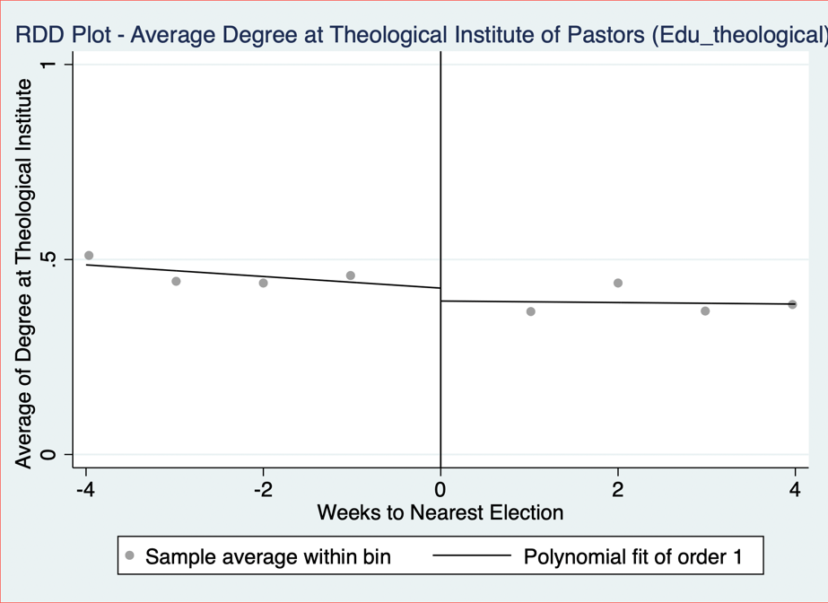

Edu0:
Edu0 is a categorical variable for the level of education a pastor has, where:
- 1 = high school degree
- 2 = bachelor’s degree
- 3 = master’s degree
- 4 = PhD
To construct this variable, the following steps were followed:
Step 1: Identifying Relevant Text Fields
To determine a pastor’s level of education, information was extracted from the ‘education’ variable.
Step 2: Keyword Matching
The classification was based on specific keywords found in the ‘education; text field, by using commonly used phrases to describe education level to build the variable.
Indication that a pastor has a high-school diploma (coded as 1):
Words searched in sermons: High School, HS diploma, school degree, Eagle Academy, Associate of Arts
Indication that a pastor has a bachelor’s degree (coded as 2):
Words searched in sermons: Bachelor, Bachelors, BA, BSC, undergraduate, B.A., Bachelor of Art, BS, B.S., BTh, Business Degree,
Indication that a pastor has a master’s degree (coded as 3):
Words searched in sermons: Masters, Th.M, Master of Theology, MTh, M.Div, Master, MA, MDiv, MOM.Div., M A, MAOM
Indication that a pastor has a PhD (coded as 4):
Words searched in sermons: PhD, Doctorate, Doctor of, Th.D, ThD

Note: Pastors with Associate of Arts degrees were classified as having a high school diploma, even though an AA degree is higher than a high school diploma but lower than a bachelor's degree. This classification was made due to its equivalence to the first or second year of a bachelor's program.

Step 3: Handling Missing Data
To ensure accuracy, pastors who did not respond to 'education' were automatically classified as having no education (coded as 0).

Step 4: Manual Review & Adjustments
Following the automated classification, a manual review was conducted to validate and refine the education variable. A random sample of 10 observations from pastors whose education level remained unclassified (i.e., not yet coded) was drawn. These cases were individually examined to assess whether they were correctly left unclassified. Where appropriate, pastors were manually recoded based on the highest level of education identified. This process involved using the strpos string function to detect relevant educational keywords in the text fields, ensuring more consistent and accurate classification. After reviewing the initial 10 observations, the process was repeated iteratively 20 times.

Edu: The 'edu' variable is the same as the 'edu0' variable except that pastors who do not respond to the 'education' variable are treated as missing observations instead of being coded as not having an education (coded as '.').

Step 5: Plotting Edu0 and Edu against ‘week_to_nearest_election’

Denom_index:
Denom_Index is a numerical variable representing the religious denomination of the pastor. It assigns a numerical index to each denomination, as listed in Section 1.3.

Denominations with High Relative Coverage
To take a closer look at the denomination of Pastors, separate dummy variables were created for the ‘Baptist’, ‘Evangelical/Non-Denominational’, and ‘Christian/Church of Christ’ denominations. All other denominations were grouped together under a binary variable labeled ‘OtherDenom’. Descriptive statistics for these variables are presented below.

Variables | Obs | Mean | Std. Dev. | Min | Max | p1 | p99 | Skew. | Kurt.
Baptist | 164133 | 0.333 | 0.471 | 0 | 1 | 0 | 1 | 0.707 | 1.499
Evangelical | 164133 | 0.115 | 0.319 | 0 | 1 | 0 | 1 | 2.418 | 6.848
ChurchofChrist | 164133 | 0.105 | 0.307 | 0 | 1 | 0 | 1 | 2.571 | 7.612
OtherDenom | 164133 | 0.447 | 0.497 | 0 | 1 | 0 | 1 | 0.215 | 1.046

Checking for Smoothness in High-Relative-Coverage Denominations:
The RDD-style graphs for Baptist, Evangelical/Non-Denominational, and Christian/Church of Christ pastors, as well as pastors from all other denominations, are presented below.

Family_index:
Family_index is a numerical variable representing the religious family of the pastor. It assigns a numerical index to each religious family, as listed in Section ‎1.4. To clarify the distinction between denomination and religious family: denominations were self-reported by pastors and provide a more detailed, granular classification. Religious families, on the other hand, group these denominations into broader categories based on ARDA’s classifications.

Religious Families with High Relative and High Adjusted Relative Coverage
To take a closer look at the religious families of Pastors, separate dummy variables were created for the ‘Baptist’ and ‘Pentecostal’ families which had a high relative coverage and for the ‘Froehlich’ Family which had a High Adjusted Relative Coverage. All other religious families were grouped together under a binary variable labeled ‘OtherFam’. Descriptive statistics for these variables are presented below.

Variables | Obs | Mean | Std. Dev. | Min | Max | p1 | p99 | Skew. | Kurt.
Baptist Family | 164133 | .333 | .471 | 0 | 1 | 0 | 1 | .707 | 1.499
Pentecostal Family | 164133 | .155 | .361 | 0 | 1 | 0 | 1 | 1.912 | 4.654
Froehlich Family | 164133 | .018 | .132 | 0 | 1 | 0 | 1 | 7.328 | 54.694
OtherFam | 164133 | .494 | .5 | 0 | 1 | 0 | 1 | .022 | 1
Checking for Smoothness in High (Adjusted) Relative Coverage Religious Families:
The RDD-style graphs for pastors from Baptist, Pentecostal, and Froehlich religious families, as well as pastors from all other religious families, are presented below.

Exp bin:
Exp bin is a categorical variable for the level of experience of the pastor has, binned into the following categories:
- 10: from 0-10 years of experience
- 20: from 11-20 years of experience
- 30: from 21-30 years of experience
- 40: from 31-40 years of experience
- 50: from 41-50 years of experience
- 60: 51+ years of experience

To construct this variable, the following steps were followed:
Step 1: Identifying Relevant Text Fields
To determine a pastor’s level of experience, information was extracted from the ‘experience’ variable.
Step 2: Manual Review
Since the responses in the experience variable were highly heterogeneous, approximately 19,000 observations of the experience variable were manually coded. This process involved either:
- Directly extracting the number of years of experience provided by the pastor, or
- Applying the following method:
  - Extracting any dates mentioned by the pastor.
  - Comparing these dates to the sermon contribution date to calculate the total years of experience.
  - Assigning the corresponding experience bin based on the calculated number of years.

Step 3: Using ChatGPT API to classify Exp Bin:
To classify the exp_bin variable for all observations, the ChatGPT API was used to categorize all the sermons based on 400 manually coded observations. The process followed these steps:
- Reference Set Creation:
  - A sample of 400 manually coded observations was extracted to serve as reference examples.
  - These examples demonstrated how pastors’ descriptions were mapped to experience bins.
- Prompt Design:
  - The system prompt included:
  - The reference examples for pattern recognition.
  - Rules for assigning experience bins based on mentioned years or inferred tenure. If pastors mention retirement from the military, GPT was instructed to add 20 years on top of their years of experience.
  - If experience was missing or unclear, GPT was instructed to return a placeholder (".") rather than forcing a classification.
- Processing with GPT:
  - For each pastor, a structured input was created with:
    - The unique id of the pastor
    - Their experience field.
    - Their latest sermon contribution date (to infer years of experience).
  - The GPT model was queried with this information.
  - The returned classifications were saved and merged with the main dataset.

Step 4: Plotting Exp_Bin against ‘week_to_nearest_election’

Note of Discretion regarding Experience Coding:
The classification of pastoral experience is based on self-reported information, which introduces several limitations. Some pastors reported overlapping church and non-church roles separately (e.g., serving part-time as a pastor while working another job), which may inflate their total years of pastoral service. In contrast, others focused solely on church-related roles and omitted relevant non-church experience, making comparisons across individuals more difficult. For retired military veterans, 20 years were added to their church-related experience to account for military service; however, actual lengths of service may differ from this standardized adjustment.

Sentiment Analysis

Two sentiment models were used to analyse sermon text sentences mentioning presidential candidates. The sentences before and after were considered when classifying each mention to give more context to the sentiment of the statement – we refer to such a collection of sentences as a sentence block. The analysis was run on two datasets: one that contained sentence blocks that mention at least one candidate, and another that contained only sentence blocks that mention exactly one candidate. For sentence blocks that mention exactly one candidate, the analysis for Bill Clinton and Hillary Clinton captures only sentence blocks that contain “Bill Clinton” and “Hillary Clinton”, respectively, without discarding if the other is also mentioned. The analysis for Clinton captures sentence blocks that contain any of “Bill Clinton”, “Hillary Clinton”, or “Clinton” and can be thought of as the Clinton family. 240 of the 337 captured sentence blocks mention exactly one candidate.

Positive/Negative Sentiment Analysis:

The first model, distilbert-base-uncased-finetuned-sst-2-english, classified sentiment as positive or negative. The candidates were then ranked by their difference in percent of mentions labelled positive and percent of mentions labelled negative. The following outputs were produced.

At Least 1 Candidate Mentioned in Sentence Block:

Candidate Sentiment Ranking
Rank | Name | Party | Total Mentions | Pos % | Neg % | Pos - Neg %
1 | Kerry | Democrat | 19 | 57.89 | 42.11 | 15.78
2 | Trump | Republican | 118 | 51.69 | 48.31 | 3.38
3 | Obama | Democrat | 124 | 45.16 | 54.84 | -9.68
4 | McCain | Republican | 36 | 44.44 | 55.56 | -11.12
5 | Bush | Republican | 51 | 43.14 | 56.86 | -13.72
6 | Clinton | Democrat | 60 | 36.67 | 63.33 | -26.66
7 | Bill Clinton | Democrat | 23 | 34.78 | 65.22 | -30.44
8 | Biden | Democrat | 22 | 27.27 | 72.73 | -45.46
9 | Hillary Clinton | Democrat | 10 | 20.00 | 80.00 | -60.00
10 | Romney | Republican | 13 | 15.38 | 84.62 | -69.24

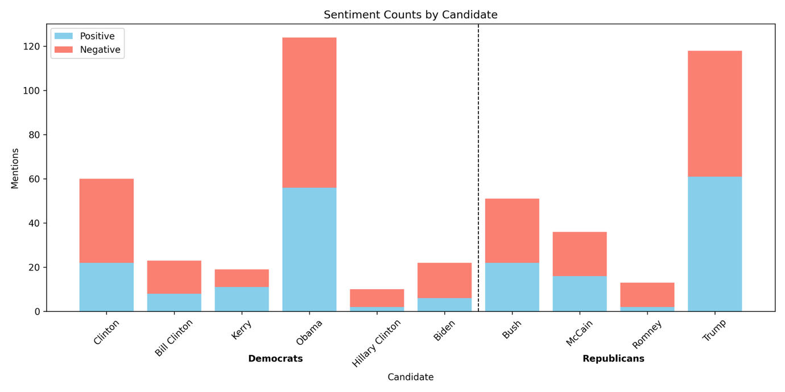

Top Sentence Blocks per Candidate
Label | Candidate | Sentence Block
Negative | Biden | We must rely on the grace of Christ to carry us through, and His sacramental presence and consolation. What if it gets worse as Biden and Harris have promised it would and lasts for four years or eight or the rest of our lives, God forbid. The Ephesus church also had a third attaboy from St.
Negative | Bush | It's the Economy, Stupid. This buzz phrase become very popular during the first President Bush's administration, and could easily be used today. Today let's take a look at God's spiritual economic plan for His people.
Negative | Clinton | When reporters hounded him about Clintonian lies, Stephanopoulos accused them of an excess of literalism. Stephanopoulos, to his credit, did tire of the Clinton lies and left the White House. CHALLENGE:Finding the truth, and acting on it, is an old problem.
Negative | Bill Clinton | You're sitting there thinking You just told us that you have no idea what a perfect gift is... and now you are going to preach about what one is. That seems like listening to Mickey Rooney pontificate about the dangers of being tall or Roseanne speaking on morality Michael Jordan giving a seminar on How To Survive on A Limited Income, Bill Clinton on Honesty... or Frank Gifford on Marital Fidelity. Now, before you get testy and negative I want you to know I am not speaking from personal experience of from my own wisdom.
Negative | Hillary Clinton | 83 a year after taxes. Those opposed to Hillary Clinton will point out that as a First Lady, Senator, and Secretary of State she never accomplished anything. Many accuse her of having an open marriage, allowing her husband the freedom to have affairs.
Negative | Kerry | You'll be congratulated for all your hard work, and you'll probably be given a job in the government somewhere that's your reward, if you want it, for working on the campaign for the winner. But if you were on John Kerry's campaign staff, then election day for you is not a good day. All your work didn't result in what you had hoped.
Negative | McCain | You might think it would be a disaster. If your perspective is that John McCain is the right man to be our next president, then you might think that an Obama presidency is something to fear. If you have any money invested in the stock market, you've no doubt lost a lot of money in the past few months at least on paper.
Negative | Obama | This bad form, bad manners. It would be a little like Obama sending a White House page boy to greet Putin or the Queen of England. 5.
Negative | Romney | Conan O'Brien4. Today Mitt Romney visited a firehouse here in New York City. Of course, he was disappointed when he learned that the firehouse is not where you get to fire people.
Negative | Trump | Our nation will be in a mess. Those who oppose Trump declare that Islamic Mosques will be closed, inhibiting their freedom of religion. The press will be suppressed with only those in his favor getting access to him.
Positive | Biden | WILL WE TRUST HIM. BIDEN. TRUMP.
Positive | Bush | B. Following this bold tradition President Bush made the following proclamation concerning thanksgiving on November 21, 2008:Thanksgiving is a time for families and friends to gather together and express gratitude for all that we have been given, the freedoms we enjoy, and the loved ones who enrich our lives. We recognize that all of these blessings, and life itself, come not from the hand of man but from Almighty God.
Positive | Clinton | A good teacher inspires a thirst for learning that lasts a lifetime. Bill Clinton said that on August 5, 1993 during a ceremony honoring inductees into the teacher's Hall of Fame. Henry Brooks Adams said, Teachers affect eternity, they can never know the full range of their influence.
Positive | Bill Clinton | A good teacher inspires a thirst for learning that lasts a lifetime. Bill Clinton said that on August 5, 1993 during a ceremony honoring inductees into the teacher's Hall of Fame. Henry Brooks Adams said, Teachers affect eternity, they can never know the full range of their influence.
Positive | Hillary Clinton | I like to play golf. Hillary Clinton has been dealing with scandals concerning her husband for years. Bill Clinton has been publicly accused by several women of sexual misconduct.
Positive | Kerry | One of the candidates answered with a very strong religious statement. It wasn't George Bush because he answered, I don't know -It was Senator John Kerry who said - We're all God's children, he said. And I think if you were to talk to Dick Cheney's daughter, who is a lesbian, she would tell you that she's being who she was.
Positive | McCain | John McCain, you are a minister of God. Barack Obama, you are a minister of God. We must look for people to put into office who are moving closer to divine revelation from God.
Positive | Obama | And I do my very best to remember Him through His Son, Jesus Christ, and to focus on Him first and foremost in my life. Let us thank all of our veterans for their courageous service for America, and let us also remember to pray for our leaders, including President-elect Barrack Obama and his staff, that they might find themselves being led by God Almighty in their administration of this blessed nation. This is a time of healing and refocusing on our Lord, not a time of bitterness and negativity.
Positive | Romney | Jay Leno 6. Mitt Romney believes that marriage should be between one man and one woman. Which is better than his grandfather, who believed that it should be between one man and five women.
Positive | Trump | Psalm 72, NLT -Include in the bulletin for members:Dear Heavenly Father,I come before you with a humble and grateful heart. I ask you to lift up those who are seated in places of authority in our nation President Trump, those representing me in the United States Senate, in the U. S.

Exactly 1 Candidate Mentioned in Sentence Block:

Candidate Sentiment Ranking
Rank | Name | Party | Total Mentions | Pos % | Neg % | Pos - Neg %
1 | Kerry | Democrat | 10 | 60.00 | 40.00 | 20.00
2 | Trump | Republican | 83 | 56.63 | 43.37 | 13.26
3 | Bush | Republican | 26 | 53.85 | 46.15 | 7.70
4 | Obama | Democrat | 68 | 50.00 | 50.00 | 0.00
5 | McCain | Republican | 6 | 50.00 | 50.00 | 0.00
6 | Bill Clinton | Democrat | 18 | 38.89 | 61.11 | -22.22
7 | Clinton | Democrat | 35 | 37.14 | 62.86 | -25.72
8 | Romney | Republican | 4 | 25.00 | 75.00 | -50.00
9 | Biden | Democrat | 8 | 12.50 | 87.50 | -75.00
10 | Hillary Clinton | Democrat | 5 | 0.00 | 100.00 | -100.00

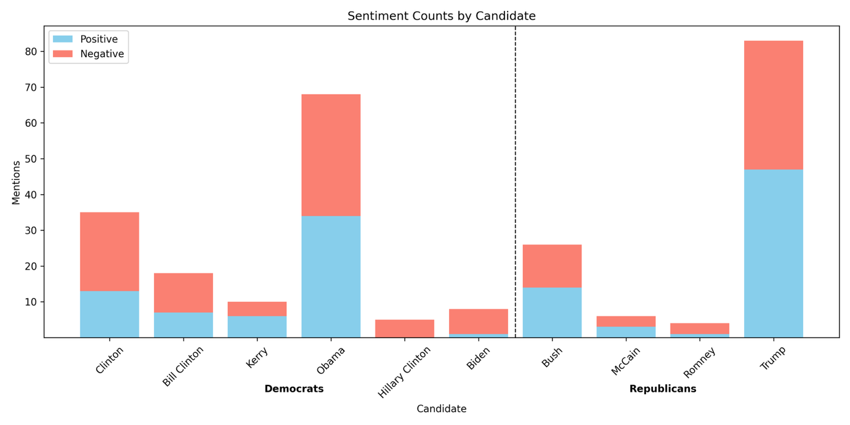

Top Sentence Blocks per Candidate
Label | Candidate | Sentence Block
Negative | Biden | We must rely on the grace of Christ to carry us through, and His sacramental presence and consolation. What if it gets worse as Biden and Harris have promised it would and lasts for four years or eight or the rest of our lives, God forbid. The Ephesus church also had a third attaboy from St.
Negative | Bush | It's the Economy, Stupid. This buzz phrase become very popular during the first President Bush's administration, and could easily be used today. Today let's take a look at God's spiritual economic plan for His people.
Negative | Clinton | When reporters hounded him about Clintonian lies, Stephanopoulos accused them of an excess of literalism. Stephanopoulos, to his credit, did tire of the Clinton lies and left the White House. CHALLENGE:Finding the truth, and acting on it, is an old problem.
Negative | Bill Clinton | You're sitting there thinking You just told us that you have no idea what a perfect gift is... and now you are going to preach about what one is. That seems like listening to Mickey Rooney pontificate about the dangers of being tall or Roseanne speaking on morality Michael Jordan giving a seminar on How To Survive on A Limited Income, Bill Clinton on Honesty... or Frank Gifford on Marital Fidelity. Now, before you get testy and negative I want you to know I am not speaking from personal experience of from my own wisdom.
Negative | Hillary Clinton | 83 a year after taxes. Those opposed to Hillary Clinton will point out that as a First Lady, Senator, and Secretary of State she never accomplished anything. Many accuse her of having an open marriage, allowing her husband the freedom to have affairs.
Negative | Kerry | You'll be congratulated for all your hard work, and you'll probably be given a job in the government somewhere that's your reward, if you want it, for working on the campaign for the winner. But if you were on John Kerry's campaign staff, then election day for you is not a good day. All your work didn't result in what you had hoped.
Negative | McCain | There were emails that went around saying that this child was not Palin's baby, but her daughter's child. Now, there is no evidence of that being true, it is just what some people were saying in an effort to hurt the McCain-Palin campaign. These emails are by no means alone.
Negative | Obama | This bad form, bad manners. It would be a little like Obama sending a White House page boy to greet Putin or the Queen of England. 5.
Negative | Romney | Conan O'Brien4. Today Mitt Romney visited a firehouse here in New York City. Of course, he was disappointed when he learned that the firehouse is not where you get to fire people.
Negative | Trump | Our nation will be in a mess. Those who oppose Trump declare that Islamic Mosques will be closed, inhibiting their freedom of religion. The press will be suppressed with only those in his favor getting access to him.
Positive | Biden | There are 4900 friends on my page. If you voted Biden say so. If not unfriend me.
Positive | Bush | B. Following this bold tradition President Bush made the following proclamation concerning thanksgiving on November 21, 2008:Thanksgiving is a time for families and friends to gather together and express gratitude for all that we have been given, the freedoms we enjoy, and the loved ones who enrich our lives. We recognize that all of these blessings, and life itself, come not from the hand of man but from Almighty God.
Positive | Clinton | A good teacher inspires a thirst for learning that lasts a lifetime. Bill Clinton said that on August 5, 1993 during a ceremony honoring inductees into the teacher's Hall of Fame. Henry Brooks Adams said, Teachers affect eternity, they can never know the full range of their influence.
Positive | Bill Clinton | A good teacher inspires a thirst for learning that lasts a lifetime. Bill Clinton said that on August 5, 1993 during a ceremony honoring inductees into the teacher's Hall of Fame. Henry Brooks Adams said, Teachers affect eternity, they can never know the full range of their influence.
Positive | Hillary Clinton
Positive | Kerry | -Rush Limbaugh and Bill O'Reilly are not the two prophets in the book of Revelation who come to prepare the way for Jesus' second coming. -You say, well I am not even a Republican, I am a Democrat well to you I say - John Kerry is not a male Mother Theresa. -Now some of you may be really looking forward to this series but I know what some of you are thinking.
Positive | McCain | And ultimately, do what is right and do it with love. John McCain on CourageSource: Fast Company magazine's First Impression newsletter 8-2-06 Copied from Preaching Today Courage is like a muscle, the late US Senator John McCain said. The more we exercise it, the stronger it gets.
Positive | Obama | And I do my very best to remember Him through His Son, Jesus Christ, and to focus on Him first and foremost in my life. Let us thank all of our veterans for their courageous service for America, and let us also remember to pray for our leaders, including President-elect Barrack Obama and his staff, that they might find themselves being led by God Almighty in their administration of this blessed nation. This is a time of healing and refocusing on our Lord, not a time of bitterness and negativity.
Positive | Romney | Jay Leno 6. Mitt Romney believes that marriage should be between one man and one woman. Which is better than his grandfather, who believed that it should be between one man and five women.
Positive | Trump | Psalm 72, NLT -Include in the bulletin for members:Dear Heavenly Father,I come before you with a humble and grateful heart. I ask you to lift up those who are seated in places of authority in our nation President Trump, those representing me in the United States Senate, in the U. S.

Positive/Neutral/Negative Sentiment Analysis:

The second model, finiteautomata/bertweet-base-sentiment-analysis, classified sentiment as positive, neutral, or negative. The candidates were then ranked by their difference in percent of mentions labelled positive and percent of mentions labelled negative. The following outputs were produced.

At Least 1 Candidate Mentioned in Sentence Block:

Candidate Sentiment Ranking
Rank | Name | Party | Total Mentions | Neu % | Pos % | Neg % | Pos - Neg %
1 | Kerry | Democrat | 19 | 57.89 | 26.32 | 15.79 | 10.53
2 | Bush | Republican | 51 | 56.86 | 21.57 | 21.57 | 0.00
3 | Trump | Republican | 118 | 52.54 | 22.03 | 25.42 | -3.39
4 | Obama | Democrat | 124 | 49.19 | 21.77 | 29.03 | -7.26
5 | McCain | Republican | 36 | 61.11 | 13.89 | 25.00 | -11.11
6 | Biden | Democrat | 22 | 63.64 | 9.09 | 27.27 | -18.18
7 | Clinton | Democrat | 60 | 50.00 | 11.67 | 38.33 | -26.66
8 | Hillary Clinton | Democrat | 10 | 50.00 | 10.00 | 40.00 | -30.00
9 | Bill Clinton | Democrat | 23 | 52.17 | 4.35 | 43.48 | -39.13
10 | Romney | Republican | 13 | 53.85 | 0.00 | 46.15 | -46.15

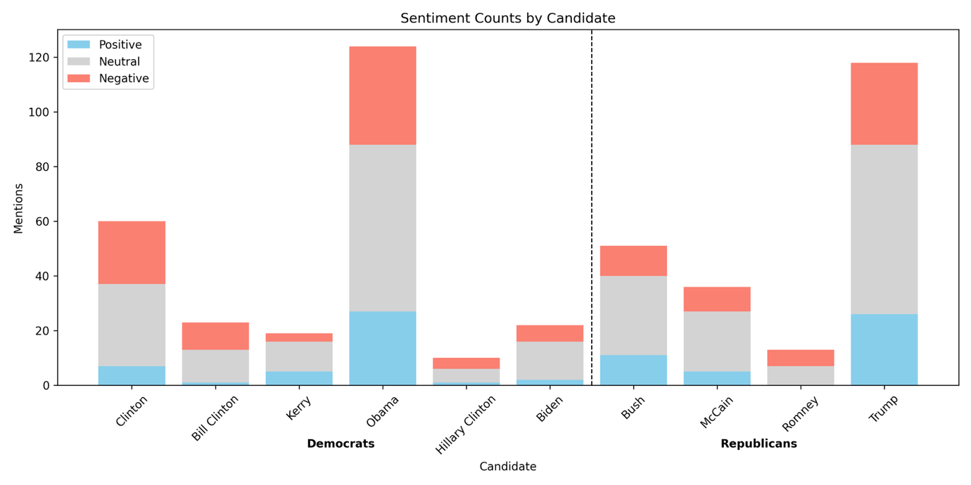

Top Sentence Blocks per Candidate
Label | Candidate | Sentence Block
Negative | Biden | OBAMA, and Joe Biden. Seems evil reports follow Obama from the first. Then President 45, Donald Trump.
Negative | Bush | When their breath departs, they return to the earth; on that very day their plans perish. In the words of one of my colleagues from a blog post this week, Donald Trump and Hilary Clinton are not gods. And I might add that neither is Barack Obama, or the Bushes, or any others.
Negative | Clinton | C. surrounded by officials and President Bill Clinton she declared I feel that the greatest destroyer of peace today is abortion. It is a direct war against the child, a direct killing of an innocent child.
Negative | Bill Clinton | C. surrounded by officials and President Bill Clinton she declared I feel that the greatest destroyer of peace today is abortion. It is a direct war against the child, a direct killing of an innocent child.
Negative | Hillary Clinton | The polls back this up as 71 of seniors say they are stressed and half of all adults are experiencing anxiety during this election season. On the other end of the age spectrum, according to one study, 1 in 4 millennials would rather the earth get hit by a giant meteor strike than have Donald Trump or Hillary Clinton in the White House. Here are some words that describe what many are feeling fear, anger, disgust, distrust, frustration, embarrassment, and hostility.
Negative | Kerry | Our country is divided into red and blue states and black and blue candidates. Both President Bush and Senator Kerry have practiced political polemics and have attacked each other's characters. One political commentator put it this way: Destroying the opposition rather than just winning the election seems to have become the trend in recent campaigns.
Negative | McCain | FinancesWe have a financial system that cannot seem to find its footing. Homes are being foreclosed onRetirement savings have been decimatedJobs are being lost by the thousandsThe Cost of living continues to riseThis is not only in America, but across much of the worldAdministration changeWe are in for a change of administration for sureWe are certain to have a president that scares a lot of people, whether that is John McCain or Barak Obama. Societal changesWe live in a different society that we did 10 years ago.
Negative | Obama | Let's call it for what it is baby killing. And Obama recently signed into law a bill that allowed, not only partial birth abortion but that the baby could be killed if it is alive outside the womb. God says that is an abomination.
Negative | Romney | I thought Romney would win in a landslide. With broken promises, high unemployment, economic woes, deficient sky high and the lies and deception of Libya I didn't think there was any way the majority of American's would vote for Obama. I didn't realize how effective his negative campaigning worked and how unaware, uninformed and uneducated the majority of the American public is.
Negative | Trump | Again a pause, Do you know, he added, I cannot, for the life of me, figure out where. Trump's words expose and express the sadness of the people of this world. All the people in Hollywood, all the people in politics, all the people with their big bank accounts don't have the answer or a clue as to what really gives meaning to life.
Positive | Biden | someone is going to win. Either Biden or Trump. Someone will walk away a winner.
Positive | Bush | B. Following this bold tradition President Bush made the following proclamation concerning thanksgiving on November 21, 2008:Thanksgiving is a time for families and friends to gather together and express gratitude for all that we have been given, the freedoms we enjoy, and the loved ones who enrich our lives. We recognize that all of these blessings, and life itself, come not from the hand of man but from Almighty God.
Positive | Clinton | A good teacher inspires a thirst for learning that lasts a lifetime. Bill Clinton said that on August 5, 1993 during a ceremony honoring inductees into the teacher's Hall of Fame. Henry Brooks Adams said, Teachers affect eternity, they can never know the full range of their influence.
Positive | Bill Clinton | A good teacher inspires a thirst for learning that lasts a lifetime. Bill Clinton said that on August 5, 1993 during a ceremony honoring inductees into the teacher's Hall of Fame. Henry Brooks Adams said, Teachers affect eternity, they can never know the full range of their influence.
Positive | Hillary Clinton | That role is saved for one Our savior. His name isn't Donald Trump or Hillary Clinton. As Christians we believe His name is Jesus.
Positive | Kerry | This filter also operates in a third and very important way. I am indebted to my ministerial colleague, Kerry Robinson, for opening up the final verses of our passage through a sermon I heard him give at Yellow Creek Lake Camp meeting a couple of years ago. He was speaking on this issue of holiness and he pointed out that we often focus on verses 22 and 23 but we forget about verses 25 and 26.
Positive | McCain | Even if we criticize them, we can acknowledge their efforts to serve their country. Senator McCain showed an incredible amount of support which revealed his character during his concession speech. When people started booing that Obama had won, he shut them down and said that response was completely inappropriate.
Positive | Obama | Let's honor the king. Barack Obama is our king. He is our president.
Positive | Romney
Positive | Trump | ILL. - Early in 1989, when Donald Trump's bank account was still bulging, a writer asked Trump the inevitable question about what horizons were left to conquer. Right now, I'm genuinely enjoying myself, Trump replied.

Exactly 1 Candidate Mentioned in Sentence Block:

Candidate Sentiment Ranking
Rank | Name | Party | Total Mentions | Neu % | Pos % | Neg % | Pos - Neg %
1 | Trump | Republican | 83 | 53.01 | 26.51 | 20.48 | 6.03
2 | Bush | Republican | 26 | 65.38 | 19.23 | 15.38 | 3.85
3 | Obama | Democrat | 68 | 47.06 | 27.94 | 25.00 | 2.94
4 | Kerry | Democrat | 10 | 80.00 | 10.00 | 10.00 | 0.00
5 | Biden | Democrat | 8 | 62.50 | 12.50 | 25.00 | -12.50
6 | McCain | Republican | 6 | 50.00 | 16.67 | 33.33 | -16.66
7 | Clinton | Democrat | 35 | 40.00 | 17.14 | 42.86 | -25.72
8 | Hillary Clinton | Democrat | 5 | 60.00 | 0.00 | 40.00 | -40.00
9 | Bill Clinton | Democrat | 18 | 44.44 | 5.56 | 50.00 | -44.44
10 | Romney | Republican | 4 | 50.00 | 0.00 | 50.00 | -50.00

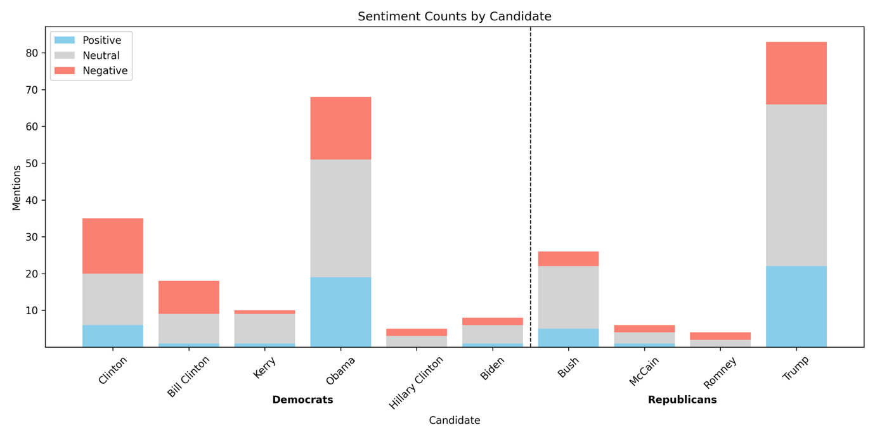

Top Sentence Blocks per Candidate
Label | Candidate | Sentence Block
Negative | Biden | We worry about our freedoms when the political winds change. Will Joe Biden and the Democrats clamp down on Christian freedom and condemn Biblical doctrines as hate speech. Or will we be able to maintain our freedoms to worship.
Negative | Bush | I hear religious scholars say, Islam is a peaceful religion. I heard President Bush recently say, Islam is a godly religion that has been hijacked. I respectfully disagree.
Negative | Clinton | C. surrounded by officials and President Bill Clinton she declared I feel that the greatest destroyer of peace today is abortion. It is a direct war against the child, a direct killing of an innocent child.
Negative | Bill Clinton | C. surrounded by officials and President Bill Clinton she declared I feel that the greatest destroyer of peace today is abortion. It is a direct war against the child, a direct killing of an innocent child.
Negative | Hillary Clinton | 83 a year after taxes. Those opposed to Hillary Clinton will point out that as a First Lady, Senator, and Secretary of State she never accomplished anything. Many accuse her of having an open marriage, allowing her husband the freedom to have affairs.
Negative | Kerry | You'll be congratulated for all your hard work, and you'll probably be given a job in the government somewhere that's your reward, if you want it, for working on the campaign for the winner. But if you were on John Kerry's campaign staff, then election day for you is not a good day. All your work didn't result in what you had hoped.
Negative | McCain | Obviously I couldn't finish it until I knew who won the election. Friends, this message is my effort, and would have been virtually identical had John McCain won the election, to see the hate stop among our citizens but even more among people of faith. I pray that I never see or hear about another situation like Mike and Buddy again.
Negative | Obama | Let's call it for what it is baby killing. And Obama recently signed into law a bill that allowed, not only partial birth abortion but that the baby could be killed if it is alive outside the womb. God says that is an abomination.
Negative | Romney | Conan O'Brien4. Today Mitt Romney visited a firehouse here in New York City. Of course, he was disappointed when he learned that the firehouse is not where you get to fire people.
Negative | Trump | Again a pause, Do you know, he added, I cannot, for the life of me, figure out where. Trump's words expose and express the sadness of the people of this world. All the people in Hollywood, all the people in politics, all the people with their big bank accounts don't have the answer or a clue as to what really gives meaning to life.
Positive | Biden | At one point, the interviewer spoke of how, under the economic proposals of his party, wealthier Americans would pay more taxes. Senator Biden defended the proposal saying, It's time to be patriotic time to jump in, time to be part of the deal, time to help get America out of the rut. Douglas K.
Positive | Bush | B. Following this bold tradition President Bush made the following proclamation concerning thanksgiving on November 21, 2008:Thanksgiving is a time for families and friends to gather together and express gratitude for all that we have been given, the freedoms we enjoy, and the loved ones who enrich our lives. We recognize that all of these blessings, and life itself, come not from the hand of man but from Almighty God.
Positive | Clinton | A good teacher inspires a thirst for learning that lasts a lifetime. Bill Clinton said that on August 5, 1993 during a ceremony honoring inductees into the teacher's Hall of Fame. Henry Brooks Adams said, Teachers affect eternity, they can never know the full range of their influence.
Positive | Bill Clinton | A good teacher inspires a thirst for learning that lasts a lifetime. Bill Clinton said that on August 5, 1993 during a ceremony honoring inductees into the teacher's Hall of Fame. Henry Brooks Adams said, Teachers affect eternity, they can never know the full range of their influence.
Positive | Hillary Clinton
Positive | Kerry | This filter also operates in a third and very important way. I am indebted to my ministerial colleague, Kerry Robinson, for opening up the final verses of our passage through a sermon I heard him give at Yellow Creek Lake Camp meeting a couple of years ago. He was speaking on this issue of holiness and he pointed out that we often focus on verses 22 and 23 but we forget about verses 25 and 26.
Positive | McCain | And ultimately, do what is right and do it with love. John McCain on CourageSource: Fast Company magazine's First Impression newsletter 8-2-06 Copied from Preaching Today Courage is like a muscle, the late US Senator John McCain said. The more we exercise it, the stronger it gets.
Positive | Obama | Let's honor the king. Barack Obama is our king. He is our president.
Positive | Romney
Positive | Trump | ILL. - Early in 1989, when Donald Trump's bank account was still bulging, a writer asked Trump the inevitable question about what horizons were left to conquer. Right now, I'm genuinely enjoying myself, Trump replied.

