Descriptive Statistics – New religious Sermon Dataset

The descriptive statistics below include the two following variables:
- Absolute coverage: The raw number of sermons coming from a certain feature

- Relative Coverage: Represents the percentage of observations in each category relative to the total number of observations across all categories.

- Relative Coverage adjusted: The Adjusted Relative coverage is the proportion of observations in a category, adjusted by that category’s population share. For example, relative coverage for each U.S. state is calculated by dividing the state’s Relative coverage by its proportion of the total U.S. population.

Note: Both the relative coverages are expressed as percentages.

Table of Contents
Descriptive Statistics – New religious Sermon Dataset 1
1 Coverage Variables 3
1.1 Coverage by Year 3
1.2 Coverage by State 4
1.3 Coverage by Denomination of Sermon 5
1.4 Coverage by Religious Family 6
2 Tabulation of Variables 10
2.1 Tabulation of star rating: 10
2.2 Tabulation of Binned Views: 10
2.3 Tabulation of Binned Sermons Contributed: 10
3 Exhibits: 11
3.1 State: Relative Coverage 11
3.2 State: Adjusted Relative Coverage 11
3.3 Election-Related Words 12
3.4 Presidential Election Candidates’ Mentions 17
3.5 RDD-Style Graphs: Sermon Count and View Count 21
4 Pastor-Level Controls 24
4.1 Married0 24
4.2 Children0: 25
4.3 Edu theology0: 32
4.4 Edu theological0: 34
4.5 Edu0: 35
4.6 Denom_index: 37
4.7 Family_index: 38
4.8 Exp bin: 38

Coverage Variables

Coverage by Year

Year | Absolute Coverage | Relative Coverage
2000 | 2470 | 1.488
2001 | 6776 | 4.104
2002 | 8295 | 5.133
2003 | 8084 | 4.953
2004 | 7413 | 4.514
2005 | 8207 | 5.001
2006 | 9043 | 5.572
2007 | 11006 | 6.698
2008 | 9708 | 5.934
2009 | 8392 | 5.117
2010 | 6682 | 4.085
2011 | 7100 | 4.333
2012 | 6381 | 3.879
2013 | 6046 | 3.698
2014 | 6312 | 3.821
2015 | 5447 | 3.293
2016 | 4945 | 2.988
2017 | 4245 | 2.582
2018 | 5252 | 3.176
2019 | 4942 | 2.987
2020 | 4868 | 2.975
2021 | 5574 | 3.383
2022 | 8417 | 5.091
2023 | 5331 | 3.234
2024 | 3197 | 1.954

The highest absolute (and relative) coverage of sermons is from the year 2007, while the lowest percentage of sermons is from the year 2000.

Coverage by State

State | Absolute Coverage | Relative Coverage | Adjusted Relative Coverage (Relative coverage / Percent population in state)
Alabama | 5275 | 3.214 | 2.034
Alaska | 629 | 0.383 | 1.72
Arizona | 4025 | 2.452 | 1.345
Arkansas | 3272 | 1.994 | 2.099
California | 6073 | 3.7 | 0.307
Colorado | 2111 | 1.286 | 0.842
Connecticut | 317 | 0.193 | 0.16
Delaware | 189 | 0.115 | 0.414
Florida | 10161 | 6.191 | 1.09
Georgia | 6904 | 4.205 | 1.446
Hawaii | 164 | 0.1 | 0.232
Idaho | 412 | 0.251 | 0.546
Illinois | 6745 | 4.109 | 0.931
Indiana | 7589 | 4.624 | 2.14
Iowa | 1759 | 1.072 | 1.031
Kansas | 3751 | 2.285 | 2.392
Kentucky | 5144 | 3.134 | 2.182
Louisiana | 4736 | 2.885 | 1.817
Maine | 325 | 0.198 | 0.437
Maryland | 2862 | 1.744 | 0.926
Massachusetts | 1272 | 0.775 | 0.344
Michigan | 4653 | 2.835 | 0.803
Minnesota | 926 | 0.564 | 0.323
Mississippi | 2726 | 1.661 | 1.643
Missouri | 3749 | 2.284 | 1.149
Montana | 49 | 0.03 | 0.093
Nebraska | 211 | 0.129 | 0.211
Nevada | 1109 | 0.676 | 0.952
New Hampshire | 97 | 0.059 | 0.135
New Jersey | 1133 | 0.688 | 0.23
New Mexico | 2471 | 1.505 | 2.329
New York | 3471 | 2.114 | 0.314
North Carolina | 4631 | 2.821 | 0.986
North Dakota | 206 | 0.126 | 0.55
Ohio | 7352 | 4.477 | 1.11
Oklahoma | 6205 | 3.78 | 3.083
Oregon | 1691 | 1.03 | 0.847
Pennsylvania | 5488 | 3.344 | 0.766
Rhode Island | 34 | 0.021 | 0.056
South Carolina | 7306 | 4.451 | 3.122
South Dakota | 745 | 0.453 | 1.69
Tennessee | 7936 | 4.835 | 2.392
Texas | 14746 | 8.984 | 1.213
Utah | 95 | 0.058 | 0.073
Vermont | 39 | 0.024 | 0.11
Virginia | 4670 | 2.845 | 1.131
Washington | 2888 | 1.758 | 0.84
West Virginia | 3093 | 1.884 | 2.933
Wisconsin | 2215 | 1.35 | 0.708
Wyoming | 483 | 0.294 | 1.677

The highest absolute (and relative) coverage of sermons is in the state of Texas, and the lowest absolute coverage of sermons is in Vermont and Rhode Island.
By using US state census data from 2000, the highest adjusted relative coverage of sermons is found to be in Oklahoma, while the lowest adjusted relative coverage is in Rhode Island.

Coverage by Denomination of Sermon
Index | Denomination | Absolute Coverage | Relative Coverage
1 | *Other | 3262 | 1.991
2 | Adventist | 182 | 0.155
3 | Anglican | 486 | 0.296
4 | Apostolic | 646 | 0.445
5 | Assembly Of God | 6911 | 4.395
6 | Baptist | 54723 | 33.607
7 | Bible Church | 803 | 0.49
8 | Brethren | 456 | 0.278
9 | Calvary Chapel | 1974 | 1.205
10 | Catholic | 1867 | 1.186
11 | Charismatic | 1423 | 0.886
12 | Christian Church | 2063 | 1.262
13 | Christian Missionary Alliance | 1280 | 0.78
14 | Christian/Church Of Christ | 17288 | 10.562
15 | Church Of God | 4509 | 2.765
16 | Congregational | 831 | 0.506
17 | Disciples Of Christ | 88 | 0.054
18 | Episcopal | 207 | 0.126
19 | Episcopal/Anglican | 230 | 0.14
20 | Evangelical Free | 1296 | 0.796
21 | Evangelical/Non-Denominational | 18825 | 11.587
22 | Foursquare | 981 | 0.6
23 | Free Methodist | 845 | 0.515
24 | Friends | 285 | 0.174
25 | Grace Brethren | 15 | 0.009
26 | Holiness | 1547 | 0.957
27 | Independent Bible | 6927 | 4.226
28 | Lutheran | 5436 | 3.341
29 | Mennonite | 243 | 0.148
30 | Methodist | 5437 | 3.319
31 | Nazarene | 2896 | 1.764
32 | Orthodox | 577 | 0.352
33 | Pentecostal | 7789 | 5.024
34 | Presbyterian/Reformed | 5253 | 3.266
35 | Salvation Army | 741 | 0.507
36 | Seventh-Day Adventist | 222 | 0.178
37 | United Methodist | 3348 | 2.067
38 | Vineyard | 322 | 0.197
39 | Wesleyan | 1905 | 1.161

The highest absolute and relative coverage of sermons is in the Baptist denomination and the lowest absolute coverage is in the Disciples of Christ denomination.

Coverage by Religious Family

To explore coverage using a broader grouping of religious denominations, a new variable for religious family was created. The table below shows how each denomination (as listed in the table under Section 1.3) is categorized into its corresponding religious family, based on the classification provided by ARDA.

Note: The denominations labelled 'Evangelical/Non-Denominational' and 'Independent Bible' were classified as 'Other groups' because the characteristics of the denominations did not fit into other families.

Denomination | Family (ARDA)
*Other | Other Groups Family
Adventist | Adventist Family
Anglican | Anglican/Episcopal Family
Apostolic | Pentecostal Family
Assembly of God | Pentecostal Family
Baptist | Baptist Family
Bible Church | Pentecostal Family
Brethren | Friends/Brethren Family
Calvary Chapel | Pentecostal Family
Catholic | Catholic Liturgical Family
Charismatic | Pentecostal Family
Christian Church | Restorationists Family
Christian/Church of Christ | Restorationists Family
Christian Missionary Alliance | Holiness Family
Church of God | Pentecostal Family
Congregational | Congregationalists (United Church of Christ) Family
Disciples of Christ | Restorationists Family
Episcopal | Anglican/Episcopal Family
Episcopal/Anglican | Anglican/Episcopal Family
Evangelical Free | Methodist Family
Evangelical/Non-Denominational | Other Groups Family
Foursquare | Pentecostal Family
Free Methodist | Holiness Family
Friends | Friends/Brethren Family
Grace Brethren | Friends/Brethren Family
Holiness | Holiness Family
Independent Bible | Other Groups Family
Lutheran | Lutheran Family
Mennonite | Mennonite/Amish Family
Methodist | Methodist Family
Nazarene | Froehlich Churches Family
Orthodox | Eastern Liturgical (Orthodox) Family
Pentecostal | Pentecostal Family
Presbyterian/Reformed | Presbyterian/Reformed Family
Salvation Army | Holiness Family
Seventh-day Adventist | Adventist Family
United Methodist | Methodist Family
Vineyard | Pentecostal Family
Wesleyan | Holiness Family

The absolute and relative coverages of the religious families can be found below. The Adjusted Relative coverage by family is calculated as the relative coverage divided by the number of adherents per religious family (according to the ARDA 2020 data).
Adherents, according to the definition by the USRC, are defined as the most complete count of individuals affiliated with a congregation, including members, children of members, other attendees who are not members.

Index | Family (ARDA) | Absolute Coverage | Relative Coverage | Adjusted Relative Coverage (Relative coverage / adherents per religious family)
1 | Adventist Family | 404 | 0.246 | 0.082
2 | Anglican/Episcopal Family | 923 | 0.562 | 0.519
3 | Baptist Family | 54724 | 33.341 | 2.017
4 | Catholic Liturgical Family | 1867 | 1.137 | 0.027
5 | Congregationalists (United Church of Christ) Family | 831 | 0.506 | 0.762
6 | Eastern Liturgical (Orthodox) Family | 577 | 0.352 | 0.439
7 | Friends/Brethren Family | 758 | 0.461 | 3.113
8 | Froehlich Churches Family | 2896 | 1.764 | 97.501
9 | Holiness Family | 6323 | 3.849 | 2.384
10 | Lutheran Family | 5436 | 3.312 | 0.86
11 | Mennonite/Amish Family | 243 | 0.148 | 0.358
12 | Methodist Family | 10082 | 6.142 | 0.908
13 | Other Groups Family | 29014 | 17.677 | 1.207
14 | Pentecostal Family | 25363 | 15.45 | 3.837
15 | Presbyterian/Reformed Family | 5253 | 3.2 | 1.899
16 | Restorationists Family | 19439 | 11.843 | 5.382

In terms of absolute coverage and the relative coverage, the highest representation of sermons is in the Baptist Family, while the lowest is in the Mennonite/Amish Family.
Regarding the adjusted relative coverage (based on the number of adherents per family), the Froehlich Churches Family has the highest representation, while the Catholic Liturgical Family has the lowest.

Tabulation of Variables

Tabulation of star rating:
Stars | Freq. | Percent | Cum.
0 | 3 | 0.00 | 0.00
1 | 705 | 0.43 | 0.43
2 | 2305 | 1.40 | 1.84
3 | 84860 | 51.70 | 53.54
4 | 61014 | 37.17 | 90.71
5 | 15246 | 9.29 | 100.00
Total | 164133 | 100.00

Tabulation of Binned Views:
 | Freq. | Percent | Cum.
0-25 | 149855 | 91.30 | 91.30
25-50 | 6229 | 3.80 | 95.10
50-100 | 1858 | 1.13 | 96.23
100-500 | 2216 | 1.35 | 97.58
500-1000 | 3975 | 2.42 | 100.00
Total | 164133 | 100.00

Tabulation of Binned Sermons Contributed:
 | Freq. | Percent | Cum.
0-25 | 22800 | 13.89 | 13.89
25-50 | 14284 | 8.70 | 22.59
50-100 | 18712 | 11.40 | 33.99
100-500 | 62261 | 37.93 | 71.93
500-1514 | 46076 | 28.07 | 100.00
Total | 164133 | 100.00

Exhibits:

State: Relative Coverage

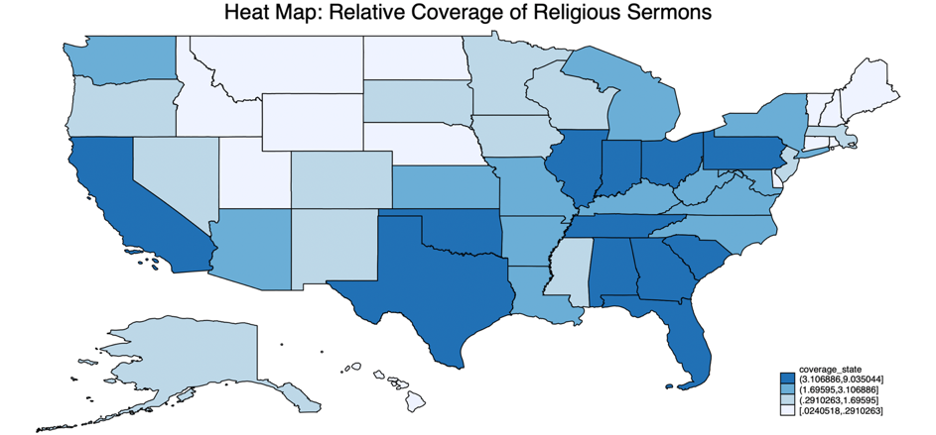

State: Adjusted Relative Coverage

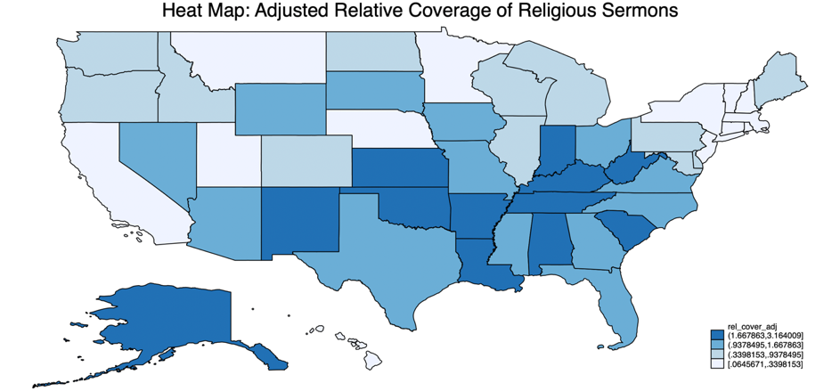

Election Mentions
Two lists of keywords were screened in sermon texts to find mentions of elections: election related keywords and candidate keywords. We also screened for government keywords separately.

The list of election related keywords included:
vote, votes, voted, voting, voter, voters, candidate, candidates, campaign, campaigns, campaigned, campaigning, president, presidents, presidential, administration, senate, senator, senators, congress, congressman, congresswoman, congressmen, congresswomen, politic, politics, politics, political, politically, politician, politicians, elect, elects, elected, electing, election, elections, nominate, nominates, nominated, nominating, nomination, nominations, poll, polls, polling, pollster, ballot, ballots, democratic, republic, democrat, democrats, republican, and republicans.

The list of candidate keywords included:
Bill Clinton, Hillary Clinton, Clinton, George W. Bush, George Bush, President Bush, Mr. Bush, Barack Obama, Obama, Joe Biden, Biden, John McCain, McCain, Mitt Romney, Romney, Donald Trump, Trump, Bernie Sanders, Kamala Harris, and Al Gore.

The list of government keywords included:
office, govern, government, federal, state, states, nation, democracy, policy, policies, law, laws, judicial, court, legislative, legislation, constitution, constitutional, amendment, and amendments.

Election Keywords Graphs

Election Word Counts in All Election Years, 12 Months Before & After Election

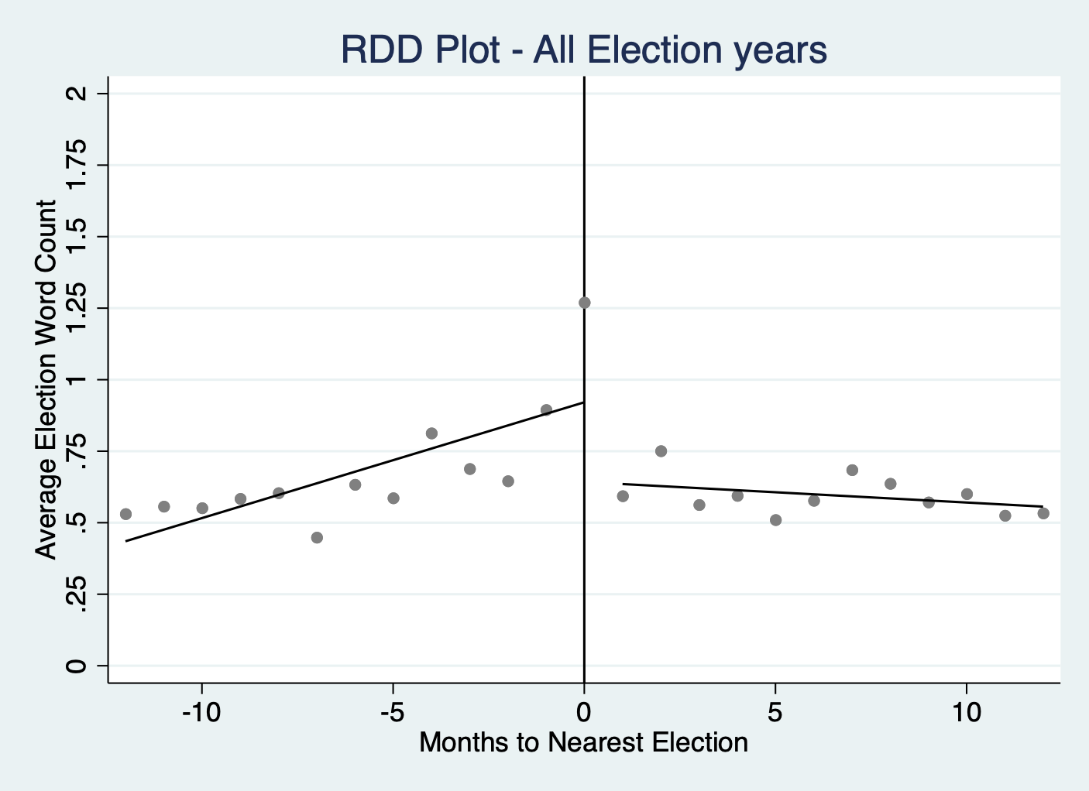

Election Word Counts for Election Years and Non-Election Years, 4 Weeks Before & After Election Tuesday

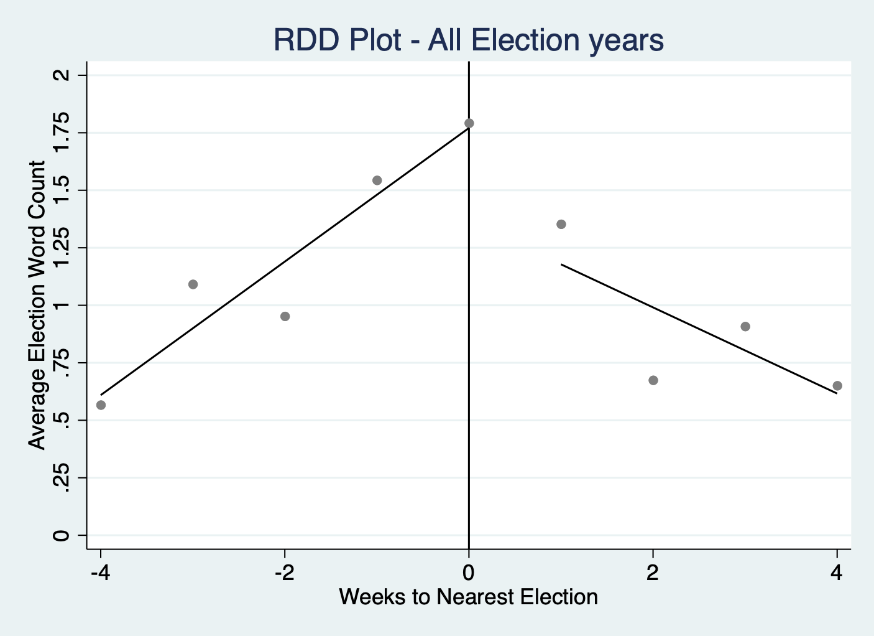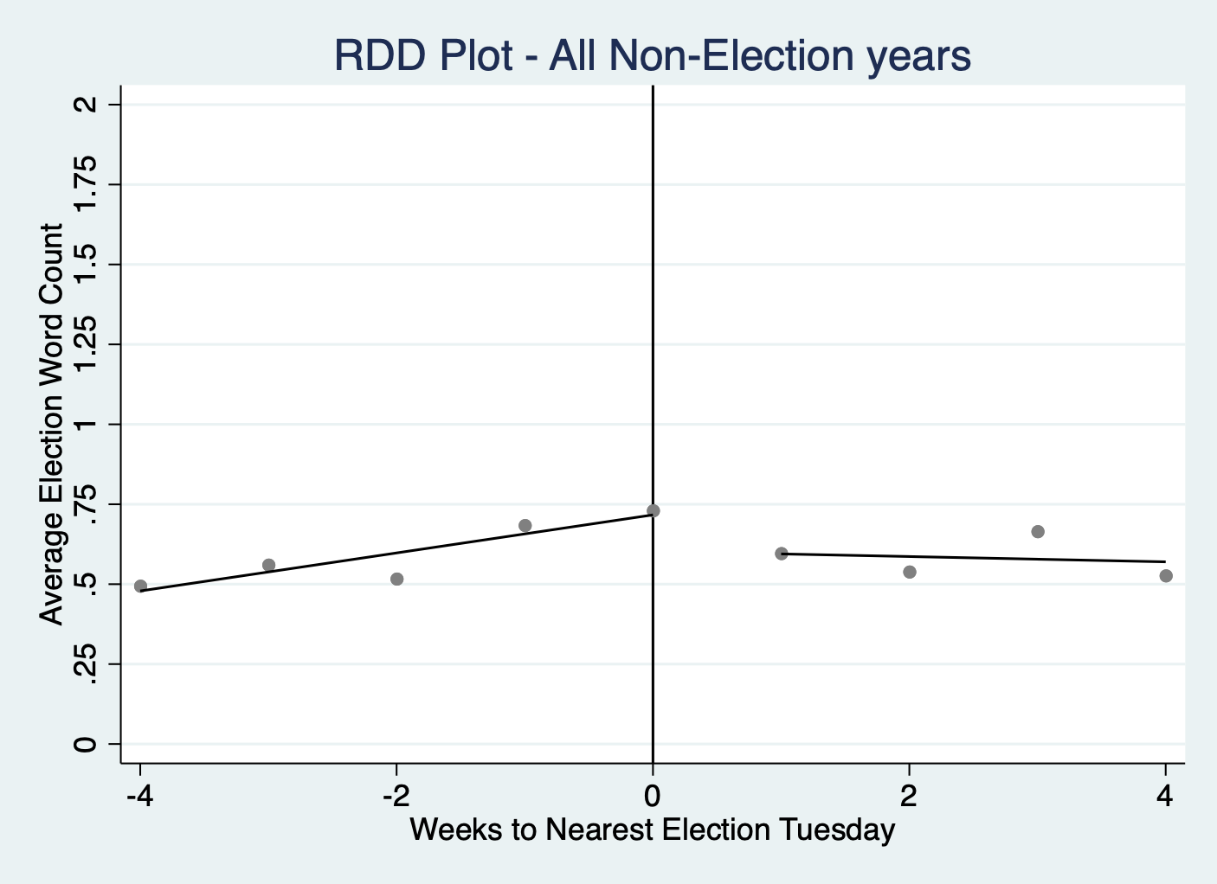

Candidate Keywords Graphs

Candidate Mentions in All Election Years, 12 Months Before & After Election

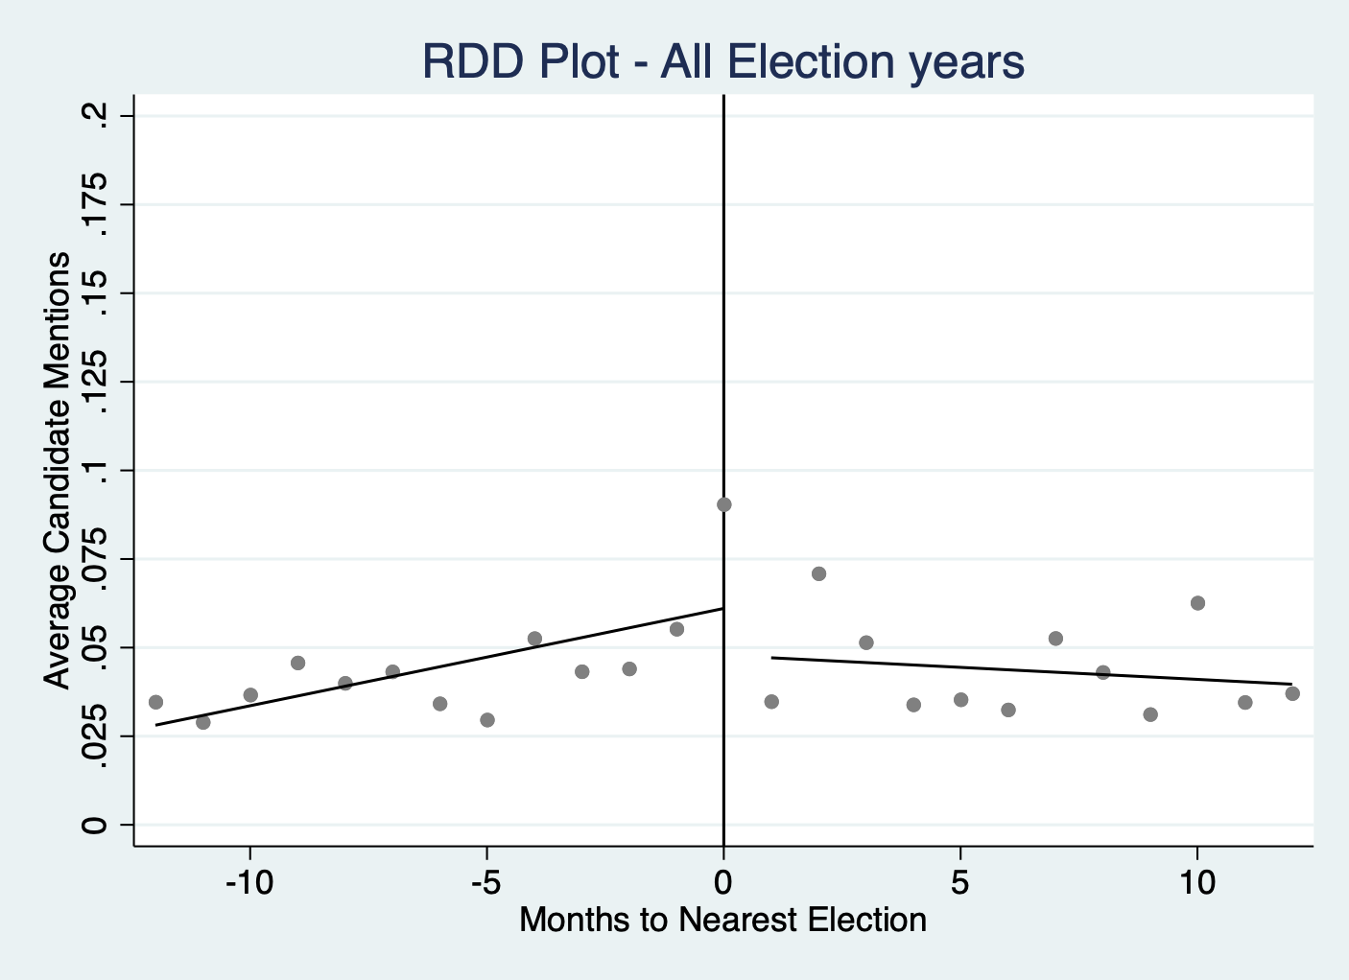

Candidate Mentions for Election Years and Non-Election Years, 4 Weeks Before & After Election Tuesday

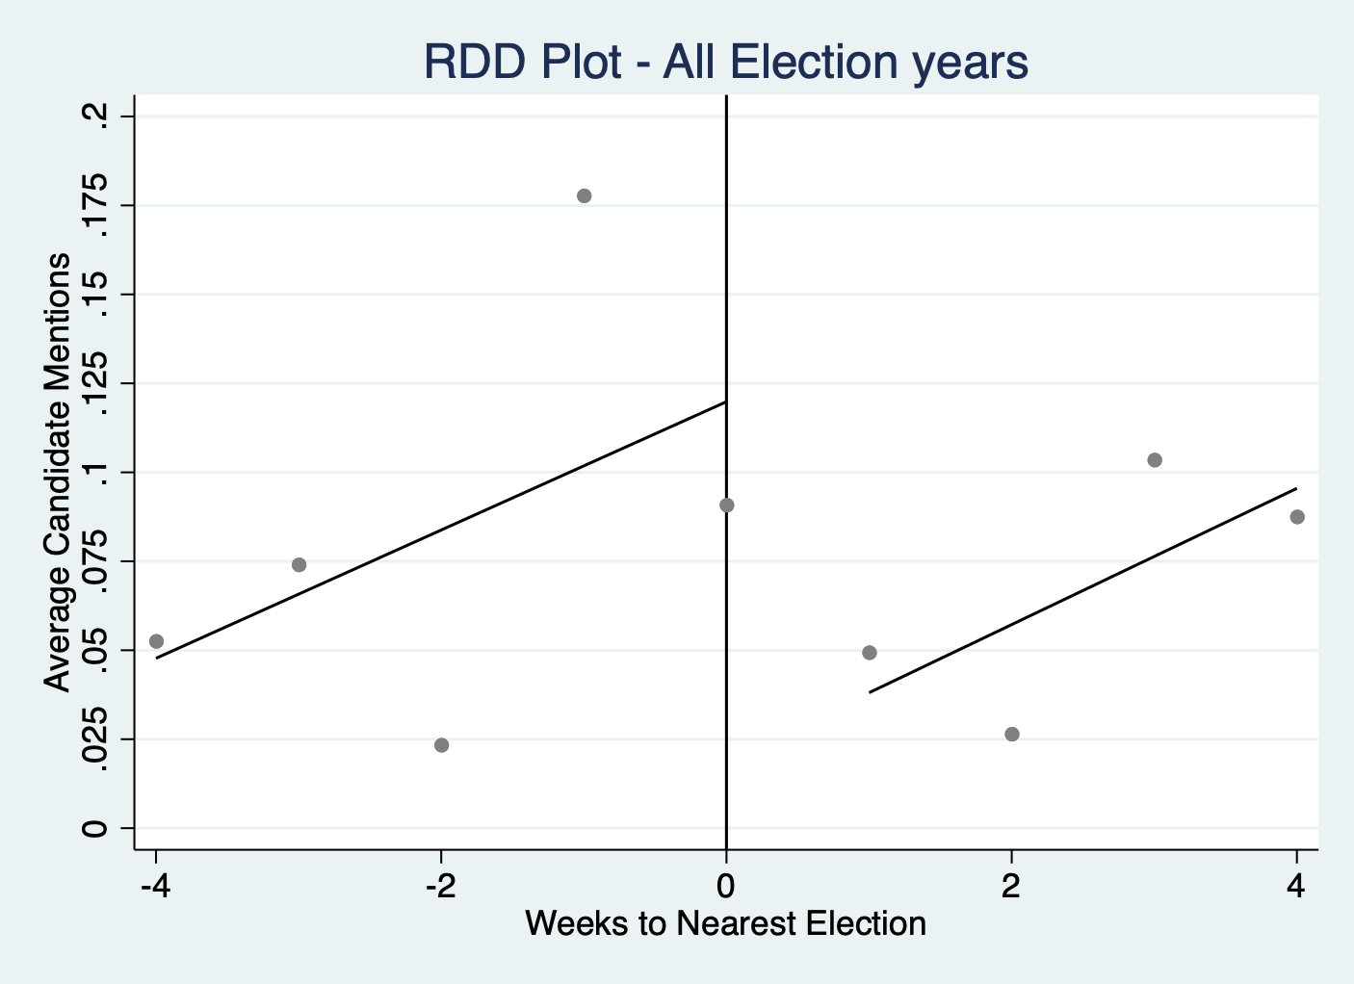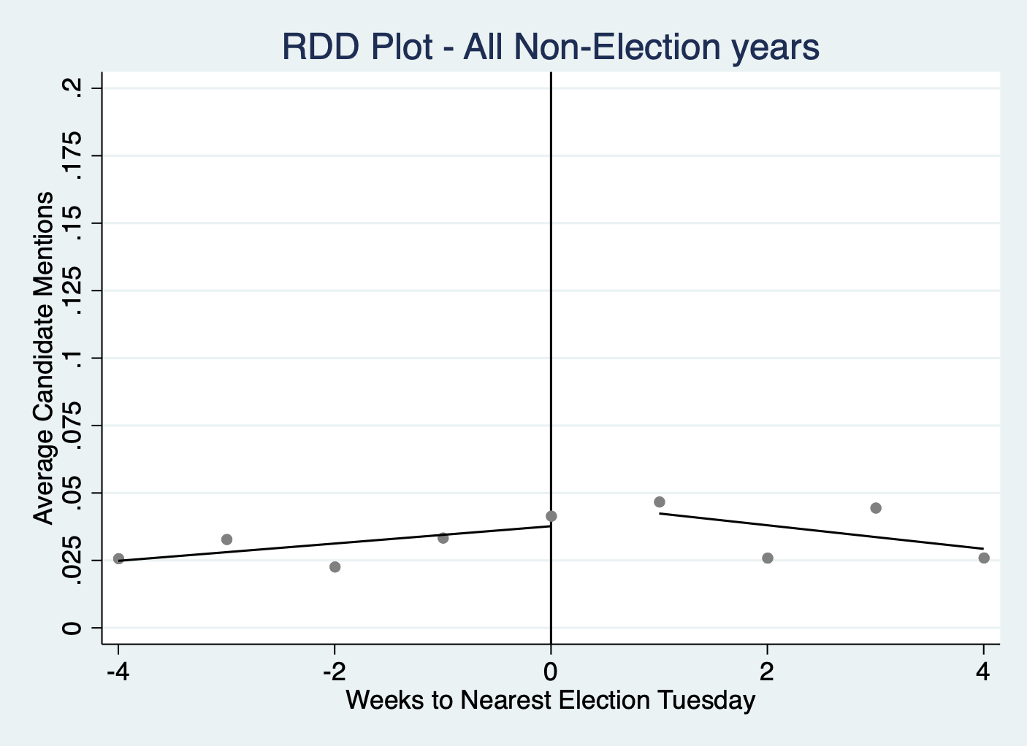

Election Mentions Graphs

Election Mentions in All Election Years, 12 Months Before & After Election

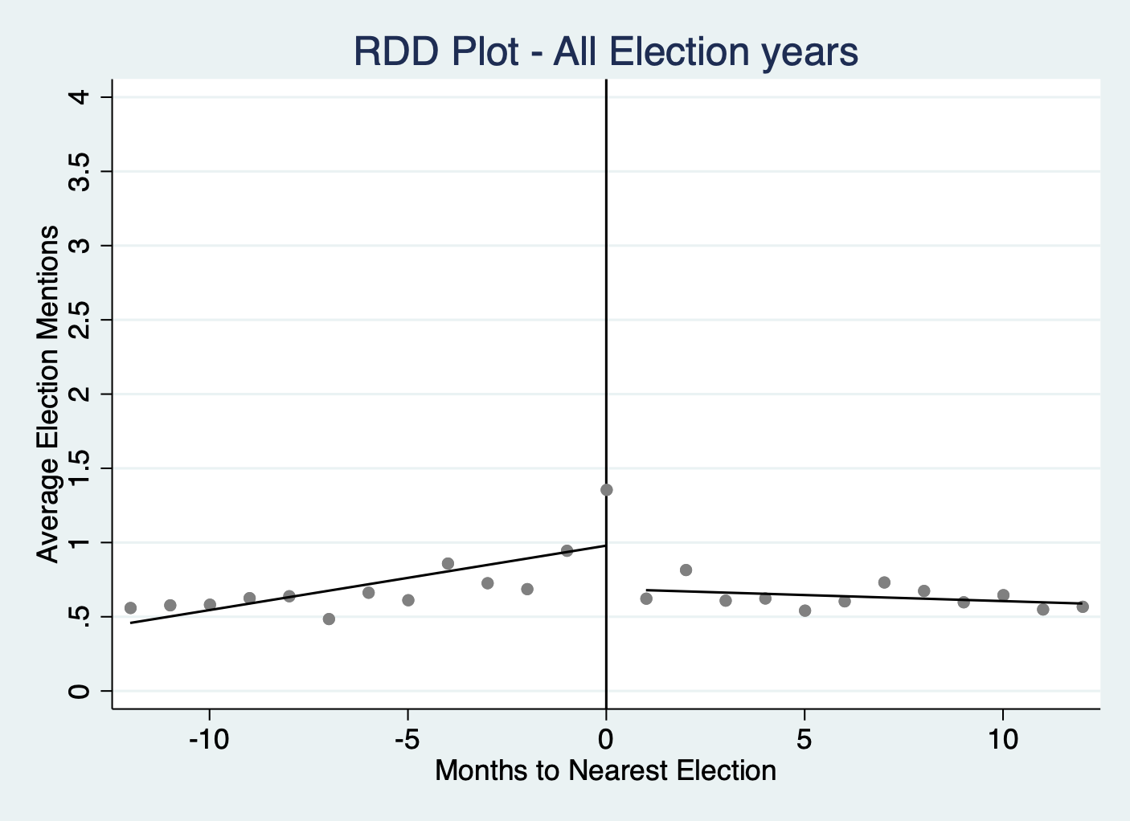

Election Mentions for Election Years and Non-Election Years, 4 Weeks Before & After Election Tuesday

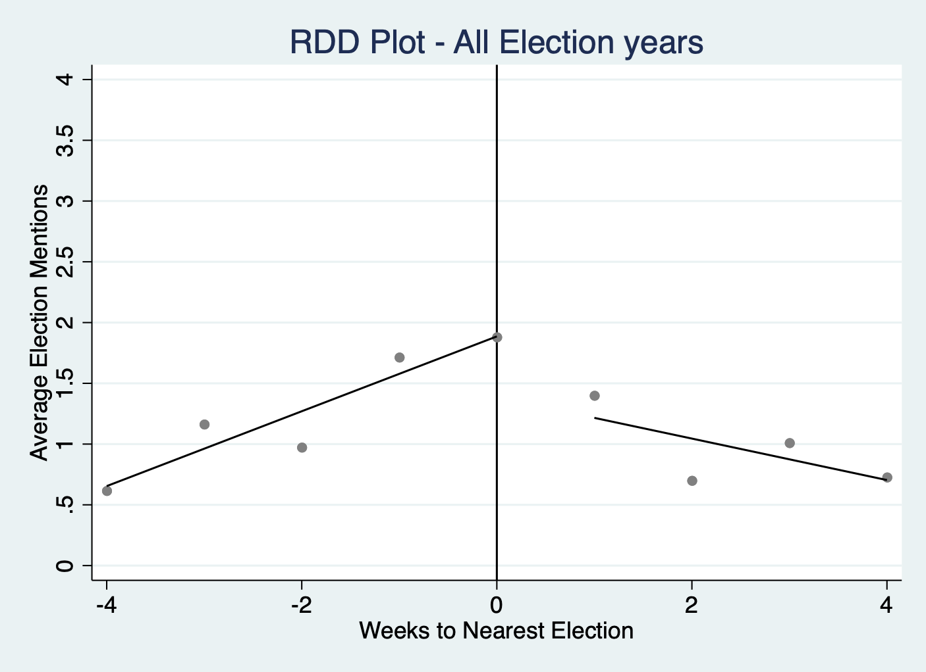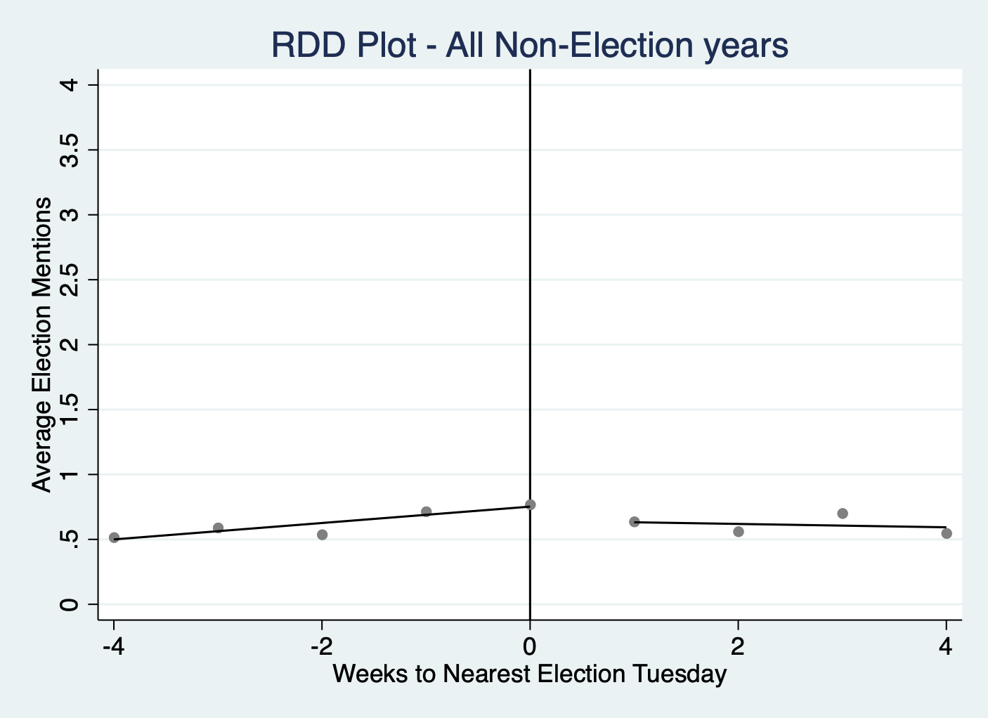

Election Mentions for Each Election Year from 2004 to 2020, 4 Weeks Before & After Election and Election Mentions Over Time

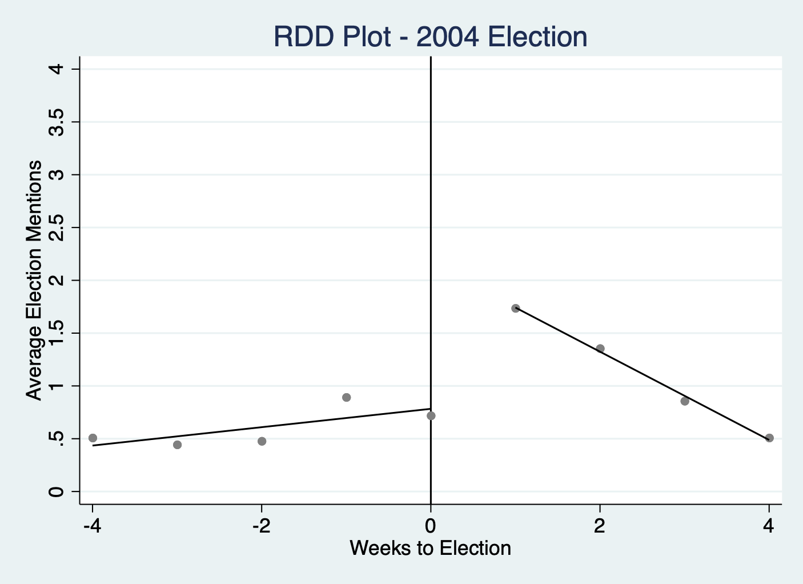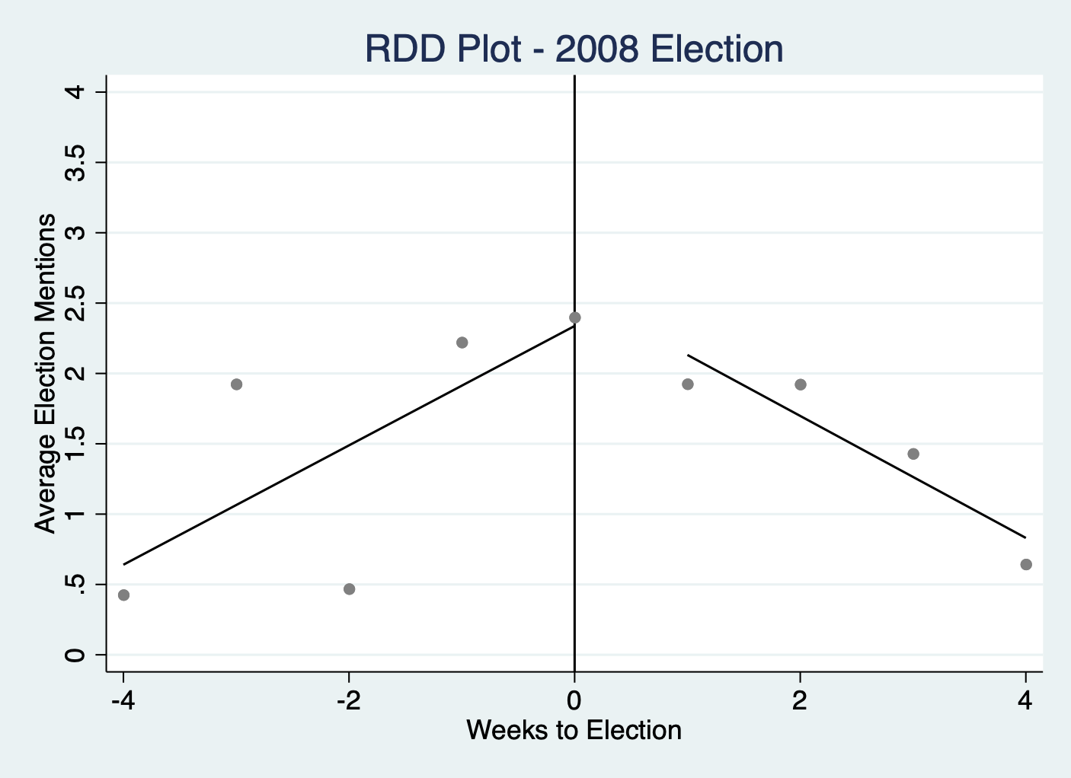

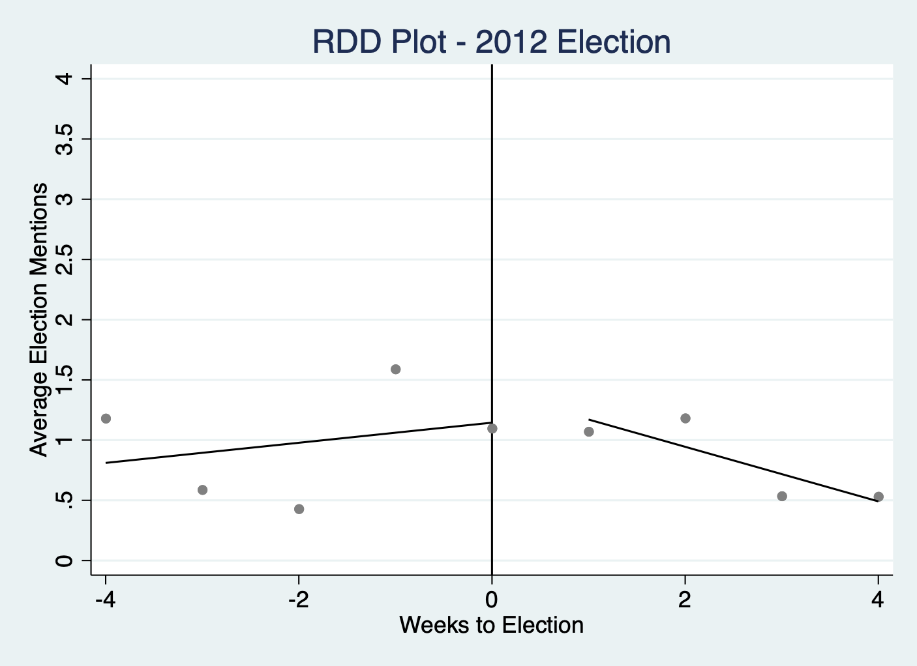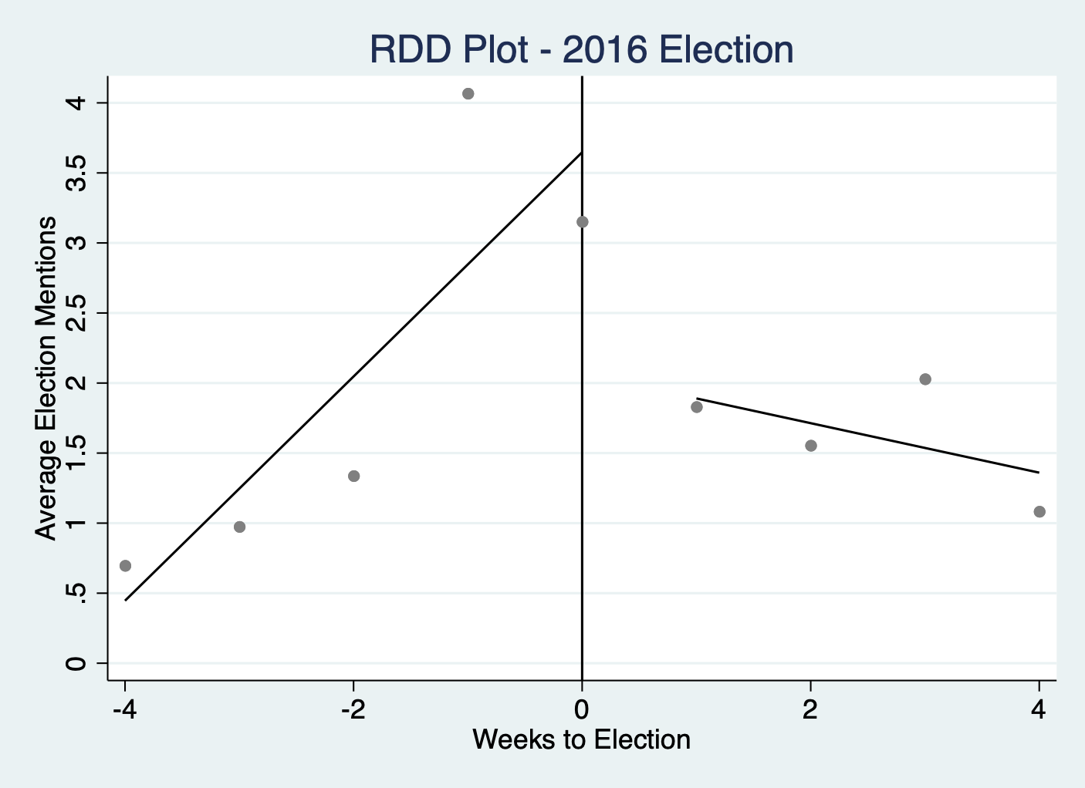

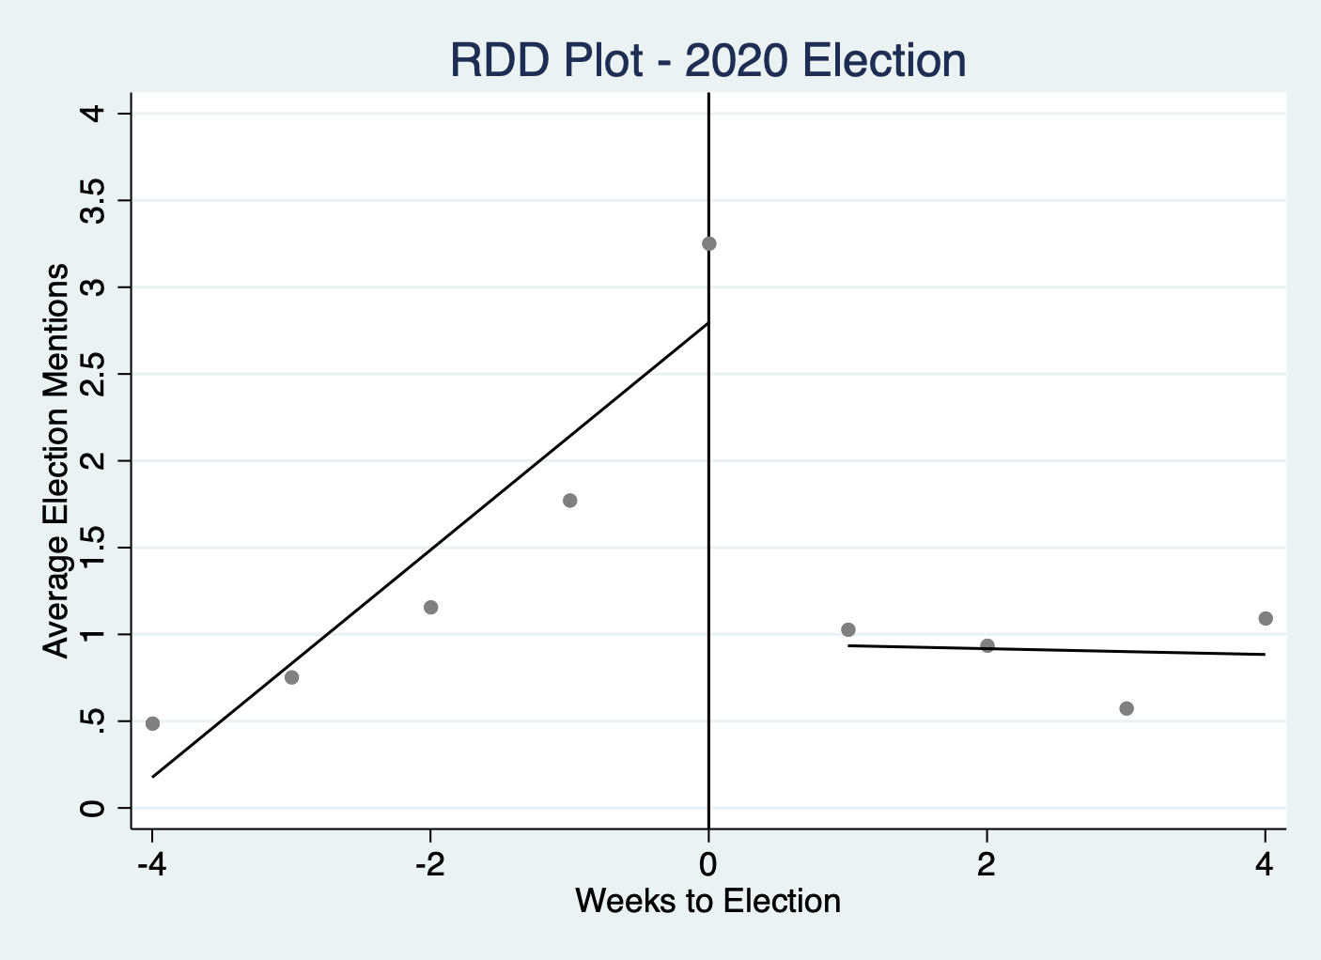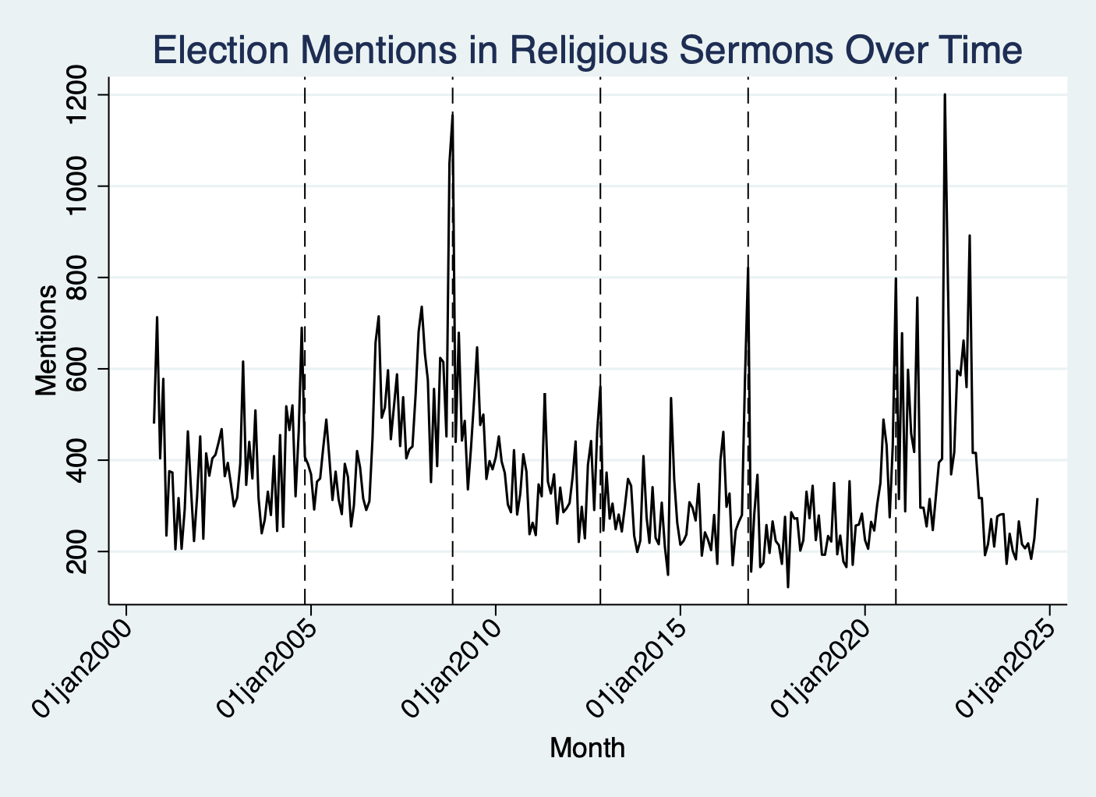

Government Keyword Graphs

Government Word Counts in All Election Years, 12 Months Before & After Election

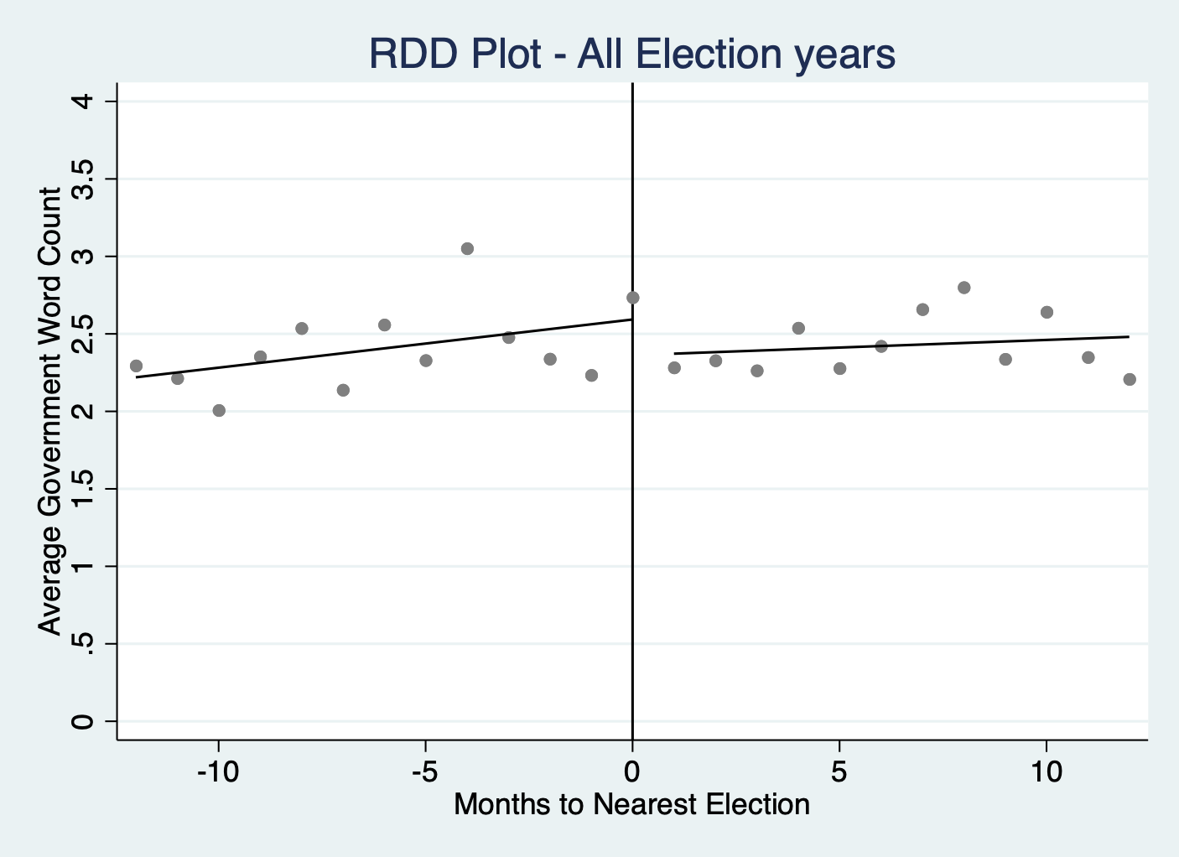

Government Word Counts for Election Years and Non-Election Years, 4 Weeks Before & After Election Tuesday

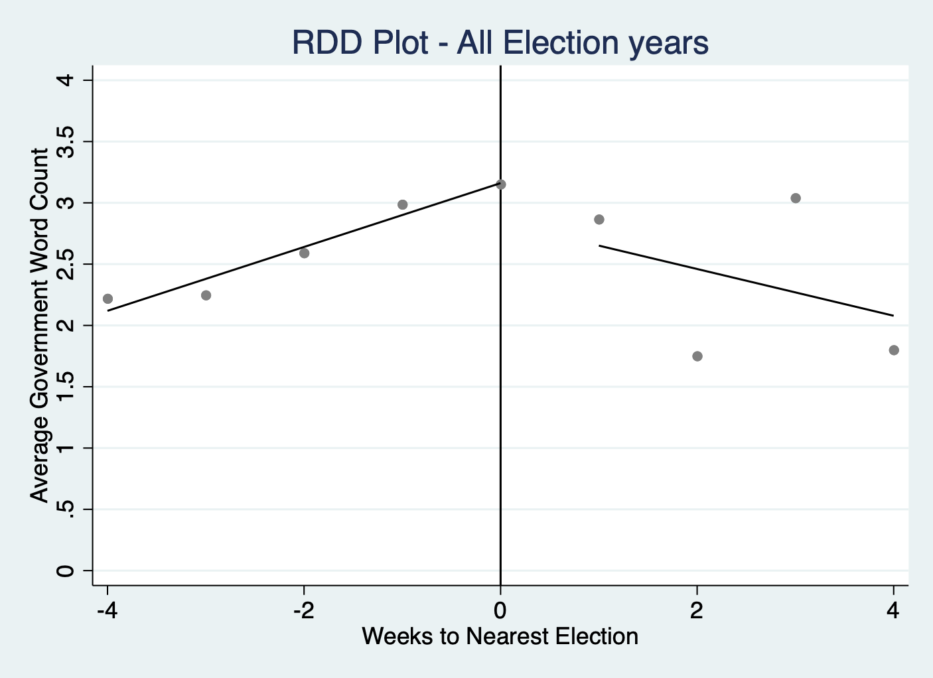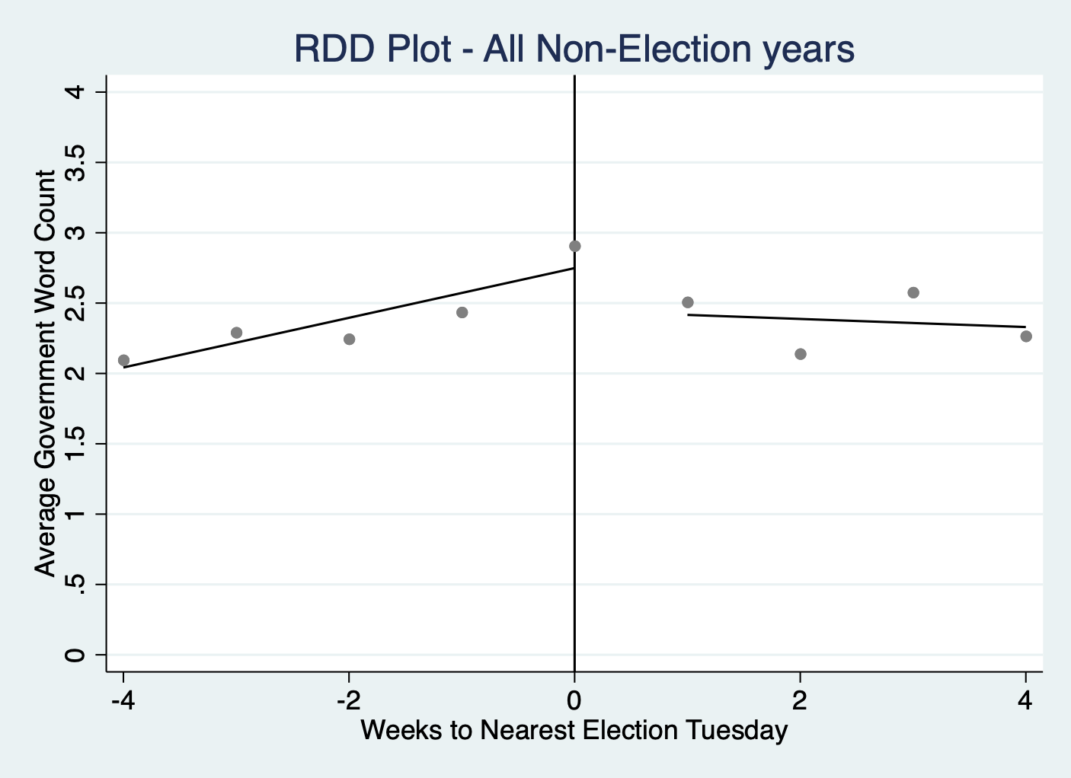

General Graphs

Sermon Counts in All Election Years, 12 Months Before & After Election

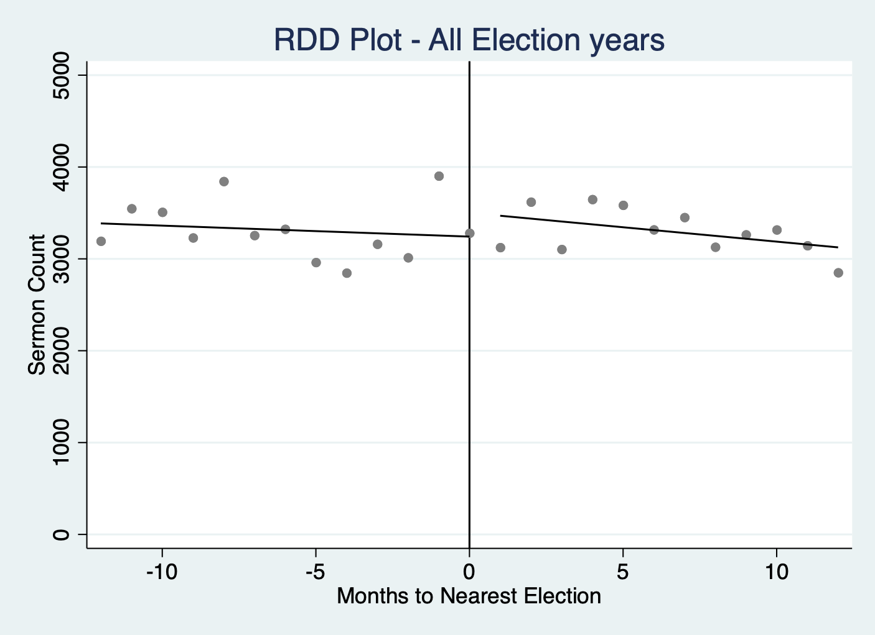

Sermon Counts for Election Years and Non-Election Years, 4 Weeks Before & After Election Tuesday

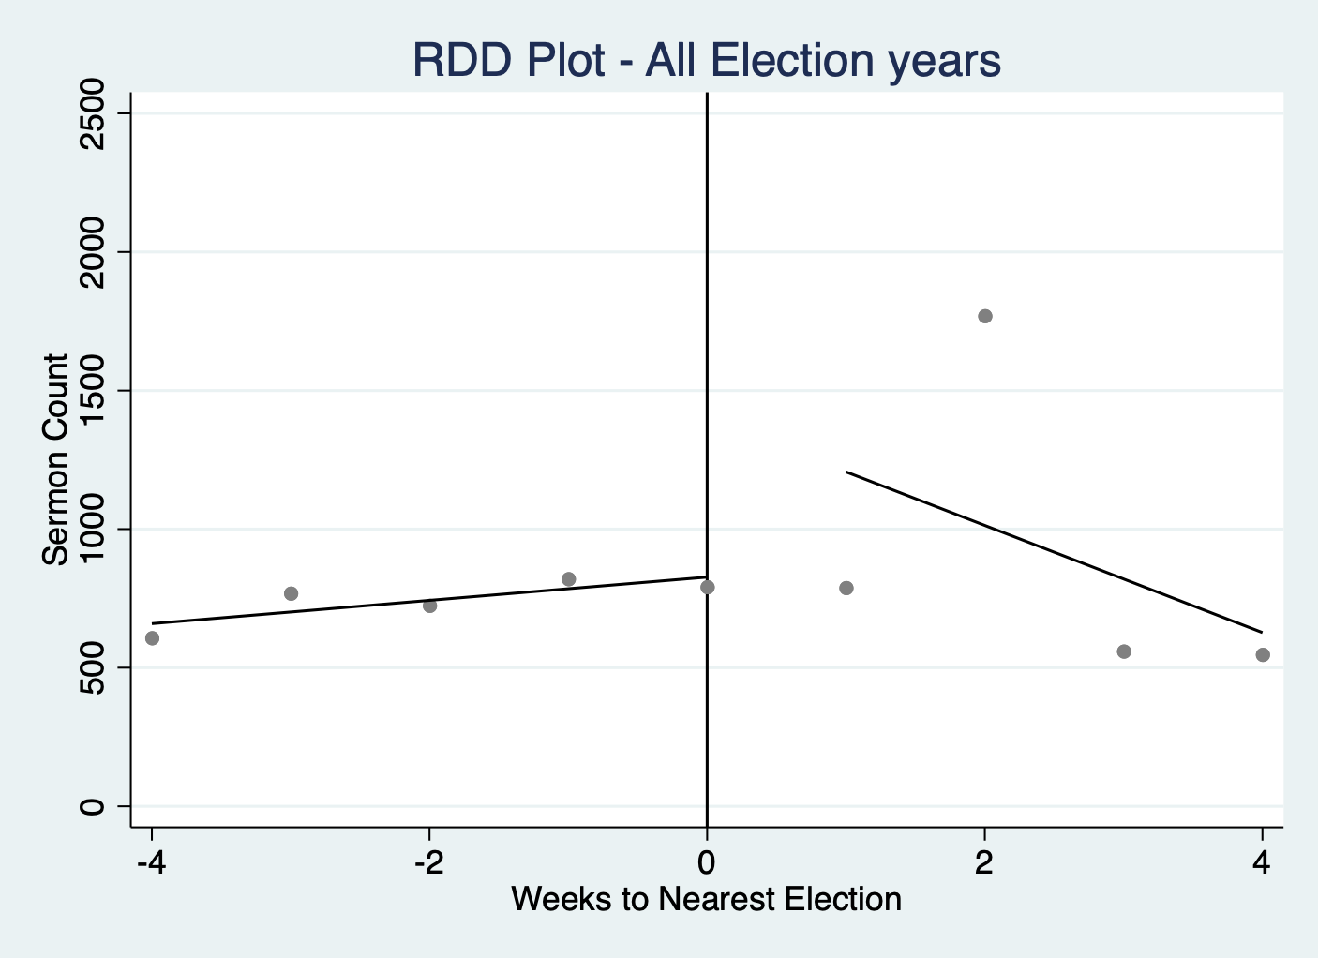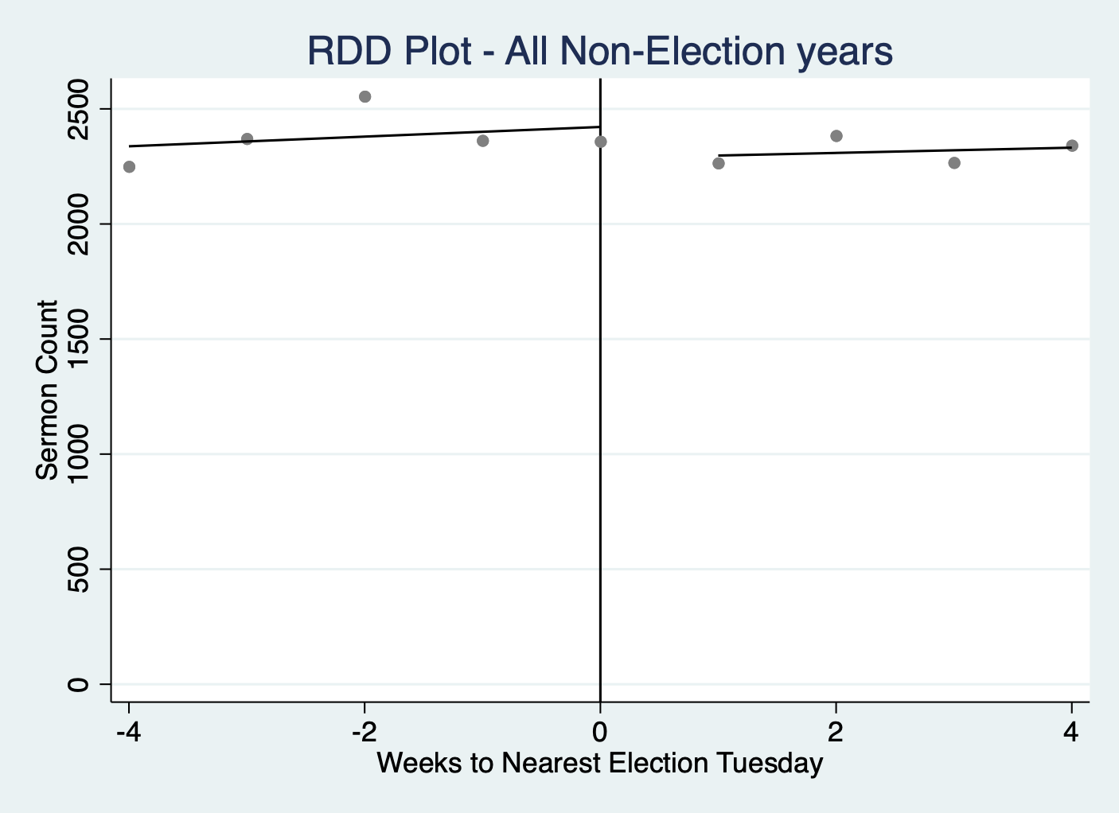

Pastor-Level Controls

Variables | Obs | Mean | Std. Dev. | Min | Max | p1 | p99 | Skew. | Kurt.
married0 | 163056 | 0.487 | 0.5 | 0 | 1 | 0 | 1 | 0.052 | 1.003
married | 83097 | 0.955 | 0.208 | 0 | 1 | 0 | 1 | -4.381 | 20.195
children0 | 140606 | 1.117 | 1.71 | 0 | 9 | 0 | 7 | 1.475 | 4.659
children | 57918 | 2.737 | 1.654 | 0 | 9 | 0 | 8 | 0.562 | 3.858
edu theology0 | 163761 | 0.107 | 0.309 | 0 | 1 | 0 | 1 | 2.541 | 7.455
edu theology | 103345 | 0.167 | 0.373 | 0 | 1 | 0 | 1 | 1.79 | 4.204
edu theological0 | 163761 | 0.283 | 0.451 | 0 | 1 | 0 | 1 | 0.962 | 1.925
edu theological | 103345 | 0.446 | 0.497 | 0 | 1 | 0 | 1 | 0.218 | 1.047
edu0 | 144946 | 1.675 | 1.533 | 0 | 4 | 0 | 4 | 0.069 | 1.41
edu | 84542 | 2.872 | 0.768 | 1 | 4 | 1 | 4 | -0.104 | 2.355
denom index | 164133 | 15.923 | 10.728 | 1 | 39 | 1 | 39 | 0.536 | 1.904
family index | 164133 | 9.547 | 5.178 | 1 | 16 | 3 | 16 | -0.298 | 1.363
exp bin | 8765 | 26.826 | 12.317 | 10 | 60 | 10 | 50 | 0.409 | 2.332
The explanation behind the variables and their construction can be explained below:

Married0
Married0 is a binary (dummy) variable that takes the value 1 if the pastor is married and 0 if the pastor is not married.
To construct this variable, the following steps were followed:

Step 1: Identifying Relevant Text Fields
To determine a pastor’s marital status, text from the following variables was screened:
- 'family'
- 'whatmyspousereallythinksofmyserm'
- 'experience'
Step 2: Keyword Matching
The classification was based on specific keywords found in these text fields:
Indications of being married (assigned 1):
Words searched in sermons: wife, husband, married, spouse, helpmate, marriage, casado
Indications of being unmarried (assigned 0):
Words searched in sermons: widow, widower, girlfriend, I am single

Step 3: Handling Missing Data
Pastors who did not respond to 'whatmyspousereallythinksofmyserm' and ‘family’ were automatically classified as unmarried (coded as 0).

Step 4: Manual Review & Adjustments
Following the automated classification, a manual review was conducted to validate and refine the variable. A random sample of 10 observations from pastors whose marital status remained unclassified (i.e., not coded as 0 or 1) was drawn. These observations were individually examined to assess whether they were correctly left unclassified. Where appropriate, pastors were manually recoded as married (1), unmarried (0), or missing (.). This process involved using the strpos string function to identify relevant keywords in the text fields and ensure more accurate classification. After reviewing the initial 10 observations, the process was repeated iteratively 20 times.

Married: The 'married' variable is the same as the 'married0' variable except that pastors who do not respond to the 'whatmyspousereallythinksofmyserm' variable are treated as missing observations instead of being coded as unmarried (coded as '.').

Step 5: Plotting Married0 and Married against ‘week_to_nearest_election’

Children0:
Children0 is a variable for the number of children a pastor has, ranging from 0 to 9.
To construct this variable, the following steps were followed:

Step 1: Identifying Relevant Text Fields
To determine the number of children a pastor has, information was extracted from the ‘family’ variable.

Step 2: Keyword Matching
The classification was based on specific keywords found in these text fields, by using commonly used phrases to describe number of children to build the variable.

Indication that a pastor has no kids (assigned children = 0):
Words searched in sermons:
- we don’t have children, we don't have any children, i don’t have children, i don't have any children
- no kids, no children
- just me and my wife, just me and my husband, just my wife and me, just my husband and me, it’s just the two of us, just my wife, just my husband, just my parents

Indication that a pastor has one child (assigned children = 1):
Words searched in sermons:
- one child, 1 child, one kid, 1 kid
- one grown child, 1 grown child, one grown kid, 1 grown kid, one adult child, 1 adult child, one adult kid, 1 adult kid, one married child, 1 married child, one married kid, 1 married kid, one beautiful child, 1 beautiful child, one beautiful kid, 1 beautiful kid, one wonderful child, 1 wonderful child, one wonderful kid, 1 wonderful kid, one great child, 1 great child, one great kid, 1 great kid, one terrific kid, 1 terrific kid
- one son, 1 son, one boy, 1 boy, one daughter, 1 daughter, one girl, 1 girl, our only child, first and only child, our one child, our 1 child
- one adult son, 1 adult son, one adult daughter, 1 adult daughter, one married son, 1 married son, one married daughter, 1 married daughter, one grown son, 1 grown son, one grown daughter, 1 grown daughter, one beautiful son, 1 beautiful son, one beautiful daughter, 1 beautiful daughter, one wonderful son, 1 wonderful son, one wonderful daughter, 1 wonderful daughter, one amazing son, 1 amazing son, one amazing daughter, 1 amazing daughter, one great son, 1 great son, one great daughter, 1 great daughter, one terrific son, 1 terrific son, one terrific daughter, 1 terrific daughter
- 1 stepson, one stepson, 1 stepdaughter, one stepdaughter

Indication that a pastor has two children (assigned children = 2):
Words searched in sermons:
- two children, 2 children, two kids, 2 kids
- two grown children, 2 grown children, , two grown kids, 2 grown kids, two adult children, 2 adult children, two adult kids, 2 adult kids, two married children, 2 married children, two married kids, 2 married kids, two beautiful children, 2 beautiful children, two beautiful kids, 2 beautiful kids, two wonderful children, 2 wonderful children, two wonderful kids, 2 wonderful kids, two amazing children, 2 amazing children, two amazing kids, 2 amazing kids, two great children, 2 great children, two great kids, 2 great kids, two terrific children, 2 terrific children, two terrific kids, 2 terrific kids
- two sons, 2 sons, two boys, 2 boys, two daughters, 2 daughters, two girls, 2 girls, one son and one daughter, a son and a daughter, 1 son and 1 daughter, one daughter and one son, a daughter and a son, 1 daughter and 1 son
- two adult sons, 2 adult sons, two adult daughters, 2 adult daughters, two married sons, 2 married sons, two married daughters, 2 married daughters, two grown-up sons, 2 grown-up sons, two grown-up daughters, 2 grown-up daughters, two beautiful sons, 2 beautiful sons, two beautiful daughters, 2 beautiful daughters, two wonderful sons, 2 wonderful sons, two wonderful daughters, 2 wonderful daughters, two amazing sons, 2 amazing sons, two amazing daughters, 2 amazing daughters, two great sons, 2 great sons, two great daughters, 2 great daughters, two terrific sons, 2 terrific sons, two terrific daughters, 2 terrific daughters
- two stepchildren, 2 stepchildren

Indication that a pastor has three children (assigned children = 3):
Words searched in sermons:
- three children, 3 children, three kids, 3 kids
- three grown children, 3 grown children, , three grown kids, 3 grown kids, three adult children, 3 adult children, three adult kids, 3 adult kids, three married children, 3 married children, three married kids, 3 married kids, three beautiful children, 3 beautiful children, three beautiful kids, 3 beautiful kids, three wonderful children, 3 wonderful children, three wonderful kids, 3 wonderful kids, three amazing children, 3 amazing children, three amazing kids, 3 amazing kids, three great children, 3 great children, three great kids, 3 great kids, three terrific children, 3 terrific children, three terrific kids, 3 terrific kids
- three sons, 3 sons, three boys, 3 boys, three daughters, 3 daughters, three girls, 3 girls, one son and two daughters, 1 son and 2 daughters, a son and two daughters, a son and 2 daughters, two sons and one daughter, 2 sons and 1 daughter, two sons and a daughter, 2 sons and a daughter, one daughter and two sons, 1 daughter and 2 sons, a daughter and two sons, a daughter and 2 sons, two daughters and one son, 2 daughters and 1 son, two daughters and a son, 2 daughters and a son
- three adult sons, 3 adult sons, three adult daughters, 3 adult daughters, three married sons, 3 married sons, three married daughters, 3 married daughters, three grown-up sons, 3 grown-up sons, three grown-up daughters, 3 grown-up daughters, three beautiful sons, 3 beautiful sons, three beautiful daughters, 3 beautiful daughters, three wonderful sons, 3 wonderful sons, three wonderful daughters, 3 wonderful daughters, three amazing sons, 3 amazing sons, three amazing daughters, 3 amazing daughters, three great sons, 3 great sons, three great daughters, 3 great daughters, three terrific sons, 3 terrific sons, three terrific daughters, 3 terrific daughters
- three stepchildren, 3 stepchildren

Indication that a pastor has four children (assigned children = 4):
Words searched in sermons:
- four children, 4 children, four kids, 4 kids
- four grown children, 4 grown children, , four grown kids, 4 grown kids, four adult children, 4 adult children, four adult kids, 4 adult kids, four married children, 4 married children, four married kids, 4 married kids, four beautiful children, 4 beautiful children, four beautiful kids, 4 beautiful kids, four wonderful children, 4 wonderful children, four wonderful kids, 4 wonderful kids, four amazing children, 4 amazing children, four amazing kids, 4 amazing kids, four great children, 4 great children, four great kids, 4 great kids, four terrific children, 4 terrific children, four terrific kids, 4 terrific kids
- four sons, 4 sons, four boys, 4 boys, four daughters, 4 daughters, four girls, 4 girls, one son and three daughters, 1 son and 3 daughters, a son and three daughters, a son and 3 daughters, two sons and two daughters, 2 sons and 2 daughters, three sons and one daughter, 3 sons and 1 daughter, three sons and a daughter, 3 sons and a daughter, one daughter and three sons, 1 daughter and 3 sons, a daughter and three sons, a daughter and 3 sons, three daughters and one son, 3 daughters and 1 son, three daughters and one son, three daughters and a son, 3 daughters and a son
- four adult sons, 4 adult sons, four adult daughters, 4 adult daughters, four married sons, 4 married sons, four married daughters, 4 married daughters, four grown-up sons, 4 grown-up sons, four grown-up daughters, 4 grown-up daughters, four beautiful sons, 4 beautiful sons, four beautiful daughters, 4 beautiful daughters, four wonderful sons, 4 wonderful sons, four wonderful daughters, 4 wonderful daughters, four amazing sons, 4 amazing sons, four amazing daughters, 4 amazing daughters, four great sons, 4 great sons, four great daughters, 4 great daughters, four terrific sons, 4 terrific sons, four terrific daughters, 4 terrific daughters
- four stepchildren, 4 stepchildren

Indication that a pastor has five children (assigned children = 5):
Words searched in sermons:
- five children, 5 children, five kids, 5 kids
- five grown children, 5 grown children, , five grown kids, 5 grown kids, five adult children, 5 adult children, five adult kids, 5 adult kids, five married children, 5 married children, five married kids, 5 married kids, five beautiful children, 5 beautiful children, five beautiful kids, 5 beautiful kids, five wonderful children, 5 wonderful children, five wonderful kids, 5 wonderful kids, five amazing children, 5 amazing children, five amazing kids, 5 amazing kids, five great children, 5 great children, five great kids, 5 great kids, five terrific children, 5 terrific children, five terrific kids, 5 terrific kids
- five sons, 5 sons, five boys, 5 boys, five daughters, 5 daughters, five girls, 5 girls
- one son and four daughters, 1 son and 4 daughters, a son and four daughters, a son and 4 daughters, two sons and three daughters, 2 sons and 3 daughters, three sons and two daughters, 3 sons and 2 daughters, four sons and one daughter, 4 sons and 1 daughter, one daughter and four sons, 1 daughter and 4 sons, a daughter and four sons, a daughter and 4 sons, two daughters and three sons, 2 daughters and 3 sons, three daughters and two sons, 3 daughters and 2 sons, four daughters and one son, 4 daughters and 1 son, four daughters and a son, 4 daughters and a son
- five adult sons, 5 adult sons, five adult daughters, 5 adult daughters, five married sons, 5 married sons, five married daughters, 5 married daughters, five grown-up sons, 5 grown-up sons, five grown-up daughters, 5 grown-up daughters, five beautiful sons, 5 beautiful sons, five beautiful daughters, 5 beautiful daughters, five wonderful sons, 5 wonderful sons, five wonderful daughters, 5 wonderful daughters, five amazing sons, 5 amazing sons, five amazing daughters, 5 amazing daughters, five great sons, 5 great sons, five great daughters, 5 great daughters, five terrific sons, 5 terrific sons, five terrific daughters, 5 terrific daughters
- five stepchildren, 5 stepchildren

Indication that a pastor has six children (assigned children = 6):
Words searched in sermons:
- six children, 6 children, six kids, 6 kids
- six grown children, 6 grown children, , six grown kids, 6 grown kids, six adult children, 6 adult children, six adult kids, 6 adult kids, six married children, 6 married children, six married kids, 6 married kids, six beautiful children, 6 beautiful children, six beautiful kids, 6 beautiful kids, six wonderful children, 6 wonderful children, six wonderful kids, 6 wonderful kids, six amazing children, 6 amazing children, six amazing kids, 6 amazing kids, six great children, 6 great children, six great kids, 6 great kids, six terrific children, 6 terrific children, six terrific kids, 6 terrific kids
- six sons, 6 sons, six boys, 6 boys, six daughters, 6 daughters, six girls, 6 girls,
- one son and five daughters, 1 son and 5 daughters, a son and five daughters, a son and 5 daughters, two sons and four daughters, 2 sons and 4 daughters, three sons and three daughters, 3 sons and 3 daughters, four sons and two daughters, 4 sons and 2 daughters, five sons and one daughter, 5 sons and 1 daughter, 5 sons and a daughter, five sons and a daughter, one daughter and five sons, 1 daughter and 5 sons, a daughter and five sons, a daughter and 5 sons, two daughters and four sons, 2 daughters and 4 sons, three daughters and three sons, 3 daughters and 3 sons, four daughters and two sons, 4 daughters and 2 sons, 5 daughters and 1 son, five daughters and one son, five daughters and a son, 5 daughters and a son
- six adult sons, 6 adult sons, six adult daughters, 6 adult daughters, six married sons, 6 married sons, six married daughters, 6 married daughters, six grown-up sons, 6 grown-up sons, six grown-up daughters, 6 grown-up daughters, six beautiful sons, 6 beautiful sons, six beautiful daughters, 6 beautiful daughters, six wonderful sons, 6 wonderful sons, six wonderful daughters, 6 wonderful daughters, six amazing sons, 6 amazing sons, six amazing daughters, 6 amazing daughters, six great sons, 6 great sons, six great daughters, 6 great daughters, six terrific sons, 6 terrific sons, six terrific daughters, 6 terrific daughters
- six step-children, 6 stepchildren

Indication that a pastor has seven children (assigned children = 7):
Words searched in sermons:
- seven children, 7 children, seven kids, 7 kids
- seven grown children, 7 grown children, , seven grown kids, 7 grown kids, seven adult children, 7 adult children, seven married children, 7 married children, seven married kids, 7 married kids, seven adult kids, 7 adult kids, seven beautiful children, 7 beautiful children, seven wonderful children, 7 wonderful children, seven amazing kids, 7 amazing kids, seven great kids, 7 great kids, seven terrific kids, 7 terrific kids,
- seven sons, 7 sons, seven boys, 7 boys, seven daughters, 7 daughters, seven girls, 7 girls
- one son and six daughters, 1 son and 6 daughters, a son and six daughters, a son and 6 daughters, two sons and five daughters, 2 sons and 5 daughters, three sons and four daughters, 3 sons and 4 daughters, four sons and three daughters, 4 sons and 3 daughters, five sons and two daughters, 5 sons and 2 daughters, six sons and one daughter, 6 sons and 1 daughter, six sons and a daughter, 6 sons and a daughter, one daughter and six sons, 1 daughter and 6 sons, a daughter and six sons, a daughter and 6 sons, two daughters and five sons, 2 daughters and 5 sons, three daughters and four sons, 3 daughters and 4 sons, four daughters and three sons, 4 daughters and 3 sons, five daughters and two sons, 5 daughters and 2 sons, six daughters and one son, 6 daughters and 1 son, 6 daughters and a son, six daughters and a son
- seven adult sons, 7 adult sons, seven adult daughters, 7 adult daughters, seven married sons, 7 married sons, seven married daughters, 7 married daughters, seven grown-up sons, 7 grown-up sons, seven grown-up daughters, 7 grown-up daughters, seven beautiful sons, 7 beautiful sons, seven beautiful daughters, 7 beautiful daughters, seven wonderful sons, 7 wonderful sons, seven wonderful daughters, 7 wonderful daughters, seven amazing sons, 7 amazing sons, seven amazing daughters, 7 amazing daughters, seven great sons, 7 great sons, seven great daughters, 7 great daughters, seven terrific sons, 7 terrific sons, seven terrific daughters, 7 terrific daughters
- seven step-children, 7 step-children

Indication that a pastor has eight children (assigned children = 8):
Words searched in sermons:
- eight children, 8 children, eight kids, 8 kids
- eight grown children, 8 grown children, , eight grown kids, 8 grown kids, eight adult children, 8 adult children, eight adult kids, 8 adult kids, eight married children, 8 married children, eight married kids, 8 married kids, eight beautiful children, 8 beautiful children, eight beautiful kids, 8 beautiful kids, eight wonderful children, 8 wonderful children, eight wonderful kids, 8 wonderful kids, eight amazing children, 8 amazing children, eight amazing kids, 8 amazing kids, eight great children, 8 great children, eight great kids, 8 great kids, eight terrific children, 8 terrific children, eight terrific kids, 8 terrific kids
- eight sons, 8 sons, eight boys, 8 boys, eight daughters, 8 daughters, eight girls, 8 girls,
- one son and seven daughters, 1 son and 7 daughters, a son and seven daughters, a son and 7 daughters, two sons and six daughters, 2 sons and 6 daughters, three sons and five daughters, 3 sons and 5 daughters, four sons and four daughters, 4 sons and 4 daughters, five sons and three daughters, 5 sons and 3 daughters, six sons and two daughters, 6 sons and 2 daughters, seven sons and one daughter, 7 sons and 1 daughter, 7 sons and a daughter, seven sons and a daughter, one daughter and seven sons, 1 daughter and 7 sons, a daughter and seven sons, a daughter and 7 sons, , two daughters and six sons, 2 daughters and 6 sons, three daughters and five sons, 3 daughters and 5 sons, four daughters and four sons, 4 daughters and 4 sons, five daughters and three sons, 5 daughters and 3 sons, six daughters and two sons, 6 daughters and 2 sons, seven daughters and one son, 7 daughters and 1 son, 7 daughters and a son, seven daughters and a son
- eight adult sons, 8 adult sons, eight adult daughters, 8 adult daughters, eight married sons, 8 married sons, eight married daughters, 8 married daughters, eight grown-up sons, 8 grown-up sons, eight grown-up daughters, 8 grown-up daughters, eight beautiful sons, 8 beautiful sons, eight beautiful daughters, 8 beautiful daughters, eight wonderful sons, 8 wonderful sons, eight wonderful daughters, 8 wonderful daughters, eight amazing sons, 8 amazing sons, eight amazing daughters, 8 amazing daughters, eight great sons, 8 great sons, eight great daughters, 8 great daughters, eight terrific sons, 8 terrific sons, eight terrific daughters, 8 terrific daughters
- eight step-children, 8 step-children

Indication that a pastor has nine children (assigned children = 9):
Words searched in sermons:
- nine children, 9 children, nine kids, 9 kids
- nine grown children, 9 grown children, , nine grown kids, 9 grown kids, nine adult children, 9 adult children, nine adult kids, 9 adult kids, nine married children, 9 married children, nine married kids, 9 married kids, nine beautiful children, 9 beau-tiful children, nine beautiful kids, 9 beautiful kids, nine wonderful children, 9 won-derful children, nine wonderful kids, 9 wonderful kids, nine amazing children, 9 amazing children, nine amazing kids, 9 amazing kids, nine great children, 9 great children, nine great kids, 9 great kids, nine terrific children, 9 terrific children, nine terrific kids, 9 terrific kids
- nine sons, 9 sons, nine boys, 9 boys, nine daughters, 9 daughters, nine girls, 9 girls
- one son and eight daughters, 1 son and 8 daughters, a son and eight daughters, a son and 8 daughters, two sons and seven daughters, 2 sons and 7 daughters, three sons and six daughters, 3 sons and 6 daughters, four sons and five daughters, 4 sons and 5 daughters, five sons and four daughters, 5 sons and 4 daughters, six sons and three daughters, 6 sons and 3 daughters, seven sons and two daughters, 7 sons and 2 daughters, eight sons and one daughter, 8 sons and 1 daughter, eight sons and a daughter, 8 sons and a daughter, one daughter and eight sons, 1 daughter and 8 sons, a daughter and eight sons, a daughter and 8 sons, two daughters and seven sons, 2 daughters and 7 sons, three daughters and six sons, 3 daughters and 6 sons, four daughters and five sons, 4 daughters and 5 sons, five daughters and four sons, 5 daughters and 4 sons, six daughters and three sons, 6 daughters and 3 sons, seven daughters and two sons, 7 daughters and 2 sons, eight daughters and one son, 8 daughters and one son, eight daughters and a son, 8 daughters and a son.
- nine adult sons, 9 adult sons, nine adult daughters, 9 adult daughters, nine married sons, 9 married sons, nine married daughters, 9 married daughters, nine grown-up sons, 9 grown-up sons, nine grown-up daughters, 9 grown-up daughters, nine beautiful sons, 9 beautiful sons, nine beautiful daughters, 9 beautiful daughters, nine wonderful sons, 9 wonderful sons, nine wonderful daughters, 9 wonderful daughters, nine amazing sons, 9 amazing sons, nine amazing daughters, 9 amazing daughters, nine great sons, 9 great sons, nine great daughters, 9 great daughters, nine terrific sons, 9 terrific sons, nine terrific daughters, 9 terrific daughters
- nine step-children, 9 step-children

Step 3: Handling Missing Data
To ensure accuracy, pastors who did not respond to 'family' were automatically classified as having no children (coded as 0).

Children: The 'children' variable is the same as the 'children0' variable except that pastors who do not respond to the 'family' variable are treated as missing observations instead of being coded as not having a family (coded as '.').

Step 4: Plotting Children0 and Children against ‘week_to_nearest_election’

Edu theology0:
Edu theology0 is a binary (dummy) variable that takes the value 1 if the pastor has a degree in theology, and 0 if the pastor has does not have a degree in theology.
To construct this variable, the following steps were followed:

Step 1: Identifying Relevant Text Fields
To determine whether a pastor pursued a degree in theology, information was extracted from the ‘education’ variable.

Step 2: Keyword Matching
The classification was based on specific keywords found in the text field of ‘education’
Indications of having a degree in theology (assigned 1):
Words searched in sermons: Theology, Th.M, ThD, Master of Theology, MTh, BTh, Th.D
Indications of not having a degree in theology (assigned 0):
All other observations which did not contain the words indicative of a theological degree were coded as 0. This included pastors who studied non-theology courses at theological institute at university.

Step 3: Handling Missing Data
To ensure accuracy, pastors who did not respond to 'education' were automatically classified as having no degree in theology (coded as 0).

Edu theology: The 'edu theology' variable is the same as the 'edu theology0' variable except that pastors who do not respond to the 'education' variable are treated as missing observations instead of being coded as not having a degree in theology(coded as '.').

Step 4: Plotting Edu_theology0 and Edu_theology against ‘week_to_nearest_election’

Edu theological0:
Edu theological0 is a binary (dummy) variable that takes the value 1 if the pastor studied at a theological institution or department, or 0 otherwise.
Note: The variable Edu theological also includes the pastors which pursued a degree in theology (from the variable edu theology)
To construct this variable, the following steps were followed:

Step 1: Identifying Relevant Text Fields
To determine whether a pastor pursued a degree from a theological institute, information was extracted from the ‘education’ variable.
Step 2: Keyword Matching
The classification was based on specific keywords found in the text field of ‘education’
Indications of having a degree at a theological institute (assigned 1):
Words searched in sermons: Theology, Th.M, ThD, Master of Theology, MTh, BTh, Th.D, theological
Indications of not having a degree at a theological institute (assigned 0):
All other observations which did not contain the words indicative of a degree at a theological institute were coded as 0.

Step 3: Handling Missing Data
To ensure accuracy, pastors who did not respond to 'education' were automatically classified as having no degree at a theological institute (coded as 0).
Edu theological: The 'Edu theological' variable is the same as the 'Edu theological0' variable except that pastors who do not respond to the 'education' variable are treated as missing observations instead of being coded as not having a degree from a theological institute (coded as '.').

Step 4: Plotting Edu_theological0 and Edu_theological against ‘week_to_nearest_election’

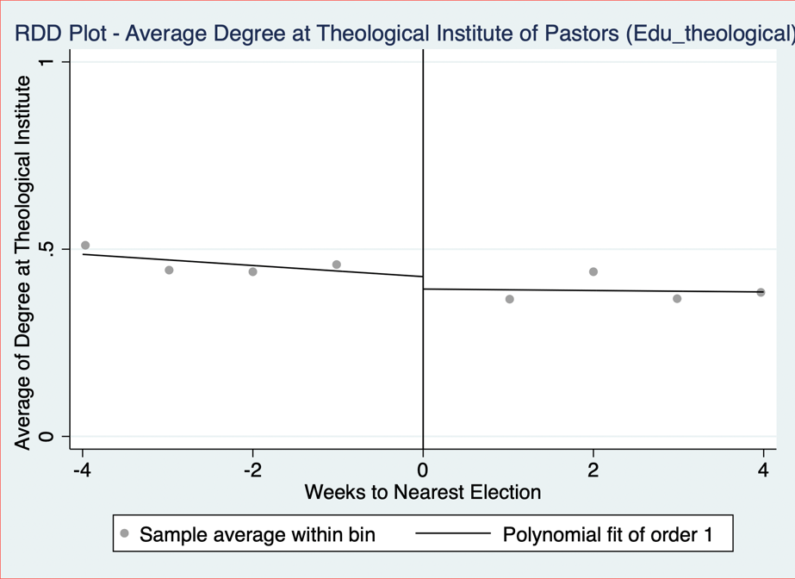

Edu0:
Edu0 is a categorical variable for the level of education a pastor has, where:
- 1 = high school degree
- 2 = bachelor’s degree
- 3 = master’s degree
- 4 = PhD
To construct this variable, the following steps were followed:
Step 1: Identifying Relevant Text Fields
To determine a pastor’s level of education, information was extracted from the ‘education’ variable.
Step 2: Keyword Matching
The classification was based on specific keywords found in the ‘education; text field, by using commonly used phrases to describe education level to build the variable.
Indication that a pastor has a high-school diploma (coded as 1):
Words searched in sermons: High School, HS diploma, school degree, Eagle Academy, Associate of Arts
Indication that a pastor has a bachelor’s degree (coded as 2):
Words searched in sermons: Bachelor, Bachelors, BA, BSC, undergraduate, B.A., Bachelor of Art, BS, B.S., BTh, Business Degree,
Indication that a pastor has a master’s degree (coded as 3):
Words searched in sermons: Masters, Th.M, Master of Theology, MTh, M.Div, Master, MA, MDiv, MOM.Div., M A, MAOM
Indication that a pastor has a PhD (coded as 4):
Words searched in sermons: PhD, Doctorate, Doctor of, Th.D, ThD

Note: Pastors with Associate of Arts degrees were classified as having a high school diploma, even though an AA degree is higher than a high school diploma but lower than a bachelor's degree. This classification was made due to its equivalence to the first or second year of a bachelor's program.

Step 3: Handling Missing Data
To ensure accuracy, pastors who did not respond to 'education' were automatically classified as having no education (coded as 0).

Step 4: Manual Review & Adjustments
Following the automated classification, a manual review was conducted to validate and refine the education variable. A random sample of 10 observations from pastors whose education level remained unclassified (i.e., not yet coded) was drawn. These cases were individually examined to assess whether they were correctly left unclassified. Where appropriate, pastors were manually recoded based on the highest level of education identified. This process involved using the strpos string function to detect relevant educational keywords in the text fields, ensuring more consistent and accurate classification. After reviewing the initial 10 observations, the process was repeated iteratively 20 times.

Edu: The 'edu' variable is the same as the 'edu0' variable except that pastors who do not respond to the 'education' variable are treated as missing observations instead of being coded as not having an education (coded as '.').

Step 5: Plotting Edu0 and Edu against ‘week_to_nearest_election’

Denom_index:
Denom_Index is a numerical variable representing the religious denomination of the pastor. It assigns a numerical index to each denomination, as listed in Section 1.3.

Denominations with High Relative Coverage
To take a closer look at the denomination of Pastors, separate dummy variables were created for the ‘Baptist’, ‘Evangelical/Non-Denominational’, and ‘Christian/Church of Christ’ denominations. All other denominations were grouped together under a binary variable labeled ‘OtherDenom’. Descriptive statistics for these variables are presented below.

Variables | Obs | Mean | Std. Dev. | Min | Max | p1 | p99 | Skew. | Kurt.
Baptist | 164133 | 0.333 | 0.471 | 0 | 1 | 0 | 1 | 0.707 | 1.499
Evangelical | 164133 | 0.115 | 0.319 | 0 | 1 | 0 | 1 | 2.418 | 6.848
ChurchofChrist | 164133 | 0.105 | 0.307 | 0 | 1 | 0 | 1 | 2.571 | 7.612
OtherDenom | 164133 | 0.447 | 0.497 | 0 | 1 | 0 | 1 | 0.215 | 1.046

Checking for Smoothness in High-Relative-Coverage Denominations:
The RDD-style graphs for Baptist, Evangelical/Non-Denominational, and Christian/Church of Christ pastors, as well as pastors from all other denominations, are presented below.

Family_index:
Family_index is a numerical variable representing the religious family of the pastor. It assigns a numerical index to each religious family, as listed in Section ‎1.4. To clarify the distinction between denomination and religious family: denominations were self-reported by pastors and provide a more detailed, granular classification. Religious families, on the other hand, group these denominations into broader categories based on ARDA’s classifications.

Religious Families with High Relative and High Adjusted Relative Coverage
To take a closer look at the religious families of Pastors, separate dummy variables were created for the ‘Baptist’ and ‘Pentecostal’ families which had a high relative coverage and for the ‘Froehlich’ Family which had a High Adjusted Relative Coverage. All other religious families were grouped together under a binary variable labeled ‘OtherFam’. Descriptive statistics for these variables are presented below.

Variables | Obs | Mean | Std. Dev. | Min | Max | p1 | p99 | Skew. | Kurt.
Baptist Family | 164133 | .333 | .471 | 0 | 1 | 0 | 1 | .707 | 1.499
Pentecostal Family | 164133 | .155 | .361 | 0 | 1 | 0 | 1 | 1.912 | 4.654
Froehlich Family | 164133 | .018 | .132 | 0 | 1 | 0 | 1 | 7.328 | 54.694
OtherFam | 164133 | .494 | .5 | 0 | 1 | 0 | 1 | .022 | 1
Checking for Smoothness in High (Adjusted) Relative Coverage Religious Families:
The RDD-style graphs for pastors from Baptist, Pentecostal, and Froehlich religious families, as well as pastors from all other religious families, are presented below.

Exp bin:
Exp bin is a categorical variable for the level of experience of the pastor has, binned into the following categories:
- 10: from 0-10 years of experience
- 20: from 11-20 years of experience
- 30: from 21-30 years of experience
- 40: from 31-40 years of experience
- 50: from 41-50 years of experience
- 60: 51+ years of experience

To construct this variable, the following steps were followed:
Step 1: Identifying Relevant Text Fields
To determine a pastor’s level of experience, information was extracted from the ‘experience’ variable.
Step 2: Manual Review
Since the responses in the experience variable were highly heterogeneous, approximately 19,000 observations of the experience variable were manually coded. This process involved either:
- Directly extracting the number of years of experience provided by the pastor, or
- Applying the following method:
  - Extracting any dates mentioned by the pastor.
  - Comparing these dates to the sermon contribution date to calculate the total years of experience.
  - Assigning the corresponding experience bin based on the calculated number of years.

Step 3: Using ChatGPT API to classify Exp Bin:
To classify the exp_bin variable for all observations, the ChatGPT API was used to categorize all the sermons based on 400 manually coded observations. The process followed these steps:
- Reference Set Creation:
  - A sample of 400 manually coded observations was extracted to serve as reference examples.
  - These examples demonstrated how pastors’ descriptions were mapped to experience bins.
- Prompt Design:
  - The system prompt included:
  - The reference examples for pattern recognition.
  - Rules for assigning experience bins based on mentioned years or inferred tenure. If pastors mention retirement from the military, GPT was instructed to add 20 years on top of their years of experience.
  - If experience was missing or unclear, GPT was instructed to return a placeholder (".") rather than forcing a classification.
- Processing with GPT:
  - For each pastor, a structured input was created with:
    - The unique id of the pastor
    - Their experience field.
    - Their latest sermon contribution date (to infer years of experience).
  - The GPT model was queried with this information.
  - The returned classifications were saved and merged with the main dataset.

Step 4: Plotting Exp_Bin against ‘week_to_nearest_election’

Note of Discretion regarding Experience Coding:
The classification of pastoral experience is based on self-reported information, which introduces several limitations. Some pastors reported overlapping church and non-church roles separately (e.g., serving part-time as a pastor while working another job), which may inflate their total years of pastoral service. In contrast, others focused solely on church-related roles and omitted relevant non-church experience, making comparisons across individuals more difficult. For retired military veterans, 20 years were added to their church-related experience to account for military service; however, actual lengths of service may differ from this standardized adjustment.

Sentiment Analysis

Two sentiment models were used to analyse sermon text sentences mentioning presidential candidates. The sentences before and after were considered when classifying each mention to give more context to the sentiment of the statement – we refer to such a collection of sentences as a sentence block. The analysis was run on two datasets: one that contained sentence blocks that mention at least one candidate, and another that contained only sentence blocks that mention exactly one candidate. For sentence blocks that mention exactly one candidate, the analysis for Bill Clinton and Hillary Clinton captures only sentence blocks that contain “Bill Clinton” and “Hillary Clinton”, respectively, without discarding if the other is also mentioned. The analysis for Clinton captures sentence blocks that contain any of “Bill Clinton”, “Hillary Clinton”, or “Clinton” and can be thought of as the Clinton family. 240 of the 337 captured sentence blocks mention exactly one candidate.

Positive/Negative Sentiment Analysis:

The first model, distilbert-base-uncased-finetuned-sst-2-english, classified sentiment as positive or negative. The candidates were then ranked by their difference in percent of mentions labelled positive and percent of mentions labelled negative. The following outputs were produced.

At Least 1 Candidate Mentioned in Sentence Block:

Candidate Sentiment Ranking
Rank | Name | Party | Total Mentions | Pos % | Neg % | Pos - Neg %
1 | Kerry | Democrat | 6 | 66.67 | 33.33 | 33.34
2 | Trump | Republican | 148 | 51.35 | 48.65 | 2.7
3 | Obama | Democrat | 124 | 48.39 | 51.61 | -3.22
4 | Hillary Clinton | Democrat | 19 | 47.37 | 52.63 | -5.26
5 | Bill Clinton | Democrat | 30 | 43.33 | 56.67 | -13.34
6 | McCain | Republican | 37 | 43.24 | 56.76 | -13.52
7 | Bush | Republican | 56 | 42.86 | 57.14 | -14.28
8 | Clinton | Democrat | 78 | 41.03 | 58.97 | -17.94
9 | Romney | Republican | 14 | 28.57 | 71.43 | -42.86
10 | Biden | Democrat | 31 | 25.81 | 74.19 | -48.38

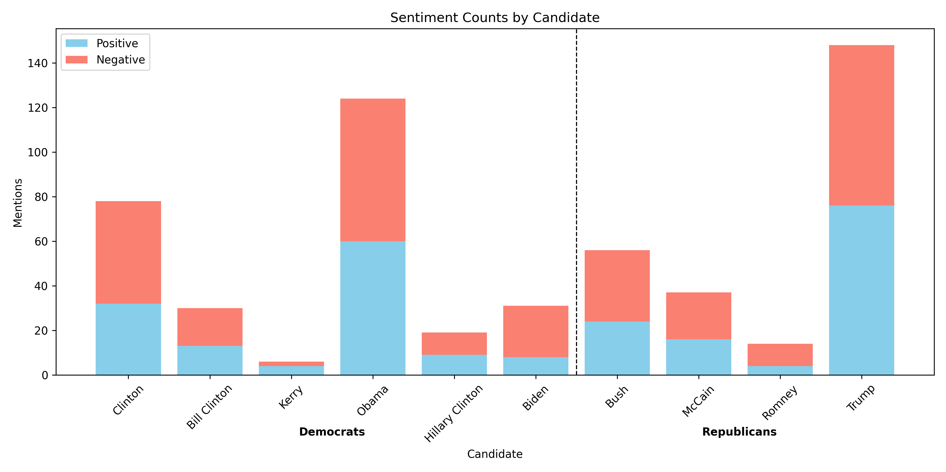

Exactly 1 Candidate Mentioned in Sentence Block:

Candidate Sentiment Ranking
Rank | Name | Party | Total Mentions | Pos % | Neg % | Pos - Neg %
1 | Kerry | Democrat | 6 | 66.67 | 33.33 | 33.34
2 | Trump | Republican | 101 | 58.42 | 41.58 | 16.84
3 | Obama | Democrat | 68 | 52.94 | 47.06 | 5.88
4 | Bush | Democrat | 38 | 52.63 | 47.37 | 5.26
5 | Bill Clinton | Republican | 22 | 50.0 | 50.0 | 0.0
6 | Clinton | Democrat | 47 | 44.68 | 55.32 | -10.64
7 | McCain | Republican | 8 | 37.5 | 62.5 | -25.0
8 | Romney | Republican | 4 | 25.0 | 75.0 | -50.0
9 | Hillary Clinton | Democrat | 6 | 16.67 | 83.33 | -66.66
10 | Biden | Democrat | 8 | 12.5 | 87.5 | -75.0

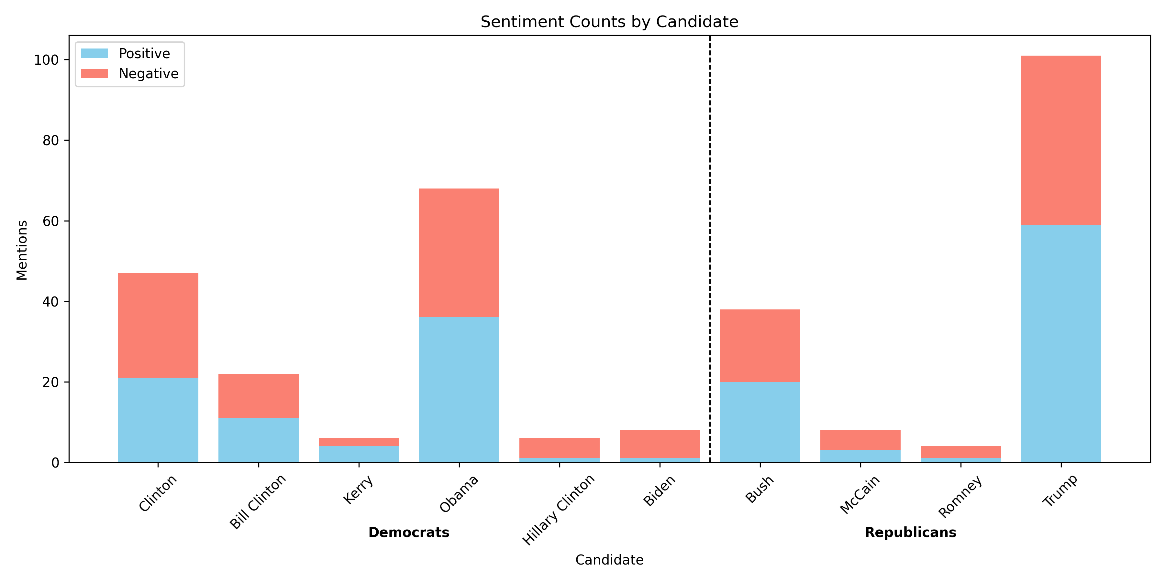

Positive/Neutral/Negative Sentiment Analysis:

The second model, finiteautomata/bertweet-base-sentiment-analysis, classified sentiment as positive, neutral, or negative. The candidates were then ranked by their difference in percent of mentions labelled positive and percent of mentions labelled negative. The following outputs were produced.

At Least 1 Candidate Mentioned in Sentence Block:

Candidate Sentiment Ranking
Rank | Name | Party | Total Mentions | Neu % | Pos % | Neg % | Pos - Neg %
1 | Kerry | Democrat | 6 | 33.33 | 50.0 | 16.67 | 33.33
2 | Bush | Republican | 56 | 53.57 | 25.0 | 21.43 | 3.57
3 | Trump | Republican | 148 | 53.38 | 22.3 | 24.32 | -2.02
4 | Obama | Democrat | 124 | 46.77 | 24.19 | 29.03 | -4.84
5 | McCain | Republican | 37 | 62.16 | 13.51 | 24.32 | -10.81
6 | Biden | Democrat | 31 | 61.29 | 9.68 | 29.03 | -19.35
7 | Hillary Clinton | Democrat | 19 | 57.89 | 10.53 | 31.58 | -21.05
8 | Clinton | Democrat | 78 | 50.0 | 12.82 | 37.18 | -24.36
9 | Romney | Republican | 14 | 42.86 | 14.29 | 42.86 | -28.57
10 | Bill Clinton | Democrat | 30 | 43.33 | 3.33 | 53.33 | -50.0

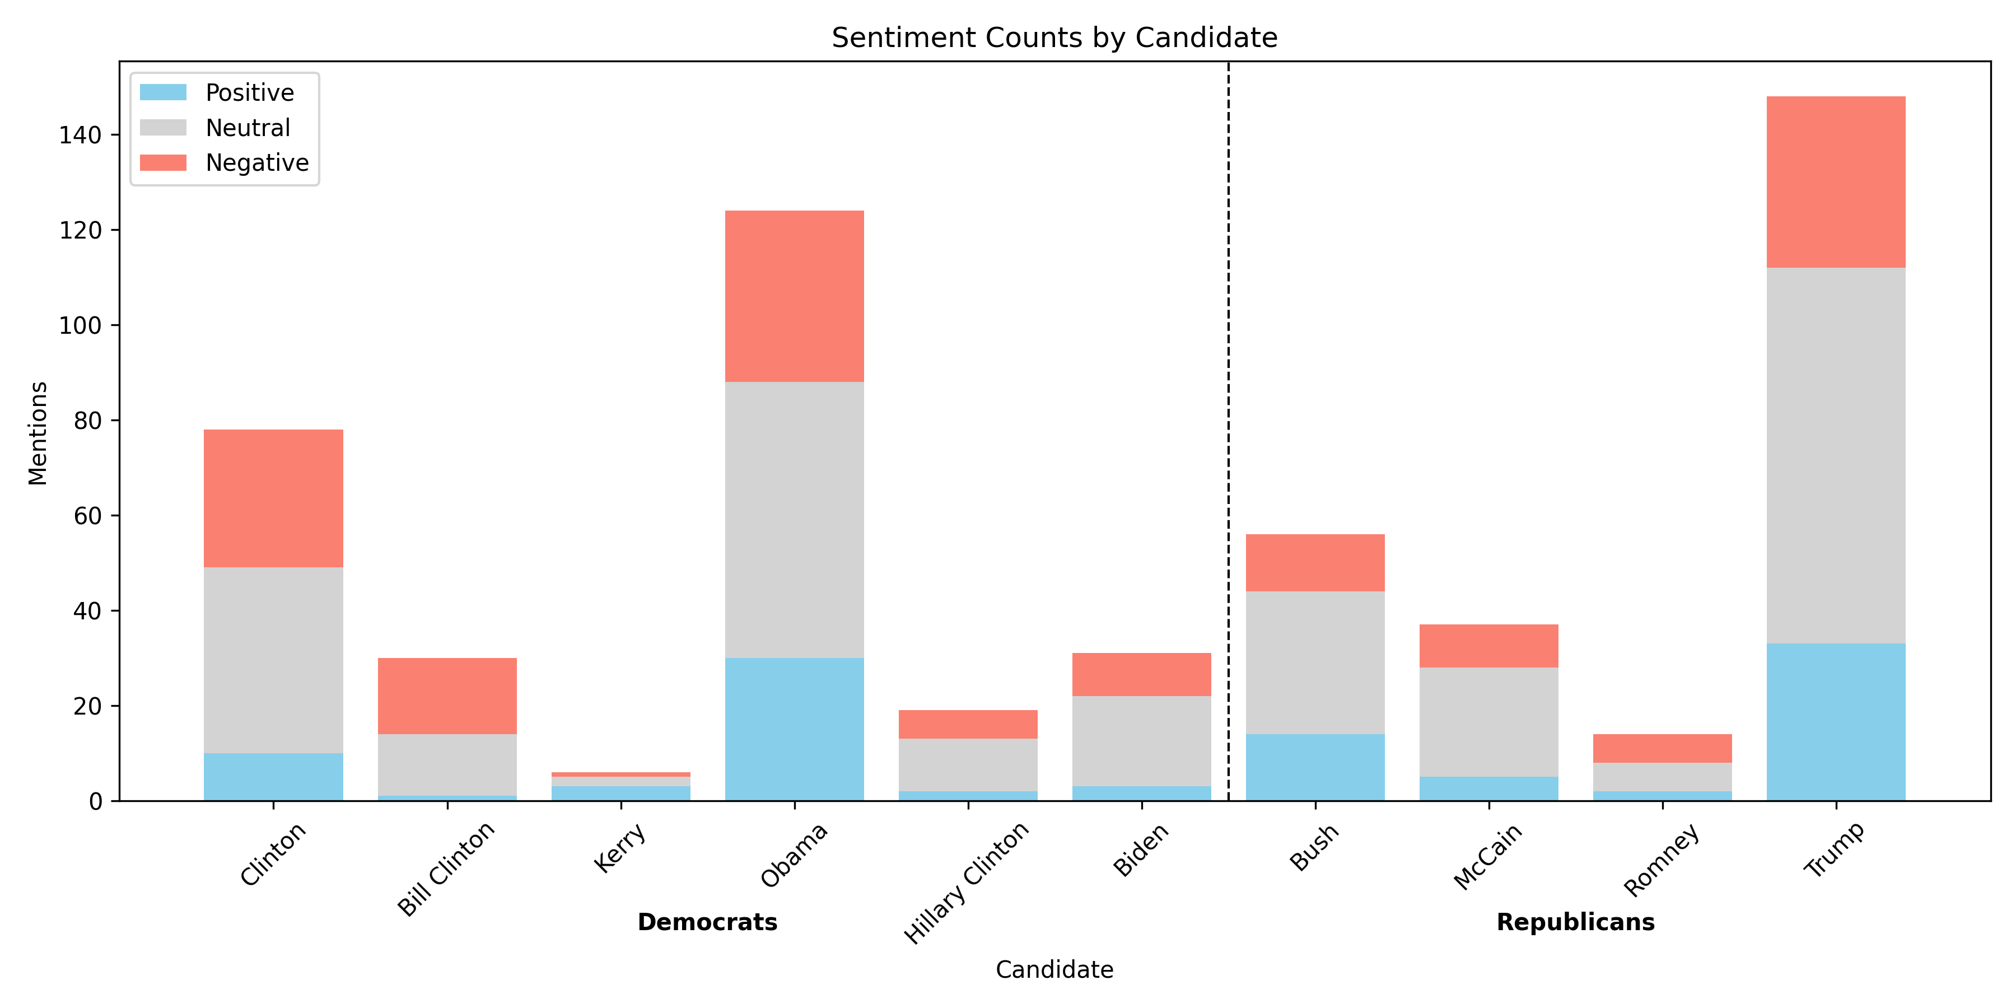

Exactly 1 Candidate Mentioned in Sentence Block:

Candidate Sentiment Ranking
Rank | Name | Party | Total Mentions | Neu % | Pos % | Neg % | Pos - Neg %
1 | Kerry | Democrat | 6 | 33.33 | 50.0 | 16.67 | 33.33
2 | Bush | Republican | 38 | 55.26 | 31.58 | 13.16 | 18.42
3 | Trump | Republican | 101 | 52.48 | 27.72 | 19.8 | 7.92
4 | Obama | Democrat | 68 | 45.59 | 29.41 | 25.0 | 4.41
5 | Biden | Democrat | 8 | 62.5 | 12.5 | 25.0 | -12.5
6 | McCain | Republican | 8 | 62.5 | 12.5 | 25.0 | -12.5
7 | Hillary Clinton | Democrat | 6 | 50.0 | 16.67 | 33.33 | -16.66
8 | Clinton | Democrat | 47 | 40.43 | 19.15 | 40.43 | -21.28
9 | Romney | Republican | 4 | 50.0 | 0.0 | 50.0 | -50.0
10 | Bill Clinton | Democrat | 22 | 36.36 | 4.55 | 59.09 | -54.54

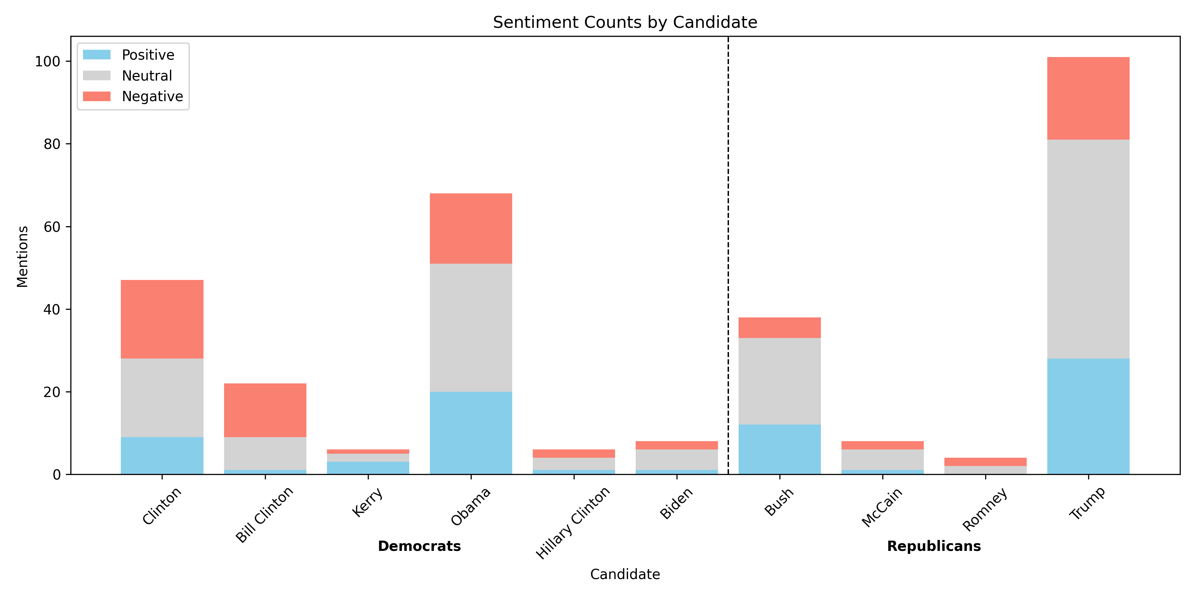

Topic Analysis
The topic modeling algorithm BERTopic was used to determine topics discussed by American pastors within a 4-week window of election day. We first initialized the model with an embedding model, a vectorizer, and a representation model. The "all-MiniLM-L6-v2" embedding model made it so that the topic model defines topics by semantic meaning rather than word frequency. The vectorizer model prevented certain stop words from being used to define a topic, and also excluded words that appear in less than 5 docs or more than 90% of docs. We defined our list of stop words by a list of candidate names and a custom list of common English words to discourage meaningless topics or topics about a specific election. The representation model set a diversity requirement between topic representative words so that the words to describe the topic were not too similar in meaning (i.e. candidate and candidates). We fit BERTopic on a list of election docs, which were subtexts gathered from our sermon text dataset. Two methods were used to obtain the list of election docs, each described in 6.1 and 6.2 below.

We fit BERTopic with 64 topics then used the “reduce_topics” method to reduce the initial topics to 16. Many initial and final topic size combinations were tested; we found 64 and 16, respectively, worked the best. Testing this approach against directly fitting the model to 16 topics showed that it leads to more diverse topics. This is because the model initially captures more detailed distinctions between topics before merging them based on similarity. We found greater consistency in the final topics using this approach as well. We also attempted to fit a separate topic model on the docs assigned to the outlier topic, but the topics did not differ significantly from the theme of the outlier topic, so we did not include this extension.

A topic label was generated for each topic by providing gpt-4o with the following information from BERTopic: topic name, top 10 words, and top subtexts assigned to the topic, ranked by probability of assignment to the topic. The generated label, top 10 words, and top subtexts are included below for each topic.

We then transformed a list of docs, gathered with the same method used to gather the election docs, to the topics. That is, each doc was assigned to the topic it best fit to. Note that the election docs are a subset of this list of docs. Then, for each sermon text, we say a topic is mentioned in the sermon text if there exists a doc in the sermon text that best fit to the topic and with a confidence score of at least 0.50.

We ran two regressions to analyse the result.

Before Tuesday, in Election Year DiD Regression
For each topic, we ran the following regression
mentions = β0​ + β1​(pre-Tuesday dummy) + β2​(election year dummy) + β3​(interaction) + ϵ

where, for each sermon text
- mentions = 1 if the topic is mentioned in the sermon text, 0 otherwise
- pre-Tuesday dummy = 1 if the sermon is given before the nearest election Tuesday, 0 otherwise
- election year dummy = 1 if the sermon is given in an election year, 0 otherwise
- interaction = 1 if the sermon is given before the nearest election Tuesday and in an election year, 0 otherwise
The resulting regression coefficients and statistics are displayed below.

Docs from Pattern Matching

We first approached gathering docs for the topic model using pattern matching. Like in the sentiment model, we used sentence blocks to provide more context for BERTopic. If the pattern detected a candidate keyword or election keyword (e.g. “Trump” or “vote”), then a sentence block was formed around the detected sentence and added to the list of docs.

Topic | Name | pre-Tuesday dummy | election year dummy | interaction | constant | Mean Dep. Var. | Std. Dev. Dep. Var. | Adj. R² | N
all | All Topics | 0.000379 (0.00395) | 0.0143** (0.00581) | 0.0214** (0.00836) | 0.0879*** (0.00294) | 0.0947 | 0.2928 | 0.0017 | 28293
outlier | Religion and Government Influence | 0.0  (0.0) | 0.0  (0.0) | 0.0  (0.0) | 0.0  (0.0) | 0.0000 | 0.0000 | 0.0000 | 28293
0 | Religion and Politics in Modern Society | 0.00365* (0.00192) | 0.00983*** (0.00303) | 0.00918** (0.00463) | 0.0177*** (0.00137) | 0.0235 | 0.1514 | 0.0022 | 28293
1 | Biblical Prophecy and Theology | -0.00292 (0.00289) | 0.000567 (0.00412) | 0.00662 (0.00578) | 0.0463*** (0.00218) | 0.0458 | 0.2090 | 0.0000 | 28293
2 | Political Anecdotes and Historical Figures | 0.00106 (0.00132) | 0.00309 (0.00202) | 0.00256 (0.00300) | 0.00864*** (0.000962) | 0.0104 | 0.1012 | 0.0003 | 28293
3 | Election News and Polls | -0.000415 (0.000870) | 0.00244 (0.00149) | 0.0100*** (0.00261) | 0.00410*** (0.000665) | 0.0058 | 0.0761 | 0.0028 | 28293
4 | Marriage and Abortion Legislation | -0.0000785 (0.000625) | 0.00204* (0.00115) | 0.00326* (0.00186) | 0.00205*** (0.000470) | 0.0030 | 0.0544 | 0.0010 | 28293
5 | Economic Policy and Taxation | -0.00151* (0.000852) | 0.00293* (0.00157) | 0.000608 (0.00211) | 0.00443*** (0.000690) | 0.0045 | 0.0666 | 0.0005 | 28293
6 | Voting and Political Influence | -0.000292 (0.000575) | 0.00225** (0.00114) | 0.00185 (0.00172) | 0.00184*** (0.000445) | 0.0025 | 0.0500 | 0.0008 | 28293
7 | Political Scandals and Deception | -0.000348 (0.000837) | 0.00195 (0.00140) | -0.00161 (0.00181) | 0.00378*** (0.000638) | 0.0039 | 0.0622 | 0.0000 | 28293
8 | Faith and Trust in Uncertain Times | 0.000658 (0.000495) | 0.00121 (0.000836) | 0.00281* (0.00153) | 0.000972*** (0.000324) | 0.0020 | 0.0448 | 0.0010 | 28293
9 | Generational Wisdom and Learning | -0.000914* (0.000546) | 0.000510 (0.000937) | 0.00250* (0.00143) | 0.00194*** (0.000458) | 0.0019 | 0.0436 | 0.0004 | 28293
10 | Authority and Leadership | 0.000140 (0.000533) | -0.0000407 (0.000723) | 0.00200 (0.00126) | 0.00140*** (0.000389) | 0.0017 | 0.0416 | 0.0002 | 28293
11 | Spiritual Gifts and Church Roles | -0.000895 (0.000602) | 0.000186 (0.000955) | -0.000752 (0.00112) | 0.00227*** (0.000494) | 0.0017 | 0.0416 | 0.0001 | 28293
12 | Spiritual Warfare and Peace in Christianity | 0.000382 (0.000398) | 0.000715 (0.000664) | 0.000677 (0.00109) | 0.000648** (0.000265) | 0.0011 | 0.0336 | 0.0002 | 28293
13 | Bible Study and Sermon Resources | -0.000130 (0.000175) | 0.000329 (0.000415) | 0.000931 (0.000736) | 0.000216 (0.000153) | 0.0004 | 0.0188 | 0.0004 | 28293
14 | Pet Bird and Voting Reflections | 0.000362 (0.000306) | -0.0000513 (0.000331) | -0.0000968 (0.000560) | 0.000324* (0.000187) | 0.0005 | 0.0222 | -0.0000 | 28293
15 | Islam and Democracy Tensions | -0.000155 (0.000365) | -0.000211 (0.000480) | 0.000956 (0.000802) | 0.000756*** (0.000286) | 0.0007 | 0.0272 | -0.0000 | 28293

Standard errors in parentheses
* p<0.1, ** p<0.05, *** p<0.01

Docs from gpt-4o

We also tried gathering docs for the topic model using gpt-4o. We tasked it with extracting all discussion about American presidential elections, presidential candidates, and voting motivations (e.g. environmental, social, economic, financial factors; a candidate or political party's ideologies; law and policy). It performed this task on each sermon text, returning a list of strings that was then extended to the list of docs.

Topic | Name | pre-Tuesday dummy | election year dummy | interaction | constant | Mean Dep. Var. | Std. Dev. Dep. Var. | Adj. R² | N
all | All Topics | -0.00105 (0.00107) | 0.0133*** (0.00244) | 0.0161*** (0.00393) | 0.00637*** (0.000827) | 0.0114 | 0.1061 | 0.0091 | 28293
outlier | Political Elections and Campaigns | 0.0  (0.0) | 0.0  (0.0) | 0.0  (0.0) | 0.0  (0.0) | 0.0000 | 0.0000 | 0.0000 | 28293
0 | Christian Voting Responsibility | -0.000190 (0.000696) | 0.00886*** (0.00184) | 0.00596** (0.00285) | 0.00259*** (0.000529) | 0.0056 | 0.0745 | 0.0052 | 28293
1 | Political Leadership and Divine Influence | -0.000272 (0.000628) | 0.00629*** (0.00159) | 0.00851*** (0.00266) | 0.00216*** (0.000483) | 0.0048 | 0.0689 | 0.0054 | 28293
2 | Faith and Leadership Guidance | -0.000441 (0.000545) | 0.00618*** (0.00153) | 0.00438* (0.00236) | 0.00173*** (0.000432) | 0.0037 | 0.0605 | 0.0039 | 28293
3 | Christian Political Engagement | -0.000203 (0.000504) | 0.00405*** (0.00128) | 0.00309 (0.00199) | 0.00140*** (0.000389) | 0.0028 | 0.0524 | 0.0023 | 28293
4 | U.S. Presidential Elections | -0.000219 (0.000327) | 0.000443 (0.000606) | 0.00667*** (0.00155) | 0.000648** (0.000265) | 0.0015 | 0.0390 | 0.0035 | 28293
5 | Abortion Debate and Republican Perspectives | -0.000524 (0.000454) | 0.00225** (0.00105) | 0.000478 (0.00145) | 0.00130*** (0.000374) | 0.0017 | 0.0407 | 0.0007 | 28293
6 | Civic Responsibility and Economic Concerns | -0.000540** (0.000241) | 0.00301*** (0.00101) | 0.00157 (0.00150) | 0.000540** (0.000241) | 0.0012 | 0.0352 | 0.0023 | 28293
7 | Same-Sex Marriage and Constitutional Rights | -0.000391 (0.000303) | 0.000443 (0.000606) | 0.00253** (0.00112) | 0.000648** (0.000265) | 0.0009 | 0.0297 | 0.0009 | 28293
8 | Financial Crisis Coverage | 0.0000858 (0.0000858) | 0.000273 (0.000273) | -0.0000893 (0.000393) | 2.23e-17 (4.24e-11) | 0.0001 | 0.0103 | -0.0000 | 28293
9 | Faith and Finances in Christianity | -0.000324* (0.000187) | 0.000221 (0.000429) | 0.00139* (0.000786) | 0.000324* (0.000187) | 0.0004 | 0.0197 | 0.0006 | 28293
10 | Biblical Leadership and Governance | 3.13e-16 (.) | 4.48e-16 (.) | 0.000808* (0.000466) | -1.31e-16 (.) | 0.0001 | 0.0103 | 0.0006 | 28293
11 | Taxation and Government Policy Critique | -0.000238 (0.000206) | 0.000221 (0.000429) | 0.000770 (0.000693) | 0.000324* (0.000187) | 0.0004 | 0.0188 | 0.0002 | 28293
12 | Faith and Leadership | -1.32e-16 (2.87e-11) | -4.25e-16 (2.89e-11) | 0.000269 (0.000269) | 1.20e-16 (2.87e-11) | 0.0003 | 0.0178 | 0.0001 | 28293
13 | Political Promises | -0.000216 (0.000153) | 0.000602 (0.000496) | 0.000475 (0.000732) | 0.000216 (0.000153) | 0.0003 | 0.0178 | 0.0004 | 28293
14 | Respect for Authority | 6.10e-16 (6.81e-11) | 0.000818* (0.000472) | 0.000797 (0.000811) | -4.07e-16 (6.78e-11) | 0.0006 | 0.0245 | 0.0009 | 28293
15 | Freedom and Liberty | 0.000172 (0.000121) | 0.000273 (0.000273) | 0.0000940 (0.000484) | -2.26e-17 (1.02e-10) | 0.0002 | 0.0133 | 0.0001 | 28293

Standard errors in parentheses
* p<0.1, ** p<0.05, *** p<0.01

In Window, in Election Year DiD Regression

For each topic, we ran the following regression
mentions = β0​ + β1​(in-window dummy) + β2​(election year dummy) + β3​(interaction) + ϵ

where, for each sermon text
- mentions = 1 if the topic is mentioned in the sermon text, 0 otherwise
- in window dummy = 1 if the sermon is given within the 4-week window to the nearest election Tuesday, 0 otherwise
- election year dummy = 1 if the sermon is given in an election year, 0 otherwise
- interaction = 1 if the sermon is given before the nearest election Tuesday and in an election year, 0 otherwise
The resulting regression coefficients and statistics are displayed below.

Docs from Pattern Matching

We only approached gathering docs for the topic model using pattern matching because of the cost of OpenAI Api calls on all sermon texts.

Topic | Name | in window dummy | election year dummy | interaction | constant | Mean Dep. Var. | Std. Dev. Dep. Var. | Adj. R² | N
all | All Topics | 0.00179 (0.00215) | 0.00270 (0.00180) | 0.0222*** (0.00455) | 0.0865*** (0.000883) | 0.0885 | 0.2841 | 0.0004 | 162664
outlier | Religion and Government Influence | 0.0  (0.0) | 0.0  (0.0) | 0.0  (0.0) | 0.0  (0.0) | 0.0000 | 0.0000 | 0.0000 | 162664
0 | Religion and Politics in Modern Society | 0.00214** (0.00104) | 0.00128 (0.000850) | 0.0134*** (0.00247) | 0.0173*** (0.000410) | 0.0186 | 0.1352 | 0.0006 | 162664
1 | Biblical Prophecy and Theology | -0.00223 (0.00158) | -0.000323 (0.00134) | 0.00446 (0.00318) | 0.0470*** (0.000664) | 0.0467 | 0.2111 | -0.0000 | 162664
2 | Political Anecdotes and Historical Figures | 0.000626 (0.000724) | 0.000834 (0.000608) | 0.00330** (0.00161) | 0.00865*** (0.000291) | 0.0091 | 0.0950 | 0.0001 | 162664
3 | Election News and Polls | 0.000547 (0.000457) | 0.000526 (0.000379) | 0.00712*** (0.00136) | 0.00318*** (0.000177) | 0.0037 | 0.0610 | 0.0007 | 162664
4 | Marriage and Abortion Legislation | -0.000801** (0.000355) | 0.000365 (0.000355) | 0.00327*** (0.000995) | 0.00286*** (0.000168) | 0.0030 | 0.0543 | 0.0001 | 162664
5 | Economic Policy and Taxation | 0.0000589 (0.000453) | -0.000214 (0.000368) | 0.00354*** (0.00111) | 0.00353*** (0.000186) | 0.0036 | 0.0603 | 0.0001 | 162664
6 | Voting and Political Influence | 0.000127 (0.000308) | 0.000520* (0.000279) | 0.00268*** (0.000903) | 0.00155*** (0.000123) | 0.0018 | 0.0426 | 0.0002 | 162664
7 | Political Scandals and Deception | 0.000781* (0.000439) | 0.000756** (0.000363) | 0.000494 (0.000968) | 0.00271*** (0.000163) | 0.0031 | 0.0552 | 0.0001 | 162664
8 | Faith and Trust in Uncertain Times | 0.0000171 (0.000282) | 0.000181 (0.000246) | 0.00236*** (0.000810) | 0.00137*** (0.000116) | 0.0015 | 0.0390 | 0.0002 | 162664
9 | Generational Wisdom and Learning | -0.0000194 (0.000273) | 0.000392 (0.000254) | 0.00157** (0.000752) | 0.00131*** (0.000114) | 0.0015 | 0.0384 | 0.0001 | 162664
10 | Authority and Leadership | 0.000221 (0.000288) | -0.000258 (0.000207) | 0.00135** (0.000679) | 0.00126*** (0.000111) | 0.0013 | 0.0360 | 0.0001 | 162664
11 | Spiritual Gifts and Church Roles | 0.0000957 (0.000313) | -0.000288 (0.000238) | 0.000192 (0.000599) | 0.00163*** (0.000126) | 0.0016 | 0.0397 | -0.0000 | 162664
12 | Spiritual Warfare and Peace in Christianity | -0.000144 (0.000226) | 0.000150 (0.000212) | 0.000885 (0.000585) | 0.00101*** (0.0000995) | 0.0011 | 0.0325 | 0.0000 | 162664
13 | Bible Study and Sermon Resources | -0.0000551 (0.000108) | 0.0000577 (0.000108) | 0.000699* (0.000386) | 0.000246*** (0.0000493) | 0.0003 | 0.0168 | 0.0001 | 162664
14 | Pet Bird and Voting Reflections | 0.0000530 (0.000173) | 0.0000439 (0.000143) | -0.000164 (0.000317) | 0.000473*** (0.0000683) | 0.0005 | 0.0220 | -0.0000 | 162664
15 | Islam and Democracy Tensions | 0.0000275 (0.000203) | -0.000173 (0.000150) | 0.000404 (0.000430) | 0.000690*** (0.0000824) | 0.0007 | 0.0259 | -0.0000 | 162664

Standard errors in parentheses
* p<0.1, ** p<0.05, *** p<0.01

Example Docs

Pattern Matching

Outlier Topic: Political Election and Leadership
- Gift of mercy Don't feel too bad. It could have happened to anyoneGift of administration - Lucas, would you get the mop. Soyoon, please help pick this up.
- Because he was a Zealot. The Zealots were a Jewish political party. They were a fanatical Jewish sect that militantly opposed the Roman domination of Palestine during the first century A.
- GC 446 National Ruin Follows National Apostasy Do you thing it is impossible for this country to abandon the principle of God, giving up the first amendment. Look, in one session the Congress voted a very unpopular law One trillion bail-out from our money 8 minutes bam. Both candidates united and saying yes They are aware of what Main Street wants. But they ignored the voices 1 trillion After that, another unprecedented and unpopular measure: federal government ownership of a good chunk of banking system...Did you heard that Jesus is coming as a thief in the night.
- Without the direction of the Holy Spirit, this concern can easily turn to slander, for some times there is a fine line between voicing a concern and gossip, and between help and hurt. George Bush the first made a trip to Australia during his term in office, when getting off the plane he decided to flash the reporters, tv crews and bystanders what he thought was the peace sign. What he accomplished was flying the entire nation the bird.
- OK, ask your relatives to help you, I have my own problems. Ha, I remember Joe Biden gafe during an electoral meeting, asking a guy in wheel chair to stand up. Apply... church-sinner-insensitive speaker/pastor... I am sure that the crippled beggar knew about Jesus.

Topic 0: Religion and Politics in Christianity
- The Spirit was bestowed upon the apostles because they were unified, one in purpose, one in goal. We have an evangelistic campaign fast approaching. If we are not all together how effective can we be.
- They do not perform miracles and they will disappoint us. The 2nd Problem: When we Christians vote, we often cast our vote under the mistaken belief that the candidate, or the party for which we vote has the power within themselves to change the course of our city, state, or nation. The problem is that's not true.
- 2 Chronicles 7:14 reads, if my people who are called by my name humble themselves, and pray and seek my face and turn from their wicked ways, then I will hear from heaven and will forgive their sin and heal their land. We should we pray that power of God is unleashed in us and in every Christian who votes. We should pray for the godly welfare and godly success of whoever is in leadership.
- 1 Cor. 15:51-52, Behold, I show you a mystery; We shall not all sleep, but we shall all bechanged, In a moment, in the twinkling of an eye, at the last trump: for the trumpet shall sound, and the dead shall be raised incorruptible, and we shall be changed. B..
- THE PROCESSES OF AUTHORITY, 13:5-7. These words beginning in verse 1 are as important as any that have ever been written on political thought and duties. Every person is to be in subjection to the governing authorities.

Topic 1: Economic and Political Uncertainty
- Everybody wants to live as if they can afford everything. Borrowing more and more, spending more and more which means that the future is uncertain the use of this word - uncertain good politician. The US Government don't have enough money to pay for everything; SS, Medicare, the war, federal institutions... And no politicians dare to raise the taxes. So it is only one way to get money: beginning with February 2006 they print money without releasing the information to the public Nobody really knows how much money is printed anymore this is considered top secret information for the security reasons This means suicide for our economy I mean we will never be able to pay the interest of what we borrowed so far.
- Because everybody trust this system Bust some day, when I will want back what left from my water, I will realize that is no water anymore It was consumed all for long time ago for other things, buying TVs from China and cars from Germany, financing the war, while I thought that I still have it in the bank -And everybody will be nervous about the real value of paper money. And one day I will try to pay as usual and I will be rejected sorry, I will not accept paper; I will accept only food or gas And people will panic, government will have to reinforce the law, any law voted by a frightened mob It will be the end The whole system will collapse We are not far from that day. Today we still using dollars, paper money or plastic And this is because we believe money still having value But this cannot last forever A rumor and bam.
- Not by military might. Not by political intrigue. But by the Spirit who gives us ...the grace and peace ...we need.
- There have been numerous pandemics throughout history; the Black Death of the 14th century, Small Pox, Spanish Flu 1918-19 , HIV/AIDS, Hong Cong Flu 1968-70 to name just a few. Not only are we in the midst of a world-wide pandemic but a hotly contested national election. But we should not look to any political party to save us. We dare not identify our faith with any political party. Government cannot save us.
- Anxiety and Depression Association of America. , https://adaa.org/learn-from-us/from-the-experts/blog-posts/consumer/watching-new-making-your-anxiety-worse/tips] When this pandemic ends and it will end and this election is settled, we are can be guaran-teed of these basic truths. Whoever is president, God will still be on His throne. Jesus will still be King of Kings and Lord of Lords.

Topic 2: U.S. Presidential History
- The aide threw up his hands and said, Nothing. Excellent, noted the president. We won't even have to train him.
- Jefferson replied: Tell him I have already engaged a room. I value his good intentions highly but if he has no place for a dirty American farmer, he none for the Vice President of the United States. Oh how we love to point our fingers at others and say look at them.
- Charles Blondin Jean Francois Gravelet 1859 --- 1st person to cross Niagara Falls on a tightropeJesse James 1873 --- committed the world's first train robbery on July 21. Adair, Iowa Herbert Hoover 1874 --- 1st US President born west of the Mississippi Annie Moore 1892 --- 1st immigrant to pass through Ellis Island. She was 15 years old and from County Cork, IrelandAlexander Winton 1903 --- set the 1st land speed record in car racing.
- 10 A. Former Senator Dwight W. Morrow searched in vain to find his railroad ticket as he was on a train leaving New York City.
- . THOUGHTS ABOUT THE PASSAGE: President Nixon once told about talking to Winston Churchill's son; he told him how much he admired the prime minister's great ability at giving extemporaneous speeches. Churchill's son replied, Oh, yes.

Topic 3: Biblical Political Leadership
- They hadn't called for a time of national prayer and fasting to ask for His opinion. They simply held a vote, an election, and decided that that was all they needed to do. God later told Samuel in 1 Samuel 8:7: Listen to all that the people are saying to you; it is not you they have rejected, but THEY HAVE REJECTED ME as their king.
- In the Old Testament Babylon was the great enemy of IsraelBecause of this, the very name of Babylon came to stand for.... a corrupt political system that stood against God. a corrupt economic system that stood against God.
- a corrupt religion that stood against God. Babylon symbolized the political, economic, and religious center of a godless society. It was a society-nation or government or religion-that defied God.
- It was a society-nation or government or religion-that defied God. Here in the Revelation Babylon stands for the city of the antichrist, the capital of the world: it stands for the political and economic system which he establishes. Isaiah 21:9Rev 18: 2Jer 51: 8Jer 50:2There is the reason why Babylon will be destroyed.
- Isaiah 21:9Rev 18: 2Jer 51: 8Jer 50:2There is the reason why Babylon will be destroyed. Why will the political and religious system of the world be destroyed in the end time. Is not a one-world government and religion a good thing.

Topic 4: Marriage and Abortion Policy Debate
- Once conception occurs nothing else is added by either the mother or father genetically to the baby, by the way, when a mother is pregnant she says she is having a baby not a fetus. Here are 10 questions you never hear a pro-choice candidate asked by the media:1. You say you support a woman's right to make her own reproductive choices in regards to abortion and contraception.
- But over the past decade and a half, each of the 30 states to consider constitutional amendments that would outlaw such unions have adopted the ban from Alaska in 1998 to North Carolina earlier this year. That may change on Election Day, when voters in Maryland, Washington, Maine and Minnesota awash in money, messages and advertisements from both sides of the issue will make their decision on whether to recognize gay marriage It will be the first major test since President Obama in May became the first president to publicly state his support for gay marriage. This week, Obama also personally endorsed ballot measures in Maine, Maryland and Washington state that would legalize gay marriage; he has previously expressed opposition to efforts in Minnesota to pass a constitutional amendment barring same-sex marriage. I am thankful that 30 states have seen fit to adopt constitutional amendment's in support of traditional marriage and it is my hope that in the six states this year where same-sex marriage is being voted on that they will be defeated but whether they are or not there is only one definition of marriage that counts and it is the definition found in Genesis 2:Genesis 2:20 And Adam gave names to all cattle, and to the fowl of the air, and to every beast of the field; but for Adam there was not found an help meet for him. 21 And the LORD God caused a deep sleep to fall upon Adam, and he slept: and he took one of his ribs, and closed up the flesh instead thereof;22 And the rib, which the LORD God had taken from man, made he a woman, and brought her unto the man.
- They shed innocent blood. If the Washington politicians had to live by the same law that Joe Blow Citizen has to live by, we would see a lot of changes made quickly. If the Senate and Congress really wanted to they could put a halt to abortion in 4 weeks. They don't want to.
- The murder of an innocent, unborn life is just that murder. It is sin for a Christian to knowingly vote for a politician who is pro abortion. Let me give you another example: Homsexual rights.
- a culture for family. One of the big issues in the 2004 election, of course, revolves around the definition of marriage. Are homosexual unions right in the sight of God.

Topic 5: Judicial Elections and Decision-Making
- 6 THE SIGNATURE By Christ Jesus. A My check My signature Rockefeller's signature Donald Trump'ssignature. Jesus gives us a blank check with His signature on it and says, Just fill it inwith what you need, and I will provide it for you.
- It will go down as a monumental day in constitutional law. Their decision on the case will not be made until June, but court observers and experts believe the 9 justices are split right down the middle, with Justice Kennedy likely making the deciding vote. In the course of the oral arguments, the justices questioned the attorneys on both sides of the issue.
- 2. No president or elected official will provide everything we're looking for. As Chuck Colson used to say, Salvation will not arrive on Air Force One.
- HERE IT ISWHAT THINK YE OF CHRIST. YOU ASK A FRIEND,' WHAT DO YOU THINK OF THE PRESIDENT OR GOVERNOR, OR THE MAJOR. BUT THESE ARE INSIGNIFICANT QUESTIONS COMPARED TO THE GREAT QUESTION.
- Level of education. Political affiliation. Economic level.

Topic 6: Political Campaign Misinformation
- . We have an election this coming November. And so far it has been an excellent example of modern American political campaigning. There has been vast confusion, accusations galore, an abundance of mudslinging advertisements, both real and false personal attacks and, of course, there has been the attendant media circus.
- The Parties1. Political parties use tactics today to ensnare' the uninformed to their line of thinking. a.
- Catering to everyone's special interest'2. Political rhetoric is selective truth-telling and outright liesAction Point: Don't be fooled by the campaign ads and flamboyant personalities. II.
- But that's how I began to see my entire person: a scar faced, wire headed misfit that would never amount to anything. A few years ago, Coca Cola embarked on a campaign where they put names on the cans and bottles. This ad ran in Indonesia watch the subtitles at the bottom of the screens.
- In fact, in Communism, lying is a virtue. It teaches the lie that its political philosophy can ultimately create a heaven on earth, and the evil lie that Christianity is the greatest enemy of mankind's happiness when it is really the greatest good ever granted to mankind. M.

Topic 7: Political Scandals and Public Perception
- Monica Lewinsky is a name known by many. She is the former White House intern who had a scandalous affair with President Bill Clinton in the late 1990s. Since then, Lewinsky has lived in the shadow of public shame.
- I sought for it in her rich mines, her vast world commerce, her public school system, and in her institutions of higher learning--and it was not there. I looked for it in her democratic Congress and her matchless Constitution--and it was not there. Not until I went into the churches of America and heard her pulpits flame with righteousness did I understand the secret of her genius and power.
- I sought for it in her rich mines, her vast world commerce, her public school system, and in her institutions of higher learning--and it was not there. I looked for it in her democratic Congress and her matchless Constitution--and it was not there. Not until I went into the churches of America and heard her pulpits flame with righteousness did I understand the secret of her genius and power.
- It was not her intention, but it had the effect of shaming those who spoke the careless words. Would to God both candidates would have followed her example. There is an ancient door on display in St.
- I sought for it in her rich mines, her vast world commerce, her public school system, and in her institutions of higher learning -- and it was not there. I looked for it in her democratic Congress and her matchless Constitution -- and it was not there. Not until I went into the churches of America and heard her pulpits flame with righteousness did I understand the secret of her genius and power.

Topic 8: American Beliefs and Cultural Values
- Thirdly, we need to help people see that they need to be rescued from hell by Jesus Christ. A poll done by The Minneapolis Star Tribune a few years ago found that 65 of the people in Minnesota believed in hell. That is a pretty high number.
- S. Gallup Poll, 72 percent of respondents said they believed in angels. Books, magazines, films, stories, talk shows and angel paraphernalia abound.
- The labels come out because it is apparently immoral to be intolerant according to the relativist's definition. This kind of thinking is even reflected by our own education system here in New York:ILL Tolerance S New York State Regents' goal for our children is this: Each student will develop the ability to understand, respect and accept people of different races; sex; cultural heritage; national origin; religion; and political economic and social background, and their values, beliefs and attitudes. If you don't look to carefully at that, you will say, Sure, what's the matter with that.
- This is a popular notion today. Pollster George Barna indicates that nearly 75 of Americans do NOT believe in absolute truth. But again, the claim of Jesus Christ runs counter to this assertion.
- Bill Muehlenberg in his blog, CultureWatch, says, Tolerance is all the rage today, and perhaps no other value is so trumpeted in modern Western culture than this one. It is the ultimate test of whether one is politically correct or not. But the modern notion of tolerance is devastatingly false.

Topic 9: Taxation and Political Issues
- Raising taxes. What politician will do this. No one.
- Pay the right taxes Government should support and encourage what is right. Nothing that is morally wrong should be politically right. When authorities exercise their power for right they faithfully represent the source of their authority and fulfill their duty.
- . LIVING IN A GOD BLESSED-NATIONOctober 24, 2004With an election in the wings and some already voting, we hear an awful lot these days about taxes, and about what our government is doing right and doing wrong. Our news journalists do their best to give us the latest updates on the stock market, oil prices, unemployment rates, and such.
- Moreover, we must consider the fact that this regressive tax plan comes from the liberal, non-biblical worldview. You must take note of the fact that this comes from the same politicians who support abortion and gay marriage. This fact is without dispute.
- They moved to states with lower tax rates. On our ballot this year you will be voting on various tax issues. We are expected to read the fine print.

Topic 10: Reality TV Competition: The Apprentice
- So what do they do on these shows. They vote each other out. They make each other into castaways.
- . Last season's new TV reality show The Apprentice centering around Donald Trump was a big hit. The 58 year old Trump commands an empire of over 100 companies, billions of dollars, and some of the most illustrious buildings in the world. The newest addition to the Trump kingdom is a massive skyscraper under construction in Chicago and that project is being supervised by Bill he winner of the first season of The Apprentice. This season began 10 days ago with a new group of business hopefuls vying for the job of a lifetime.
- This season began 10 days ago with a new group of business hopefuls vying for the job of a lifetime. The position: Trump is looking for the right person to come and work with him in a high level role in one of his companies. 18 candidates arrived on the scene for a 15 week job interview. They came from all over the country from all walks of life, the best and brightest of what America has to offer: attorneys, stockbrokers, executives, and entrepreneurs.
- They came from all over the country from all walks of life, the best and brightest of what America has to offer: attorneys, stockbrokers, executives, and entrepreneurs. Those who watch the show become acquainted with these candidates and select their own favorites while Trump decides by the process of elimination-- AKA firing candidates each week in the board room--who he will select as one of his inner circle, his leaders, his apprentice. Almost 2000 years ago there was a 30 year old man who had more power and influence than Donald Trump could ever dream of. And he was ready to begin a three year venture of building a Kingdom here on earth that would alter the course of human history and would stand forever.
- Last week we began this brief series I've entitled The Apprentice: The Type of Person God Chooses. The Apprentice is of course the TV reality show centered around Donald Trump in which 18 candidates arrive on scene for a 15 week job interview. They are put through all kinds of challenges, situations and competitions so that Trump through the process of elimination known as firing in the board room each week selects one to be his apprentice to work with him in building his Trump kingdom. Last seasons show was such a big hit that they began a new season three weeks ago.

Topic 11: Bible Study Campaign
- This sermon is contributed by Hal Seed of New Song Church in Oceanside, California and of www.PastorMentor.com. Hal is the author of numerous books including The God Questions and The Bible Questions. If you are interested in The Bible Questions Church-wide Campaign, please visit and watch Hal's video at www.PastorMentor.com. How is the Bible Different than Other Books. The Bible Questions, Part 2Psalm 119:97-105Special notes to the pastor/teacher:1.
- In Jesus' name, Amen. Hal SeedThe Bible Questions Campaign Kit is available at www.pastormentor.com.
- This sermon is contributed by Hal Seed of New Song Church in Oceanside, California and of www.PastorMentor.com. Hal is the author of numerous books including The God Questions and The Bible Questions. If you are interested in The Bible Questions Church-wide Campaign, please visit and watch Hal's video at www.PastorMentor.com. How Do I Live What I've Learned. The Bible Questions, Part 6Ps.
- Let's pray. Hal SeedThe Bible Questions Campaign Kit is available at www.pastormentor.com.
- This sermon is contributed by Hal Seed of New Song Church in Oceanside, California and of www.PastorMentor.com. Hal is the author of numerous books including The God Questions and The Bible Questions. If you are interested in The Bible Questions Church-wide Campaign, please visit and watch Hal's video at www.PastorMentor.com. What Can the Bible Do for Me. The Bible Questions, Part 1Joshua 1:6-8For Bumper Video: https://vimeo.com/48489274Special notes to the pastor/teacher:1.

Topic 12: Spiritual Guidance and Voting
- . A SERMON ON LORDSHIP FOR ELECTION DAYLUKE 9:57-62 umadbroPETE'S BIRD PART 1 p There once was a guy named Pete. Pete decided that he wanted to buy a pet and have that pet with him at all times and always be with him.
- It never took all that long. But to be honest, he wasn't all that pleased with anything he had to vote for. He looked at his bird and started to talk as they sat at the traffic light.
- He looked at his bird and started to talk as they sat at the traffic light. I don't want to vote. I don't think my vote really matters. I am not even sure what should guide my vote. The bird looked at him with one eye and cocked its head and said, Follow Jesus in all things.
- The bird looked at him with one eye and cocked its head and said, Follow Jesus in all things. Pete was a little puzzled and looked at the bird Are you telling me that as a Christian, Jesus cares whether or not I vote and also has a divine opinion on how I should vote. Are you sure.
- The bird just bobbed his head up and down. He got up to the library and he turned into the voting place. He walked up and the volunteer on the outside asked him to have his ID out as that makes it all go faster.

Topic 13: Presidential Staff and Leadership Dynamics
- p. 293 A presidential aide said, Mr. President, I was wondering, sir if it might be possible for MY SON TO WORK somewhere in the White House. Of course, answered the president. What does he do.
- He is sleeping, Mr. President. He said not to disturb him.
- No, Mr. President. I work for him, not you.
- I work for him, not you. When I called the President back, he could scarcely control his pleasure. Tell that woman I want her here in the White House.
- He is sleeping, Mr. President. He said not to disturb him.

Topic 14: Islam and Politics
- We must wake up as a nation and see the danger of allowing our children to be taught Islam in school. Allowing our elected officials to be sworn in on the Quran or other books besides the Bible. We have only one God.
- It marks a great revolution in the nature of Islam. Islam went from a religious and spiritual revelation to a political agenda. b.
- Attacks by terrorists in the past 13 years have changed everything and all of this has brought the religion of Islam to the front page of our newspapers. Our president and other leaders have bent over backwards to make sure that the world understands that Islam and terrorism are in no way related and that the Moslem faith is actually peaceful. There is a Greek word for that.
- Where the Muslim is taught that Islam does have complete control over all areas of thought and action. It's power ranges from the pew to their politics, from the family to the job, from the diet to the dress. Key: A good Muslim is controlled completely by Islam and the Quran.
- OPEC Democracy is purely an American invention. Realize, only two Arab nations are democratic. Democracy is considered a direct threat to Islam.

Topic 15: Ancient Political Centers
- Ephesus, Smyrna, and Pergamum were all three royal citiesa. Ephesus was a political centerb. Smyrna was a commercial centerc.
- Pergamos was regarded as a noble city located in Northwest Asia Minor in what we know today as modern Turkey. It was a great city of commerce, culture, and politics. The people there were literate, established, and affluent.
- What Christ says here to the churches is relevant in all times. Church history tells us that Ephesus was a great commercial, political, religious, and sports town. The location of Ephesus made it a great town.
- In commerce and in wealth there were few cities that could match up with Ephesus in its day. Ephesus was also a city of the greatest political importance in Asia. Once again church history tells us that Ephesus enjoyed the title of Supreme Metropolis of Asia’.
- This was what was known as a free city. Ephesus also was granted political freedom by Rome, because of its status as the premier town in Asia. Therefore it had its own magistrates called strategoi; a democratically elected governing body called the boule; and an assembly of all its citizens called the ekklesisa. Further Ephesus was what was called an assize town meaning that in Roman provinces there were certain centers where justice was dispensed.

GPT

Outlier Topic: Political Elections and Morality
- There has been vast confusion, accusations galore, an abundance of mudslinging advertisements, both real and false personal attacks and, of course, there has been the attendant media circus.
- As I thought about this upcoming election, it occurred to me that everyone who is voting will be doing so in the belief that their candidate is better and that the other candidates are either: less competent, incompetent, less qualified, disqualified, or a willing or unwitting agent of Satan.
- BUT, that said, we need to realize that there are 2 inherent weaknesses in our semi-democratic process.
- The 1st Problem is that we are voting for mere mortals.
- Neither Superman nor Jesus is running for public office. I don't care how moral and upstanding any politician is that we vote into office they are still a sinner.

Topic 0: Christian Voting Responsibility
- Our votes do make a difference.
- And we who are Christians should honor this sacred privilege and vote at every opportunity.
- The 2nd Problem: When we Christians vote, we often cast our vote under the mistaken belief that the candidate, or the party for which we vote has the power within themselves to change the course of our city, state, or nation.
- I truly believe that every Christian should NOT ONLY vote but actively work within our Constitutional system to bring about God's moral righteousness in our nation.
- The vote you make on your knees has a power no ballot box can equal.

Topic 1: Religion and Politics
- In 1960, a single vote change in each precinct in Illinois would have made Richard Nixon the president, rather than John F. Kennedy.
- I truly believe that every Christian ought to be involved in the political process at some level.
- The Bible teaches that when the blind leads the blind they all fall into the ditch.
- Here we see in verse four that the elders of the people, the senate and the house, came together and told Samuel that they wanted a king like all the other nations, because his sons were not walking with God.
- The Bible says that the matter displeased Vice-President Samuel.

Topic 2: Praying for Political Leaders
- Pray for all the politicians even the ones you don't like. Especially the ones you don't like!
- We should pray for the godly welfare and godly success of whoever is in leadership.
- You see, the vote we make that counts, in any election is NOT so much the one we make privately in the voting booth, it's the vote we make privately in our prayers.
- We look at this past election and many say we prayed hard and long and the election did not turn out the way we wanted.
- We are going to vote for the next Supreme Commander in two days. It is no doubt one of the most important elections of our lifetime. And one of the reasons among many is the fact that the PRESIDENT is in charge of our military. I urge you all to take the time to pray and ask God how He would have you vote.

Topic 3: Media Influence and Perception of Truth
- Part of the problem lies with our culture. The mainstream media, entertainment industry, and secularized public education have nurtured a generation that rejects any claim of absolute truth and insists on tolerance and equal footing of all points of view.
- In other words you'll work harder, and more hours and see less of your wages.
- I have been seeing the gift of freedom laughed at, mocked, abused, and squandered.
- Freedom then, is a precious gift that God has granted to our great nation and must not be taken lightly!
- We have been given freedom because there once existed a condition of bondage!

Topic 4: Abortion Debate and Republican Perspectives
- Here are 10 questions you never hear a pro-choice candidate asked by the media: 1. You say you support a woman's right to make her own reproductive choices in regards to abortion and contraception. Are there any restrictions you would approve of? 2. In 2010, The Economist featured a cover story on the war on girls and the growth of gendercide in the world abortion based solely on the sex of the baby. Does this phenomenon pose a problem for you or do you believe in the absolute right of a woman to terminate a pregnancy because the unborn fetus is female? 3. In many states, a teenager can have an abortion without her parents' consent or knowledge but cannot get an aspirin from the school nurse without parental authorization. Do you support any restrictions or parental notification regarding abortion access for minors? 4. If you do not believe that human life begins at conception, when do you believe it begins? At what stage of development should an unborn child have human rights? 5. Currently, when genetic testing reveals an unborn child has Down Syndrome, most women choose to abort. How do you answer the charge that this phenomenon resembles the eugenics movement a century ago the slow, but deliberate weeding out of those our society would deem unfit to live? 6. Do you believe an employer should be forced to violate his or her religious conscience by providing access to abortifacient drugs and contraception to employees? 7. Alveda King, niece of Martin Luther King, Jr. has said that abortion is the white supremacist's best friend, pointing to the fact that Black and Latinos represent 25 of our population but account for 59 of all abortions. How do you respond to the charge that the majority of abortion clinics are found in inner-city areas with large numbers of minorities? 8. You describe abortion as a tragic choice. If abortion is not morally objectionable, then why is it tragic? Does this mean there is something about abortion that is different than other standard surgical procedures? 9. Do you believe abortion should be legal once the unborn fetus is viable able to survive outside the womb? 10. If a pregnant woman and her unborn child are murdered, do you believe the criminal should face two counts of murder and serve a harsher sentence?
- When we read that the majority of Americans, due to sonograms, now believe that unborn babies are truly humans alive and yet over 35 still support abortions, we must get upset.
- We're going to see attacks on innocent human life through the Freedom of Choice Act, trying to erase all the gains that have been made in the pro-life movement.
- I suspect I was not the only one filled with joy when I heard that pro-life legislators and administrators from both parties will control Congress and the administrative branch of government, and maybe even the courts.
- The election of a pro-life candidate to the presidency has the potential to stop, even reverse some of these trends, but we cannot be complacent. We've seen the election of people to high office under a pro-life banner for a couple of generations, but abortionists are still killing babies, and doctors are still killing patients, and people trapped in homosexual habits are still being told that they are doing wonderful things. Bodies and souls are dying. Politics will not save us.

Topic 5: Churches and Taxation Laws
- The Senate and Congress take our tax money and uses it for their own power and prestige. They use it for things that aren't even of American interest.
- Moreover, we must consider the fact that this regressive tax plan comes from the liberal, non-biblical worldview. You must take note of the fact that this comes from the same politicians who support abortion and gay marriage. This fact is without dispute. This is because it is the result of the same worldview and belief system.
- Now, thanks to a 1954 law, churches can no longer speak out in the same way. If they do they could be visited by thugs from the IRS who would take away their nonprofit status and make sure they repaid all those uncollected taxes that they were previously exempt from.
- If the taxation rate feels too steep the Federal Reserve will simply print the money that's needed, increasing inflation, and reducing the value of your savings. That's economic enslavement and it's only the tip of the iceberg.
- Do you realize that the average American has to work from January until May to pay all of the local, state, and federal taxes piled upon them?

Topic 6: Same-Sex Marriage Legislation and Court Decisions
- Liz Haloran of NPR writes that: Six states and the nation's capital have recognized the legality of same-sex marriages, either by law or by court order. But over the past decade and a half, each of the 30 states to consider constitutional amendments that would outlaw such unions have adopted the ban from Alaska in 1998 to North Carolina earlier this year. That may change on Election Day, when voters in Maryland, Washington, Maine and Minnesota awash in money, messages and advertisements from both sides of the issue will make their decision on whether to recognize gay marriage It will be the first major test since President Obama in May became the first president to publicly state his support for gay marriage. This week, Obama also personally endorsed ballot measures in Maine, Maryland and Washington state that would legalize gay marriage; he has previously expressed opposition to efforts in Minnesota to pass a constitutional amendment barring same-sex marriage.
- I am thankful that 30 states have seen fit to adopt constitutional amendment's in support of traditional marriage and it is my hope that in the six states this year where same-sex marriage is being voted on that they will be defeated but whether they are or not there is only one definition of marriage that counts and it is the definition found in Genesis 2..
- And last week, the latest act of arrogance and hubris by the Supreme Court, same sex marriage has been made the law of the land.
- Last Friday, the Supreme Court overruled God in redefining what marriage is in the United States of America, of what marriage has been for millennia throughout the world.
- Ultimately, the high court's ruling will have little to do with marriage, but will have a great and grave impact on the ability of the Church to function within this country.

Topic 7: Label: Financial Crisis and Government Intervention
- They formulate financial bailouts; He owns the cattle on a thousand hills.
- As one described it when interviewed on television, these financial institutions were so large, they were considered unshakable.
- Like the Titanic, nothing could cause them to sink. It was said that the Titanic was unsinkable, and similarly, that nothing could affect AIG, Merrill-Lynch, Lehman Bros., etc.
- These companies, too, were large, monstrous giants of the business world, yet they crumbled before the eyes of all men.
- These companies were so huge that our government could not take the risk of finding out what the repercussions would be if they were allowed to collapse.

Topic 8: Government and Leadership Principles
- Now we are into big government- Never before have more people been dependent upon government for having their needs met.
- Government is to preserve what is right and punish wrongdoers.
- We live under the same type of confiscatory government because we've voted in the demigods to keep us prosperous and secure.
- We can have the best government on paper, but when it's put in the hands of wrong leaders we're sunk.
- A good gov't is not how good your documents/economy are/is but how good leaders are!

Topic 9: Biblical Promises and Guidance
- That God would give him the wisdom and knowledge he needs.
- That he would allow himself to be guided by God.
- That he would seek God as he makes decisions.
- That he would be fair and just as he leads.
- That we would remember that prayer works and God is in control.

Topic 10: 2008 U.S. Presidential Election and Diversity
- We have decided as a country that there is more to a person than the color of the skin, and elected him president.
- The fact that we could have our first African American president, while history making, is NOT a good enough reason to vote for a person. That is simply the outside package. Neither is the fact that we could have our first woman vice-president a good enough reason to vote for a candidate.
- The election of the first African American President.
- Some voted for Obama simply because he is black and that is as racists as the one who didn't vote for him because he is black.
- This election cycle is an historic time for our nation. As in the election cycle of 2008 when we elected our nation's first African-American president, we may this cycle, elect our nation's first female president.

Topic 11: Leadership and Governance
- These are all things we need to keep in mind when choosing our leaders, especially our president.
- Embryonic Stem Cell Research Is it worth it to elect anyone who promises leadership as if leadership itself is a virtue? A leader who asks you to follow off a cliff on the Blue Ridge Parkway may be leading; do we want that result? Embryonic stem cells are the result of a technician bringing together sperm and egg to create an embryo. Read that a person! An embryo is a little person in process. The purpose is to let that little person grow for a short period, and then insert an instrument into that person end his or her life, so that the center of his/her healthy stem cells can be extracted and then applied to some other human being.
- One question we should ask of those running for public office, or seeking a leadership capacity is Are they capable of fulfilling the role? Not every leader is equipped to fill every role; choices must be made based on the individual's gifts, skills and talents.
- Always ask of the person we're choosing to lead, Does this person have the capability necessary to lead at this level?
- A third trait I see in Jethro's advice is that of responsibility. When we choose leaders, we must be willing to let them lead. We can't extend leadership responsibility and then micromanage their efforts.

Topic 12: Christian Civic Responsibility
- It is therefore our responsibility to combat this worldview in the public arena of ideas. Paul did this repeatedly in his ministry. Prophets in the Old Testament spoke out against anti-biblical injustice by kings and governors. The Bible clearly commands and models through examples of the role of believers to proclaim both scripture and a biblical worldview in order to advance a belief in scripture.
- Paul also says that our submission cannot be false or insincere, but that it must be genuine!
- Paul tells us in this section that if we want to escape the wrath of the government don't do evil but strive to do good because those in power don't seek to bring the sword against those who do good but only those who do evil.
- This is Paul's way of saying that our actions and attitudes in life must be respectful of recognized authorities NOT because of the value of those authorities BUT because of our respect 4 God because of His grace that placed our leaders in power.
- As in Paul's day, it is still true today one way to be a good citizen and for the gov't to NOT come down upon you is when we pay our taxes Paul says pay ALL of what you owe!

Topic 13: Respect and Honor for Authority
- How about in the workplace? Are you honoring and respecting your boss?
- The respect we reveal for our government cannot be lip service, but must be fleshed out in the essentials of our lives which means that our attitudes and actions must reflect honor and respect for our leaders!
- However, we must exhibit a respect for those in authority, even if we disagree and seek to change things.
- But we are to respect and honor the position.
- Even if we don't respect those in office, we must respect the office itself.

Topic 14: Supreme Court Appointments and Judicial Influence
- Who will become the next supreme court justices?
- They have the presidency and the United States Supreme Court.
- In the case of the next President of the United States, there is one vacant seat on the U. S. Supreme Court that he/she will fill, and the likely hood of as many of three more vacancies just in the next term. Those selections will influence the nation for the next generation.
- So what are the stakes in the upcoming election? One or two more judges on the Supreme Court may be appointed by the next President.
- But let me make you aware of another serious issue - yes we all know there are 6 ballot proposals - different interest groups that want to change the constitution - but what slips under the radar is that we are electing THREE new Michigan supreme court justices. Judges either are rule of law judges who see to interpret the laws we have, or they are activist judges who want to reinterpret the laws we have to change our laws to be what they as an individual think it should be.

Topic 15: Political Campaign Promises
- Each candidate wants your vote and has made promises that will be almost impossible to keep.
- How many believe that these two who are seeking the position of our leader will keep these promises that they are making to us.
- Political promises don't carry the same weight as political performance. The election has come and gone. Now we must deal with the real issues.
- Every person who runs for office makes promises some we hope he or she will keep and others we know he or she probably will not be able to keep.
- What we need to be concerned about is not the promises candidates make to us.

