Exercises 1b: MAE Unit 1
Name: Josep Famadas Alsamora
Collaboration Info: I have used some information from mathworks.com.

Exercise 5. Network connectivity.

Explanation:

- I created randomly two vectors x and y of N numbers from 1 to 100 and plotted them in red circles.

- I created the matrix D by operating with two previously designed X and Y matrices using the meshgrid.

- I stablished a maximum distance and used the function find to create two vectors F (for rows) and C (for columns) containing the indexes of the links with less than Dmax value in the matrix D.

- First of all I added infinites to the diagonal and computed a horizontal vector with the minimum value of each column of D. Then I setted to 0 the poins in D with this values, and using the function find I got the indexes of them. Finally I plotted them.

MATLAB Code:

%% (1)
N = 50;

x = round(100*rand(1,N));
y = round(100*rand(1,N));

plot(x,y,'O r')
hold on;
%% (2)

[X1,X2] = meshgrid(x,x);
[Y1,Y2] = meshgrid(y,y);

D = sqrt((X2-X1).^2+(Y2-Y1).^2);

%% (3)

Dmax = 15;
[F,C] = find(D<=Dmax);
Mx = [x(F);x(C)];
My = [y(F);y(C)];

plot(Mx,My,'b');

%% (4)

D1 = D + diag(inf*ones(1,N)); %infinits a la diagonal
Mins = min(D1,[],1); %minim de cada columna

D2 = D1-repmat(Mins,N,1); %Posem 0 a les connexions que són les mes petites en la columna
[F1,C1] = find(D2==0);
Mx1 = [x(F1);x(C1)];
My1 = [y(F1);y(C1)];

plot(Mx1,My1,'g','Linewidth',3);

Results:

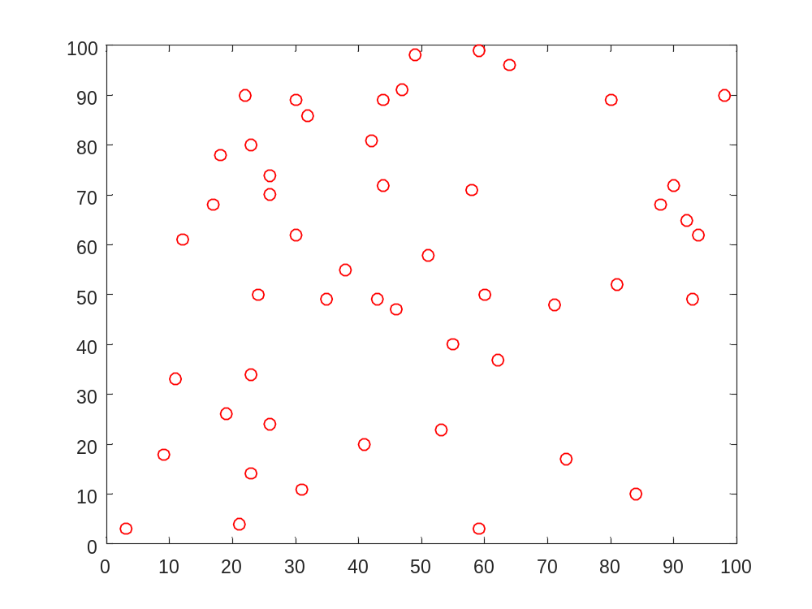

(3)
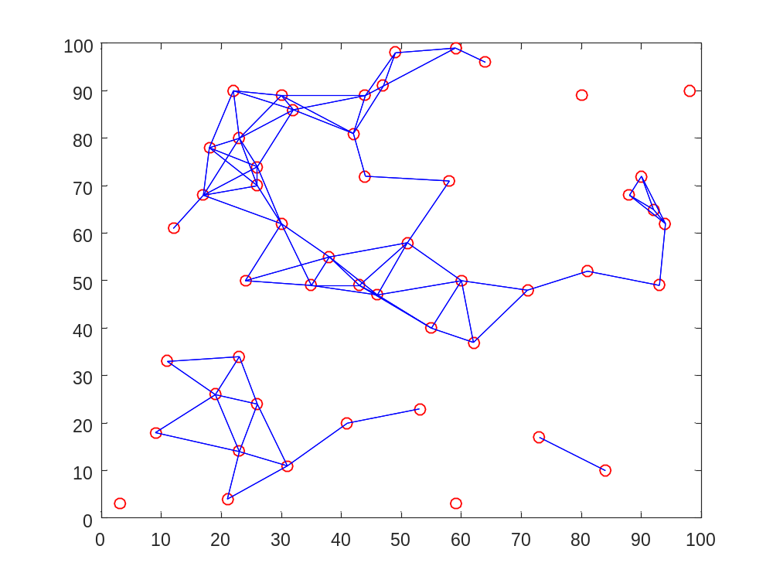

(4)

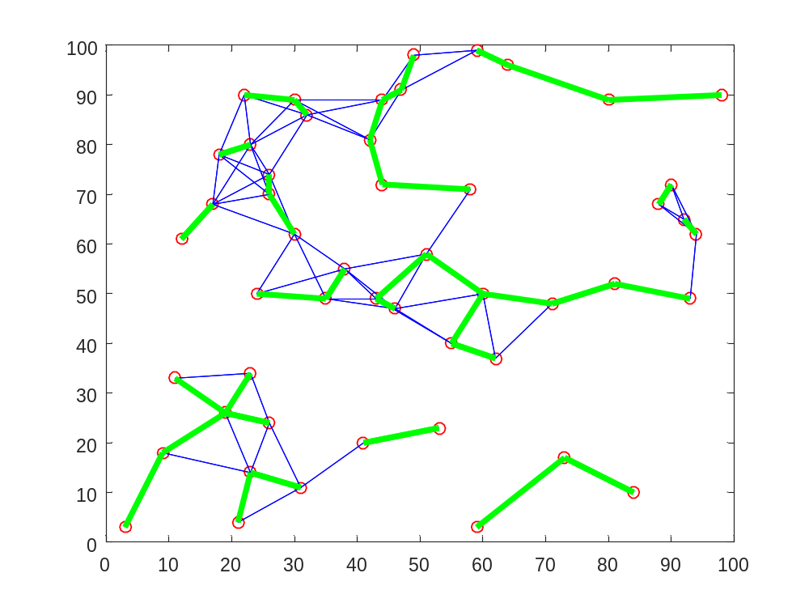
Exercise 6. Plots of two-dimensional functions.

Explanation:

- In this first part I generated the three vectors (theta, f1 and f2) and plotted them in a 3D plot using the function plot.

- First of all I created the -4:4 x -4:4 base square with the function meshgrid. Then, with 2 for loops I iterated the whole square and created a matrix with the square sum of the distances, founded the minimum of this matrix, founded the indexes of this minimum and added them to the new matrix Xc. Finally I ploted Xc and -Xc in function of f1 and f2.

MATLAB Code:

%% (1)

theta = 0:pi/200:5*pi;
f1 = theta/pi.*sin(theta);
f2 = theta/pi.*cos(theta);

plot3(f1,f2,theta)
axis([min([f1,f2]),max([f1,f2]),min([f1,f2]),max([f1,f2]),min(theta),max(theta)]);
xlabel('f_1(\theta)');
ylabel('f_2(\theta)');
zlabel('\theta');
grid on;

%% (2)

[X2,X1] = meshgrid(-4:1/200:4);

theta = 0:pi/200:5*pi;
f1 = theta/pi.*sin(theta);
f2 = theta/pi.*cos(theta);

for i = 1:length(X1)

for j = 1:length(X2)

A = ((X1(i,j)-f1).^2+(X2(i,j)-f2).^2);
c = min(min(A));
Xc(i,j) = theta(find(A==c));
end
i/length(X1)*100 %this is just to see the percentatge of completition and avoid waiting too much

end

figure(1)
mesh(X1,X2,Xc)
xlabel('X_1')
ylabel('X_2')
zlabel('X_c')
grid on;

figure(2)
mesh(X1,X2,-Xc)
xlabel('X_1')
ylabel('X_2')
zlabel('-X_c')
grid on;

Results:

(1)

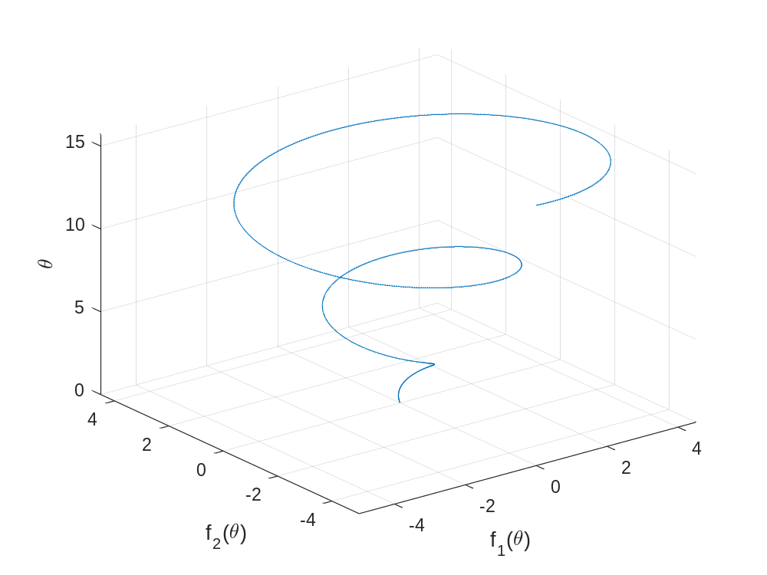
(2)

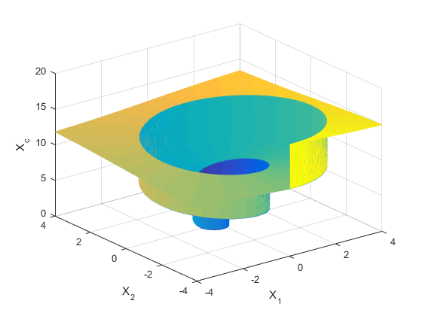

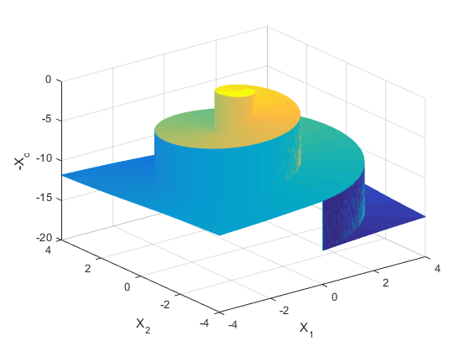
Comments:
Exercise 7. Polygons and colours.

Explanation:

First of all, I decided to divide the square in 16x16. Then, I create each figure separately, with a vector for their X coordinates and another for Y coordinates. Then, I drawn them using function fill, and finally I place the letter in the center of the figure.

Once the compact figure was created, I edit each polygon separately in order to get the example final polygon.

MATLAB Code:

figure(1)
axis([0 16 0 16])
hold on;
%A
Xa = [0 0 8];
Ya = [8 16 16];
fill(Xa,Ya,'g')
text(sum(Xa)/length(Xa),sum(Ya)/length(Ya),'A','FontSize',20,'Color','k')

%B
Xb = [4 8 12 8];
Yb = [12 16 12 8];
fill(Xb,Yb,'c')
text(sum(Xb)/length(Xb),sum(Yb)/length(Yb),'B','FontSize',20,'Color','b')

%C
Xc = [8 16 12];
Yc = [16 16 12];
fill(Xc,Yc,'y')
text(sum(Xc)/length(Xc),sum(Yc)/length(Yc),'C','FontSize',20,'Color','k')

%D
Xd = [0 4 4 0];
Yd = [8 12 4 0];
fill(Xd,Yd,'m')
text(sum(Xd)/length(Xd),sum(Yd)/length(Yd),'D','FontSize',20,'Color','g')

%E
Xe = [4 4 8];
Ye = [4 12 8];
fill(Xe,Ye,'r')
text(sum(Xe)/length(Xe),sum(Ye)/length(Ye),'E','FontSize',20,'Color','y')

%F
Xf = [8 16 16];
Yf = [8 16 0];
fill(Xf,Yf,'b')
text(sum(Xf)/length(Xf),sum(Yf)/length(Yf),'F','FontSize',20,'Color','k')

%G
Xg = [0 8 16];
Yg = [0 8 0];
fill(Xg,Yg,'k')
text(sum(Xg)/length(Xg),sum(Yg)/length(Yg),'G','FontSize',20,'Color','w')

hold off;

% Second part

figure(2)

hold on;

%A
Xa2 = Xa-3;
Ya2 = Ya+3;
fill(Xa2,Ya2,'g')
text(sum(Xa2)/length(Xa2),sum(Ya2)/length(Ya2),'A','FontSize',20,'Color','k')

%B
Xb = [4 8 12 8];
Yb = [12 16 12 8];
fill(Xb,Yb,'c')
text(sum(Xb)/length(Xb),sum(Yb)/length(Yb),'B','FontSize',20,'Color','b')

%C
Yc2 = Yc+4;
fill(Xc,Yc2,'y')
text(sum(Xc)/length(Xc),sum(Yc2)/length(Yc2),'C','FontSize',20,'Color','k')

%D
Xd2 = -Yd;
Yd2 = Xd;
D = fill(Xd2,Yd2,'m');
text(sum(Xd2)/length(Xd2),sum(Yd2)/length(Yd2),'D','FontSize',20,'Color','g')

%E
Xe = [4 4 8];
Ye = [4 12 8];
fill(Xe,Ye,'r')
text(sum(Xe)/length(Xe),sum(Ye)/length(Ye),'E','FontSize',20,'Color','y')

%F
Xf2 = Xf+3;
Yf2 = Yf-3;
fill(Xf2,Yf2,'b')
text(sum(Xf2)/length(Xf2),sum(Yf2)/length(Yf2),'F','FontSize',20,'Color','k')

%G
Xg2 = Xg+3;
Yg2 = Yg-3;
fill(Xg2,Yg2,'k')
text(sum(Xg2)/length(Xg2),sum(Yg2)/length(Yg2),'G','FontSize',20,'Color','w')

Results:

The result of the compacted figure is
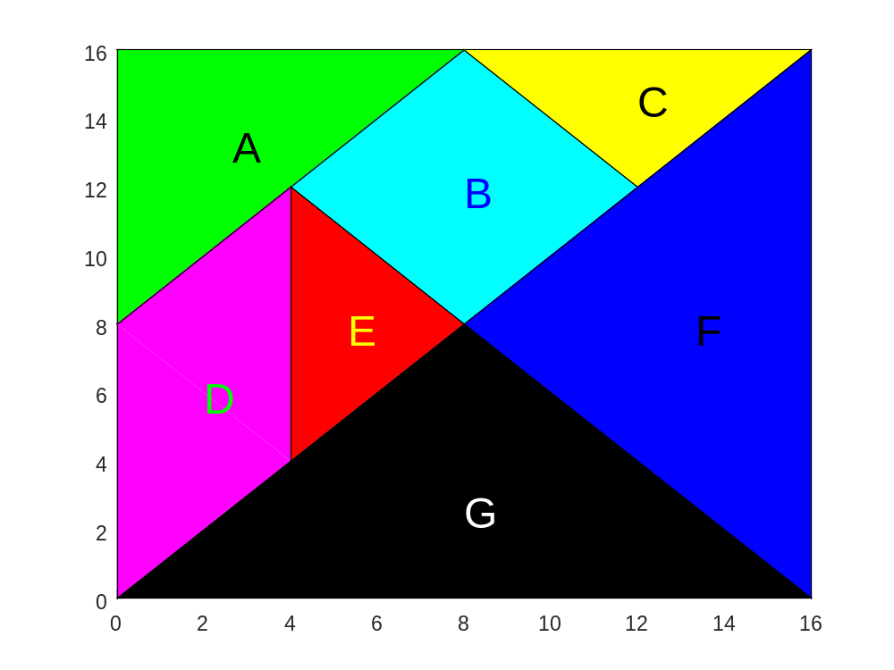
And when the changes are applied we finally get.

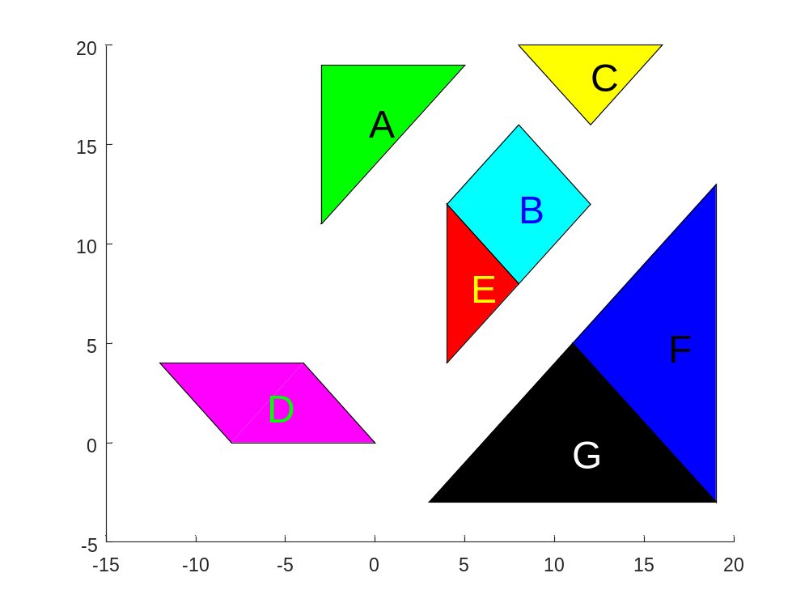

Comments:

