Universitat Rovira i Virgili

Introduction to MultiAgent Systems

Activity 1

**Final implementation of the practical exercise**

**Authors: Aleix Toda Mas, Alvaro Rom Diaz, Jordi Riu, Jorge Alexander, Josep Famadas**

**Supervisor: Dr. Jordi Pujol**

**Date: 1st January 2018**



## 

Table of Content

1. Introduction 3

2. Problem statement: The miner cycle 3

3. Action Flow 4

4. Agents and Behaviors 6

4.1. System Agent 6

4.2. Coordinator Agent 7

4.3. Digger Coordinator Agent 7

4.4. Prospector Coordinator Agent 7

4.5. Digger Agent 8

4.6. Prospector Agent 8

5. Work Changes 8

5.1. Digger Coordinator Gold / Digger Coordinator Silver 8

5.2. Other Changes?? 9

6. Performance 9

7. Conclusions and Future Work 9

8. Bibliography 9

# Introduction

Explain Multi agent systems, the type of work (decision making system) and intro to it.

# Problem statement

This work consists on the implementation of a multi-agent system that efficiently simulates a metal collection center. This task is accomplished by two types of agent:

* Prospectors: this type of agent is responsible for going through the map cells and discovering metals. They must report the type of metal and quantity.
* Diggers: these agents are in charge of collecting the metals. They dig the different metal units that exist in a cell and store them in their own backpack. Where appropriate, they should go to manufacturing sites to exchange metals for “points”.

For the coordination of all the agents of the system there are a series of agents that must supervise all the operation of the game:

* System agent: agent in charge of game control and simulation. Its most important task is to continually update the game status.
* Coordinator agent: the link between the system agent and all other agents. It centralizes the orders to be executed in each turn.
* Prospector coordinator agent: agent responsible for coordinating prospectors. It is the means of communication between prospectors and other agents.
* Digger coordinator agent: agent responsible for coordinating diggers. It is the means of communication between diggers and other agents.

Therefore, taking into account all these agents we can set our multi-agent structure as the next network:

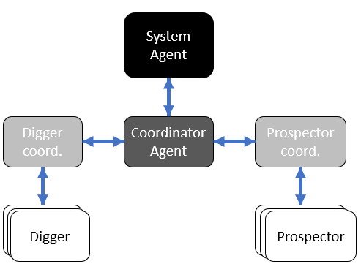

The exchange of metals must be carried out at specific points called manufacturing centres. Depending on the centre, the amount of points awarded to each metal varies and, therefore, to maximize the statistics there must be a reasoning that makes every digger go to the right manufacturing centre.

To conclude, say that the metal must be randomly generated in the grid to obtain a correct simulation of the requested multi-agent system.

# Action Flow

The shift starts when the system agent sends the current state's game settings to all the other agents. This flow of information is represented in the next graph:

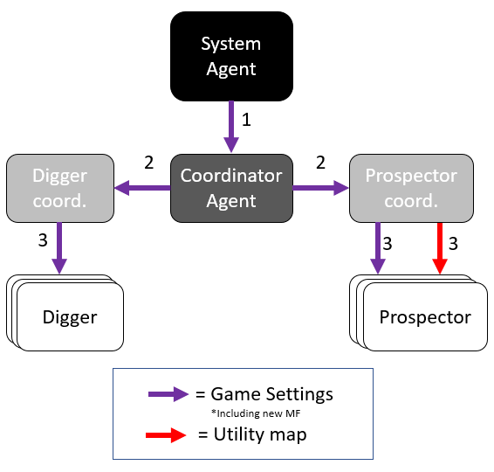

As we can see, the information leaves the system agent and advances through the coordinators agents to all nodes, thus covering all diggers and all prospectors (represented as leaf nodes). Also, the prospector coordinator has the map of utilities implemented and in each turn, he sent it updated to each prospector.

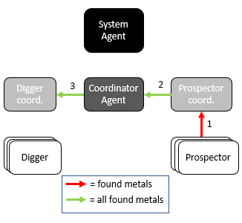

When all the agents have the map, it's the prospectors' turn. They should discover the metals that exist in its vision range and send them to the prospector coordinator. He collects all the metals and brings them together in a single list to transmit this information through the coordinator to the digger coordinator.

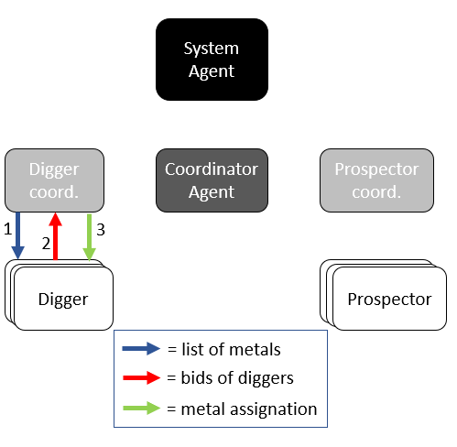

When the digger coordinator has the list of discovered metals, He transmits it to the diggers. Internally, each one of them calculates a bid price for each metal and send it back to the digger coordinator. Once the digger coordinator has received bids from all diggers, he decides the allocation of the metals and communicates it to the diggers.

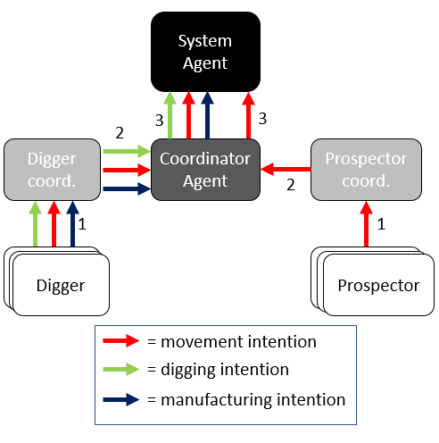

Once all these steps have been completed, we can proceed to the requests that are made to the system agent, such as motion requests, digging requests and manufacturing requests (these last two are only made by the diggers).

# Agents and Behaviors

Missing Behaviours.

## System Agent

* **Amount:** 1
* **Mobility:** Static
* **Communication:** Coordinator Agent
* **Function:** This is an agent which acts as the environment. It is responsible for creating the game settings and graphical interface, adding new metal fields to the map and apply the movements of diggers and prospectors. Each turn starts and ends in this agent.
* **Behaviors:**
  + **RequestResponseBehaviour:** It triggers when the Coordinator Agent sends a “GET_MAP” request to the System. Its only function is to send to the requester the first turn GameSettings, which will start the game.
  + **ChooseActionSA:** It triggers when it receives a “CHOOSE_ACTION” message (from the Coordinator Agent) which will always contain a CompleteMessage object (This object is formed by all the movement, digging and manufacturing petitions from the diggers and prospectors). The behavior calls the methods to check and apply the turn changes and then send back to the Coordinator Agent the new turn GameSettings.

## Coordinator Agent

* **Amount:** 1
* **Mobility:** Static
* **Communication:** System Agent, Digger Coordinator Agent, Prospector Coordinator Agent.
* **Function:** This agent is the general coordinator of the Multi Agent System. It acts as link of the system agent and the system, meaning that every single communication that any agent wants to send to the system has to go through it. It is also responsible for communicating the diggers side with the prospectors’ side.
* **Behaviors:**
  + **RequesterBehaviour:** It is the only Initiator behavior of the system, it triggers when the Coordinator Agent is created and sends a “GET_MAP” request to the System Agent. When it receives the initial GameSettings it resends them to the Digger Coordinator and the Prospector Coordinator.
  + **ActionHandlingCA:** It triggers when the Coordinator Agent receives a “DIG_ACTION” message (It has nothing to do with diggers). It will act depending on the content of the message:
    - Metal Field List (from Prospector Coordinator): It merges the current found metals with the new ones received and send the resulting metal field list to the Digger Coordinator.
    - Digging Message List (from Digger Coordinator): It adds the petition to a Complete Message with all the petitions, if the 4 petitions have been added, sends the Complete Message to the System Agent.
    - Moving Message List (from Digger Coordinator): It adds the petition to a Complete Message with all the petitions, if the 4 petitions have been added, sends the Complete Message to the System Agent.
    - Digging Message List (from Prospector Coordinator): It adds the petition to a Complete Message with all the petitions, if the 4 petitions have been added, sends the Complete Message to the System Agent.
    - Manufacturing Message List (from Digger Coordinator): It adds the petition to a Complete Message with all the petitions, if the 4 petitions have been added, sends the Complete Message to the System Agent.
  + **MapHandlingCA:** It triggers when the Coordinator Agent receives a “NEW_MAP” message from the System Agent. It updates the complete metal field list with the turn changes and then sends the new turn game settings to the Digger Coordinator and Prospector Coordinator.

## Digger Coordinator Agent

* **Amount:** 1
* **Mobility:** Static
* **Communication:** Coordinator Agent, Digger Agents (all of them).
* **Function:** This agent is responsible for the coordination of the digging side. It receives from the Coordinator Agent the metal fields found in the new turn by the prospectors and assigns them to the diggers through a protocol explained in this document.
* **Behaviors:**
  + **MapHandlingDCA:** It triggers when the Digger Coordinator Agent receives a “GET_MAP” message from the Coordinator Agent and acts depending on the content of the message:
    - (new turn) Game Settings: It simply updates its own current Game Settings and send them to all the diggers.
    - MetalFieldList: Sends the MetalFieldList to the diggers so they can “bid” (the “bids” will be handled in SelectivityVotingDCA).
  + **SelectivityVotingDCA:** It triggers when the Digger Coordinator receives a “SELECTIVITY” message from any of the Diggers containing their “bids” for the current MetalFieldList. If is has received all the “bids”, makes the assignation and sends a message to the Diggers with it.
  + **ChooseActionDCA:** It triggers when the Digger Coordinator receives a “CHOOSE_ACTION” message from any of the Diggers containing their petition to move, dig or manufacture. Once it has received the petition from all the Diggers, put them together and send them to the Coordinator Agent.

## Prospector Coordinator Agent

* **Amount:** 1
* **Mobility:** Static
* **Communication:** Coordinator Agent, Prospector Agents (all of them).
* **Function:** This agent is responsible for the coordination of the prospecting side. It receives the metal fields found in the new turn by the prospector agents and sends them to the digging side through the Coordinator Agent. It is also responsible for the organization of the prospectors’ movement.
* **Behaviors:**
  + **MapHandlingPC:** It triggers when the Prospector Coordinator receives an “INFORM” message and acts depending on its content:
    - (new turn) Game Settings (from Coordinator): It updates its current game settings, computes the new utility map for the Prospectors and send it to them.
    - MetalFieldList (from any Prospector): It adds the new fount metals to its list, checks if all Prospectors have sent they new metal field list, and, if so, sends it to the Coordinator Agent.
    - MovingMessage (from any Prospector): It adds the moving petition to a list and, when it has received the petition of every Prospector, it sends the moving message list to the Coordinator Agent.

## Digger Agent

* **Amount:** Depends on the game settings (In the provided case: 8)
* **Mobility:** Can move through the map.
* **Communication:** Digger Coordinator Agent, [Prospector Agent] (Just in case they form a coalition to follow it).
* **Function:** These agents are the ones in charge of extracting metals from the metal fields and carry them to a manufacturing center. They are assigned a metal field to go depending on a protocol (Reference to the protocol explanation).
* **Behaviors:**
  + **MapHandlingDA:** It triggers then the Digger receives a “GET_MAP” message from the Digger Coordinator containing the new turn Game Settings. It just updates the Digger current position.
  + **SelectivityVotingDA:** It triggers when the Digger receives a “SELECTIVITY” message from the Digger Coordinator containing the current found Metal Field List. It computes the “bid” for every of the Metal Fields and sends the list of “bids” to the Digger Coordinator.
  + **ChooseActionDA:** It triggers when the Digger receives a “CHOOSE_ACTION” message from the Digger Coorinator containing its assignation after the Selectivity process has finished. Acts in function of the assignation and its currentstate:
    - No metal assigned + Carrying Metal + Touching a valid Manufacturing Center: Sends a manufacturing message to the Digger Coordinator.
    - No metal assigned + Carrying Metal + NOT Touching a valid Manufacturing Center: Computes the best manufacturing center to go and also computes the movement to go there. Sends a movement message to the Digger Coordinator.
    - No metal assigned + NOT Carrying Metal: The digger has to follow its nearest prospector. It starts a ContractNet protocol to find the best prospector.
    - Metal assigned: Computes the distance to the assigned metal. If it is touching the metal, sends a Digging message to the Digger Coordinator. Else, computes the best movement towards the metal field and sends a Movement message to the Digger Coordinator.
  + **ContractNetDA:** It is a ContractNetInitiator behavior which triggers when the Digger has not been assigned any metal field and is not carrying metal. It sends requests to all the prospectors which will respond the request with their position and the Digger will select the “winning” prospector and tell it to him.

## Prospector Agent

* **Amount:** Depends on the game settings (In the provided case: 4)
* **Mobility:** Can move through the map. Uses the utility (explained somewhere) to decide where to move.
* **Communication:** Prospector Coordinator Agent, [Digger Agent] (Just in case they form a coalition to be followed by some of them).
* **Function:** These agents are the ones in charge of finding metals. They move through the map and try to find them. They send the metal found each turn to the Prospector Coordinator.
* **Behaviors:**
  + MapHandling: It triggers when the Prospector receives an “INFORM” message from the Prospector Coordinator containing the new utility map. It updates the Prospector position, search if there is any metal field, and builds a MetalFieldList with the metal fields found. Then, it sends the list to the Prospector Coordinator.
  + ContractNetPA: It triggers when receives a “FIPA_CONTRACT_NET” “CPF” message from a Digger. It sends back to this digger its current position, and waits for him to tell if he will follow the Prospector.

# Work Changes

## Digger Coordinator Gold / Digger Coordinator Silver

Since the beginning of the word we talked about adding a two sub-Digger Coordinators, one for gold and the other one for silver. The function of them would be just to take some of the actions that the Digger Coordinator would perform in order to reduce its computational load.

However, during the implementation of the project, we have realized that the full computational load the Multi Agent System has is not enough to be worth to add these two agents and the implementation complexity it would carry.

That is why we have finally decided not to implement them.

## Other Changes??

# Performance

Statistical performance of the system.

# Conclusions and Future Work

Conclusions of the system and future work to do.

[1]–[3] [4]

# Bibliography

[1] M. Wooldridge, *An Introduction to MultiAgent Systems*. Wiley, 2009.

[2] F. L. Bellifemine, G. Caire, and D. Greenwood, *Developing Multi-Agent Systems with JADE*. Wiley, 2007.

[3] (Fundation for Intelligent Physical Agents) FIPA, “FIPA Contract Net Interaction Protocol Specification,” *Architecture*, no. SC00029H, p. 9, 2002.

[4] “JADE DOC. API.” [Online]. Available: http://jade.tilab.com/doc/api/.