

URV | Facultat de Informàtica

Planning and approximate reasoning - Exercise 2

Josep Famadas alsamora / jordi riu vicente

Fuzzy Expert System

2017

Table of content

Table of Tables 3

Table of Figures 4

1. Introduction 6

2. Input variables 7

2.1. Rainfall 7

2.2. Lightness 7

2.3. Fog 8

2.4. Tires pressure 8

3. Output variables 9

3.1. Visibility Level 9

3.1.1. Fuzzy sets 9

3.1.2. Rules 9

3.2. Light Instruction 11

3.2.1. Fuzzy sets 11

3.2.2. Rules 11

3.3. Front Car Distance 12

3.3.1. Fuzzy sets 12

4. System testing 13

4.1. Situation 1 13

4.1.1. Values 13

4.1.2. Input sets 13

4.1.3. Rules activation 15

4.1.4. Output sets 17

4.2. Situation 2 18

4.2.1. Values 18

4.2.2. Input sets 18

4.2.3. Rules activation 20

4.2.4. Output sets 22

4.3. Situation 3 23

4.3.1. Values 23

4.3.2. Input sets 23

4.3.3. Rules activation 25

4.3.4. Output sets 27

5. Manual calculation 28

6. Degree of support variation 31

7. Tires pressure to determine Safe distance 32

# Table of Tables

Table 1: Situation 1: Input sets and its membership values 28

Table 2: Situation 1: Rules activated for the visibility level 28

# Table of Figures

Figure 1: Rainfall fuzzy sets 7

Figure 2: Lightness fuzzy sets 7

Figure 3: Fog fuzzy sets 8

Figure 4: Tires pressure fuzzy set 8

Figure 5: Visibility level fuzzy sets 9

Figure 6: Visibility level rules 10

Figure 7: Light Instruction fuzzy sets 11

Figure 8: Light Instruction rules 11

Figure 9: Front Car Distance fuzzy sets 12

Figure 10: Situation 1: Values for the inputs and outputs 13

Figure 11: Situation 1: Rainfall and Lightness fuzzy sets memberships 13

Figure 12: Situation 1: Fog and Tires Pressure fuzzy sets memberships 14

Figure 13: Situation 1: Visibility level rules block (In red the activated rules) 15

Figure 14: Situation 1: Light Instruction rules block (In red the activated rules) 16

Figure 15: Situation 1: Front Car Distance rules block (In red the activated rules) 16

Figure 16: Situation 1: Output variables fuzzy sets memberships 17

Figure 17: Situation 2: Values for the inputs and outputs 18

Figure 18: Situation 2: Rainfall and Lightness fuzzy sets memberships 18

Figure 19: Situation 2: Fog and Tires Pressure fuzzy sets memberships 19

Figure 20: Situation 2: Visibility level rules block (In red the activated rules) 20

Figure 21: Situation 2: Light Instruction rules block (In red the activated rules) 21

Figure 22: Situation 2: Front Car Distance rules block (In red the activated rules) 21

Figure 23: Situation 2: Output variables fuzzy sets memberships 22

Figure 24: Situation 3: Values for the inputs and outputs 23

Figure 25: Situation 3: Rainfall and Lightness fuzzy sets memberships 23

Figure 26: Situation 3: Fog and Tires Pressure fuzzy sets memberships 24

Figure 27: Situation 3: Visibility level rules block (In red the activated rules) 25

Figure 28: Situation 3: Light Instruction rules block (In red the activated rules) 26

Figure 29: Situation 3: Front Car Distance rules block (In red the activated rules) 26

Figure 30: Situation 3: Output variables fuzzy sets memberships 27

Figure 31: Situation 1: Activated Visibility level fuzzy sets with their memberships (From left to right: Medium, High, Maximum) 29

Figure 32: Situation 1: Area where half of the total area has been covered 30

Figure 33: Front Car Distance (Vertical) as a function of Tires pressure (Horizontal) and Fog (Depth) 32

Figure 34: Front Car Distance (Vertical) as a function of Tires pressure (Horizontal) and Lightness (Depth) 33

Figure 35: Front Car Distance (Vertical) as a function of Tires pressure (Horizontal) and Rainfall (Depth) 33

# Introduction

In this document we present the results of our project, which is devoted to design a fuzzy expert system.

The system controls the light intensity of a car required and the safety distance between it and the car in front. It takes into account environmental variables such as rain intensity, lightness, fog and tires pressure.

The system uses the Mamdani inference procedure and the Center of Area as defuzzification method.

To design this system, we have used the fuzzyTECH software.

# Input variables

In this system we have considered 4 different input variables. The first 3 are given and we have decided the fuzzy sets of the fourth one.

## Rainfall

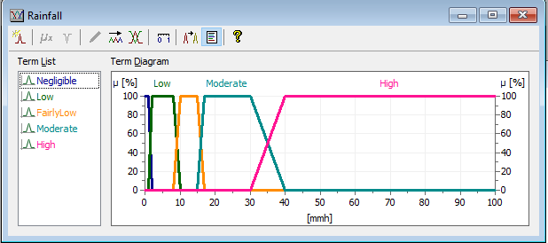

Figure 1: Rainfall fuzzy sets

## Lightness

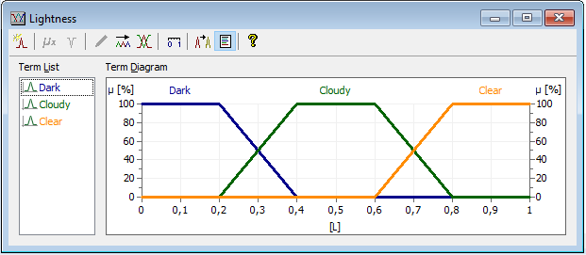

Figure 2: Lightness fuzzy sets

## Fog

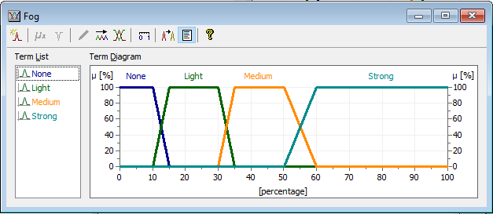

Figure 3: Fog fuzzy sets

## Tires pressure

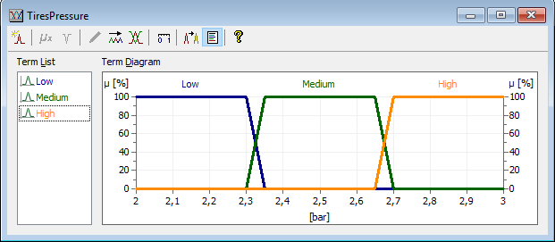

Figure 4: Tires pressure fuzzy set

For this variable we have considered three equal fuzzy sets and for the values in barometers we have looked it up on the internet for real data.

# Output variables

For each one of the 2 previously mentioned output variables we have defined their fuzzy sets and created a block of rules. There is also an intermediate variable (Visibility level) that has its own sets and rules.

## Visibility Level

### Fuzzy sets

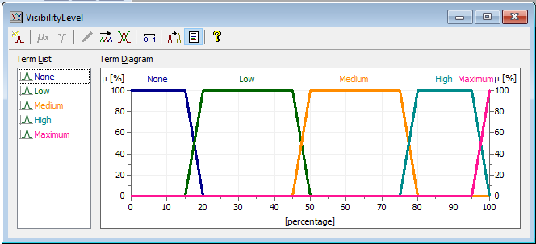

Figure 5: Visibility level fuzzy sets

For the visibility we have considered 5 different fuzzy sets because it is an intermediate variable and we wanted the system to consider as much options as possible.

As it can be seen in *Figure 5* the sets are not equal. Low and Medium visibility are the biggest ones because we thought that in real life they are the most common visibility levels. On the other hand, Maximum visibility is something that nearly ever happens so it is really short.

### Rules

In *Figure 6* can be appreciated the rules for the Visibility level. To design them we have considered that the fog is the most significant issue to visibility. For this reason, if it is strong there is no visibility. Apart from this, the combination of maximum rain level (High) and minimum lightness (Dark) also gives no visibility. Due to the fact that these two rules admit some uncertainty in one or more parameters, they do not have a 100% degree of support.

For the rest of the rules we have followed a logic procedure decreasing the visibility level as the fog and rain intensity increased and the lightness decreased.

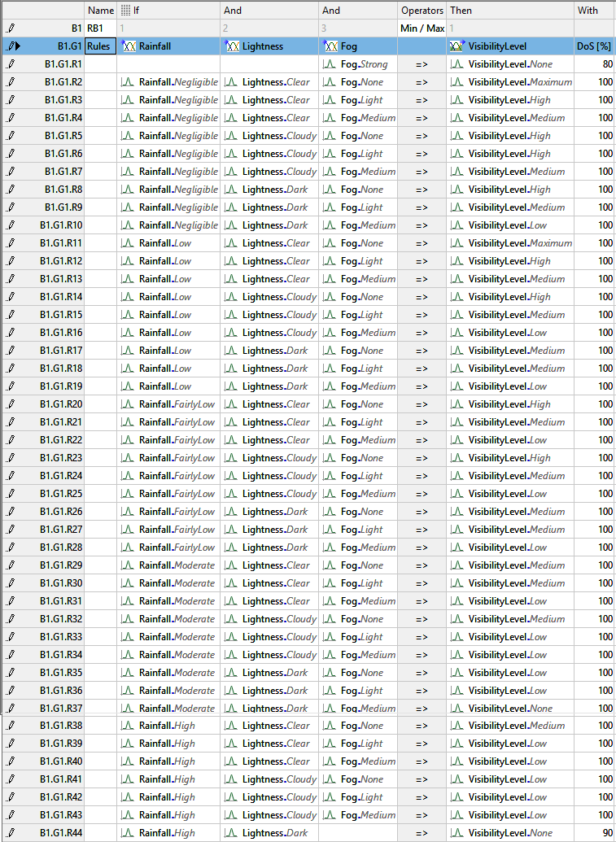

Figure 6: Visibility level rules

## Light Instruction

### Fuzzy sets

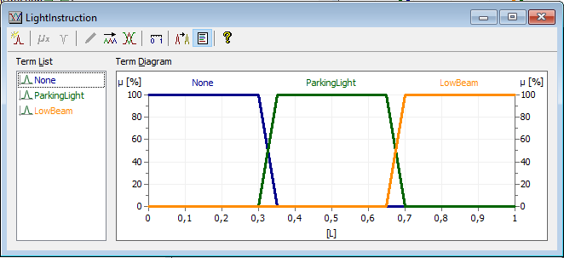

Figure 7: Light Instruction fuzzy sets

For the first output variable we have designed 3 equispaced sets. They represent not having the lights on, having just the Parking Lights (which are just to help other cars to see you) and the Low Beam light which allow you to better see the environment.

### Rules

For these rules we just made the assignment minimum visibility with maximum light, the other way around and Medium visibility with parking light.

The intermediate levels between the maximum or minimum and the medium (Low and High), have been assigned to the higher and lower lights but with less degree of support.

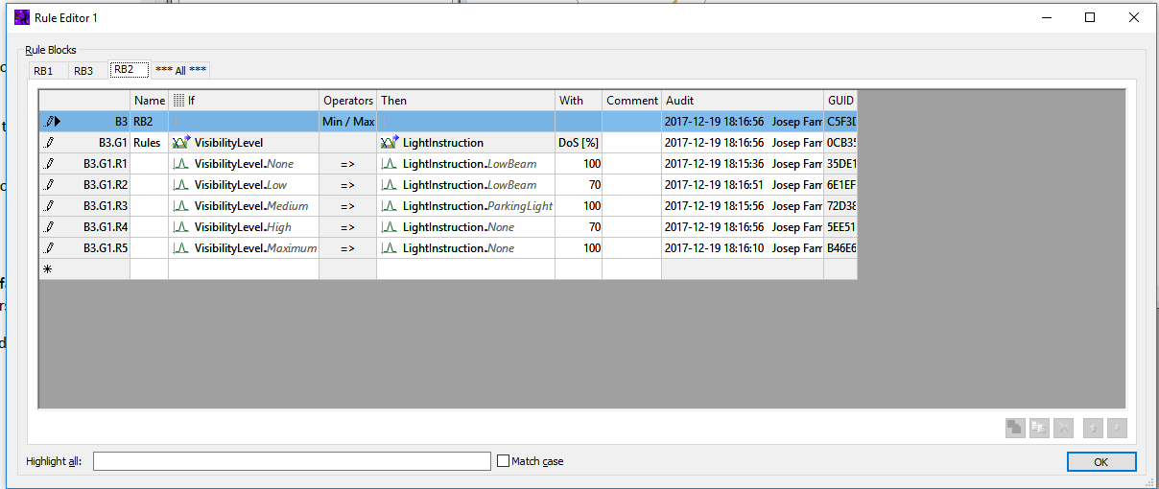

Figure 8: Light Instruction rules

## Front Car Distance

### Fuzzy sets

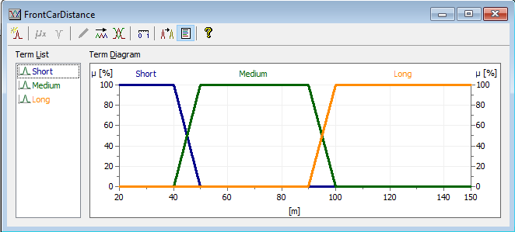

Figure 9: Front Car Distance fuzzy sets

TODO

# System testing

In order to test the system, we have thought of 3 different real-life situations, one with good conditions, another with medium and a last one with bad environmental conditions.

## Situation 1

### Values

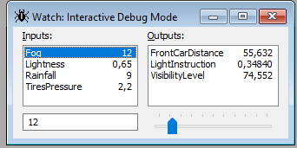

Figure 10: Situation 1: Values for the inputs and outputs

### Input sets

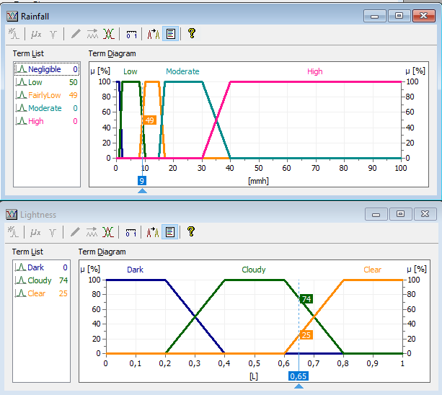

Figure 11: Situation 1: Rainfall and Lightness fuzzy sets memberships

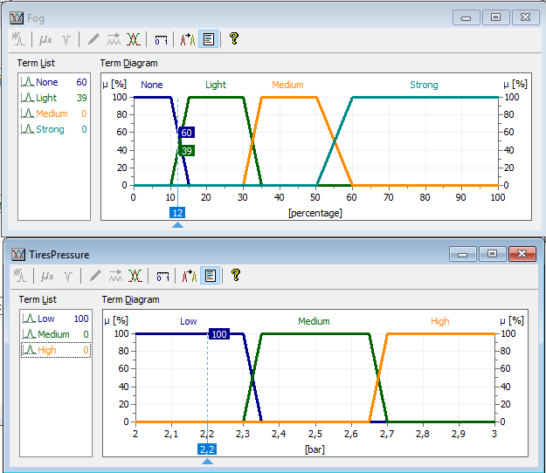

Figure 12: Situation 1: Fog and Tires Pressure fuzzy sets memberships

### Rules activation

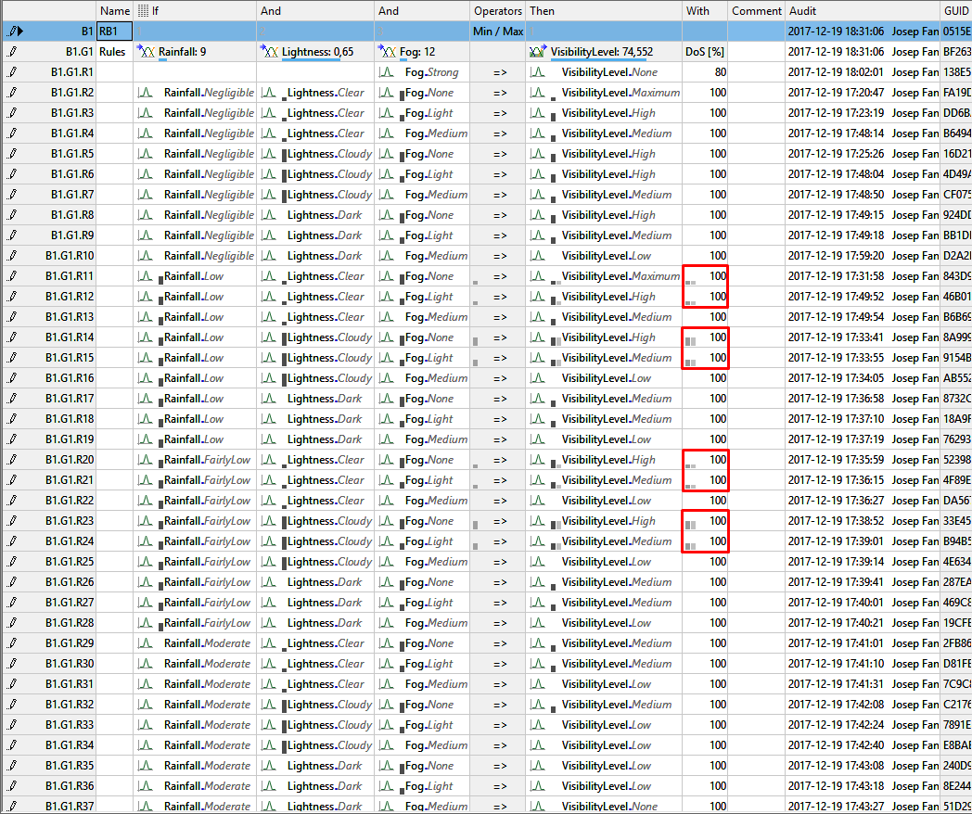

Figure 13: Situation 1: Visibility level rules block (In red the activated rules)

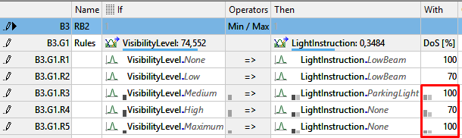

Figure 14: Situation 1: Light Instruction rules block (In red the activated rules)

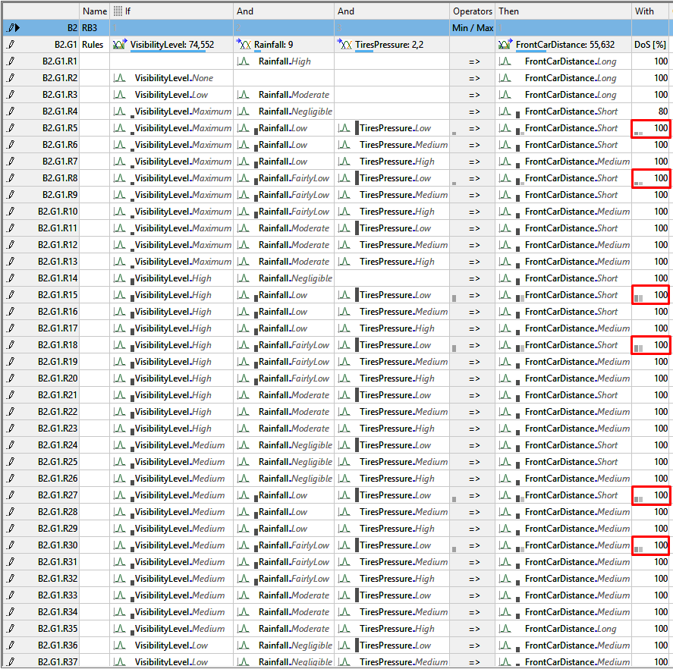

Figure 15: Situation 1: Front Car Distance rules block (In red the activated rules)

### Output sets

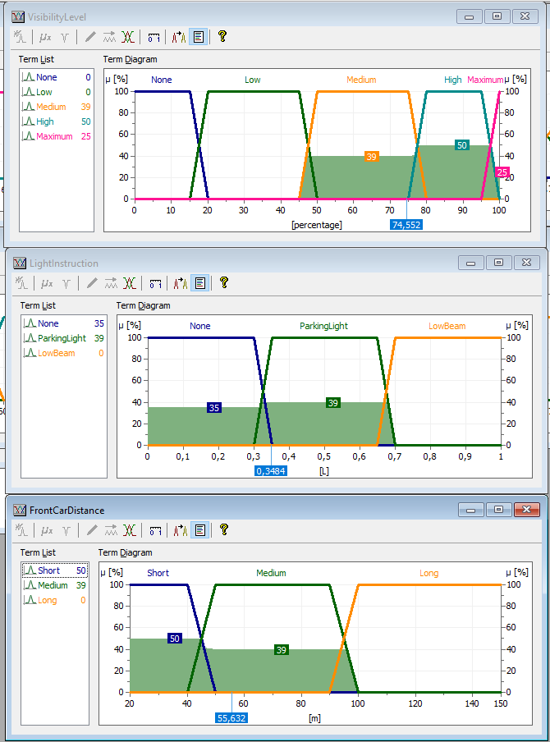

Figure 16: Situation 1: Output variables fuzzy sets memberships

## Situation 2

### Values

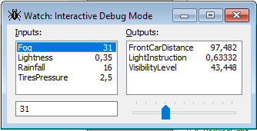

Figure 17: Situation 2: Values for the inputs and outputs

### Input sets

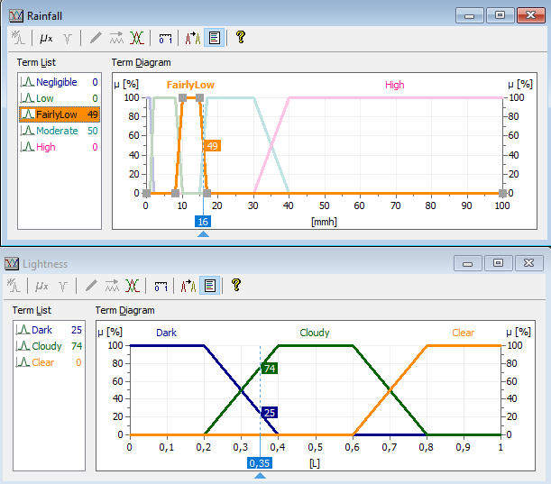

Figure 18: Situation 2: Rainfall and Lightness fuzzy sets memberships

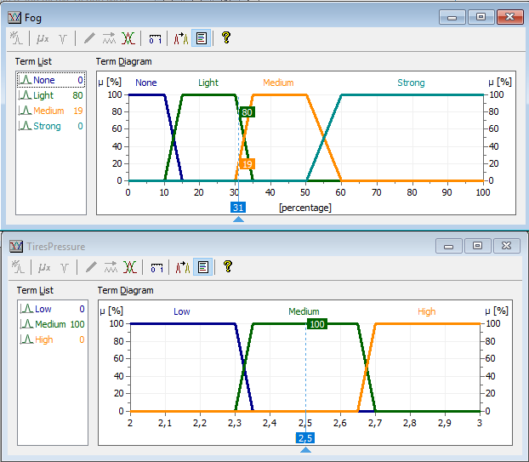

Figure 19: Situation 2: Fog and Tires Pressure fuzzy sets memberships

### Rules activation

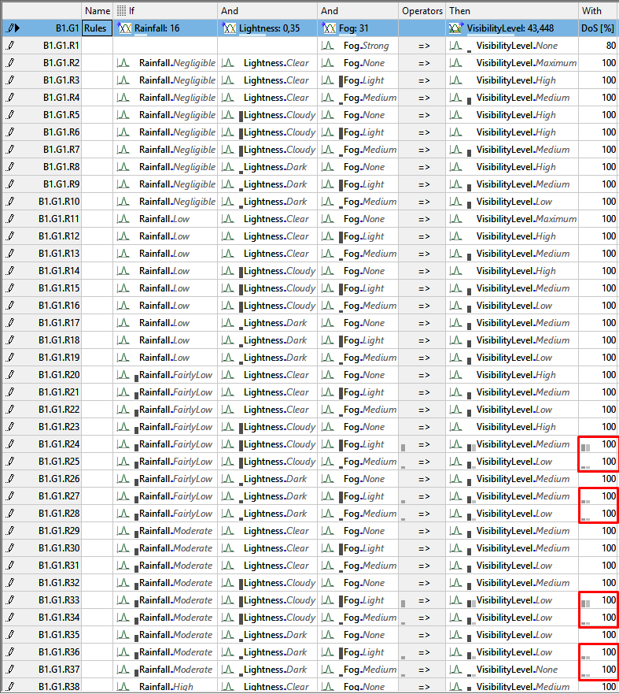

Figure 20: Situation 2: Visibility level rules block (In red the activated rules)

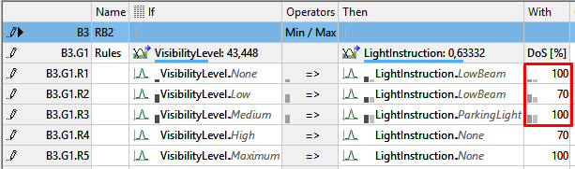

Figure 21: Situation 2: Light Instruction rules block (In red the activated rules)

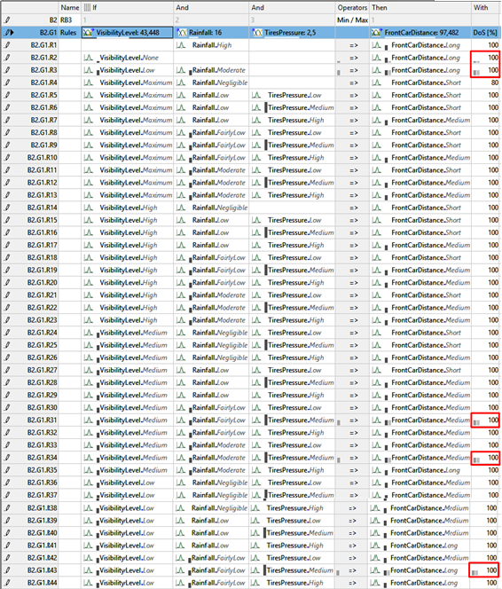

Figure 22: Situation 2: Front Car Distance rules block (In red the activated rules)

### Output sets

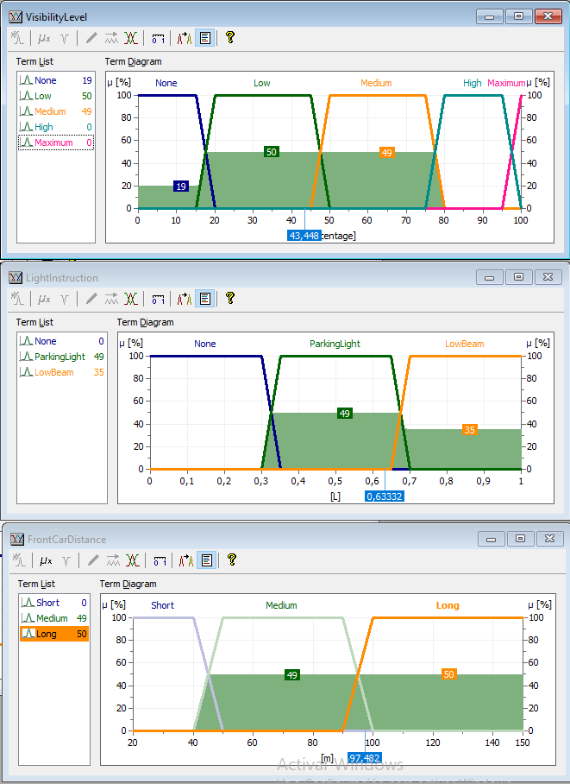

Figure 23: Situation 2: Output variables fuzzy sets memberships

## Situation 3

### Values

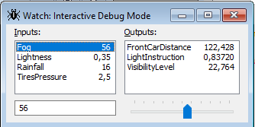

Figure 24: Situation 3: Values for the inputs and outputs

### Input sets



Figure 25: Situation 3: Rainfall and Lightness fuzzy sets memberships

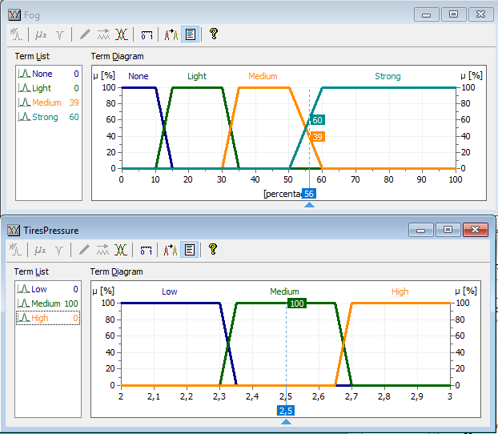

Figure 26: Situation 3: Fog and Tires Pressure fuzzy sets memberships

### Rules activation

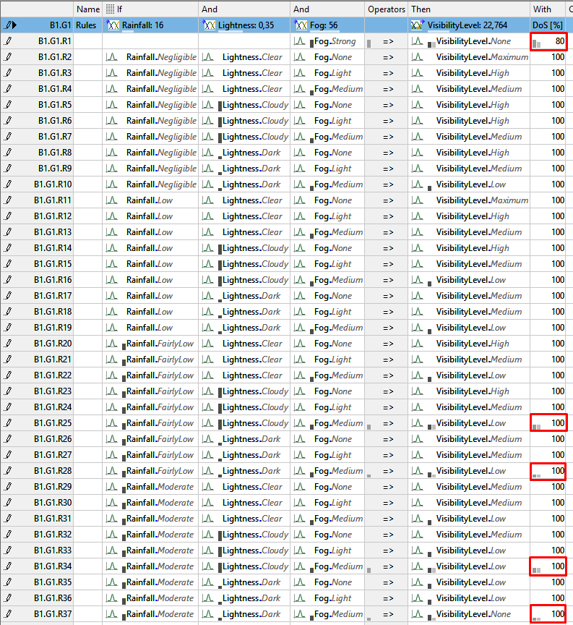

Figure 27: Situation 3: Visibility level rules block (In red the activated rules)

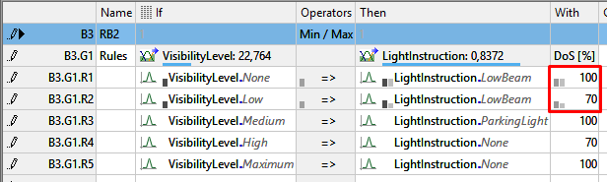

Figure 28: Situation 3: Light Instruction rules block (In red the activated rules)

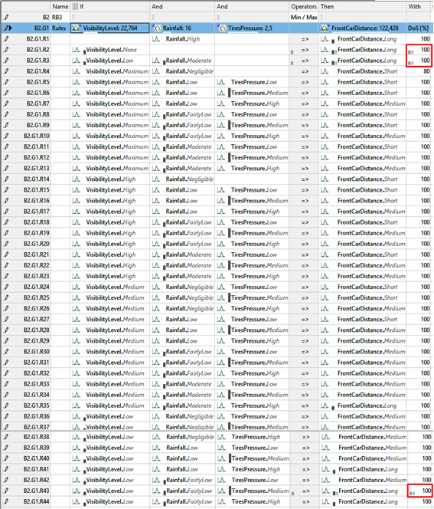

Figure 29: Situation 3: Front Car Distance rules block (In red the activated rules)

### Output sets

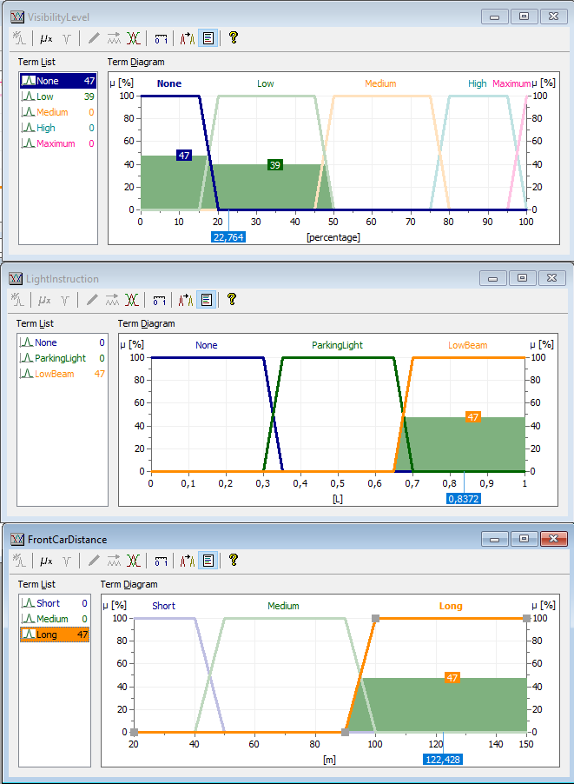

Figure 30: Situation 3: Output variables fuzzy sets memberships

# Manual calculation

For this part of the project we have selected the first situation and calculated its value for the visibility level manually to check that it coincides with the one provided by the fuzzyTECH.

|  |  |  |  |  |
| --- | --- | --- | --- | --- |
|  | Set 1 | Membership 1 | Set 2 | Membership 2 |
| Rainfall | Low | 50.5 | FairlyLow | 49.5 |
| Lightness | Cloudy | 74.5 | Clear | 25.5 |
| Fog | None | 60.5 | Light | 39.5 |

Table 1: Situation 1: Input sets and its membership values

|  |  |  |  |  |  |  |
| --- | --- | --- | --- | --- | --- | --- |
|  | Rainfall | Lightness | Fog | Min | Dos (%) | Visibility Level |
| Rule 11 | Low – 50.5 | Clear – 25.5 | None – 60.5 | 25.5 | 100 | Maximum |
| Rule 12 | Low – 50.5 | Clear – 25.5 | Light – 39.5 | 25.5 | 100 | High |
| Rule 14 | Low – 50.5 | Cloudy – 74.5 | None – 60.5 | 50.5 | 100 | High |
| Rule 15 | Low – 50.5 | Cloudy – 74.5 | Light – 39.5 | 39.5 | 100 | Medium |
| Rule 20 | FairlyLow – 49.5 | Clear – 25.5 | None – 60.5 | 25.5 | 100 | High |
| Rule 21 | FairlyLow – 49.5 | Clear – 25.5 | Light – 39.5 | 25.5 | 100 | Medium |
| Rule 23 | FairlyLow – 49.5 | Cloudy – 74.5 | None – 60.5 | 49.5 | 100 | High |
| Rule 24 | FairlyLow – 49.5 | Cloudy – 74.5 | Light – 39.5 | 39.5 | 100 | High |

Table 2: Situation 1: Rules activated for the visibility level

Once all the activated rules have given their output values, for each visibility level set we selected the maximum membership, which are:

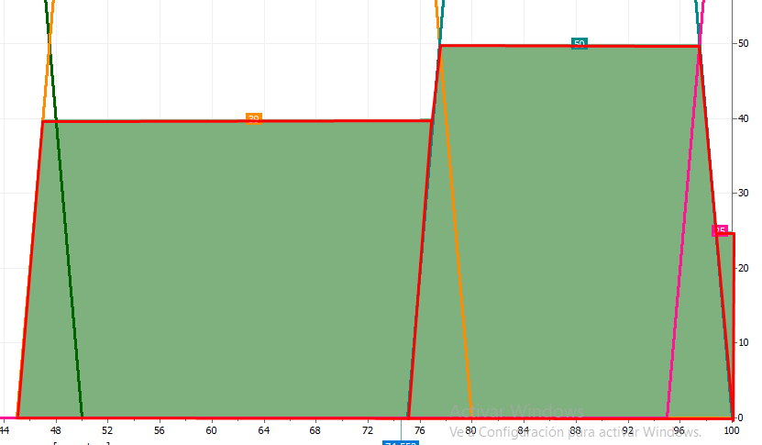

Figure 31: Situation 1: Activated Visibility level fuzzy sets with their memberships (From left to right: Medium, High, Maximum)

Finally we divided the final figure in 3 subfigures to compute their areas

Therefore, the final center of areas must be calculated starting from the left side and see when we have covered half of the total area (1166.875).

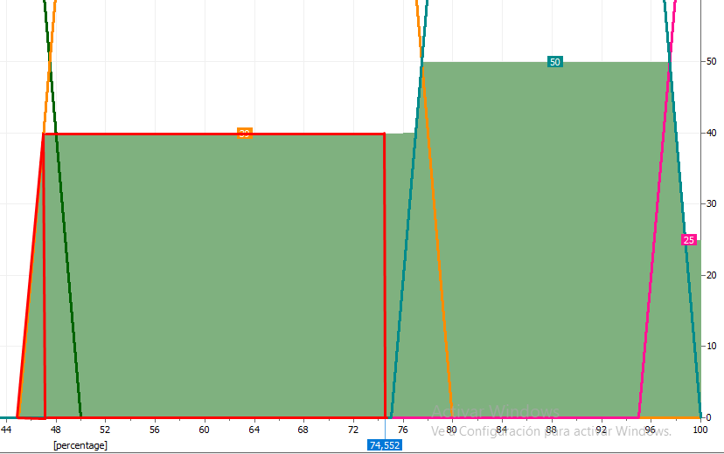

Figure 32: Situation 1: Area where half of the total area has been covered

The area of the left triangle is 39.5, so we still have to cover 1127.375. With the height of 39.5, the base of the rectangle that covers this area must be 28.54, which added to the 47 where the rectangle starts gives 75.54, which is our final defuzzified value for the variable VisibilityLevel. The error of 1 might be due to the fact that when we were given values that did not sum 100 (e.g. 39 and 60) we gave half point to each of them.

# Degree of support variation

In this part, to check the utility of the degree of support (DoS) we have selected the Situation 1, and played with the DoS of the Front Car Distance rules.

As we expected, changing the DoS of a rule that does not give the maximum output does not affect the final result.

On the other hand, reducing the DoS of the rule that provides the maximum value for a set of the output variable, reduces the corresponding membership to that set until it reaches the value of the second most dominant rule for the same set, which will be now the dominant one.

In our case, we first reduced the DoS of rule 18 which gives a value of 49 to 90%. Therefore, the membership value of the output to set FrontCarDistance.Short changed from 49 to 44. But, if we reduce the DoS of that rule to 75%, the output value becomes 37 which is lower than the one given by the rule 27 (with a value of 39) and it will become the maximum value.

(Just to explain this example we have reduced to 0 the rule 15 because it gave a value of 50 and we could not compare it to the value of 49 of the rule 18 by changing the DoS).

# Tires pressure to determine Safe distance

In the next three figures we can observe the influence of the tires pressure respect to the other 3 inputs variables. In the first and third images, the three levels of tire pressure can easily be appreciated but in the second one, the safety distance do not differentiate whether the pressure is High or Medium.

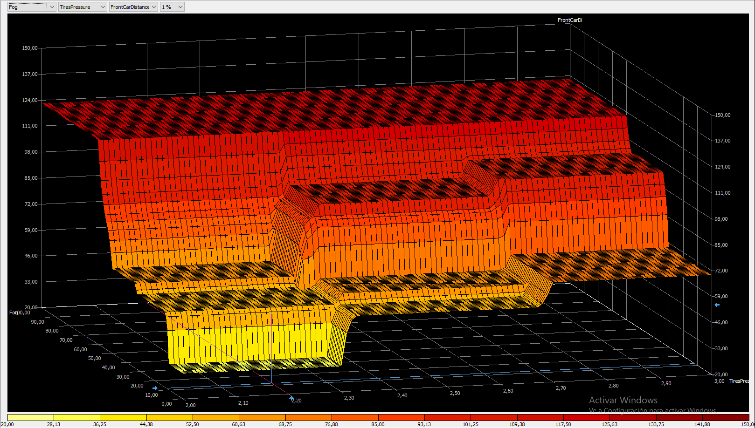

Figure 33: Front Car Distance (Vertical) as a function of Tires pressure (Horizontal) and Fog (Depth)

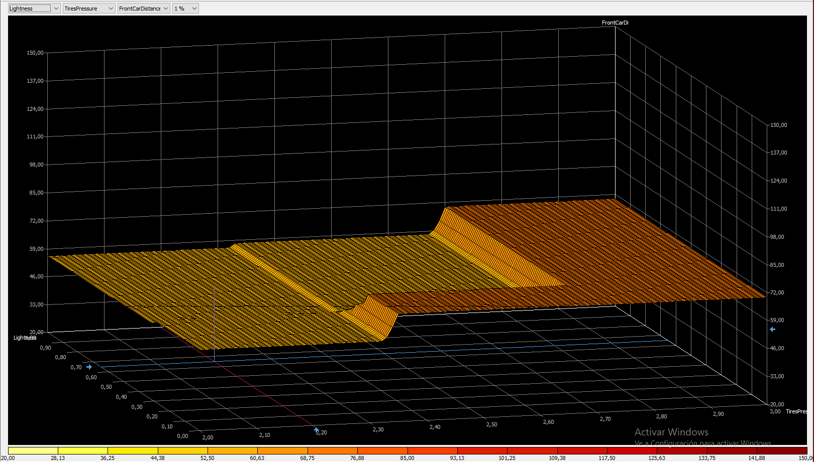

Figure 34: Front Car Distance (Vertical) as a function of Tires pressure (Horizontal) and Lightness (Depth)

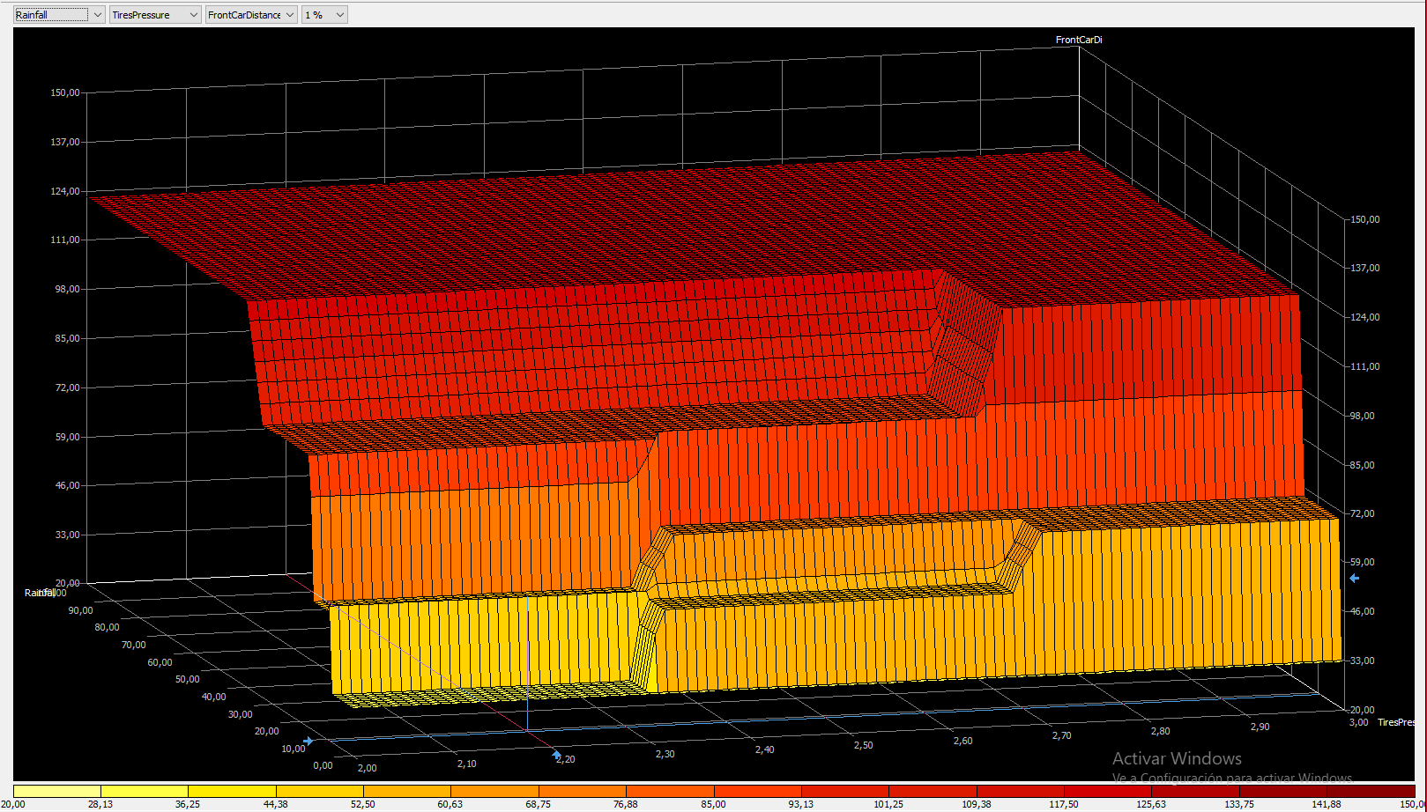

Figure 35: Front Car Distance (Vertical) as a function of Tires pressure (Horizontal) and Rainfall (Depth)