Original

Data reduction(delete attributes)

Data transformation(numberic, birthyear to age)

Data discretization(age)

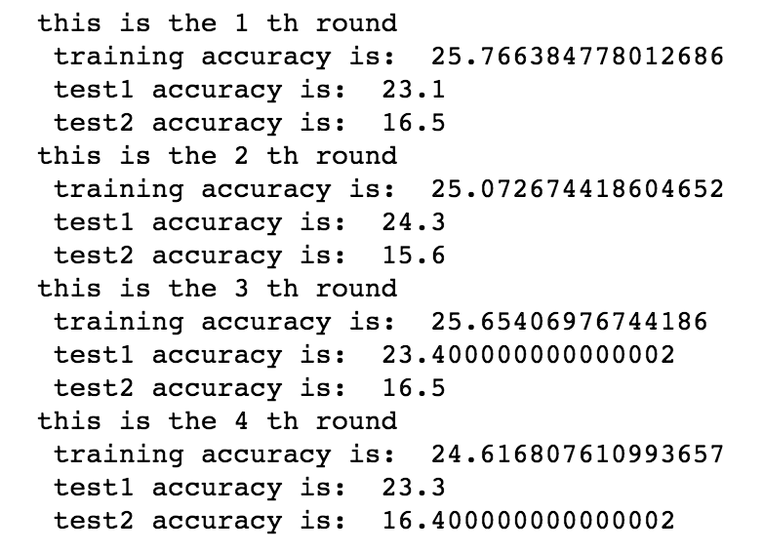

Data cleaning(delete duration>600 age<3 age>13)

Data integration(month)

