7. **Sorting students' data by rin**

Command: SELECT * FROM `students` ORDER BY `rin` ASC

Output: 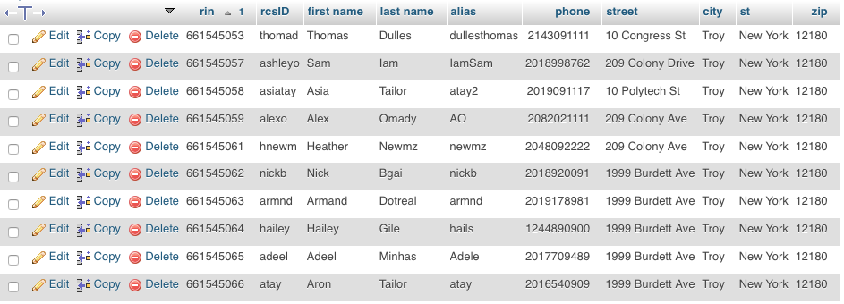

**Sorting students' data by last name**

Command: SELECT * FROM `students` ORDER BY `last name` ASC

Output:

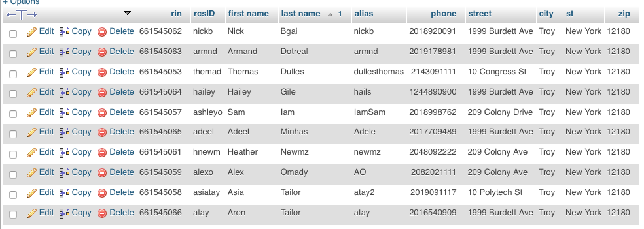

**Sorting students' data by rcsID**

SELECT * FROM `students` ORDER BY `rcsID` ASC

Output: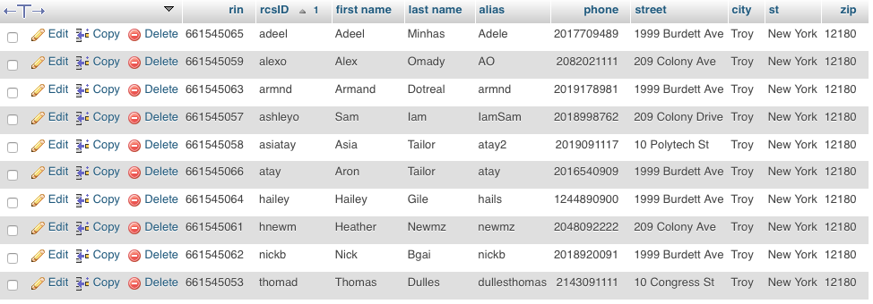

**Sorting students' data by first name**

SELECT * FROM `students` ORDER BY `first name` ASC

Output:

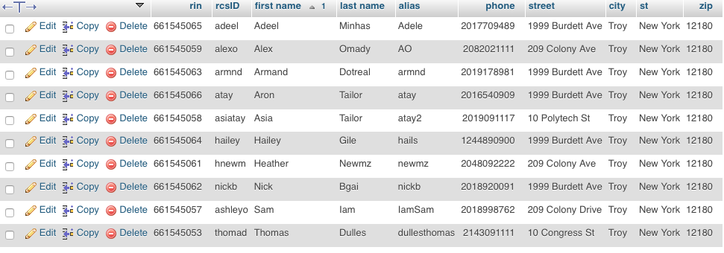

8. **List all students first name and last name if their grade in any course was higher than a 90**

Command:

[SELECT](http://localhost/phpmyadmin/url.php?url=http://dev.mysql.com/doc/refman/5.5/en/select.html) `students`.`first name`, `students`.`last name`, `grades`.`grade` FROM `grades` [LEFT](http://localhost/phpmyadmin/url.php?url=http://dev.mysql.com/doc/refman/5.5/en/string-functions.html#function_left) JOIN `students` ON `students`.`rin` = `grades`.`rin` [LEFT](http://localhost/phpmyadmin/url.php?url=http://dev.mysql.com/doc/refman/5.5/en/string-functions.html#function_left) JOIN `courses` ON `grades`.`crn` = `courses`.`crn` WHERE `grades`.`grade` > 90

Output:

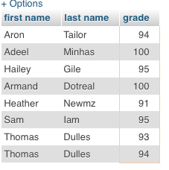

9. **List out the average grade in the second course** (second course entered in courses table was ECON 1200 Introductory Economics, crn: 35303)

Command:

SELECT AVG(`grade`) FROM `grades` where `crn`=35303

Output:

../../../../../../../Users/JohnFantell/Desktop/Screen%20Shot%202016-

10. List out the number of students

Command: SELECT COUNT(`rin`) FROM students

../../../../../../../Users/JohnFantell/Desktop/Screen%20Shot%202016-