**Table 1.** Distribution of coyote reports across coyote boldness categories.

|  |  |  |  |
| --- | --- | --- | --- |
| **Coyote Boldness (ordinal scale value)** | **Description and form classification as coyote response to humans** | **Number of Reports** | **Percentage of Total Reports** |
| **Avoidance (1)** | Ran away | 645 | 7.2% |
|  | Walked away | 348 | 3.8% |
| **Indifferent (2)** | Did not appear to notice or care about people | 1105 | 12.2% |
|  | Watched the person | 381 | 4.2% |
|  | Vocalized at the person | 46 | 0.5% |
| **Bold (3)** | Followed or stalked pets or people | 464 | 5.1% |
|  | Approached pets or people | 218 | 2.4% |
| **Aggressive (4)** | Chased or charged pets or people | 194 | 2.1% |
|  | Physical contact with pets or people | 139 | 1.5% |
| **Sighting (N/A)** | Reports were submitted as sightings or comments indicated no interaction between people and coyote(s) | 4770 | 52.2% |
| **Unknown (N/A)** | Reports were submitted as encounters, but coyote boldness could not be determined | 824 | 9.0% |

**Table 2.** Distribution of reports across human concern categories.

|  |  |  |  |
| --- | --- | --- | --- |
| **Human Concern† (ordinal scale value)** | **Description** | **Number of Reports** | **Percentage of Total Reports** |
| **Positive (1)** | Reports containing words like love, happy, exciting, cool or beautiful | 147 | 1.6% |
| **Neutral (2)** | Reports containing words like surprised or curious, or denying negative reaction | 195 | 2.1% |
| **Negative (3)** | Reports containing words like scared, nervous, disturbed, concerned, uncomfortable or alarmed | 718 | 7.9% |
| **Unknown (N/A)** | Human concern could not be determined | 7958 | 87.1% |

† 116 (1.3%) reports where reporters were concerned for the well-being of the coyote were excluded.

**Table 3.** Land cover classes representing different degrees of human development and coyote habitat suitability in Edmonton, Alberta. These were determined from the City of Edmonton Urban Planning Land and Vegetation Inventory (uPLVI) site types.

|  |  |
| --- | --- |
| **Land Cover Class (uPLVI site types)** | **% Study Area** |
| 1. Natural   (forested, native grass, closed shrub, medial shrub, exposed mineral soil, marsh, treed fen, shrubby fen) | 8.2% |
| 1. Modified Open   (annual crops, tame pasture, rough pasture, agriculture hygric tillage site, non-maintained grass/shrub, recent clearing, farmyard/acreage, treed shelterbelt, transplant treed site, nursery/tree farm) | 16.0% |
| 1. Mowed   (maintained grass site) | 7.7% |
| 1. Residential   (established residential community, residential development site, acreage subdivision) | 42.0% |
| 1. Commercial   (established commercial/industrial, commercial/industrial development, aggregates or fill sites, building and/or parking complex, oil and gas field site, transportation surface) | 23.4% |
| 1. Water   (anthropogenic water, natural water) | 2.7% |

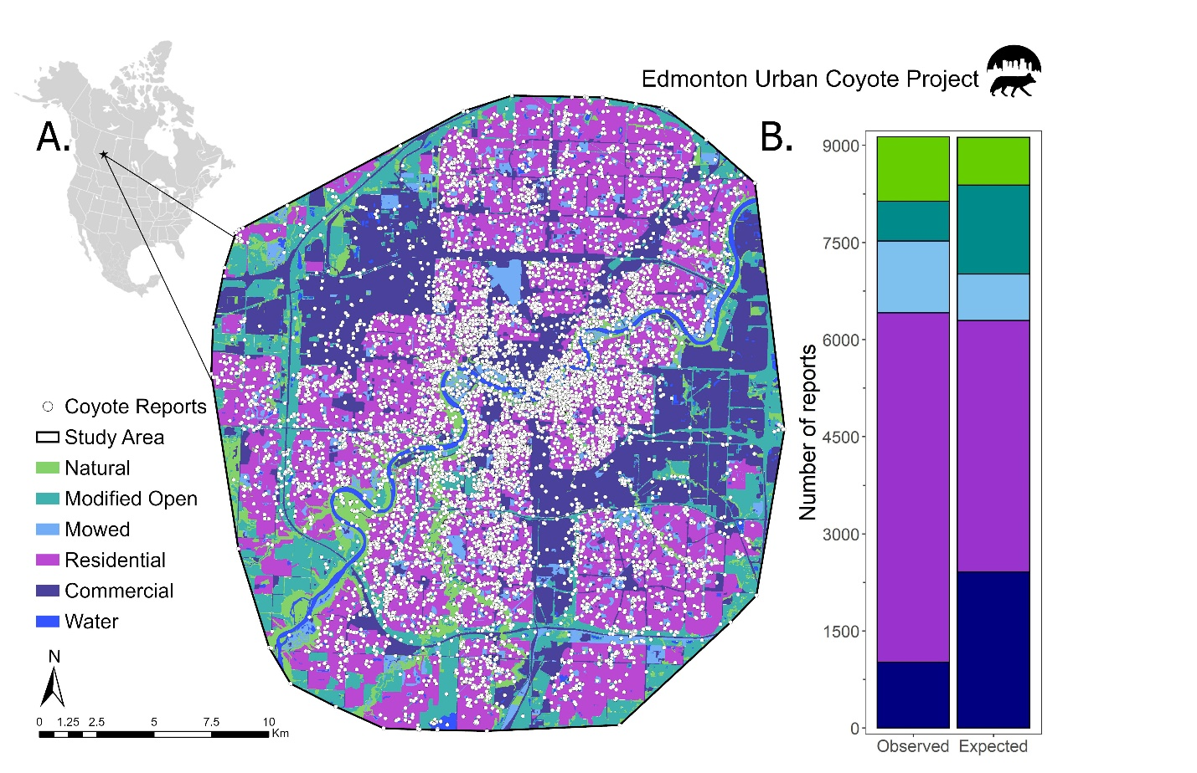

**Figure 1.** Spatial distribution of coyote reports across Edmonton, Canada (A) and across land cover categories (B). Reports were collected from 2011-2021 through the Edmonton Urban Coyote project website and included the location of the coyote sighting or interaction. The observed distribution of reports across land cover types was significantly different from the distribution expected based on the proportion of each land cover type in the study area (χ24 = 1564, p < 0.001).

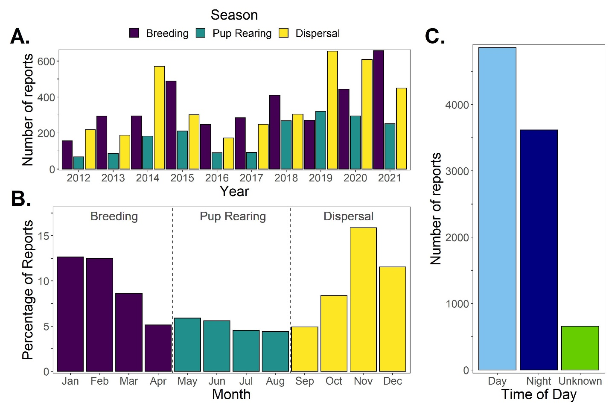

**Figure 2.** Temporal patterns in coyote reporting across years (A), months (B), coyote seasons (A & B) and time of day (C). Reports were collected through the Edmonton Urban Coyote project website and the date and time of report were submitted by the reporter.

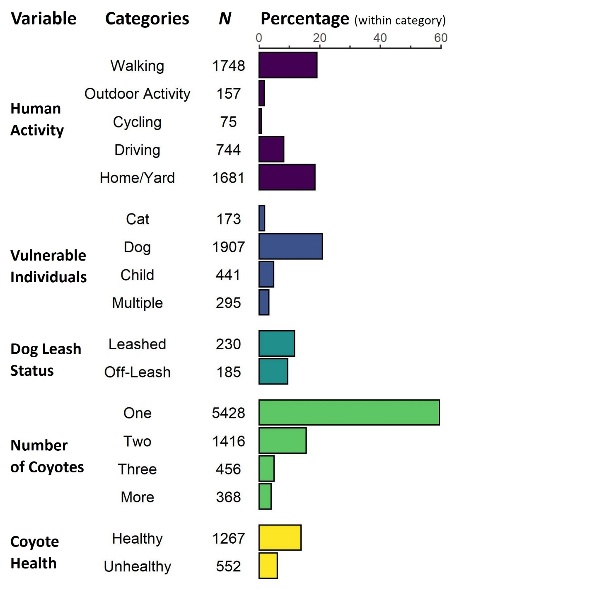

**Figure 3.** Coyote report distribution across contextual variables. Percentages were calculated based on the total number of reports (*N* = 9,134) with the exception of dog leash status, which is based on the number of reports that mentioned dogs (*N* = 1,958). These percentages do not add up to 100 because contextual variables could not be determined for all reports.

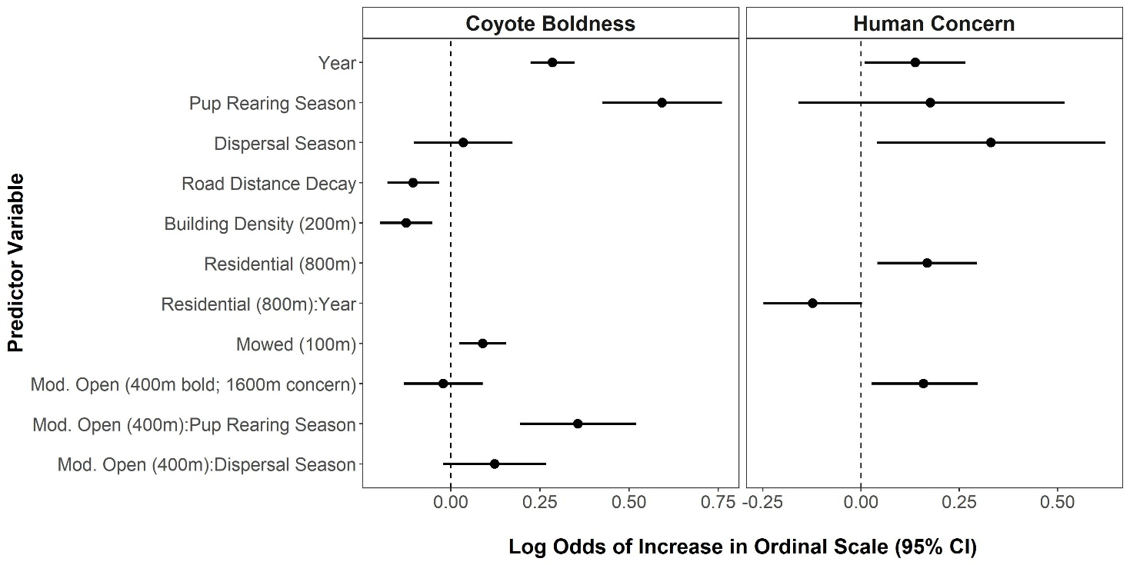

**Figure 4.** Log odds coefficient values and 95% confidence intervals for the explanatory variables retained in the top ordered logistic regression models (lowest AICc) for coyote boldness and human concern of coyotes. The full set of variables included in each global model is available in Table X of Appendix 4. Positive values indicate that the variable causes a higher likelihood of conflict-associated coyote behaviour or human concern, while negative values suggest reduced likelihoods.

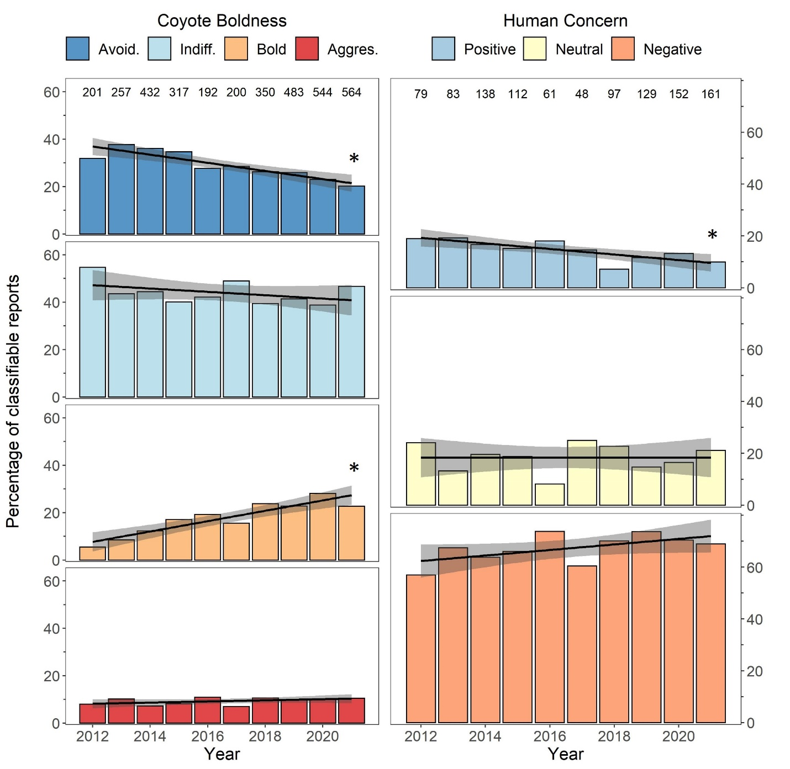

**Figure 5.** Long-term (10 year) trends in coyote boldness and human concern of coyotes as indicated by the percentage of reports in each of the boldness or concern categories. Reports were collected through the Edmonton Urban Coyote project website, and boldness and human concern were scored on ordinal scales using predetermined criterial. Numbers at the top of each chart denote the total number of reports for each year for which an ordinal score could be assigned. Linear trends are shown with 95% confidence intervals shaded in grey and significant trends are indicated by asterisks (p < 0.05).

**Figure 6:** Relationship between each of coyote boldness and human concern of coyotes with contextual independent variables (human activity, the presence or mention of vulnerable individuals, dog leash status, coyote number and coyote health). Colors represent Pearson’s residual values calculated post-hoc from statistically significant chi-square tests of independence, with positive values (red) indicating positive relationships and negative values (blue) indicating negative relationships. P values were adjusted for multiple comparisons with Holm’s correction and significance is indicated by asterisks (* p < 0.05, ** p <0.01, *** p < 0.001). Grey boxes (NA) indicate comparisons for which insufficient reports were available to allow for robust chi square tests (e.g., *N* = 12 reports submitted by cyclists mentioned their level of concern).