Figures & Tables

Question 1 – Patterns of conflict

1. SPACE
   1. **Map of point locations (coupled with heat map – main text?)** 
      1. Map of habitat types (supplementary)
      2. Table with spatial variables + descriptions (supplementary)
   2. **Figure with boldness/perceptions across habitat types**
2. TIME
   1. **Stacked bar plot with boldness/perceptions per month**
   2. Stacked bar plot with boldness/perceptions per time of day (supplementary)
3. CONTEXT
   1. **Multi-panel plot with boldness/perceptions over contextual variables**

Question 2 – Conflict over time

1. **Stacked bar plot with boldness/perceptions per year**
2. **Coefficient plot – 2-panel as discussed with Colleen**
   1. Supplementary Table with all top models for perception & boldness 🡪 coeff, 95% CI, stat value, AIC for model

Question 3 – Conflict over time 🡪 linked to other variables?

1. Plot with boldness/perceptions over habitat types, over time?
2. Simply lean on the coefficient plot?

Table S1. Spatial variables measured for ordinal regression analyses.

|  |  |  |
| --- | --- | --- |
| **Variable Name** | **Description** | **% Study Area** |
| Nat | Forest, wetland and naturally non-wooded areas | 8.2% |
| Mod | Modified open areas such as agricultural areas and deforested areas that are not maintained/mowed | 16.0% |
| Mow | Open mowed/maintained grass | 7.7% |
| Water | Water (anthropogenic or natural in origin) | 2.7% |
| Res | Developed residential areas | 42.0% |
| Com | Highly developed commercial areas | 23.4% |
| Build | Building density | NA |
| RoadDist | Road Distance Decay (*e*-*ad*, d = distance to roads, a = 0.002) | NA |

Figure X. The percentage of annual classifiable coyote reports within each of the coyote boldness or human perception categories. Numbers at the top of bars denote the number of classified reports per year.

SUPPLEMENTARY FIGURE 1

Figure S1. Distribution of coyote reports (in raw numbers) across habitat types, years, months, time of day, human activity, and several contextual variables.

Supplementary Figure X: Changes in coyote boldness and human perceptions across habitat types. Habitat types were classified as the dominant habitat type within a 200m buffer

Supplementary Figure X: Change in coyote boldness over years in each of the habitat types

Supplementary Figure X: Changes in coyote boldness and human perceptions over the months of the year

Supplementary Figure X: Changes in coyote boldness and human perceptions over the time of day

Supplementary Figure X: Changes in coyote boldness and human perceptions for each of the contextual variables.

Figure SX: Change in coyote boldness and human perception in relation to dog status.

Figure SX: The effect of dogs on coyote boldness in various habitat types

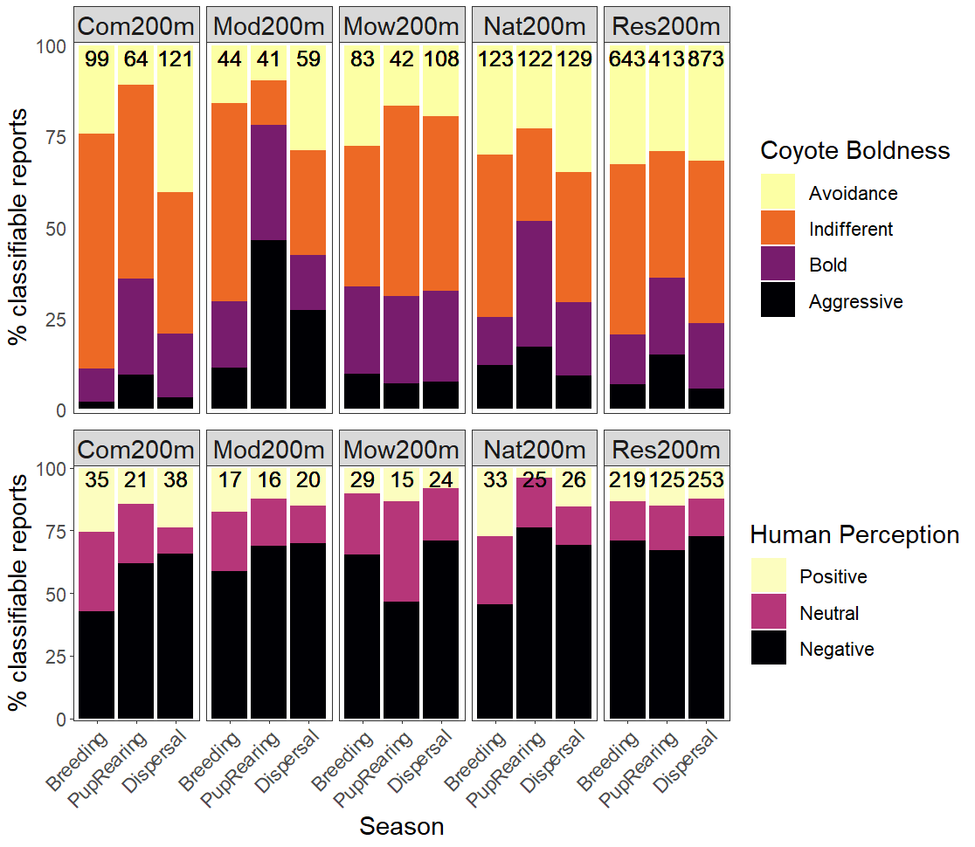

Figure SX: Human-coyote interactions across habitat type and season

Table Supplementary: Contextual variables

|  |  |
| --- | --- |
| Contextual Variable | Variable Categories |
| Human activity | Walking |
|  | Cycling |
|  | Outdoor activity (jogging, golfing, hiking, skiing) |
|  | Driving |
|  | Home or yard |
| Presence or mention of vulnerable individuals | Dog |
|  | Cat |
|  | Child |
|  | Multiple (pets and children) |
| Number of coyotes | One |
|  | Two |
|  | Three |
|  | More |
| Coyote Health | Healthy (strong, beautiful, healthy or majestic) |
|  | Unhealthy (injured, limping, hurt, unhealthy, mangy, scruffy or wounded) |

Appendix 1. Patterns in Coyote Reports

We mapped the point location of each coyote report using ArcGIS Pro v2.7 (Figure 2). We also used the Kernel Density tool to visualize reporting density across Edmonton classified into 10 equal-interval bins. To assess the distribution of reports across land cover classes we used geospatial data from the City of Edmonton Urban Planning Land and Vegetation Inventory (uPLVI) database, a high resolution (minimum polygon size = 1 ha) database that uses remotely sensed imagery and Softcopy photogrammetry to identify land cover types for urban land use decisions (City of Edmonton 2018). We categorized land cover into six land cover classes representing various degrees of human development and coyote habitat suitability (Figure S1; Table S1). We determined the number of reports within each land cover class and used a chi-square goodness of fit test to compare the observed count of reports to the expected count, which we calculated by multiplying the total number of reports by the proportion of each land cover class in the study area (Poessel et al. 2013). We used pairwise comparisons to determine which land cover classes differed from expected values, and adjusted P values for multiple comparisons using a Bonferroni correction (Jafari & Ansari-Pour 2019).

To examine temporal characteristics of reports, we examined inter-annual, monthly and diel trends in reporting. We evaluated long-term changes in reporting by measuring the frequency of reporting, in four-month intervals, from January 2011 to December 2020. We quantified monthly trends in reporting by calculating the mean annual reports for each month. To reflect the biological seasons of coyotes (Morey et al. 2007), we calculated the percentage of total reports that occurred during the breeding (January 1 – April 30), pup rearing (May 1 – August 31), and dispersal (September 1 – December 31) seasons.

Reporters submitted time of day using a drop-down menu with the option to select hourly times between 5 AM and midnight, or one of the following categories: dawn, morning, afternoon, evening or night. We manually categorized time of day into either day or night. Day included the categories of morning or afternoon, or any hourly time at least half an hour after sunrise and half an hour before sunset, which varies substantially across the year due to Edmonton’s northern latitude. Night included the categories night and dawn, or any times half an hour before sunrise or after sunset. We excluded 842 reports in which time was submitted as evening or without a selected time from all daily temporal analyses. We calculated the percentage of reports occurring at night or during the day.

Supplementary Table SX: Outputs from Pearson’s chi square tests examining collinearity between categorical contextual variables.