Task To Convert Word Documents to PDF Documents

Article I Found at https://www.pickupbrain.com/ms-word/bulk-convert-word-to-pdf/

**BULK CONVERT WORD TO PDF FOR FREE**

* by [pickupbr](https://www.pickupbrain.com/author/pickupbr/" \o "Posts by pickupbr)
* [10 Comments](https://www.pickupbrain.com/ms-word/bulk-convert-word-to-pdf/#comments)
* November 4, 2020

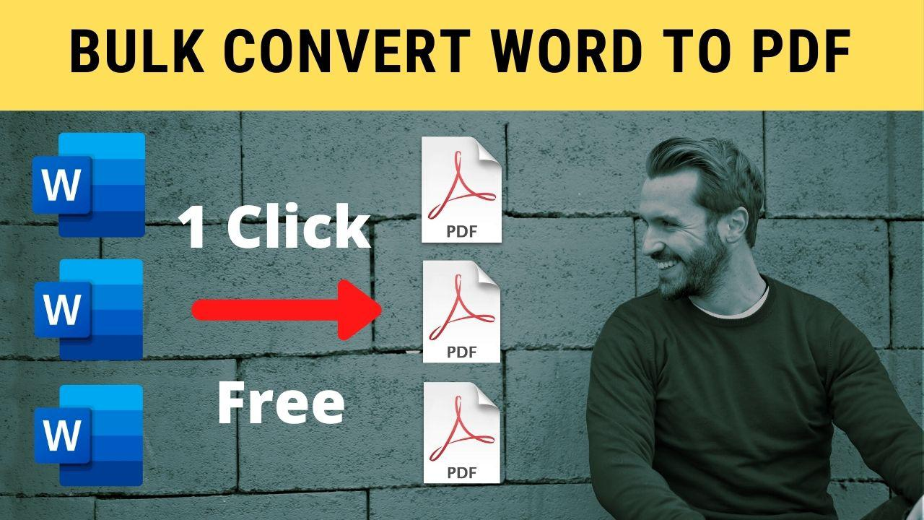

Converting a Word document to PDF file is simple and easy. Just open Word document in Ms Word and save as PDF. But what if you have tons of Word files to convert into PDF? Opening each file manually and saving it to PDF will take ages. But using the following trick, you can bulk convert Word to PDF in just one click. And that too using no external tool. You just need Ms Word.

**Requirement**

**Only Ms Word.**Yes, you the only requirement is MS Word with capability to save document as PDF. For Ms Word 2010 and above, this feature is already available. However, for Ms Word 2007 or lower, you need to install “[Microsoft Save as PDF or XPS](https://filehippo.com/download_2007_microsoft_office_add_in_microsoft_save_as_pdf_or_xps/)” plugin.

**Step to Bulk Convert Word to PDF**

**Step 1: Organizing word files**

Move all your Ms Word documents, that needs to be converted to PDF in one folder say “***fldr***“. You can name it anything you like.

**Step 2: Code to convert Word to PDF**

Open notepad/notepad++ and copy the following code and save file as ***“SaveAsPDF.js”*** in a folder say***“fldr”***. **Note**: Don’t use Ms Word to save it.

Following code converts Word document to PDF file.

var obj = new ActiveXObject("Scripting.FileSystemObject");

var docPath = WScript.Arguments(0);

docPath = obj.GetAbsolutePathName(docPath);

var pdfPath = docPath.replace(/\.doc[^.]*$/, ".pdf");

var objWord = null;

try

{

objWord = new ActiveXObject("Word.Application");

objWord.Visible = false;

var objDoc = objWord.Documents.Open(docPath);

var format = 17;

objDoc.SaveAs(pdfPath, format);

objDoc.Close();

WScript.Echo("Saving '" + docPath + "' as '" + pdfPath + "'...");

}

finally

{

if (objWord != null)

{

objWord.Quit();

}

}

JavaScript

Copy

**Step 3: Create Batch file to bulk convert Word to PDF**

Open notepad or notepad++ and copy the following code. Save the file with **“.bat”** extension say **“bulk-convert-Word2PDF.bat”** in folder ***“fldr”***.

echo off

for %%X in (*.docx) do cscript.exe //nologo SaveAsPDF.js "%%X"

for %%X in (*.doc) do cscript.exe //nologo SaveAsPDF.js "%%X"

PowerShell

Copy

**Step 4: Running Batch file**

Double click batch file **“bulk-convert-Word2PDF.bat”** created in above step and relax. All the word documents with **.docx** and **.doc**extension in folder **“fldr”** is saved to the pdf file with the same name.

**Summary**

Simple code shown in the blog helps automate task of converting Ms Word document into pdf files. To bulk convert Word to PDF, just double click on **“bulk-convert-Word2PDF.bat”** and Relax!!!