Roxy Peck

Many of these questions are from the clicker questions that accompany the following two textbooks:

Roxy Peck and Jay Devore, Statistics: The Exploration and Analysis of Data, 6th Edition, Brooks/Cole Cengage Learning 2008.

Roxy Peck, Chris Olsen and Jay Devore, Introduction to Statistics and Data Analysis, 3rd Edition, Brooks/Cole Cengage Learning 2008.

Increasing sample size

- Has no effect on bias
- Increases bias
- Decreases bias

In order to estimate the proportion of students at a small liberal arts college who watch reality TV for more than 4 hours per week, a random sample of students at the school is selected and each is interviewed about his or her reality TV viewing habits. The students conducting the survey are worried that people that watch reality TV might be embarrassed to admit it and that they may not respond to the survey with honest answers. What type of bias are the students conducting the survey worried about?

- They shouldn't worry—there is no obvious source of bias.
- Selection bias
- Nonresponse bias
- Measurement or response bias

“Graduating is good for your health,” according to a headline in the Boston Globe (3 April 1998). The article noted “According to the Center for Disease Control, college graduates feel better emotionally and physically than do high school dropouts.” Do you think the headline is justified based on this statement?

- Yes, as long as the data was from random samples of college graduates and high school dropouts.
- Yes, because this must have been an observational study. As long as it was a well-designed study, the headline is justified.
- No, because the headline implies a cause and effect relationship, which is not justified based on an observational study.
- No, because this study must have been an experiment and we can’t draw cause and effect conclusions from an experiment.
In a study of perceived importance of money, 100 attorneys were selected at random from those in private practice and 100 attorneys were selected at random from those employed by government agencies as district attorneys. The attorneys in each group were asked to respond to a set of questions designed to assess level of stress in the workplace. This study is ____.

- an observational study
- an experiment

When is it unreasonable to reach a cause-and-effect conclusion based on data from a statistical study?

- Any time the study is based on a random sample from a population of interest.
- When the study is observational.
- When the study is a well-designed experiment that uses random assignment to experimental conditions (treatments).
- It is always reasonable to reach a cause-and-effect conclusion based on data from a statistical study.

In an experiment to evaluate the effect of room temperature on reaction time, a researcher decides to use only males as subjects in the experiment. This is an example of ____.

- direct control
- blocking
- repetition
- randomization

Fifty college students were asked what type of movie they had seen most recently. The responses are summarized in the frequency distribution shown.

Type of Movie | Frequency
Comedy | 23
Drama | 9
Action | 7
Western | 4
Animated | 4
Other | 3

What is the relative frequency for the comedy category?

- 23
- .23
- .46
- 46

The pie chart shown here represents the marital status for a random sample of 100 U.S. adults ages 18 and over. Is this pie chart misleading?

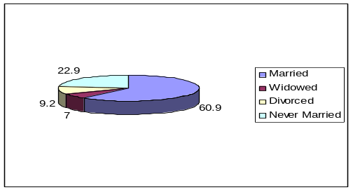

- It is misleading because the smallest category (widowed) should always be at the top of the pie.
- The pie chart is not misleading. Adding the third dimension makes the graph more interesting.
- It is misleading because adding the third dimension distorts the areas of the slices – they are no longer proportional to the category relative frequencies.

Suppose that the value of the variable arm span is recorded for each person in a sample of n = 25 people. Which of the following would be the most appropriate graphical display for this data set?

- bar chart
- comparative bar chart
- pie chart
- dotplot

Suppose that the value of the variable major was recorded for each student in a random sample of n = 500 Cal Poly students. Which of the following would be the most appropriate graphical display for this data set?

- bar chart
- comparative bar chart
- pie chart
- dotplot

Suppose that the values of the variables sex and political affiliation were recorded for each student in a random sample of n = 500 Cal Poly students. Which of the following would be the most appropriate graphical display if the objective was to allow a comparison of males and females with respect to political affiliation?

- two bar charts
- comparative bar chart
- two pie charts
- two dotplots, drawn to the same scale

A data set consists of fifty three-digit numbers ranging from 180 to 510. The best choice for stems in a stem-and-leaf display would be to use ____.

- 1 digit stems (1, 2, …, 5)
- 2 digit stems (18, 19, …, 51)
- 3 digit stems (180, 181, …, 510)

The body lengths (in inches) of 143 bears are summarized in the following histogram. Which of the following two values best represents a typical body length?

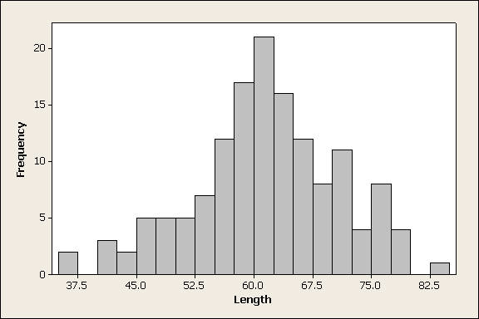

- 21
- 60

Which of the two histograms shown is positively skewed?

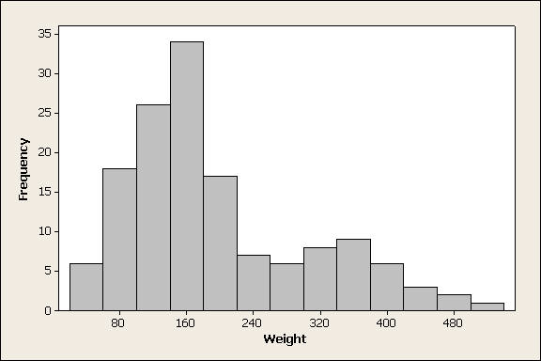

- Weight
- Length

If a frequency distribution is based on intervals of unequal widths, the vertical axis used to construct the corresponding histogram must use ____.

- a frequency scale
- a relative frequency scale
- a density scale
- either a frequency or a relative frequency scale can be used
- a frequency, a relative frequency, or a density scale may be used

For the data set displayed in the following histogram, which would be larger?

- mean
- median
- Can't tell from the given histogram.

A study was carried out at a small college to estimate the mean amount of money spent per semester on books. A random sample of 50 students was selected and the cost for books in the fall semester was recorded for each student. The summary statistics for this sample are shown below.

Variable N Mean StDev Median
Books 50 288.90 44.23 237.19

Based on these statistics, which of the following might be a description of the distribution of values in the sample?
- symmetric and mound shaped
- negatively skewed
- positively skewed

Which of the following two histograms is for a data set with mean > median?

- The histogram of weight
- The histogram of length
- Neither histogram

Suppose your statistics instructor tells you that you scored 70 on an exam and that the class mean was 74. You should hope that the standard deviation of exam scores was ____.

- Small
- Large

Which of the three histograms shown summarizes the data set with the smallest standard deviation?

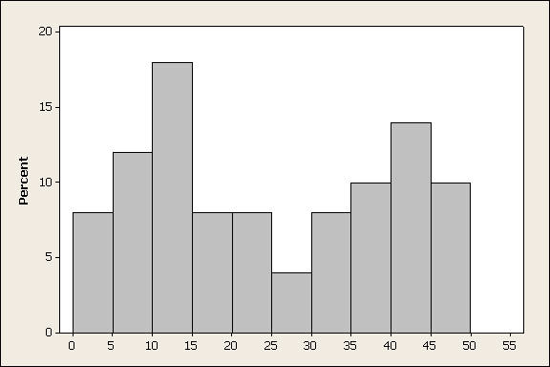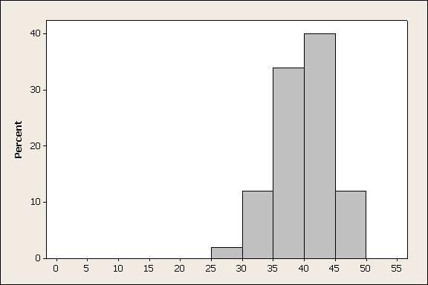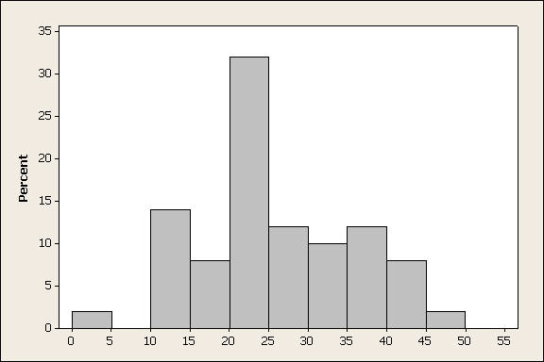
1 2 3

- 1
- 2
- 3

The three dotplots shown display data sets that have standard deviations of 2.6, 6.6, and 14.0. Which of the three dotplots corresponds to the data set with the standard deviation of 6.6?

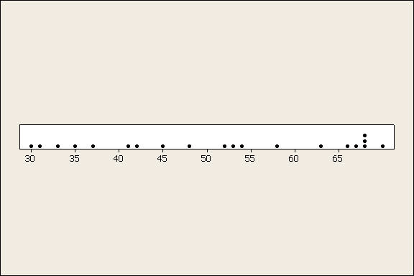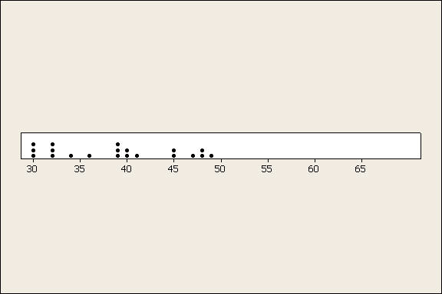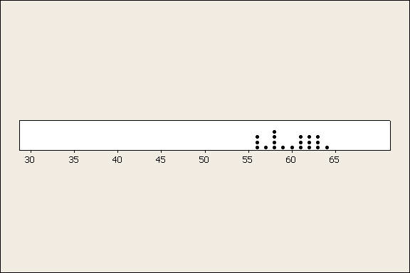

1 2 3

- 1
- 2
- 3

Which boxplot has the smallest IQR?

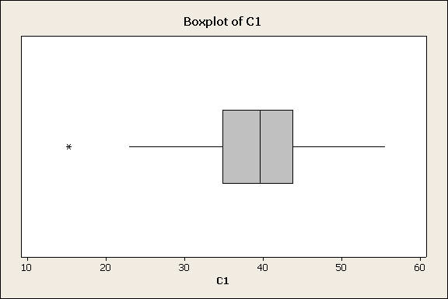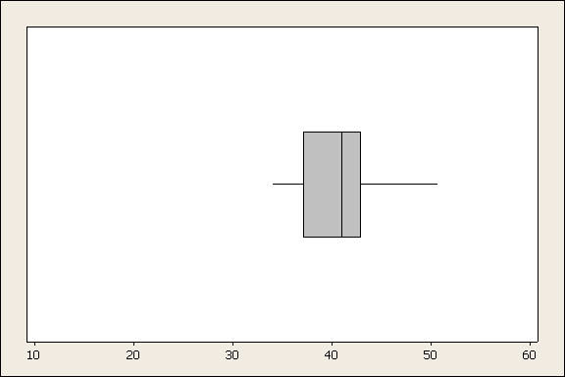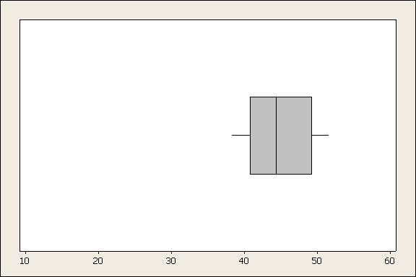

1 2 3

- 1
- 2
- 3

Yogurt is sold in cartons labeled as containing 6 oz, but the actual contents vary slightly from container to container. Suppose that the content distribution is approximately normal in shape with a mean of 6 oz and a standard deviation of 0.05 oz. What can be said about the percentage of cartons that have actual contents less than 5.95 oz?

- The percentage is approximately 68%
- The percentage is approximately 34%
- The percentage is approximately 32%
- The percentage is approximately 16%

Which of the two dotplots shown displays the data set with the smaller IQR?
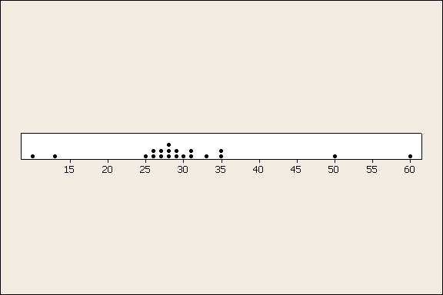 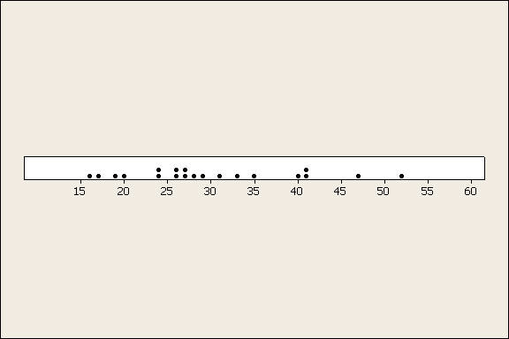
1 2
- 1
- 2

The scatterplots below display three bivariate data sets. The correlation coefficients for these data sets are .03, .68, and .89. Which scatter plot corresponds to the data set with r = .03?
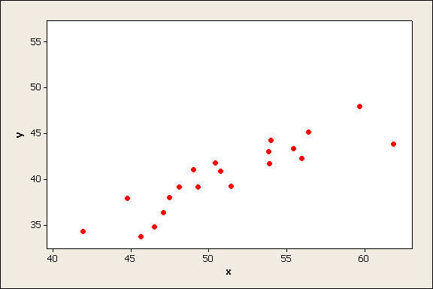 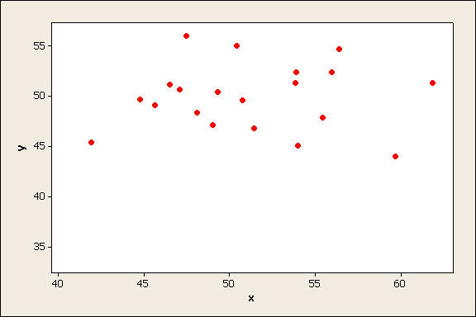 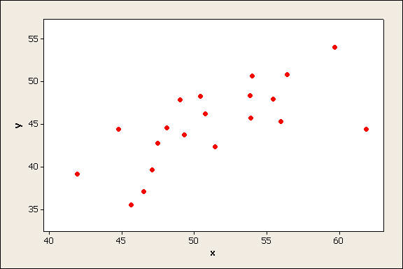
1 2 3

- 1
- 2
- 3

Gas mileage and weight were recorded for each automobile in a sample of 20 compact cars. There was a strong negative correlation, with r = -.87. Based on the value of r, it is reasonable to conclude that increasing the weight of a compact car causes a decrease in gas mileage.

- True
- False

Data on x = age and y = recovery time after
shoulder surgery for 10 weightlifters was used to fit the
regression line. The resulting regression line was 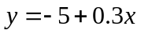.
Which of the following statements is true?
- The line 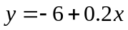 will have a smaller sum of squared deviations than the regression line.
- The line will have the same sum of squared deviations as the regression line.
- The line will have a larger sum of squared deviations than the regression line.

Two lines are proposed to describe the relationship between x and y for a particular data set. Shown below are the lines and the sum of squared error for each line.

Line 1: 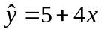, Sum of squared error = 48.6
Line 2: 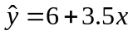, Sum of squared error = 40.8

One of these two lines is the regression line. Which line is the regression line?

- Line 1
- Line 2

A store manager conducted an experiment in which he systematically varied the width of a display for toothpaste from 3 ft. to 6 ft. and recorded the corresponding number of tubes of toothpaste sold per day. The data was used to fit a regression line, which was

What is the predicted number of tubes sold per day for a display width of 12 feet?

- 120
- 140
- It would be unwise to use the regression line to make a prediction for a display width of 12 ft.

Below is a scatterplot that also shows the regression line.
For the point shown in blue, the residual would be ____.

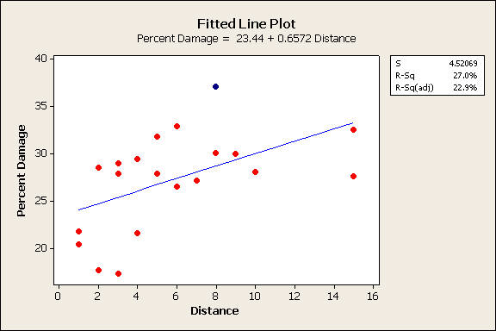

- negative
- zero
- positive

Below is a scatterplot that also shows the regression line.
Which of the points shown in blue and green has a residual that is larger in magnitude (absolute value)?

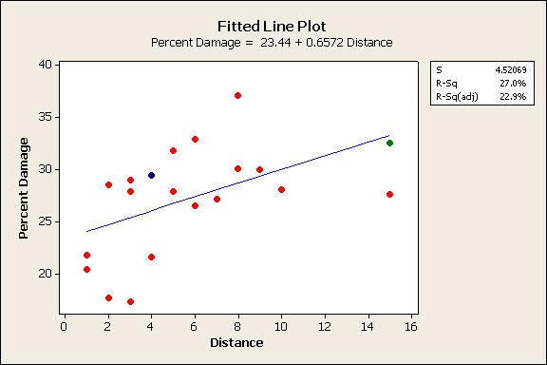

- The blue point
- The green point

Which of the following characteristics in a residual plot are indicative of potential problems?

- A strong pattern in the residual plot
- Isolated points in the residual plot
- lack of any strong pattern in the residual plot
- Both 1 and 2 above are indicative of potential problems
- 1, 2, and 3 above are all indicative of potential problems

When there is a strong linear relationship between two variables, the value of r2 will be ____.

- close to 0
- around .5
- closer to 1 than to 0
- close to either +1 or -1

The regression line that describes the relationship between x = house size (in square feet) and y = house price (in dollars) has r2 = .89 and se = 12,000. If it was important that predictions of house price be within $20,000 of the actual price, should you use the regression line to make predictions?

- Yes
- No

Which of the following is the best evidence that the regression line is an effective summary of the relationship between two variables?
- low r² and low s_{e}
- low r² and high s_{e}
- high r² and low s_{e}
- high r² and high s_{e}

Suppose that a random sample of size 60 resulted in a 90% confidence interval for the proportion of students who carry more than 2 credit cards of (.52, .76). Which of the following is a correct interpretation of the 90% confidence level?

- 90% of the time the population proportion will be between .52 and .76.
- The method used to construct the interval will produce an interval that includes the value of the population proportion about 90% of the time in repeated sampling.
- If 100 different random samples of size 60 from this population were each used to construct a confidence 90% confidence interval, 90 of them will contain the value population proportion.
- The probability that the population proportion is between .52 and .76 is .90.

In order to estimate the proportion of students at a university who carry more than two credit cards, a random sample of students is selected. For which of the following combinations of n and p would it be appropriate to use the confidence interval 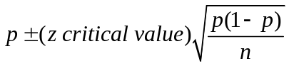?
- n = 10 and p = .6
- n = 20 and p = .4
- n = 40 and p = .3
- n = 100 and p = .05

To estimate the proportion of students at a university who watch reality TV shows, a random sample of 50 students was selected and resulted in a sample proportion of .3. A 95% confidence interval for the proportion that watches reality TV would be ____ a 90% confidence interval.

- narrower than
- the same width as
- wider than

Which of the following pairs gives a legitimate null and alternative hypothesis for carrying out a hypothesis test?

- H_{o}: π = .4 H_{a}: π > .6
- H_{o}: μ < 80 H_{a}: μ > 80
- H_{o}: μ = 80 H_{a}: μ < 80
- H_{o}: = 25 H_{a}: > 25

A grocery store manager is interested in determining if the proportion of customers who pay by credit card at his store is greater than the reported national figure of .10. What hypotheses should the store manager test?

- H_{o}: μ > .1 H_{a}: μ = .1
- H_{o}: μ = .1 H_{a}: μ > .1
- H_{o}: π = .1 H_{a}: π > .1
- H_{o}: π > .1 H_{a}: π = .1
- H_{o}: π > .1 H_{a}: π < .1

The manager of a university computing help line is trying to decide whether to hire additional staff. She has decided to hire if there is evidence that the average time callers to the help line must wait on hold before receiving assistance is greater than 5 minutes. She decides to collect data in order to test
H_{o}: μ = 5 versus H_{a}: μ > 5
where μ is the mean time on hold. From the caller’s perspective, which type of error would be more serious?

- Type I error
- Type II error
- Both types of error would be considered equally serious

If the conclusion in a hypothesis test is to fail to reject H₀, we can conclude that there is strong evidence that the null hypothesis is true.

- True
- False

Suppose that the P-value in a hypothesis test is .08. If the significance level for the test is α = .05, which of the following is the appropriate decision?

- Fail to reject H₀
- Reject H₀
- There is not enough information given to know whether or not H₀ should be rejected.

In order to investigate a claim that the average time required for the county fire department to respond to a reported fire is greater than 15 minutes, county staff determined the response times for 40 randomly selected fire reports. The data was used to test H₀: μ = 15 versus H_{a}: μ > 15 and the computed P-value was .12. If a .05 level of significance is used, what conclusions can be drawn?

- There is convincing evidence that the mean response time is 15 minutes (or less).
- There is convincing evidence that the mean response time is greater than15 minutes.
- There is not convincing evidence that the mean response time is greater than 15 minutes.

