Exam guidelines GEO4300 fall 2019

This document lists the key elements of the expected answers of the written exam (i.e. these do not represent the complete/full answers). The grade achieved in the written exam was combined with the hand-ins to produce the final grade.

**Question 1**

1. Mean

for continuous variables



for discrete variable



Median: F(x_median)=0.5

Mode: max(f(x))

b) E.g. variance

for continuous variable



for discrete variable



c) Pearson correlation: Covariance divided by the product of the standard deviations  
Spearman correlation: Calculate the rank of the data. Calculate the correlation between the ranks  
  
Difference: Pearson: Need a linear relationship to get a correlation of 1.  
Spearman: Can get correlation of 1 also for non-linear relationships

**Question 2**

a)

Test for the difference of mean,

Ho: mu1=mu2 Ha: not equal

Two sample, two-tail

Z=(mu1-mu2)/sqrt(var1/n1+var2/n2)=-4.36

Reject H0 if |z|>1.96

Therefore Ho is rejected, i.e. the means are different at the significance level of 5%.

Test different standard deviations. We can equally test if the variances are different.

H0: var1=var2 Ha: not equal

Fc=var1/var2=1.9

F1−a,n1−1,n2−1=F0.95,999,99= 1.30 < *Fc*

Therefore, Ho is rejected, i.e. there is a significant change in the standard deviations.

b)

Type I error: reject a true null hypothesis. Depends on alpha value.

Type II error: don’t reject a false null hypothesis. Depends on the power of the test, i.e. the sample size, alpha, test specifics…

**Question 3**

1. Use around 4 to 6 classes. Cumulative histogram increases monotonically until 30 (or 1 if normalized).
2. H0: data normally distributed. Find the expected number of observation for each class assuming a normal distribution. The calculations below would differ if different bins are used:

|  |  |  |  |  |
| --- | --- | --- | --- | --- |
| Class | Observed | Relative frequency | Expected | (obs-ex)^2/ex |
| P<2 | 6 | 0.19 | 5.7 | 0.016 |
| 2<P<3 | 6 | 0.38-0.19 | 5.7 | 0.016 |
| 3<P<4 | 6 | 0.60-0.38 | 6.6 | 0.054 |
| 4<P<5 | 5 | 0.80-0.60 | 6.0 | 0.166 |
| P>=5 | 7 | 1.00-0.80 | 6.0 | 0.166 |
| Total | 30 | 1 | 30 | **0.42** |

Chi2=5.99 with alpha=0.05 and ndof=k-p-1=5-2-1=2

Therefore, don’t reject H0.

**Question 4**

1. A, because B doesn’t have periodicity and C doesn’t have any noise
2. Ordinary (least-squares) linear regression: significant slope? You’d have to check the normality of the resulting residuals before your decision.

Mann-Kendall test: statistic based on sum of signs of differences

Maybe also the runs test (even though it would detect the periodicity here, rather than a trend): statistic based on expected number of runs

Also not ideal, but somehow possible would be a jump test: divide the time series in two and check if the means differ significantly

**Question 5**

a) See slide below. Example: linear regression is a supervised model because you predict an outcome that is part of the data used to fit the regression coefficients.

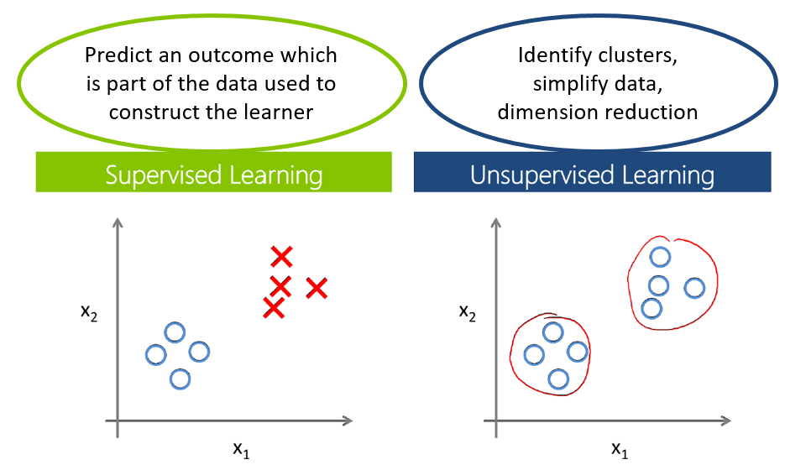

b) See slide below. Example: input is temperature, precipitation, altitude, vegetation type, latitude…. A regression could have this input and have output, Y=annual flood magnitude. A classification could have the same input, but have output, Y=whether there is permafrost or not.  
